HTTP Status Code 500:

A "500 Internal Server Error" is a generic HTTP status code that indicates an issue with the server while processing the request.

1. Exception Handling
2. Infinite Loop
3. External Dependencies
4. Configuration Errors
5. Logging
6. Testing

Authorization And Authentication

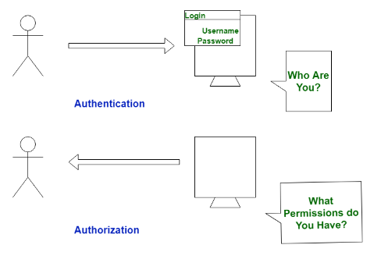

Authentication
In the authentication process, the identity of users are checked for providing the access to the system.

Authorization

Authorization is the process of determining what actions or resources an authenticated user or entity is allowed to access or perform within a system.

