Billing Machine

# Technologies Used:

* Programming Language: C++
* Data Storage System: File System
* Operating System: Windows

# Description:

A typical bill value calculator which we generally come across through super markets. Where it takes inputs from the user which products are to be considered for billing and their quantity keeping their respective discounts. This reduces the manual work of workers in the market to remember the value of each item and their respective discount percentage and also calculates the bill instantly. These helps in saving more time and helps in increases the sales of the market.

# Class Diagrams:

* User Class:

The ID attribute contains a value which is set by default to a certain value which is the passcode to enter the system.

The Logged attribute is flag variable which acts as switch if the user is logged in the system or not.

Login() function is the function to login in the user by prompting the user to enter the passcode.

getLogged() function returns the information about whether the user is logged in to the system successfully or not.

* Cart Class:

Add() add an item into the cart

Remove() removes an item from the cart based upon id

Update() updates an cart’s quantity

Bill() calculates the total bill value of the items in cart

Copy() copies the contents of the cart into a temp file for computational performance

Count() counts number of items in the cart

Show() displays content of the cart

* List Class:

Add() adds an item to the list

Remove() removes an item from the list

Update() updates an item in the list

Copy() copies the content of the list to a temp file for computational purpose.

Count() returns the number of items in the list

Show() displays the content of the list.

User

* ID
* Logged
* Login()
* getLogged()

List

* Add()
* Remove()
* Update()
* Copy()
* Count()
* Show()

Cart

* Add()
* Remove()
* Update()
* Bill()
* Copy()
* Clear()
* Count()
* Show()

# Screenshots:

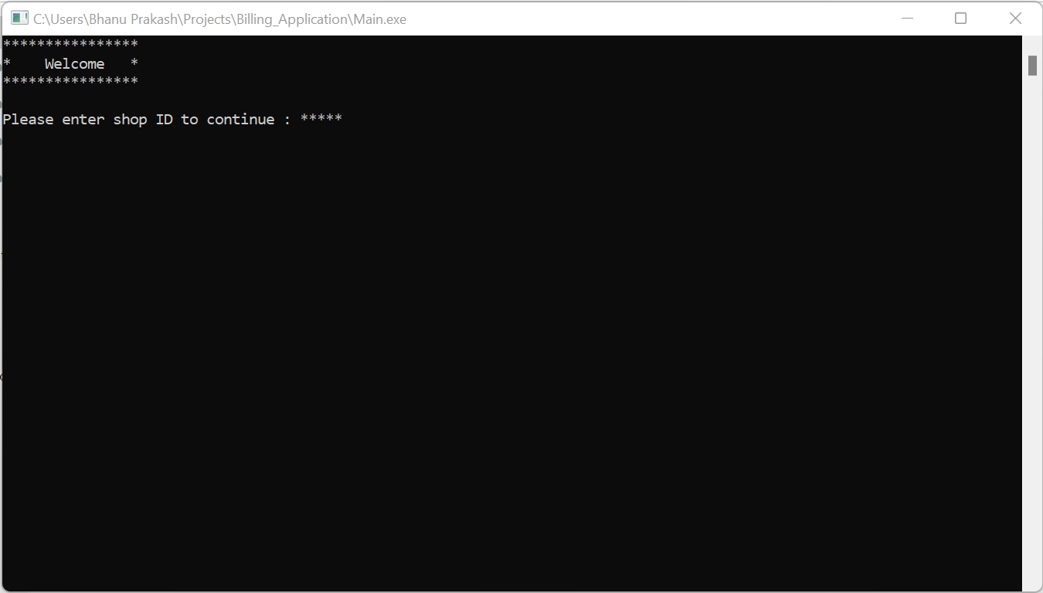

Login Window

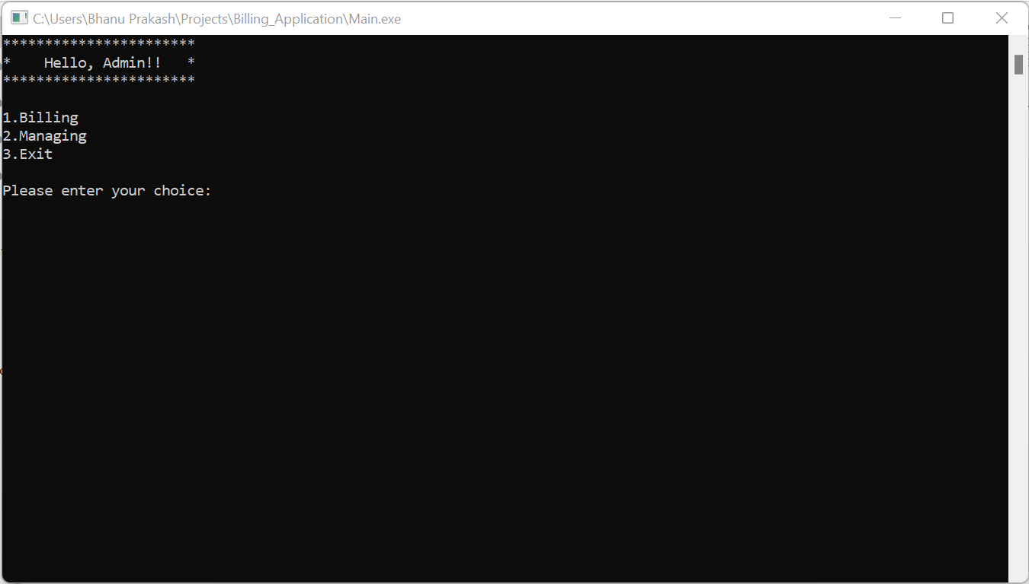

Main Menu

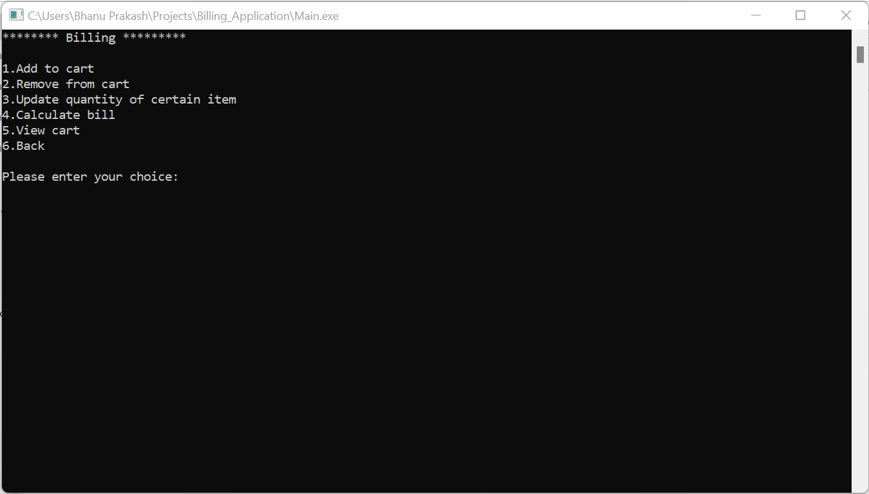

Billing Menu

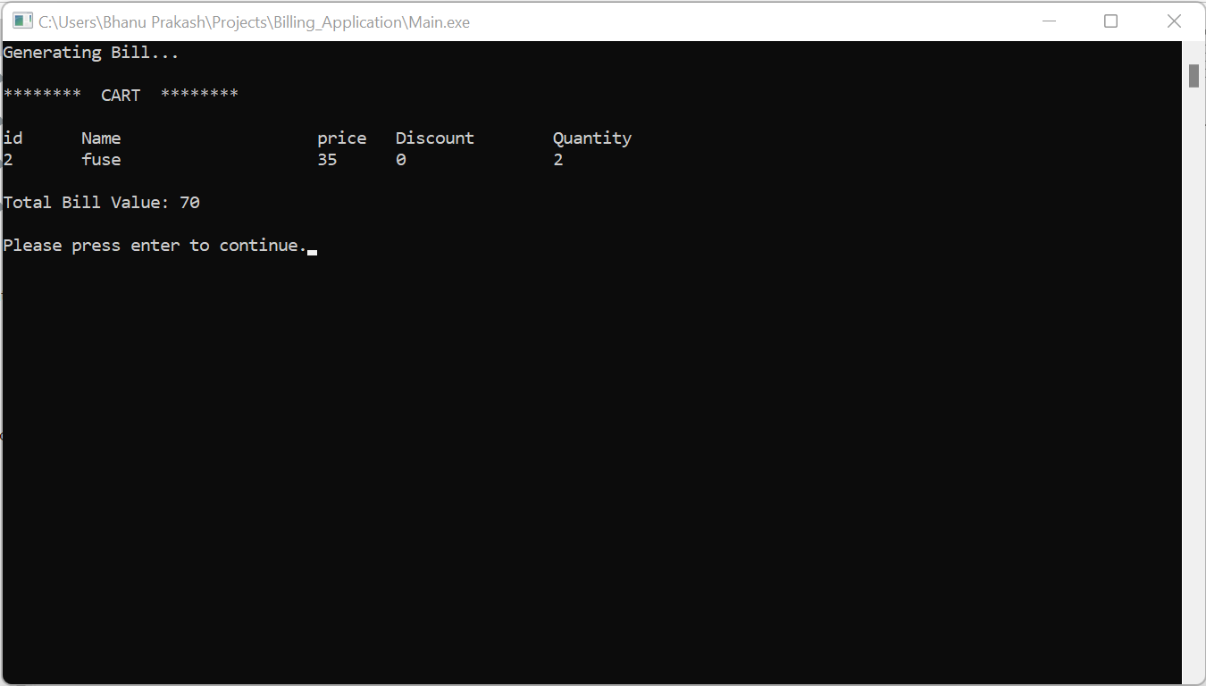

After Billing

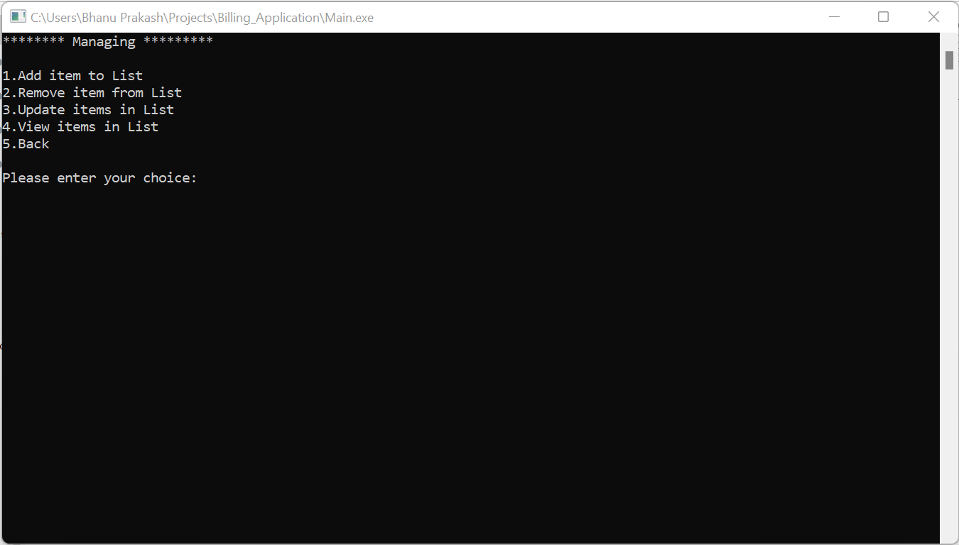

List Menu

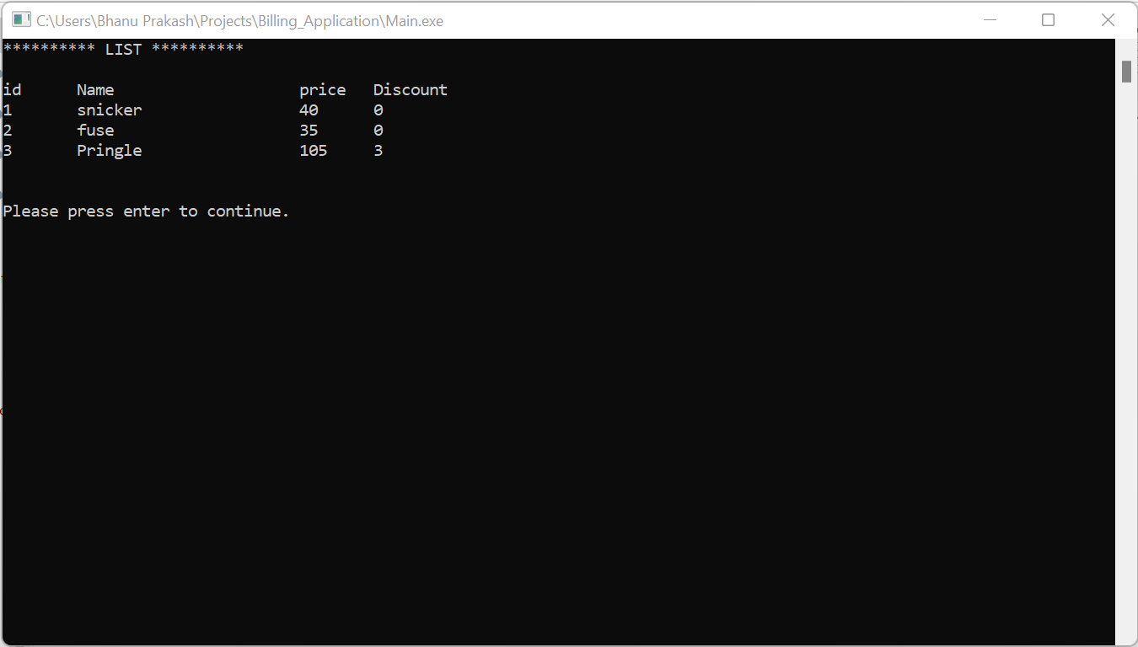

Items in List