SIMATS ENGINEERING

DSA0201-Computer Vision with OpenCV for Robotics and Automation

NAME: N. BHANU PRAKASH REDDY
REG.NO:192111264

1.Perform basic Image Handling and processing operations on the image is to read an image in python and Convert an Iage to Gray-scale.

Aim: To Perform basic Image Handling and processing operations on the image is to read an image in python and Convert an Image to Gray-scale.

Program & Output:
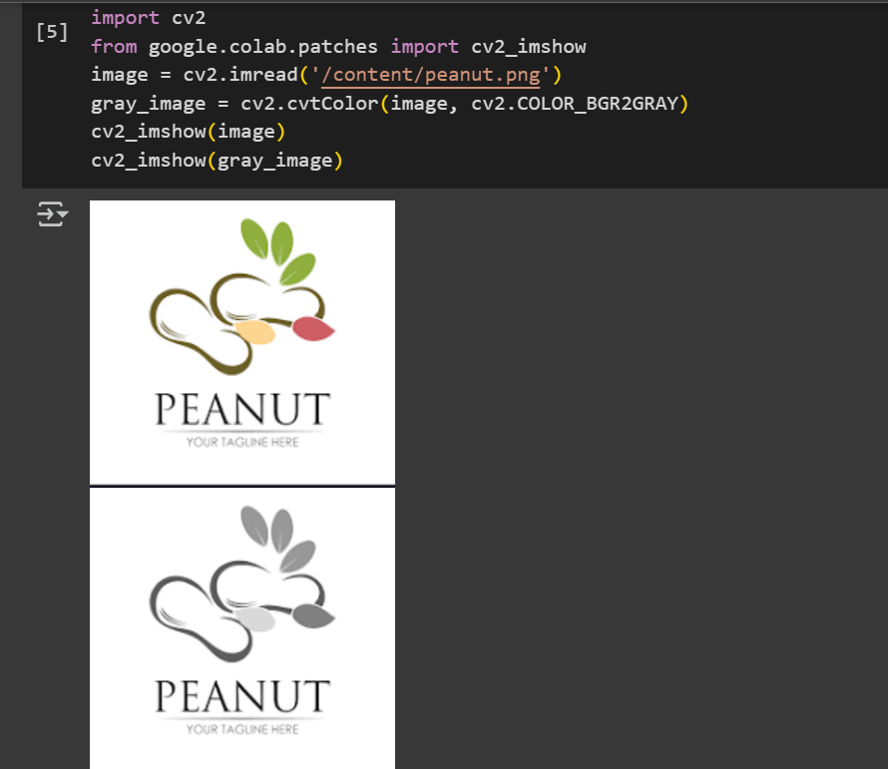

2.Perform basic Image Handling and processing operations on the image is to read an image in python and Convert an Image to Blur using Gaussian Blur

Aim: To Perform basic Image Handling and processing operations on the image is to read an image in python and Convert an Image to Blur using Gaussian Blur.

Program & Output:
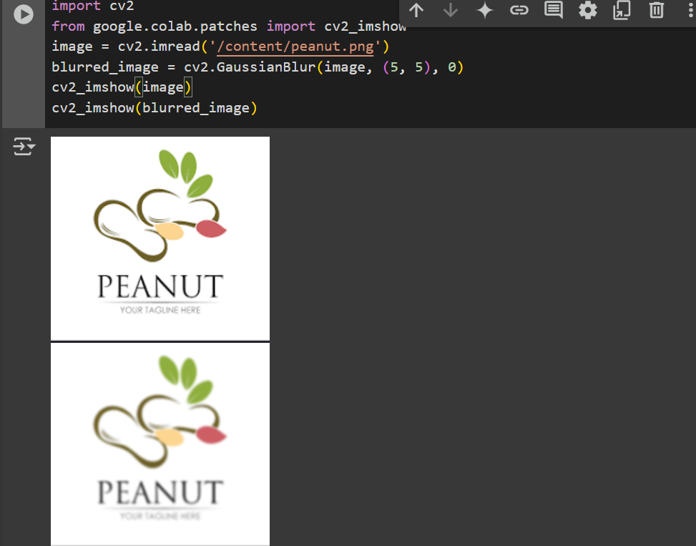

3.Perform basic Image Handling and processing operations on the image is to read an image in python and Convert an Image to show outline using Canny function.

Aim: To Perform basic Image Handling and processing operations on the image is to read an image in python and Convert an Image to show outline using Canny function.

Program & Output:
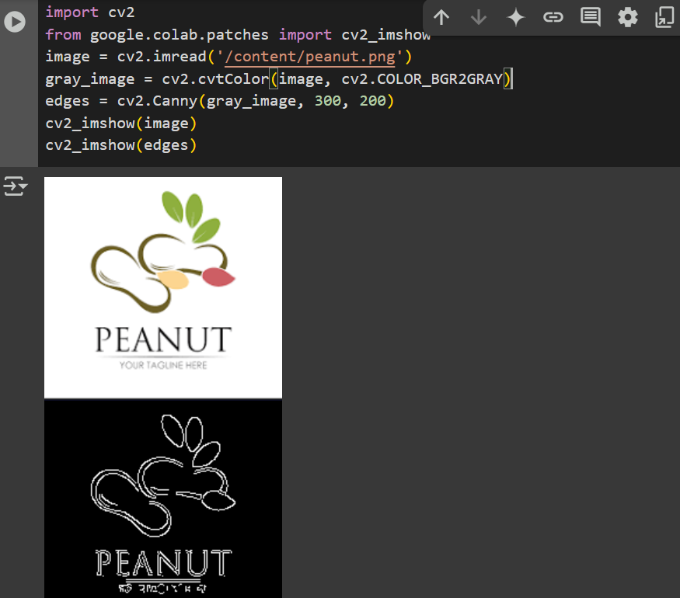

4.Implement histogram equalization on the given image and compare it with the original image using Open CV.

Aim: To Implement histogram equalization on the given image and compare it with the original image using Open CV.

Program & Output:


5.Perform basic Image Handling and processing operations on the image
Aim: To Implement histogram equalization on the given image and compare it with the original image using Open CV.

Program & Output:
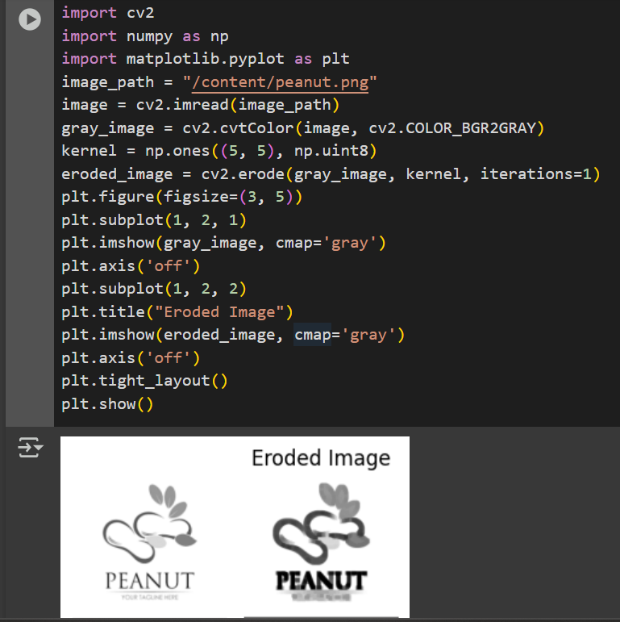

6. Perform basic video processing operations on the captured video
Aim: To Perform basic video processing operations on the captured video

Program & Output:
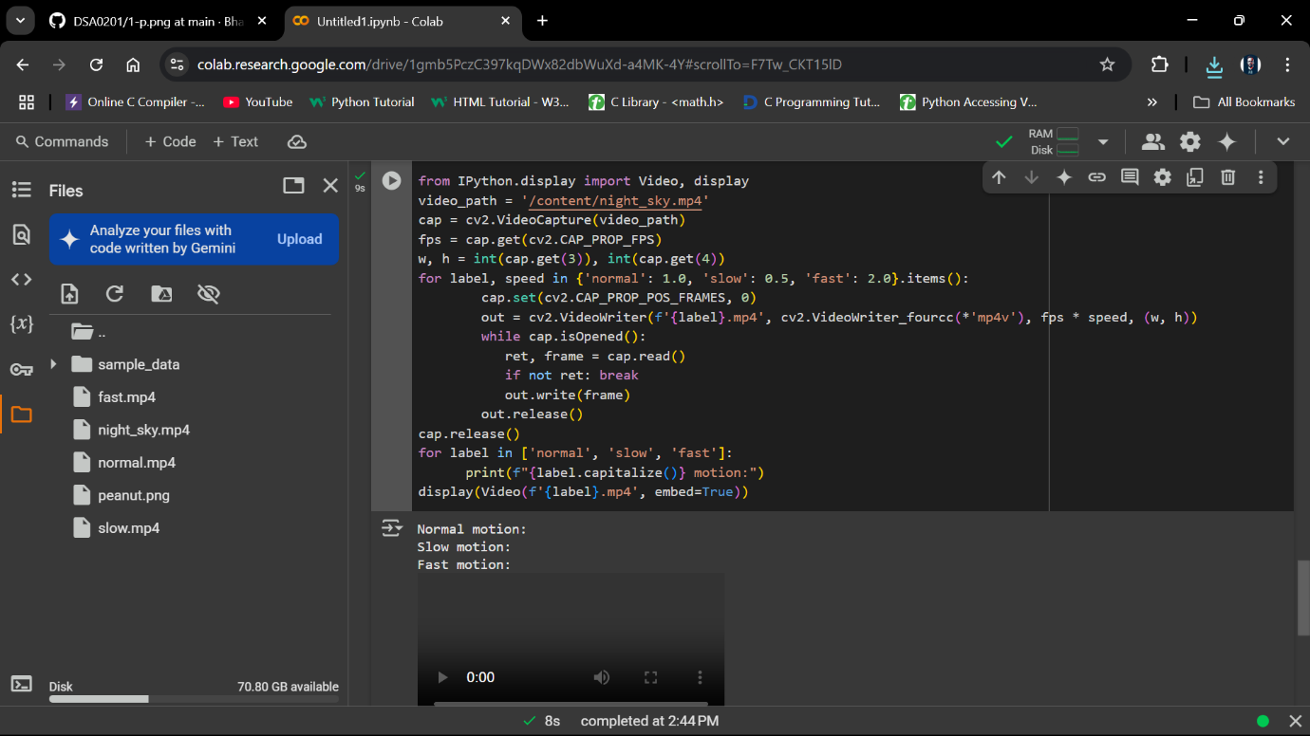
I

7. Capture video from web Camera and Display the video, in slow motion and in fast motion.
Aim: To Capture video from web Camera and Display the video, in slow motion and in fast motion.

Program & Output:
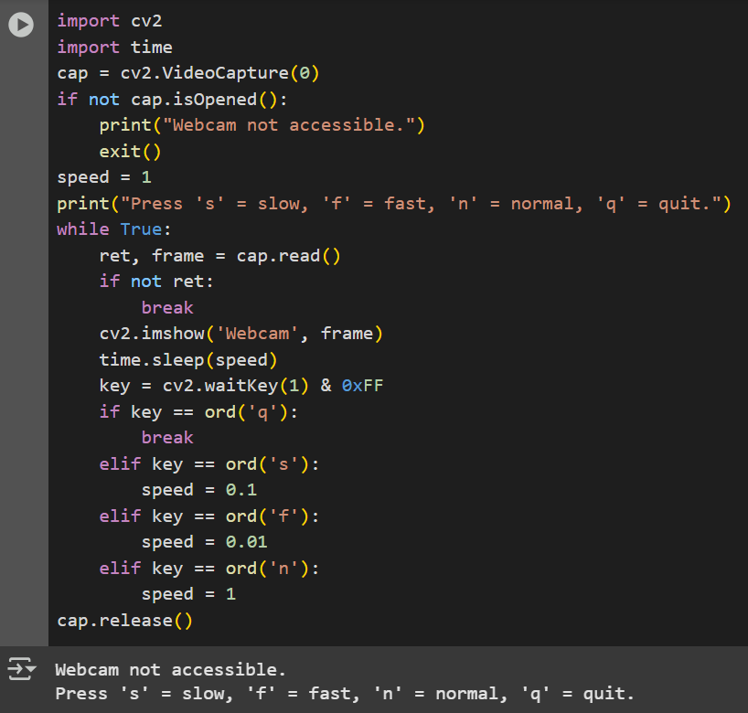

8. Scaling an image to its Bigger and Smaller sizes.

Aim: To Scaling an image to its Bigger and Smaller sizes.

Program & Output:
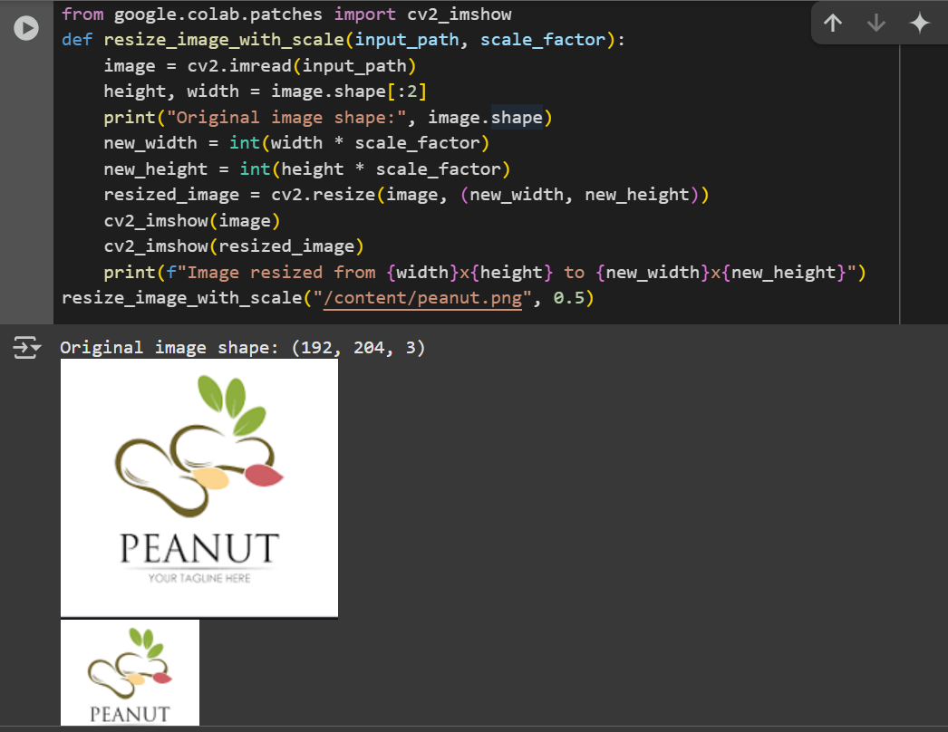

9. Perform Rotation of an image to clockwise and counter clockwise direction.
AIM: Perform Rotation of an image to clockwise and counter clockwise direction.
Program:
import cv2
image = cv2.imread('1299888.png')
if image is None:
print("Error: Could not load image.")
exit()
(h, w) = image.shape[:2]
center = (w // 2, h // 2)
M_clockwise = cv2.getRotationMatrix2D(center, -90, 1.0)
rotated_clockwise = cv2.warpAffine(image, M_clockwise, (w, h))
M_counter = cv2.getRotationMatrix2D(center, 90, 1.0)
rotated_counter = cv2.warpAffine(image, M_counter, (w, h))
cv2.imshow("Original Image", image)
cv2.imshow("Rotated Clockwise (90°)", rotated_clockwise)
cv2.imshow("Rotated Counter-Clockwise (-90°)", rotated_counter)
cv2.waitKey(0)
cv2.destroyAllWindows()
Output:
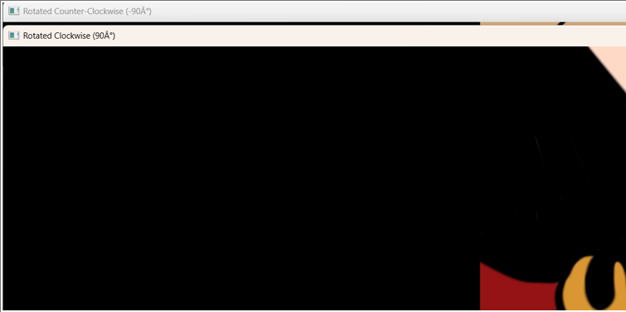
10. Perform moving of an image from one place to another.
AIM: Perform moving of an image from one place to another.
Program:
import cv2
import numpy as np
image = cv2.imread('1299888.png')
if image is None:
print("Error: Could not load image.")
exit()
tx = 200
ty = 150
translation_matrix = np.float32([[1, 0, tx], [0, 1, ty]])
moved_image = cv2.warpAffine(image, translation_matrix, (image.shape[1], image.shape[0]))
cv2.imshow("Original Image", image)
cv2.imshow("Moved Image", moved_image)
cv2.waitKey(0)
cv2.destroyAllWindows()
Output:
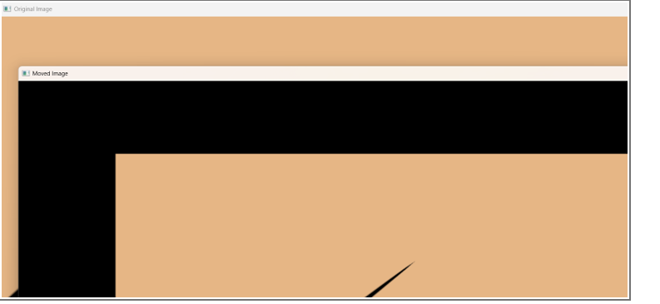
11. Perform Affine Transformation on the image.
AIM: Perform Affine Transformation on the image.
Program:
import cv2
import numpy as np
from google.colab.patches import cv2_imshow
image = cv2.imread(r"pexels-souvenirpixels-414612.jpg")
rows, cols, ch = image.shape
pts1 = np.float32([[50, 50], [200, 50], [50, 200]])
pts2 = np.float32([[10, 100], [200, 50], [100, 250]])
matrix = cv2.getAffineTransform(pts1, pts2)
transformed_image = cv2.warpAffine(image, matrix, (cols, rows))
cv2_imshow(image)
cv2_imshow(transformed_image)
output:
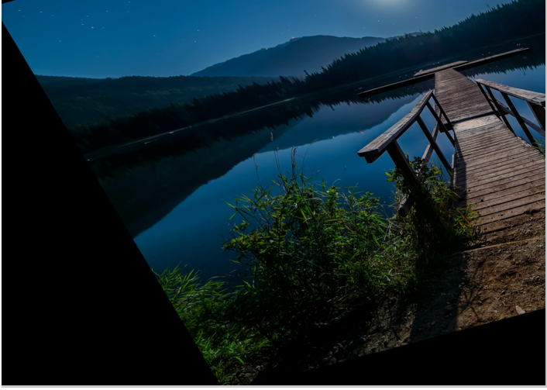
12. Perform Perspective Transformation on the image.
AIM: Perform Perspective Transformation on the image.
Program:
import cv2
import numpy as np
from google.colab.patches import cv2_imshow
image = cv2.imread("pexels-souvenirpixels-414612.jpg")
if image is None:
print("Error: Image not found!")
exit()
pts1 = np.float32([[100, 100], [400, 100], [100, 400], [400, 400]])
pts2 = np.float32([[0, 0], [300, 0], [0, 300], [300, 300]])
matrix = cv2.getPerspectiveTransform(pts1, pts2)
output = cv2.warpPerspective(image, matrix, (300, 300))
cv2_imshow(image)
cv2_imshow(output)
cv2.imwrite("perspective_transformed.jpg", output)
output:
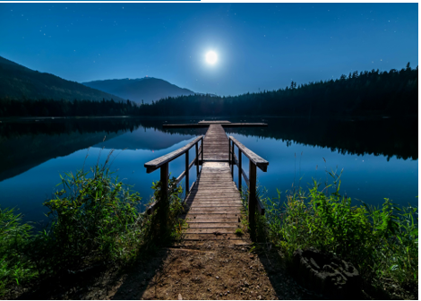
13. Perform Perspective Transformation on the Video.
AIM: Perform Perspective Transformation on the Video.
Program:
import cv2
import numpy as np

cap = cv2.VideoCapture("nature_video.mp4")
out = cv2.VideoWriter("transformed_video.mp4", cv2.VideoWriter_fourcc(*'mp4v'),
cap.get(cv2.CAP_PROP_FPS), (300, 300))
w = int(cap.get(3))
h = int(cap.get(4))
pts1 = np.float32([[50, 50], [w-50, 50], [50, h-50], [w-50, h-50]])
pts2 = np.float32([[0, 0], [300, 0], [0, 300], [300, 300]])
matrix = cv2.getPerspectiveTransform(pts1, pts2)

while True:
ret, frame = cap.read()
if not ret:
break
warped = cv2.warpPerspective(frame, matrix, (300, 300))
out.write(warped)

cap.release()
out.release()
Output:
Video
14. Perform transformation using Homography matrix.
AIM: Perform transformation using Homography matrix.
Program:
import cv2
import numpy as np
from google.colab.patches import cv2_imshow
image = cv2.imread('cv 14.jpg')
if image is None:
print("Error: Image not found!")
else:
src_pts = np.float32([[50, 50], [300, 50], [50, 300], [300, 300]])
dst_pts = np.float32([[0, 0], [400, 0], [0, 400], [400, 400]])
H, _ = cv2.findHomography(src_pts, dst_pts)
transformed_image = cv2.warpPerspective(image, H, (400, 400))
cv2_imshow(image)
cv2_imshow(transformed_image)
cv2.imwrite('transformed_image.jpg', transformed_image)
Output:
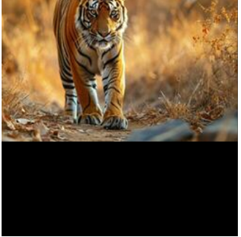
15. Perform transformation using Direct Linear Transformation.
AIM: Perform transformation using Direct Linear Transformation.
Program:
import cv2
import numpy as np
from google.colab.patches import cv2_imshow
image = cv2.imread('images.jpg')
if image is None:
print("Error: Image not found!")
else:
src_pts = np.float32([[50, 50], [300, 50], [50, 300], [300, 300]])
dst_pts = np.float32([[0, 0], [400, 0], [0, 400], [400, 400]])
A = []
for i in range(4):
x1, y1 = src_pts[i]
x2, y2 = dst_pts[i]
A.append([x1, y1, 1, 0, 0, 0, -x2*x1, -x2*y1, -x2])
A.append([0, 0, 0, x1, y1, 1, -y2*x1, -y2*y1, -y2])
A = np.array(A)
_, _, Vt = np.linalg.svd(A)
H = Vt[-1].reshape(3, 3)
transformed_image = cv2.warpPerspective(image, H, (400, 400))
cv2_imshow(image)
cv2_imshow(transformed_image)
cv2.imwrite('transformed_image_dlt.jpg', transformed_image)
Output:
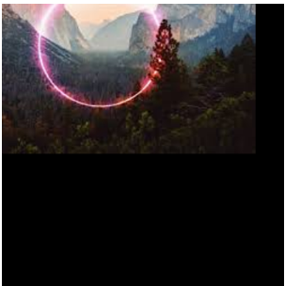
16. Perform Edge detection using canny method
AIM: Perform Edge detection using canny method
Program:
import cv2
import matplotlib.pyplot as plt

image = cv2.imread('1.png', cv2.IMREAD_GRAYSCALE)
blurred = cv2.GaussianBlur(image, (5, 5), 1.4)

edges = cv2.Canny(blurred, threshold1=100, threshold2=200)

plt.figure(figsize=(10,5))
plt.subplot(1,2,1), plt.imshow(image, cmap='gray'), plt.title('Original Image')
plt.subplot(1,2,2), plt.imshow(edges, cmap='gray'), plt.title('Canny Edge Detection')
plt.show()
Ouput:
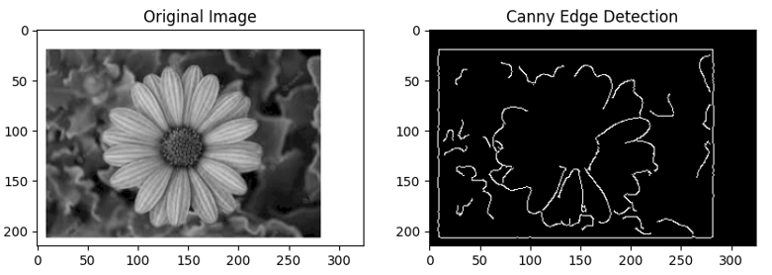
17. Perform Edge detection using Sobel Matrix along X axis
Aim: Perform Edge detection using Sobel Matrix along X axis
Program:
import cv2
import numpy as np
import matplotlib.pyplot as plt
image = cv2.imread('1.png', cv2.IMREAD_GRAYSCALE)
sobel_x = cv2.Sobel(image, cv2.CV_64F, dx=1, dy=0, ksize=3)
sobel_x = cv2.convertScaleAbs(sobel_x)
plt.figure(figsize=(10,5))
plt.subplot(1,2,1), plt.imshow(image, cmap='gray'), plt.title('Original Image')
plt.subplot(1,2,2), plt.imshow(sobel_x, cmap='gray'), plt.title('Sobel X - Vertical Edges')
plt.show()
Output:
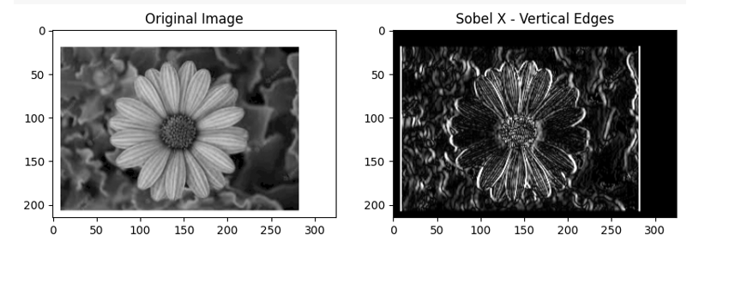
18. Perform Edge detection using Sobel Matrix along Y axis
AIM: Perform Edge detection using Sobel Matrix along Y axis
Program:
import cv2
import numpy as np
import matplotlib.pyplot as plt
image = cv2.imread('1.png', cv2.IMREAD_GRAYSCALE)
sobel_y = cv2.Sobel(image, cv2.CV_64F, dx=0, dy=1, ksize=3)
sobel_y = cv2.convertScaleAbs(sobel_y)
plt.figure(figsize=(10,5))
plt.subplot(1,2,1), plt.imshow(image, cmap='gray'), plt.title('Original Image')
plt.subplot(1,2,2), plt.imshow(sobel_y, cmap='gray'), plt.title('Sobel Y - Horizontal Edges')
plt.show()
Output:
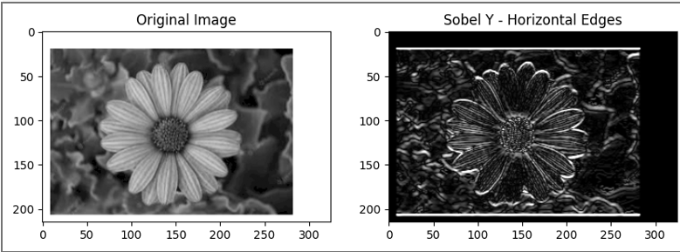
19. Perform Edge detection using Sobel Matrix along XY axis
AIM: Perform Edge detection using Sobel Matrix along XY axis
Program:
import cv2
import numpy as np
import matplotlib.pyplot as plt
image = cv2.imread('1.png', cv2.IMREAD_GRAYSCALE)
sobel_x = cv2.Sobel(image, cv2.CV_64F, dx=1, dy=0, ksize=3)
sobel_y = cv2.Sobel(image, cv2.CV_64F, dx=0, dy=1, ksize=3)
sobel_combined = cv2.magnitude(sobel_x, sobel_y)
sobel_combined = cv2.convertScaleAbs(sobel_combined)
plt.figure(figsize=(12,6))
plt.subplot(1,2,1), plt.imshow(image, cmap='gray'), plt.title('Original Image')
plt.subplot(1,2,2), plt.imshow(sobel_combined, cmap='gray'), plt.title('Sobel XY - All Edges')
plt.show()
output:
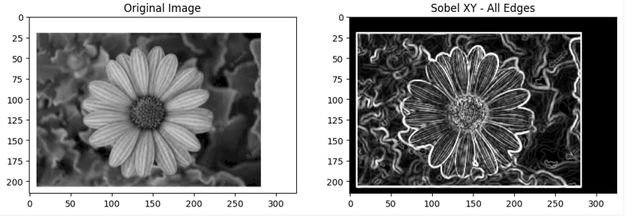

20. Perform Sharpening of Image using Laplacian mask with negative center coefficient.
AIM: Perform Sharpening of Image using Laplacian mask with negative center coefficient.
Program:
import cv2
import numpy as np
import matplotlib.pyplot as plt
image = cv2.imread('1.png')
image_gray = cv2.cvtColor(image, cv2.COLOR_BGR2GRAY)
kernel = np.array([[0, -1, 0],
[-1, 5, -1],
[0, -1, 0]])
sharpened = cv2.filter2D(image_gray, -1, kernel)
plt.figure(figsize=(10,5))
plt.subplot(1,2,1), plt.imshow(image_gray, cmap='gray'), plt.title('Original Grayscale')
plt.subplot(1,2,2), plt.imshow(sharpened, cmap='gray'), plt.title('Sharpened Image (Laplacian)')
plt.show()

Output:
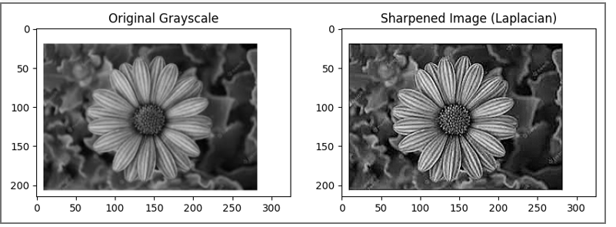

21. Perform Sharpening of Image using Laplacian mask implemented with an extension of
diagonal neighbors,
AIM: Perform Sharpening of Image using Laplacian mask implemented with an extension of
diagonal neighbors.
Program:
import cv2
import numpy as np
import matplotlib.pyplot as plt
image = cv2.imread('1.png')
gray = cv2.cvtColor(image, cv2.COLOR_BGR2GRAY)
laplacian_kernel_8 = np.array([[1, 1, 1],
[1, -8, 1],
[1, 1, 1]])
laplacian = cv2.filter2D(gray, cv2.CV_64F, laplacian_kernel_8)
sharpened = cv2.convertScaleAbs(gray - laplacian)
plt.figure(figsize=(10, 5))
plt.subplot(1, 2, 1)
plt.imshow(gray, cmap='gray')
plt.title("Original Grayscale")
plt.axis('off')
plt.subplot(1, 2, 2)
plt.imshow(sharpened, cmap='gray')
plt.title("Sharpened with 8-Neighborhood Laplacian")
plt.axis('off')
plt.tight_layout()
plt.show()
output:
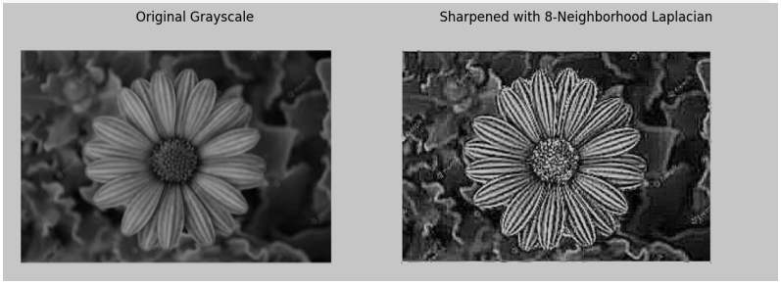
22. Perform Sharpening of Image using Laplacian mask with positive center coefficient.
AIM: Perform Sharpening of Image using Laplacian mask with positive center coefficient.
Program:
import cv2
import numpy as np
import matplotlib.pyplot as plt
image = cv2.imread('1.png')
gray = cv2.cvtColor(image, cv2.COLOR_BGR2GRAY)
laplacian_kernel_pos = np.array([[0, -1, 0],
[-1, 4, -1],
[0, -1, 0]])
laplacian = cv2.filter2D(gray, cv2.CV_64F, laplacian_kernel_pos)
sharpened = cv2.convertScaleAbs(gray + laplacian)
plt.figure(figsize=(10, 5))
plt.subplot(1, 2, 1)
plt.imshow(gray, cmap='gray')
plt.title("Original Grayscale")
plt.axis('off')
plt.subplot(1, 2, 2)
plt.imshow(sharpened, cmap='gray')
plt.title("Sharpened with Positive Center Laplacian")
plt.axis('off')
plt.tight_layout()
plt.show()
output:
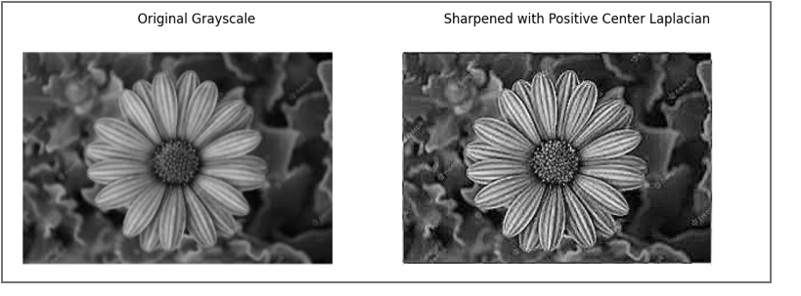
23. Perform Sharpening of Image using unsharp masking.
AIM: Perform Sharpening of Image using unsharp masking.
Program:
import cv2
import numpy as np
import matplotlib.pyplot as plt
image = cv2.imread('1.png')
gray = cv2.cvtColor(image, cv2.COLOR_BGR2GRAY)
blurred = cv2.GaussianBlur(gray, (5, 5), 0)
unsharp_mask = cv2.addWeighted(gray, 1.5, blurred, -0.5, 0)
plt.figure(figsize=(10, 5))
plt.subplot(1, 2, 1)
plt.imshow(gray, cmap='gray')
plt.title("Original Grayscale")
plt.axis('off')
plt.subplot(1, 2, 2)
plt.imshow(unsharp_mask, cmap='gray')
plt.title("Sharpened using Unsharp Masking")
plt.axis('off')
plt.tight_layout()
plt.show()
Output:
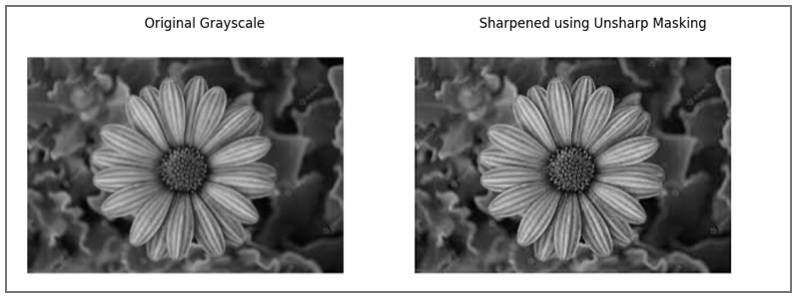
24. Perform Sharpening of Image using High-Boost Masks.
AIM: Perform Sharpening of Image using High-Boost Masks.
Program:
import cv2
import numpy as np
from matplotlib import pyplot as plt
image = cv2.imread('1.png', cv2.IMREAD_GRAYSCALE)
A = 1.5
mask_4 = np.array([[0, -1, 0],
[-1, A + 4, -1],
[0, -1, 0]])

mask_8 = np.array([[-1, -1, -1],
[-1, A + 8, -1],
[-1, -1, -1]])
sharpened_4 = cv2.filter2D(image, -1, mask_4)
sharpened_8 = cv2.filter2D(image, -1, mask_8)
plt.figure(figsize=(12, 4))
plt.subplot(1, 3, 1)
plt.title("Original")
plt.imshow(image, cmap='gray')
plt.subplot(1, 3, 2)
plt.title("High-Boost (4-neighbor)")
plt.imshow(sharpened_4, cmap='gray')
plt.subplot(1, 3, 3)
plt.title("High-Boost (8-neighbor)")
plt.imshow(sharpened_8, cmap='gray')
plt.tight_layout()
plt.show()
Output:
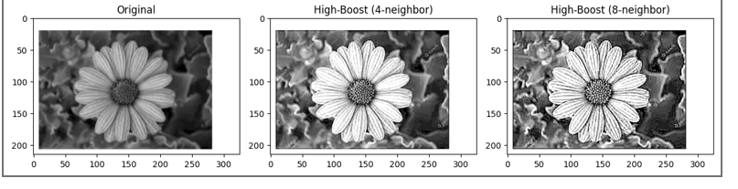
25. Perform Sharpening of Image using Gradient masking.
AIM: Perform Sharpening of Image using Gradient masking.
Program:
import cv2
import numpy as np
from matplotlib import pyplot as plt
image = cv2.imread('1.png', cv2.IMREAD_GRAYSCALE)
gradient_mask1 = np.array([[-1, -2, -1],
[ 0, 0, 0],
[ 1, 2, 1]])
gradient_mask2 = np.array([[-1, 0, 1],
[-2, 0, 2],
[-1, 0, 1]])
grad1 = cv2.filter2D(image, -1, gradient_mask1)
grad2 = cv2.filter2D(image, -1, gradient_mask2)
gradient_magnitude = cv2.addWeighted(grad1, 0.5, grad2, 0.5, 0)
sharpened = cv2.add(image, gradient_magnitude)
plt.figure(figsize=(12, 4))
plt.subplot(1, 4, 1)
plt.title("Original")
plt.imshow(image, cmap='gray')
plt.subplot(1, 4, 2)
plt.title("Gradient Mask 1")
plt.imshow(grad1, cmap='gray')
plt.subplot(1, 4, 3)
plt.title("Gradient Mask 2")
plt.imshow(grad2, cmap='gray')
plt.subplot(1, 4, 4)
plt.title("Sharpened")
plt.imshow(sharpened, cmap='gray')
plt.tight_layout()
plt.show()
Output:
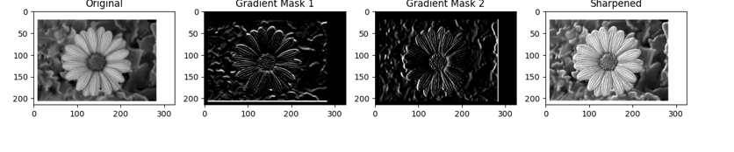
26. Insert water marking to the image using OpenCV.
AIM: Insert water marking to the image using OpenCV.
Program:
import cv2
import numpy as np
image = cv2.imread('1.png')
watermark_text = "MyWatermark"
font = cv2.FONT_HERSHEY_SIMPLEX
font_scale = 1
thickness = 2
color = (255, 255, 255)
opacity = 0.5
(h, w) = image.shape[:2]
(text_width, text_height), _ = cv2.getTextSize(watermark_text, font, font_scale, thickness)
x = w - text_width - 10
y = h - 10
overlay = image.copy()
cv2.putText(overlay, watermark_text, (x, y), font, font_scale, color, thickness)
watermarked = cv2.addWeighted(overlay, opacity, image, 1 - opacity, 0)
cv2.imwrite('2.png', watermarked)
Output:
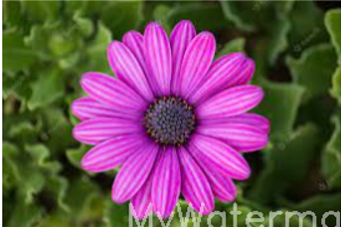
27. Do Cropping, Copying and pasting image inside another image using OpenCV.
AIM: Do Cropping, Copying and pasting image inside another image using OpenCV.
Program:
import cv2
image = cv2.imread('1.png')
crop_y1, crop_y2 = 50, 150
crop_x1, crop_x2 = 100, 200
cropped_region = image[crop_y1:crop_y2, crop_x1:crop_x2]
paste_y, paste_x = 10, 10
paste_y2 = paste_y + cropped_region.shape[0]
paste_x2 = paste_x + cropped_region.shape[1]
image[paste_y:paste_y2, paste_x:paste_x2] = cropped_region
cv2.imwrite('3.png', image)
Output:
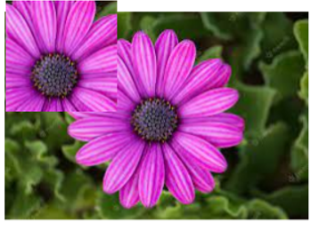

28. Find the boundary of the image using Convolution kernel for the given image.
AIM: Find the boundary of the image using Convolution kernel for the given image.
Program:
import cv2
import numpy as np
from matplotlib import pyplot as plt
image = cv2.imread('1.png', cv2.IMREAD_GRAYSCALE)
laplacian_kernel = np.array([[0, 1, 0],
[1, -4, 1],
[0, 1, 0]])
boundary = cv2.filter2D(image, -1, laplacian_kernel)
cv2.imwrite('4.png', boundary)
plt.figure(figsize=(10, 4))
plt.subplot(1, 2, 1)
plt.title("Original")
plt.imshow(image, cmap='gray')
plt.axis('off')
plt.subplot(1, 2, 2)
plt.title("Image Boundary")
plt.imshow(boundary, cmap='gray')
plt.axis('off')
plt.tight_layout()
plt.show()
Output:
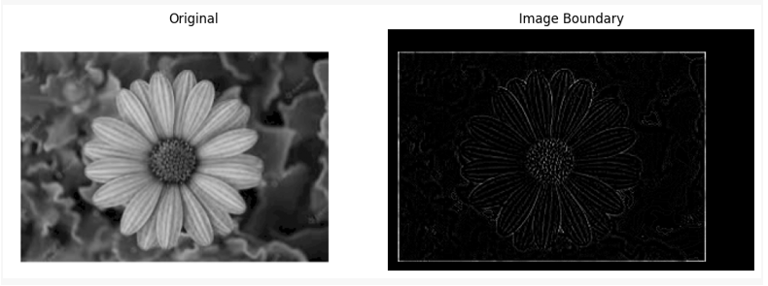
29. Morphological operations based on OpenCV using Erosion technique.
AIM: Morphological operations based on OpenCV using Erosion technique.
Program:
import cv2
import numpy as np
from matplotlib import pyplot as plt
image = cv2.imread('1.png', cv2.IMREAD_GRAYSCALE)
_, binary = cv2.threshold(image, 127, 255, cv2.THRESH_BINARY)
kernel = np.ones((5, 5), np.uint8)
eroded = cv2.erode(binary, kernel, iterations=1)
cv2.imwrite('5.png', eroded)
plt.figure(figsize=(10, 4))
plt.subplot(1, 2, 1)
plt.title("Original Binary")
plt.imshow(binary, cmap='gray')
plt.axis('off')
plt.subplot(1, 2, 2)
plt.title("Eroded Image")
plt.imshow(eroded, cmap='gray')
plt.axis('off')
plt.tight_layout()
plt.show()
Output:
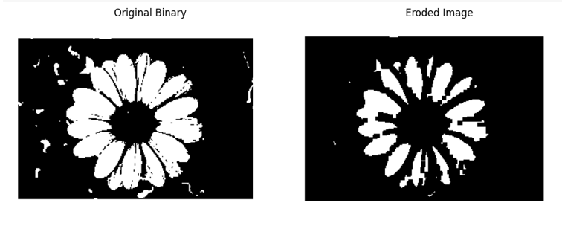
30. Morphological operations based on OpenCV using Dilation technique.
AIM: Morphological operations based on OpenCV using Dilation technique.
PROGRAM:
import cv2
import numpy as np
from matplotlib import pyplot as plt
image = cv2.imread('1.png', cv2.IMREAD_GRAYSCALE)
_, binary = cv2.threshold(image, 127, 255, cv2.THRESH_BINARY)
kernel = np.ones((5, 5), np.uint8)
dilated = cv2.dilate(binary, kernel, iterations=1)
cv2.imwrite('6.png', dilated)
plt.figure(figsize=(10, 4))
plt.subplot(1, 2, 1)
plt.title("Original Binary")
plt.imshow(binary, cmap='gray')
plt.axis('off')
plt.subplot(1, 2, 2)
plt.title("Dilated Image")
plt.imshow(dilated, cmap='gray')
plt.axis('off')
plt.tight_layout()
plt.show()
output:
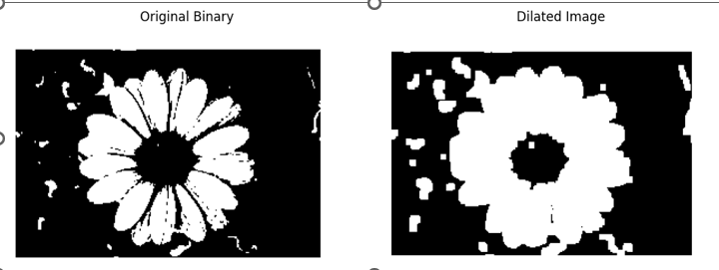

31. Morphological operations based on OpenCV using Opening technique.
AIM: Morphological operations based on OpenCV using Opening technique.
PROGRAM:
import cv2
import numpy as np
from matplotlib import pyplot as plt
image = cv2.imread('1.png', cv2.IMREAD_GRAYSCALE)
_, binary = cv2.threshold(image, 127, 255, cv2.THRESH_BINARY)
kernel = np.ones((5, 5), np.uint8)
opened = cv2.morphologyEx(binary, cv2.MORPH_OPEN, kernel)
cv2.imwrite('7.png', opened)
plt.figure(figsize=(10, 4))
plt.subplot(1, 2, 1)
plt.title("Original Binary")
plt.imshow(binary, cmap='gray')
plt.axis('off')
plt.subplot(1, 2, 2)
plt.title("After Opening")
plt.imshow(opened, cmap='gray')
plt.axis('off')
plt.tight_layout()
plt.show()
OUTPUT:
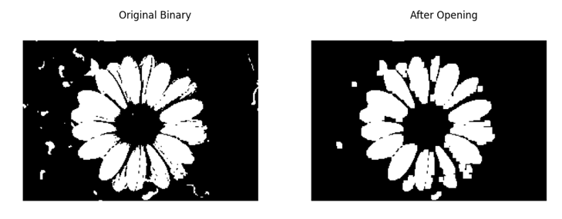
32. Morphological operations based on OpenCV using Closing technique.
AIM: Morphological operations based on OpenCV using Closing technique.
PROGRAM:
import cv2
import numpy as np
from matplotlib import pyplot as plt
image = cv2.imread('1.png', cv2.IMREAD_GRAYSCALE)
_, binary = cv2.threshold(image, 127, 255, cv2.THRESH_BINARY)
kernel = np.ones((5, 5), np.uint8)
closed = cv2.morphologyEx(binary, cv2.MORPH_CLOSE, kernel)
cv2.imwrite('8.png', closed)
plt.figure(figsize=(10, 4))
plt.subplot(1, 2, 1)
plt.title("Original Binary")
plt.imshow(binary, cmap='gray')
plt.axis('off')
plt.subplot(1, 2, 2)
plt.title("After Closing")
plt.imshow(closed, cmap='gray')
plt.axis('off')
plt.tight_layout()
plt.show()
OUTPUT:
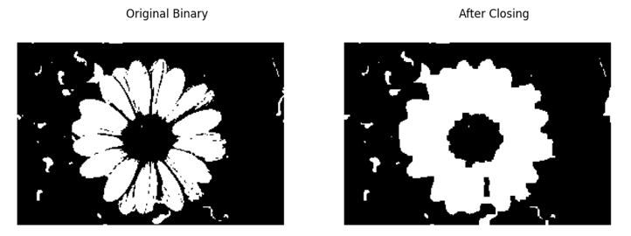33. Morphological operations based on OpenCV using Morphological Gradient technique.
AIM: Morphological operations based on OpenCV using Morphological Gradient technique.
PROGRAM:
import cv2
import numpy as np
from matplotlib import pyplot as plt
image = cv2.imread('1.png', cv2.IMREAD_GRAYSCALE)
_, binary = cv2.threshold(image, 127, 255, cv2.THRESH_BINARY)
kernel = np.ones((5, 5), np.uint8)
gradient = cv2.morphologyEx(binary, cv2.MORPH_GRADIENT, kernel)
cv2.imwrite('9.png', gradient)
plt.figure(figsize=(10, 4))
plt.subplot(1, 2, 1)
plt.title("Original Binary")
plt.imshow(binary, cmap='gray')
plt.axis('off')
plt.subplot(1, 2, 2)
plt.title("Morphological Gradient")
plt.imshow(gradient, cmap='gray')
plt.axis('off')
plt.tight_layout()
plt.show()
OUTPUT:
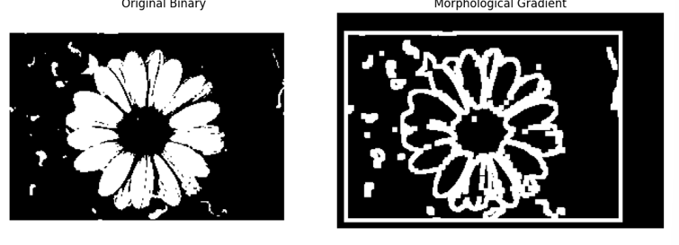
34. Morphological operations based on OpenCV using Top hat technique.
AIM:Morphological operations based on OpenCV using Top hat technique.
PROGRAM:
import cv2
import numpy as np
from matplotlib import pyplot as plt
image = cv2.imread('1.png', 0)
kernel = cv2.getStructuringElement(cv2.MORPH_RECT, (15, 15))
top_hat = cv2.morphologyEx(image, cv2.MORPH_TOPHAT, kernel)
plt.subplot(1, 2, 1)
plt.title('Original Image')
plt.imshow(image, cmap='gray')
plt.subplot(1, 2, 2)
plt.title('Top Hat Result')
plt.imshow(top_hat, cmap='gray')
plt.show()

OUTPUT:
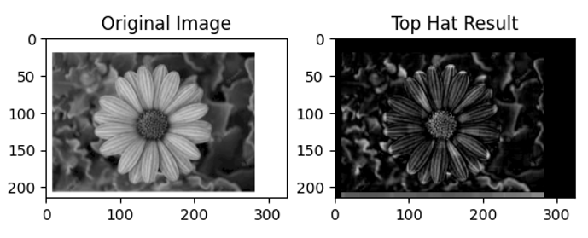
35. Morphological operations based on OpenCV using Black hat technique.
AIM: Morphological operations based on OpenCV using Black hat technique.
PROGRAM:
import cv2
import numpy as np
from matplotlib import pyplot as plt
image = cv2.imread('1.png', 0)
kernel = cv2.getStructuringElement(cv2.MORPH_RECT, (15, 15))
black_hat = cv2.morphologyEx(image, cv2.MORPH_BLACKHAT, kernel)
plt.subplot(1, 2, 1)
plt.title('Original Image')
plt.imshow(image, cmap='gray')
plt.subplot(1, 2, 2)
plt.title('Black Hat Result')
plt.imshow(black_hat, cmap='gray')
plt.show()
OUTPUT:
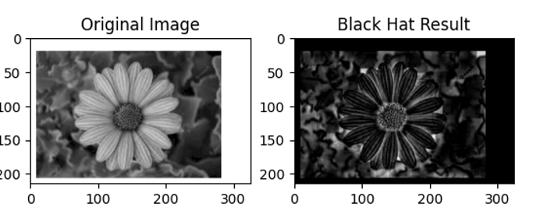
36. Recognise watch from the given image by general Object recognition using OpenCV.
AIM: Recognise watch from the given image by general Object recognition using OpenCV.
PROGRAM:
import cv2
import matplotlib.pyplot as plt
image = cv2.imread('1.png', cv2.IMREAD_GRAYSCALE)
orb = cv2.ORB_create(nfeatures=1000)
keypoints, descriptors = orb.detectAndCompute(image, None)
keypoint_image = cv2.drawKeypoints(image, keypoints, None, color=(0, 255, 0), flags=0)
plt.figure(figsize=(8, 6))
plt.title("Detected Keypoints (ORB) - Watch Recognition")
plt.imshow(keypoint_image, cmap='gray')
plt.axis('off')
plt.show()
OUTPUT:
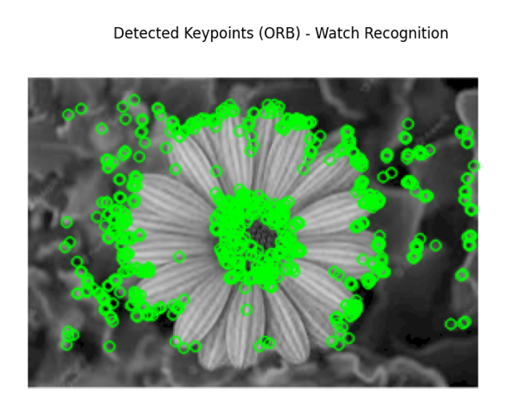
37. Using Opencv play Video in Reverse mode.
AIM: Using Opencv play Video in Reverse mode.
PROGRAM:
import cv2
from google.colab.patches import cv2_imshow
import time
video_path = 'videoplayback.mp4'
cap = cv2.VideoCapture(video_path)
if not cap.isOpened():
print("Error: Could not open video.")
exit()
frames = []
while True:
ret, frame = cap.read()
if not ret:
break
frames.append(frame)
cap.release()
for frame in reversed(frames):
cv2_imshow(frame)
time.sleep(0.03)
OUTPUT:
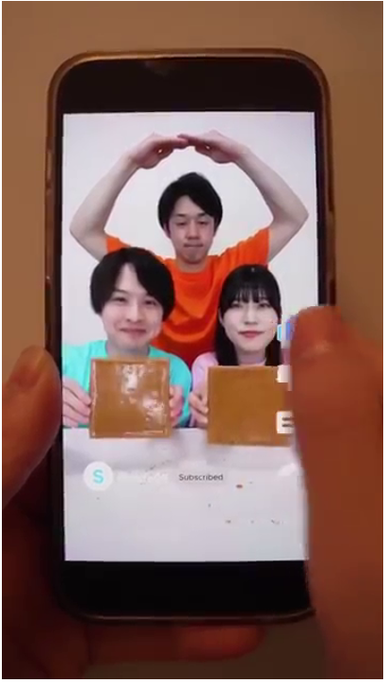
38. Face Detection using Opencv.
AIM: Face Detection using Opencv.
PROGRAM:
import cv2
face_cascade = cv2.CascadeClassifier(cv2.data.haarcascades + 'haarcascade_frontalface_default.xml')
image = cv2.imread('dd.png')
gray = cv2.cvtColor(image, cv2.COLOR_BGR2GRAY)
faces = face_cascade.detectMultiScale(gray, scaleFactor=1.1, minNeighbors=5)
for (x, y, w, h) in faces:
cv2.rectangle(image, (x, y), (x + w, y + h), (255, 0, 0), 2)
from google.colab.patches import cv2_imshow
cv2_imshow(image)
cv2.waitKey(0)
cv2.destroyAllWindows()
OUTPUT:
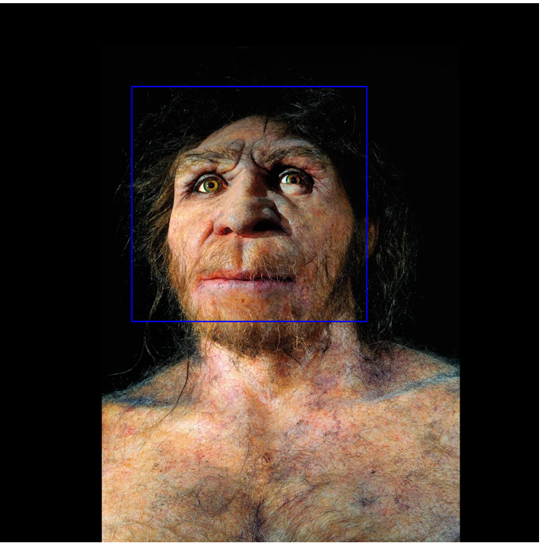

40. Draw Rectangular shape and extract objects.
AIM: Draw Rectangular shape and extract objects.
PROGRAM:
import cv2
from google.colab.patches import cv2_imshow
image = cv2.imread('12.png')
boxes = {
"Rohit Sharma": (100, 50, 150, 300),
"Virat Kohli": (300, 50, 150, 300)
}
for name, (x, y, w, h) in boxes.items():
cv2.rectangle(image, (x, y), (x + w, y + h), (255, 0, 0), 2)
cv2.putText(image, name, (x, y - 10), cv2.FONT_HERSHEY_SIMPLEX, 0.6, (255, 0, 0), 2)
cv2_imshow(image)
for name, (x, y, w, h) in boxes.items():
cropped = image[y:y+h, x:x+w]
print(f"Extracted: {name}")
cv2_imshow(cropped)
OUTPUT:
