**Traffic Signs Recognition**

**Team Members:** Molla Baquar Abbas,Mahadasu Gowtham Kishore,kandula Bhanu sandeep

# Introduction:

In the modern world, everything is advanced in its place, technology is one such advancement which led to invention of self-driving cars in which Traffic Sign Recognition is a crucial factor. Most of the companies like Tesla, Google, Ford and others have started their self-driving cars for their buyers to depend on driving. Traffic Sign Recognition is a python deep learning project which classifies the traffic signs such as U-turn, stop, walk, speed limit and so on.

Today’s more advanced technologies are furthering our goals and helping with automation in every field making the need for a human in those areas invalid, because a human is prone to making mistakes, but a machine in his/her place would certainly be more efficient, both in terms of speed and accuracy.

Technologies such as Deep Learning and Machine Learning have evolved greatly in this time.This technology helps to teach machines to learn on their own instead of having to program every single action and possibility.

So, this research required us to use techniques like convolution neural networks, Keras, TensorFlow, etc. and implement them so as to help the self- driving cars to be able to perceive traffic signs and react according to the input received. In this research, we have built a deep neural network model using Convolutional Neural Networks that have the capability to classify traffic signals that are present in the image based on its class. With the model that we have developed, we were able to detect as well as classify traffic signals, which is very crucial to self-driving cars because it can otherwise lead to fatal accidents.

# Literature Review:

The first research on traffic sign recognition can be traced back to 1987.Akatsuka and Imai attempted to make an early traffic sign recognition system. A system capable of automatic recognition of traffic signs could be used as assistance for drivers, alerting them about the presence of some specific sign (e.g. a one-way street) or some risky situation (e.g. driving at a

higher speed than the maximum speed allowed). It also can be used to provide the autonomous unmanned with some specific-designed signs. Generally, the procedure of a traffic sign recognition system can be roughly divided into two stages namely detection and classification.

## Detection

The goal of traffic sign detection is to locate the regions of interest (ROI) in which a traffic sign is more likely to be found and verify the hypotheses on the sign’s presence. The initial detection phase of a traffic sign recognition system offers high costs due to the large scale of detection in a complete single image. In order to reduce the space, prior information of the sign location is supposed to be cropped [3, 4]. This technique is called ROI. ROI locates the traffic sign in the image based on the shape. The traffic signs are cropped and declared as informative signals.

The background image is declared as an unwanted signal and removed by defining it as black pixel. By these assumptions, a large portion of the image can be ignored. Traffic signs are designed with particular color and shape which make them easier to be recognized.

## Classification

Image segmentation is the process of partitioning a digital image into multiple segments (sets of pixels, also known as super pixels). The goal of segmentation is to simplify and/or change the representation of an image into something that is more meaningful and easier to analyze.

A binary image classification method is a digital image that has only two possible values for each pixel. The pixels used to represent the object and background is white and black respectively. Based on the classification process, the technique used in the classification of traffic signs is a binary classification method. Each traffic sign is grouped based on the amount of white and black pixels. These amounts are matched with the amount of white and black pixels from the template data.

# [Datase](https://www.kaggle.com/meowmeowmeowmeowmeow/gtsrb-german-traffic-sign)t used:

The data set we have decided to use for our research was the GTSRB- German Traffic Sign Detection Benchmark. This is a very well-known dataset for traffic signs in websites like Kaggle. This data set has more than 40 classes of images and 50000 images for training, validation and testing purposes.We have divided the data set into training, validation and testing sets, which further helped us in understanding how well our architecture was working. The dataset is also very diverse.

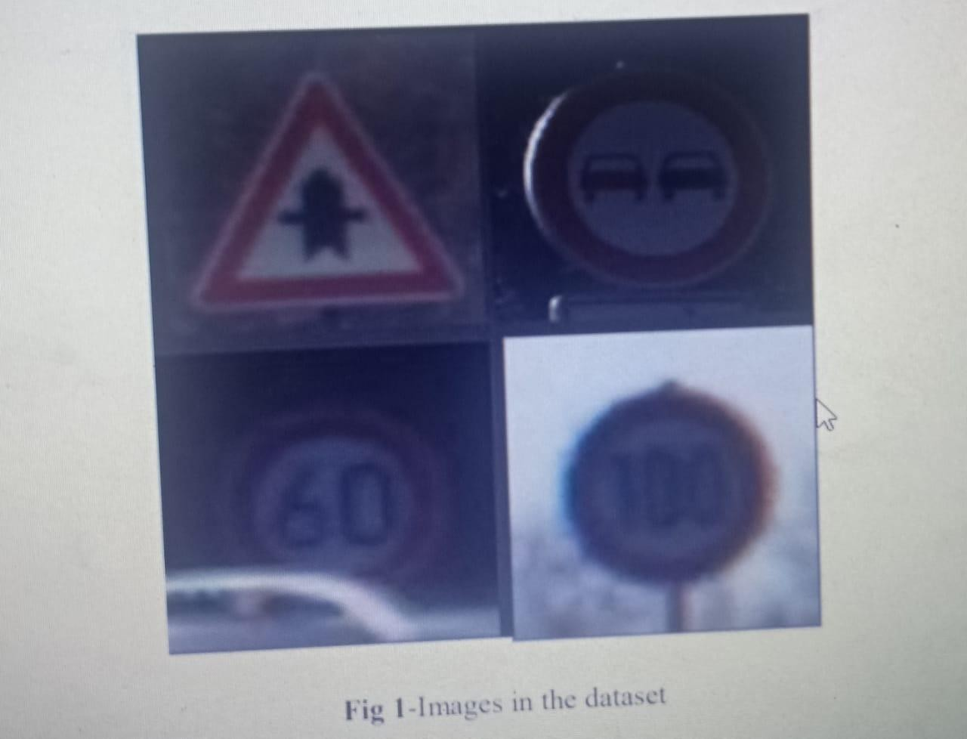

We can understand from the above figure that this dataset has been prepared in a very robust way so that the model developed can be used for future-work of any research.

# Proposed Architecture:

For the design part we have made an architecture after doing research on various other architectures like Alex net, VGG16 and VGG19.The type of network that we have used in our research is the very well-known CNN .

The research on these architectures and network structures gave us a proper insight into how to make our own architecture. This research gave us an idea of how to put convolution layer and maximum pooling layer as well as the drop out values in order to reduce the computational power needed as well as increase accuracy. The basic functionality of CNN is given in the figure below.

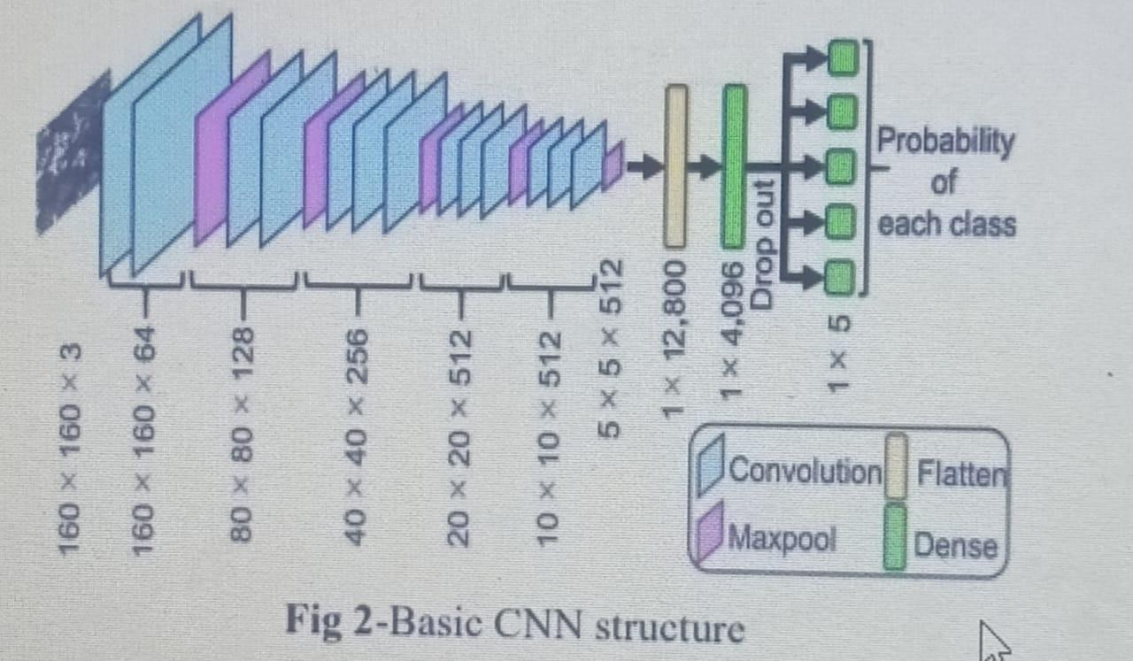

# Result And Experimental Analysis:

After building the model architecture, we then train the model using model.fit(). I tried with batch size 32 and 64. Our model performed better with 64 batch sizes. And after 15 epochs the accuracy was stable.Our model got a 92% accuracy on the training dataset. With matplotlib, we plot the graph for accuracy and the loss.

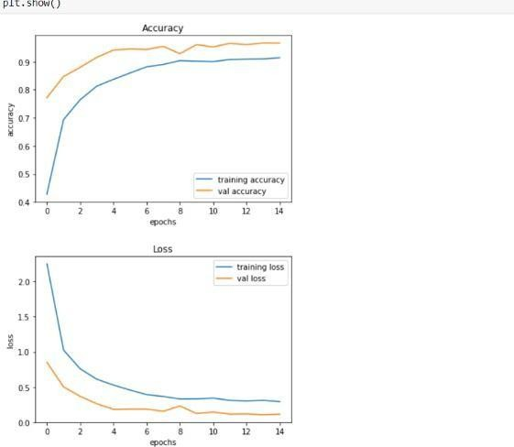

The dataset contains a test folder and in a test.csv file, the details related to the image path and their respective class labels are available. We extract the image path and labels using pandas. Then to predict the model, we have to resize our images to 30×30 pixels and make a numpy array containing all image data.

From the sklearn.metrics, the accuracy_score is imported and observed how our model predicted the actual labels.

# Screenshots

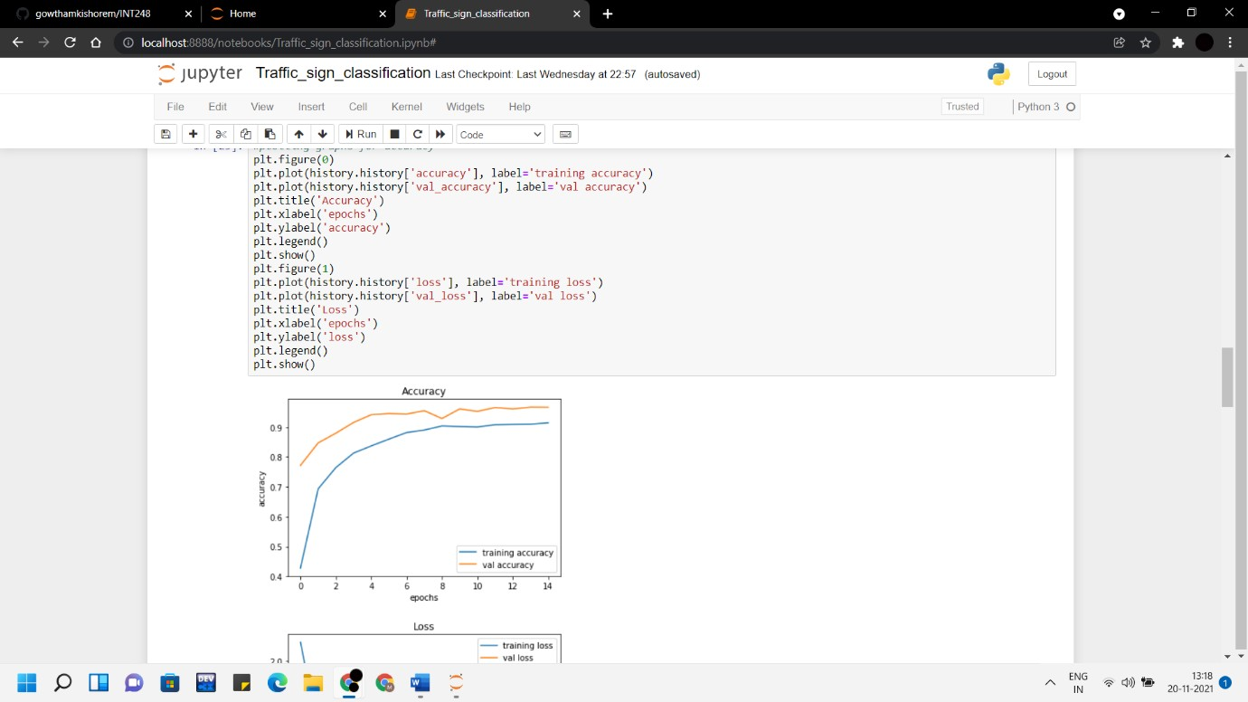

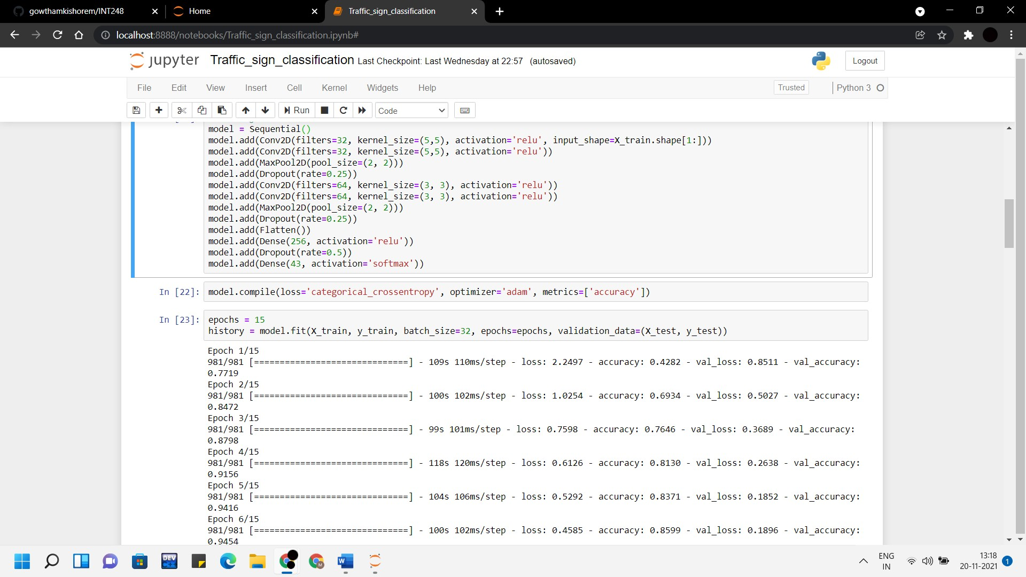

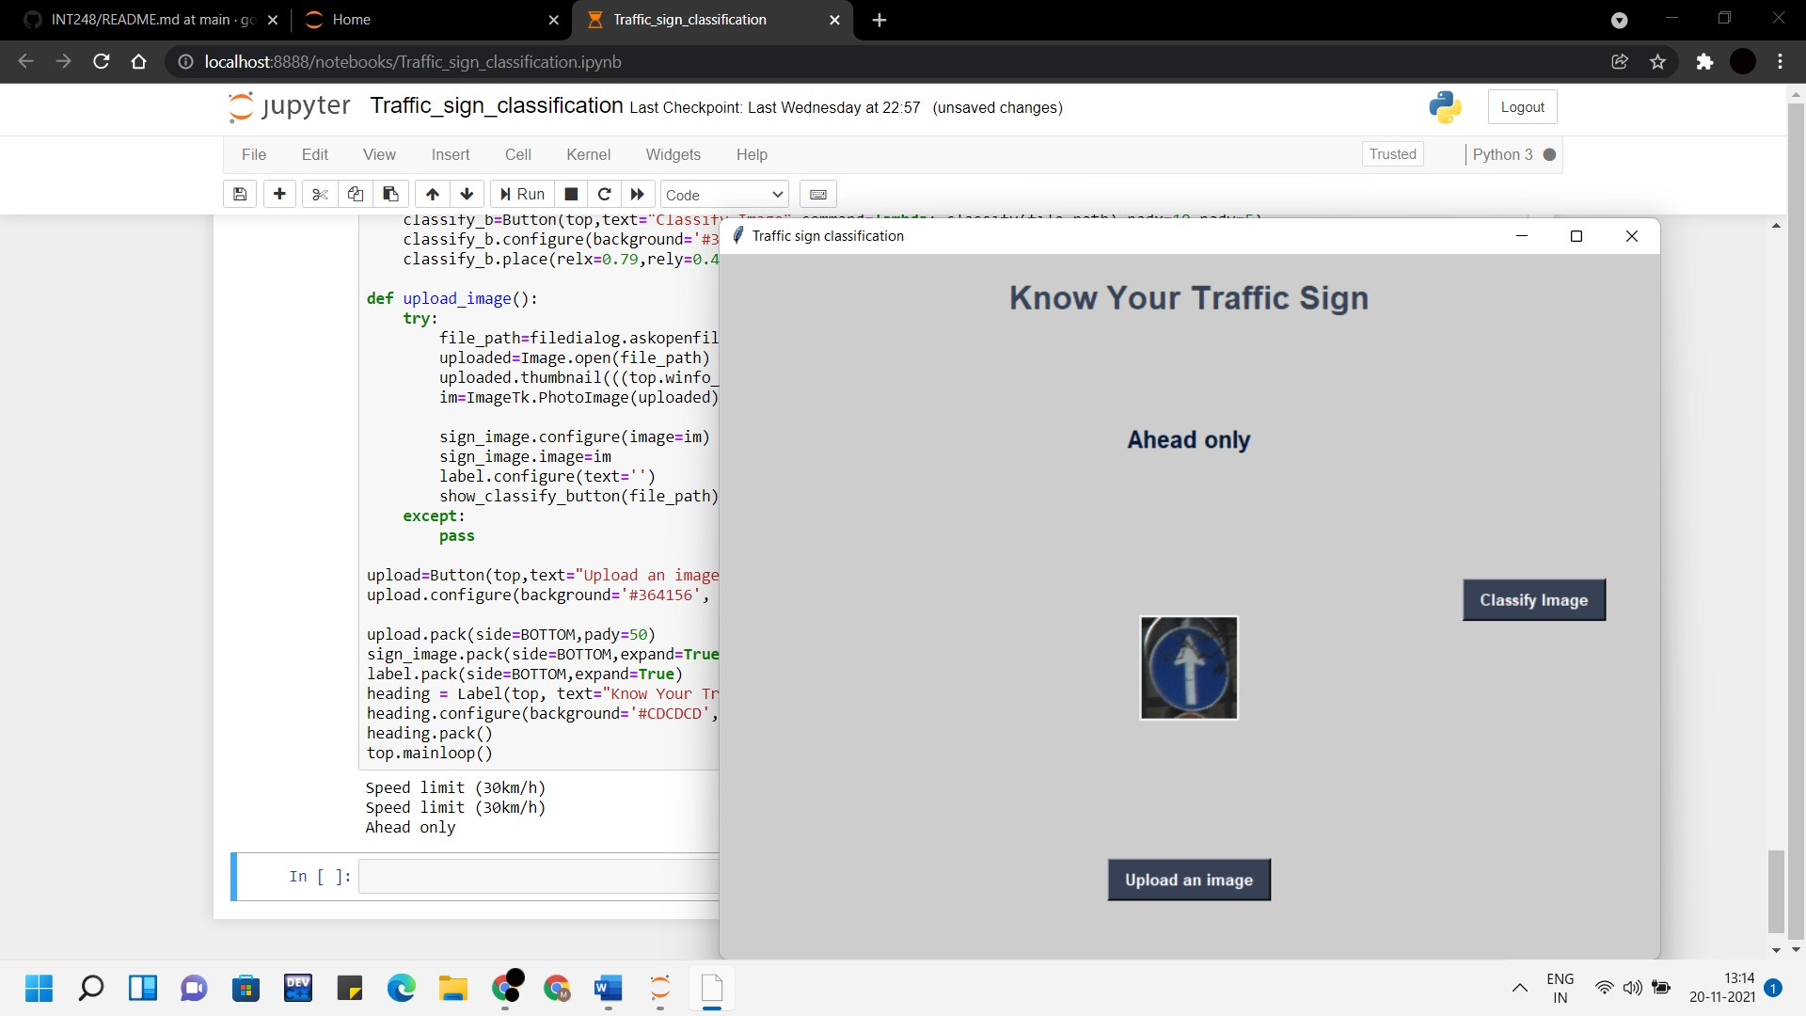

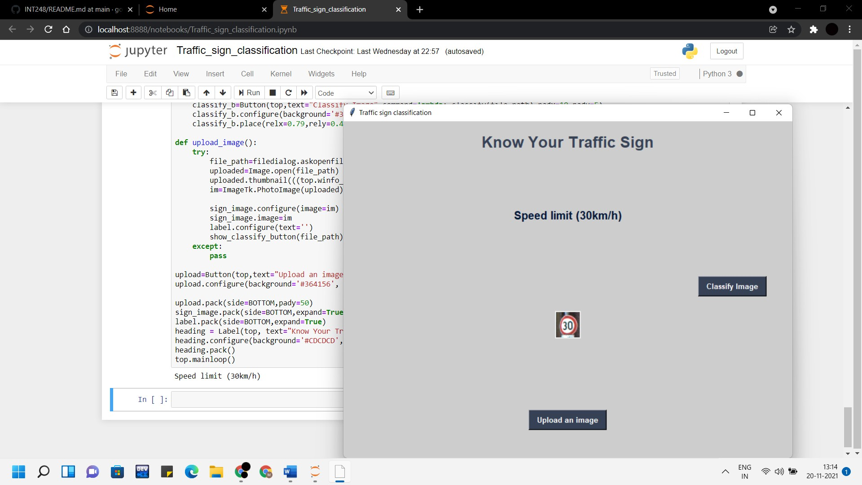

**Conclusion And FutureScope**

An accuracy of 92% is achieved in this model.

In this Python project with source code, we have successfully classified the traffic signs classifier with 92% accuracy and also visualized how our accuracy and loss changes with time, which is pretty good from a simple CNN model.

This model was saved as a h5 file whose location is further passed to our file containing our GUI, for using our trained model extensively. We were also successful in developing this GUI, using which, a user can upload an image in our GUI and the user would get a message of what traffic sign it was.

This research has given us an insight into how well deep learning can be utilized to create intelligent systems. As a part of future work, we were planning on integrating our model into a real time camera, which would further improve its functionality and application. This can further be included in industrial level products such as driverless cars in the future, provided we integrate our research work into a real time system.

# References

Balado, J., González, E., Arias, P., & Castro, D. (2020). Novel approach to automatic traffic sign inventory based on mobile mapping system data and deep learning. Remote Sensing.

12(3), 442. Belay, F. (2020). Voice-Based Automatic Traffic Sign Detection and Recognition System for Ethiopian Traffic Signs (Doctoral dissertation).

Xu, H., & Srivastava, G. (2020). Automatic recognition algorithm of traffic signs based on convolution neural networks. Multimedia Tools and Applications,

1-15.

Alam, A., &Jaffery, Z. A. (2020). Indian Traffic Sign Detection and Recognition. International Journal of Intelligent Transportation Systems Research, 18(1), 98-112.

Liu, Z., Li, D., Ge, S. S., & Tian, F. (2020). Small traffic sign detection from large images. Applied Intelligence, 50(1), 1-13.

Yakimov PY (2015) Preprocessing digital images for quickly and reliably detecting road signs. Pattern Recognition of Image Anal 25(4):729–732.