Project name
AI Career Companion
AGILE PROJECT DOCUMENTATION
Project title
AI Career Companion Agent
for Internship Matching and Interview Preparation
Prepared by
Bhanushree K
Project Duration
July 22 – September 22
Mentor
Vijay Parmar

Index
Index 2
1. Project Overview 4
1.1 Project Name 4
1.2 What is the Project? 4
1.3 Problem Statement 4
1.4 Target Users 4
2. Project Objective 5
Objectives 5
3. Technology Stack 6
4. Project Requirements 7
4.1 Functional Requirements 7
4.2 Non-Functional Requirements 7
5. System Architecture / Workflow 8
5.1 Resume Parsing Flow 8
5.2 Internship Matching Flow 8
5.3 Database Schema 9
6. Product Backlog 10
7. Sprint Planning 11
Sprint 1 — Goal: Project foundation and authentication [ 1st and 2nd week] 11
Sprint 2 — Goal: Resume intelligence and internship discovery [ 3rd and 4th week] 11
Sprint 3 — Goal: Semantic matching and career assistance [ 5th and 6th week] 11
Sprint 4 — Goal: AI assistants, integration and final validation [ 7th and 8th week] 11
8. Sprint Tasks & Status 12
9. Implementation / Key Features 13
9.1 Account Creation and Login 13
9.2 Dashboard 14
9.3 Resume Parsing 14
9.4 Internships 15
9.5 My Matches 16
9.6 Cover Letter 16
9.7 AI Product Assistant 17
9.8 Interview Preparation Agent 18
9.9 Profile 18
9.10 Additional Features 19
Parsed Resumes 19
Applied Internships 20
Light / Dark Theme 20
10. Testing 21
Testing Types 21
11. Challenges & Solutions 23
12. Final Project Status 24
12.1 Completed Features 24
12.2 Final Submission Status 24
12.3 Final Outcome 24
12.4 Conclusion 24

1. Project Overview

1.1 Project Name
AI Career Companion Agent for Internship Matching and Interview Preparation

1.2 What is the Project?
AI Career Companion is a web-based career assistance application designed to help students and internship seekers move from resume analysis to internship discovery, application support, AI-assisted product guidance and interview preparation. The application accepts PDF or DOCX resumes, extracts structured career information using a hybrid Regex + Groq LLM pipeline, and uses the resulting profile as the primary input for semantic internship matching.
The system also provides an internship catalog, matched opportunities, in-app applications, tailored cover-letter generation, a manually managed Career Profile, an AI Product Assistant developed as part of the internship feature set, and a separate AI Interview Preparation Agent that was developed subsequently and uses resume context, optional uploaded documents, and session conversation history.

1.3 Problem Statement
Students and internship seekers often have to perform several separate tasks: understand the information contained in their resume, search through internship listings, judge whether an opportunity fits their skills and education, prepare for technical and HR/behavioral interviews, and write application material. The project brings these activities into one application and uses AI-assisted processing to make the workflow more personalized.
The matching component is designed to provide not only a ranked opportunity list but also match percentage, match label, matched skills, skill gaps, and an AI-generated summary of the overall result set.

1.4 Target Users
- Students searching for internships.
- Candidates who want resume-based internship recommendations.
- Internship seekers preparing for technical and HR/behavioral interviews.
- Users who want application support such as tailored cover letters.

2. Project Objective
The main objective is to provide an integrated AI-assisted career companion that uses a candidate's resume and related context to support internship discovery, application assistance, product guidance and interview preparation.

Objectives
- Allow users to register, authenticate securely, and maintain user-specific application data.
- Parse PDF and DOCX resumes into structured career information using a hybrid Regex + LLM approach.
- Use sentence-transformer embeddings and FAISS to retrieve semantically relevant internship opportunities.
- Re-rank retrieved internships using skills, semantic similarity, education, and location signals.
- Show match explanations through matched skills, skill gaps, match percentage, and match label.
- Provide a separate Product Assistant that uses a product-knowledge document and FAISS retrieval before generating an answer with Groq.
- Provide an AI Interview Preparation Agent that can use parsed resume context, uploaded PDF/DOCX documents, and conversation history.
- Generate internship-specific cover letters using only the supplied candidate and internship information.
- Allow users to browse internships, apply within the application, and view their application history.
- Provide a manually maintained Career Profile separate from the parsed-resume data used for matching.
Scope note: The project contains both internship-matching retrieval and a separate product-knowledge RAG assistant. The Interview Preparation Agent is a separate service and should not be described as the same component as the Product Assistant.

3. Technology Stack
Category | Technology / Usage
Frontend | React 18.3.1, Vite, JavaScript, React Router, CSS, React Markdown, react-easy-crop
Backend | Python, FastAPI, Uvicorn, Pydantic, SQLAlchemy
Database | PostgreSQL
Authentication | JWT with python-jose; password hashing with Passlib/bcrypt
AI / LLM | Groq API, LangChain, LangChain-Groq, prompt-based LLM extraction and generation
Embeddings | sentence-transformers/all-MiniLM-L6-v2
Vector Search | FAISS (faiss-cpu)
Document Parsing | PyMuPDF for PDF; python-docx for DOCX
Matching | FAISS semantic retrieval + skills, education and location re-ranking
AI Product Assistant | Product-knowledge document + FAISS retrieval + Groq
Data / Persistence | PostgreSQL JSONB for parsed/profile data and application/session records
Version Control | Git / GitHub

4. Project Requirements

4.1 Functional Requirements
- User registration and login with JWT-based authentication.
- Password reset and password change flows.
- Protected application routes and user-specific data access.
- Upload PDF or DOCX resumes with file-type and size validation.
- Extract resume text and convert it into structured profile data.
- Store uploaded resumes and parsed-resume records for later reuse and re-parsing.
- Browse, search, and filter the internship catalog.
- Generate a selected number of top internship matches using FAISS-based retrieval and re-ranking.
- Display match percentage, match label, matched skills, and skill gaps.
- Apply to internships inside the application and view applied internships.
- Generate and save internship-specific cover letters.
- Maintain a separate user-managed Career Profile.
- Use the AI Product Assistant with product-knowledge retrieval and chat-session history.
- Use the Interview Preparation Agent for resume-based, document-based, technical, HR, and company-specific preparation.

4.2 Non-Functional Requirements
- Security: authenticated routes and user ownership checks for stored data.
- Reliability: validation and error handling for unsupported files and failed AI/API operations.
- Usability: clear workflows for resume parsing, matching, application, and interview preparation.
- Maintainability: separate routers and services for authentication, resume parsing, matching, chat, interview preparation, and career features.
- Readability: AI responses are presented through the frontend as readable Markdown where supported.
- Performance consideration: embedding models and FAISS indexes are cached per backend process to avoid repeated loading.

5. System Architecture / Workflow
The application follows a React/Vite frontend and FastAPI backend architecture. PostgreSQL stores persistent application data, while FAISS provides local vector retrieval. Groq is used for LLM-powered extraction and generation, and the local sentence-transformer model is used for semantic embeddings.
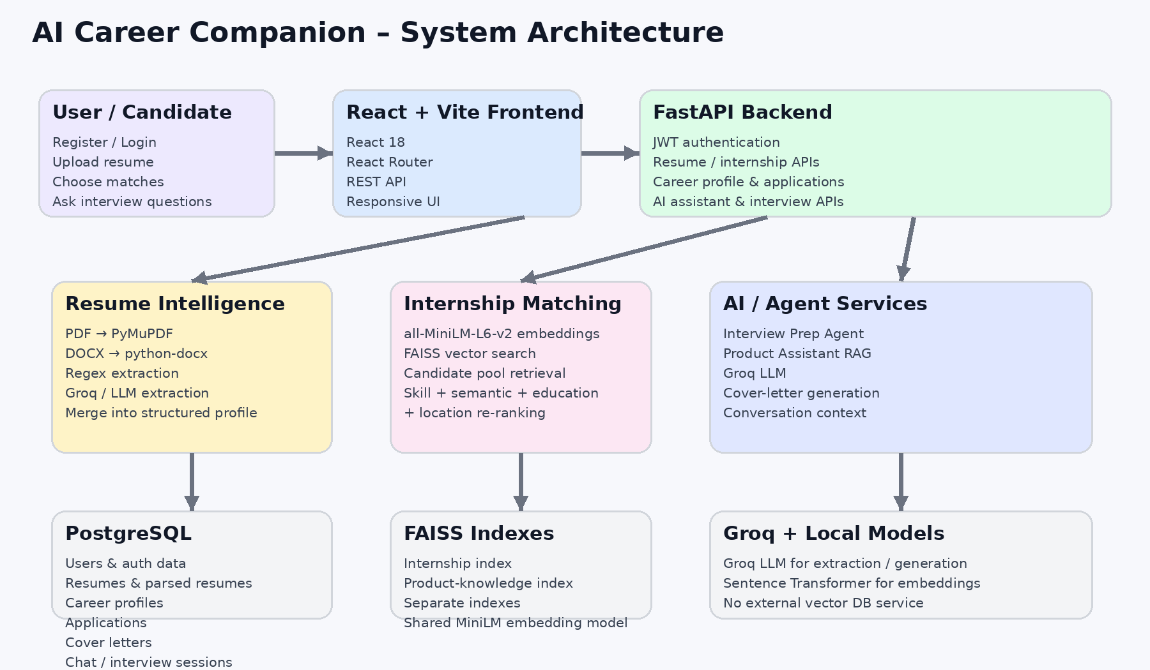
Figure 1. System architecture.

5.1 Resume Parsing Flow
- User uploads a PDF or DOCX through the React frontend.
- FastAPI validates the extension and upload size and stores the original file.
- PyMuPDF or python-docx extracts the document text.
- Regex extraction identifies deterministic contact information and other pattern-based fields.
- Groq/LLM extraction identifies semantic fields such as summary, skills, education, experience, projects, certifications, achievements, and related information.
- The merge service combines the two outputs, using Regex as authoritative for precise contact fields and LLM output for contextual/semantic fields.
- The final structured profile, together with the source resume, is stored in PostgreSQL.

5.2 Internship Matching Flow
- The latest successfully parsed resume is converted into a clean query containing skills, education, summary, and supporting project/experience text.
- The same all-MiniLM-L6-v2 embedding model is used for the resume query and internship postings.
- FAISS retrieves a larger candidate pool of semantically similar internship postings.
- The candidates are re-ranked using weighted skill, semantic, education, and location scores.
- The top-k results are returned with match percentage, label, matched skills, missing skills, and an optional Groq summary.

5.3 Database Schema
The application uses PostgreSQL with SQLAlchemy for persistent application data. The schema stores user accounts, uploaded resumes, parsed resume data, the manually maintained Career Profile, cover letters, internship applications, authentication support records, Product Assistant conversations, and Interview Preparation sessions. UUIDs are used as primary keys for the main entities, while JSONB is used for structured resume/profile data and optional conversational sources.
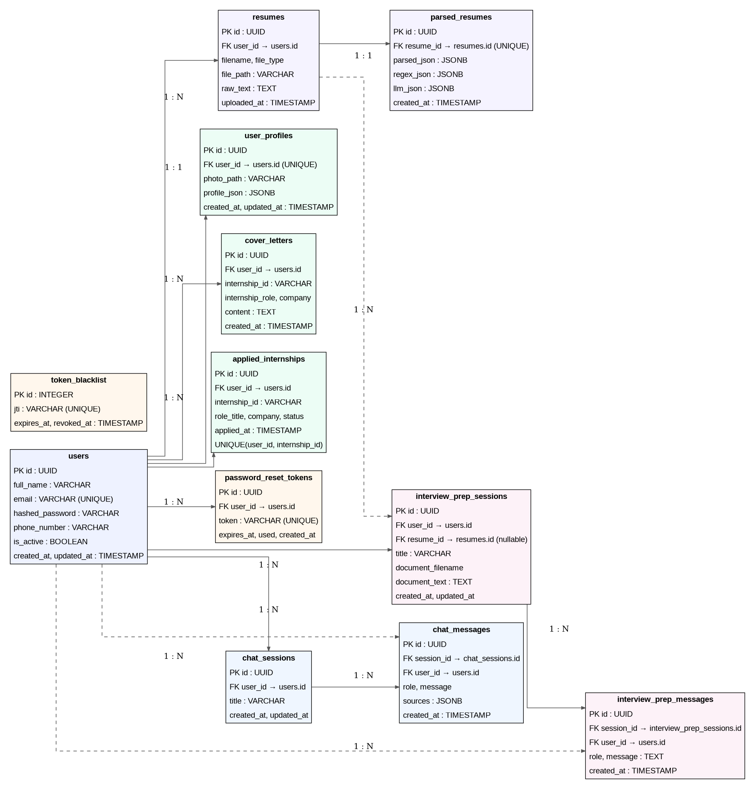
Figure 2. Database schema

6. Product Backlog
The backlog represents the major implemented feature areas found in the repository. Status is based on the presence of the corresponding working code in the final project.
ID | Feature / Task | Priority | Status
P001 | Project structure and development setup | High | Done
P002 | User registration, login, JWT authentication | High | Done
P003 | PostgreSQL models and persistence | High | Done
P004 | PDF/DOCX resume upload and extraction | High | Done
P005 | Hybrid Regex + Groq LLM resume parser | High | Done
P006 | Internship catalog, search and filtering | High | Done
P007 | FAISS semantic internship matching and re-ranking | High | Done
P008 | Career Profile management | Medium | Done
P009 | Applied Internships tracking | Medium | Done
P010 | AI-generated internship-specific cover letters | Medium | Done
P011 | AI Product Assistant with product-knowledge RAG | High | Done
P012 | AI Interview Preparation Agent | High | Done
P013 | Frontend workflow, routing and theme support | Medium | Done
P014 | Final validation, documentation and demo preparation | High | Done
Priority values: High, Medium, Low. Status values: To Do, In Progress, Testing, Done.

7. Sprint Planning
The project was organized into four development cycles.

Sprint 1 — Goal: Project foundation and authentication [ 1st and 2nd week]
- Set up frontend and backend structure.
- Configure FastAPI, React/Vite and PostgreSQL connectivity.
- Implement registration, login, JWT authentication and protected routes.
- Create core database models and persistence.

Sprint 2 — Goal: Resume intelligence and internship discovery [ 3rd and 4th week]
- Implement PDF/DOCX text extraction.
- Implement Regex and Groq LLM resume extraction.
- Merge extracted information into structured resume data.
- Create internship catalog, search/filtering and internship data handling.

Sprint 3 — Goal: Semantic matching and career assistance [ 5th and 6th week]
- Build the internship FAISS index.
- Implement all-MiniLM-L6-v2 embeddings.
- Implement candidate retrieval and skill/semantic/education/location re-ranking.
- Add Career Profile, Applied Internships and Cover Letter features.

Sprint 4 — Goal: AI assistants, integration and final validation [ 7th and 8th week]
- Implement Product Assistant RAG using a separate product-knowledge FAISS index.
- Implement the separate Interview Preparation Agent.
- Integrate frontend routes and shared UI.
- Validate registration/login and user-selected match count workflow.
- Prepare final documentation and demo materials.

8. Sprint Tasks & Status
Sprint | Task | Status
Sprint 1 | Project setup / repository / backend and frontend foundation | Done
Sprint 1 | Authentication and protected application routes | Done
Sprint 1 | Database models and PostgreSQL persistence | Done
Sprint 2 | PDF/DOCX parsing and hybrid resume extraction | Done
Sprint 2 | Structured parsed-resume storage and history | Done
Sprint 2 | Internship catalog and filtering | Done
Sprint 3 | FAISS internship index and MiniLM embeddings | Done
Sprint 3 | Composite internship ranking and match explanations | Done
Sprint 3 | Career Profile, applications and cover letters | Done
Sprint 4 | Product Assistant RAG | Done
Sprint 4 | Interview Preparation Agent | Done
Sprint 4 | Final integration / UI validation / documentation | Done

9. Implementation / Key Features
The following sections describe the major features implemented in the application.

9.1 Account Creation and Login
Feature: Users can create an account and then sign in manually. Registration does not automatically authenticate the new account.
How it works: The React registration form sends account details to the FastAPI registration endpoint. After successful registration, the application navigates to the Login page. Authentication is then performed through the login endpoint, which issues the JWT access token used by protected routes.
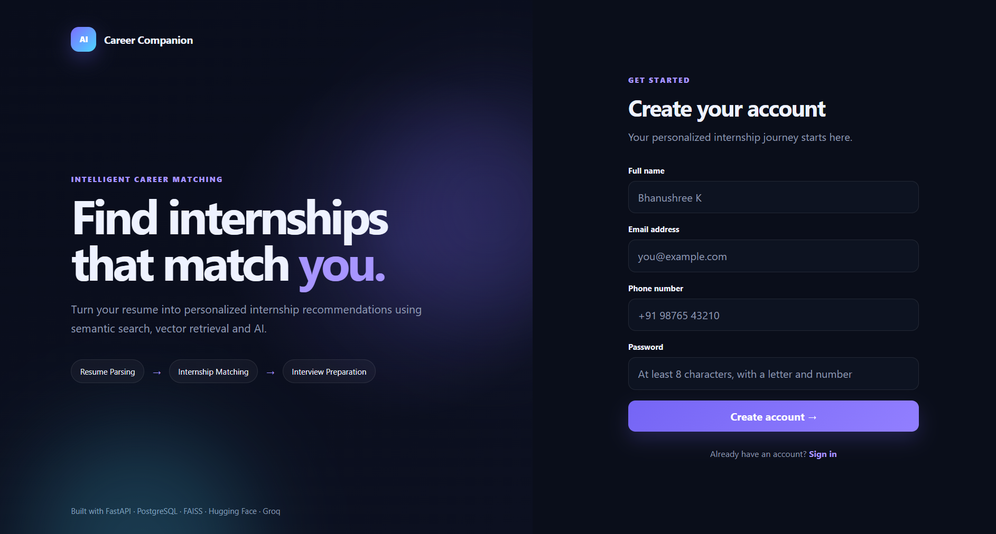
Figure 2. Create Account / Register page.
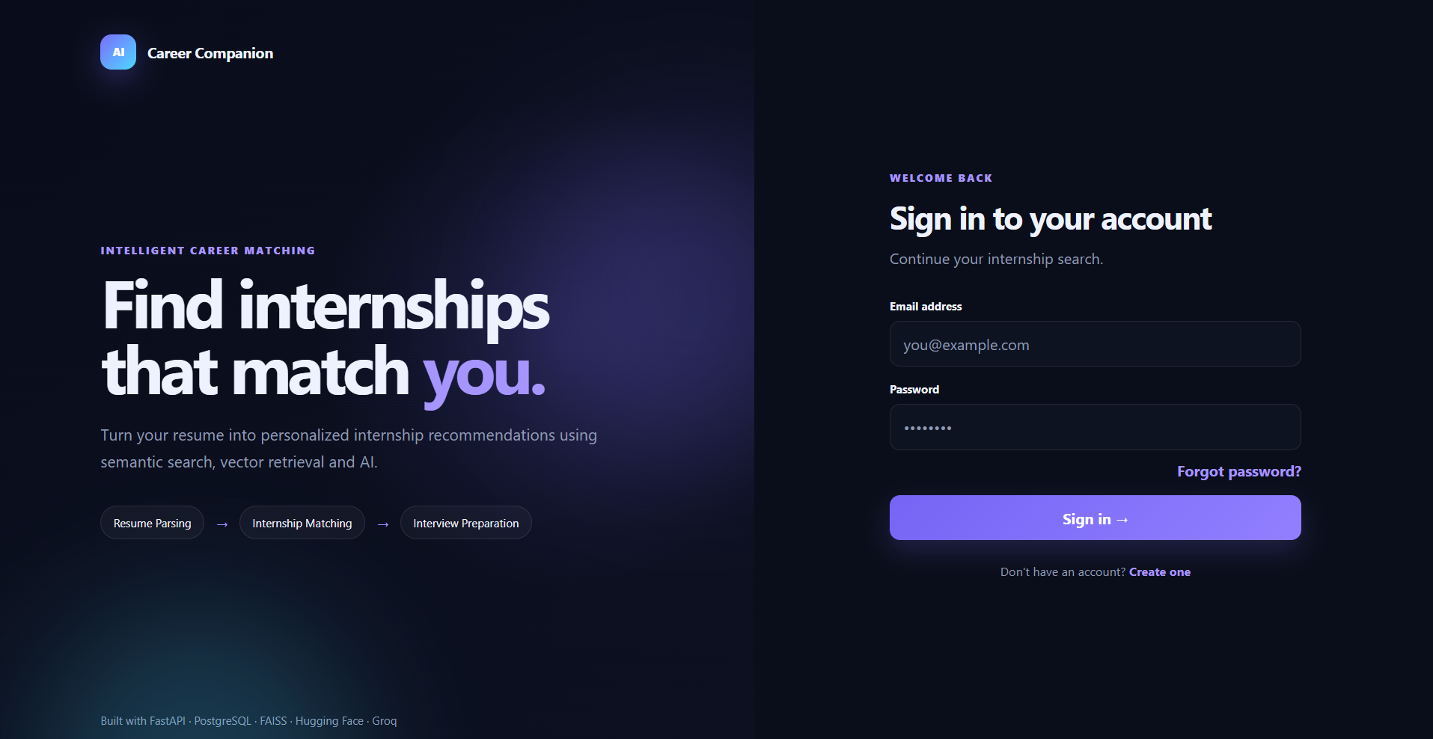
Figure 3. Login page.

9.2 Dashboard
Feature: The Dashboard is the main landing page after successful login and provides an overview of the career-assistance workflow.
How it works: The dashboard presents the resume-to-matching workflow and summarizes the technologies supporting internship matching, including FAISS, the MiniLM embedding model and Groq AI analysis. It also provides the entry point for beginning resume parsing.

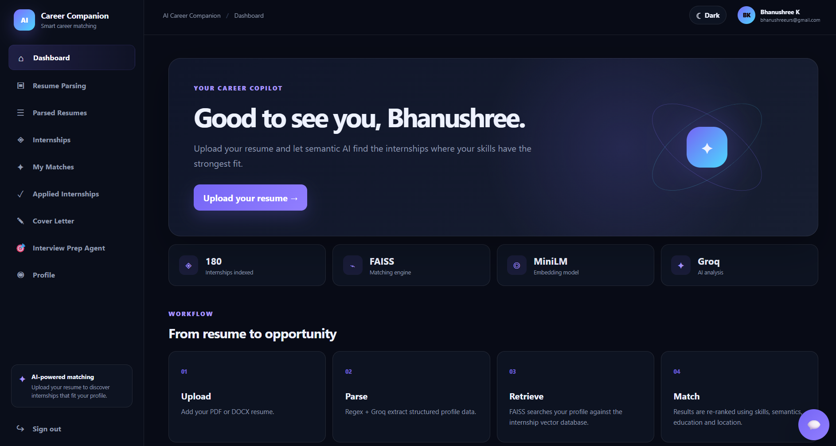
Figure 4. Application Dashboard.

9.3 Resume Parsing
Feature: Users upload a PDF or DOCX resume and receive structured career information.
How it works: The backend validates the file, extracts text with PyMuPDF or python-docx, performs Regex extraction for deterministic fields, and uses Groq/LLM extraction for contextual fields. The outputs are merged into the structured parsed-resume record stored for the user's account.
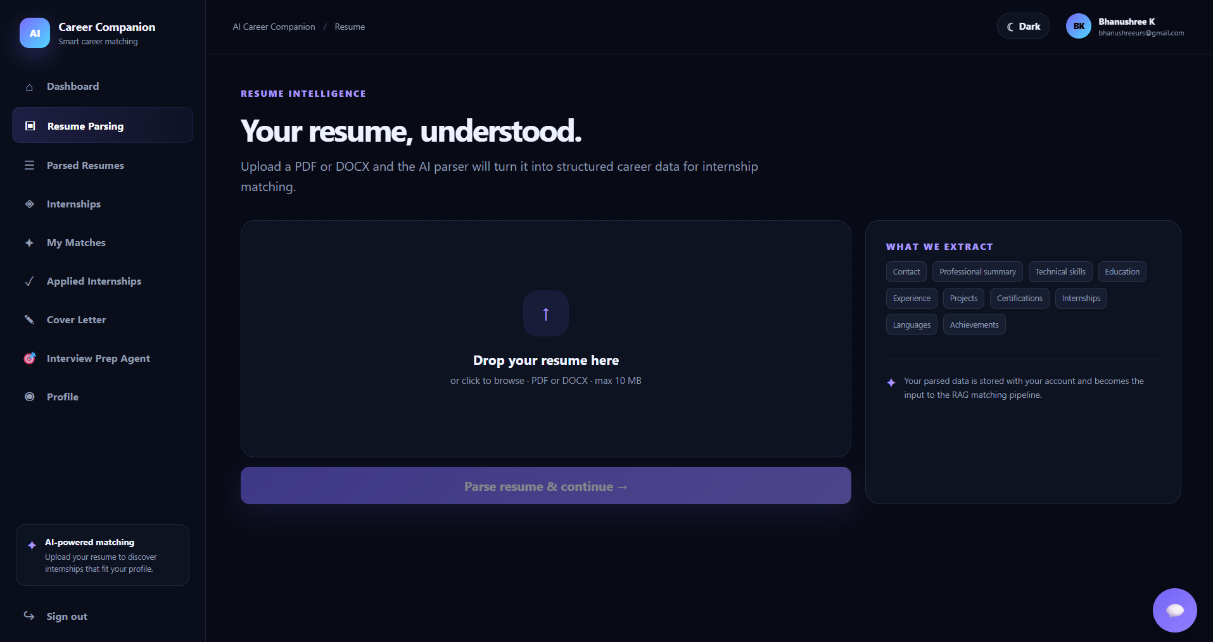
Figure 5. Resume Parsing page.

9.4 Internships
Feature: Users can browse the internship catalog and search/filter available opportunities.
How it works: The application exposes internship records through the backend and provides frontend controls for browsing and filtering. The catalog forms the source pool used by the semantic matching component.

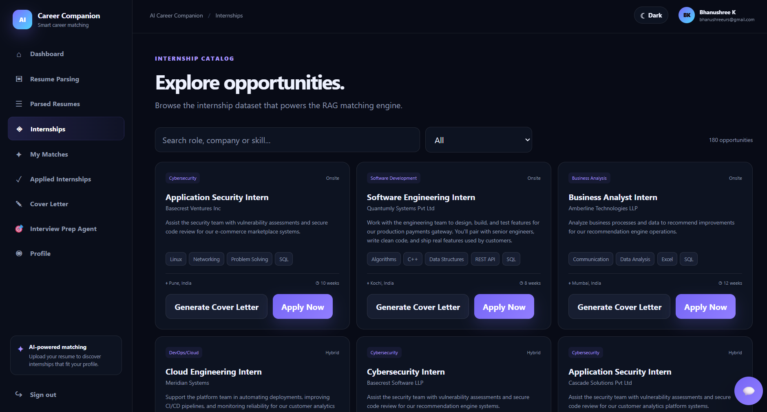
Figure 6. Internship catalog.

9.5 My Matches
Feature: Users can explicitly choose how many personalized internship matches they want and start the matching process.
How it works: Internship postings are represented using all-MiniLM-L6-v2 embeddings and indexed in FAISS. The latest parsed resume is converted into a semantic query, FAISS retrieves a candidate pool, and the candidates are re-ranked using skills, semantic similarity, education and location. The current UI provides 3, 5 and 10 match choices, defaults to 3, and starts matching only after the user clicks Find Matches.

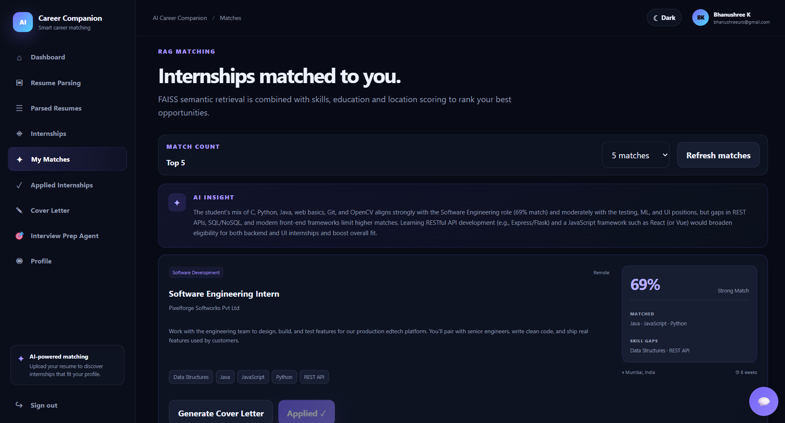
Figure 7. My Matches — user-selected internship matching.

9.6 Cover Letter
Feature: Users can generate an internship-specific cover letter.
How it works: The backend loads the selected internship and the user's parsed resume and sends those supplied facts to Groq for generation. The prompt instructs the model not to invent candidate skills, experience, dates, achievements or company facts. Generated cover letters are stored in PostgreSQL.
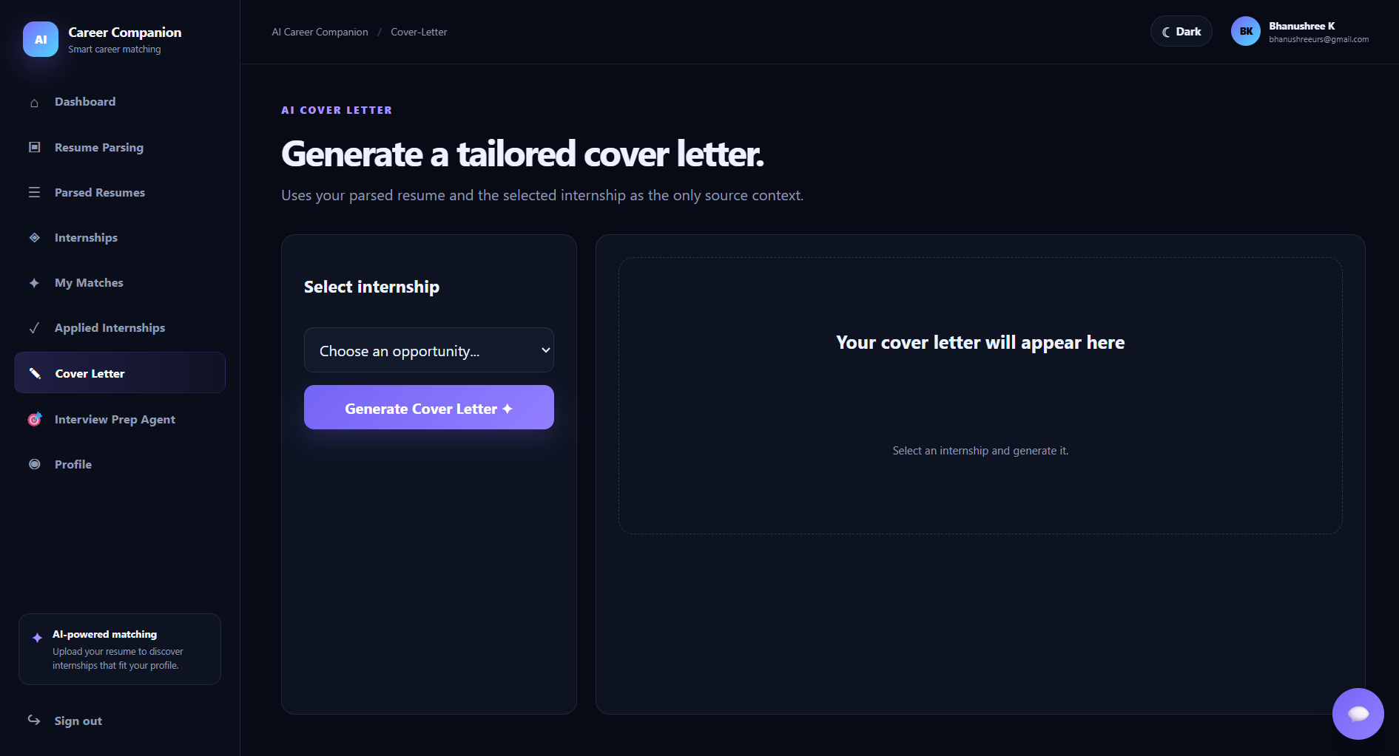
Figure 8. Cover Letter generation.

9.7 AI Product Assistant
Feature: The AI Product Assistant is a core internship-support feature developed during the internship. It helps users understand and navigate the Career Companion application through an AI assistant grounded in the project's product knowledge.
How it works: The Product Assistant retrieves relevant sections from the product-knowledge document through a dedicated FAISS index and sends the retrieved context together with recent chat history to Groq for response generation. It is a separate service from the Interview Preparation Agent.
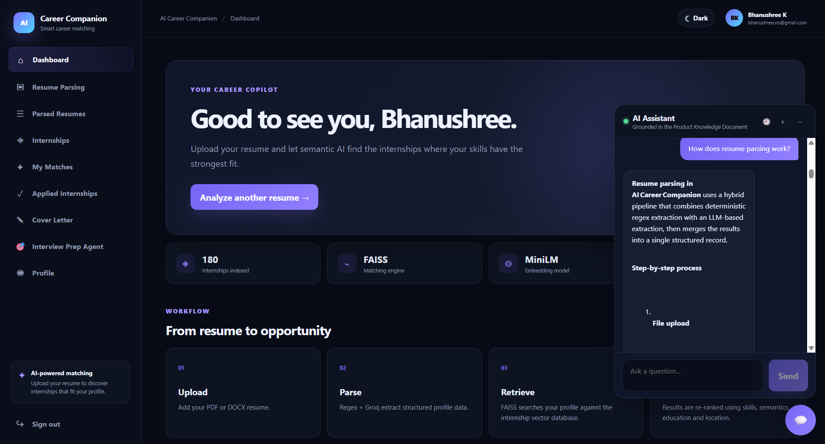
Figure 9. AI Product Assistant.

9.8 Interview Preparation Agent
Feature: A dedicated AI Interview Preparation Agent supports technical, HR/behavioral, company-specific and document-based interview preparation.
How it works: This agent is separate from the floating Product Assistant. It reuses the latest parsed resume, can use uploaded PDF/DOCX context, and retains the current interview-session conversation history. The combined context is sent to the configured Groq LLM for questions, explanations, model answers and study guidance.

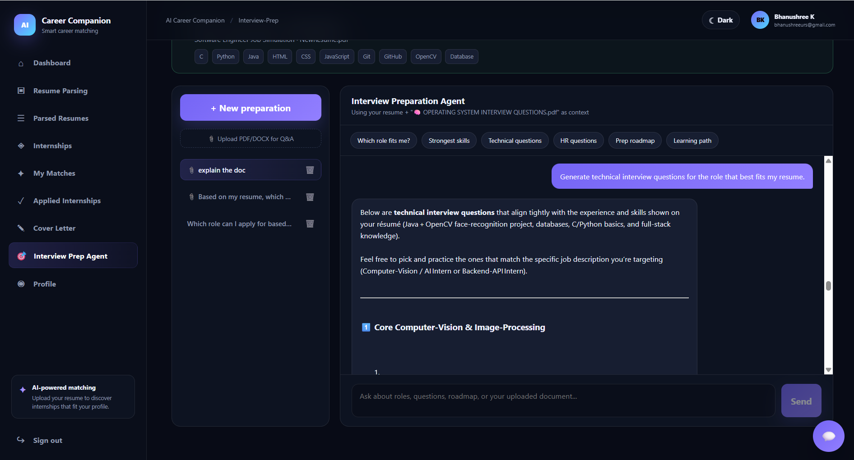
Figure 10. AI Interview Preparation.

9.9 Profile
Feature: Users can maintain a separate Career Profile.
How it works: The Career Profile is a manually managed persistent record and is intentionally separate from parsed-resume data. This allows the user to edit profile information without silently changing the stored parsed-resume record used for matching.
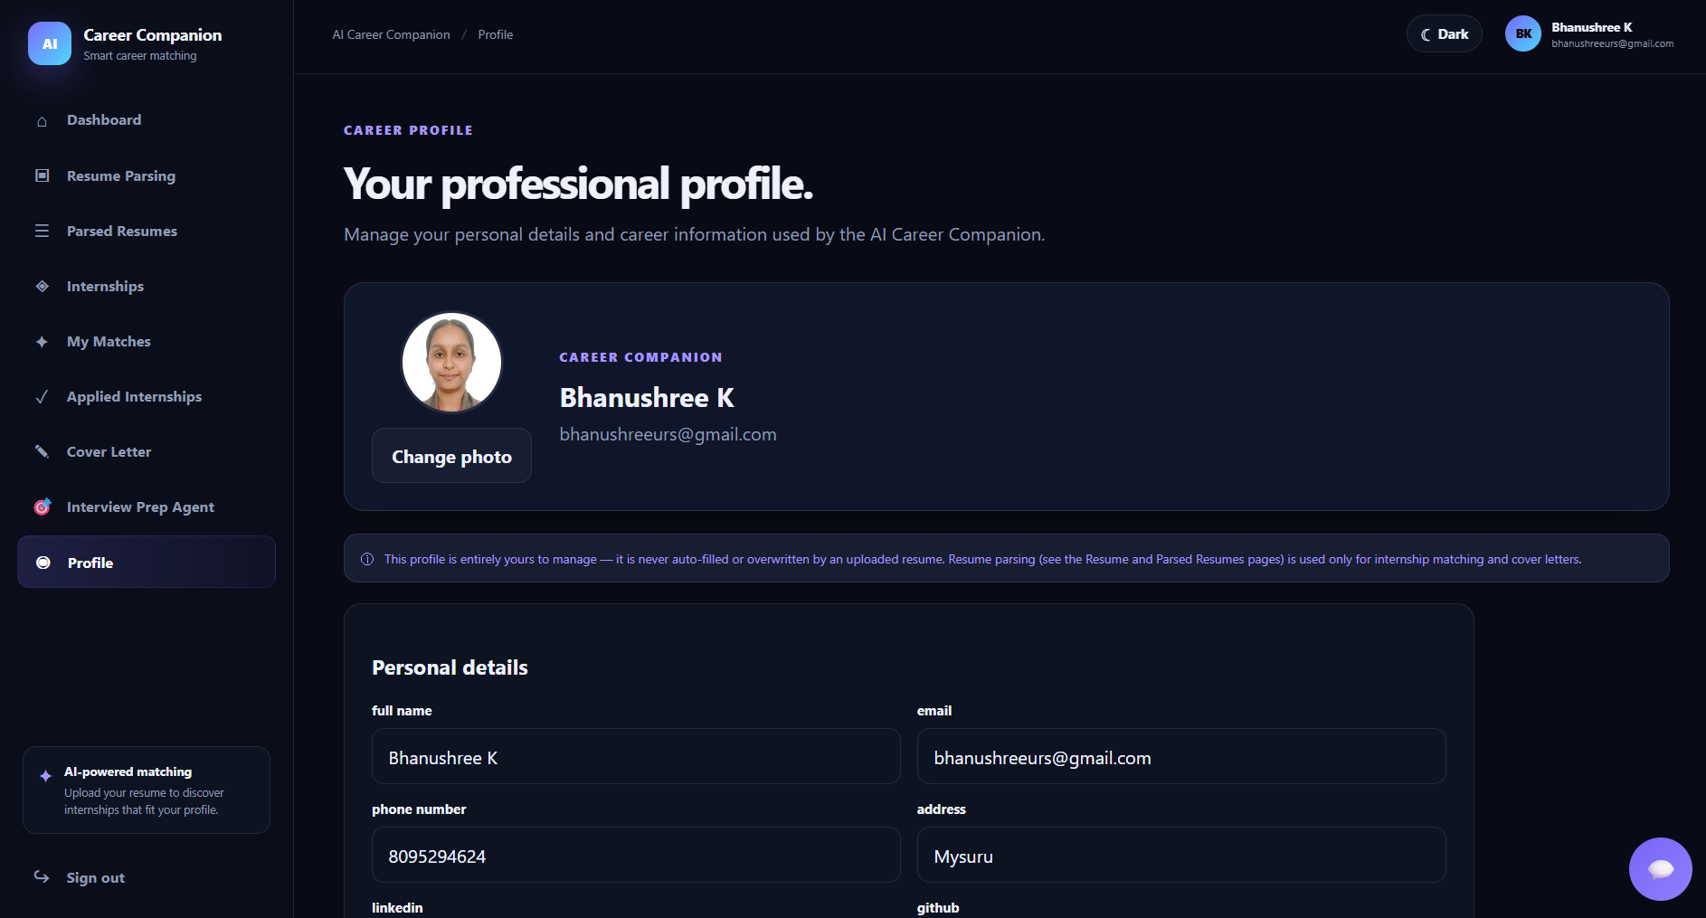
Figure 11. Career Profile.

9.10 Additional Features
The following supporting features are presented after the core post-login navigation and core internship/AI feature set: Parsed Resumes, Applied Internships, and Light / Dark Theme.

Parsed Resumes
Users can retain multiple uploaded/parsed resumes, review earlier records and reuse or re-run parsing on a selected resume.

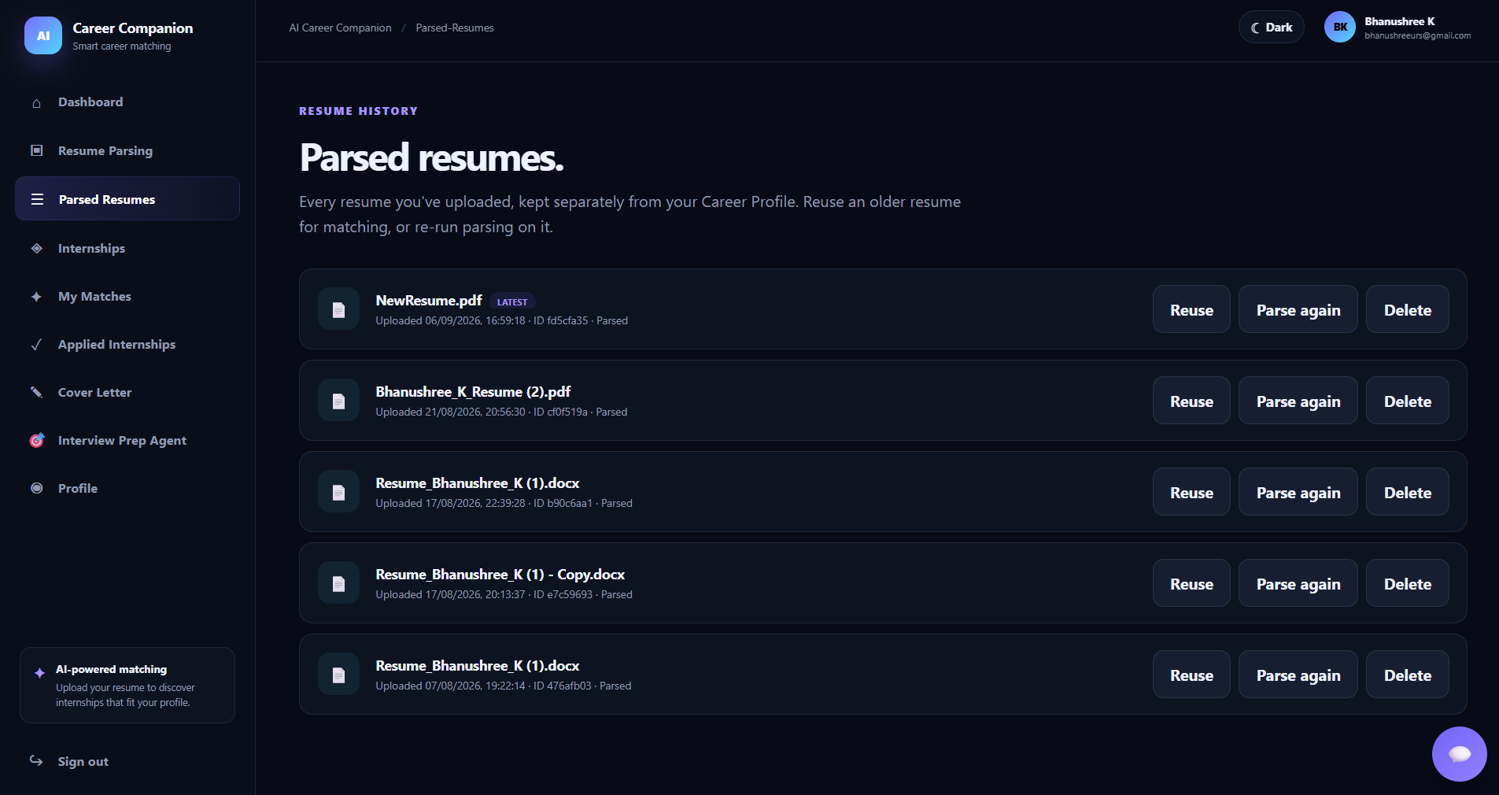
Figure 12. Parsed Resumes.

Applied Internships
Users can view internships they have applied to. Applications are persisted and duplicate applications for the same user and internship are prevented by the application's data constraints.
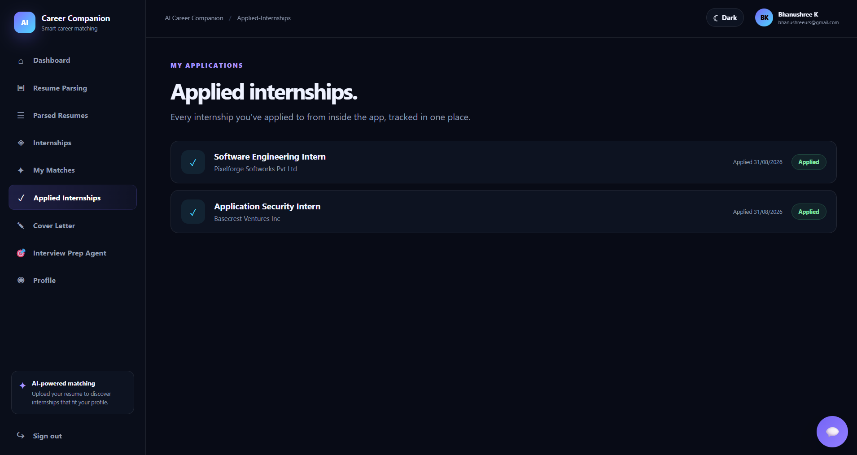
Figure 13. Applied Internships.

Light / Dark Theme
The frontend provides theme support for the application interface.
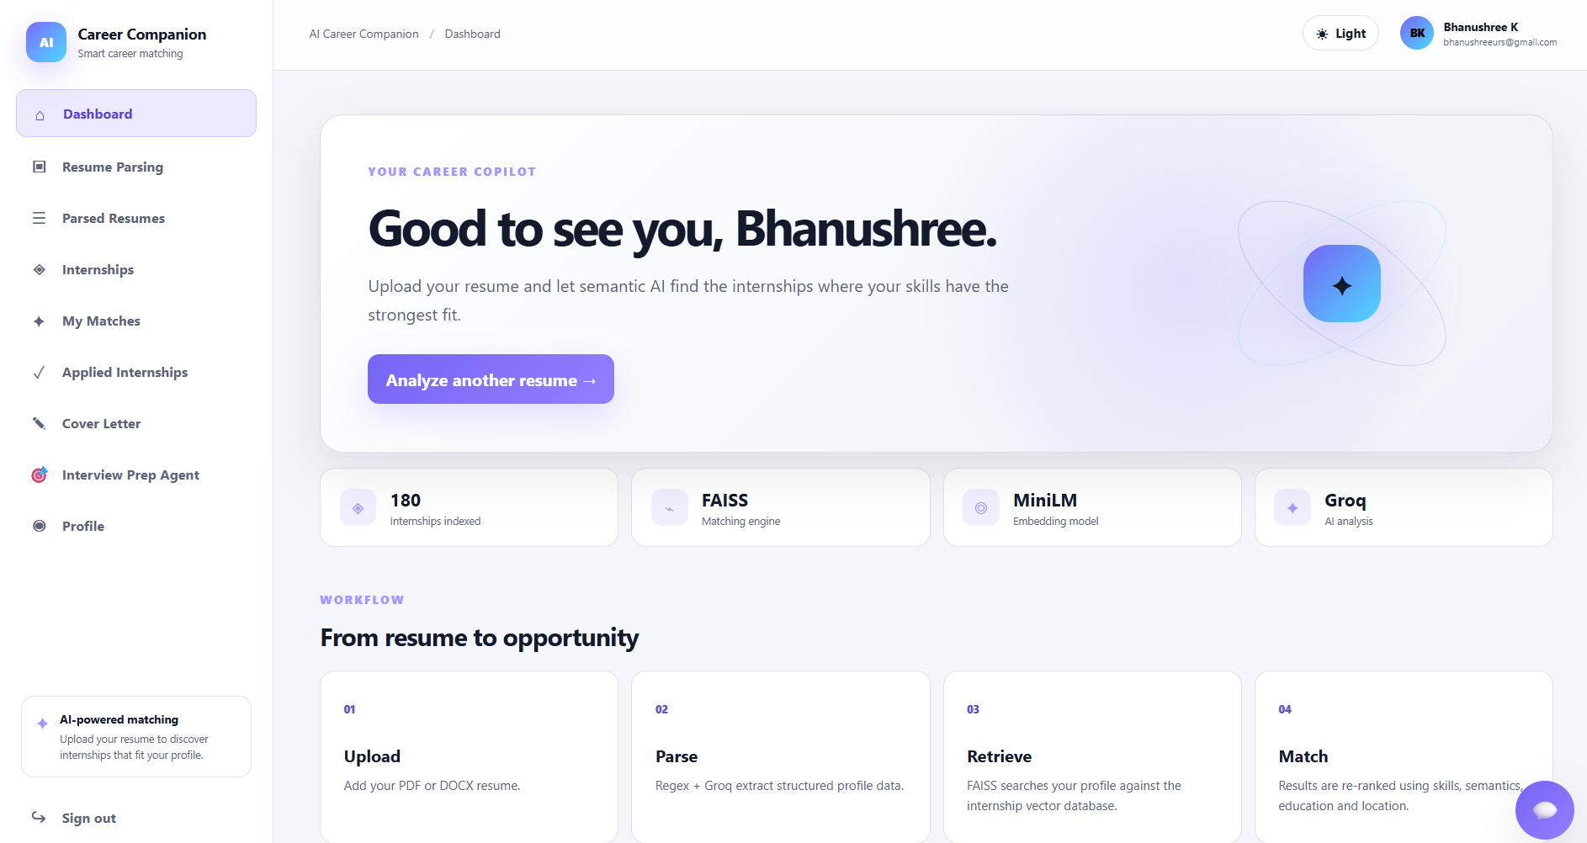
Figure 14. Light theme.

10. Testing
Testing in the current project focuses on functional behavior of the frontend-to-backend workflow, API validation, data ownership, and AI-assisted flows. The table lists final-version test cases supported by the implemented application. The two recently changed flows were verified in the current working build by running the project.
Test ID | Test Case | Expected Result | Actual / Implementation Result | Status
T001 | Register with valid details | Account is created and user is taken to Login | Registration flow navigates to /login | Pass
T002 | Login with valid credentials | JWT is issued and user reaches Dashboard | Login flow routes to Dashboard | Pass
T003 | Upload valid PDF/DOCX resume | Resume is accepted and parsed | Hybrid parsing endpoint implemented | Pass
T004 | Upload unsupported file type | Clear validation error is shown | Backend rejects unsupported extensions | Pass
T005 | Open My Matches without clicking search | No matching request starts automatically | Matching is triggered only by Find Matches | Pass
T006 | Select 3 / 5 / 10 matches | Selected count is sent to matching endpoint | Frontend passes k to the matching endpoint | Pass
T007 | Apply to an internship twice | Duplicate application is prevented | Database unique constraint protects the pair | Pass
T008 | Generate cover letter | Letter uses parsed resume + selected internship context | Groq-generated letter is saved | Pass
T009 | Use Product Assistant | Relevant product-knowledge context is retrieved | Separate FAISS product index + Groq response | Pass
T010 | Use Interview Preparation Agent | Resume/document/session context is available | Dedicated interview session and message flow implemented | Pass

Testing Types
- Functional Testing — registration, login, resume upload, matching, applications and feature workflows.
- API Testing — FastAPI endpoints and validation/error responses.
- UI Testing — navigation, forms, match selection and rendered AI content.
- Integration Testing — frontend communication with FastAPI and persistence in PostgreSQL.
- AI / Retrieval Testing — resume extraction, internship retrieval/re-ranking, Product Assistant retrieval and LLM generation.

11. Challenges & Solutions
The challenges below are based on implementation decisions visible in the supplied repository and the final workflow. They are presented as engineering challenges rather than generic AI-project statements.
Challenge | Solution
Resume extraction needs both precision and semantic understanding | Used a hybrid parser: Regex handles deterministic contact information while Groq/LLM handles contextual fields such as skills, education, projects and experience. A merge layer combines the outputs.
Semantic similarity alone is not enough for internship ranking | Retrieved a larger candidate pool from FAISS and re-ranked candidates using weighted skill, semantic, education and location scores. The result exposes matched skills and skill gaps.
Product Assistant and internship matching require different knowledge indexes | Kept separate FAISS indexes/directories for internship postings and product knowledge, while reusing the same cached MiniLM embedding model.
Interview preparation needs resume and document context without duplicating resume parsing | The Interview Preparation Agent reuses the existing parsed-resume record and existing PDF/DOCX extraction utilities, adding session history and optional uploaded document context.
Career Profile data should not silently change when a resume changes | Implemented Career Profile as a separate user-managed record. Parsed resumes remain a distinct concept used for matching and cover letters.
AI-generated content must avoid unsupported candidate facts | The cover-letter prompt limits generation to supplied candidate and internship information and instructs the model not to invent facts.
Matching should not start before the user chooses the desired result count | Changed My Matches so navigation does not automatically call the matching endpoint. The user selects 3, 5 or 10 and explicitly clicks Find Matches.

12. Final Project Status

12.1 Completed Features
- User registration, login, logout, JWT authentication and protected routes.
- Password reset/change flow.
- PDF/DOCX resume upload and hybrid Regex + Groq LLM parsing.
- Parsed resume storage, history, reuse and re-parsing.
- Internship catalog with search and domain filtering.
- FAISS + all-MiniLM-L6-v2 internship matching with composite re-ranking.
- Match explanations including percentage, label, matched skills and skill gaps.
- Career Profile management.
- Applied Internships tracking with duplicate-application protection.
- AI-generated internship-specific cover letters.
- AI Product Assistant with product-knowledge RAG.
- Separate AI Interview Preparation Agent with resume/document/session context.
- Light/dark theme support and integrated application navigation.

12.2 Final Submission Status
- Project implementation completed.
- Final documentation prepared.
- Final project demonstration prepared.

12.3 Final Outcome
The project implements an integrated AI career companion that takes a candidate from authentication and resume parsing through internship discovery, personalized matching, application support, the AI Product Assistant and interview preparation. The application is organized as a React/Vite frontend backed by FastAPI and PostgreSQL, with FAISS-based vector retrieval and Groq-powered AI services.
The current working version includes the requested interaction changes for the final flow: a newly registered user is returned to the Login page instead of being automatically logged in, and My Matches waits for the user to select 3, 5 or 10 matches and explicitly start the search. The AI Product Assistant is documented as a core internship feature and precedes the subsequently developed Interview Preparation Agent.
Project duration and official sprint dates were not supplied with the source files used for this document and therefore remain explicit confirmation fields rather than guessed values.

12.4 Conclusion
The project demonstrates the integration of web application development, secure user management, document processing, semantic retrieval, vector search, LLM-based generation, and AI-assisted career workflows in a single internship-oriented application.
Prepared by: Bhanushree K | Mentor: Vijay Parmar

