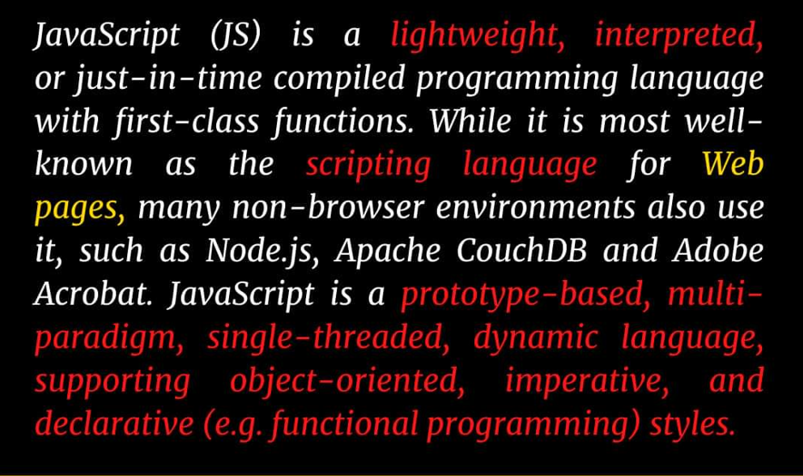

• Using console tab of web browsers

• Using Node.js

• By creating web pages



## JavaScript Keywords

Keywords are reserved words that are part of the syntax in the programming language. For example,

Here is the list of keywords available in JavaScript.

|  |  |  |  |  |
| --- | --- | --- | --- | --- |
| await | break | case | catch | class |
| const | continue | debugger | default | delete |
| do | else | enum | export | extends |
| false | finally | for | function | if |
| implements | import | in | instanceof | interface |
| let | new | null | package | private |
| protected | public | return | super | switch |
| static | this | throw | try | true |
| typeof | var | void | while | with |
| yield |  |  |  |  |

**JavaScript Identifiers**

An identifier is a name that is given to entities like variables, functions, class, etc.

Variables:

Variables are containers for storing data (values).

Rules for Variable

1.Variable names must start with either a letter, an underscore _, or the dollar sign $. For example,

let a = 'hello';

let _a = 'hello';

let $a = 'hello';

2.Variable names cannot start with numbers. For example,

//invalid

Let 1a = 'hello'; // this gives an error

3. JavaScript is case-sensitive. So y and Y are different variables. For example,

let y = "hi";

let Y = 5;

console.log(y); // hi

console.log(Y); // 5

4.Keywords cannot be used as identifier names. For example,

//invalid

const new = 5; // Error! new is a keyword.

// Numeric conversion rules:

// Value    Becomes…

// undefined    NaN

// null 0

// true and false   1 and 0

// string   Whitespaces from the start and end are removed. If the remaining string is empty, the result is 0. Otherwise, the number is “read” from the string. An error gives NaN.

// Boolean Conversion – Occurs in logical operations. Can be performed with

Boolean(value).

// Follows the rules:

// Value    Becomes…

// 0, null, undefined, NaN, "" ---->    false

// any other value ---->    true

// The three most widely used type conversions are to string, to number, and to boolean.

// String Conversion – Occurs when we output something. Can be performed with String(value). The conversion to string is usually obvious for primitive values.

// Numeric Conversion – Occurs in math operations. Can be performed with Number(value).

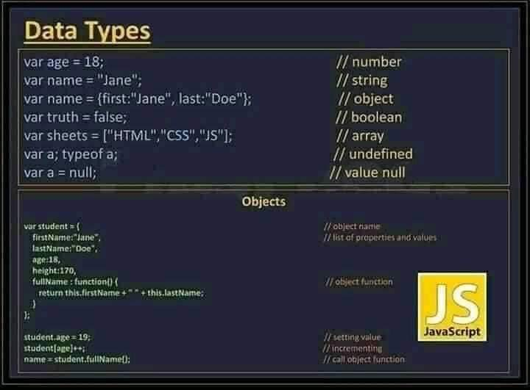

typeof undefined // "undefined"

typeof 0 // "number"

typeof 10n // "bigint"

typeof true // "boolean"

typeof "foo" // "string"

typeof Symbol("id") // "symbol"

typeof Math // "object"  (1)

typeof null // "object"  (2)

typeof alert // "function"  (3)

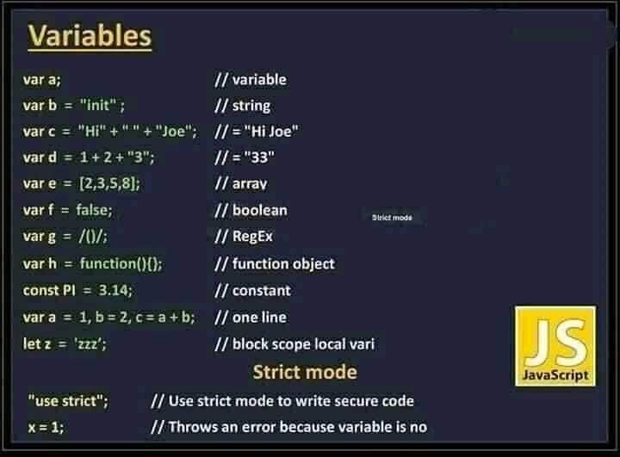

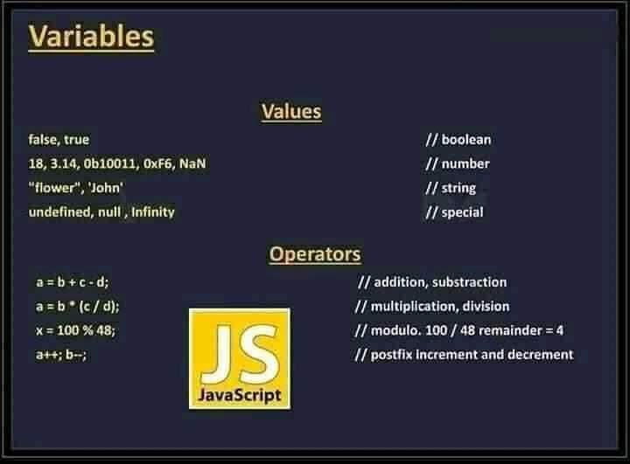

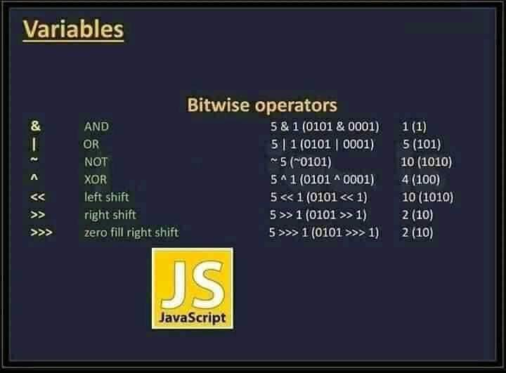

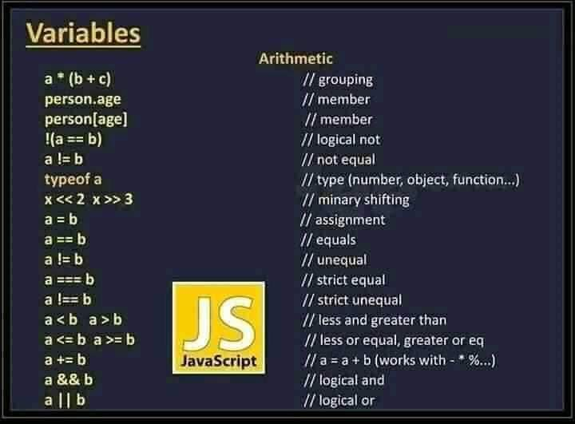

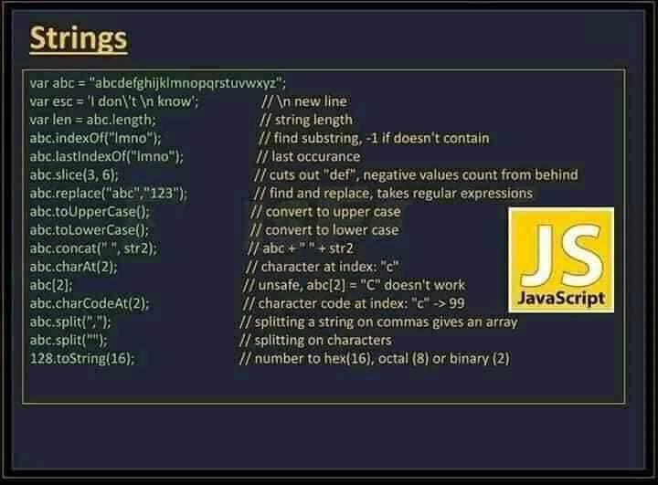

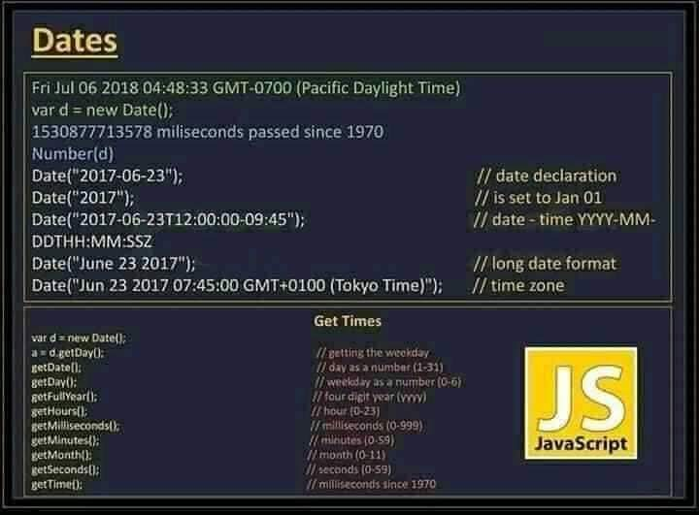

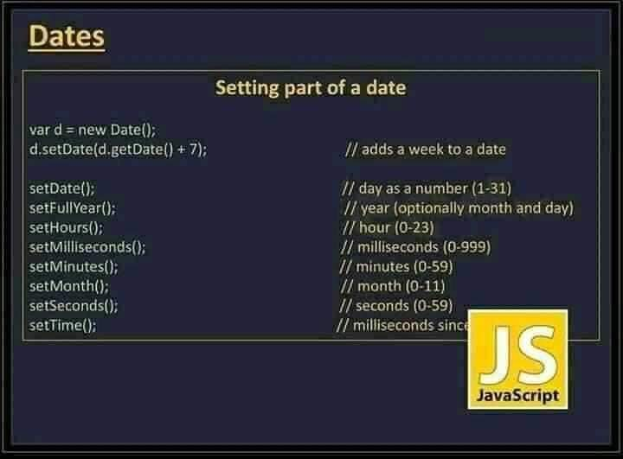

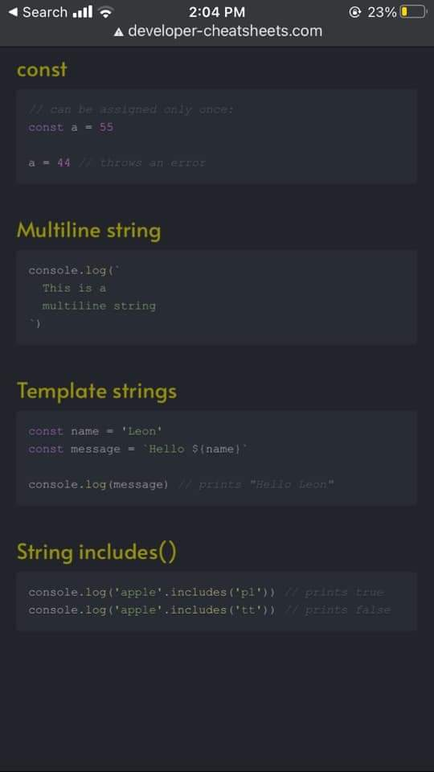

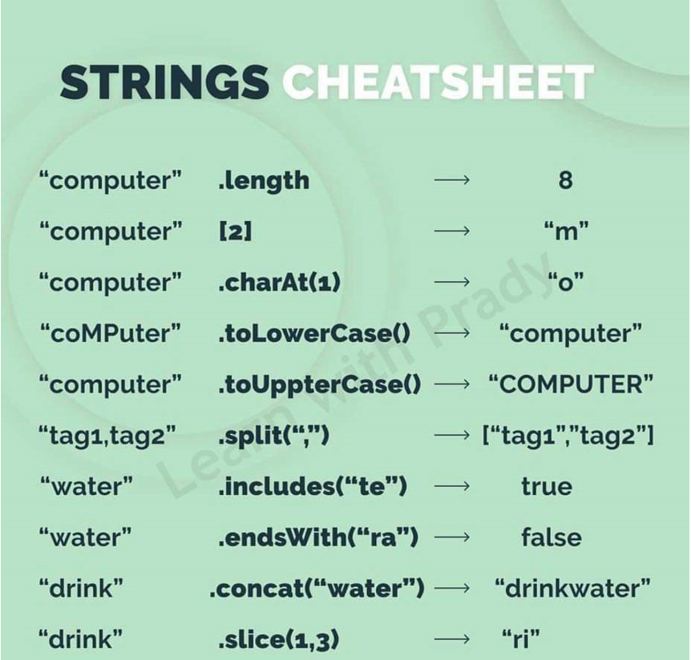

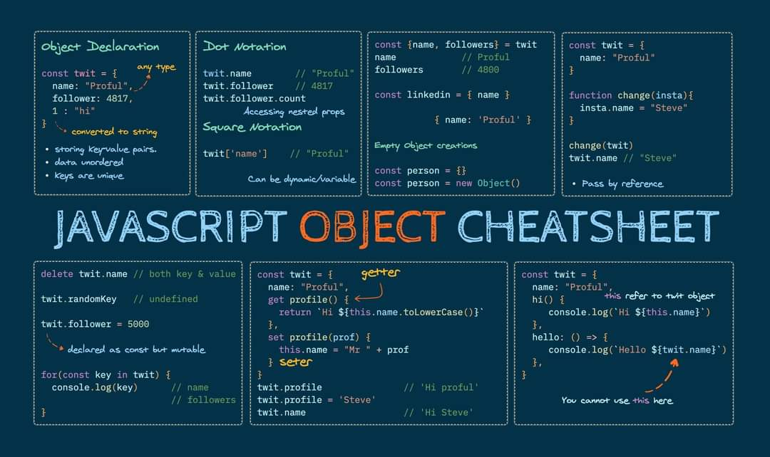

**LOOPS:**

The javaScript loop’s main task is to repeat a certain block of code until a certain condition is fully filled. As I already mentioned above 5 types of a loop which we will be going to discuss in detail.

