.

School of Computing

Department of Data Science

DATA VISUALIZATION
CERTIFICATE

This is to certify that the Cornerstone project work entitled “SPORTS PERFORMANCE ANALYTICS DASHBOARD” is submitted by

K Lakshmi Yojitha | (24B11DS102)
K Subha Sri | (24B11DS104)
P Hari Sandeep Kumar | (24B11DS158)
S Nishitha | (24B11DS199)

in partial fulfilment of the requirements for the award of the B.Tech. degree in Data Science for the academic year 2026-2027.

Project Guide Head of the Department
P. Srilatha Dr. M. Rajababu, Ph.D,
, Assistant Professor, Associate Professor & HOD
Department of IT&DS Department of IT&DS

DECLARATION

We hereby declare that the project entitled “SPORTS PERFORMANCE ANALYTICS DASHBOARD” is our original work and is submitted to ADITYA UNIVERSITY, Surampalem, in partial fulfillment of the requirements for the award of the B.Tech. degree in Data Science.
We further declare that this project work has not been submitted, either in full or in part, for the award of any degree or diploma in this or any other institution. We also confirm that this work has been carried out with academic honesty and complies with the Institutional Academic Integrity and AI Usage Policy.

Place:
Surampalem
Date:
By
K Lakshmi Yojitha | (24B11DS102)
K Subha Sri | (24B11DS104)
P Hari Sandeep Kumar | (24B11DS158)
S Nishitha | (24B11DS199)

ACKNOWLEDGEMENT

It is with immense pleasure that we express our sincere gratitude to our Cornerstone Project Guide, P. Srilatha, Assistant Professor, who has guided us throughout the project. Her valuable support, encouragement, and guidance have greatly contributed to the successful completion of this work.
We would like to thank our Deputy Heads of the Department, Dr. A. Lakshmana Rao, Associate Professor and Mrs S. Neelima, Assistant Professor, Department of IT & DS, for their support and valuable suggestions.
Our deepest thanks to our Head of the Department, Dr. M. Rajababu, Associate Professor & HOD, for her inspiration and for providing all the necessary facilities and resources required for this project.
We also extend our sincere thanks to Dr. M.V. Rajesh, Associate Dean, School of Computing, for his encouragement and support during our project.
We would like to express our sincere gratitude to Dr. G. Suresh, Registrar, Dr. A. Ramesh, Pro Vice-Chancellor (Engineering & Sciences), Dr. S. Rama Sree, Pro Vice-Chancellor (Academics), Dr. M.B. Srinivas, Vice-Chancellor, and Dr. M. Sreenivasa Reddy, Deputy Pro-Chancellor and Management, Aditya University, for providing excellent infrastructure and state-of-the-art laboratories.
Finally, we would like to thank the faculty members, lab technicians, non-teaching staff, and our friends who have directly or indirectly supported us in completing this Cornerstone project successfully.

ABSTRACT

SPORTS PERFORMANCE ANALYTICS DASHBOARD

Sports Performance Analytics Dashboard is an interactive data visualization project designed to analyze historical cricket data and provide meaningful insights into the performance of teams, players, matches, seasons, and venues. The project follows a systematic data analytics workflow involving data collection, cleaning, preprocessing, feature engineering, exploratory data analysis, and visualization. Python and Pandas are used for data preparation and statistical analysis, while Tableau is used to develop interactive dashboards for effective data exploration. The project is organized into three major dashboards: Tournament Overview, which provides an overall view of season-wise trends, team performance, top run scorers, top wicket-takers, and toss outcomes; Team & Player Performance, which enables comparison of teams and players based on wins, batting, bowling, and head-to-head performance; and Match & Venue Insights, which examines match outcomes, toss impact, scoring patterns, venue performance, and different match situations. Interactive filters allow users to explore the data across seasons, teams, players, and venues. The project demonstrates how large and complex cricket datasets can be transformed into clear, interactive, and meaningful visual insights to support effective sports performance analysis and data-driven understanding.

Table of contents

S.No. | Contents | Pages
1 | Title Page | i
2 | Certificate | ii
3 | Declaration | iii
4 | Acknowledgement | iv
5 | Abstract | v
6 | Table of Contents | vi
7 | List of Figures | vii
8 | List of Tables | viii
Chapter 1 | Introduction
1.1 | Introduction to the Project
1.2 | Problem Statement
1.3 | Objectives of the Project
1.4 | Scope of the Project
Chapter 2 | Dataset Description and Understanding
2.1 | Dataset Source
2.2 | Dataset Description
2.3 | Features / Attributes
2.4 | Dataset Statistics / Initial Exploration
Chapter 3 | Data Preprocessing
3.1 | Data Collection / Loading
3.2 | Handling Missing Values
3.3 | Handling Duplicate / Inconsistent Data
3.4 | Other Project-Specific Preprocessing
Chapter 4 | System Design and Methodology
4.1 | Proposed Methodology
4.2 | System Workflow / Architecture
4.3 | Flowchart
4.4 | Tools and Technologies Used
Chapter 5 | Implementation
5.1 | Development Environment
5.2 | Dataset Loading and Exploration
5.3 | Preprocessing Implementation
5.4 | Exploratory Data Analysis (EDA)
5.5 | Model / Analysis Implementation
5.6 | Important Code Explanation
Chapter 6 | Data Visualization and Results
6.1 | Bar charts
6.2 | Pie Chart
6.3 | Line charts
6.4 | Scatter Plot
6.5 | Multi-Line Chart
6.6 | Map, TreeMap, Heatmap
6.7 | KPI
6.8 | Interpretation of Visualizations
Chapter 7 | Model Evaluation / Analysis of Results
7.1 | Experimental Results
7.2 | Result Interpretation
7.3 | Discussion
Chapter 8 | Output Screenshots
8.1 | Input / Dataset Screenshots
8.2 | Preprocessing Outputs
8.3 | Visualization Outputs
Chapter 9 | Conclusion and Future Enhancements
9.1 | Conclusion
9.2 | Limitations
9.3 | Future Enhancements
10 | References
11 | Appendix – Source Code

- INTRODUCTION

  - Introduction to project
Sports Performance Analytics Dashboard is a data visualization project developed to analyze cricket performance using historical match data. It focuses on studying teams, players, matches, seasons, and venues through statistical analysis and interactive visualizations. Python and Pandas are used for data cleaning, preprocessing, and analysis, while Tableau is used to create an interactive dashboard. The dashboard provides insights into team win percentage, player performance, match outcomes, toss results, venue performance, and season-wise trends, helping transform complex cricket data into simple and meaningful visual insights.

  - Problem Statement
Cricket generates large volumes of match and player data, making it difficult to analyze raw records manually and identify important performance patterns. Team and player statistics, match outcomes, toss results, scoring patterns, and venue information need to be organized for effective comparison and analysis. Therefore, an interactive system is required to simplify cricket data analysis and present meaningful insights through clear and interactive visualizations. The project addresses this need by organizing cricket data into three dashboards covering Tournament Overview, Team & Player Performance, and Match & Venue Insights.

  - Objectives of the Project
The main objectives of the project are to:
- Analyze historical cricket data using Python and Pandas.
- Study team, player, match, season, and venue performance.
- Develop three interactive dashboards for comprehensive analysis.
- Compare teams and players using meaningful performance metrics.
- Present cricket data through clear and interactive visualizations.

  - Scope of the Project
The scope of the project is to analyze historical cricket data and provide interactive insights into teams, players, matches, seasons, and venues. The project covers three dashboards: Tournament Overview, Team & Player Performance, and Match & Venue Insights. It includes data preprocessing, performance comparison, trend analysis, toss analysis, and venue-based analysis using Python, Pandas, and Tableau. The system is intended to help users explore cricket performance through interactive filters and visualizations.

- DATA SET DESCRIPTION AND UNDERSTANDING

  - Dataset Source
The dataset used in this project is obtained from Cricsheet, an open cricket data source that provides detailed ball-by-ball and match information. The project uses the IPL dataset in the New CSV format, which contains historical match data including teams, players, deliveries, runs, wickets, venues, toss results, and match outcomes. This dataset is used for data preprocessing, analysis, and developing the three interactive Tableau dashboards.

  - Dataset Description
The dataset contains detailed IPL cricket match and ball-by-ball information used to analyze team, player, match, and venue performance. It includes information such as match details, teams, players, batting runs, bowling details, wickets, toss results, venues, and match outcomes. The data covers multiple IPL seasons and provides sufficient information for analyzing season-wise trends, team and player performance, toss impact, scoring patterns, and venue-based statistics. The dataset is processed using Python and Pandas before being used to create the three interactive Tableau dashboards.

  - Features/Attributes
The main features/attributes used in the project include:
- Match ID and Date – Identifies each match and its date.
- Season – Indicates the IPL season.
- Teams – Records the participating teams.
- Players – Contains batsmen, bowlers, and other players involved.
- Venue – Specifies the location where the match was played.
- Toss Details – Includes toss winner and decision.
- Runs and Wickets – Records batting scores and wickets taken.
- Overs and Deliveries – Provides ball-by-ball match information.
- Match Result – Contains the winning team and match outcome.
2.4 Dataset Statistics / Initial Exploration
The dataset is initially explored to understand its size, structure, seasons, teams, players, venues, and match records. Basic statistical analysis is performed using Python and Pandas to identify the number of matches, unique teams and players, missing values, and important performance variables. This initial exploration helps understand the dataset and prepares it for further preprocessing, analysis, and visualization.

- DATA PREPROCESSING

  - Data Collection / Loading
The IPL dataset is collected from Cricsheet in the New CSV format and loaded into Python using the Pandas library. The dataset files are examined to understand their structure, columns, data types, and available match records. The required data is then organized and prepared for further preprocessing, feature engineering, analysis, and visualization.

3.2 Handling Missing Values
Missing values in the IPL dataset are identified during the preprocessing stage using Python and Pandas. Required fields are checked for null or empty values, and appropriate handling is applied based on the nature of the data. This ensures that the dataset is clean and suitable for accurate analysis and visualization.

  - Handling Duplicate / Inconsistent Data
The dataset is checked for duplicate records and inconsistencies during the preprocessing stage. Duplicate entries are identified and removed where necessary, while inconsistent values in fields such as team names, player names, venues, and match details are standardized. This helps maintain data consistency and improves the accuracy of the analysis and visualizations.
3.4 Other Project-Specific Preprocessing
Project-specific preprocessing is performed to prepare the cricket data for analysis and visualization. Relevant match and ball-by-ball information is organized into suitable tables, and useful attributes such as runs, wickets, overs, win percentage, toss outcomes, and player performance statistics are derived. The processed data is then structured for creating the three Tableau dashboards and applying interactive filters.

- SYSTEM DESIGN AND METHODOLOGY

4.1 Proposed Methodology
The proposed methodology involves collecting historical IPL data from Cricsheet, loading and preprocessing it using Python and Pandas, and performing exploratory analysis to identify useful performance patterns. Relevant features and performance metrics are derived from the processed data. The analyzed data is then integrated into Tableau to create three interactive dashboards: Tournament Overview, Team & Player Performance, and Match & Venue Insights. Interactive filters and visualizations are used to explore the data and present meaningful insights about cricket performance.

4.2 System Workflow / Architecture
The system follows a sequential workflow that transforms raw cricket data into meaningful interactive visualizations. The process begins with collecting the IPL dataset from Cricsheet and continues through data loading, cleaning, preprocessing, feature engineering, and exploratory analysis. The processed data is then integrated into Tableau for dashboard development. The overall workflow of the proposed system is shown below:

IPL Dataset (Cricsheet)
↓
Data Collection & Loading
↓
Data Cleaning & Preprocessing
↓
Feature Engineering & Metric Calculation
↓
Exploratory Data Analysis
↓
Processed Data Integration into Tableau
↓
Dashboard Development
↓
Tournament Overview
Team & Player Performance
Match & Venue Insights

↓
Interactive Analysis & Insights

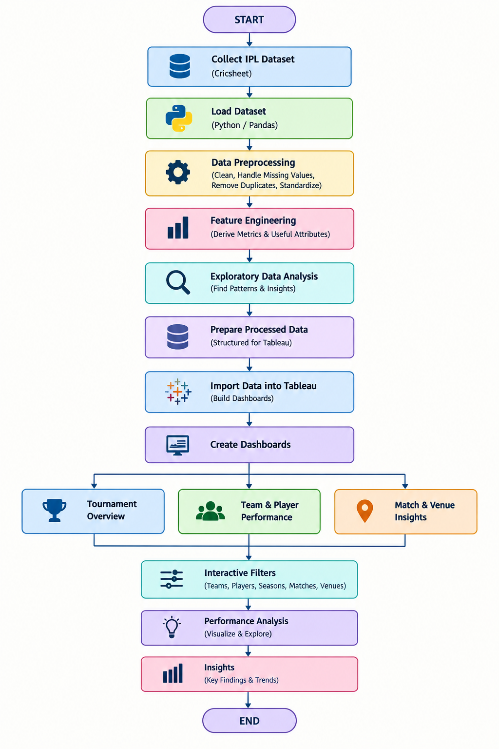
4.3 Flowchart

4.4 Tools and Technologies

- Python – Used for data processing and analysis.
- Pandas – Used for data loading, cleaning, and preprocessing.
- NumPy – Used for numerical calculations and data manipulation.
- Matplotlib – Used for exploratory data visualization.
- Tableau Public – Used for creating interactive dashboards and visualizations.
- VS Code (Visual Studio Code) – Used as the Python development environment.
- Cricsheet – Used as the source of IPL cricket data.
- CSV (Comma-Separated Values) – Used for storing and exchanging dataset files.

- IMPLEMENTATION

  - Development Environment
The project is developed using Python in Visual Studio Code (VS Code) for data loading, preprocessing, and analysis. Pandas and NumPy are used for data manipulation and calculations, while Matplotlib is used for exploratory visualization. Tableau Public is used to create the final interactive dashboards. The project uses the Cricsheet IPL dataset in New CSV format as the primary data source.

  - Dataset Loading and Exploration
The IPL dataset obtained from Cricsheet is loaded into Python using the Pandas library. The dataset is examined to understand its structure, columns, data types, and available records. Initial exploration is performed to identify the number of matches, teams, players, seasons, venues, and other important attributes. This step helps understand the dataset and prepares it for further preprocessing and analysis.

  - Preprocessing Implementation
The collected IPL data is preprocessed using Python and Pandas to make it suitable for analysis and visualization. The preprocessing includes handling missing values, removing duplicate or inconsistent records, standardizing relevant fields, and organizing match and ball-by-ball data. Additional performance attributes such as runs, wickets, win percentage, toss outcomes, and player statistics are derived. The resulting clean and structured data is then prepared for exploratory analysis and integration with Tableau

  - Exploratory Data Analysis (EDA)
Exploratory Data Analysis (EDA) is performed to understand the patterns and trends present in the IPL dataset before creating the final dashboards. The analysis focuses on season-wise match trends, team performance, player statistics, toss outcomes, scoring patterns, match results, and venue performance. Different statistical summaries and visualizations are used to identify important relationships and variations in the data. The findings from EDA help in selecting relevant features and performance metrics for the three Tableau dashboards: Tournament Overview, Team & Player Performance, and Match & Venue Insights.

  - Model / Analysis Implementation
Since the project is focused on data visualization and cricket performance analysis, no machine learning model is used. Instead, statistical and analytical techniques are applied to the preprocessed IPL dataset. The analysis calculates important performance measures such as total runs, wickets, batting performance, bowling performance, win percentage, toss outcomes, scoring patterns, and venue statistics. Season-wise and team-wise comparisons are performed to identify performance trends and variations. Player-level analysis is used to identify top run scorers, wicket-takers, and other performance patterns. Match-level analysis is used to study winning teams, toss decisions, chasing performance, and scoring behavior. Venue-level analysis examines match results and performance across different grounds. The calculated measures are organized into suitable datasets and integrated with Tableau, where they are used to create the three dashboards: Tournament Overview, Team & Player Performance, and Match & Venue Insights. Interactive filters allow users to analyze the results based on season, team, player, venue, and other relevant dimensions.

  - Important Code Explanation
The Python code is used to load, clean, process, and analyze the IPL dataset. Pandas is used to read CSV files, handle missing values, remove duplicates, and organize the data. Calculations are performed to obtain runs, wickets, win percentage, toss results, and player performance. The processed data is then prepared for exploratory analysis and Tableau dashboard development.

- DATA VISUALIZATION AND RESULTS

  - Bar Charts – Performance and Ranking Analysis
Bar charts are used to compare different cricket performance metrics clearly. In this project, they are used to analyze Phase Run Rates, Team Win Percentage, Top Run Scorers, Top Wicket Takers, Economy Leaders, and Top Venues. An interactive Season filter is provided to allow users to view and compare these performance metrics for different IPL seasons. These visualizations make it easier to identify important team, player, scoring, bowling, and venue-wise patterns.

6.2 Pie Chart – Toss Decisions
The pie chart represents the distribution of toss decisions made by teams, such as batting first or fielding first. It helps understand the preference of teams after winning the toss. An interactive Season filter allows users to view the toss decision distribution for different IPL seasons.

6.3 Line Charts – Season and Team Trends
Line charts are used to analyze changes and trends over different IPL seasons. In this project, they are used to represent Runs per Season and Team Trends Over Time. An interactive Season filter allows users to explore the data for selected seasons and compare performance trends.

6.4 Scatter Plot – Economy vs Wickets
The scatter plot is used to analyze the relationship between bowling economy and wickets taken by players. It helps identify patterns between bowling efficiency and wicket-taking performance. An interactive Season filter allows users to explore the relationship for different IPL seasons.

6.5 Multi-Line Chart – Team Trends Over Time
The multi-line chart is used to compare team performance trends across different IPL seasons. Each line represents a team, making it easier to observe changes in performance over time. An interactive Season filter allows users to explore selected seasons and compare team trends.

6.6 Map – Venue Distribution
The map visualization is used to show the geographical distribution of IPL venues. It helps identify the locations where matches are played and understand the distribution of venues across different regions. An interactive Season filter allows users to explore venue distribution for selected IPL seasons.

6.6.1 Tree Map – Player Batting Contribution
The tree map is used to represent player batting contribution based on total runs scored. The size of each block represents the player's total runs, while the grouping helps compare batting contributions across teams. An interactive Season filter allows users to explore player contributions for different IPL seasons.

6.6.2 Heat Map – Team vs Team Head-to-Head
The heat map is used to compare team performance in head-to-head matches. Teams are displayed against their opponents, and the color intensity represents the number of wins. This visualization helps identify team-wise performance patterns against different opponents. An interactive Season filter allows users to explore head-to-head performance across different IPL seasons.

6.7 KPI Cards – Key Performance Indicators
The KPI cards provide a quick summary of the overall IPL dataset. The dashboard displays Total Matches, Total Deliveries, Total Runs, and Total Wickets to represent the scale of match activity, deliveries, scoring, and wicket-taking performance. The KPIs show 1,243 matches, 295,732 deliveries, 381,529 total runs, and 14,705 wickets. An interactive Season filter allows users to view these KPI values for different IPL seasons.

6.8 Interpretation of Visualizations
The visualizations help us understand the IPL data in a simple and clear way. Bar charts are used to compare teams, players, run rates, wickets, economy, and venues. Pie charts show the distribution of toss decisions, such as batting or fielding first. Line charts show how runs and team performance change across different seasons. The scatter plot helps understand the relationship between a bowler’s economy and wickets taken. The multi-line chart allows comparison of different teams across seasons. The map shows the geographical locations of IPL venues. The tree map highlights player batting contribution based on total runs, while the heat map helps compare team performance against different opponents. The Season filter allows users to select a particular IPL season and view the corresponding results. Overall, these visualizations make it easier to compare performances, identify trends, and understand important patterns in IPL cricket data.

- MODEL EVALUATION / ANALYSIS OF RESULTS

7.1 Experimental Results
The developed IPL Analytics Dashboard successfully presents IPL data through interactive visualizations, covering 1,243 matches, 295,732 deliveries, 381,529 runs, and 14,705 wickets. The visualizations show season-wise run trends, toss decisions, team win percentages, top run scorers, top wicket-takers, bowling economy, phase-wise run rates, team trends, venue statistics, player batting contribution, and team head-to-head performance. The dashboard shows that fielding was selected more often than batting after winning the toss. The scatter plot compares bowling performance, while the tree map shows player batting contribution and the heat map compares team performance against different opponents. Interactive Season filters allow users to explore selected seasons and understand IPL performance clearly.

7.2 Result Interpretation
The results show different patterns in team, player, match, and venue performance. Season-wise charts show scoring changes, while team and player visualizations highlight performance differences. Toss analysis shows batting and fielding decisions, and bowling charts compare economy and wicket-taking performance. The tree map highlights player batting contribution, while the heat map compares team performance against different opponents. Overall, the dashboard makes large IPL datasets easier to compare, understand, and explore using interactive visualizations and Season filters.

7.3 Discussion
The developed dashboard provides a simple way to analyze team, player, match, season, and venue performance. The visualizations make it easier to compare performances, identify scoring and bowling patterns, study toss decisions, and observe changes across seasons. The tree map compares player batting contributions, while the heat map helps analyze team performance against different opponents. Interactive Season filters allow users to explore specific seasons quickly. Overall, the project shows how data visualization can transform large cricket datasets into clear, useful, and easy-to-understand insights.

- OUTPUT SCREENSHOTS

8.1 Input / Dataset Screenshots
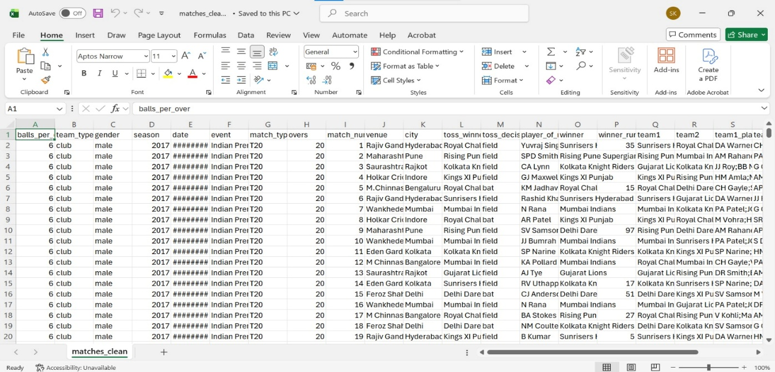
The project uses the IPL dataset from Cricsheet, containing matches, teams, players, venues, runs, wickets, and deliveries.
Fig 8.1.1 Input dataset
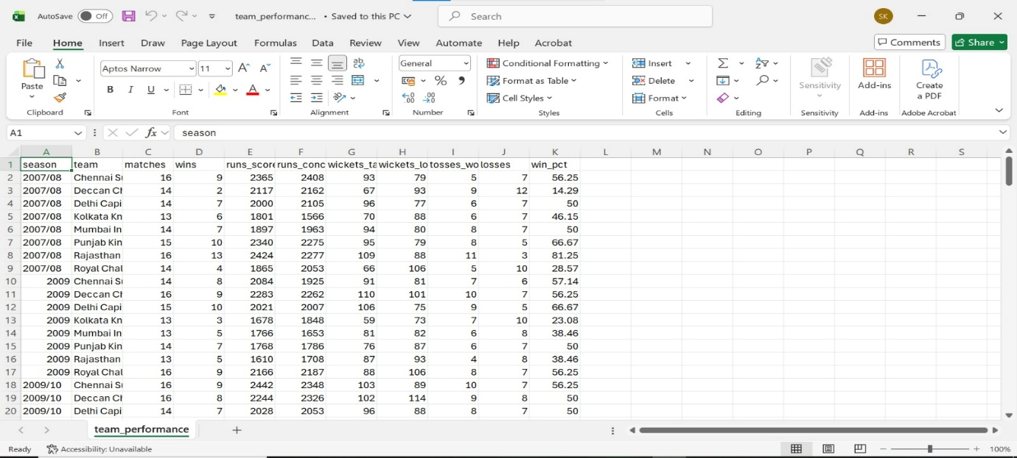

Fig 8.1.2 Input dataset

8.2 Preprocessing Outputs
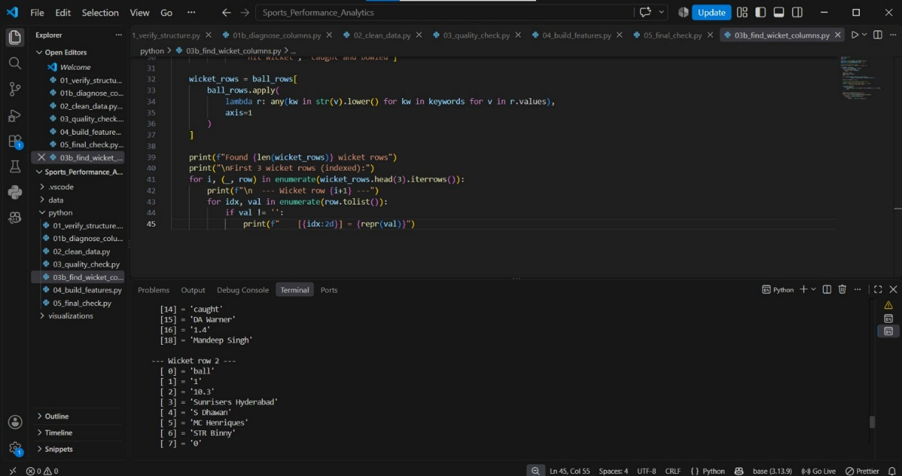
The preprocessing output contains cleaned and organized IPL data after handling missing values, duplicates, and inconsistent records. The processed data is prepared for analysis and Tableau dashboard development.
Fig 8.2.1

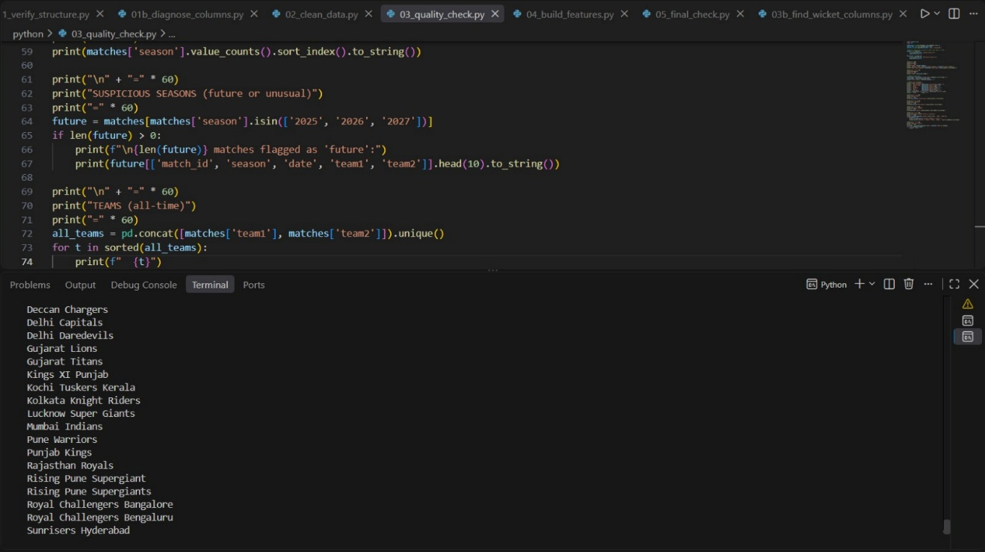
Fig 8.2.2

8.3 Visualization Outputs
The processed IPL data is presented through interactive Tableau visualizations, including bar charts, pie charts, line charts, scatter plots, multi-line charts, tree maps, heat maps, and venue maps. These visualizations help analyze team, player, season, match, and venue performance.
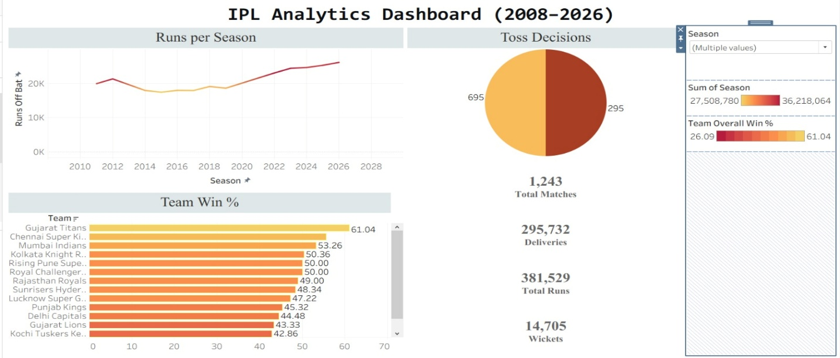

Fig 8.3.1 Tournament Overview Dashboard

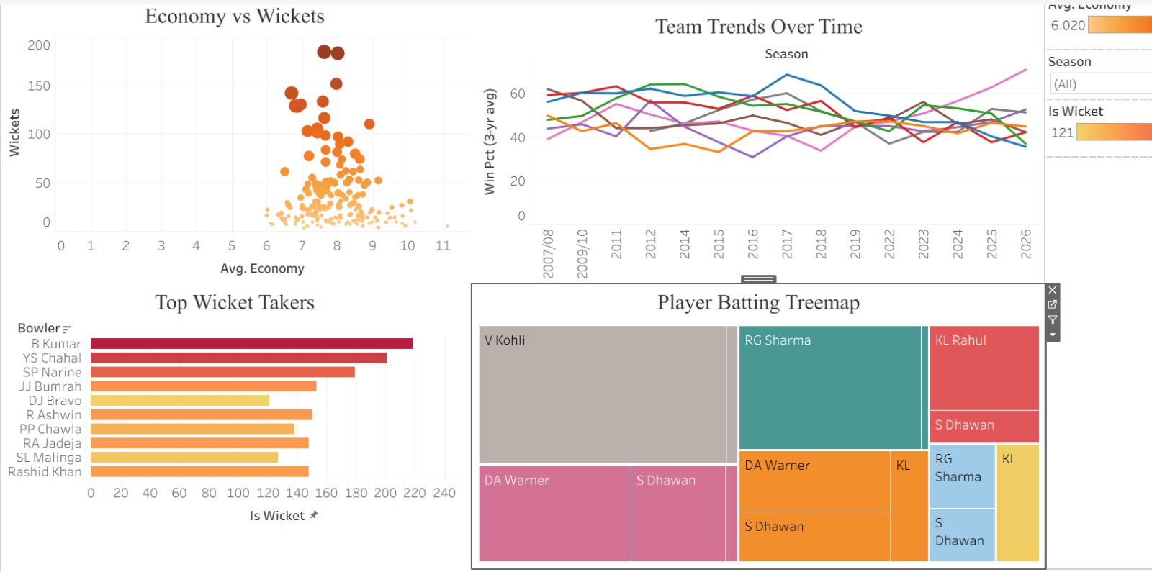
Fig 8.3.2 Team & player performance Dashboard

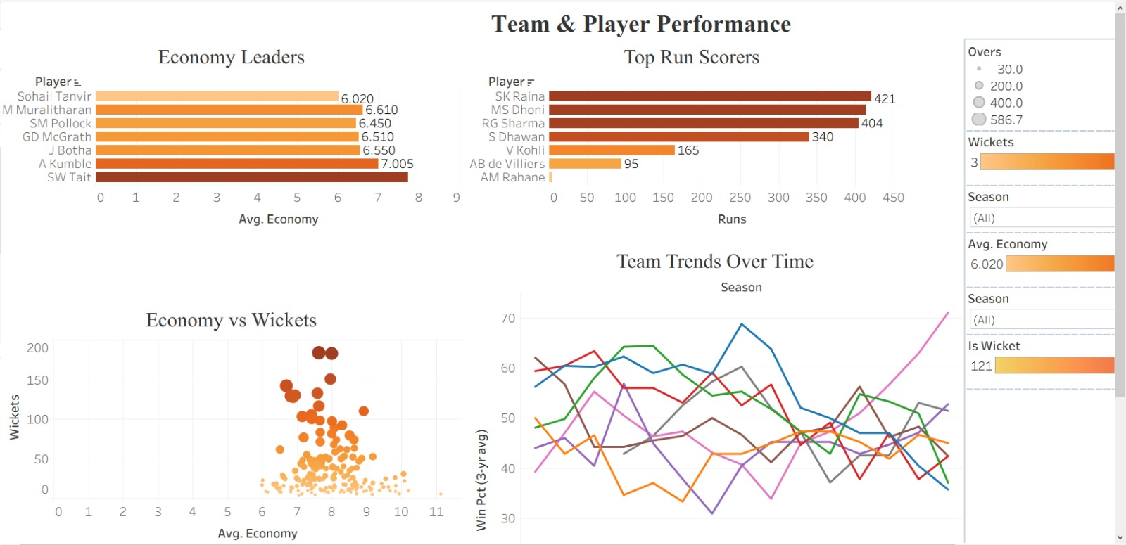
Fig 8.3.3 Team & Player performance

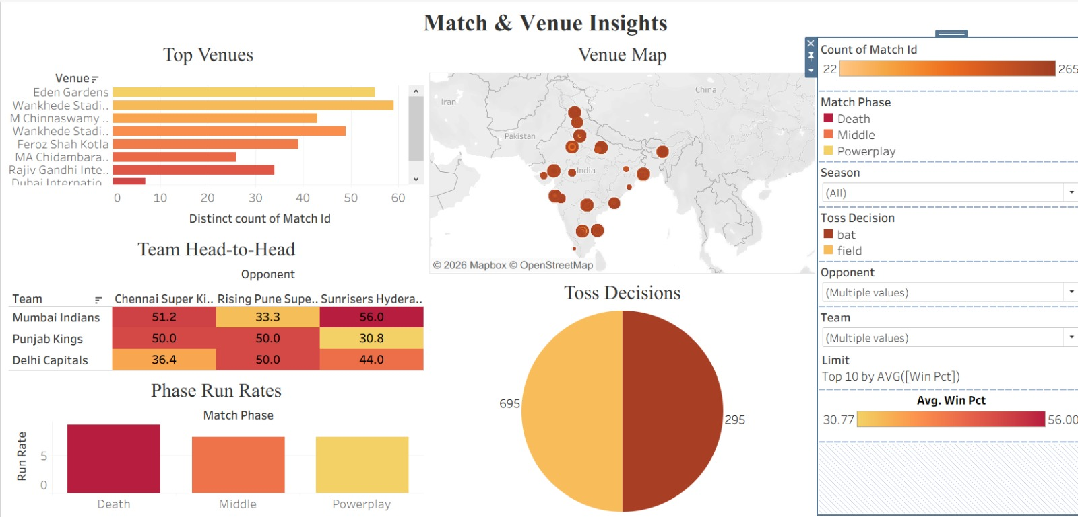
Fig 8.3.4 Match & Venue Insights Dashboard

- CONCLUSION AND FUTURE ENHANCEMENTS

  - Conclusion
The Sports Performance Analytics Dashboard successfully analyzes historical IPL data using Python, Pandas, NumPy, Matplotlib, and Tableau Public. The project provides three interactive dashboards covering Tournament Overview, Team & Player Performance, and Match & Venue Insights, which analyze team and player performance, match results, toss decisions, scoring patterns, bowling performance, season trends, venue statistics, and head-to-head team performance using bar charts, pie charts, line charts, scatter plots, tree maps, heat maps, and maps. Interactive Season filters help users compare different IPL seasons and identify important performance patterns. Overall, the project converts complex IPL data into clear, interactive, and meaningful visual insights.
9.2 Limitations
- Uses historical IPL data and does not provide real-time updates.
- Depends on the quality and completeness of the Cricsheet dataset.
- Focuses only on IPL cricket.
- Provides descriptive analysis, not predictions.
- Large datasets may require higher processing resources.
- Uses a fixed set of visualizations and metrics.

9.3 Future Enhancements
- Add real-time IPL match data and live performance updates.
- Include more detailed player and team performance analysis.
- Extend the dashboard to cover other cricket tournaments and formats.
- Add advanced player comparison and performance tracking features.
- Introduce machine learning-based prediction features for future performance analysis.
- Add more interactive filters and customized visualizations.
- Integrate additional cricket data sources to improve the depth and accuracy of analysis.

- REFERENCES

- Cricsheet – Cricket Data
https://cricsheet.org/
- Cricsheet – IPL Dataset Downloads
https://cricsheet.org/downloads/
- Python – Official Documentation
https://docs.python.org/3/
- Pandas – Official Documentation
https://pandas.pydata.org/docs/
- NumPy – Official Documentation
https://numpy.org/doc/
- Matplotlib – Official Documentation
https://matplotlib.org/stable/
- Tableau Public – Data Visualization Platform
https://public.tableau.com/
- Visual Studio Code – Official Documentation
https://code.visualstudio.com/docs

- APPENDIX – SOURCE CODE

Ball-by-Ball Data Inspection Code
import pandas as pd
import glob
import os
SCRIPT_DIR = os.path.dirname(os.path.abspath(__file__))
PROJECT_ROOT = os.path.dirname(SCRIPT_DIR)
RAW_DIR = os.path.join(PROJECT_ROOT, "data", "raw")
# Pick one NEW file (2023) and one OLD file (2008)
new_file = os.path.join(RAW_DIR, "1082591.csv") # 2023
old_file = os.path.join(RAW_DIR, "335982.csv") # 2008
for label, f in [("NEW (2023)", new_file), ("OLD (2008)", old_file)]:
if not os.path.exists(f):
print(f"❌ {label}: file missing: {f}")
continue
print(f"\n{'='*60}")
print(f"{label}: {os.path.basename(f)}")
print('='*60)
df = pd.read_csv(f, header=None, names=range(30),
low_memory=False, dtype=str)
# Get first 3 ball rows
balls = df[df[0] == 'ball'].head(3)
for idx, row in balls.iterrows():
print(f"\nBall row (file line {idx+1}):")
for i, val in enumerate(row.tolist()):
if pd.notna(val):
print(f" [{i:2d}] = {repr(val)}")
Wicket Data Inspection Code
import pandas as pd
import glob
import os
SCRIPT_DIR = os.path.dirname(os.path.abspath(__file__))
PROJECT_ROOT = os.path.dirname(SCRIPT_DIR)
RAW_DIR = os.path.join(PROJECT_ROOT, "data", "raw")
# Look at files we know have wickets
test_files = ["335982.csv", "335983.csv", "1082591.csv"]
for filename in test_files:
fpath = os.path.join(RAW_DIR, filename)
if not os.path.exists(fpath):
print(f"❌ Missing: {filename}")
continue
print(f"\n{'='*70}")
print(f"FILE: {filename}")
print('='*70)
df = pd.read_csv(fpath, header=None, names=range(25),
dtype=str, low_memory=False, keep_default_na=False)
ball_rows = df[df[0] == 'ball']
# Show only rows that have MORE than 21 fields filled
# or where some field has a dismissal keyword
keywords = ['caught', 'bowled', 'lbw', 'run out', 'stumped',
'hit wicket', 'caught and bowled']
wicket_rows = ball_rows[
ball_rows.apply(
lambda r: any(kw in str(v).lower() for kw in keywords for v in r.values),
axis=1
)]
print(f"Found {len(wicket_rows)} wicket rows")
print("\nFirst 3 wicket rows (indexed):")
for i, (_, row) in enumerate(wicket_rows.head(3).iterrows()):
print(f"\n --- Wicket row {i+1} ---")
for idx, val in enumerate(row.tolist()):
if val != '':
print(f" [{idx:2d}] = {repr(val)}")

