

School of Computing

Department of Data Science

DATA VISUALIZATION
CERTIFICATE
This is to certify that the Cornerstone project work entitled “Global Military Fire Power Analysis” is submitted by

G. Bhanu Teja | 24B11DS072
A. Madhan | 24B11DS002
M. Chethan | 24B11DS128
K. Durga | 25B21DS008
in partial fulfilment of the requirements for the award of the B.Tech. degree in Data Science for the academic year 2026-2027.

Project Guide Head of the Department
P. Srilatha, M.Tech., (Ph.D) Dr. M. Rajababu, Ph.D,
Assistant Professor, Associate Professor & HOD
Department of IT&DS Department of IT&DS

DECLARATION
We hereby declare that the project entitled “Global Military Firepower Analysis” is our original work and is submitted to ADITYA UNIVERSITY, Surampalem, in partial fulfillment of the requirements for the award of the B.Tech. degree in Data Science.
We further declare that this project work has not been submitted, either in full or in part, for the award of any degree or diploma in this or any other institution. We also confirm that this work has been carried out with academic honesty and complies with the Institutional Academic Integrity and AI Usage Policy.

Place: Surampalem
Date:

By
G. Bhanu Teja | 24B11DS072
A. Madhan | 24B11DS002
M. Chethan | 24B11DS128
K. Durga | 25B21DS008

ACKNOWLEDGEMENT
It is with immense pleasure that we express our sincere gratitude to our Cornerstone Project Guide, P. Srilatha, Assistant Professor, who has guided us throughout the project. Her valuable support, encouragement, and guidance have greatly contributed to the successful completion of this work.
We would like to thank our Deputy Heads of the Department, Dr. A. Lakshmana Rao, Associate Professor and Mrs S. Neelima, Assistant Professor, Department of IT & DS, for their support and valuable suggestions.
Our deepest thanks to our Head of the Department, Dr. M. Rajababu, Associate Professor & HOD, for his inspiration and for providing all the necessary facilities and resources required for this project.
We also extend our sincere thanks to Dr. M.V. Rajesh, Associate Dean, School of Computing, for his encouragement and support during our project.
We would like to express our sincere gratitude to Dr. G. Suresh, Registrar, Dr. A. Ramesh, Pro Vice-Chancellor (Engineering & Sciences), Dr. S. Rama Sree, Pro Vice-Chancellor (Academics), Dr. M.B. Srinivas, Vice-Chancellor, and Dr. M. Sreenivasa Reddy, Deputy Pro-Chancellor and Management, Aditya University, for providing excellent infrastructure and state-of-the-art laboratories.
Finally, we would like to thank the faculty members, lab technicians, non-teaching staff, and our friends who have directly or indirectly supported us in completing this Cornerstone project successfully.

ABSTRACT
GLOBAL MILITARY FIREPOWER ANALYSIS
The Global Military Firepower Analysis is an interactive data visualization project that analyses the Global Military Firepower 2025 dataset, covering 145 countries and 57 assessment factors. The dataset describes demographics and manpower, financial indicators, air, land and naval hardware, logistics, geography and natural-resource consumption. The project follows a systematic analytics workflow: data collection, cleaning and preprocessing in Microsoft Excel and Power Query, pivot-table based summarization, and dashboard development in Microsoft Power BI Desktop.
Twelve pivot tables summarize country-wise and region-wise aircraft, population and manpower, naval fleet, submarines, destroyers, rocket projectors, sea and land coverage, and coal, natural gas and oil consumption. These are presented through two interactive Power BI dashboard pages. The first page contains a country-wise aircraft bar chart, a military manpower versus total population column chart, a natural gas consumption donut chart, a coal consumption pie chart and a multi-line chart of destroyers, rocket projectors, submarines and total naval fleet. The second page contains a land-coverage map, KPI cards for military strength, foreign exchange, defence budget and water coverage, and a gauge chart for trainer aircraft, aircraft carriers and attack aircraft. Region slicers (Africa, Asia, Europe, North America, Oceania and South America) allow users to filter every visual.
The project shows how large, multi-dimensional defence data can be converted into clear and interactive visual insights that support comparison of military capability, regional strength and resource dependence across nations.

TABLE OF CONTENTS
CERTIFICATE | i
DECLARATION | ii
ACKNOWLEDGEMENT | iii
ABSTRACT | Iv
TABLE OF CONTENTS | 1
LIST OF FIGUERS | 3
CHAPTER 1: INTRODUCTION | 3
1.1 Introduction to the Project | 3
1.2 Problem Statement | 3
1.3 Objectives of the Project | 3
1.4 Scope of the Project | 3
CHAPTER 2: DATASET DESCRIPTION AND UNDERSTANDING | 5
2.1 Dataset Source | 5
2.2 Dataset Description | 5
2.3 Features / Attributes Used in the Dashboard | 6
2.4 Dataset Statistics / Initial Exploration | 6
CHAPTER 3: DATA PREPROCESSING | 7
3.1 Data Collection / Loading | 7
3.2 Handling Missing Values | 7
3.3 Handling Duplicate / Inconsistent Data | 7
3.4 Other Project-Specific Preprocessing | 7
CHAPTER 4: SYSTEM DESIGN AND METHODOLOGY | 8
4.1 Proposed Methodology | 8
4.2 System Workflow / Architecture | 8
4.3 Flowchart | 8
4.4 Tools and Technologies Used | 9
4.5 Software and Hardware Requirements | 10
CHAPTER 5: IMPLEMENTATION | 11
5.1 Development Environment | 11
5.2 Dataset Loading and Exploration | 11
5.3 Preprocessing Implementation | 11
5.4 Pivot Table Creation (Exploratory Data Analysis) | 11
5.5 Dashboard Implementation in Power BI | 17
5.6 Important Calculations | 17
CHAPTER 6: DATA VISUALIZATION AND RESULTS | 18
6.1 Bar Chart – Country-wise Aircraft | 18
6.2 Column Chart – Military Manpower vs Total Population | 18
6.3 Donut Chart – Natural Gas Consumption | 19
6.4 Pie Chart – Coal Consumption | 19
6.5 Line Chart – Destroyers, Rocket Projectors, Submarines and Total Naval Fleet | 20
6.6 Map – Land Coverage Area of Countries | 20
6.7 KPI Cards – Key Performance Indicators | 21
6.8 Gauge Chart – Trainer Aircraft, Aircraft Carriers and Attack Aircraft | 22
6.9 Region Slicers | 23
6.10 Interpretation of Visualizations | 23
CHAPTER 7: ANALYSIS OF RESULTS | 24
7.1 Experimental Results | 24
7.2 Result Interpretation | 24
7.3 Discussion | 24
CHAPTER 8: OUTPUT SCREENSHOTS | 25
8.1 Input / Dataset Screenshots | 25
8.2 Visualization Outputs | 26
CHAPTER 9: CONCLUSION AND FUTURE ENHANCEMENTS | 27
9.1 Conclusion | 27
9.2 Limitations | 27
9.3 Future Enhancements | 27
REFERENCES | 30

LIST OF FIGUERS
Fig No. | Caption / Title | Page No.
Fig 1.1 | Raw dataset – Excel view (remaining columns) | Page 7
Fig 2.1 | Project flowchart | Page 9
Fig 3.1 | PT 1 – Country-wise Aircraft (pivot table) | Page 13
Fig 3.2 | PT 2 – Region-wise Population and Manpower (pivot table) | Page 13
Fig 3.3 | PT 3 – Region-wise Aircraft (pivot table) | Page 13
Fig 3.4 | PT 4 – Asia – Country-wise Population and Military (pivot table) | Page 14
Fig 3.5 | PT 5 – Country-wise Attack Aircraft (pivot table) | Page 14
Fig 3.6 | PT 6 – Country-wise Naval Fleet (pivot table) | Page 15
Fig 3.7 | PT 7 – Country-wise Military Data (pivot table) | Page 15
Fig 3.8 | PT 8 – Country-wise Sea Coverage (pivot table) | Page 16
Fig 3.9 | PT 9 – Country-wise Land Coverage (pivot table) | Page 16
Fig 3.10 | PT 10 – Country-wise Coal Data (pivot table) | Page 17
Fig 3.11 | PT 11 – Country-wise Natural Gas Consumption (pivot table) | Page 17
Fig 3.12 | PT 12 – Country-wise Oil Consumption (pivot table) | Page 17
Fig 4.1 | Country Wise Aircraft chart | Page 19
Fig 4.2 | Military Manpower vs Total Population chart | Page 19
Fig 4.3 | Natural Gas Consumption donut chart | Page 20
Fig 4.4 | Coal Consumption pie chart | Page 20
Fig 4.5 | Naval multi-line chart | Page 21
Fig 4.6 | Land Coverage map | Page 21
Fig 4.7 | Military Strength KPI card | Page 22
Fig 4.8 | Foreign Exchange KPI card | Page 22
Fig 4.9 | Defence Budget KPI card | Page 22
Fig 4.10 | Water Coverage KPI card | Page 23
Fig 4.11 | Gauge chart | Page 23
Fig 4.12 | Region slicer buttons | Page 24
Fig 5.1 | Input dataset | Page 26
Fig 5.2 | Dashboard Page 1 – full view | Page 27
Fig 5.3 | Dashboard Page 2 – full view | Page 27

CHAPTER 1: INTRODUCTION

1.1 Introduction to the Project
Global defence capability is determined by many interacting factors: population and manpower, active and reserve forces, air, land and naval hardware, financial strength, geography and access to energy resources. Raw datasets with hundreds of rows and dozens of columns are hard to interpret in tabular form. The Global Military Power Analytical Dashboard converts the Global Military Firepower 2025 dataset into a set of interactive visualizations built with Microsoft Excel pivot tables and Microsoft Power BI.
The dashboard lets analysts, students and decision-makers compare countries and regions, identify leaders in each military domain and understand how resource consumption relates to military scale.

1.2 Problem Statement
In the modern geopolitical landscape, military power is determined not merely by raw troop counts, but by how nations combine manpower, technology, naval and air capability, finances and natural resources. Raw datasets and surface-level rankings fail to reveal per-capita militarization, domain specialization and regional concentration of power. Without an interactive visualization system, evaluating military readiness, force allocation and resource dependence across nations remains fragmented and opaque. This project addresses the need by building an interactive dashboard that makes these comparisons simple and visual.

1.3 Objectives of the Project
- To clean and preprocess the Global Military Firepower 2025 dataset, including removal of duplicate country entries and validation of data types.
- To create pivot tables in Excel that summarize the data by country and by region.
- To design interactive Power BI dashboards using map, bar, column, line, pie, donut, gauge and KPI-card visuals.
- To provide region-wise slicers so that every visual can be filtered interactively.
- To derive insights on global military strength, regional dominance, naval and air capability and energy consumption.

1.4 Scope of the Project
The project covers 145 countries across six regions (Africa, Asia, Europe, North America, Oceania and South America). It includes data cleaning, twelve pivot-table summaries and two dashboard pages. The analysis is descriptive and uses a single-year (2025) snapshot of the dataset; it does not include forecasting or machine-learning models.

CHAPTER 2: DATASET DESCRIPTION AND UNDERSTANDING

2.1 Dataset Source
The dataset used is the Global Military Firepower 2025 dataset (global_military_firepower_2025.xlsx), derived from the Global Firepower (GFP) 2025 ranking available at globalfirepower.com. It is provided as an Excel workbook.

2.2 Dataset Description
The dataset contains 145 rows (one per country) and 57 columns (assessment factors) covering military, economic and logistical capabilities. The columns can be grouped into the following categories.
Category | Attributes
Demographics & Manpower | Total population, total military manpower, fit for service, annual military-age population, active personnel, reserve personnel, paramilitary forces
Financial Indicators | Defence budget (USD), external debt, purchasing power parity (PPP), foreign exchange and gold reserves
Air Power | Total military aircraft, fighter, attack, transport, trainer, special-mission and tanker aircraft, total helicopters, attack helicopters
Land Power | Tanks, armored fighting vehicles, self-propelled artillery, towed artillery, rocket projectors
Naval Power | Total naval fleet, fleet tonnage, aircraft carriers, helicopter carriers, submarines, destroyers, frigates, corvettes, coastal patrol craft, mine-warfare craft
Logistics & Geography | Serviceable airports, labor force, ports and terminals, merchant marine, railway and roadway coverage, land area, coastline, shared borders
Natural Resources | Production, consumption and proven reserves of oil, natural gas and coal

2.3 Features / Attributes Used in the Dashboard
Attribute | Used For
country, region | Grouping, map and region slicers
total_population, total_military_manpower | Manpower vs population chart; Military Strength KPI
fighter_aircraft, attack_aircraft, trainer_aircraft, aircraft_carriers | Aircraft bar chart and gauge chart
destroyers, rocket_projectors, submarines, total_naval_fleet | Multi-line naval chart
land coverage, water (sea) coverage | Land-coverage map; Water Coverage KPI
defence budget, foreign exchange reserves | Defence Budget and Foreign Exchange KPIs
coal_consumption_mt, natural_gas_consumption_cum, oil consumption | Pie chart, donut chart and pivot tables

2.4 Dataset Statistics / Initial Exploration
The workbook contains 145 countries and 57 attributes. Initial exploration involved checking the structure of the sheet, column names and data types, identifying duplicate country records in the Asia region, and checking for blank or zero values. Countries with a legitimate zero value (for example, no submarines or no aircraft carriers) were retained because they represent real data points.
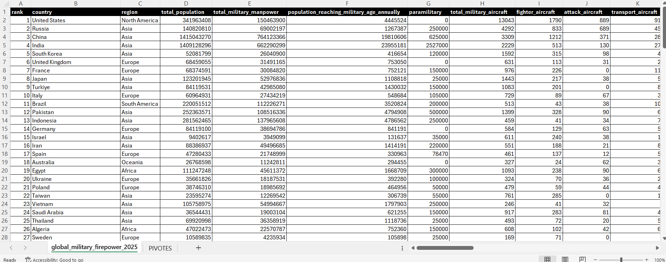

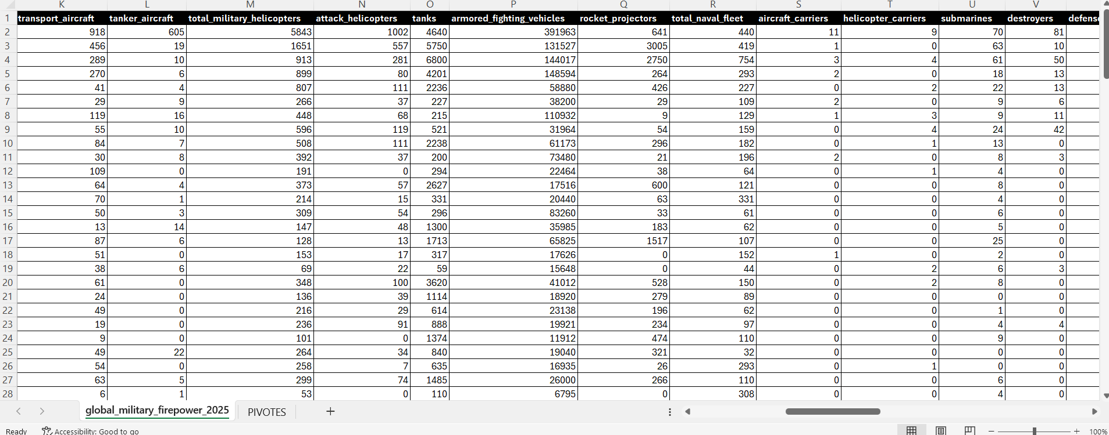
Fig 1.1 Raw dataset – Excel view (remaining columns)

CHAPTER 3: DATA PREPROCESSING

3.1 Data Collection / Loading
The Global Military Firepower 2025 dataset was downloaded in Excel format and opened in Microsoft Excel. The file was later loaded into Power BI Desktop through Power Query for modelling and visualization.

3.2 Handling Missing Values
All columns were inspected for blank or null cells. Values that are zero because a country does not possess an asset were retained, since replacing them would distort comparisons. Numeric columns that were stored as text were converted to numeric format so that they could be aggregated correctly.

3.3 Handling Duplicate / Inconsistent Data
Duplicate country entries for the Asia region were identified and removed so that each country appears exactly once. Column headers were standardized to a consistent naming convention (lower-case names with underscores, such as total_military_manpower) to enable error-free import into Power BI.

3.4 Other Project-Specific Preprocessing
- Region column validated so that every country maps to exactly one of the six regions.
- Numeric fields formatted as whole numbers or decimals as appropriate.
- Pivot-table-ready layout prepared, with one row per country and one column per attribute.
- Data loaded into Power BI using Power Query, and DAX used for measures where required.

CHAPTER 4: SYSTEM DESIGN AND METHODOLOGY

4.1 Proposed Methodology
The methodology starts with collecting the Global Military Firepower 2025 dataset and cleaning it in Excel. Twelve pivot tables summarize the data from different angles. The cleaned data and pivot summaries are then loaded into Power BI, where the dashboard visuals, KPI cards and region slicers are created and arranged on a custom military-themed background.

4.2 System Workflow / Architecture
Step | Stage | Description
1 | Global Military Firepower 2025 dataset | Source Excel workbook (145 rows × 57 columns)
2 | Data collection & loading | Open in Excel / load into Power BI
3 | Data cleaning & preprocessing | Remove duplicates, validate types, standardize columns
4 | Pivot table creation | Twelve country-wise and region-wise summaries
5 | Data modelling in Power BI | Relationships, measures and formatting
6 | Dashboard development | Page 1 (charts) and Page 2 (map, KPIs, gauge)
7 | Interactive analysis | Region slicers, cross-filtering, tooltips

4.3 Flowchart
Insert the project flowchart below (Dataset → Cleaning → Pivot Tables → Power BI → Dashboard → Insights).
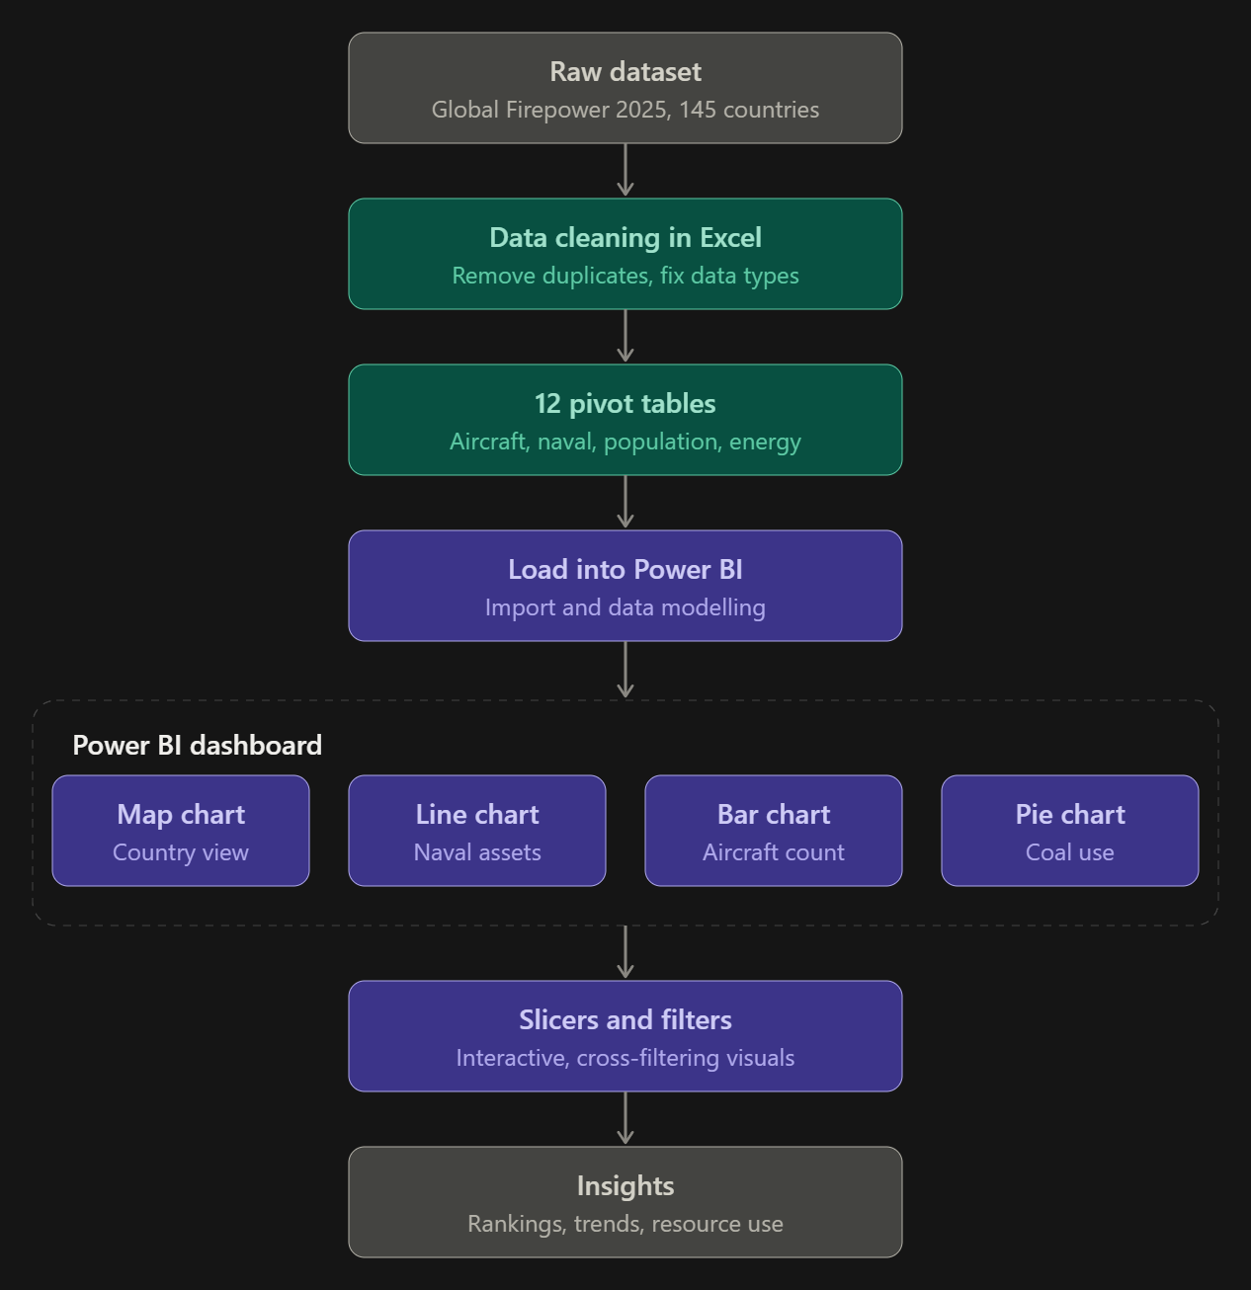
Fig 2.1 Project flowchart

4.4 Tools and Technologies Used
Tool | Purpose
Microsoft Excel | Data cleaning, removal of duplicates, pivot tables
Power Query | Data loading and transformation inside Power BI
DAX | Measures and calculations in Power BI
Microsoft Power BI Desktop | Interactive dashboard creation
CSV / XLSX | Data source formats
Google Chrome / Microsoft Edge | Dataset download and report publishing

4.5 Software and Hardware Requirements
Software Requirements
Operating System | Windows 10 / 11
Data Visualization Tool | Microsoft Power BI Desktop
Data Source | CSV / Excel dataset
Data Cleaning | Power Query, DAX and MS Excel
Web Browser | Google Chrome or Microsoft Edge

Hardware Requirements
Processor | Intel Core i3 or higher (i5 recommended)
RAM | Minimum 8 GB (16 GB recommended)
Storage | 20 GB free disk space
Display | 1366 × 768 resolution or higher
Internet | Required for downloading datasets and publishing reports
Input devices | Standard keyboard and mouse

CHAPTER 5: IMPLEMENTATION

5.1 Development Environment
The project was developed on Windows using Microsoft Excel for data cleaning and pivot tables and Microsoft Power BI Desktop for the dashboard. Power Query handled data transformation, and DAX was used for calculations where needed.

5.2 Dataset Loading and Exploration
The Excel workbook was opened and the structure of all 57 columns reviewed. The sheet was then converted into a clean tabular layout suitable for pivot tables.

5.3 Preprocessing Implementation
Duplicate Asia country rows were removed using Excel’s Remove Duplicates and manual verification, column headers were standardized and data types were validated, as described in Chapter 3.

5.4 Pivot Table Creation (Exploratory Data Analysis)
Twelve pivot tables were created to explore the data from different analytical angles. Each pivot table is documented below with its purpose, followed by space for the screenshot.
PT # | Pivot Table | Purpose
PT 1 | Country-wise Aircraft | Compares air-force size across nations and feeds the Country Wise Aircraft bar chart.
PT 2 | Region-wise Population and Manpower | Shows regional demographic strength and feeds the Military Manpower vs Total Population chart.
PT 3 | Region-wise Aircraft | Shows air power by continent.
PT 4 | Asia – Country-wise Population and Military | Deep dive into the military demographics of Asia.
PT 5 | Country-wise Attack Aircraft | Shows offensive air capability.
PT 6 | Country-wise Naval Fleet | Compares naval strength across nations.
PT 7 | Country-wise Military Data | Multi-metric comparison; feeds the multi-line naval chart.
PT 8 | Country-wise Sea Coverage | Shows maritime territory; feeds the Water Coverage KPI.
PT 9 | Country-wise Land Coverage | Shows territorial land area; feeds the land-coverage map.
PT 10 | Country-wise Coal Data | Energy-resource analysis; feeds the coal consumption pie chart.
PT 11 | Country-wise Natural Gas Consumption | Energy-resource analysis; feeds the natural gas donut chart.
PT 12 | Country-wise Oil Consumption | Energy-resource analysis for oil dependence.

PT 1: Country-wise Aircraft
Configuration: Rows: Country. Values: aircraft counts (such as fighter aircraft).
Purpose: Compares air-force size across nations and feeds the Country Wise Aircraft bar chart.
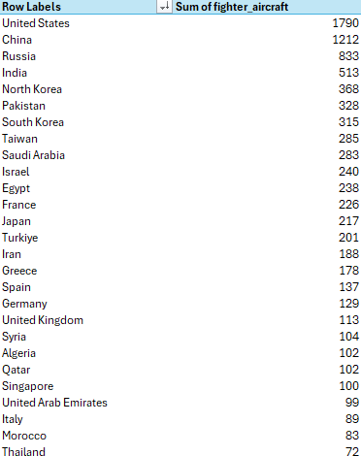
Fig 3.1 PT 1 – Country-wise Aircraft (pivot table)

PT 2: Region-wise Population and Manpower
Configuration: Rows: Region. Values: total population and total military manpower.
Purpose: Shows regional demographic strength and feeds the Military Manpower vs Total Population chart.
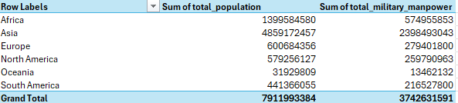
Fig 3.2 PT 2 – Region-wise Population and Manpower (pivot table)

PT 3: Region-wise Aircraft
Configuration: Rows: Region. Values: aircraft counts.
Purpose: Shows air power by continent.
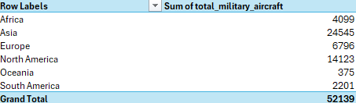
Fig 3.3 PT 3 – Region-wise Aircraft (pivot table)

PT 4: Asia – Country-wise Population and Military
Configuration: Filter: Region = Asia. Rows: Country. Values: population and military manpower.
Purpose: Deep dive into the military demographics of Asia.
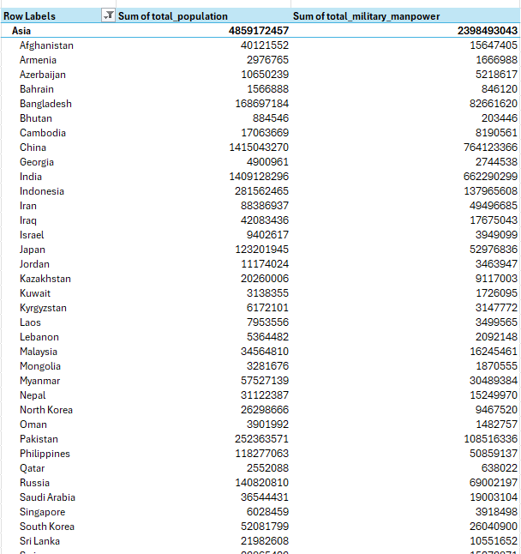
Fig 3.4 PT 4 – Asia – Country-wise Population and Military (pivot table)

PT 5: Country-wise Attack Aircraft
Configuration: Rows: Country. Values: attack aircraft.
Purpose: Shows offensive air capability.
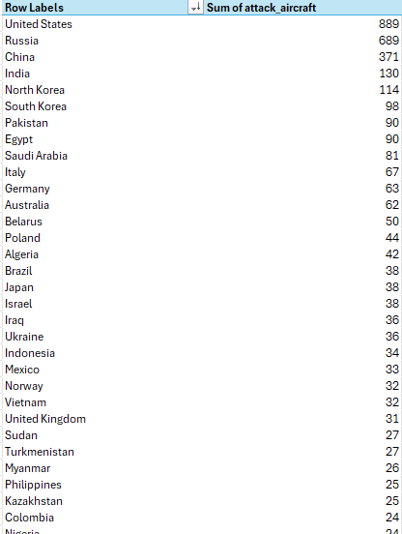
Fig 3.5 PT 5 – Country-wise Attack Aircraft (pivot table)

PT 6: Country-wise Naval Fleet
Configuration: Rows: Country. Values: total naval fleet.
Purpose: Compares naval strength across nations.
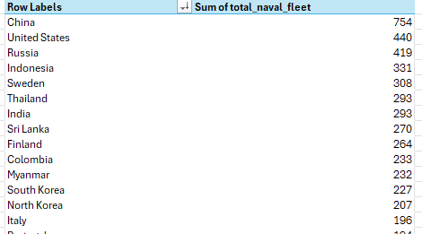
Fig 3.6 PT 6 – Country-wise Naval Fleet (pivot table)

PT 7: Country-wise Military Data
Configuration: Rows: Country. Values: submarines, rocket projectors, naval fleet and destroyers.
Purpose: Multi-metric comparison; feeds the multi-line naval chart.
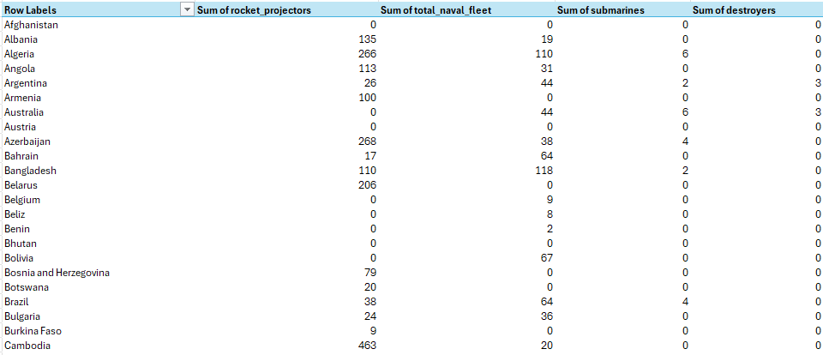Fig 3.7 PT 7 – Country-wise Military Data (pivot table)

PT 8: Country-wise Sea Coverage
Configuration: Rows: Country. Values: water / sea coverage.
Purpose: Shows maritime territory; feeds the Water Coverage KPI.
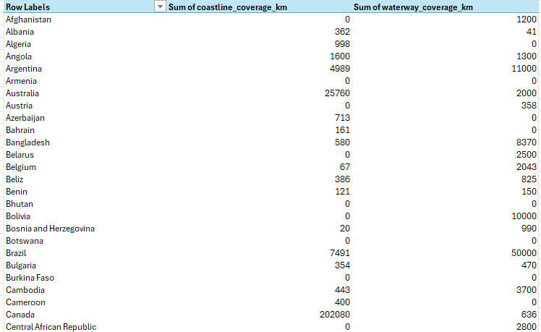
Fig 3.8 PT 8 – Country-wise Sea Coverage (pivot table)

PT 9: Country-wise Land Coverage
Configuration: Rows: Country. Values: land area.
Purpose: Shows territorial land area; feeds the land-coverage map.
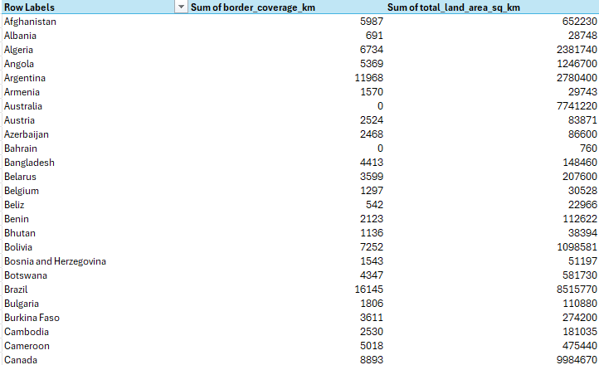
Fig 3.9 PT 9 – Country-wise Land Coverage (pivot table)

PT 10: Country-wise Coal Data
Configuration: Rows: Country / Region. Values: coal consumption (metric tons).
Purpose: Energy-resource analysis; feeds the coal consumption pie chart.
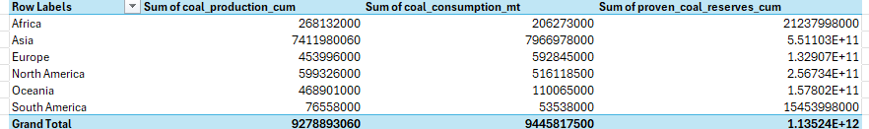Fig 5.10 PT 10 – Country-wise Coal Data (pivot table)

PT 11: Country-wise Natural Gas Consumption
Configuration: Rows: Country / Region. Values: natural gas consumption (cubic metres).
Purpose: Energy-resource analysis; feeds the natural gas donut chart. 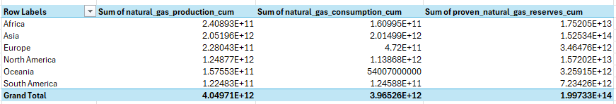 Fig 3.11 PT 11 – Country-wise Natural Gas Consumption (pivot table)

PT 12: Country-wise Oil Consumption
Configuration: Rows: Country. Values: oil consumption.
Purpose: Energy-resource analysis for oil dependence.
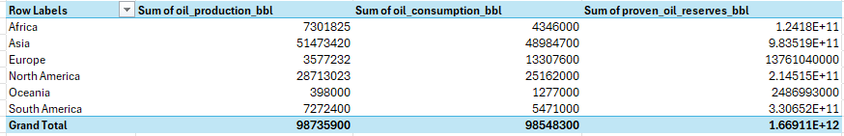 Fig 3.12 PT 12 – Country-wise Oil Consumption (pivot table)

5.5 Dashboard Implementation in Power BI
After the pivot summaries were prepared, the cleaned data was loaded into Power BI Desktop. A custom military-themed background (world map, fighter jets, battle tank and warships) was designed and each visual was placed inside a bordered panel. Six region buttons (Africa, Asia, Europe, North America, Oceania and South America) were added at the top and work as slicers. The dashboard has two pages with a consistent title bar and the Aditya University logo.

5.6 Important Calculations
- Total military manpower and total population are aggregated by country using Sum.
- Aircraft, naval and resource-consumption values are aggregated with Sum and displayed by country or region.
- KPI cards display the top two countries (by Sum of the selected metric) for Military Strength, Foreign Exchange, Defence Budget and Water Coverage.
- The gauge chart shows the combined total of trainer aircraft, aircraft carriers and attack aircraft, with the minimum and maximum axis values.

CHAPTER 6: DATA VISUALIZATION AND RESULTS
This chapter presents each chart and KPI of the Power BI dashboard individually. Paste the screenshot of each visual into the space provided under its description.

6.1 Bar Chart – Country-wise Aircraft
Chart type: Clustered column / bar chart. Axis: Country. Value: Sum of fighter aircraft.
The chart ranks countries by fighter aircraft. The United States leads with a count of about 1,800, followed by China at roughly 1,200, Russia at about 830 and India at about 500. After the top four, counts fall steeply and most nations have only a few hundred fighter aircraft or fewer, showing that air power is highly concentrated in a few countries.
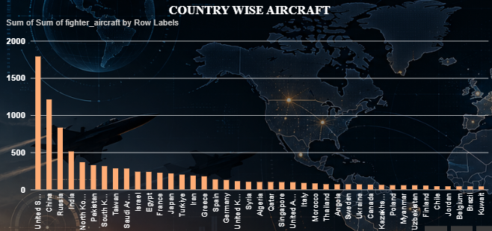
Fig 4.1 Country Wise Aircraft chart

6.2 Column Chart – Military Manpower vs Total Population
Chart type: Clustered column chart. Axis: Country. Values: Sum of total military manpower and Sum of total population.
China and India dominate both measures, with values approaching 1.5 billion on the axis for population, followed by Indonesia, Pakistan, Bangladesh and Russia. For every country, military manpower is only a fraction of total population, which highlights the difference between available manpower and total population.

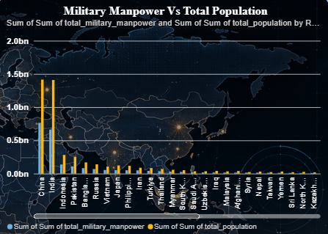
Fig 4.2 Military Manpower vs Total Population chart

6.3 Donut Chart – Natural Gas Consumption
Chart type: Donut chart. Legend: Region. Value: Sum of natural gas consumption.
Asia accounts for the largest share of natural gas consumption at about 153T (73.42%). The next regions contribute about 18T (8.43%), 16T (7.5%) and smaller shares such as 2T (0.97%) and 1T. The centre of the donut shows the total.
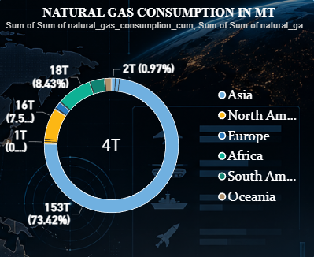
Fig 4.3 Natural Gas Consumption donut chart

6.4 Pie Chart – Coal Consumption
Chart type: Pie chart. Legend: Region. Value: Sum of coal consumption in metric tons.
Asia consumes about 8bn metric tons (84.34%) of coal, far ahead of Europe (about 6.28%) and North America (about 5.46%). The remaining regions together make up a very small share, showing the heavy dependence of Asian economies on coal.
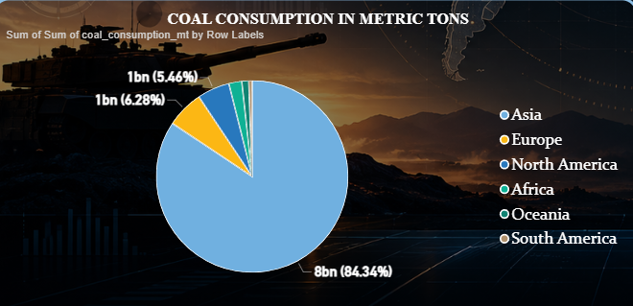
Fig 4.4 Coal Consumption pie chart

6.5 Line Chart – Destroyers, Rocket Projectors, Submarines and Total Naval Fleet
Chart type: Multi-line chart. Axis: Country. Series: Sum of destroyers, rocket projectors, submarines and total naval fleet.
Two clear peaks appear for rocket projectors (green line) for a small number of countries, while destroyers and submarines stay close to zero for most nations. Naval and rocket-artillery strength is concentrated in a few countries, and the majority of countries have very small values.
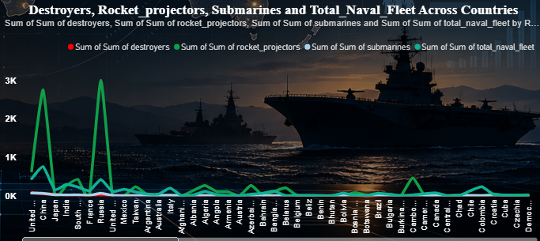
Fig 4.5 Naval multi-line chart

6.6 Map – Land Coverage Area of Countries
Chart type: Filled (ArcGIS) map. Location: Country. Colour: land coverage.
Russia is shown in the darkest shade as the country with the largest land area. China, India, Kazakhstan, Chad, DR Congo and others are shaded in lighter colours according to land area. The map gives an immediate spatial view of territorial size.
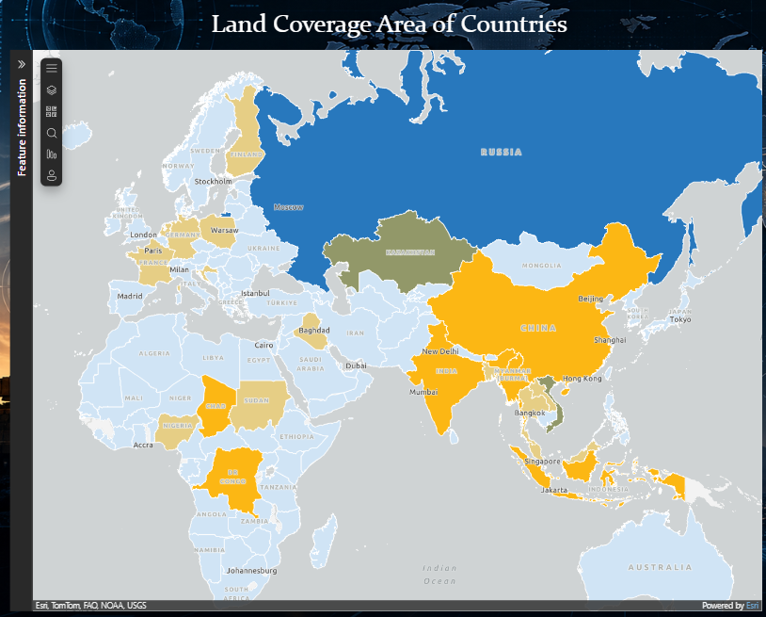Fig 4.6 Land Coverage map

6.7 KPI Cards – Key Performance Indicators
KPI cards summarize the leading countries for four key measures. Each card is shown below with the values displayed on the dashboard.
KPI Card | First Country | Value | Second Country | Value
Military Strength (Sum of total military manpower) | China | 764M | India | 662M
Foreign Exchange (reserves) | China | 3T | Japan | 1T
Defence Budget | China | 267bn | United … (name truncated in card) | 895bn
Water Coverage | Brazil | 50K | Russia | 102K

Military Strength KPI

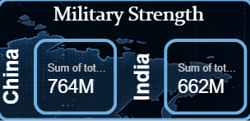

Fig 4.7 Military Strength KPI card

Foreign Exchange KPI

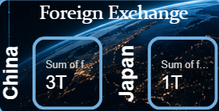

Fig 4.8 Foreign Exchange KPI card

Defence Budget KPI

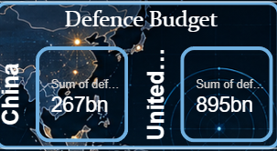

Fig 4.9 Defence Budget KPI card

Water Coverage KPI

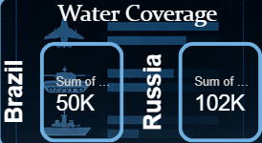

Fig 4.10 Water Coverage KPI card

6.8 Gauge Chart – Trainer Aircraft, Aircraft Carriers and Attack Aircraft
The gauge chart shows the combined sum of trainer aircraft, aircraft carriers and attack aircraft. The gauge ranges from 23 (minimum) to 22K (maximum), with the current value of about 11K at its centre and a marker at 3,758. It gives a quick view of how the combined strike and training capability compares with the maximum value.
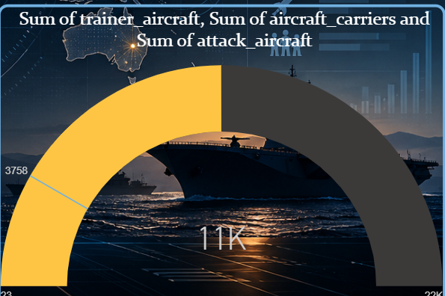
Fig 4.11 Gauge chart

6.9 Region Slicers
The six buttons at the top of both pages (Africa, Asia, Europe, North America, Oceania, South America) act as slicers. Selecting a region filters every chart, map and KPI card on the page, enabling region-level analysis.
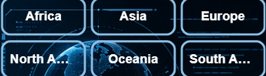
Fig 4.12 Region slicer buttons

6.10 Interpretation of Visualizations
The bar chart compares air power, the column chart compares manpower with population, the donut and pie charts show the share of each region in natural gas and coal consumption, the line chart compares naval and rocket-artillery assets, the map shows land area, the KPI cards show the leading countries on key measures and the gauge shows combined aircraft totals. Together, they give a complete picture of global military capability and resource dependence.

CHAPTER 7: ANALYSIS OF RESULTS

7.1 Experimental Results
- Air Power: Air power is concentrated: the United States, China, Russia and India lead in fighter aircraft by a wide margin.
- Manpower: China and India have the largest population and military manpower, with China at about 764M and India at about 662M on the Military Strength KPI.
- Energy: Asia accounts for about 84% of coal consumption and about 73% of natural gas consumption in the dataset.
- Naval and Rocket Forces: Destroyers, submarines and rocket projectors are held in significant numbers by only a few countries.
- Geography: Russia has the largest land area; Russia (about 102K) and Brazil (about 50K) lead the Water Coverage KPI.
- Finance: China shows the highest foreign exchange value (about 3T) followed by Japan (about 1T). Defence budget KPI values are about 267bn for China and 895bn for the second country shown.

7.2 Result Interpretation
The results show that military capability and energy consumption are strongly concentrated in a small group of countries, mainly in Asia and North America. Larger militaries are supported by larger populations, larger industrial bases and greater energy use. A small number of countries dominate air power, naval strength and budgets, while most countries have limited capability in these domains.

7.3 Discussion
The dashboard makes it easy to compare countries and regions quickly. Region slicers support focused analysis, and the combination of charts, a map and KPI cards allows users to move from a global overview to specific countries. The project shows how business-intelligence tools can turn complex defence statistics into understandable visual insights.

CHAPTER 8: OUTPUT SCREENSHOTS

8.1 Input / Dataset Screenshots

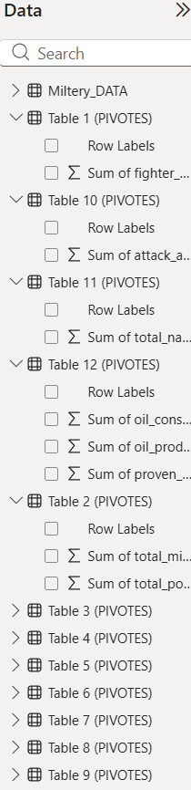

Fig 5.1 Input dataset

8.2 Visualization Outputs
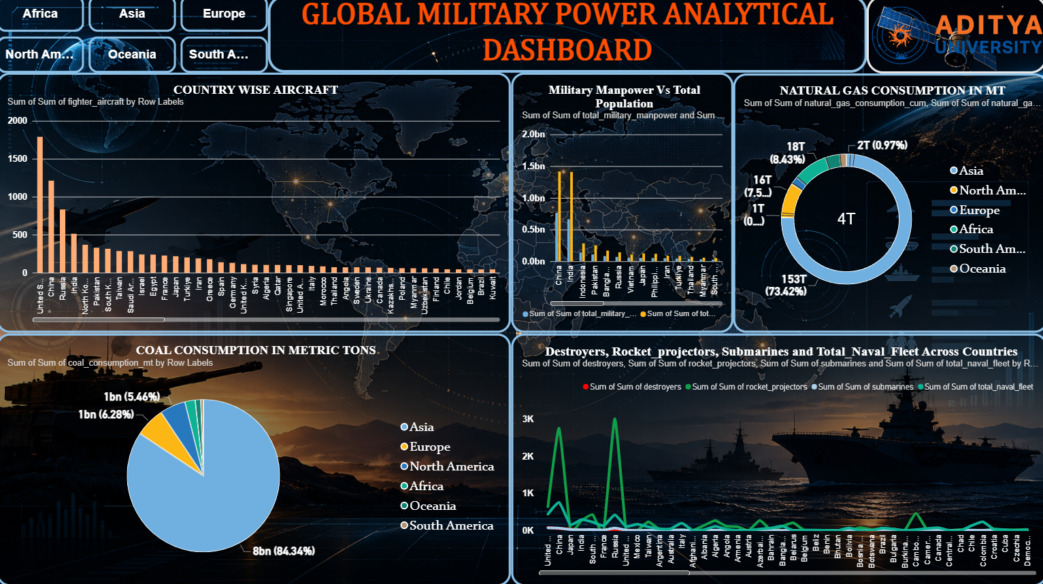
Fig 5.2 Dashboard Page 1 – full view

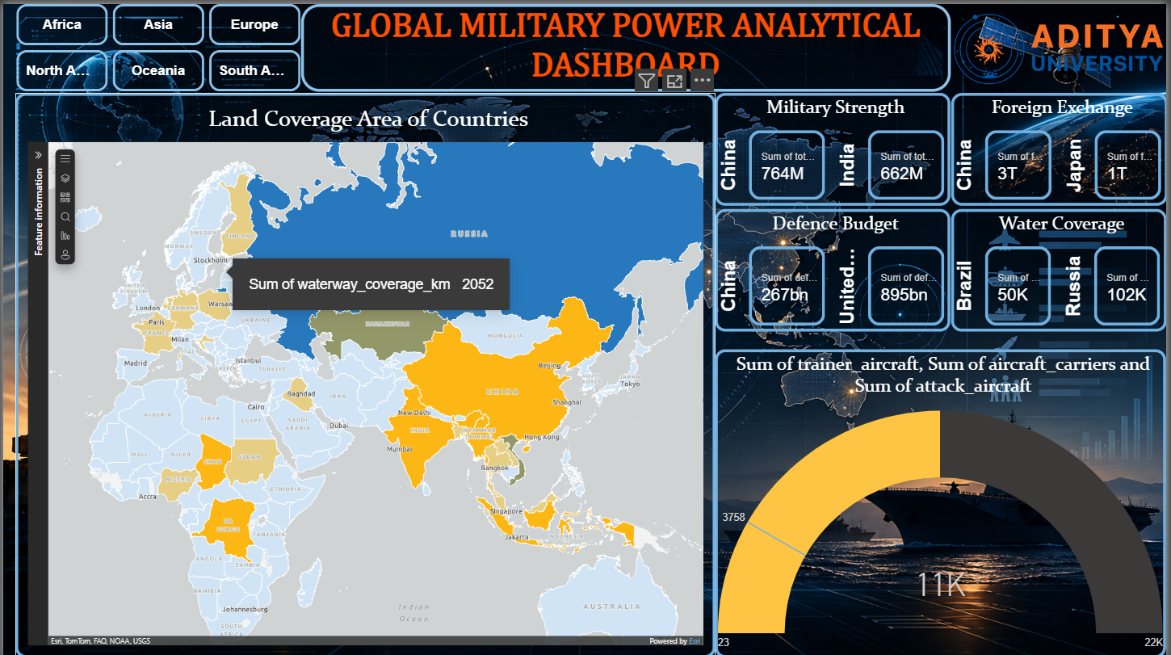
Fig 5.3 Dashboard Page 2 – full view

CHAPTER 9: CONCLUSION AND FUTURE ENHANCEMENTS

9.1 Conclusion
The Global Military Power Analytical Dashboard successfully analyzes the Global Military Firepower 2025 dataset using Microsoft Excel and Power BI. Data cleaning produced a reliable dataset, twelve pivot tables summarized the data from several perspectives, and two dashboard pages present country and region level insights through bar, column, line, pie, donut and gauge charts, a land-coverage map and KPI cards, all filterable by region. The project demonstrates a complete analytics workflow from raw data to interactive visual storytelling.

9.2 Limitations
- Uses a single-year (2025) snapshot and does not show trends over time.
- Descriptive analysis only; no predictions.
- Depends on the quality and completeness of the Global Firepower data.
- The proposed What-If alliance builder and per-capita readiness metrics are not part of the final dashboard.
- Some chart labels are truncated for countries with long names because of limited space.

9.3 Future Enhancements
- Add historical Global Firepower data (for example 2020–2025) to show trends over time.
- Add a What-If parameter for building hypothetical alliances and comparing blocs.
- Add per-capita militarization and readiness (active vs reserve) indices using DAX.
- Include defence budget efficiency and scatter-plot analysis.
- Publish the report to Power BI Service for sharing and collaboration.
- Introduce machine-learning models for forecasting rankings.

REFERENCES
- Global Firepower – 2025 Military Strength Ranking. https://www.globalfirepower.com
- Microsoft – Power BI Documentation. https://learn.microsoft.com/en-us/power-bi/
- Microsoft – Excel PivotTable Support. https://support.microsoft.com/en-us/excel
- Tufte, E. R. (1983). The Visual Display of Quantitative Information. Graphics Press.
- Few, S. (2012). Show Me the Numbers: Designing Tables and Graphs to Enlighten. Analytics Press.
- Kirk, A. (2019). Data Visualisation: A Handbook for Data Driven Design. SAGE Publications.

