LAB ASSIGNMENT – 14
Web Frontend Development – AI-Assisted HTML/CSS/JS Generation
Course: AI Assisted Coding | Course Code: 25CS002PC304
B.Tech • Academic Year 2025–2026 • Regulation R25
Assignment 14 / 24

Program | B. Tech
Course Title | AI Assisted Coding
Assignment | Lab 14: Web Frontend Development – AI-Assisted HTML/CSS/JS Generation
Duration / Week | 2 Hours / Week 7

Lab Objectives
- Design functional, visually appealing web applications using HTML, CSS, and JavaScript with AI assistance.
- Apply responsive, accessible, and interactive design principles.
- Create practical UI components for real-world web applications.
- Use AI to optimize layout, UX, and performance.

Lab Outcomes
- Apply AI assistance to frontend development tasks.
- Understand how HTML, CSS, and JavaScript work together.
- Improve responsiveness, interactivity, and usability.
- Evaluate and refine AI-generated frontend code.
The assignment sheet requires one Word report containing prompts, comments and code explanation, output, and screenshots where required. fileciteturn0file0L134-L136

Task 1: Responsive Homepage Layout for a Startup Website
Scenario / Requirement: A startup needs a basic homepage that looks good on desktop, tablet, and mobile devices.
AI Prompt Used: Create a responsive startup homepage using HTML, CSS, and JavaScript. Include a header with navigation links, a main content section, and a footer. Use responsive CSS media queries so the layout works on desktop, tablet, and mobile screens.

Code
VS Code screenshot of the implementation:
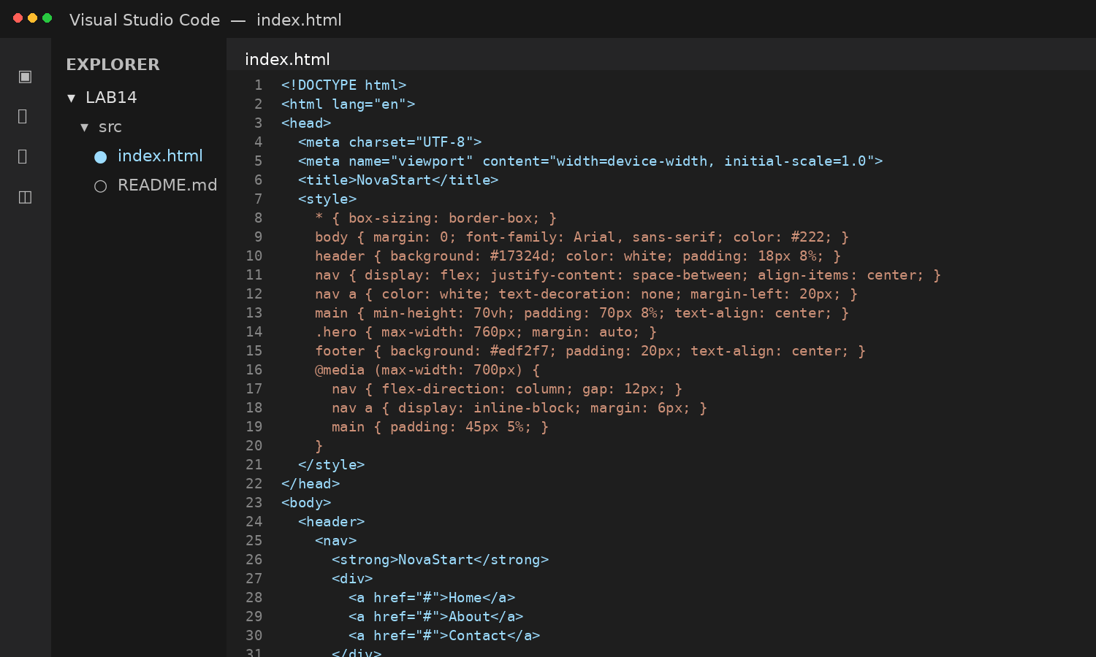

Code Explanation
The HTML provides the page structure, CSS creates a responsive layout with a media query, and the JavaScript adds a small menu-toggle interaction for narrow screens.

Output
Expected/representative browser output:
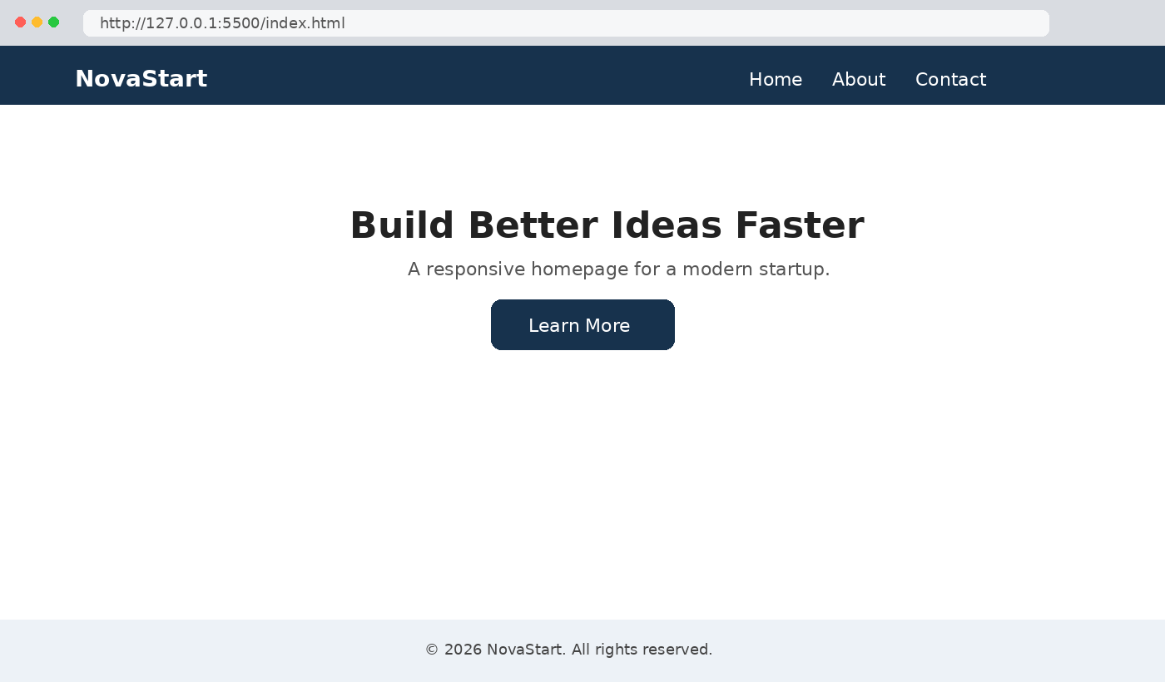

Expected Output:
- Header, content, and footer are clearly separated.
- Layout adapts to mobile, tablet, and desktop views.
- Code is clean and well-structured.

Task 2: Interactive Call-to-Action Button
Scenario / Requirement: A marketing page needs a call-to-action button that responds when users interact with it.
AI Prompt Used: Add a call-to-action button to a web page. Use JavaScript to respond to a click by displaying a visible message or alert. Include meaningful comments and avoid a page reload.

Code
VS Code screenshot of the implementation:
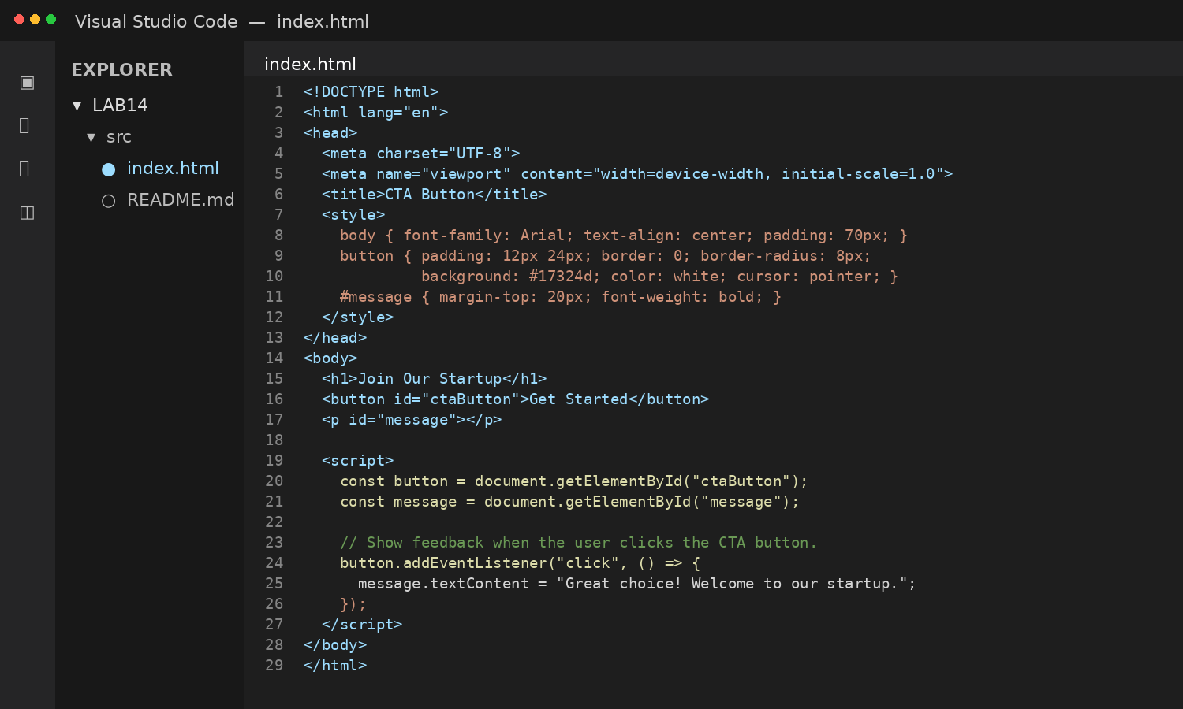

Code Explanation
The button uses an event listener. When clicked, the message element is updated immediately, so the page does not reload.

Output
Expected/representative browser output:
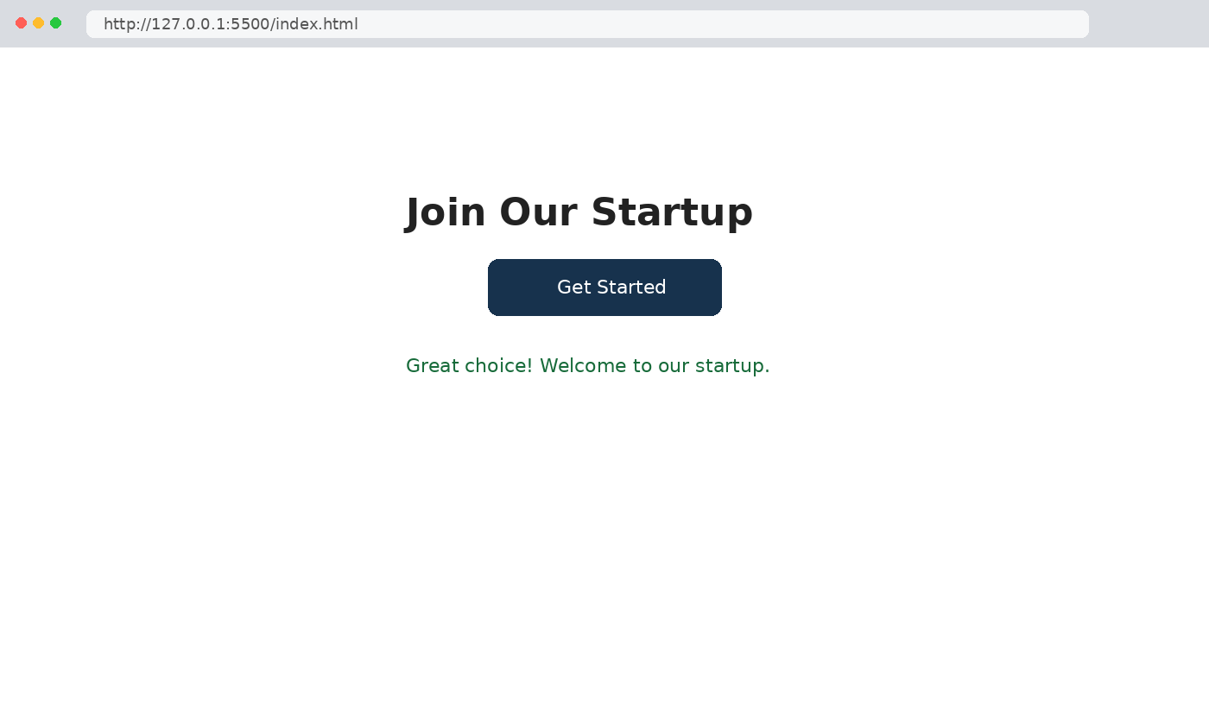

Expected Output:
- Clicking the button triggers a visible response.
- JavaScript is readable and commented.
- No page reload occurs.

Task 3: Contact Form with Client-Side Validation
Scenario / Requirement: A company website needs a contact form that collects user queries safely and correctly.
AI Prompt Used: Create a contact form containing Name, Email, and Message fields. Use JavaScript validation to prevent empty submissions, check for a valid email format, and display clear inline error messages.

Code
VS Code screenshot of the implementation:
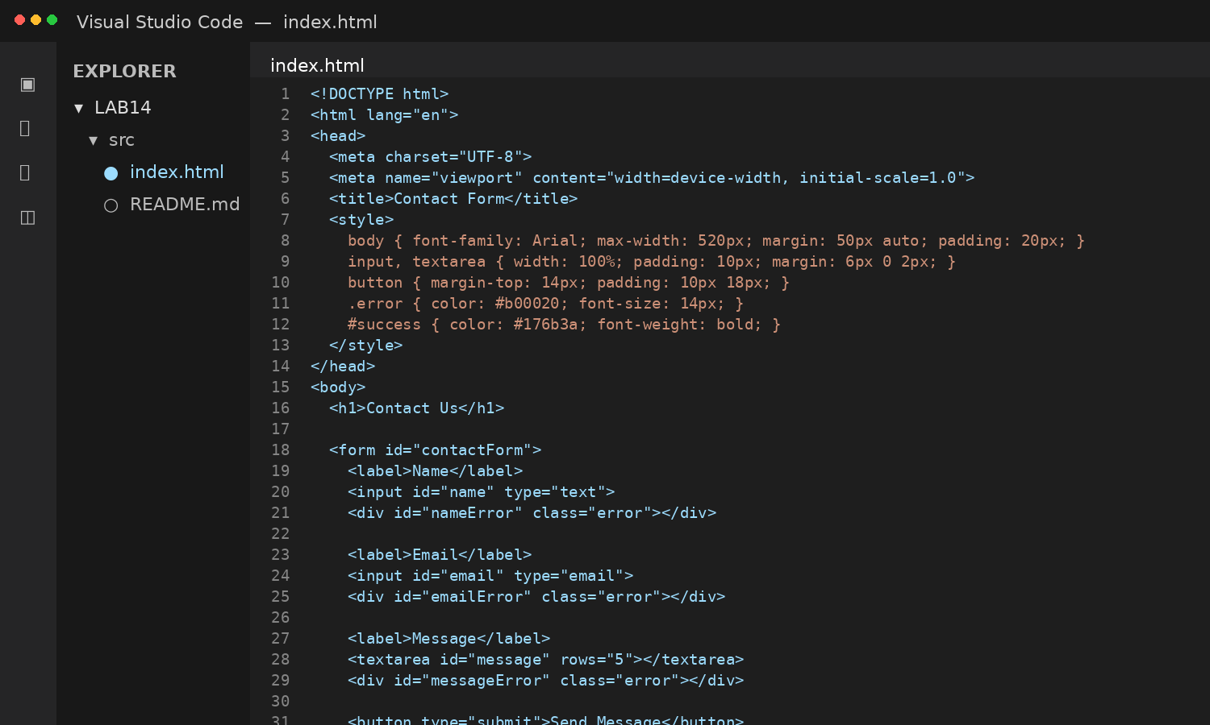

Code Explanation
The submit handler prevents the default page reload, checks each field, validates the email with a regular expression, and shows either inline errors or a success message.

Output
Expected/representative browser output:
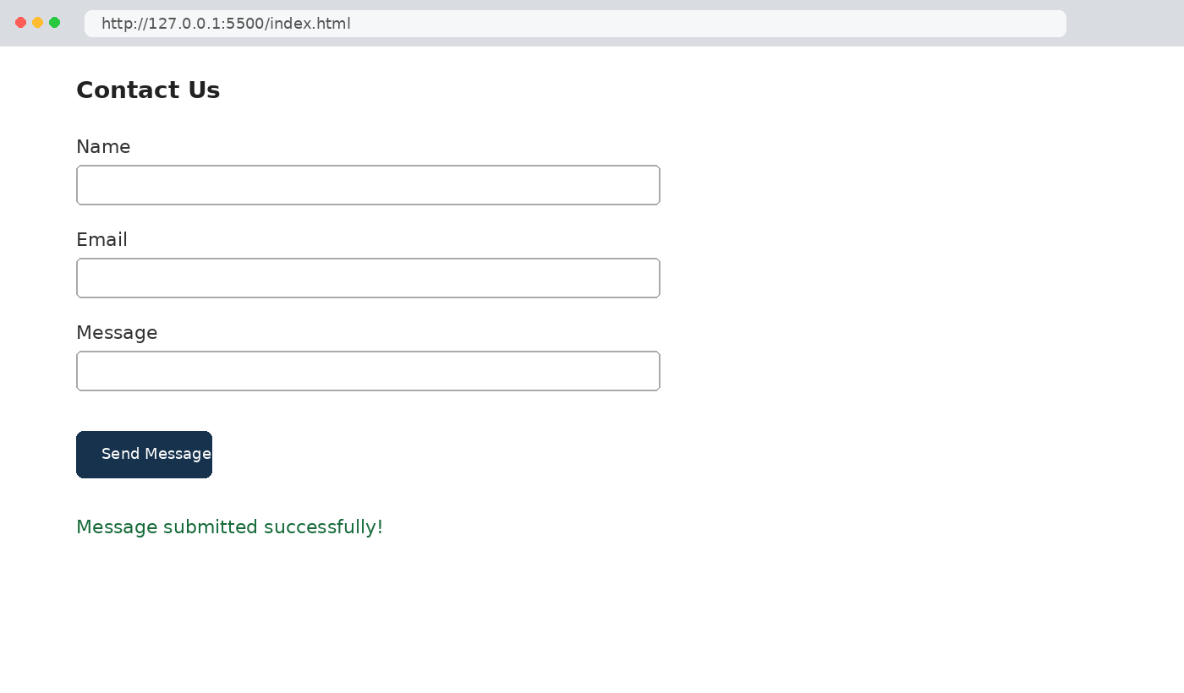

Expected Output:
- Invalid input shows inline error messages.
- Valid input displays a success message.
- Validation happens on the client side using JavaScript.

Task 4: Dynamic List Management for a Product Page
Scenario / Requirement: A product listing page needs to add or remove items dynamically without refreshing the page.
AI Prompt Used: Create a simple HTML list and use JavaScript to add a new item when Add is clicked and remove the last item when Remove is clicked. Update the DOM dynamically without refreshing the page.

Code
VS Code screenshot of the implementation:
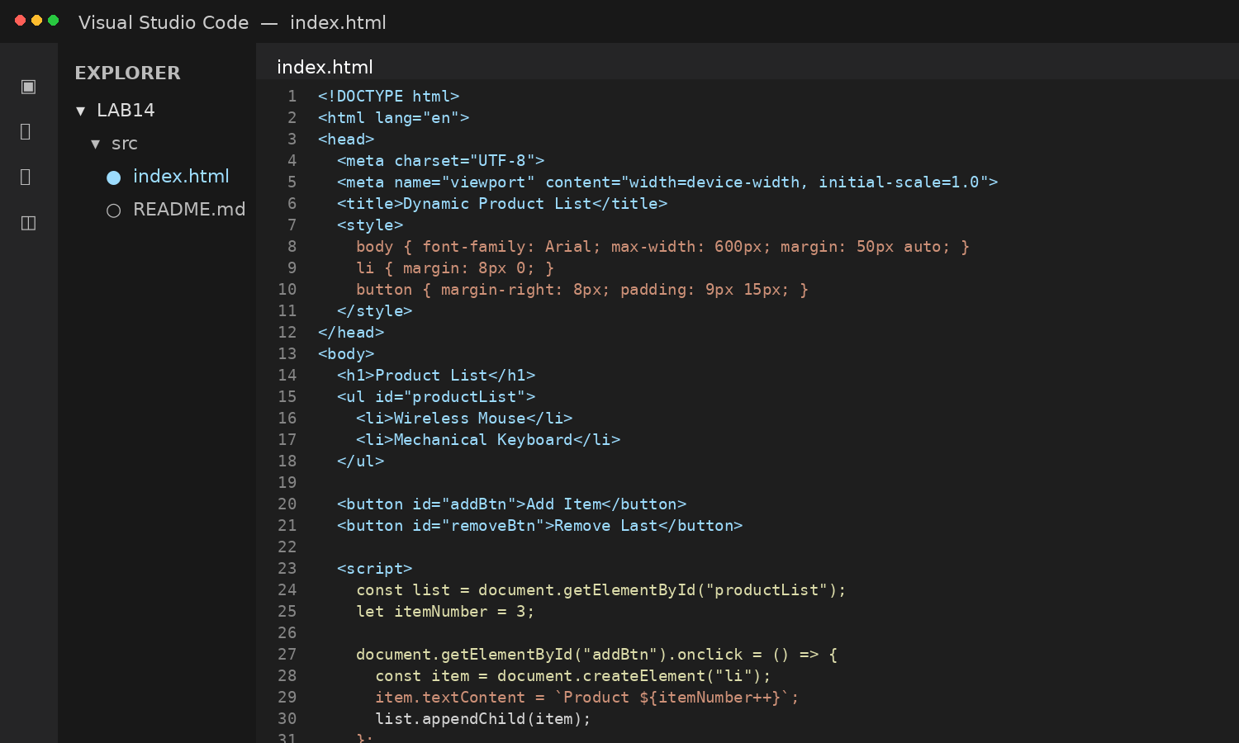

Code Explanation
JavaScript creates a new list item with createElement and appends it to the list. The Remove button deletes the last child of the list.

Output
Expected/representative browser output:
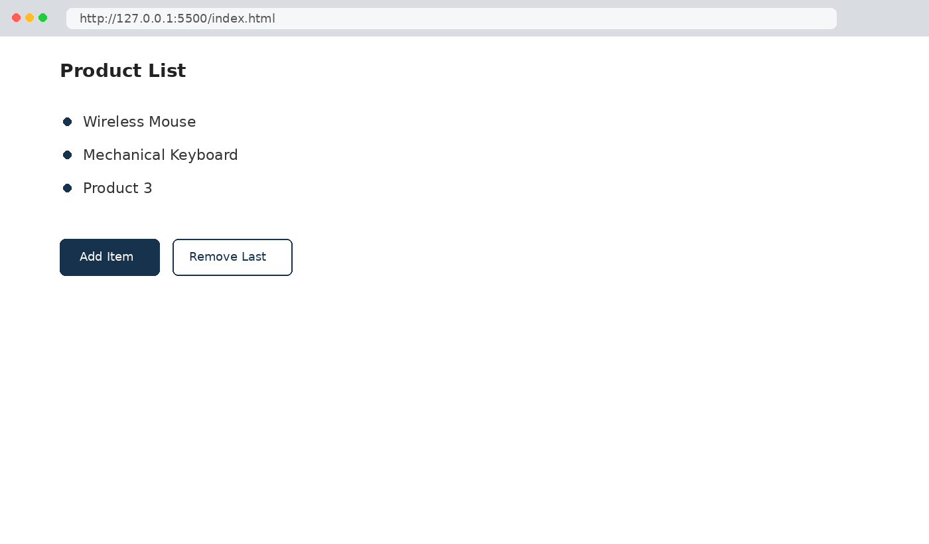

Expected Output:
- Items can be added and removed dynamically.
- Changes appear instantly without page reload.
- JavaScript logic is clear and maintainable.

Task 5: Modal Popup for User Notifications
Scenario / Requirement: A website needs a user notification popup for announcements or alerts.
AI Prompt Used: Create a notification modal using HTML, CSS, and JavaScript. Add a semi-transparent overlay, JavaScript to open and close the modal, and multiple closing methods using a button or overlay click.

Code
VS Code screenshot of the implementation:
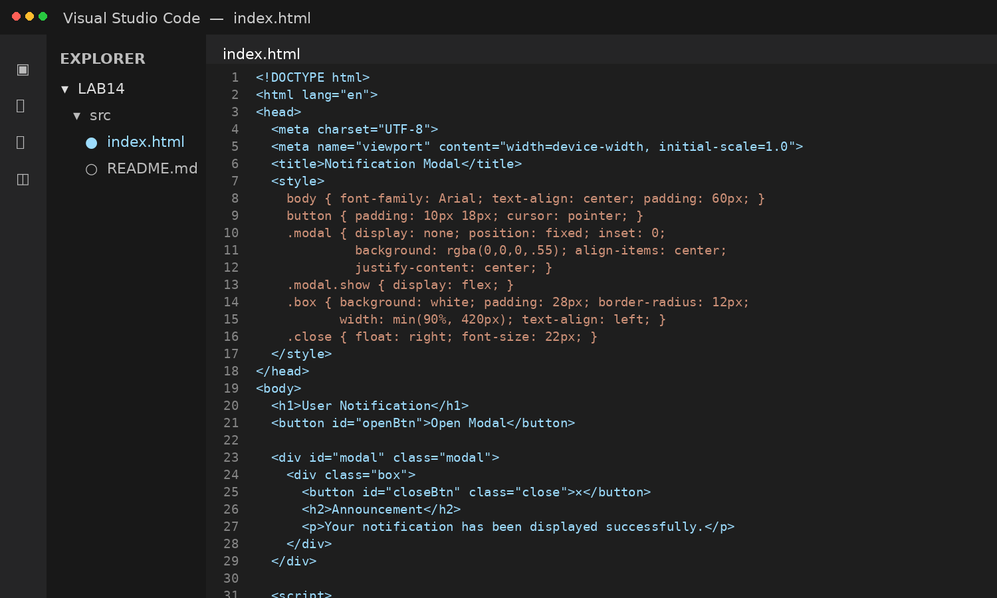

Code Explanation
The modal is hidden by default. Clicking Open Modal adds a visible class. The close button and overlay click remove the class, returning the page to its normal state.

Output
Expected/representative browser output:
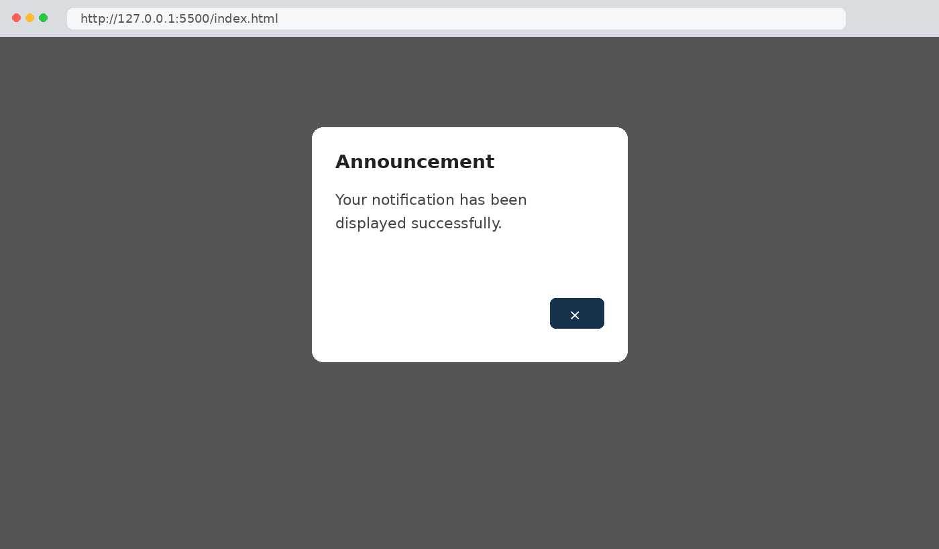

Expected Output:
- Clicking Open Modal displays the popup.
- The popup overlays the page content clearly.
- The modal can be closed using the close button or overlay click.

Conclusion
The five tasks demonstrate AI-assisted frontend development using HTML, CSS, and JavaScript. The implementation covers responsive layout, interactive events, client-side form validation, dynamic DOM manipulation, and modal notifications.

