LAB ASSIGNMENT 13
Code Refactoring – Improving Legacy Code with AI Suggestions
Course: AI Assisted Coding
Course Code: 25CS002PC304
Program: B. Tech
Academic Year: 2026–2027
Assignment: 13 / 24

Prepared with VS Code-style code screenshots

Lab Objective
Identify code smells and inefficiencies in legacy Python scripts and use AI-assisted coding/refactoring techniques to improve readability, maintainability, modularity, and performance while preserving output correctness.
The assignment contains eight refactoring tasks. The original assignment specifies reusable functions, set lookups, constants, meaningful variable names, modular functions, and list comprehensions as appropriate.

Task 1 – Removing Code Duplication
Refactor repeated rectangle calculations into a reusable function with a docstring.
Refactored Python Code – VS Code Screenshot
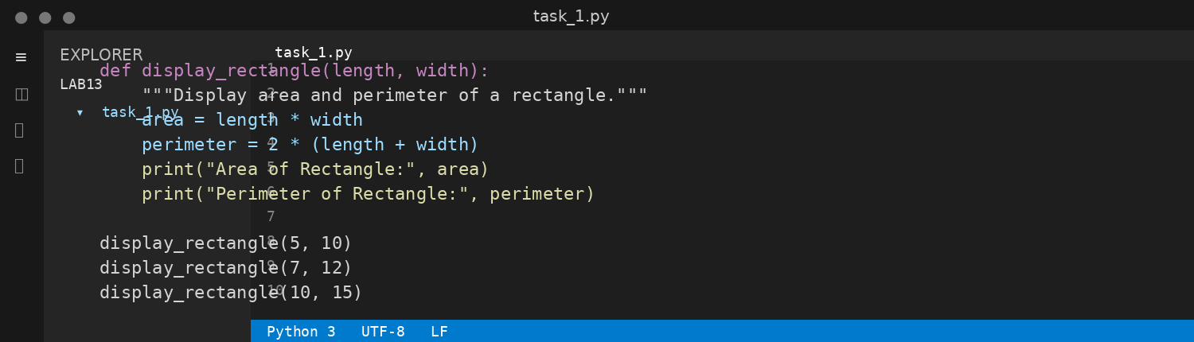
Expected / Sample Output
Area of Rectangle: 50
Perimeter of Rectangle: 30
Area of Rectangle: 84
Perimeter of Rectangle: 38
Area of Rectangle: 150
Perimeter of Rectangle: 50

Task 2 – Optimizing Loops and Conditionals
Replace nested list searches with a set lookup for faster membership testing.
Refactored Python Code – VS Code Screenshot
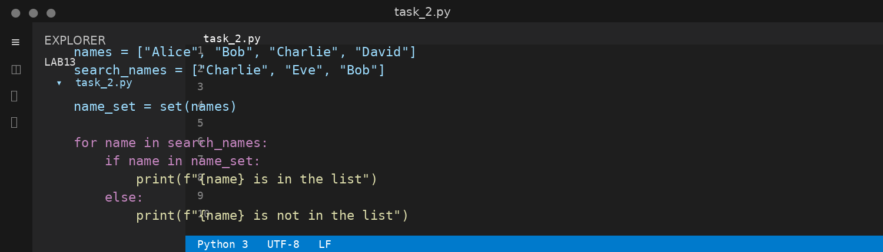
Expected / Sample Output
Charlie is in the list
Eve is not in the list
Bob is in the list
Performance note: the legacy approach checks each search name against every item (nested loop). The refactored version creates a set once and uses average O(1) membership lookup.

Task 3 – Extracting Reusable Functions
Extract repeated price/tax calculations into calculate_total(price).
Refactored Python Code – VS Code Screenshot
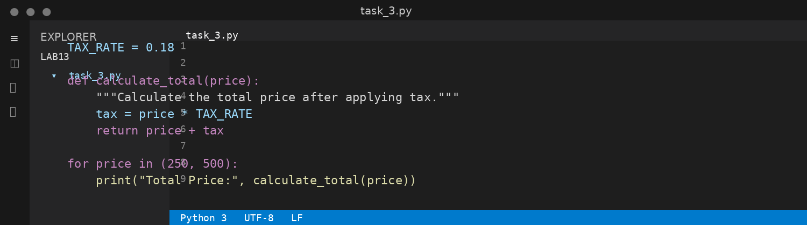
Expected / Sample Output
Total Price: 295.0
Total Price: 590.0

Task 4 – Replacing Hardcoded Values with Constants
Replace magic numbers with named constants for maintainability.
Refactored Python Code – VS Code Screenshot
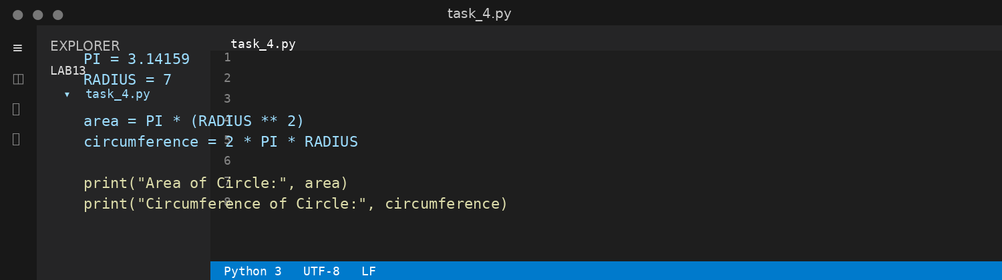
Expected / Sample Output
Area of Circle: 153.93791
Circumference of Circle: 43.98226

Task 5 – Improving Variable Naming and Readability
Use meaningful variable names and an explanatory comment.
Refactored Python Code – VS Code Screenshot
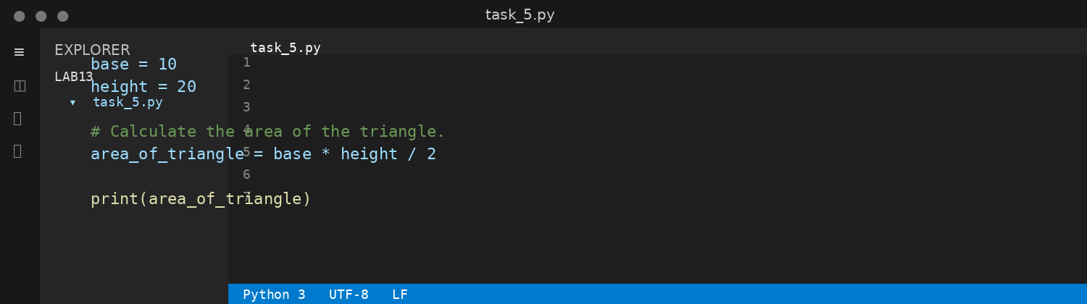
Expected / Sample Output
100.0

Task 6 – Removing Redundant Conditional Logic
Move repeated grading logic into a reusable calculate_grade(marks) function.
Refactored Python Code – VS Code Screenshot
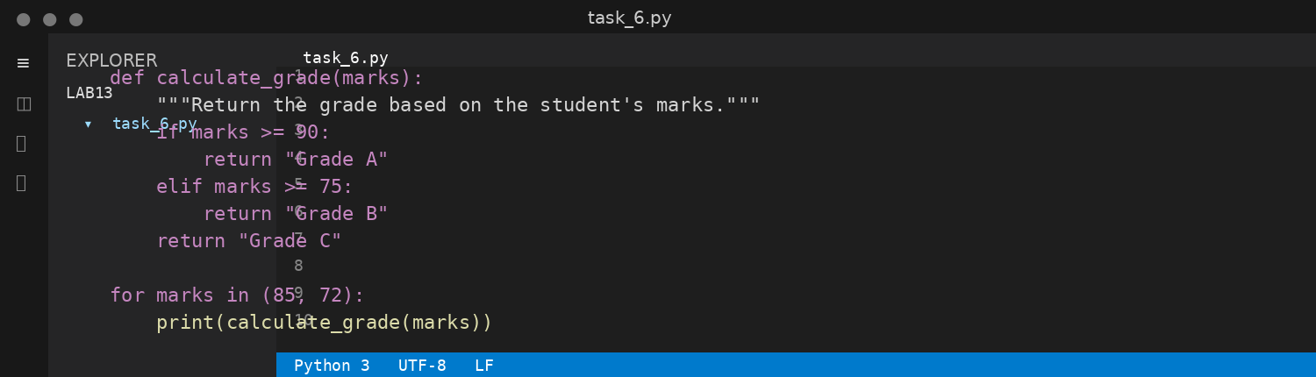
Expected / Sample Output
Grade B
Grade C

Task 7 – Converting Procedural Code to Functions
Separate input, processing, and output into modular functions.
Refactored Python Code – VS Code Screenshot
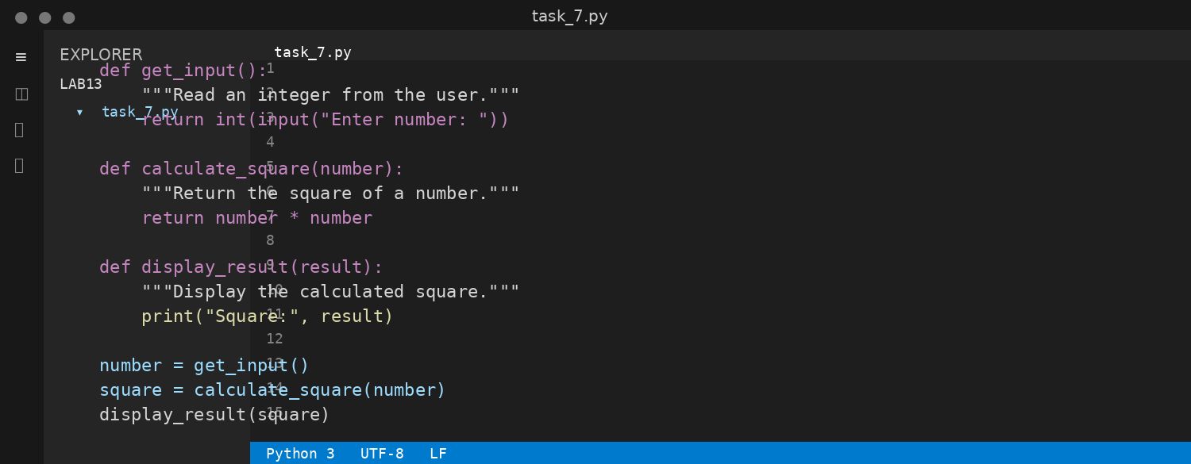
Expected / Sample Output
Enter number: 5
Square: 25

Task 8 – Optimizing List Processing
Replace a manual loop with a concise list comprehension.
Refactored Python Code – VS Code Screenshot
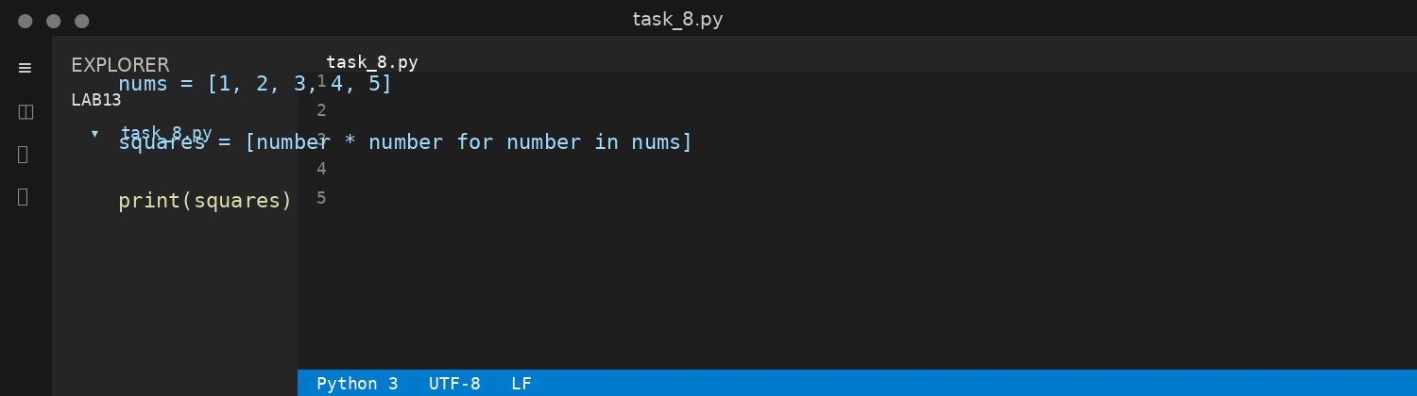
Expected / Sample Output
[1, 4, 9, 16, 25]
The list comprehension produces the same list as the original manual append loop with less code and improved readability.

Conclusion
The eight legacy-code examples were refactored into clearer and more maintainable Python solutions. The refactoring removes duplication, improves lookup efficiency, extracts reusable functions, replaces magic numbers with constants, improves naming, removes repeated conditional logic, modularizes procedural code, and simplifies list processing while preserving the intended behavior.

