LAB ASSIGNMENT – 16
Database Design and Queries
Schema Design and SQL Generation

Course | AI Assisted Coding
Course Code | 25CS002PC304
Academic Year | 2026–2027
Student Name | G.BhanuTeja
Roll Number / Section | 2503a51247

FORMAT: PROMPT FIRST, FOLLOWED IMMEDIATELY BY VS CODE SCREENSHOT

Task 1: Employee Management Database
PROMPT
I am completing Lab Assignment 16 – Task 1: Employee Management Database. Generate a complete MySQL script for an organization employee management database.
Requirements:
1. Create a database named employee_management.
2. Create Departments, Employees, and Salaries tables.
3. Define suitable primary keys and foreign keys. Use NOT NULL and UNIQUE constraints where appropriate (for example, employee email).
4. Add suitable data types and sensible validation constraints.
5. Insert a small set of sample records into all tables.
6. Write SQL queries to:
a) List all employees in a specific department.
b) Retrieve salary details of a selected employee.
c) Find the highest-paid employee in each department.
7. Demonstrate joins and explain how the constraints maintain data integrity.
8. Include comments, expected result descriptions, and instructions to run the script in MySQL or the VS Code SQL extension.
Use standard MySQL syntax. Keep the script organized and beginner-friendly.

VS CODE SCREENSHOT
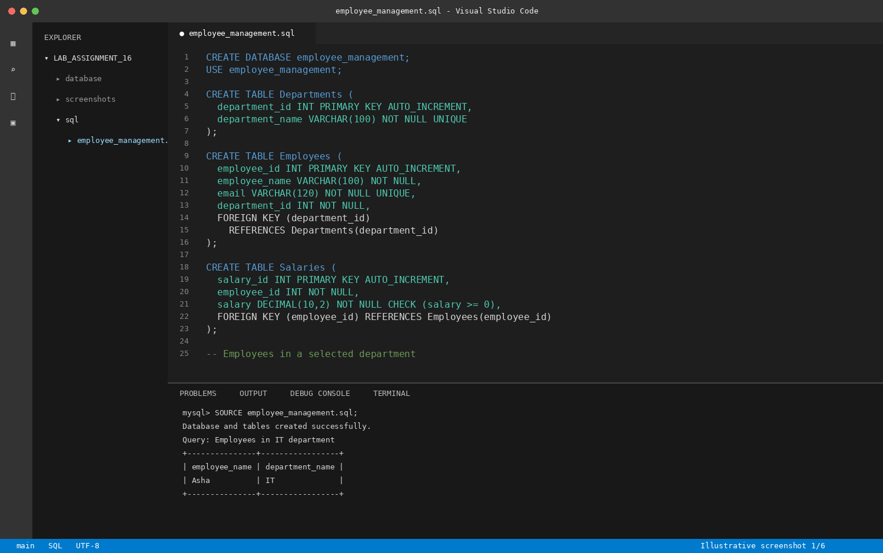
Illustrative VS Code editor and terminal view – employee_management.sql

Task 2: Online Course Platform Database
PROMPT
I am completing Lab Assignment 16 – Task 2: Online Course Platform Database. Generate a complete MySQL schema and queries for an online learning platform.
Requirements:
1. Create a database named online_learning.
2. Create Users, Courses, Lessons, and Enrollments tables.
3. Define primary keys, foreign keys, NOT NULL and UNIQUE constraints where appropriate.
4. Model the many-to-many relationship between users and courses through the Enrollments table.
5. Add sample records to demonstrate the relationships.
6. Write SQL queries to:
a) List all courses enrolled by a selected user.
b) Count the number of learners per course.
c) Retrieve lesson details for a selected course.
7. Use joins and aggregate functions where appropriate.
8. Add comments and explain the relationships and how to execute the script in MySQL or VS Code.
Use valid MySQL syntax and beginner-friendly formatting.

VS CODE SCREENSHOT
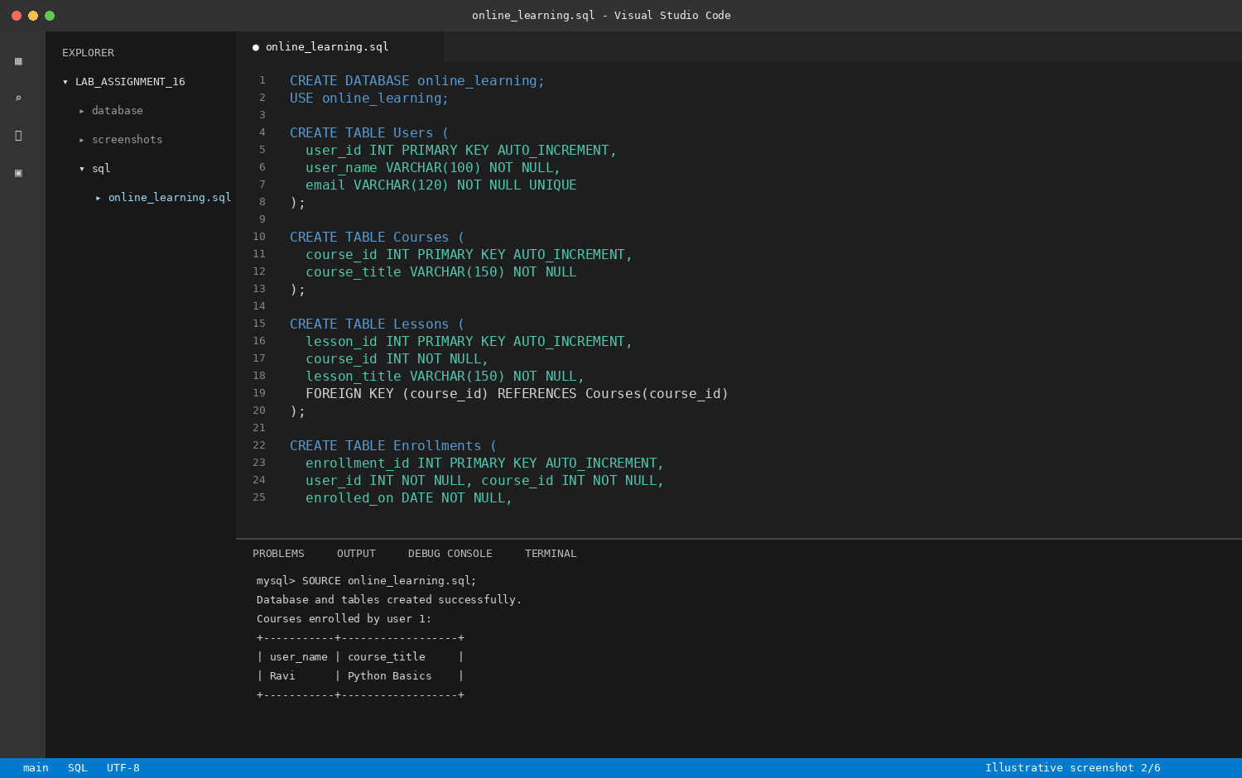
Illustrative VS Code editor and terminal view – online_learning.sql

Task 3: Banking Transaction Database
PROMPT
I am completing Lab Assignment 16 – Task 3: Banking Transaction Database. Generate a secure, beginner-friendly MySQL database schema for banking transaction management.
Requirements:
1. Create a database named banking_system.
2. Create Customers, Accounts, and Transactions tables.
3. Define primary keys, foreign keys, NOT NULL and UNIQUE constraints.
4. Add suitable constraints for transaction validity, including non-negative amounts and a transaction type restricted to Deposit or Withdrawal.
5. Include sample data for customers, accounts, and transactions.
6. Write SQL queries to:
a) Retrieve transaction history for a selected account.
b) Calculate total deposits and total withdrawals.
c) Find accounts with balance below a user-specified threshold.
7. Use joins and aggregate functions. Explain the purpose of each constraint.
8. Include comments and instructions to execute the SQL script.
Use MySQL syntax. Mention that production banking systems require additional transaction handling, authorization, auditing, and security controls; do not imply this teaching schema alone is production-ready.

VS CODE SCREENSHOT
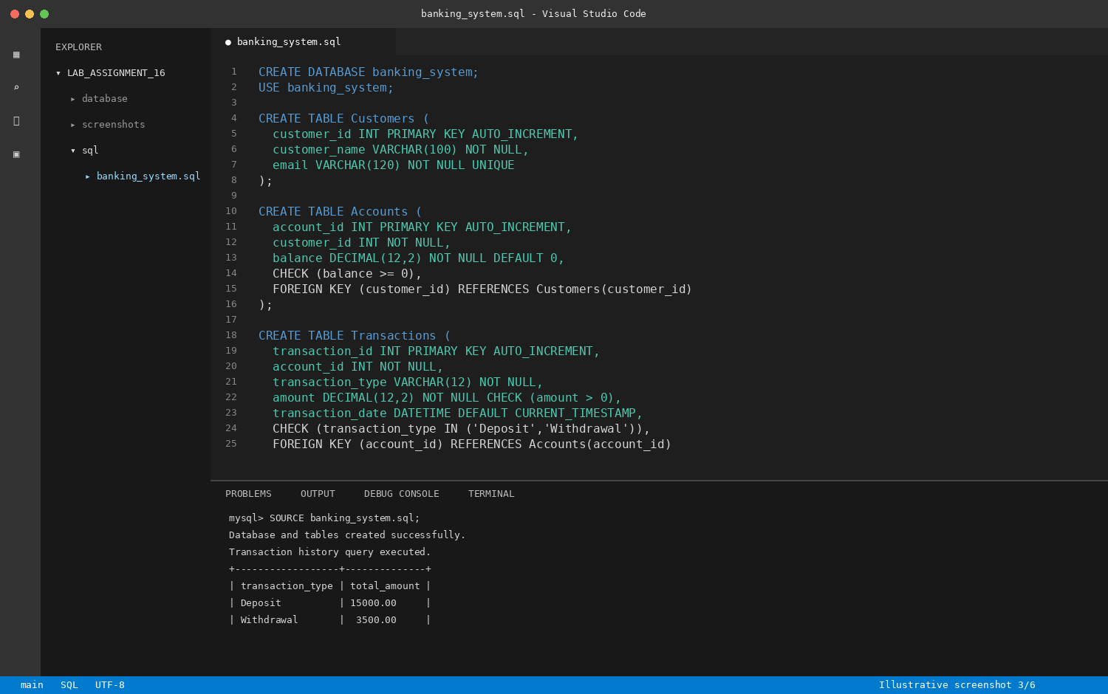
Illustrative VS Code editor and terminal view – banking_system.sql

Task 4: Airline Reservation Database
PROMPT
I am completing Lab Assignment 16 – Task 4: Airline Reservation Database. Generate a MySQL schema for an airline reservation system.
Requirements:
1. Create a database named airline_reservations.
2. Create Flights, Passengers, Tickets, and Bookings tables.
3. Define primary keys, foreign keys, suitable NOT NULL and UNIQUE constraints.
4. Model the relationships between flights, passengers, tickets, and bookings.
5. Include a clear seat allocation approach. Prevent the same seat from being booked twice on the same flight using a suitable UNIQUE constraint.
6. Add sample data.
7. Write SQL queries to:
a) List all passengers on a specific flight.
b) Find available seats for a flight (state how total seat capacity is represented).
c) Count total bookings per flight.
8. Use joins and aggregate functions, add comments, and explain how to run the script in MySQL or VS Code.
Use valid MySQL syntax and keep the solution suitable for a lab assignment.

VS CODE SCREENSHOT
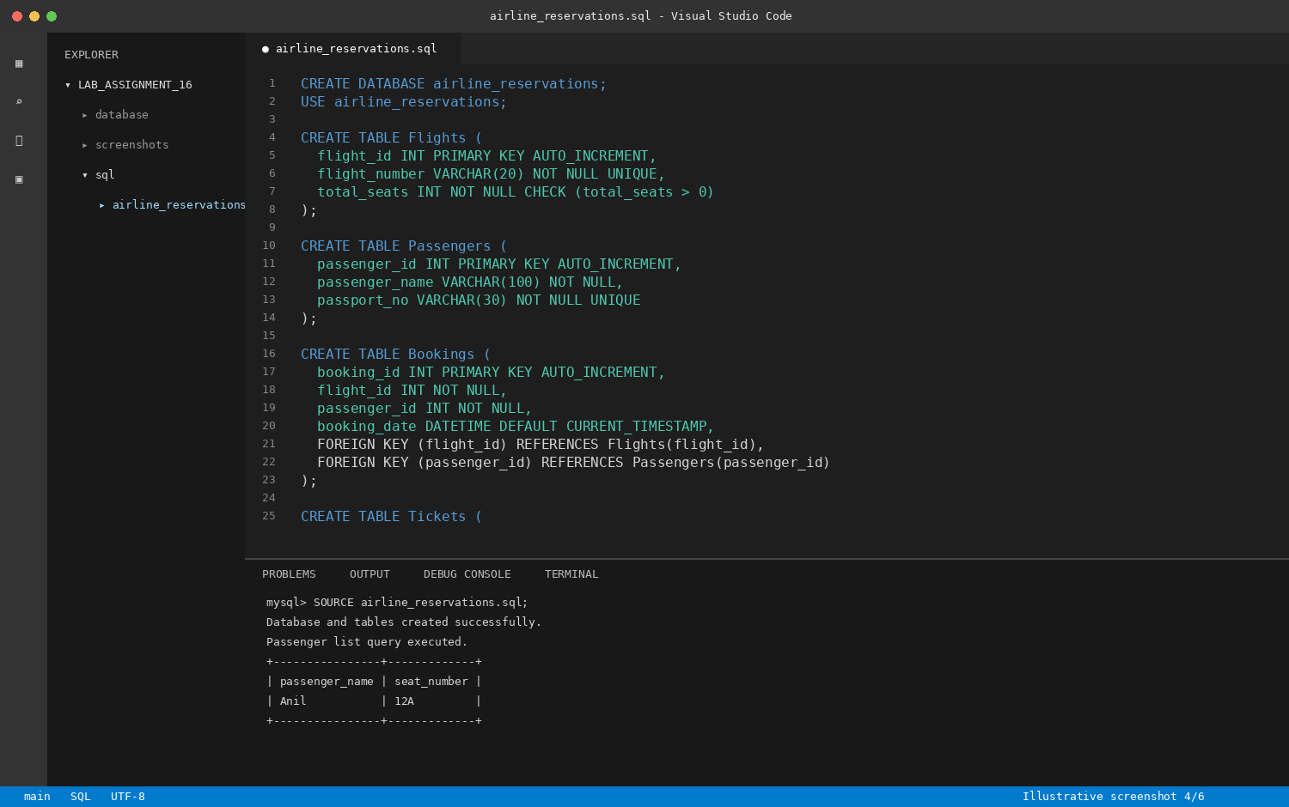
Illustrative VS Code editor and terminal view – airline_reservations.sql

Task 5: Transport Management Database
PROMPT
I am completing Lab Assignment 16 – Task 5: Transport Management Database. Generate a MySQL schema for transport route management.
Requirements:
1. Create a database named transport_management.
2. Create Vehicles, Routes, Drivers, and Assignments tables.
3. Define primary keys, foreign keys, NOT NULL and UNIQUE constraints where appropriate.
4. Model how vehicles and drivers are assigned to routes. Include suitable assignment dates or trip details.
5. Suggest useful indexes for common searches and joins, and explain why each index is useful. Avoid redundant indexes on columns already indexed by primary or unique keys.
6. Add sample records.
7. Write SQL queries to:
a) List vehicles assigned to a selected route.
b) Retrieve driver details for a selected vehicle.
c) Count trips per route.
8. Use joins and aggregate functions. Include comments and instructions to run the script in MySQL or VS Code.
Use valid MySQL syntax and beginner-friendly explanations.

VS CODE SCREENSHOT
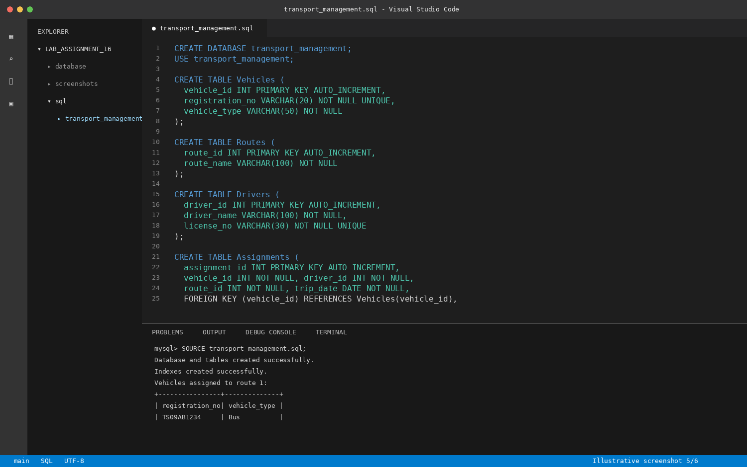
Illustrative VS Code editor and terminal view – transport_management.sql

Task 6: Hotel Reservation Database
PROMPT
I am completing Lab Assignment 16 – Task 6: Hotel Reservation Database. Generate a relational MySQL schema for hotel reservations.
Requirements:
1. Create a database named hotel_reservations.
2. Create Hotels, Rooms, Guests, and Reservations tables.
3. Define primary keys, foreign keys, NOT NULL and UNIQUE constraints where appropriate.
4. Define date constraints so check-out is later than check-in.
5. Model relationships between hotels, rooms, guests, and reservations.
6. Explain how to check room availability for a date range. Avoid overlapping active reservations for the same room; explain that this requires appropriate application logic or transaction-safe enforcement in addition to basic table constraints.
7. Add sample data.
8. Write SQL queries to:
a) List all reservations for a selected guest.
b) Find available rooms for a date range.
c) Calculate occupancy rate per hotel.
9. Use joins and aggregate functions, add comments, and provide instructions to run the script in MySQL or VS Code.
Use valid MySQL syntax and beginner-friendly explanations.

VS CODE SCREENSHOT
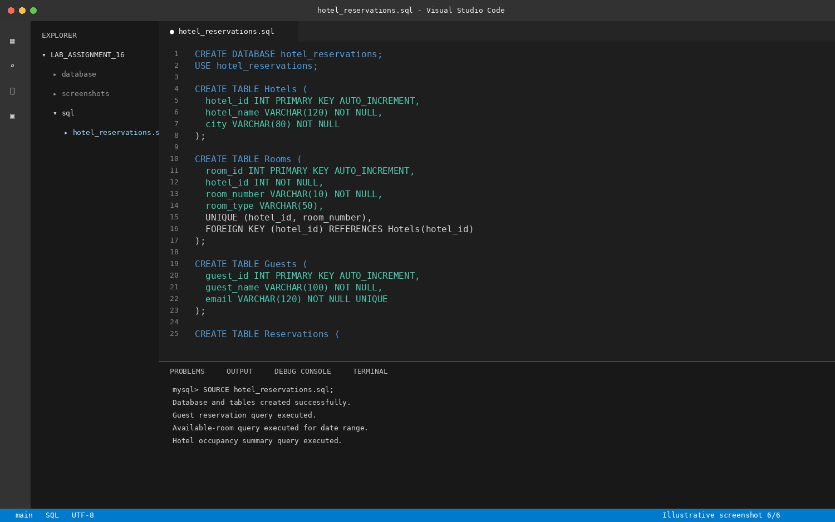
Illustrative VS Code editor and terminal view – hotel_reservations.sql

Submission Checklist
- All six database tasks are included.
- Each task has its prompt followed immediately by a VS Code-style screenshot.
- SQL examples demonstrate schema definitions, constraints, relationships, joins, and aggregate queries as required.
- Run and verify the SQL scripts in your own MySQL environment before submission.
- Add your name, roll number, and section on the cover page.
Screenshot note: The screenshots in this document are illustrative VS Code-style mockups showing example SQL code and terminal output. They are not captures from your own VS Code/MySQL installation. Verify the SQL and replace them with actual execution screenshots if your instructor requires genuine software captures.

