LAB ASSIGNMENT – 19
CODE TRANSLATION: CONVERTING BETWEEN PROGRAMMING LANGUAGES

Course Title | AI Assisted Coding
Course Code | 25CS002PC304
Program / Year / Semester | B.Tech / II / I
Regulation | R25
Academic Year | 2026–2027
Assignment Number | 19 of 24
Student Name | G.BhanuTeja
Roll Number | 2503a51247
Section / Batch | 43

Submitted as a single report containing AI prompts, source and translated code, explanations, test outputs, and editor screenshots.

Lab Objectives
- Understand how AI tools can assist in translating code between different programming languages.
- Verify correctness and functionality after translation.
- Explore syntactic and semantic differences between Python, Java, C++, SQL, and Pandas.
- Practice debugging and validating AI-translated code.

Software and Requirements
Visual Studio Code (or another code editor), Python 3, Java JDK, a C++ compiler, and Python Pandas are used as applicable. Task 4 additionally requires a Flask environment and a Spring Boot project with the Spring Web dependency.

Procedure
- Read the original program or query and identify its purpose.
- Give the stated prompt to an AI coding assistant to request an equivalent implementation.
- Review the translated code for syntax, library, and behavior differences.
- Run both versions with the same sample data or requests.
- Compare outputs and record observations.

Task 1 – Python to Java Conversion (File Handling)

AI Prompt
Convert the following Python file-handling program into an equivalent Java program. The program must read a text file named input.txt, convert each line to uppercase, write the converted lines to output.txt, handle file exceptions, and print a completion message. Preserve the same behavior and output.

Original / Source

Python source code
# Read input.txt, convert each line to uppercase, and write output.txt
try:
with open("input.txt", "r", encoding="utf-8") as source:
lines = source.readlines()
with open("output.txt", "w", encoding="utf-8") as target:
for line in lines:
target.write(line.upper())
print("File processing completed successfully.")
except FileNotFoundError:
print("Error: input.txt was not found.")
except OSError as error:
print("File error:", error)

Translated Java code
import java.io.*;
import java.nio.file.*;
public class FileTranslation {
public static void main(String[] args) {
Path input = Paths.get("input.txt");
Path output = Paths.get("output.txt");
try (BufferedReader reader = Files.newBufferedReader(input);
BufferedWriter writer = Files.newBufferedWriter(output)) {
String line;
while ((line = reader.readLine()) != null) {
writer.write(line.toUpperCase());
writer.newLine();
}
System.out.println(
"File processing completed successfully.");
} catch (NoSuchFileException e) {
System.out.println("Error: input.txt was not found.");
} catch (IOException e) {
System.out.println("File error: " + e.getMessage());
}
}
}
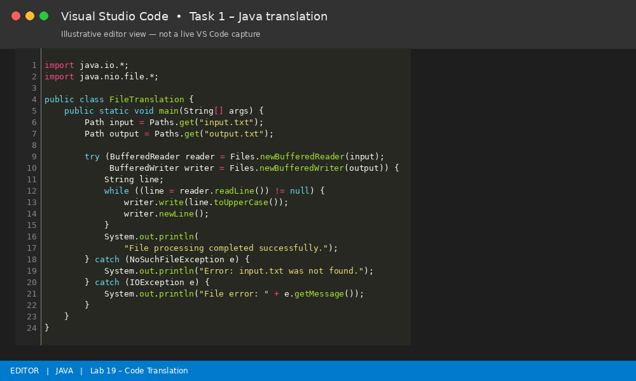
Figure: Illustrative VS Code-style editor view of Task 1 – Java translation.

Code Explanation and Comments
Python uses open() with a context manager, while Java uses BufferedReader and BufferedWriter inside try-with-resources. Both automatically close the files. The Java version catches missing-file and general I/O exceptions. Each input line is converted with toUpperCase() and written to the output file.

Sample Output
File processing completed successfully.\n\noutput.txt:\nHELLO WORLD\nAI ASSISTED CODING

Testing and Verification
Create input.txt in the same folder as the program. Run the Python and Java versions. Compare output.txt and confirm that both produce the same uppercase content.

Task 2 – C++ to Python Function Conversion (Bubble Sort)

AI Prompt
Translate this C++ Bubble Sort program into Python. Keep the same ascending-order sorting behavior. Use a function, accept a list of integers, and demonstrate the result using a sample list. Explain the equivalent logic.

Original / Source

C++ source code
#include <iostream>
using namespace std;
void bubbleSort(int a[], int n) {
for (int i = 0; i < n - 1; i++) {
for (int j = 0; j < n - i - 1; j++) {
if (a[j] > a[j + 1]) {
int temp = a[j];
a[j] = a[j + 1];
a[j + 1] = temp;
}
}
}
}
int main() {
int a[] = {64, 34, 25, 12, 22, 11, 90};
int n = sizeof(a) / sizeof(a[0]);
bubbleSort(a, n);
cout << "Sorted array: ";
for (int i = 0; i < n; i++)
cout << a[i] << " ";
cout << endl;
return 0;
}

Translated Python code
def bubble_sort(numbers):
n = len(numbers)
for i in range(n - 1):
for j in range(n - i - 1):
if numbers[j] > numbers[j + 1]:
numbers[j], numbers[j + 1] = (
numbers[j + 1], numbers[j]
)
return numbers
values = [64, 34, 25, 12, 22, 11, 90]
print("Sorted array:", *bubble_sort(values))
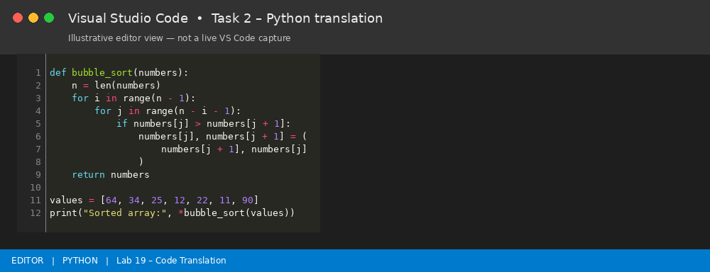
Figure: Illustrative VS Code-style editor view of Task 2 – Python translation.

Code Explanation and Comments
Bubble Sort repeatedly compares adjacent elements and swaps them when they are in the wrong order. The inner loop becomes shorter after each pass because the largest remaining value moves to the end. Python swaps two values in one statement; C++ uses a temporary variable.

Sample Output
Sorted array: 11 12 22 25 34 64 90

Testing and Verification
Test an already sorted list, a reverse-sorted list, a list with duplicates, and a single-element list. Expected results should be in ascending order.

Task 3 – SQL GROUP BY to Pandas

AI Prompt
Convert this SQL query into equivalent Python Pandas code. Use a sample sales table with department and amount columns. The SQL query groups records by department and calculates total sales and average sales. Display the result and explain the mapping between SQL GROUP BY and Pandas groupby().

Original / Source

SQL source query
SELECT department,
SUM(amount) AS total_sales,
AVG(amount) AS average_sales
FROM sales
GROUP BY department
ORDER BY department;

Translated Pandas code
import pandas as pd
# Sample data equivalent to the SQL sales table
sales = pd.DataFrame({
"department": ["CSE", "ECE", "CSE", "ECE", "CSE"],
"amount": [1200, 900, 800, 1100, 500]
})
result = (
sales.groupby("department", as_index=False)
.agg(
total_sales=("amount", "sum"),
average_sales=("amount", "mean")
)
.sort_values("department")
)
print(result.to_string(index=False))
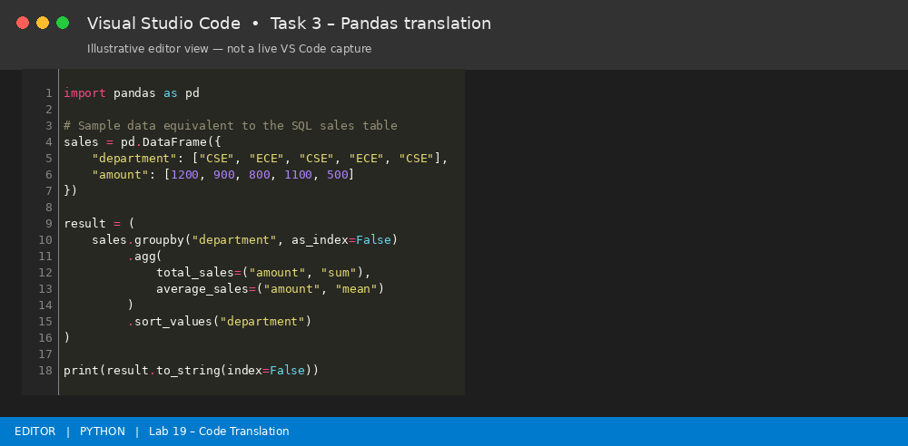
Figure: Illustrative VS Code-style editor view of Task 3 – Pandas translation.

Code Explanation and Comments
SQL GROUP BY department is equivalent to DataFrame.groupby('department'). SUM(amount) maps to the Pandas sum aggregation, and AVG(amount) maps to mean. as_index=False keeps department as a normal column. sort_values() matches ORDER BY department.

Sample Output
department total_sales average_sales\n CSE 2500 833.333333\n ECE 2000 1000.000000

Testing and Verification
Run the code with the supplied sample data. Check CSE total = 1200 + 800 + 500 = 2500 and ECE total = 900 + 1100 = 2000. The averages are 833.33 and 1000 respectively.

Task 4 – Real-Time Application: Multi-Language Snippet Converter

AI Prompt
Convert this simple Python Flask REST endpoint into an equivalent Java Spring Boot REST endpoint. Both versions should expose GET /api/greeting?name=... and return a greeting string. Include the required Java imports and application entry point. Explain differences in framework structure and request handling.

Original / Source

Python Flask source code
from flask import Flask, request
app = Flask(__name__)
@app.get("/api/greeting")
def greeting():
name = request.args.get("name", "Student")
return f"Hello, {name}! Welcome to the API."
if __name__ == "__main__":
app.run(port=5000)

Java Spring Boot translation
import org.springframework.boot.SpringApplication;
import org.springframework.boot.autoconfigure.SpringBootApplication;
import org.springframework.web.bind.annotation.*;
@SpringBootApplication
public class GreetingApplication {
public static void main(String[] args) {
SpringApplication.run(GreetingApplication.class, args);
}
}
@RestController
@RequestMapping("/api")
class GreetingController {
@GetMapping("/greeting")
public String greeting(
@RequestParam(defaultValue = "Student") String name) {
return "Hello, " + name + "! Welcome to the API.";
}
}
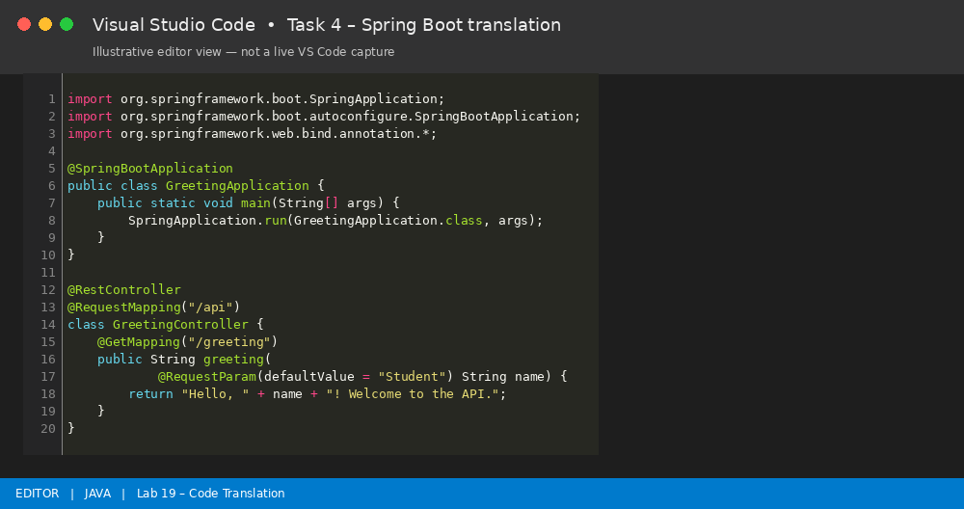
Figure: Illustrative VS Code-style editor view of Task 4 – Spring Boot translation.

Code Explanation and Comments
Flask uses a Python function decorated with @app.get. Spring Boot uses a controller class with @RestController and a method annotated with @GetMapping. Flask reads the query parameter through request.args.get(), while Spring uses @RequestParam. Both use Student when the name parameter is omitted.

Sample Output
Request: GET http://localhost:5000/api/greeting?name=Bhanu\nResponse: Hello, Bhanu! Welcome to the API.\n\nRequest without name parameter:\nResponse: Hello, Student! Welcome to the API.

Testing and Verification
Run Flask with its dependencies installed. Run the Spring Boot application in a project containing the Spring Web dependency. Send the same GET requests to each server (use the configured port) and compare response text. The Java example requires a Spring Boot project; it is not a standalone javac program.

Task 5 – Basic Function Translation (Python to C++)

AI Prompt
Translate this Python function that checks whether an integer is even or odd into equivalent C++. Preserve the modulo-based logic, read an integer from standard input, print the result, and make sure negative and positive integers are handled.

Original / Source

Python source code
def even_or_odd(number):
if number % 2 == 0:
return "Even"
return "Odd"
value = int(input("Enter a number: "))
print(even_or_odd(value))

Translated C++ code
#include <iostream>
using namespace std;
string evenOrOdd(int number) {
if (number % 2 == 0) {
return "Even";
}
return "Odd";
}
int main() {
int value;
cout << "Enter a number: ";
cin >> value;
cout << evenOrOdd(value) << endl;
return 0;
}
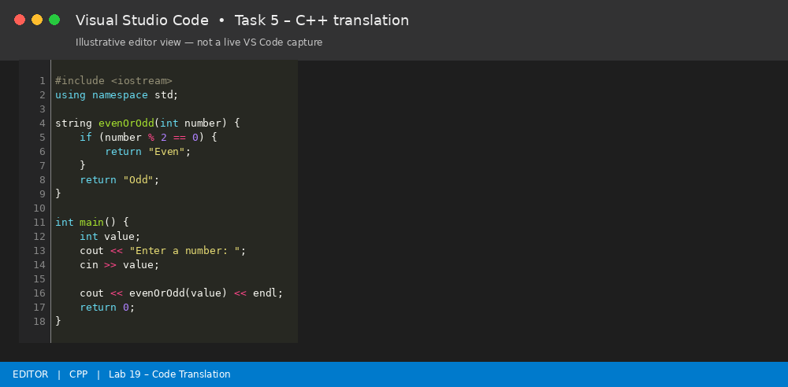
Figure: Illustrative VS Code-style editor view of Task 5 – C++ translation.

Code Explanation and Comments
Both programs use the modulo operator (%). If number % 2 equals zero, the number is even; otherwise it is odd. Python uses input() and int(), while C++ uses cin. The C++ program returns a string from the evenOrOdd() function.

Sample Output
Enter a number: 8\nEven\n\nEnter a number: 7\nOdd\n\nEnter a number: -4\nEven

Testing and Verification
Test at least three values: 8 (Even), 7 (Odd), and -4 (Even). You can also test 0, which is Even.

Overall Observations
- The same algorithm or operation can be implemented in different languages, but syntax and standard libraries differ.
- File handling in Java uses stream classes and checked I/O exceptions, whereas Python provides a compact with-open pattern.
- Bubble Sort retains the same comparison and swap logic after conversion to Python.
- SQL aggregate operations can be represented using Pandas groupby() and agg().
- Web frameworks use different structures and annotations, so equivalent API behavior must be tested through matching requests.
- A translated program should always be compiled or executed and tested with multiple inputs rather than accepted based only on generated code.

Conclusion
The lab demonstrates AI-assisted code translation across Python, Java, C++, SQL, and Pandas. Each translated implementation is accompanied by an explanation and sample verification. Correctness is established by comparing behavior and outputs, while noting language- and framework-specific requirements.

Screenshot Note
The editor images in this report are illustrative VS Code-style code views generated for documentation. They are not photographs or direct screen captures from a running VS Code session. For an authentic submission, open each corresponding file in Visual Studio Code, run it, and replace or supplement these figures with your own screenshots showing the editor and terminal output.

