Pizaa-Sales-Report
Project Overview
This project analyzes one year of pizza sales data to uncover key business insights such as revenue trends, customer ordering behavior, top-performing products, and category-wise performance. The analysis was performed using SQL for data exploration and Power BI for interactive dashboard creation.
The goal of the project is to provide a data-driven understanding of sales performance, identify improvement opportunities, and support business decision-making.
Dataset Description
The dataset represents transactional-level pizza sales data. Each row corresponds to an item sold in an order and includes details such as:
•Order information (Order ID, Order Date, Time) •Product details (Pizza Name, Category, Size) •Sales metrics (Quantity, Total Price) •Source: Pizza Sales Dataset (CSV)
Key Attributes Include
Column Name | Description
order_id | Unique identifier for each order
order_date | Date when the order was placed
order_time | Time when the order was placed
pizza_name | Name of the pizza
pizza_category | Category (Classic, Chicken, Supreme, Veggie)
pizza_size | Size (S, M, L, XL, XXL)
quantity | Number of units sold
total_price | Total price for the line item

Business Objectives
The main business objectives of this analysis are:
•Understand Overall Sales Performance Track revenue, total orders, and pizzas sold. Calculate average order value and average pizzas per order.
•Identify Trends Over Time Daily and monthly patterns in ordering behavior. Identify peak and low sale periods.
•Analyze Category & Size Performance Which pizza category contributes the most? Which size generates maximum sales?
•Evaluate Product-Level Insights Identify top & bottom pizzas by: Revenue Quantity Number of orders
•Support Business Decisions Improve marketing strategies Optimize inventory Identify best-selling categories and pizza types
Key Business Questions Answered
Here are the major questions solved using SQL and Power BI:
- What is the total revenue generated?
- What is the average order value?
- How many total pizzas were sold?
- What are the total number of orders?
- How many pizzas are ordered per order on average?
- What are the daily and monthly ordering trends?
- Which pizza category contributes the most to revenue?
- Which pizza size generates maximum sales?
- What are the best- and worst-selling pizzas?

Product Analysis:
• Sales by Pizza Category
Using SQL queries on category revenue and quantity:
Classic category leads in both revenue & number of orders.
Veggie and Supreme categories follow next. (Reference: Category Revenue Query)
Pizza_Sales_Sql_Queries
• Sales by Pizza Size
Large (L) pizzas contribute the highest revenue share.
Medium (M) and Regular (S) sizes follow.
XX-Large contributes the least due to limited demand.
• Best-Selling Products
Based on top 5 queries:
Certain Classic pizzas dominate revenue and orders.
High-performing pizzas are consistent across quantity & revenue metrics.
• Least-Performing Products
From bottom 5 queries:
A few niche pizzas (specialized flavors) have low demand.
Smaller business opportunity in these items.
• Ordering Behavior
Weekends (Friday, Saturday) show the highest order volume.
Monthly trends show peaks in July and January.

Deliverables:
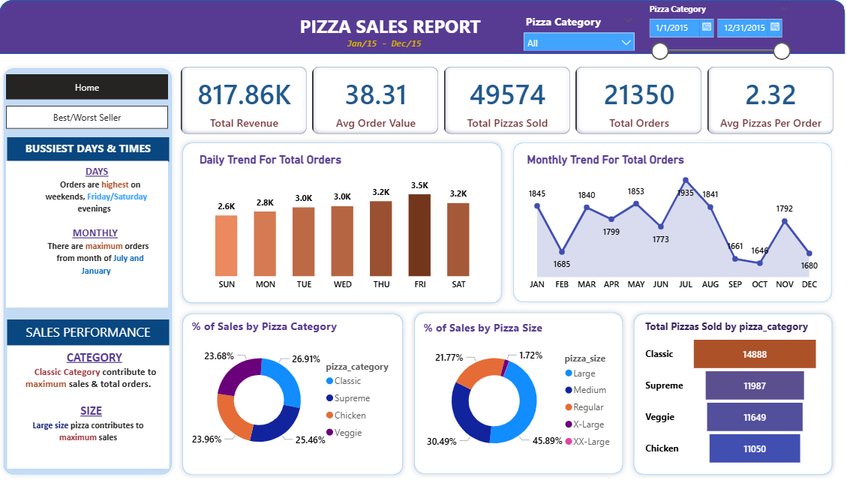

Insights From the Visualization:
1.Overall Sales Performance: The business generated $817K+ in total revenue for the year. Total orders: ~21.3K Total pizzas sold: ~49.5K Average order value (AOV): $38.31 Avg pizzas per order: 2.32 These KPIs indicate healthy sales volume and consistent customer purchasing patterns.
2.Daily Trend Analysis: Friday and Saturday are the busiest days, each seeing over 3.5K orders. Weekends show significantly higher customer engagement compared to weekdays. The flow suggests that customers prefer ordering pizzas for weekend celebrations and gatherings.
3.Monthly Trend Insights July records the highest orders, followed by January and June. September and February reflect relatively lower sales. This pattern suggests seasonality—holidays, summer activities, and festival periods drive demand.
4.Sales Distribution by Pizza Category Classic pizzas contribute the largest share of total sales (26.91%), making them the core revenue driver. Veggie, Chicken, and Supreme categories each contribute around 23–25%, showing balanced customer preferences. The Classic category should be prioritized in marketing, stock management, and promotions.
5.Sales Distribution by Pizza Size Large (L) pizzas dominate sales at 45.89%, showing strong customer preference for larger portions. Medium (M) sizes contribute 30%+, maintaining steady demand. Small, X-Large, and XX-Large sizes contribute minimal revenue, indicating these may be niche or low-demand offerings.
6.Category-Wise Quantity Sold Classic category leads in total pizzas sold (~14,888 units). Supreme (11,987), Veggie (11,649), and Chicken (11,050) follow closely. Demand across categories is fairly balanced, but Classics clearly outperform.
7.Best/Worst Sellers (From Visualization Summary) Top sellers (by revenue, quantity, and orders) are mainly from Classic and Supreme categories. Pizzas with complex toppings or premium pricing perform well. Certain niche pizzas consistently appear in bottom performers, suggesting: Limited customer interest Potential overstock risk Opportunities to optimize menu offerings
8.Customer Buying Behavior Customers tend to purchase larger-sized pizzas, often buying 2+ pizzas per order. Strong weekend spikes show shared meals and group orders. AOV and total revenue indicate a healthy spending pattern among customers.
9.Business Recommendations Based on Visualization Increase promotional campaigns around weekends to capitalize on surge demand. Promote Large Classic pizzas—your strongest revenue drivers. Monitor and optimize slow-moving pizza types to reduce waste. Consider bundled offers combining Medium + Large pizzas to increase weekday sales. Launch seasonal promotions during low-performing months like September and February.

