**Prototype Ontology for School Library**

**Introduction**

There is no better place than a library to obtain knowledge, even in the current age that we live in. Libraries have come a long way from their inception about 3000 years ago. Use [this link](https://en.wikipedia.org/wiki/History_of_libraries#:~:text=The%20first%20libraries%20appeared%20five,writing%2C%20sometime%20before%203000%20BC) to find out more. In my opinion, a library is a sacred place for the human beings of any generation, wanting to enrich their knowledge on any subject matter. With the advancements in technology, one can safely say, that libraries today, across the globe, have undergone major changes in how they function. Especially, the addition of computers in the library, has played a major role in the aforementioned change. This, however has hindered certain aspects, or experiences rather, of human beings who like to visit the library, spend quality time in exploring various resources offered by it, in the form of physical books. Nevertheless, this change in the library can be balanced. That is going to be the aim of this current project.

**Business Context and Justification**

To give this project some business context, the library in an institution wants to improve its services offered to its users by using the technologies available today. They have taken the aid of a software named Protégé ([sample video](sample%20video)), which can help organize their resources and serve the readers efficiently. The above mentioned library has a plethora of books, wherein the genres range from fiction to non-fiction, with many other genres in between them. With the use of Protégé, the library was able to develop something called an ‘Ontology’, using which the librarians/Receptionists will be able to guide the readers better to what they are looking for. In simple terms, an ontology is something similar to that of a flow chart, that helps organize and identify the resources present in the library, using which, the library staff can guide its readers. And since the institution is only prototyping this new change in their library, the designed ontology also has a limited number of entities/classes, subclasses, and instances. Should this prove to be successful, the institution will be base this prototype run as a benchmark and further develop deeper ontologies, possibly across the various departments of the whole institution (admin, staff, etc.).

**Rationale**

The institutes library primarily consists of two sections, the first being E-Library, where readers can utilize computers to surf the internet and browse for books, journals, articles and many other resources, and the second being the Regular Library, where the readers can access physical copies of what they are looking for and consume the same. It is to be noted that the books present on the computers in the E-Library section are also present in the Regular Library section, just to maintain the essence and the experience of physically going to the library and accessing a book. Furthermore, each section is divided into few more sections or wings. The E-Library has 4 wings, namely, Art-and-History, Curie, Feynman, and Ramanujan, each pertaining to a specific genre. The machines present in these wings are designed in such manner as well. Nevertheless, these machines can surf the internet too. In a similar manner, the Regular Library has wings and are named VanGogh-and-Napoleon, James-Bond, R-and-J, and Tom-Cruise, respectively. Each of these wings in both sections of the library have resources at the ready for the readers. All the above wings have been assigned with a unique ID using the Protégé software (Ontology file included at the end of report and on the submission portal).

The representation of this on Protégé is done with the Web Ontology Language (OWL), and looks something like the image shown below.

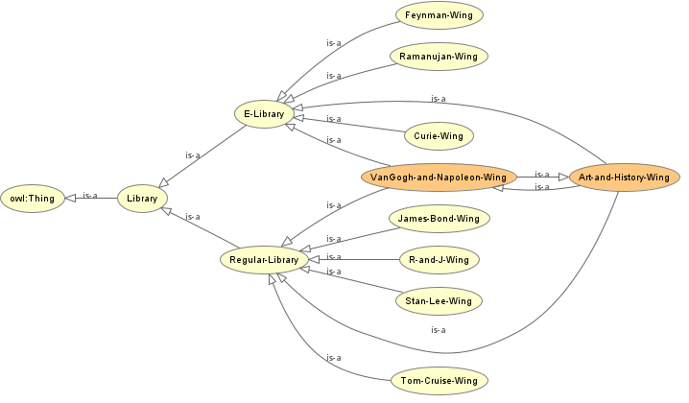

Figure 1: Ontology Visualization of the Library.

In Protégé, each ontology starts with something called ‘owl: Thing’ or simply put, the root. The ontology is then expanded as per the requirement, in this case, library, which further consists of E-Library and Regular-Library, which, further contain their respective wings. In our case, we previously stated that the books present in the Art-and-History wing of the E-library are also present in the VanGogh-and-Napoleon wing of the regular library. They are similar. Hence the orange instances in the above image.

The library primarily consists of the receptionist (also the librarian), maintenance staff, and managers of each section of the library, called as Wingers. Each of these members are assigned an ID of their own. This is done using the Object Properties and the Data Properties tab in Protégé. Next, each wing is constituted with resources; books, in our case. After doing so, Protégé produces something called inferences, which tells us information about any specific branch in the ontology. An inference will not be generated if there is any inconsistency present in the ontology. Protégé throws an error, explaining the same. This is explained in detail below.

**Analysis and Demonstration**

Let’s assume that a reader wants access to physics materials. The Librarian uses Protégé to guide the reader to the physics section as follows:

* The librarian navigates to the library section, identifies that the physics materials are present in the Feynman Wing of the E-Library section.
* The librarian then assists the reader to contact the winger of the E-Library section, who can finally help the reader access the Feynman Wing.
* The reader finally accesses the Feynman Wing and continues with their work.

This can be seen on Protégé as follows (double click icon to enlarge image):



Figure 2: Assisting Reader with Their Requirement Using Ontology.

The top left section of the image indicates the classes and subclasses present in the ontology. The bottom left section of the image tells us the instances present in each class or subclass. The right half of the image contains details about the properties of the classes, subclasses, instances, their datatypes, and so on.

The librarian was able to guide the reader accurately because Protégé produced an inference with no error. An inference with no error implies that the ontology is consistent and is in the right place. In this manner, the library can utilize Protégé to serve the readers efficiently. This can possibly be set as the benchmark and deeper and more insightful ontologies can be built for various departments of the institution.

**References:**

Wikipedia (2023) History of libraries, Available from: https://en.wikipedia.org/wiki/History_of_libraries#:~:text=The%20first%20libraries%20appeared%20five,writing%2C%20sometime%20before%203000%20BC [Accessed April 10 2023].

Read This Twice (N.D.) 94 best art history books. Available from: https://www.readthistwice.com/lists/best-art-history-books [Accessed April 10 2023].

Nayang Technological University Singapore (2023) Libguides: Chemistry: Books. Available from: https://libguides.ntu.edu.sg/chemistry/books [Accessed April 10 2023].

Read This Twice (N.D.) 98 best physics books. Available from: https://www.readthistwice.com/lists/best-physics-books [Accessed April 10 2023].

Read This Twice (N.D.) 100 best math books. Available from: https://www.readthistwice.com/lists/best-math-books [Accessed April 10 2023].

American Inst. of Mathematics (N.D.) Approved textbooks: American Inst. of Mathematics. Available at: https://aimath.org/textbooks/approved-textbooks/ [Accessed April 10 2023].

Read This Twice (N.D.) 100 best adventure books. Available from: https://www.readthistwice.com/lists/best-adventure-books [Accessed April 10 2023].

Read This Twice (N.D.) 39 best young adult romance books. Available from: https://www.readthistwice.com/lists/best-young-adult-romance-books [Accessed April 10 2023].

Read This Twice (N.D.) 21 best royal romance books. Available from: https://www.readthistwice.com/lists/best-royal-romance-books [Accessed April 10 2023].

Read This Twice (N.D.) 19 best historical romance books. Available from: https://www.readthistwice.com/lists/best-historical-romance-books [Accessed April 10 2023].

Read This Twice (N.D.) 100 best comic books. Available from: https://www.readthistwice.com/lists/best-comic-books [Accessed April 10 2023].

Read This Twice (N.D.) 61 best psychological thriller books. Available from: https://www.readthistwice.com/lists/best-psychological-thriller-books [Accessed April 10 2023].

Read This Twice (N.D.) 100 best science fiction books. Available from: https://www.readthistwice.com/lists/best-science-fiction-books [Accessed April 10 2023].

Read This Twice (N.D.) 65 best cyberpunk books. Available from: https://www.readthistwice.com/lists/best-cyberpunk-books [Accessed April 10 2023].

**Appendix**

Figure 1: Ontology Visualization of the Library.

Figure 2: Assisting Reader with Their Requirement Using Ontology.

Ontology File:

