**Prototype Ontology for XYZ Pharma**

**Introduction**

The process of healing in a living organism has been known for a very long time to humankind. With evolution of time and technology, people have managed to industrialize the same and call it the Healthcare Domain or Healthcare Industry. The healthcare domain is one of worlds largest contributors to the generation of data, production of effective medicines, and most importantly, curing peoples’ lives. Physio-pedia.com (N.D.) states that according to the World Health Organization (WHO), a health system is a culmination of organizations whose main intention is to promote, restore and maintain health. They say that the health system is a pyramid of publicly owned facilities that serve in this domain. You can find more info [here](https://www.physio-pedia.com/Health_Care_Systems). G C Reddy (2021) says that the healthcare domain is essential for software developers, and analysts to gather insights, and patterns generated from the data. Reddy has also explained the bits and bobs that are required for the purchase of a healthcare policy in India. [This](https://www.gcreddy.com/2021/08/healthcare-domain-knowledge.html) link gives more info on the same. Our point of interest in the healthcare domain is the pharmacy division, who, primarily manufacture and sell the medicines, thereby promoting good health. This domain, backed by AI, is bound to yield significant results and we will see this by using the example of a pharma company and how they managed to inculcate AI in their practice.

**Business Context and Justification**

In the interest of the assignment, we will now explore how XYZ Pharma, a company that specializes in the manufacture and sales of prescribed and Over the Counter (OTC) medicines, for pets. The company had decided to adapt to the use of AI because of the increase in the demand for consultations, which further led to a delay in its online services. XYZ Pharma has its own pharmacy and consultation divisions for which they were planning to introduce an AI powered system. To develop the system, the company has relied on Protégé, a software that is specifically used to design systematic workflows ([Sample video here](https://www.youtube.com/watch?v=LQ4iW3PO36E&t=703s) ), to serve its customers. Using Protégé, they have developed an ‘Ontology, which will help them run things smoothly. This designed ontology is still a prototype and that is why, they have decided to trial run it first with limited resources like medicines in the pharmacy division and scheduling an appointment with only 7 doctors. Should this prove to be successful, the pharmacy could benchmark this prototype ontology and build more complex and efficient ontologies for better services.

**Rationale**

As mentioned above, the company consists of 2 divisions namely the pharmacy and the consultation divisions. The pharmacy division is primarily responsible for the sale of medicines, both prescribed and OTC where as the consultation division, as the name suggests, helps consultation of patients with the doctors. The Ontology was devised in such a way that the incoming patients would have a choice of their own in choosing which method would they prefer while using the services, i.e., whether they like online services or offline services. The ontology has an online and an offline option for the pharmacy division using which the customers can choose whichever they like their medicine to be delivered. Similarly, the consultation division of the ontology too offers choice to the patients with the options of physical appointments and virtual appointments. By designing the prototype ontology in this way, the company is able to make a customer-centric move, giving priority as well as flexibility to the customer, indirectly enhancing the customers’ experience.

The below figure represents the flow chart generated by the Protégé software.

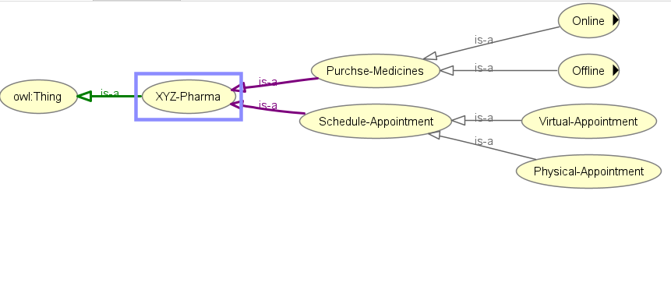

Figure 1: Flowchart Generated by Protégé.

As we can see, the online and offline options in the purchase medicine section can further be expanded. The same is shown below.

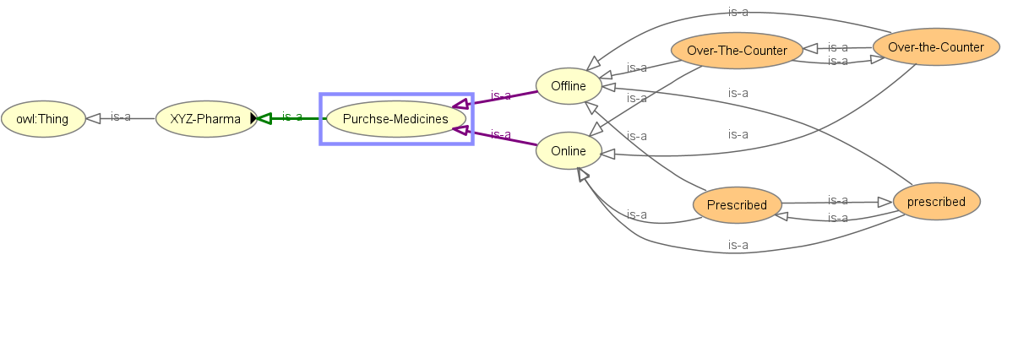

Figure 2: Complete Flow Chart of the Pharmacy Division using Protégé.

In this prototype ontology, the company, for simplicity, has made all the medicines available online and offline, thereby giving people the choice.

The following image shows the options available to the customer in the schedule appointment (consultation) section.

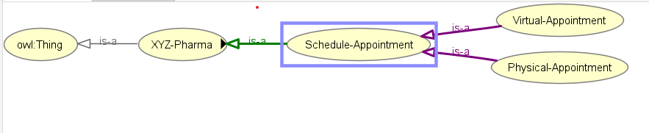

Figure 3: Complete Flow Chart of the Consultation Division using Protégé.

Each section of the ontology has been assigned to an individual, with a unique identifier, and is responsible for carrying out the activity. For instance, the below image (double click to enlarge) represents that Bruce Banner is the individual with an ID of Ch02 is responsible for the offline section of the pharmacy division.



Figure 4: Assertion of Individuals to Each Division of Ontology

The whole graph (graph file in appendix) of the ontology looks like this:

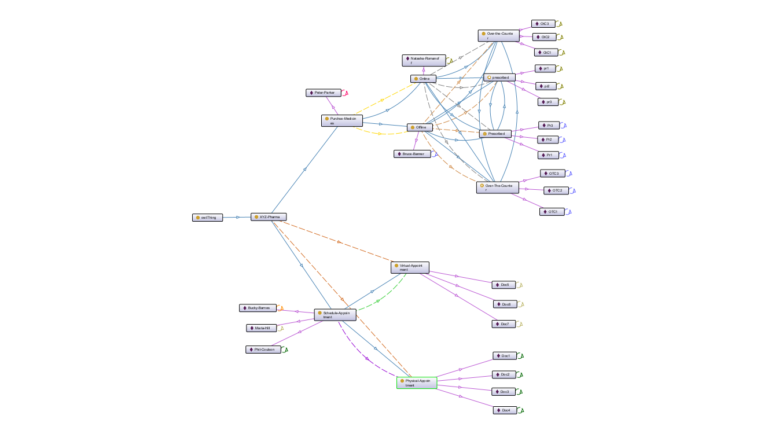

Figure 5: Ontology Graph using Protégé.

Furthermore, we will explore how to read the ontology, how to check whether there are errors and how to visualize the whole ontology.

**Analysis and Demonstration**

In order to determine the correctness of an ontology, Protégé generates what are called as ‘Inferences’. Inferences are generated by a logic called reasoner and Protégé has a good number of reasoners built into it. For this prototype ontology, HermiT 1.4.3.456 version of the reasoner was used (Info on the reasoner [here](http://www.hermit-reasoner.com/)). Using these inferences, the user can recommend a solution desired by the customer. Protégé cannot generate an inference if there’s a blocker in the developed ontology. The inference highlights the different hierarchies present in the ontology, same individuals if present in 2 different sections, and so on. The below image is the depiction of an inference of an ontology.

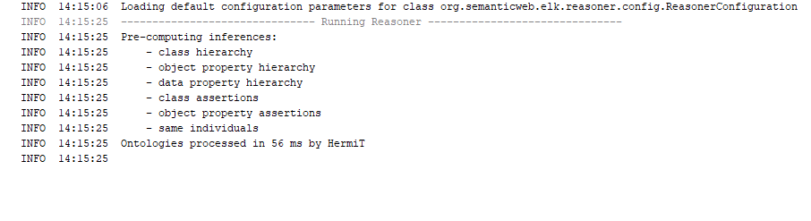

Figure 6: Inference Log by the Ontology.

Also, you can read the inference for any given instance using Protégé. You can access the explanation of the inference by clicking on the question mark beside the instance. Now, we will move on to how an employee of the company can use Protégé for making recommendations to the customers.

Assume a patient wants to get his pet dog checked up, and he visits the facility. The receptionist can do the following procedure to help out the customer:

* Offer a choice of online and offline consultation.
* If online, direct the customer to the dedicated doctor for the treatment.

After this procedure, the chemist, who manages the pharmacy, can do the following:

* Offer the choice of purchasing the medicine online or offline.
* If online, direct the customer to the respective division.

The point to be noted here is that when it comes to prescribed medicine, whether purchasing online or offline, the customer has to produce a copy (physical or soft) in order to purchase the medicine. In this manner, the staff of the company can effectively utilize the Protégé software and make effective recommendations to its customers.

Should this prototype be successful, the company can use this as a benchmark and develop more meaningful and deep ontologies across all its departments. This is how XYZ Pharma has leaned onto AI to build a prototype ontology for its pharmacy and consultation divisions respectively.

**References:**

Physiopedia (N.D.) Health Care Systems, Physiopedia. Available From: https://www.physio-pedia.com/Health_Care_Systems [Accessed 31 July 2023].

Reddy, G.C. (2021) Healthcare Domain Knowledge, Software Testing. Available From: https://www.gcreddy.com/2021/08/healthcare-domain-knowledge.html [Accessed 31 July 2023].

Protege Tutorial (2021) YouTube. YouTube. Available From: https://www.youtube.com/watch?v=LQ4iW3PO36E&t=703s [Accessed 31 July 2023].

Data and Knowledge Group (N.D.) Data and Knowledge Group, HermiT Reasoner: Home. Available From: http://www.hermit-reasoner.com/ [Accessed 31 July 2023].

**Appendix**

Figure 1: Flowchart Generated by Protégé.

Figure 2: Complete Flow Chart of the Pharmacy Division using Protégé.

Figure 3: Complete Flow Chart of the Consultation Division using Protégé.

Figure 4: Assertion of Individuals to Each Division of Ontology

Figure 5: Ontology Graph using Protégé.

Figure 6: Inference Log by the Ontology.

Attached below are the ontology file and the graph file generated by the ontology.

 