# FL-01: AI Workflow Audit & Tool Setup
**Name:** [Bharadwaj Mittapelli]
**Role:** Backend AI Engineer Intern

## 1. Tool Setup & Course Evidence
* [ ] ChatGPT Account: Active (Free Tier)
* [ ] Anthropic Academy Account: Active
* [ ] Course Enrolled: AI Fluency: Framework & Foundations (Module 1 Completed)
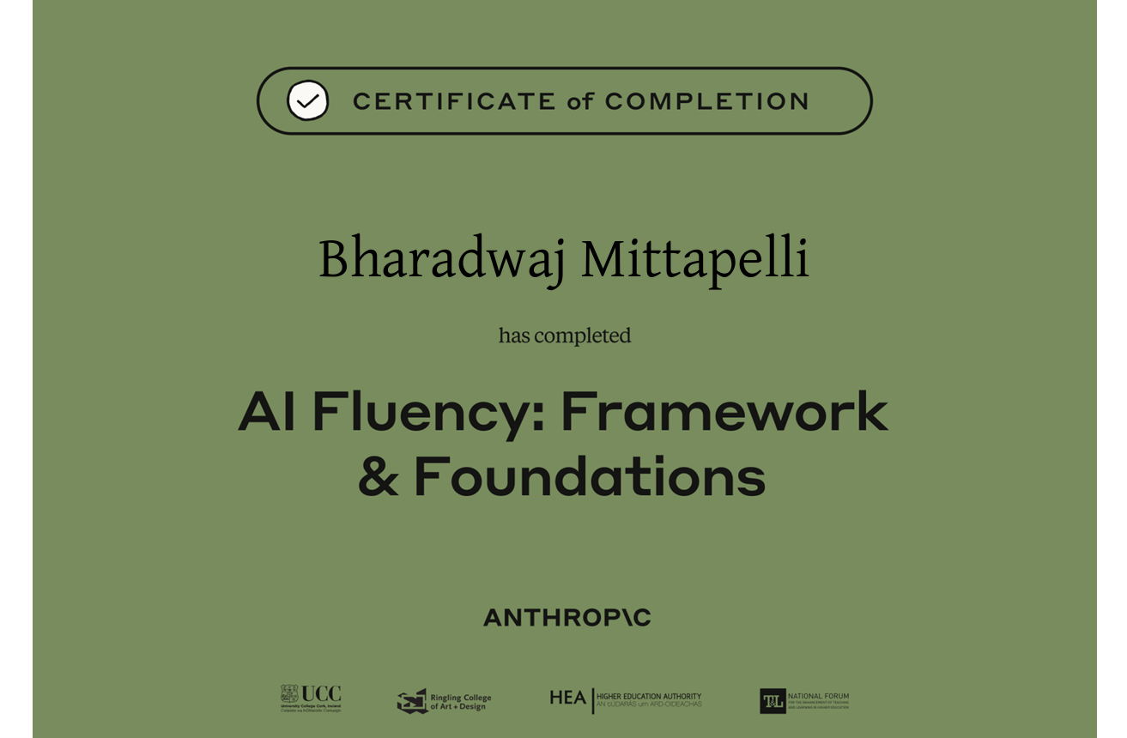

## 2. Claude Project Configuration
* Project Name: Flyrank-Backend-Internship
* Custom Instructions: Applied (Backend engineering focus)
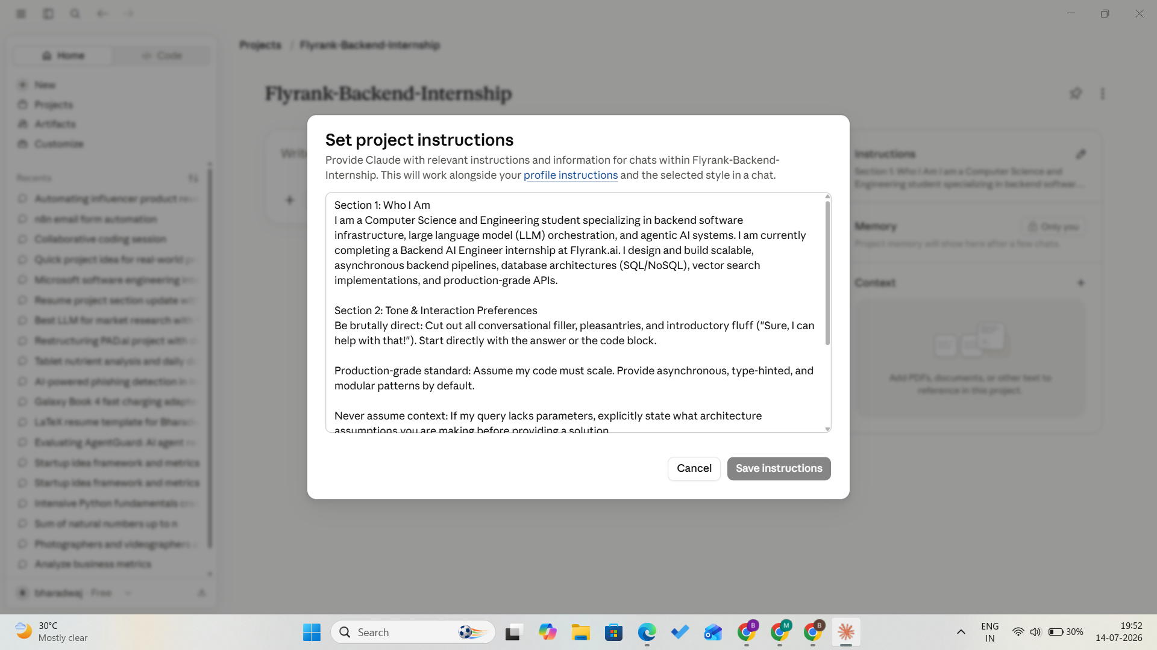

## 3. Workflow Audit Table

# | Recurring Task | Classification | One-Line Rationale
1 | Completing repetitive laboratory records and standard documentation for the IARE (Institute of Aeronautical Engineering) curriculum. | Delegate with Review | Standard academic theory definitions and boilerplate structures are easily drafted by AI, allowing me to focus strictly on verifying the calculations.
2 | Writing boilerplate frontend components using Tailwind CSS and React for project dashboards. | Fully Automate | Translating wireframes into functional Tailwind utility classes is a mechanical task that LLMs execute flawlessly from a structural description.
3 | Reviewing code logic and pull requests from peers on collaborative projects. | Just me | Delegating code reviews entirely to an LLM creates a dangerous dependency; human accountability is mandatory to maintain absolute system integrity.
4 | Formulating the long-term proprietary ecosystem strategy and platform monetization models for my startup concepts. | Just me | High-level entrepreneurial vision, defensibility planning, and market positioning require deep human intuition that static models cannot replicate.
5 | Parsing and filtering incoming daily emails for critical industry alerts, platform notices, or recruitment updates. | Delegate with Review | I use automated rules or an LLM script to summarize dense newsletters and filter out marketing spam, but I manually review direct recruitment threads.
6 | Scouting job boards and executing application forms for external software engineering internships. | Collaborate with AI | I use AI to match my resume bullet points precisely against a job description's keywords, but I execute the manual submission myself to prevent form parsing errors.
7 | Reviewing the IARE college communication portal for daily notices, exam schedules, and compliance updates. | Just me | Relying on AI scraping for high-stakes university compliance risks missed deadlines due to portal UI changes or session authentication timeouts.
8 | consuming long-form technical podcasts, business breakdowns, and deep-dive updates on AI/AGI developments on YouTube. | Delegate with Review | I feed video transcripts to an LLM to extract core architectural claims and engineering breakthroughs, then manually watch only the high-value segments to avoid wasting hours.
9 | Formulating the long-term proprietary ecosystem strategy and platform monetization models for my startup concepts. | Just me | High-level entrepreneurial vision, defensibility planning, and market positioning require deep human intuition that static models cannot replicate.
10 | Architecting the Instagram Graph API webhook receivers and comment parsing engine for my short-form video e-commerce startup. | Collaborate with AI | I engineer the system architecture and handle Meta's strict OAuth/permission flows; I use AI to write the regex patterns and payload extraction scripts.
11 | Developing production grade RAG application. | Collaborate with AI | Engineering the system architecture & handle data pipelines.

## 4. Target Tasks for FL-02 through FL-04

Target Task 1: Writing Asynchronous Unit Tests for Backend APIs * **What "Done Well" Means:** Reaching a minimum baseline of 85% statement and branch test coverage across all primary routing and controller files. * **Measurable Success Criteria:** The test suite runs entirely decoupled from live databases (using mocks/fakes), executes concurrently in under 10 seconds, and yields zero flaky test results across 50 consecutive automated iterations.

Target Task 2: Optimizing Database Schema Performance & Query Latency * **What "Done Well" Means:** Restructuring indexes and rewriting queries to eliminate redundant table scans and minimize memory utilization under load. * **Measurable Success Criteria:** The target database queries execute with an execution time under 50ms at p95 benchmarks under a simulated local load test of 50 concurrent requests per second.
Target Task 3: Formatting and Synthesizing Contextual Data for RAG Pipelines * **What "Done Well" Means:** Programmatically chunking and processing raw technical documents into structured formats optimized for vector database ingestion. * **Measurable Success Criteria:** Generating chunks that preserve semantic context perfectly (zero dropped critical entities) while ensuring the token length variance between chunks stays within a strict 15% tolerance threshold.

