# Assignment 2- Submission: Portfolio Sitemap & System Toolkit
**Name:** Mittapelli Bharadwaj
**Role:** Backend AI Engineer Intern
**Organization:** Flyrank.ai
**Date:** July 2026

---

## 1. Tool Setup Verification
All core AI research and assistance tools have been registered and configured for this internship track:
* [x] **Claude.ai:** Active (Custom Project "Portfolio-Build-Tutor" created)
* [x] **ChatGPT:** Active (Free Tier)
* [x] **Gemini:** Active
* [x] **Perplexity:** Active

---

## 2. Lean Portfolio Sitemap
My portfolio is structured strictly to serve as a high-conversion funnel. The goal is to take an overworked engineering manager from landing to believing, culminating in a direct technical code-review call.

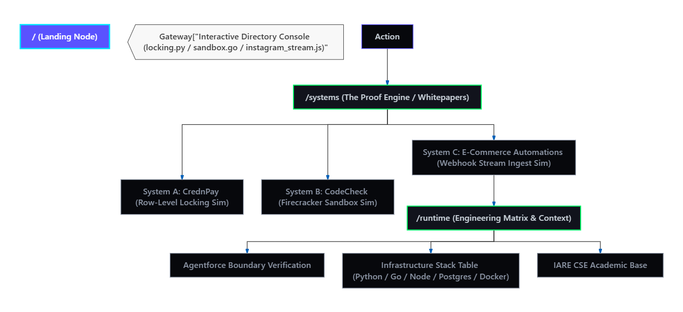
### Route & Architecture Breakdown:
1. **`/` (The Landing Node):** States my core backend thesis immediately (building deterministic infrastructure out of non-deterministic components). It features a single, prominent call-to-action (CTA) to book a system review.
2. **`/systems` (The Proof Engine):** High-depth technical write-ups of my actual builds rather than generic feature lists:
* **CrednPay:** Async escrow processing, webhook validation, and PostgreSQL transaction lock handling under race conditions.
* **CodeCheck:** Isolated dynamic cloud code execution environments and sandboxed runtime safety boundaries.
* **Instagram Graph API Automations:** Real-time event-driven webhook processing and rate-limiting navigation.
3. **`/runtime` (The Engineering Matrix):** A structured layout of my operational capacity, including my verified **Salesforce Agentforce Specialist** certification, backend stack proficiencies (Python, FastAPI, Redis, Docker), and computer science foundations from **IARE**.

---

## 3. Claude Project Configuration
* **Project Name:** `portfolio-sitemap `
### Configured Custom Instructions:
> You are an elite Backend AI Systems Architect acting as my personal technical tutor for an 8-week engineering portfolio build. My target audience consists of Engineering Managers at high-scale tech firms (e.g., Salesforce Futureforce, JPMorgan Chase) and AI automation companies like Flyrank.ai.
>
> My Core Claim:
> "I engineer scalable, deterministic backend architectures, robust asynchronous data pipelines, and production-grade agentic AI systems that turn non-deterministic model outputs into reliable enterprise data."
>
> Your Operational Mandate:
> 1. Challenge every architectural decision I make. If I suggest a synchronous process where a message queue (Celery/Redis) is required, call me out instantly.
> 2. Ensure my project documentation highlights quantifiable impact metrics (latency, query optimization, throughput, test coverage) rather than vague features.
> 3. Keep your advice focused strictly on backend integrity, API design, security boundaries, and database constraints. Do not give me frontend UI/UX fluff.
> 4. Maintain a direct, concise, peer-review tone. Treat me like a junior engineer who has the capacity to build production systems but needs to eliminate sloppy habits.

### Project Dashboard Proof
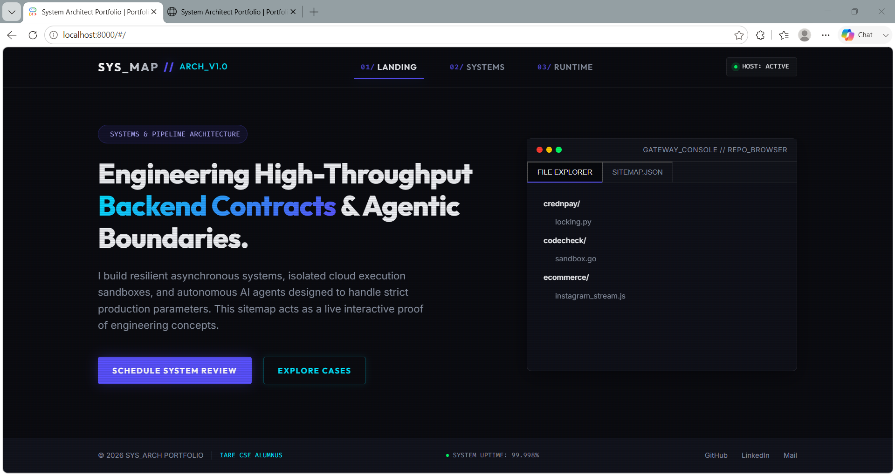

---

## 4. Pressure-Test Prompt & Output
To ensure this sitemap directly supports my engineering claim, I ran an adversarial pressure test against my core user persona.

### Input Prompt:
```text
Here is my proposed portfolio sitemap and core operational thesis. Review it against my core claim ("I engineer scalable, deterministic backend architectures and agentic AI systems") and my primary target action ("Get an Engineering Manager to book a technical interview call").

Proposed Sitemap:
1. [/] Landing Hero: Explains my core claim and features a direct booking widget/link.
2. [/projects] Case Studies: Deep technical breakdowns of CrednPay (Async P2P escrow), CodeCheck (Dynamic cloud code verification engine), and an Instagram Graph API comment automation engine.
3. [/stack] Engineering Matrix: Showcases my Salesforce Agentforce Specialist certification, technical stack competencies, and IARE academic background.

Critique this layout ruthlessly. Where does this map fail to support my claim? What am I missing that an Engineering Manager actually cares about when evaluating backend AI talent?

