EXPLORATORY DATA ANALYSIS
High-Value Customer Identification Project
Mandatory EDA Report
Histograms • Bar Charts • Line Graph • Scatter Plot • Correlation Heatmap • Pivot Tables • Trend Analysis
Prepared for academic project submission

1. Exploratory Data Analysis
Exploratory Data Analysis (EDA) was performed on the customer dataset containing 10,000 records and 15 variables. The purpose of EDA is to understand the distribution of customer characteristics, identify relationships among variables, compare customer groups, and establish analytical evidence before applying customer-value scoring and K-Means segmentation.
The project requires seven mandatory EDA components. All seven are included in this report: histograms, bar charts, line graphs, scatter plots, a correlation heatmap, pivot tables, and trend analysis.

2. Data Quality Summary
Metric | Value
Number of records | 10000
Number of variables | 15
Duplicate rows | 0
Missing values | 0

The supplied dataset contains no duplicate rows and no missing values after the cleaning stage. Therefore, EDA is performed on a complete analytical dataset without requiring imputation-driven changes to the distributions.

3. Histograms
Histograms were used to examine the distribution of the major numerical customer attributes. They are particularly useful for identifying skewness, concentration, spread and potential extreme values before standardization and clustering.

Age
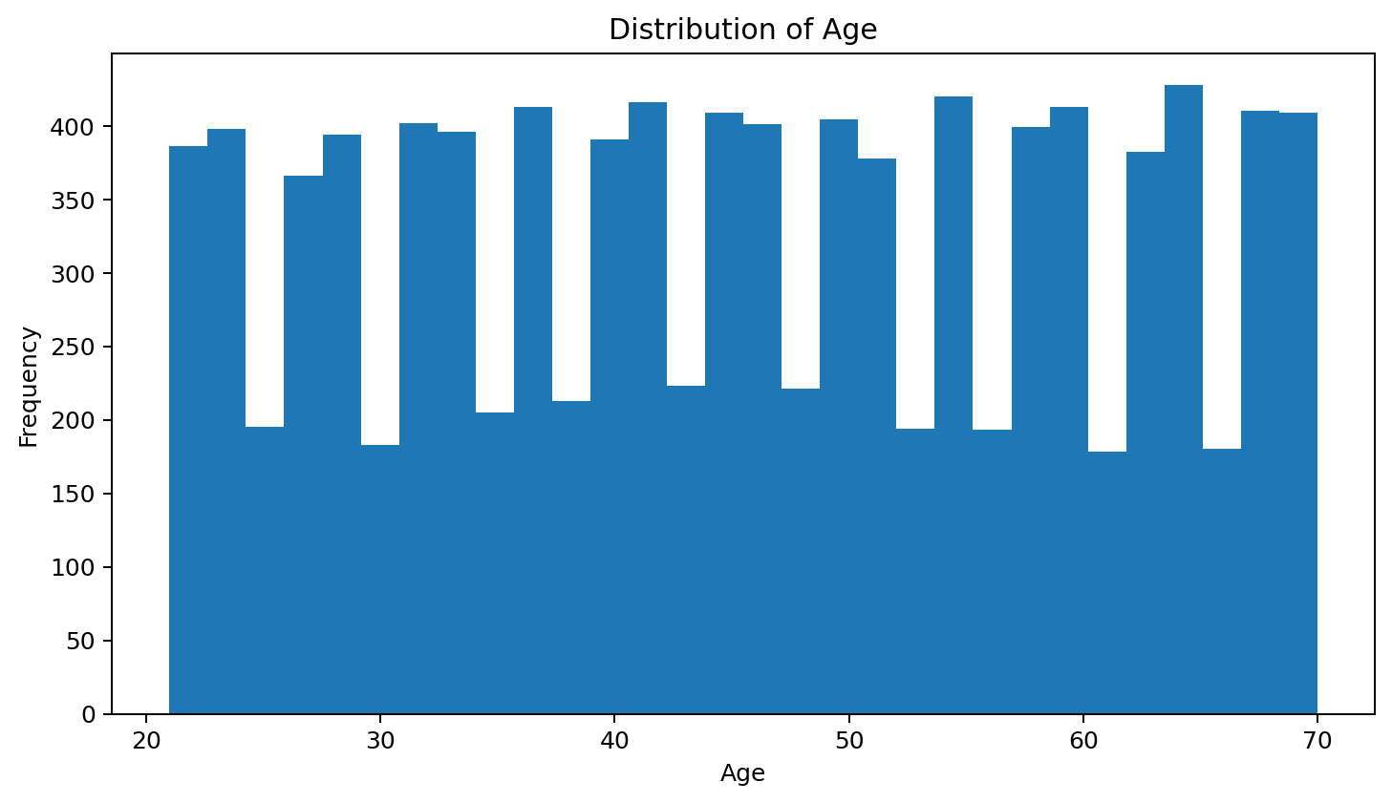
Figure: Histogram of Age
The age histogram shows the distribution and spread of this customer attribute across the population.

Annual Income
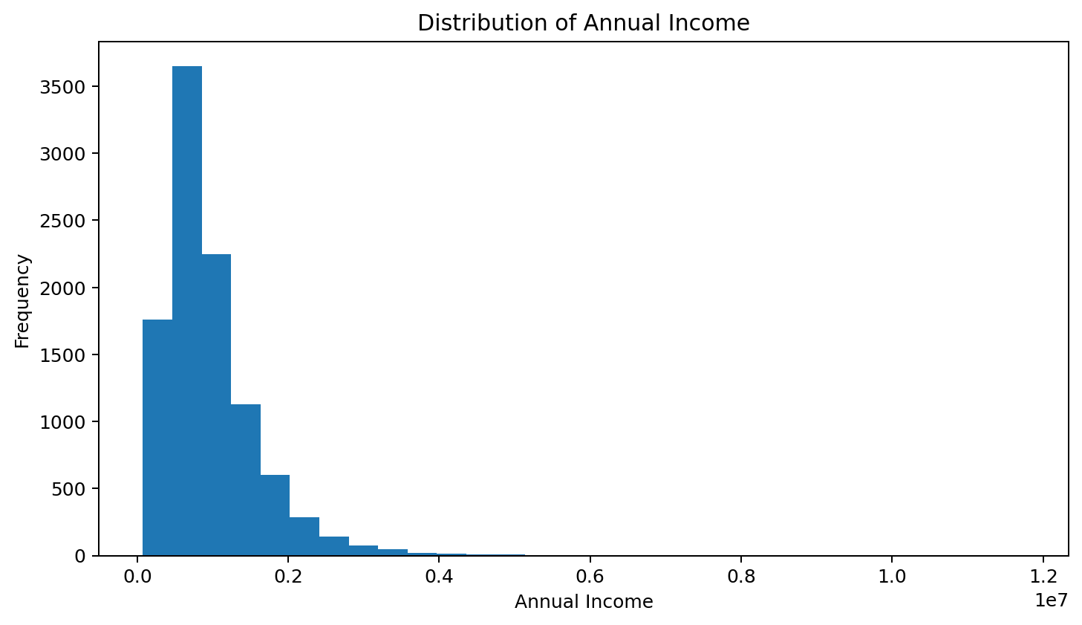
Figure: Histogram of Annual Income
The annual income distribution is strongly right-skewed, with a large concentration of customers at lower-to-moderate values and a smaller group extending to substantially higher values. This spread is relevant to customer-value segmentation because a small group can have materially greater financial value.

Avg Balance
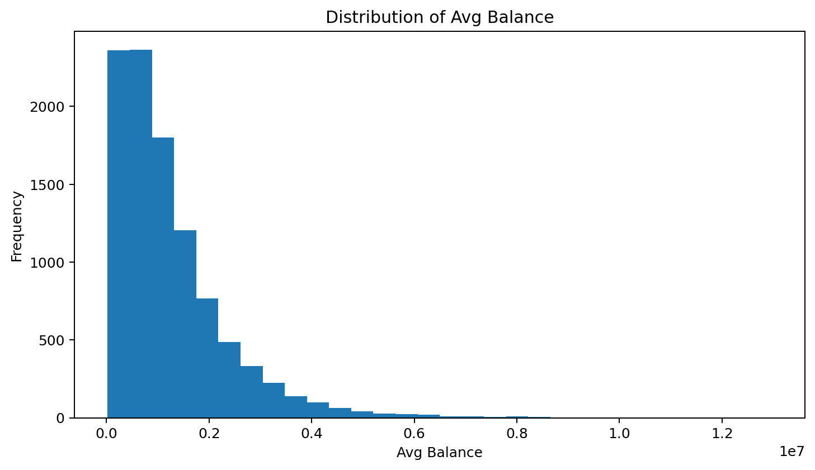
Figure: Histogram of Avg Balance
The avg balance distribution is strongly right-skewed, with a large concentration of customers at lower-to-moderate values and a smaller group extending to substantially higher values. This spread is relevant to customer-value segmentation because a small group can have materially greater financial value.

Monthly Transactions
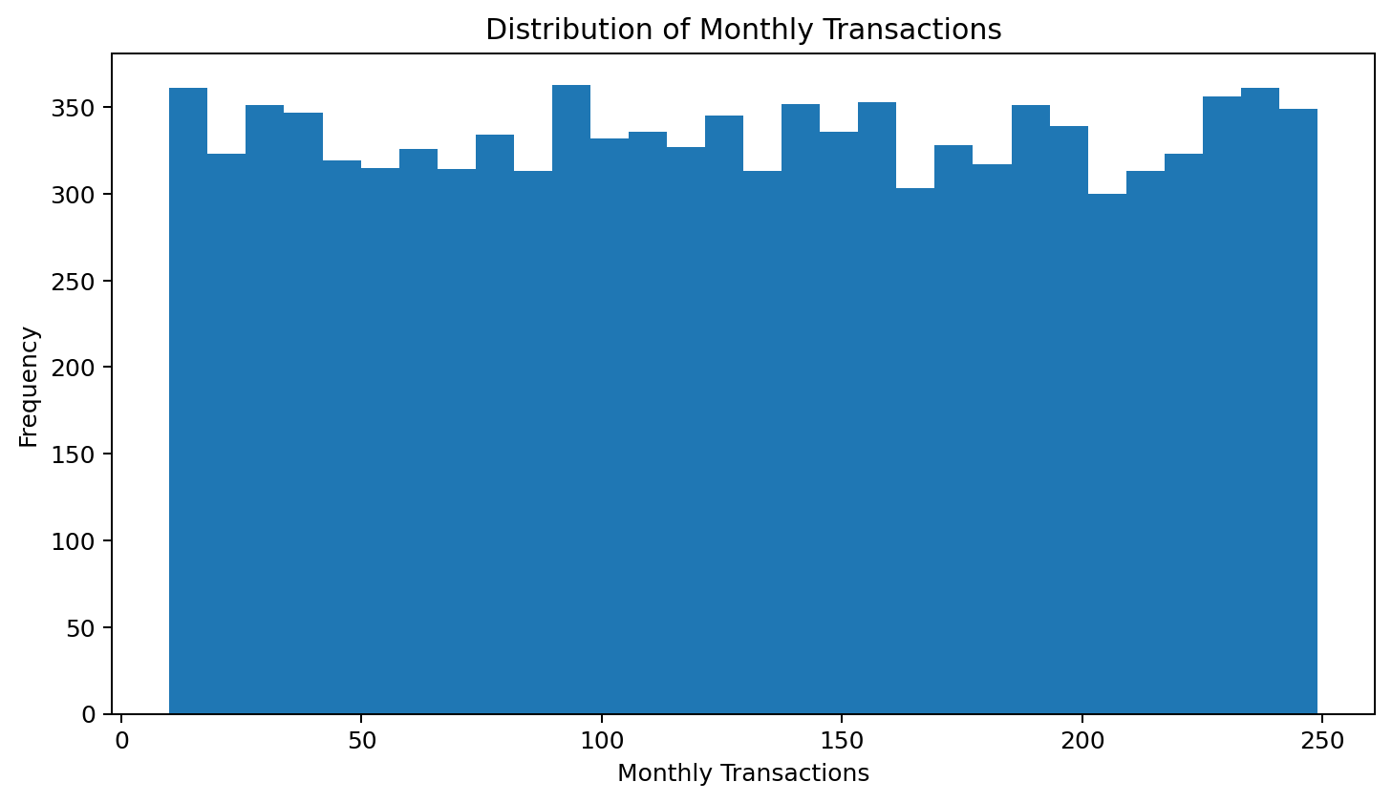
Figure: Histogram of Monthly Transactions
The monthly transactions histogram shows the distribution and spread of this customer attribute across the population.

Monthly Spend
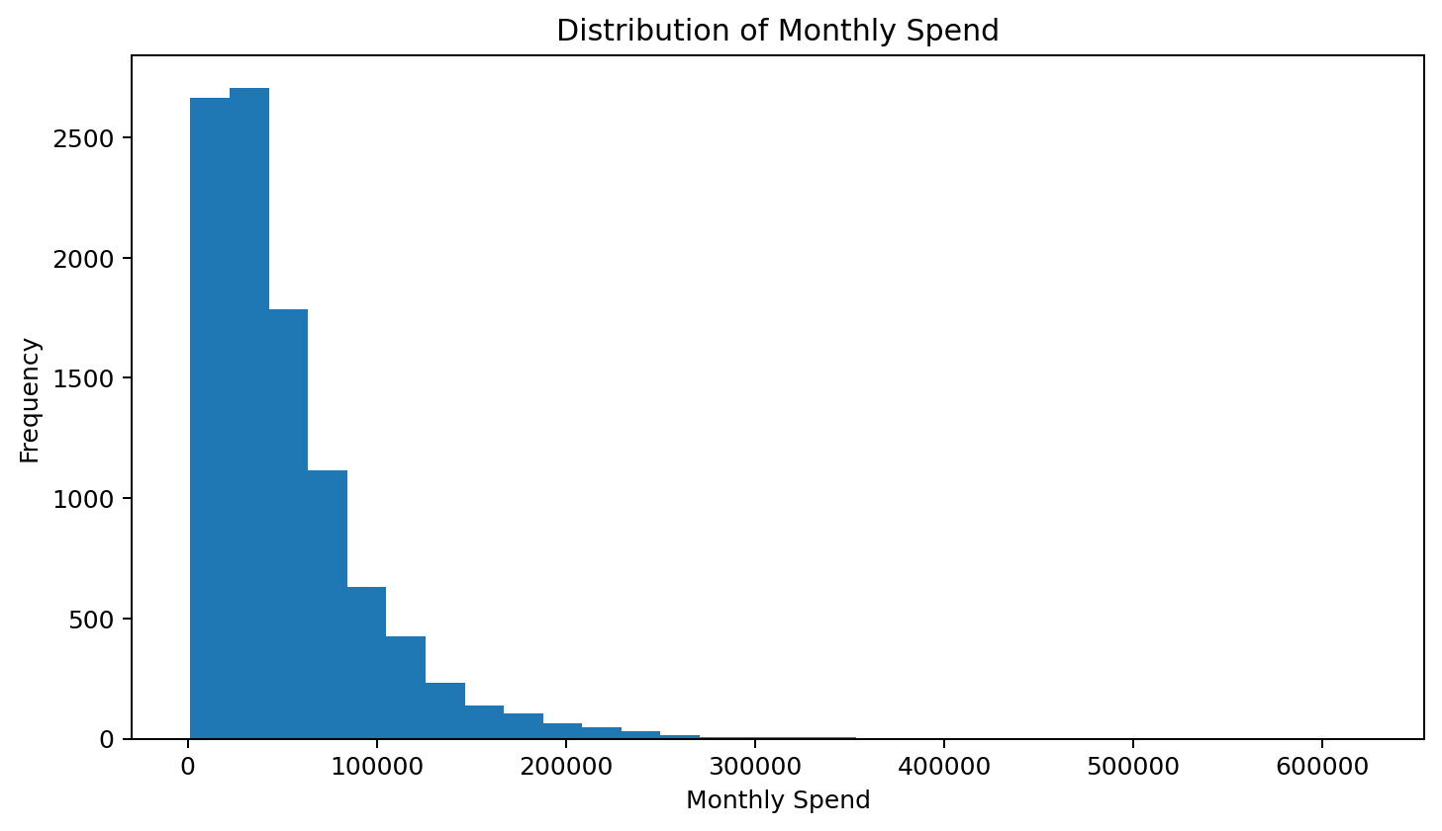
Figure: Histogram of Monthly Spend
The monthly spend distribution is strongly right-skewed, with a large concentration of customers at lower-to-moderate values and a smaller group extending to substantially higher values. This spread is relevant to customer-value segmentation because a small group can have materially greater financial value.

Credit Score
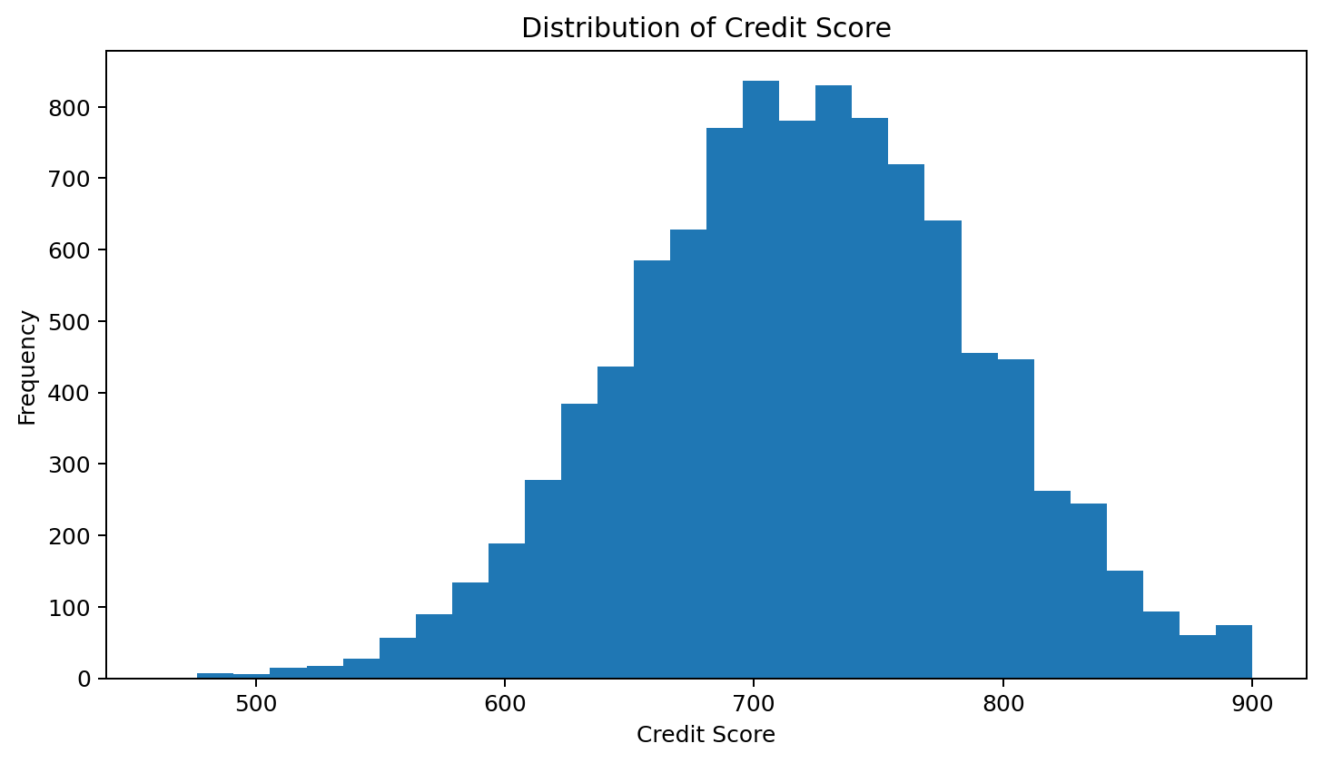
Figure: Histogram of Credit Score
Credit scores show a broadly concentrated distribution around the central range, with fewer customers at the extreme low and high ends.

4. Bar Charts
Bar charts compare categorical or discrete customer groups. They are used here to understand the composition of the customer base and the distribution of banking-product adoption.

Gender distribution
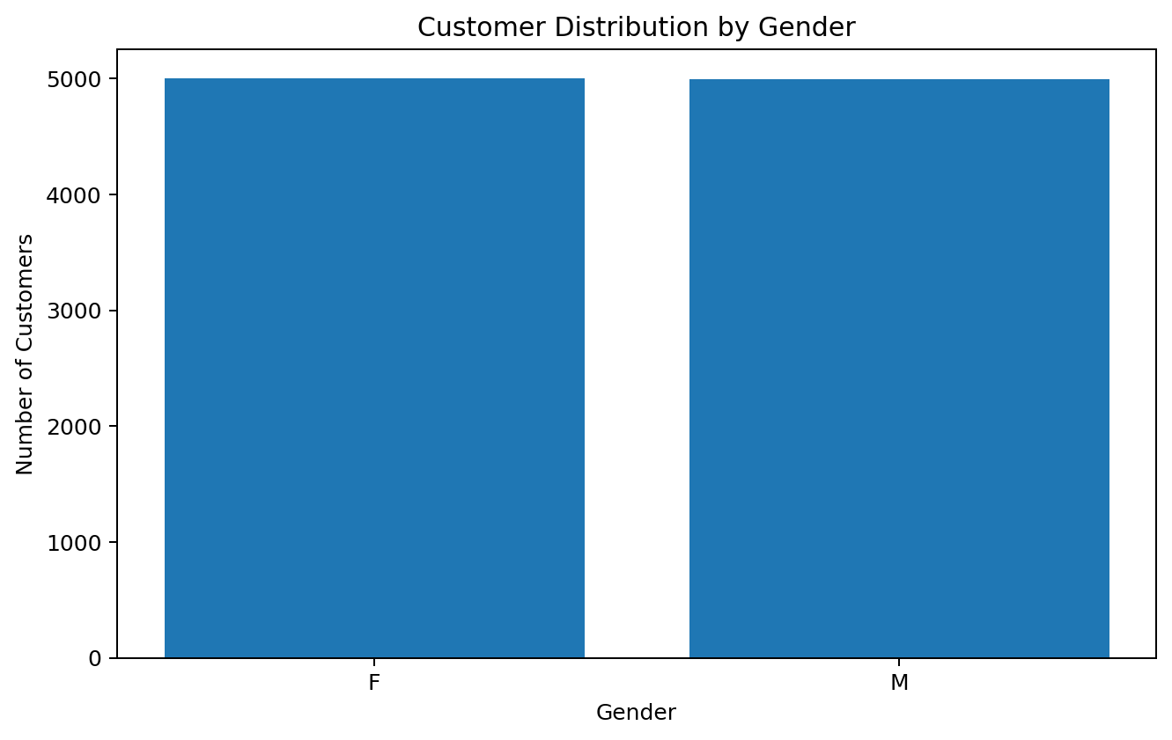
Figure: Gender distribution
The gender distribution is approximately balanced, indicating that the dataset does not have a major gender-composition imbalance.

Products used distribution
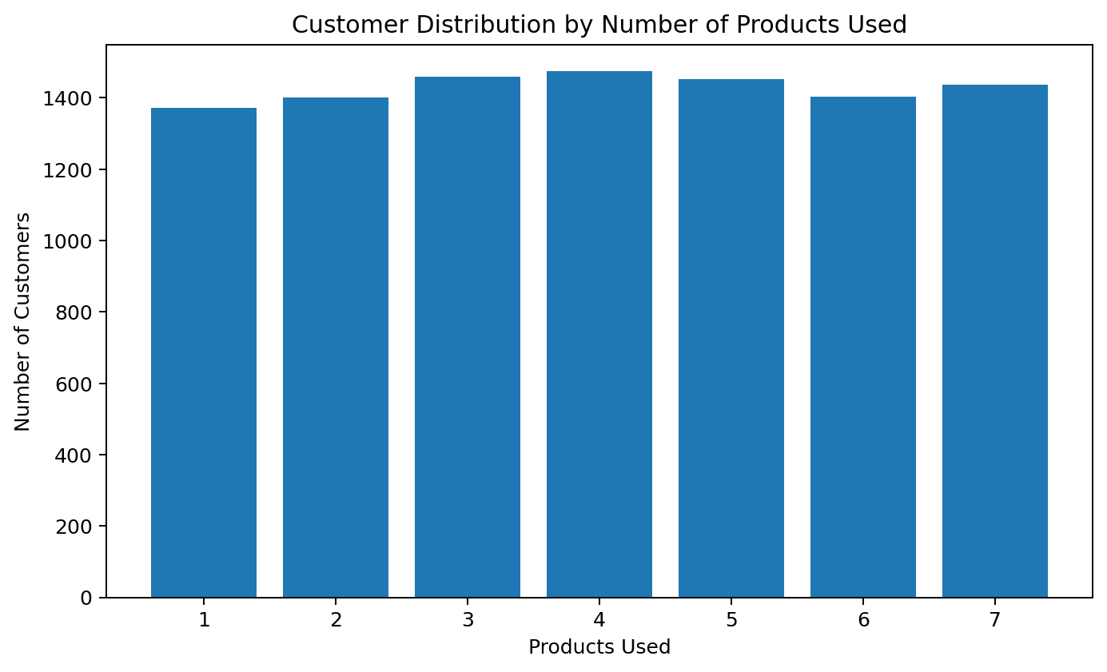
Figure: Products used distribution
Customers are distributed across one to seven products used. Product adoption therefore provides a useful relationship-depth variable for the customer-value framework.

5. Line Graph
A line graph was included as a mandatory ordered-trend visualization. The supplied dataset does not contain a calendar date or time-period field, so a genuine chronological banking trend cannot be computed without inventing time information. To avoid fabricating a time series, the analysis uses ordered age groups as the x-axis and average monthly spending as the dependent measure.
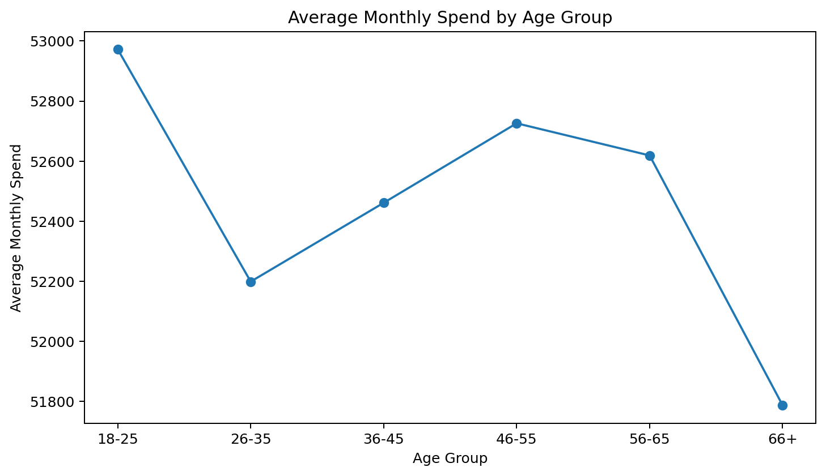
Figure: Average Monthly Spend by Age Group
Average monthly spending is highest for the 18–25 age group, falls in the 26–35 group, rises again through the 46–55 group, remains relatively high for 56–65, and is lowest for customers aged 66+. This pattern suggests that spending behaviour is not a simple monotonic function of age.

6. Scatter Plot
The scatter plot examines the relationship between annual income and monthly spending. Each point represents one customer. This visualization helps determine whether higher-income customers generally show higher spending and whether substantial variation exists within income ranges.
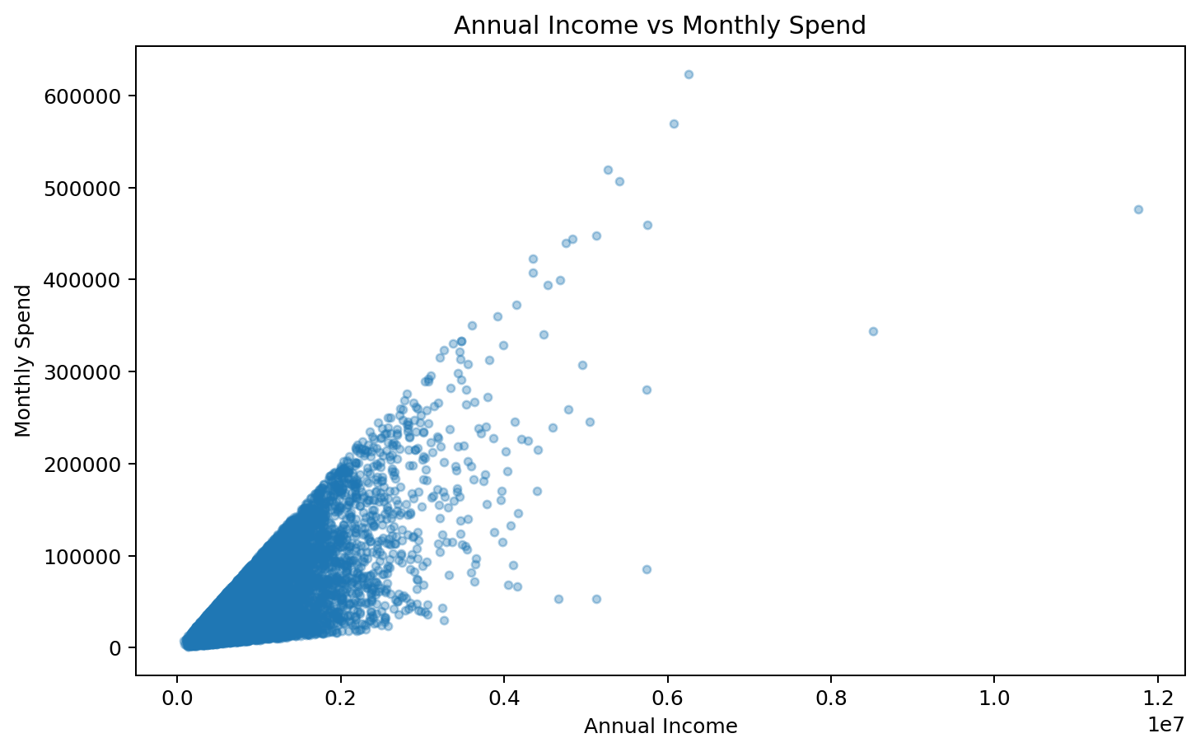
Figure: Annual Income vs Monthly Spend
The plot shows a positive relationship between annual income and monthly spending. The Pearson correlation between the two variables in the supplied data is approximately 0.75. However, the spread of points shows that income alone does not fully determine spending, supporting the use of a multidimensional customer-value model.

7. Correlation Heatmap
The correlation heatmap summarizes linear relationships among the numerical variables. Correlation analysis is useful for identifying variables that move together and for understanding whether customer value is represented by one dominant factor or several partially independent dimensions.
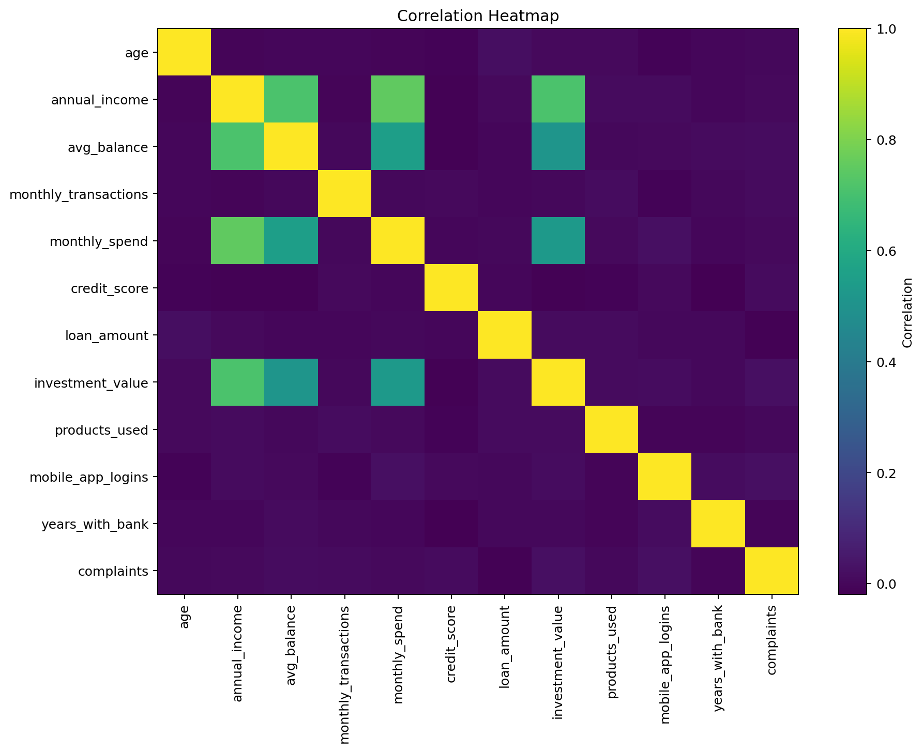
Figure: Correlation Heatmap of Numerical Customer Variables
Strongest Absolute Correlations
Category | Correlation
('annual_income', 'monthly_spend') | 0.75
('annual_income', 'avg_balance') | 0.71
('annual_income', 'investment_value') | 0.71
('avg_balance', 'monthly_spend') | 0.55
('monthly_spend', 'investment_value') | 0.53
('avg_balance', 'investment_value') | 0.51
('investment_value', 'complaints') | 0.02
('mobile_app_logins', 'complaints') | 0.02

Annual income has meaningful positive relationships with average balance, monthly spending and investment value. These relationships indicate that financial strength is an important component of customer value. At the same time, several engagement and relationship variables have weaker linear relationships with financial variables, which supports retaining them as separate dimensions.

8. Pivot Tables
Pivot tables convert individual customer records into compact business summaries. They are used to compare average spending, total spending and customer counts across important categories.
Pivot Table: Gender vs Monthly Spend
gender | ('mean', 'monthly_spend') | ('sum', 'monthly_spend') | ('count', 'monthly_spend')
F | 52,172.01 | 261,120,908.00 | 5,005.00
M | 52,784.30 | 263,657,563.00 | 4,995.00

This pivot table compares average monthly spending, total monthly spending and customer count between genders. It provides a direct group-level summary without requiring row-by-row inspection.
Pivot Table: Products Used vs Monthly Spend
products_used | ('mean', 'monthly_spend') | ('count', 'monthly_spend')
1 | 51,776.93 | 1,371.00
2 | 53,192.51 | 1,401.00
3 | 51,435.61 | 1,459.00
4 | 51,533.20 | 1,476.00
5 | 53,679.30 | 1,453.00
6 | 53,752.72 | 1,404.00
7 | 52,017.56 | 1,436.00

This pivot table compares average monthly spending and customer counts across the number of products used. It is particularly relevant to the relationship-value and cross-selling objectives of the project.

9. Trend Analysis
Trend analysis examines ordered movement in a metric and is mandatory for the project. Because no date column is available in the dataset, this report does not claim a month-over-month or year-over-year trend. Instead, it analyzes the ordered movement of average monthly spending across age groups.
Trend Table: Monthly Spend by Age Group
age_group | Average Monthly Spend | Customers
18-25 | 52,972.42 | 979.00
26-35 | 52,199.09 | 1,946.00
36-45 | 52,461.33 | 2,065.00
46-55 | 52,726.03 | 2,018.00
56-65 | 52,618.98 | 1,993.00
66+ | 51,787.43 | 999.00

The trend is non-linear. The youngest group has the highest average monthly spend, followed by a decline in 26–35, an increase through middle age, and a decline in the oldest group. The result suggests that age should be treated as a contextual customer attribute rather than a direct proxy for customer value.

10. EDA Conclusions for Subsequent Modelling
- Financial variables such as annual income, average balance, monthly spending and investment value have substantial right-skew, so scale normalization is important before K-Means.
- Income and spending are positively related, but their relationship is not sufficient to explain every customer's value.
- Product adoption provides an additional relationship-depth signal.
- Digital engagement and transaction behaviour should be retained because they capture customer activity that financial variables alone may miss.
- The absence of a time field limits true chronological trend analysis; age-group progression is therefore used as an ordered analytical trend.
- The multidimensional EDA supports the subsequent Customer Value Score and four-segment K-Means approach.

11. Mandatory EDA Checklist
Requirement | Included | Purpose
Histograms | Yes | Distribution of numerical variables
Bar charts | Yes | Category and product comparisons
Line graphs | Yes | Ordered spending trend
Scatter plots | Yes | Income-spending relationship
Correlation heatmap | Yes | Linear relationships among numerical variables
Pivot tables | Yes | Group-level business summaries
Trend analysis | Yes | Ordered movement across age groups

This EDA section is designed to be inserted directly into the larger 20–30 page project report. It contains the seven mandatory EDA components requested for the project and uses the supplied customer dataset rather than illustrative values.

