**EXNO : 3**

**SEQUENCE DIAGRAM FOR ONLINE RAILWAY RESERVATION SYSTEM**

**AIM**

        Design a sequence diagram for Ticket Booking, Make Payment and Cancellation of Tickets and show the interactions between the objects.

**PROBLEM STATEMENT**

          The online railway reservation system is a digital platform that allows passengers to book train tickets, check seat availability, view train schedules, and manage bookings from the comfort of their homes or mobile devices.

**PROCEDURE**

1. Open the Star UML / Edrawmax tool
2. Identify the actors, objects, Lifeline and activation.
3. Identify the sequence of interactions between the objects
4. Define life lines and include timing, messages, return messages, conditions and loops
5. Design the sequence diagram
6. Save the diagram

**SEQUENCE DIAGRAM:**

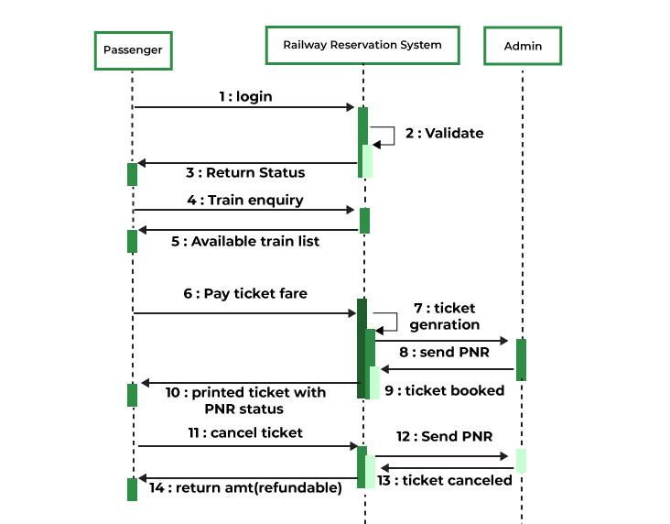

**DOCUMENTATION**

A sequence diagram that covers three main processes in a ticket booking system: Ticket Booking, Make Payment, and Cancellation.

The following sequence of process are included in the diagram.

1. Customer initiates the booking process by selecting the desired event and seats.
2. Ticket Booking System verifies the availability of the selected seats and creates a Ticket object.
3. Ticket Booking System presents the customer with the booking details and payment options.
4. Customer chooses a payment method and provides necessary payment information.
5. Ticket Booking System processes the payment through an external payment gateway.
6. If the payment is successful, the Ticket Booking System confirms the booking and sends a confirmation email to the Customer.
7. If the payment fails, the Ticket Booking System informs the Customer and allows them to retry or choose a different payment method.
8. Customer can request to Cancel the booking at any time before the event.
9. Ticket Booking System processes the Cancellation Request and updates the ticket status accordingly.
10. If the cancellation is successful, the Ticket Booking System refunds the payment to the Customer (if applicable) and sends a cancellation confirmation email.

**RESULT**

The above sequence diagram was designed successfully and documentation was made.