Delivery Operations & Profitability Analytics
DATA ARCHITECT DOCUMENT
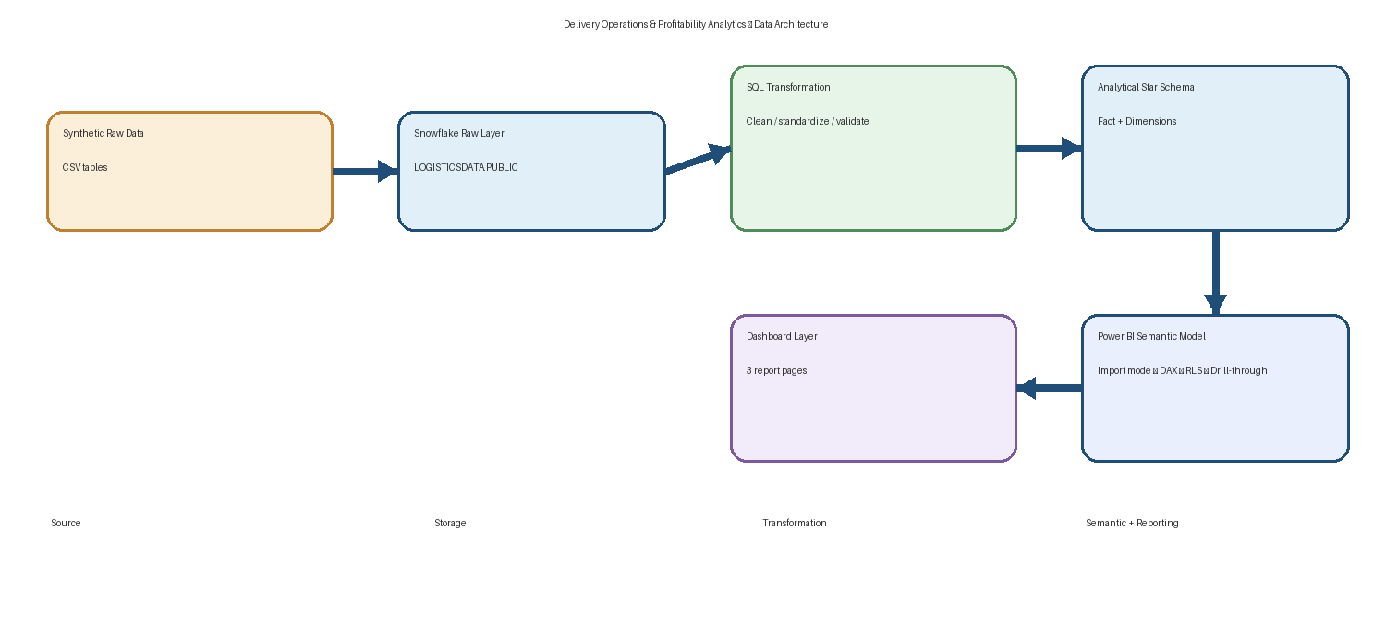
End-to-end architecture: Synthetic Raw Data → Snowflake → SQL → Star Schema → Power BI
Document purpose
This document describes the technical architecture, data model, transformation rules, analytical layer, Power BI semantic model, security design, and operational considerations for the Delivery Operations & Profitability Analytics project.

Prepared for portfolio / interview demonstration

1. Document Control
Item | Value
Project | Delivery Operations & Profitability Analytics
Architecture type | Modern BI / ELT-style analytics pipeline
Source data | Synthetic / simulated CSV data
Cloud data platform | Snowflake
BI platform | Microsoft Power BI
Storage model in Power BI | Import mode
Fact grain | One row = one unique customer delivery order
Primary analytical use case | Delivery performance, root-cause exploration, warehouse analysis, profitability
Security model | Static Row-Level Security by warehouse region
Report pages | Executive Overview, Delivery Performance, Warehouse Details
Drill-through key | DIM_WAREHOUSE[Warehouse_ID]

Important data disclaimer
All operational figures in this portfolio project are simulated/synthetic. They are intended to demonstrate architecture, analytics, and BI implementation—not to represent real company performance.

2. Contents at a Glance
- 3. Business and Technical Context
- 4. Source Data Architecture
- 5. Snowflake Architecture
- 6. Data Quality and Transformation Architecture
- 7. Analytical Star Schema
- 8. Table and Column Specifications
- 9. Derived Metrics and DAX Layer
- 10. Power BI Semantic Model
- 11. Report and Interaction Architecture
- 12. Security / Row-Level Security
- 13. Drill-through and Tooltip Design
- 14. Data Validation and Reconciliation
- 15. Performance and Maintainability Considerations
- 16. Deployment and Operational Runbook
- 17. Known Limitations and Future Enhancements
- 18. Technical Summary

3. Business and Technical Context
The project models a delivery operation in which customer orders move through warehouse processing, dispatch, carrier transit, and delivery. The analytical goal is to understand delivery performance and profitability at executive, regional, warehouse, partner, customer-segment, and time levels.

3.1 Core business questions
- Why are deliveries late, and which operational dimensions are associated with higher late-delivery rates?
- Which warehouses and regions show stronger or weaker delivery performance?
- Which delivery partners have longer transit times?
- Does distance appear to be associated with transit time?
- Where is revenue converted into profit, and where are loss-making orders concentrated?
- Do operational outcomes and profitability vary by warehouse, region, month, or customer segment?

3.2 Architecture principles
- Keep raw source tables immutable; perform cleaning and transformation into separate analytical tables.
- Use a star schema for Power BI so dimensions filter the central fact table.
- Keep row-level facts in the fact table and reusable descriptive attributes in dimensions.
- Use calculated columns for order-level elapsed-day attributes and measures for filter-context-aware aggregations.
- Treat data-quality remediation as explicit business rules rather than silent deletion.
- Use 'associated with' language for relationships unless a causal design has been established.

4. Source Data Architecture
The synthetic source package contains five CSV files. The fact table is intentionally larger and contains controlled data-quality issues to exercise the ETL/ELT process.
Table | Raw rows | Purpose | Role
fact_orders_raw.csv | 10,020 | Order-level transactional records; includes intentional duplicates and quality issues | Fact source
dim_customer_raw.csv | 2,000 | Customer master attributes | Dimension source
dim_delivery_partner_raw.csv | 100 | Delivery partner master attributes | Dimension source
dim_warehouse_raw.csv | 50 | Warehouse capacity/location attributes | Dimension source
dim_date.csv | 730 | Continuous calendar from 2024-01-01 to 2025-12-30 | Date dimension

4.1 FactOrders source columns
Column | Data type (logical) | Purpose
Order_ID | String / key | Unique order business identifier
Customer_ID | String / FK | Customer reference
Warehouse_ID | String / FK | Warehouse reference
Delivery_Partner_ID | String / FK | Delivery partner reference
Order_Date | Date | Order creation date
Order_Dispatched_Date | Date / NULL | Dispatch event date
Promised_Delivery_Date | Date | Committed delivery date
Actual_Delivery_Date | Date / NULL | Actual delivery date
Distance_KM | Decimal | Shipment distance
Order_Value | Decimal / currency | Order revenue/value
Freight_Cost | Decimal / currency | Transportation cost
Packaging_Cost | Decimal / currency | Packaging cost
Warehouse_Handling_Cost | Decimal / currency | Warehouse handling cost
Delivery_Partner_Cost | Decimal / currency | Allocated delivery partner cost
Order_Status | String | Delivered / Cancelled / Failed-Returned lifecycle state

5. Snowflake Architecture
The source tables were loaded into Snowflake before analytical transformation. The configured environment uses database LOGISTICSDATA and schema PUBLIC on Snowflake Enterprise Edition, AWS, Singapore region.

5.1 Layering
Layer | Example objects | Purpose
Raw / landing | FACT_ORDERS_RAW, DIM_CUSTOMER_RAW, DIM_DELIVERY_PARTNER_RAW, DIM_WAREHOUSE_RAW, DIM_DATE | Preserve source data with minimal changes
Cleaned / analytical | FACT_ORDERS, DIM_CUSTOMER, DIM_DELIVERY_PARTNER, DIM_WAREHOUSE, DIM_DATE | Standardized, validated, deduplicated reporting model
BI semantic | Power BI model | Measures, calculated columns, relationships, RLS, report interactions

5.2 Connection pattern
- Power BI connects to Snowflake using the configured Snowflake server endpoint.
- Import mode is used for the Power BI semantic model.
- The cleaned analytical tables are loaded into the Power BI model.
- Raw Snowflake tables remain separated from the reporting layer and are not directly used as dashboard sources.
Why keep the raw layer?
The raw layer preserves traceability. When a source value is cleaned, mapped, or excluded from a metric, the original source representation remains available for audit and reproducibility.

6. Data Quality and Transformation Architecture
Cleaning is implemented in SQL. The goal is not to delete problematic orders indiscriminately, but to repair standardized issues where rules are clear and isolate records that cannot safely participate in a metric.

6.1 Raw-data issues intentionally modeled
- Missing values in selected operational fields.
- Duplicate rows in the raw fact table.
- Inconsistent text formatting such as Chennai/chennai/CHENNAI and trailing spaces.
- Invalid Actual_Delivery_Date values earlier than Order_Date or Order_Dispatched_Date.
- Outlier distance values, including a deliberately extreme 2,840 KM record.
- Broken foreign-key references such as CUST9999, WH999, and DP999.
- Valid NULL Actual_Delivery_Date values for Cancelled and Failed/Returned orders.

6.2 Transformation rules
Area | Rule | Treatment
Deduplication | Duplicate order rows exist in raw fact | Deduplicate by Order_ID so cleaned fact contains 10,000 unique orders
Status standardization | Mixed case / text variants | TRIM and standardize to Delivered, Cancelled, Failed/Returned
Text standardization | City text casing / spaces | TRIM + INITCAP for reporting consistency
Invalid delivery date | Actual delivery earlier than order or dispatch | Set Actual_Delivery_Date to NULL; retain order
Broken customer FK | Customer reference not present | Map to UNKNOWN customer row in cleaned dimension
Broken warehouse FK | Warehouse reference not present | Map to UNKNOWN warehouse row
Broken partner FK | Delivery partner reference not present | Map to UNKNOWN partner row
Valid cancellation NULLs | No dispatch/actual delivery because order did not complete | Retain NULL values; exclude from delivery-time metrics as applicable
Outlier distance | Extreme distance value | Flag for analytical review; do not automatically delete without business rule

6.3 Final cleaned fact checks
Check | Result
FACT_ORDERS final rows | 10,000
Unique Order_IDs | 10,000
Delivered | 9,069
Cancelled | 582
Failed/Returned | 349
Invalid Actual_Delivery_Date values repaired | 12 set to NULL
Invalid customer FKs after mapping | 0
Invalid warehouse FKs after mapping | 0
Invalid delivery partner FKs after mapping | 0
Critical key/date null violations | 0 in final validation

Metric participation rule
Cancelled orders are excluded from late-delivery calculations because no completed delivery exists. Delivered orders with missing actual delivery dates are excluded from valid-delivery denominators. Failed/Returned orders are not treated as late deliveries.

7. Analytical Star Schema
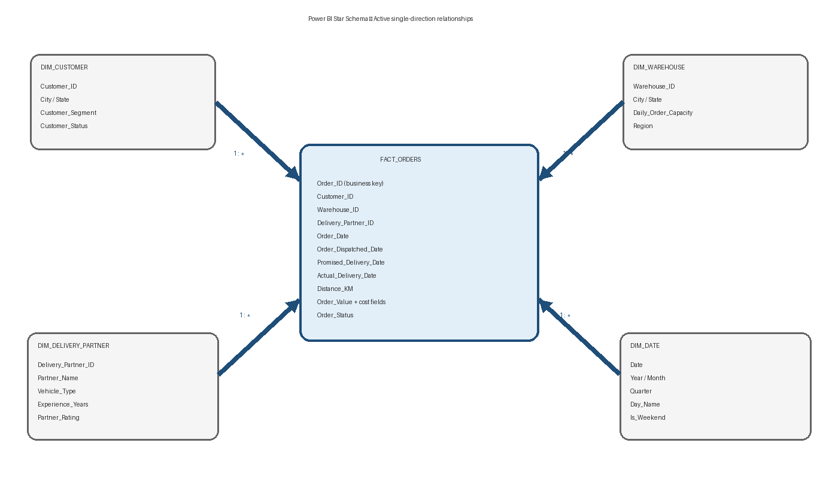
Figure 2. Power BI analytical star schema

7.1 Grain and relationships
Fact grain: one row represents one unique customer delivery order. The model uses four dimensions connected to FACT_ORDERS through one-to-many relationships.
Dimension | Key | Relationship | Filter direction
DIM_CUSTOMER | Customer_ID | 1 → * FACT_ORDERS | Dimension → Fact
DIM_DELIVERY_PARTNER | Delivery_Partner_ID | 1 → * FACT_ORDERS | Dimension → Fact
DIM_WAREHOUSE | Warehouse_ID | 1 → * FACT_ORDERS | Dimension → Fact
DIM_DATE | Date | 1 → * FACT_ORDERS via Order_Date | Dimension → Fact

8. Table and Column Specifications

8.1 DIM_CUSTOMER
Column | Purpose | Analytical use
Customer_ID | Business key | Relationship to fact
Customer_Name | Customer label | Detail / tooltip
City | Customer city | Geographic analysis
State | Customer state | Geographic analysis
Customer_Segment | Premium / Business / Standard | Segment profitability and mix
Customer_Status | Customer status | Descriptive/filter attribute

8.2 DIM_WAREHOUSE
Column | Purpose | Analytical use
Warehouse_ID | Warehouse business key | Drill-through and relationships
Warehouse_Name | Warehouse label | User-friendly display
City | Warehouse city | Geographic analysis
State | Warehouse state | Geographic analysis
Daily_Order_Capacity | Reasonable daily processing capacity | Capacity analysis / future utilization
Region | Regional grouping | Regional performance and RLS

8.3 DIM_DELIVERY_PARTNER
Column | Purpose | Analytical use
Delivery_Partner_ID | Partner business key | Relationship to fact
Partner_Name | Partner label | Partner performance
Base_City | Base operating city | Descriptive analysis
Vehicle_Type | Vehicle classification | Diagnostic attribute
Experience_Years | Partner experience | Contextual analysis
Partner_Rating | Partner rating | Outcome/performance indicator

8.4 DIM_DATE
Column | Purpose
Date | Calendar date
Year | Year grouping
Month_Number | Month sort key
Month_Name | Month display label
Quarter | Quarter grouping
Day_Name | Day label
Day_of_Week | Day ordering
Is_Weekend | Weekend classification

9. Derived Metrics and DAX Layer
The model uses a mix of calculated columns and measures. Calculated columns are evaluated at row level; measures are evaluated in the current filter context and are preferred for reusable aggregations.

9.1 Calculated columns
Processing Days =
DATEDIFF(
FACT_ORDERS[ORDER_DATE],
FACT_ORDERS[ORDER_DISPATCHED_DATE],
DAY
)
Transit Days =
DATEDIFF(
FACT_ORDERS[ORDER_DISPATCHED_DATE],
FACT_ORDERS[ACTUAL_DELIVERY_DATE],
DAY
)

9.2 Core measures
Total Orders =
COUNTROWS(FACT_ORDERS)
Total Revenue =
SUM(FACT_ORDERS[Order_Value])
Total Profit =
SUM(FACT_ORDERS[Order_Value])
- SUM(FACT_ORDERS[Freight_Cost])
- SUM(FACT_ORDERS[Packaging_Cost])
- SUM(FACT_ORDERS[Warehouse_Handling_Cost])
- SUM(FACT_ORDERS[Delivery_Partner_Cost])
Profit Margin % =
DIVIDE(
[Total Profit],
[Total Revenue]
)
Loss-Making Orders =
COUNTROWS(
FILTER(
FACT_ORDERS,
FACT_ORDERS[Order_Value]
- FACT_ORDERS[Freight_Cost]
- FACT_ORDERS[Packaging_Cost]
- FACT_ORDERS[Warehouse_Handling_Cost]
- FACT_ORDERS[Delivery_Partner_Cost]
< 0
)
)
Loss-Making Orders % =
DIVIDE(
[Loss-Making Orders],
[Total Orders]
)
Late Delivered Orders =
CALCULATE(
COUNTROWS(FACT_ORDERS),
FACT_ORDERS[Order_Status] = "Delivered",
FACT_ORDERS[Actual_Delivery_Date] > FACT_ORDERS[Promised_Delivery_Date]
)
Valid Delivered Orders =
CALCULATE(
COUNTROWS(FACT_ORDERS),
FACT_ORDERS[Order_Status] = "Delivered",
NOT ISBLANK(FACT_ORDERS[Actual_Delivery_Date])
)
Late Delivery % =
DIVIDE(
[Late Delivered Orders],
[Valid Delivered Orders]
)
Average Processing Days =
AVERAGE(FACT_ORDERS[Processing Days])
Average Transit Days =
AVERAGE(FACT_ORDERS[Transit Days])

10. Power BI Semantic Model

10.1 Semantic layer responsibilities
- Expose cleaned dimensional and fact tables to report authors.
- Provide reusable DAX measures rather than duplicating business logic across visuals.
- Maintain active dimension-to-fact relationships.
- Keep date logic centralized in DIM_DATE.
- Apply RLS to DIM_WAREHOUSE rather than directly to the fact table.
- Use descriptive dimension columns in visuals where possible; use IDs primarily for keys and drill-through.

10.2 Current relationship map
From | To | Cardinality | Purpose
DIM_CUSTOMER[Customer_ID] | FACT_ORDERS[Customer_ID] | 1:* | Customer slicing
DIM_WAREHOUSE[Warehouse_ID] | FACT_ORDERS[Warehouse_ID] | 1:* | Warehouse slicing / drill-through
DIM_DELIVERY_PARTNER[Delivery_Partner_ID] | FACT_ORDERS[Delivery_Partner_ID] | 1:* | Partner analysis
DIM_DATE[Date] | FACT_ORDERS[Order_Date] | 1:* | Time slicing

11. Report and Interaction Architecture

11.1 Page 1 — Executive Overview
- KPI cards: Total Orders, Total Revenue, Total Profit, Profit Margin %, Loss-Making Orders %, Late Delivery %.
- Monthly Revenue & Profit trend.
- Top warehouses by Late Delivery %.
- Orders by Region.
- Order Status distribution.
- Date, Region, and Warehouse slicers.
- Page-navigation buttons to Delivery Performance and Warehouse Details.

11.2 Page 2 — Delivery Performance
- KPI cards for Average Processing Days, Average Transit Days, Late Delivered Orders, and Late Delivery %.
- Warehouse Analysis field parameter switch between Average Processing Days, Late Delivery %, and Total Orders.
- Processing vs Late Delivery scatter analysis.
- Average Transit Days by Delivery Partner.
- Late Delivery % by Region.
- Bookmark-driven switch between Operational Analysis and Profitability Analysis views.

11.3 Page 2 — Profitability Analysis state
- KPI cards: Total Revenue, Total Profit, Profit Margin %, Loss-Making Orders %.
- Total Profit by Warehouse.
- Total Profit by Region.
- Loss-Making Order % by Customer Segment.
- Total Profit by Month.

11.4 Page 3 — Warehouse Details
- Drill-through filtered to DIM_WAREHOUSE[Warehouse_ID].
- KPI cards: Total Orders, Late Delivery %, Total Profit, Loss-Making Orders.
- Average Processing vs Average Transit Days.
- Order Status Distribution.
- Average Transit Days by Delivery Partner.
- Profit Margin by Customer Segment.
- Automatic Back button for returning to the source page.

12. Security / Row-Level Security
Static RLS is implemented at the warehouse-dimension level. The report contains region-specific roles such as Central, East, South, and West.

12.1 Security pattern
Example South role filter on DIM_WAREHOUSE:
[Region] = "South"
- RLS is applied to DIM_WAREHOUSE[Region].
- The dimension-to-fact relationship propagates the restriction to FACT_ORDERS.
- Because report visuals use dimension and fact data, the selected regional role limits visible report results.
- RLS is tested using Power BI 'View as' roles.
- UNKNOWN mappings remain excluded from regional business interpretation because UNKNOWN is a data-quality mapping, not a genuine region.

12.2 RLS validation procedure
- Open Modeling → View as.
- Select the region role to test.
- Confirm region-level visuals show only the permitted region.
- Check KPI cards and drill-through pages under the role.
- Return to the unrestricted / None view after testing.

13. Drill-through and Tooltip Design

13.1 Drill-through
- Source visual: warehouse-level visual such as the warehouse performance bar chart.
- Drill-through key: DIM_WAREHOUSE[Warehouse_ID].
- Destination: Warehouse Details page.
- Keep all filters = On.
- Cross-report = Off.
- The selected warehouse context filters every visual on Page 3.

13.2 Custom warehouse tooltip
- Dedicated report page named Warehouse_Tooltip.
- Metric helper table contains four rows: Total Orders, Average Processing Days, Average Transit Days, Late Delivery %.
- Tooltip Value measure uses SWITCH to return the selected metric and FORMAT to present the appropriate units.
- The tooltip table shows metric/value pairs when the user hovers a warehouse visual.
Tooltip Value =
SWITCH(
SELECTEDVALUE('Tooltip Metrics'[Metric]),
"Total Orders", FORMAT([Total Orders], "#,##0"),
"Average Processing Days", FORMAT([Average Processing Days], "0.00") & " days",
"Average Transit Days", FORMAT([Average Transit Days], "0.00") & " days",
"Late Delivery %", FORMAT([Late Delivery %], "0.0%")
)

14. Data Validation and Reconciliation

14.1 Source-to-model controls
Control | Expected / observed result | Status
Raw fact row count | 10,020 | Passed
Clean fact row count | 10,000 | Passed
Unique Order_ID count | 10,000 | Passed
Final FK validation: Customer | 0 invalid references | Passed
Final FK validation: Warehouse | 0 invalid references | Passed
Final FK validation: Partner | 0 invalid references | Passed
Delivered count | 9,069 | Passed
Cancelled count | 582 | Passed
Failed/Returned count | 349 | Passed
Invalid delivery dates repaired | 12 | Passed

14.2 Power BI report controls
- Page 1 date slicer responds to DIM_DATE[Date].
- Region and Warehouse slicers filter the executive page.
- Page 2 field-parameter switch changes the warehouse metric.
- Operational / Profitability bookmarks switch the intended visual state.
- Warehouse drill-through successfully lands on Page 3 with the selected warehouse.
- RLS roles successfully restrict the model when tested with View as.

15. Performance and Maintainability Considerations

15.1 Current design strengths
- Star schema limits relationship ambiguity and keeps filters predictable.
- Date dimension centralizes time intelligence and sorting.
- Measures centralize repeated business logic.
- Unknown member mapping prevents orphan fact rows from breaking relationships.
- Import mode provides fast interactive dashboard performance for a 10,000-row fact table.

15.2 Future scaling considerations
- Partitioning / incremental refresh can be evaluated as fact volume grows materially.
- Role-based dynamic security can replace static region roles when users must map to regions from an entitlement table.
- Warehouse-day capacity utilization should be calculated at Warehouse_ID + Date grain if capacity analysis is required later.
- Semantic model naming should favor business-friendly labels over database-style uppercase column names in visible visuals.
- SQL transformations can be organized into explicit staging and curated views/tables for stronger lineage.

16. Deployment and Operational Runbook

16.1 Refresh sequence
- Load/replace synthetic or source-equivalent raw CSV data into Snowflake raw tables.
- Execute SQL cleaning and transformation logic.
- Run row-count, uniqueness, date-validity, and foreign-key checks.
- Verify cleaned tables retain the intended 10,000-order fact grain.
- Refresh the Power BI dataset.
- Run report smoke tests for slicers, bookmarks, drill-through, tooltip, and RLS.
- Publish the final Power BI report and associated documentation.

16.2 Change-control guidance
- Any change to profit definition should be updated in one DAX measure and revalidated against the project assumptions.
- Any change to late-delivery logic should update both the measure definition and the documented business rule.
- Any addition of a source field should first be landed in raw storage, then transformed into the curated layer, then exposed in the semantic model.
- RLS role changes require regression testing of Page 1 KPIs and Page 3 drill-through.

17. Known Limitations and Future Enhancements
Area | Current limitation | Potential enhancement
Synthetic data | No production system of record | Replace with governed operational source
Cost model | Per-order costs are simplified; fixed overhead is not allocated | Introduce warehouse rent / overhead allocation rules
Cause analysis | No explicit delay-reason field | Add event timestamps and operational reason codes
Capacity | Daily capacity exists but full Warehouse-Date utilization model is not currently a report feature | Implement warehouse-day utilization / overload flags
RLS | Static region roles | Entitlement table + USERPRINCIPALNAME() dynamic RLS
Time analysis | Order_Date is the active date relationship | Add role-playing date dimensions if multiple date-role analysis is required
Data lineage | Documented manually for this portfolio project | Add formal metadata / lineage tooling

Interpretation caution
The dashboard identifies patterns and associations. A correlation or visual pattern should not be described as a proven causal relationship without an experimental or quasi-experimental design.

18. Technical Summary
The project implements a compact modern BI architecture in which synthetic operational data is preserved in a Snowflake raw layer, cleaned and validated through SQL, modeled into a star schema, and surfaced through a Power BI semantic model. The analytical layer separates facts from dimensions, centralizes calculations in DAX, and applies region-based RLS at the warehouse dimension. The report demonstrates executive monitoring, operational analysis, profitability analysis, custom tooltips, field-parameter switching, bookmarks, page navigation, and warehouse-level drill-through.

18.1 Architecture at a glance
Figure 3. Final end-to-end architecture

Appendix A — Business Metric Definitions
Metric | Definition
Total Orders | Count of rows in FACT_ORDERS at the current filter context
Total Revenue | Sum of Order_Value
Total Profit | Order_Value less Freight, Packaging, Warehouse Handling, and Delivery Partner costs
Profit Margin % | Total Profit divided by Total Revenue
Loss-Making Orders | Orders where calculated order-level profit is below zero
Loss-Making Orders % | Loss-Making Orders divided by Total Orders
Late Delivered Orders | Delivered orders whose Actual_Delivery_Date exceeds Promised_Delivery_Date
Valid Delivered Orders | Delivered orders with a non-null Actual_Delivery_Date
Late Delivery % | Late Delivered Orders divided by Valid Delivered Orders
Average Processing Days | Average of Order_Dispatched_Date minus Order_Date
Average Transit Days | Average of Actual_Delivery_Date minus Order_Dispatched_Date

Appendix B — Analytical Terminology
Term | Project interpretation
Fact table | Central transactional table at order grain
Dimension | Descriptive entity used to filter/group facts
Grain | The level represented by one row in a table
Calculated column | Row-level computation stored in the model
Measure | Dynamic calculation evaluated under current filter context
RLS | Security rule restricting rows visible to a user/role
Drill-through | Navigation from a source visual to a detail page carrying filter context
Bookmark | Saved report state that switches visuals/selections within a page
Tooltip | Contextual detail shown when hovering over a visual data point

Appendix C — Final Deliverables
Final deliverables: Power BI dashboard (.pbix) • Project Report (PDF) • Power BI User Guide (PPT) • Data Architect Document (DOCX).

