

SIMATS ENGINEERING

Saveetha Institute of Medical and Technical Sciences
Chennai- 602105

Name: BHARANI DHARAN S
Reg no: 192424141
Subject and Course Code:
DSA0502 QUERY PROCESSING FOR DATA SCIENCE

3.Write a Pandas program to display the details of jobs in descending sequence on job
Code:
import pandas as pd

data = {
"job_id": [1, 2, 3, 4],
"job_title": ["Manager", "Analyst", "Clerk", "Developer"],
"salary": [60000, 45000, 30000, 50000]
}

df = pd.DataFrame(data)

# Sort by job_title in descending order
result = df.sort_values(by="job_title", ascending=False)

print(result)
Output:
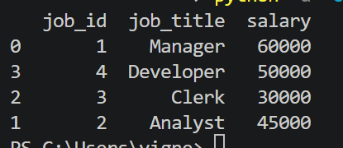
4.Write a Pandas program to create a line plot of the historical stock prices of Alphabet Inc. between two specific dates.
Code:
import pandas as pd
import matplotlib.pyplot as plt

data = {
"Date": ["2024-01-01", "2024-01-02", "2024-01-03", "2024-01-04", "2024-01-05"],
"Close": [140, 142, 141, 145, 147]
}

df = pd.DataFrame(data)

df["Date"] = pd.to_datetime(df["Date"])

plt.plot(df["Date"], df["Close"], marker="o")

plt.title("Alphabet Inc. Stock Prices")
plt.xlabel("Date")
plt.ylabel("Closing Price")
plt.grid(True)

plt.show()
Output:
