

SIMATS ENGINEERING

Saveetha Institute of Medical and Technical Sciences
Chennai- 602105

Name: BHARANI DHARAN S
Reg no: 192424141
Course Code: DSA0502
Course: QUERY PROCESSING

SET - 17
33.Write a Python program to draw a scatter plot with empty circles taking a random distribution in X and Y and plotted against each other.

CODE:
import numpy as np
import matplotlib.pyplot as plt

# Generate random X and Y values
np.random.seed(10)
x = np.random.rand(50)
y = np.random.rand(50)

# Scatter plot with empty circles
plt.scatter(x, y, facecolors='none', edgecolors='blue')

plt.xlabel('X Values')
plt.ylabel('Y Values')
plt.title('Scatter Plot with Empty Circles')

plt.show()

OUTPUT:
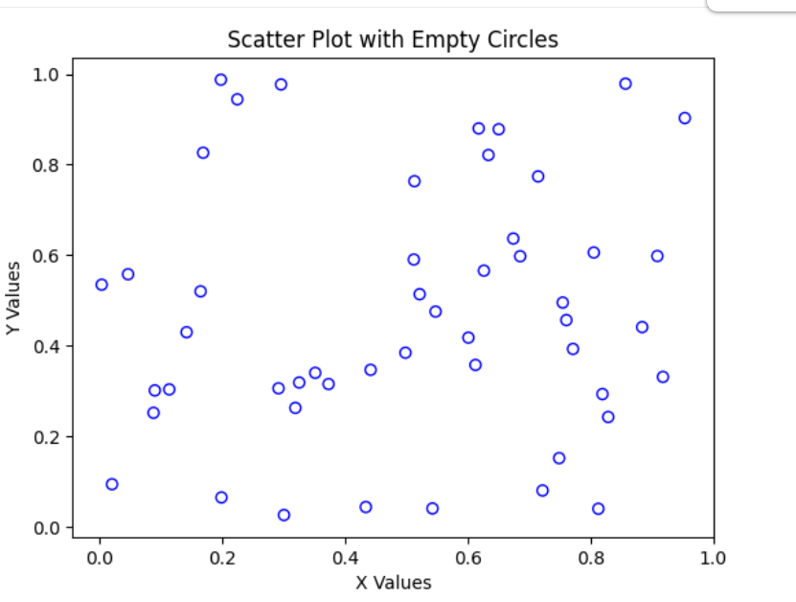

34.Write a Python program to draw a scatter plot using random distributions to generate balls of different sizes.

CODE:
import numpy as np
import matplotlib.pyplot as plt

# Generate random X and Y values
np.random.seed(10)
x = np.random.rand(50)
y = np.random.rand(50)

# Generate random sizes for the balls
sizes = np.random.randint(20, 500, 50)

# Scatter plot
plt.scatter(x, y, s=sizes, alpha=0.5)

plt.xlabel('X Values')
plt.ylabel('Y Values')
plt.title('Scatter Plot with Different Ball Sizes')

plt.show()

OUTPUT:
