

SIMATS ENGINEERING

Saveetha Institute of Medical and Technical Sciences
Chennai- 602105

Name: BHARANI DHARAN S
Reg no: 192424141
Course Code: DSA0502
Course: QUERY PROCESSING

SET - 19
37.Write a Pandas program to create a dataframe from a dictionary and display it.

CODE:
import pandas as pd

# Create dictionary
data = {
'Name': ['Arun', 'Bala', 'Chitra'],
'Age': [20, 21, 19],
'Marks': [85, 90, 88]
}

# Create DataFrame
df = pd.DataFrame(data)

# Display DataFrame
print(df)

OUTPUT:
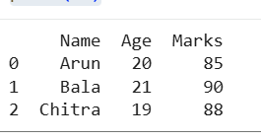
38.Write a Pandas program to create and display a DataFrame from a specified dictionary data which has the index labels.

CODE:
import pandas as pd

# Create dictionary
data = {
'Name': ['Arun', 'Bala', 'Chitra'],
'Age': [20, 21, 19],
'Marks': [85, 90, 88]
}

# Create DataFrame with index labels
df = pd.DataFrame(data, index=['Student1', 'Student2', 'Student3'])

# Display DataFrame
print(df)

OUTPUT:
