

SIMATS ENGINEERING

Saveetha Institute of Medical and Technical Sciences
Chennai- 602105

Name: BHARANI DHARAN S
Reg no: 192424141
Course Code: DSA0502
Course: QUERY PROCESSING

SET - 11
21.Write a Pandas program to swap the cases of a specified character column in a given DataFrame.
CODE:
import matplotlib.pyplot as plt

# Create a text file with x and y values
with open("data.txt", "w") as file:
file.write("1 10\n")
file.write("2 20\n")
file.write("3 30\n")
file.write("4 40\n")
file.write("5 50\n")

# Read values from text file
x = []
y = []

with open("data.txt", "r") as file:
for line in file:
values = line.split()
x.append(float(values[0]))
y.append(float(values[1]))

# Draw line
plt.plot(x, y, marker="o")

# Labels and title
plt.xlabel("X Axis")
plt.ylabel("Y Axis")
plt.title("Line Chart Using Text File Data")

# Display graph
plt.show()

OUTPUT:
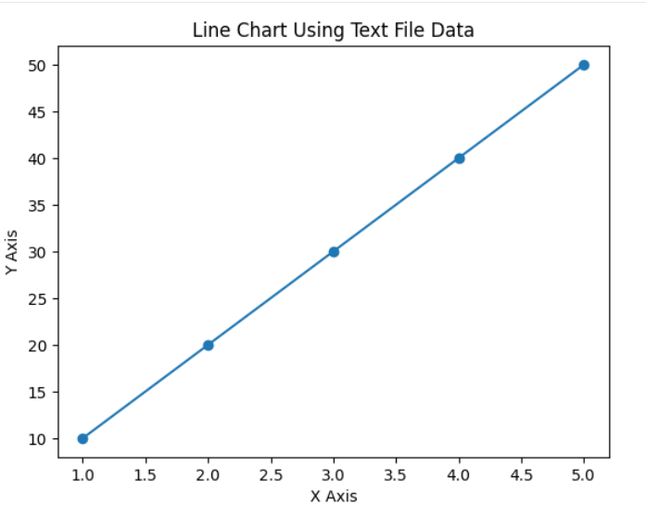

22.Write a Python program to draw a line with suitable label in the x axis, y axis and a title.
CODE:
import pandas as pd
import matplotlib.pyplot as plt

# Built-in financial dataset
data = {
"Date": [
"2026-01-01",
"2026-01-02",
"2026-01-03",
"2026-01-04",
"2026-01-05",
"2026-01-06"
],
"Open": [100, 105, 103, 108, 110, 115],
"High": [108, 110, 109, 113, 116, 120],
"Low": [98, 102, 100, 105, 108, 112],
"Close": [105, 108, 107, 111, 114, 118]
}

# Create DataFrame
df = pd.DataFrame(data)

# Convert Date column to datetime
df["Date"] = pd.to_datetime(df["Date"])

# Display financial data
print("Financial Data:")
print(df)

# Draw line charts
plt.plot(df["Date"], df["Open"], marker="o", label="Open")
plt.plot(df["Date"], df["High"], marker="o", label="High")
plt.plot(df["Date"], df["Low"], marker="o", label="Low")
plt.plot(df["Date"], df["Close"], marker="o", label="Close")

# Labels and title
plt.xlabel("Date")
plt.ylabel("Price")
plt.title("Financial Data Line Chart")

# Display legend
plt.legend()

# Rotate date labels
plt.xticks(rotation=45)

# Display graph
plt.tight_layout()
plt.show()

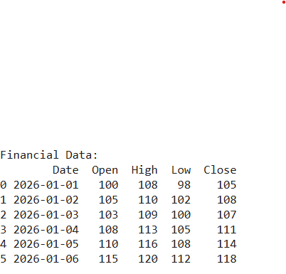
OUTPUT:
