

SIMATS ENGINEERING

Saveetha Institute of Medical and Technical Sciences
Chennai- 602105

Name: BHRANI DHARAN S
Reg no: 192424241
Course Code: DSA0502
Course: QUERY PROCESSING

SET - 15
29.Write a Python programming to display a bar chart of the popularity of programming Languages. Use different color for each bar.
CODE:
import matplotlib.pyplot as plt

# Programming languages and their popularity
languages = ['Python', 'Java', 'C', 'C++', 'JavaScript']
popularity = [90, 75, 65, 60, 80]

# Different colors for each bar
colors = ['red', 'blue', 'green', 'orange', 'purple']

# Create bar chart
plt.bar(languages, popularity, color=colors)

# Add labels and title
plt.xlabel("Programming Languages")
plt.ylabel("Popularity")
plt.title("Popularity of Programming Languages")

# Display chart
plt.show()

OUTPUT:
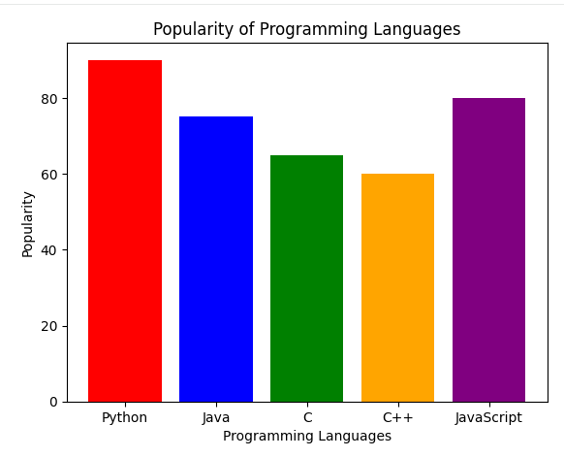

30.Write a Python program to create bar plot of scores by group and gender. Use multiple X values on the same chart for men and women.

CODE:
import matplotlib.pyplot as plt
import numpy as np

# Groups
groups = ['Group A', 'Group B', 'Group C', 'Group D']

# Scores of men and women
men_scores = [75, 85, 70, 90]
women_scores = [80, 78, 88, 85]

# X positions
x = np.arange(len(groups))

# Width of bars
width = 0.35

# Create bar plots
plt.bar(x - width/2, men_scores, width, label='Men')
plt.bar(x + width/2, women_scores, width, label='Women')

# Add labels and title
plt.xlabel("Groups")
plt.ylabel("Scores")
plt.title("Scores by Group and Gender")

# Set X-axis labels
plt.xticks(x, groups)

# Display legend
plt.legend()

# Display chart
plt.show()

OUTPUT:
