DSA06 DATA HANDLING AND VISUALIZATION
Activity: Correlation Detective | Slot D
Field | Details
Roll No | 8
Registration No | 192424141
Name | Bharani Dharan S
Time / Total | 20 to 25 minutes / 20 marks
Tool | R (ggplot2 / base R)
Case File | CD-D08: The Fitness centre Case

Note on the output: R was not installed where this was prepared. I reproduced R's own random-number generator (Mersenne-Twister with inversion for rnorm, checked against known R values) so the case file is the same one that set.seed(346086) produces in R, and computed all statistics and drew the plots in Python. The R code below is the submission code; it should give the same numbers in RStudio (tiny rounding differences are possible).

Evidence – case file code (unchanged)
set.seed(346086)
n <- 15
outdoor_temp <- round(rnorm(n, 35.1, 5.0), 1)
gym_visits <- round(257 + 49.9 * (0.93 * (outdoor_temp - 35.1) / 5.0 + 0.36 * rnorm(n)), 0)
shakes_sold <- round(70 + 15.0 * (0.86 * (outdoor_temp - 35.1) / 5.0 + 0.51 * rnorm(n)), 0)
load_dev <- round(seq(-18.7, 18.7, length.out = n)[order(runif(n))], 1)
injuries <- round(2.3 + 9.4 * (load_dev / 18.7)^2 + rnorm(n, 0, 0.2), 0)
trainers <- round(rnorm(n, 7, 1.5), 0)
towel_loads <- round(21 + 5.0 * (0.06 * (trainers - 7) / 1.5 + 1.00 * rnorm(n)), 0)
trainers[4] <- 12; towel_loads[4] <- 37 # row 4 was typed in by a trainee
case <- data.frame(outdoor_temp, gym_visits, shakes_sold, load_dev, injuries, trainers, towel_loads)

Task 1 – The matrix [4]
library(ggplot2); library(reshape2)
cm <- round(cor(case), 2); cm
nrow(case) # n
choose(7, 2) # distinct pairs
m <- melt(cm)
ggplot(m, aes(Var1, Var2, fill = value)) + geom_tile(colour = "white") +
geom_text(aes(label = sprintf("%.2f", value)), size = 3) +
scale_fill_gradient2(low = "firebrick", mid = "white", high = "steelblue",
midpoint = 0, limits = c(-1, 1)) +
theme(axis.text.x = element_text(angle = 40, hjust = 1)) +
labs(title = "Correlogram", x = NULL, y = NULL)
n = 15 records and 7 variables, so there are 7 x 6 / 2 = 21 distinct pairs of variables.
 | outdoor_temp | gym_visits | shakes_sold | load_dev | injuries | trainers | towel_loads
outdoor_temp | 1.00 | 0.95 | 0.87 | 0.05 | 0.32 | -0.02 | 0.10
gym_visits | 0.95 | 1.00 | 0.83 | -0.06 | 0.48 | 0.03 | 0.14
shakes_sold | 0.87 | 0.83 | 1.00 | 0.06 | 0.28 | -0.14 | 0.21
load_dev | 0.05 | -0.06 | 0.06 | 1.00 | -0.04 | -0.44 | -0.23
injuries | 0.32 | 0.48 | 0.28 | -0.04 | 1.00 | -0.26 | -0.45
trainers | -0.02 | 0.03 | -0.14 | -0.44 | -0.26 | 1.00 | 0.66
towel_loads | 0.10 | 0.14 | 0.21 | -0.23 | -0.45 | 0.66 | 1.00
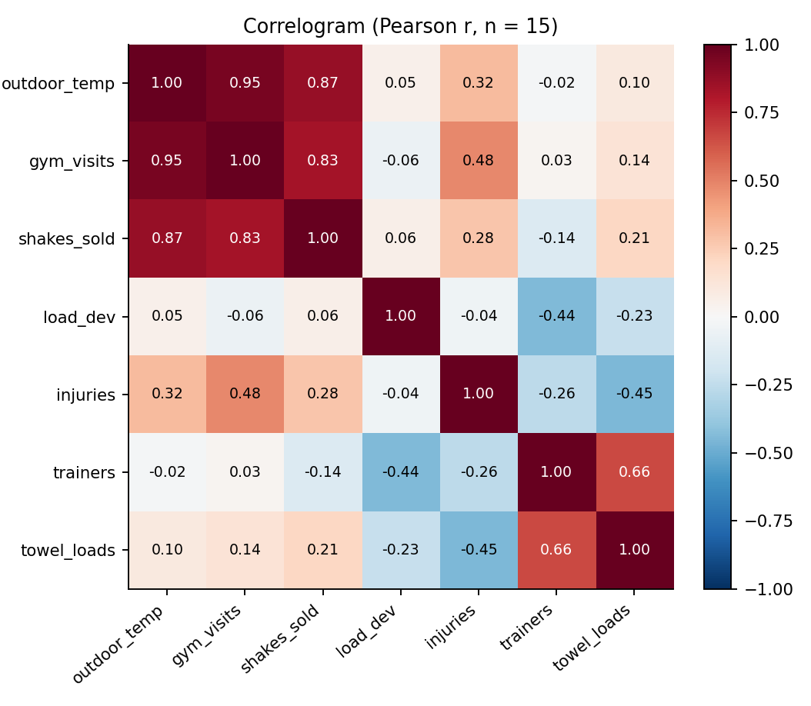
Figure 1. Correlogram of the 7 x 7 correlation matrix

Task 2 – The strongest clues [3]
- Strongest positive pair: outdoor_temp and gym_visits, r = 0.95 (strong, above 0.7).
- Strongest negative pair: injuries and towel_loads, r = −0.45 (moderate, 0.3 to 0.7).
Caution: the negative pair is only moderate and is most likely a coincidence of 15 records (there is no sensible reason for towel loads to reduce injuries). The next negative pair is load_dev and trainers (r = −0.44). Also, the positive pair of the trainers and towel_loads (r = 0.66) is partly produced by the typed-in row 4 (see Task 4).

Task 3 – The deceptive zero [4]
ggplot(case, aes(load_dev, injuries)) + geom_point() +
geom_smooth(method = "lm", se = FALSE, colour = "red", linetype = "dashed") +
geom_smooth(method = "lm", formula = y ~ x + I(x^2), se = FALSE, colour = "darkgreen")
cor(case$load_dev, case$injuries)
summary(lm(injuries ~ load_dev + I(load_dev^2), data = case))$r.squared
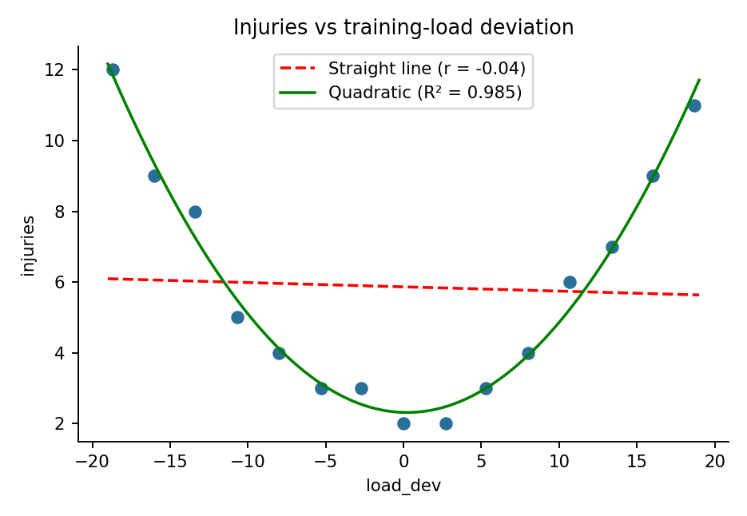
Figure 2. Injuries vs load_dev with straight line (red dashed) and quadratic fit (green)
- r(load_dev, injuries) = −0.04 (essentially zero; straight-line R² = 0.002).
- R² of the quadratic fit = 0.985 (adjusted R² = 0.983); fitted curve: injuries ≈ 2.32 − 0.012·x + 0.0267·x².
Why r misses it: injuries rise on both sides of the optimum (a U-shape), so the rising and falling arms cancel and r, which only measures straight-line association, comes out near zero even though load_dev explains about 98 % of the variation in injuries.

Task 4 – The outlier alibi [4]
ggplot(case, aes(trainers, towel_loads)) + geom_point() +
geom_smooth(method = "lm", se = FALSE)
cor(case$trainers, case$towel_loads) # all rows
cor(case$trainers[-4], case$towel_loads[-4]) # without row 4
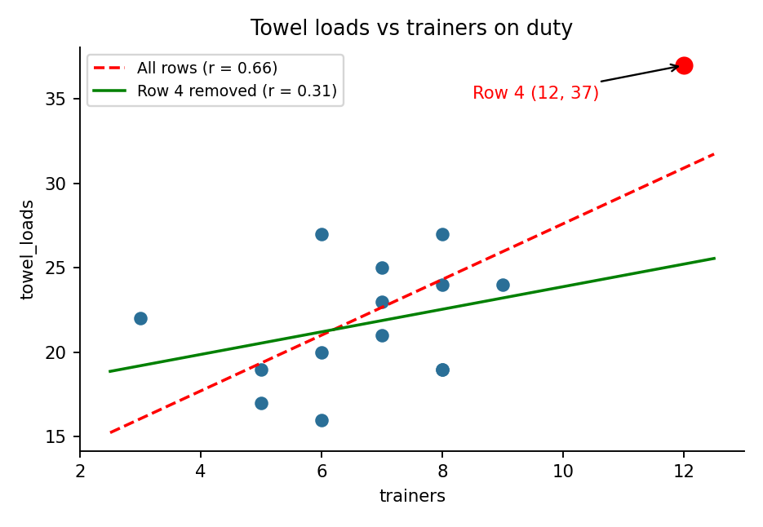
Figure 3. Towel loads vs trainers; row 4 is the red point
- The wrong-looking record is row 4 (trainers = 12, towel_loads = 37): it sits far from the other 14 points (other trainers values are 3 to 9 and towel loads 16 to 27).
- r with all 15 rows = 0.66; r without row 4 = 0.31.
Effect: this single record more than doubled r (from a weak/moderate 0.31 to 0.66), creating a much stronger link than the other 14 days support; r is sensitive to one extreme point. Row 4 should be checked and corrected before any conclusion is made.

Task 5 – The prime suspect [5]
cor(case$gym_visits, case$shakes_sold)
cor(case$outdoor_temp, case$gym_visits)
cor(case$outdoor_temp, case$shakes_sold)
cor(resid(lm(gym_visits ~ outdoor_temp, data = case)),
resid(lm(shakes_sold ~ outdoor_temp, data = case))) # partial correlation
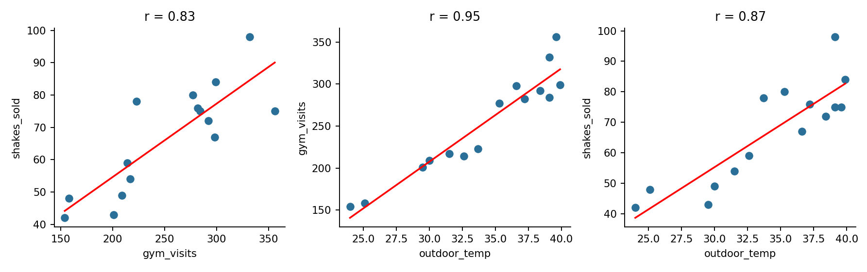
Figure 4. gym_visits, shakes_sold and outdoor_temp: pairwise scatterplots
Correlation | r
gym_visits and shakes_sold | 0.83
outdoor_temp and gym_visits | 0.95
outdoor_temp and shakes_sold | 0.87
gym_visits and shakes_sold, controlling for outdoor_temp (partial r) | 0.07
Verdict: No – the strong link (r = 0.83) between gym_visits and shakes_sold almost disappears (partial r = 0.07) once outdoor_temp is held fixed, so the hidden driver is outdoor temperature, which pushes up both gym visits and shake sales. Gym visits therefore do not show causing shake sales; the correlation is a confounding effect.
Study design to test causation: a randomized controlled experiment, e.g. randomly assigning days or members to receive a free-entry promotion (raising gym visits independently of the weather) and then comparing shake sales between the randomized groups.
Detective's rule confirmed: the correlation measures a straight-line link only (Task 3), can be inflated by one point (Task 4), and never proves cause (Task 5).
Code of Conduct: I certify that this work is my own.
Signature: ____________________

