DSA06 DATA HANDLING AND VISUALIZATION
Activity: Map Storytelling Challenge | Slot D
Field | Details
Roll No | 8
Registration No | 192424141
Name | Bharani Dharan S
Time / Total | 20 minutes / 20 marks
Tool | R (ggplot2 + maps)
Story Brief | MS-D08: High-school graduates (% of adults, 1970)
Comparison variable | Population (thousands, 1975)
Focus region / classes / colours | West / 4 classes / magma

Note on the output: R was not installed where this was prepared. The state data are the built-in R dataset state.x77 (loaded from the R datasets repository), regions follow R's state.region (West = 13 states, including Alaska and Hawaii), and all statistics were computed in Python and the maps drawn in Python with the same Albers projection (parallels 29.5° and 45.5°) and magma colours. The R code below is the submission code and should reproduce the numbers in RStudio. Exact outline shapes and colours of the maps may differ slightly from the ggplot2 output.

Set-up code (unchanged)
library(ggplot2); library(maps)
d <- data.frame(state = state.name, zone = state.region, state.x77)
names(d) <- c("state","zone","pop","income","illit","life","murder","hsgrad","frost","area")
d$id <- tolower(d$state)
mapdat <- merge(map_data("state"), d, by.x = "region", by.y = "id")
mapdat <- mapdat[order(mapdat$group, mapdat$order), ]
V <- d$hsgrad # the variable you map
W <- d$pop # the comparison variable

Task 1 – The base map [4]
ggplot(mapdat, aes(long, lat, group = group, fill = hsgrad)) +
geom_polygon(colour = "white") +
coord_map("albers", lat0 = 29.5, lat1 = 45.5) +
scale_fill_viridis_c(option = "magma", name = "HS graduates\n(% of adults)") +
labs(title = "High-school graduates by state, 1970",
caption = "Source: R datasets, state.x77 (US Census). Alaska and Hawaii not shown.") +
theme_void()
d$state[which.max(V)]; max(V)
min(V); d$state[V == min(V)]
median(V)
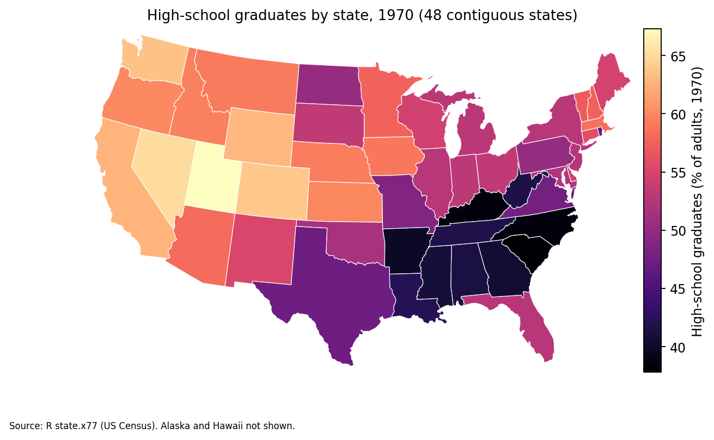
Figure 1. Choropleth of hsgrad (magma), 48 contiguous states
- Highest state: Utah, 67.3 %.
- Lowest value: 37.8 %, in South Carolina (the only state with this value).
- Median of all 50 states = 53.25 % (mean 53.11 %).

Task 2 – The regional story [4]
tapply(V, d$zone, mean)
cor(V, W)
Region | Mean hsgrad (%)
West (13 states) | 62.00
North Central (12) | 54.52
Northeast (9) | 53.97
South (16) | 44.34
- Highest region: West (62.00 %); lowest region: South (44.34 %); gap = 17.66 percentage points.
- cor(V, W) = −0.10: a weak, negative correlation, so states with larger populations tend to have slightly lower graduate percentages, but the link is almost negligible and, as a correlation, it is not proof of cause.

Task 3 – Classes change the story [4]
mapdat$eq <- cut(mapdat$hsgrad, 4)
mapdat$qt <- cut(mapdat$hsgrad, quantile(V, seq(0, 1, length.out = 5)),
include.lowest = TRUE)
table(cut(V, 4)); table(cut(V, quantile(V, seq(0,1,length.out=5)), include.lowest = TRUE))
for (v in c("eq","qt"))
print(ggplot(mapdat, aes(long, lat, group = group, fill = .data[[v]])) +
geom_polygon(colour = "white") + coord_map("albers", lat0 = 29.5, lat1 = 45.5) +
scale_fill_viridis_d(option = "magma") + theme_void())
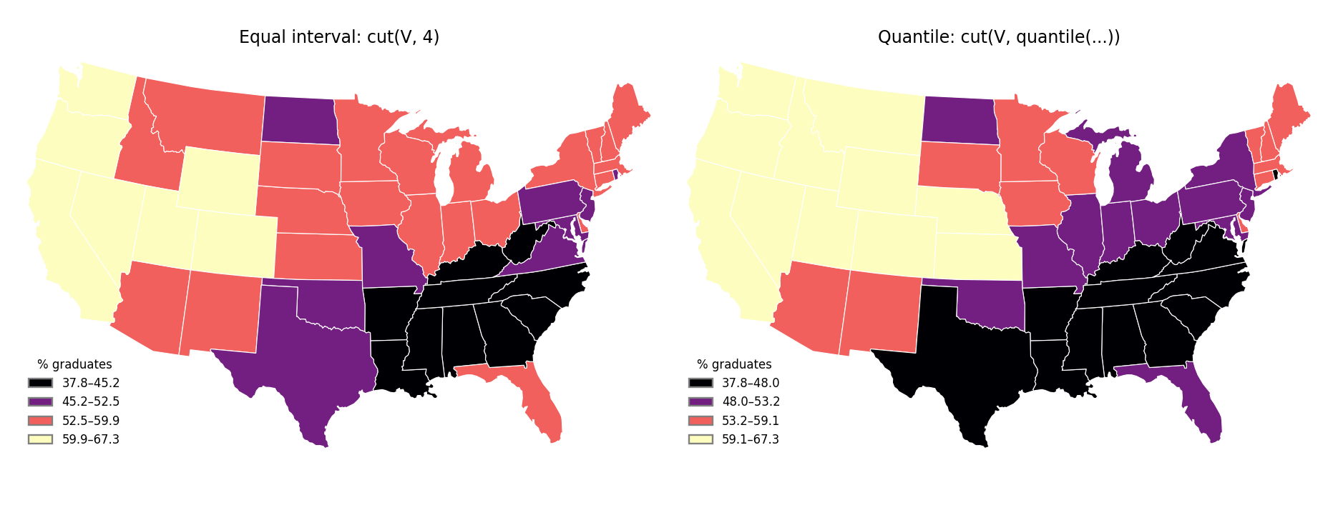
Figure 2. Same data, equal-interval classes (left) and quantile classes (right)
Method | Class counts (low to high) | Lower limit of top class | States in top class
Equal interval | 10, 9, 22, 9 | 59.9 (59.925) | 9
Quantile | 13, 12, 12, 13 | 59.15 (59.2 shown) | 13
The equal-interval method makes the highest values look rarer (only 9 states, 18 %, in the top class versus 13 states, 26 %, under quantiles). With equal intervals, 22 states are in one middle class, which hides differences among them. For a school-board audience I would choose quantile classes, because each class holds a similar number of states, so the map shows relative standing (who is in the top and bottom quarter), with the class limits printed in the legend so that readers can see the cut-points. (Quantile breaks can exaggerate small differences across a boundary, so the limits must be shown.)

Task 4 – Counts versus rates [4]
count <- d$pop * 1000 * d$hsgrad / 100
d[order(-count), c("state")][1:3]
d[order(-V), c("state")][1:3]
length(intersect(d$state[order(-count)][1:3], d$state[order(-V)][1:3]))
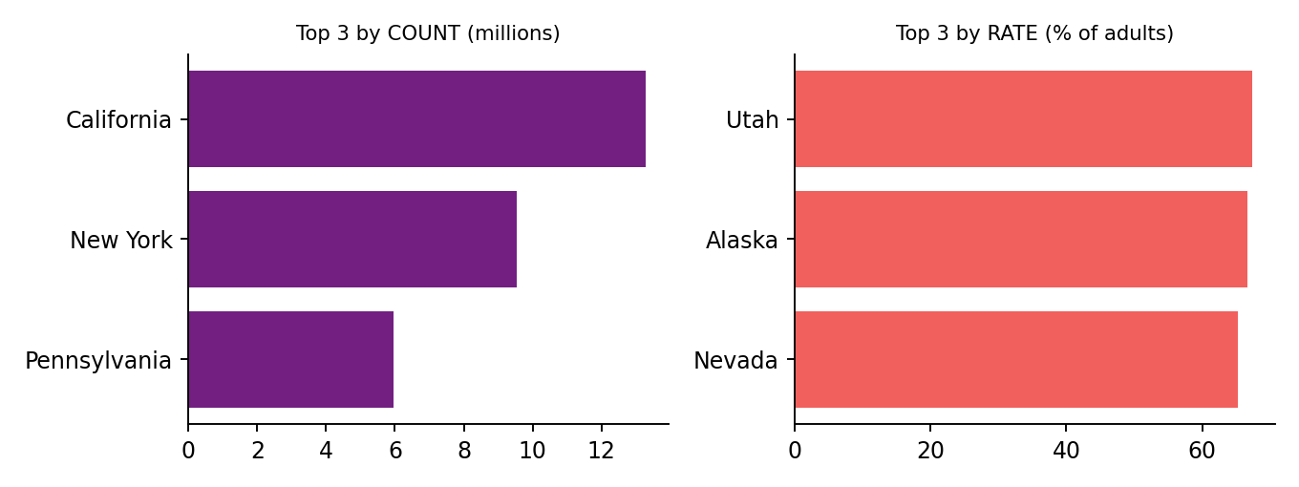
Figure 3. Top 3 states by count versus by rate
Rank | By count of graduates | By hsgrad (%)
1 | California (13.27 million) | Utah (67.3)
2 | New York (9.53 million) | Alaska (66.7)
3 | Pennsylvania (5.95 million) | Nevada (65.2)
- Number of states in both lists = 0.
A map of counts would mislead because it mostly shows where the most people live (big states look best regardless of how well their schools do); map the rate (percentage of adults) instead, which is comparable across states of different sizes.

Task 5 – The story for the West region [4]
w <- d[d$zone == "West", ]
mean(w$hsgrad); mean(w$hsgrad) / mean(V)
w[which.max(w$hsgrad), c("state","hsgrad")]
sum(w$hsgrad > median(V))
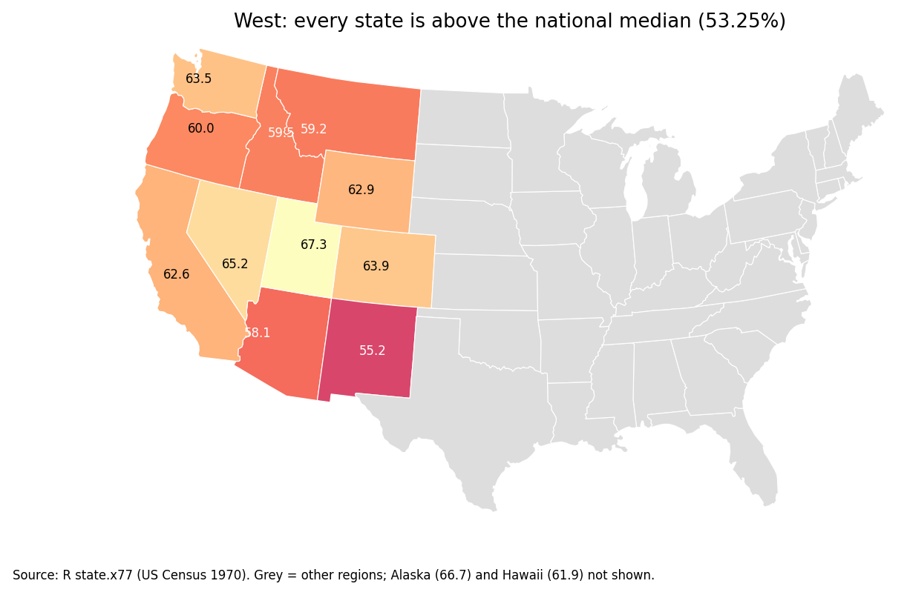
Figure 4. West region highlighted (other regions grey)
- Mean hsgrad in West = 62.00 %; ratio to the all-50-state mean (53.11 %) = 1.17.
- Highest West state: Utah, 67.3 %.
- West states above the national median (53.25 %): 13 of 13.
Headline (11 words): West leads the nation: every Western state tops the 1970 median.
Evidence: The West's average high-school graduation rate was 62.0 %, 1.17 times the national mean of 53.1 %, with Utah highest at 67.3 %. All 13 West states were above the national median of 53.25 %, and even the lowest, New Mexico (55.2 %), was ahead of it, while the South averaged only 44.3 %, 17.7 points behind the West.
Recommendation: The school board should use the West's best performers (Utah, Alaska, Nevada) as benchmarks and look at which practices explain their results, and give priority to support in lower-scoring regions rather than assuming a state's size or population explains its results.
Honest-map notes: the story uses rates (not counts) and shows the class limits and a source note; Alaska and Hawaii are in the statistics but not on the map; the data are 1970 state averages, which hide differences within states.
Code of Conduct: I certify that this work is my own.
Signature: ____________________

