DSA06 DATA HANDLING AND VISUALIZATION
Activity: Identify Seasonality Patterns | Slot D
Field | Details
Roll No | 8
Registration No | 192424141
Name | Bharani Dharan S
Time / Total | 20 to 25 minutes / 20 marks
Tool | R (ggplot2 / base R)
Series | SP-D08: Retail sales (lakh rupees), quarterly

Note on the output: R was not installed where this was prepared. I reproduced R's random-number generator (checked against known R values) so the series is the same one set.seed(13424) gives in R, and computed the results (including decompose, acf and lm) and plots in Python. The R code below is the submission code and should reproduce these numbers in RStudio.

Evidence – series code (unchanged)
set.seed(13424)
m <- 4 # observations per cycle (quarterly data)
n <- m * 11 # 11 full cycles
t <- 1:n
trend <- 120.3 + 1.222 * t
sales <- round(trend + 22.4 * cos(2 * pi * (t - 2) / m) + rnorm(n, 0, 5.6), 1)
x <- ts(sales, frequency = m, start = c(2013, 1))

Task 1 – Look at the series [3]
plot(x, type = "o", ylab = "Sales (lakh Rs)")
length(x); frequency(x); length(x) / frequency(x)
coef(lm(sales ~ 1:n))
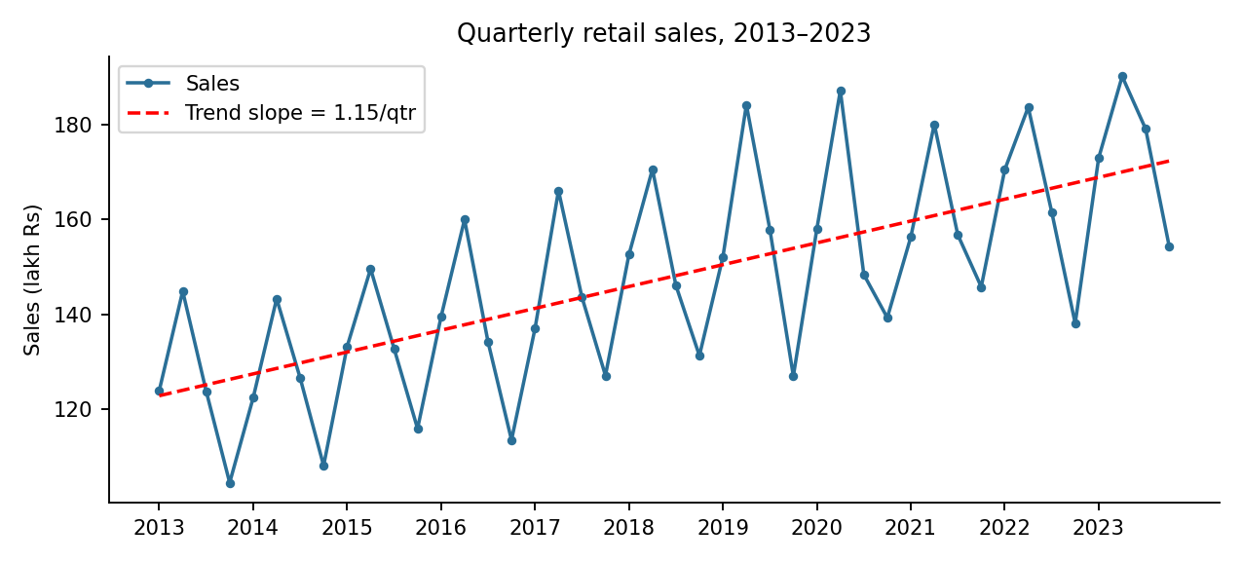
Figure 1. Quarterly sales 2013–2023 with fitted linear trend
- n = 44 observations; cycle length = 4 (quarters); 11 full cycles (2013–2023).
- Fitted line: sales = 121.69 + 1.15 per quarter. The trend is rising (about +4.6 lakh per year).

Task 2 – The seasonal pattern [4]
dc <- decompose(x)
round(dc$figure, 2)
plot(dc)
Quarter | Q1 | Q2 | Q3 | Q4
Seasonal value (lakh Rs) | +1.57 | +22.29 | −2.28 | −21.58
- Peak quarter: Q2 (+22.29); trough quarter: Q4 (−21.58).
- Seasonal swing = 22.29 − (−21.58) = 43.87 lakh rupees.

Task 3 – Is it consistent? [3]
library(ggplot2)
df <- data.frame(sales = as.numeric(x), pos = as.numeric(cycle(x)),
year = factor(floor(time(x) + 1e-6)))
ggplot(df, aes(pos, sales, group = year, colour = year)) +
geom_line() + geom_point() + scale_x_continuous(breaks = 1:4, labels = paste0("Q", 1:4))
table(tapply(seq_along(x), df$year, function(i) which.max(sales[i])))
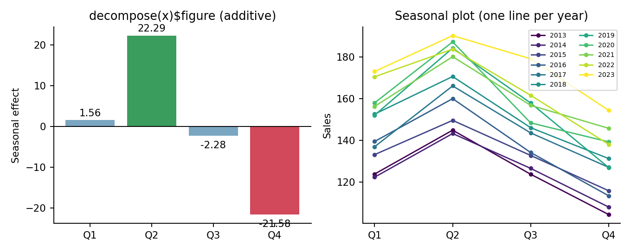
Figure 2. Seasonal values (left) and seasonal plot with one line per year (right)
The highest value of the year falls in Q2 in all 11 of 11 cycles. The pattern is consistent: every yearly line rises from Q1 to Q2, then falls through Q3 to a low in Q4, and the lines are stacked upward year by year (the trend), not crossing.

Task 4 – Confirm with autocorrelation [4]
d <- resid(lm(sales ~ 1:n))
a <- acf(d, lag.max = 4, plot = FALSE); a
2 / sqrt(n) # significance bound
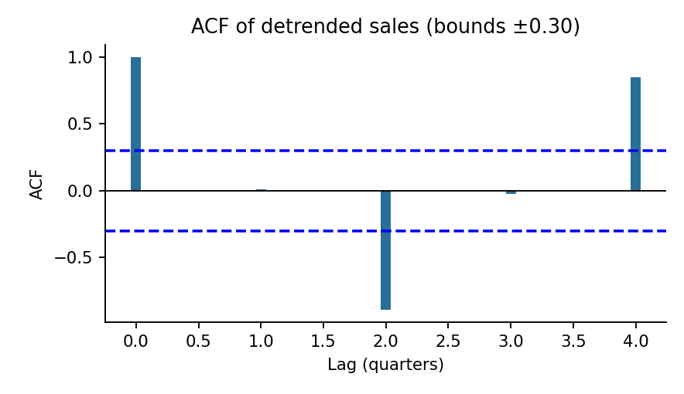
Figure 3. ACF of detrended sales
Lag | 1 | 2 | 3 | 4
Autocorrelation | 0.01 | −0.89 | −0.02 | 0.85
Bound = 2 / √44 = 0.30. Lag 4 = +0.85 (far above +0.30) and lag 2 = −0.89 (far below −0.30). A strong positive autocorrelation at lag 4 means each quarter resembles the same quarter a year earlier, which is the repeating 4-quarter cycle. The strong negative autocorrelation at lag 2 means a quarter is the opposite of the one half a cycle away (peak Q2 versus trough Q4). Together they confirm real, fixed-period seasonality; lags 1 and 3 are inside the bounds.

Task 5 – Additive or multiplicative? [6]
cyc <- matrix(sales, ncol = 4, byrow = TRUE)
range1 <- diff(range(cyc[1, ])); range11 <- diff(range(cyc[11, ]))
range1; range11; range11 / range1

dca <- decompose(x, type = "additive")
adjusted <- x - dca$seasonal
coef(lm(as.numeric(adjusted) ~ 1:n))
Quantity | Value
Range, first cycle (2013): 123.9, 144.9, 123.8, 104.5 | 144.9 − 104.5 = 40.4
Range, last cycle (2023): 173.0, 190.2, 179.1, 154.4 | 190.2 − 154.4 = 35.8
Ratio (last / first) | 35.8 / 40.4 = 0.89
Type: additive. The level rose from about 124 to 174 lakh (+40 %) while the seasonal range did not grow (the ratio is 0.89, about 1, not above 1). The swings stay roughly the same size as the level rises, so the season is a constant addition, not a percentage of the level.
Seasonally adjusted slope (additive, sales − seasonal): lm(adjusted ~ 1:n) gives 1.22 lakh per quarter. This is close to the true underlying trend of 1.222 and slightly different from the unadjusted 1.15, since removing the seasonal pattern leaves a cleaner trend estimate.
Advice to management: Plan stock and staffing for a regular Q2 peak (about 22 lakh above the yearly average) and a Q4 low (about 22 lakh below), and treat the steady growth of about 1.2 lakh per quarter as a separate trend, so that a Q4 dip is not mistaken for decline nor a Q2 rise for extra growth.
Possible bias: n = 44 gives only 11 cycles, and a linear trend line is assumed; a changing trend would affect the decomposition.
Code of Conduct: I certify that this work is my own.
Signature: ____________________

