**CAPSTONE PROJECT**

**WALMART SUPER STORE ANALYSIS**

**OVERVIEW PAGE**



**Overview / Main Page – 2**

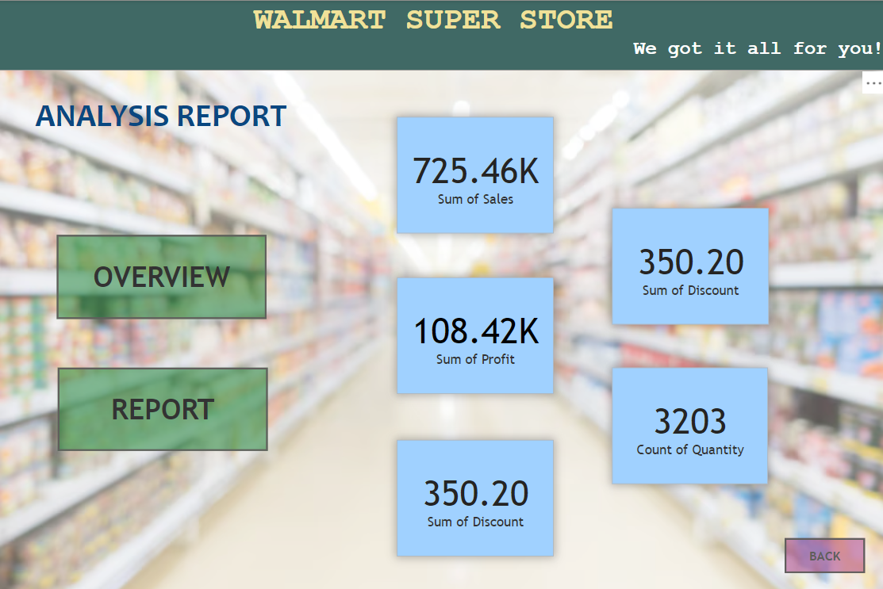

**Report Page**

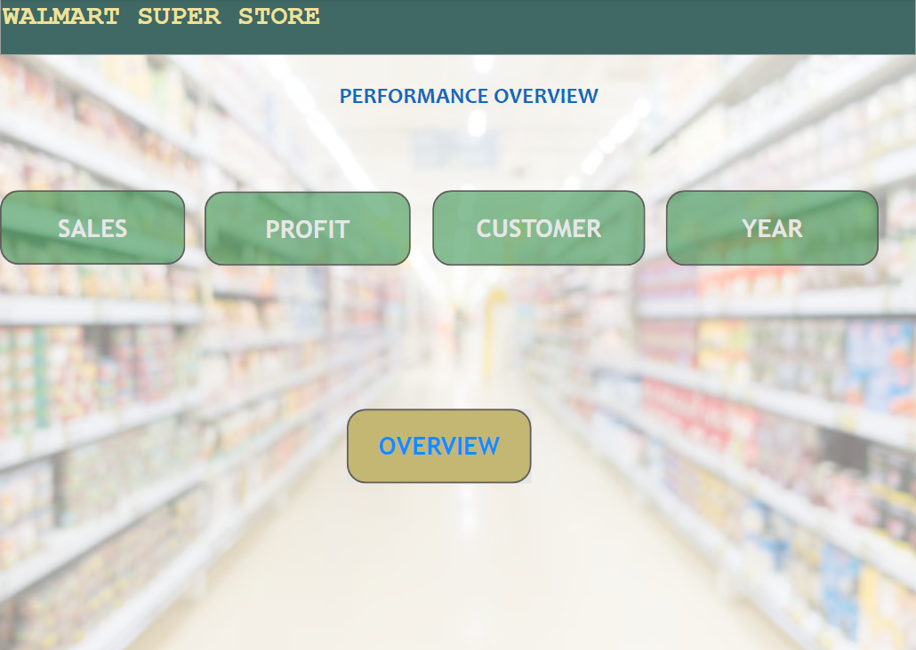

**Sales Page**

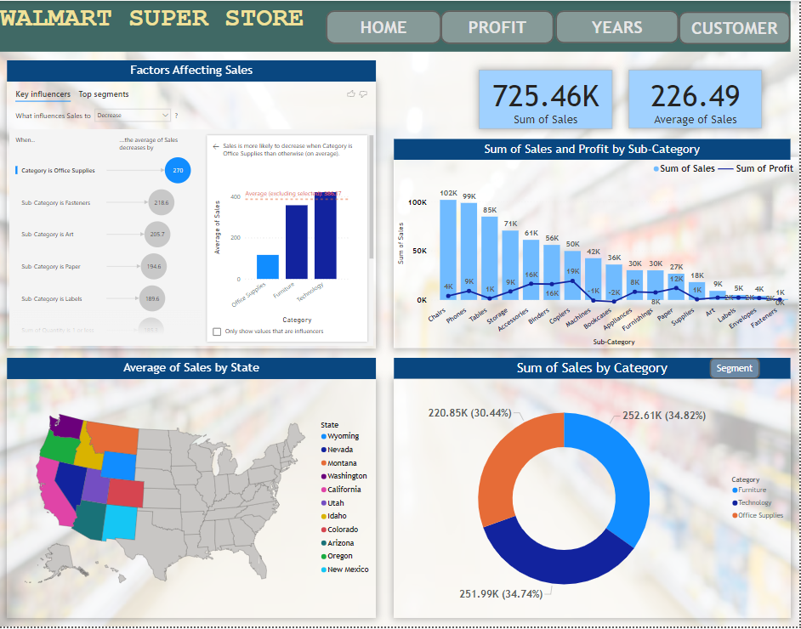

**Report Page**

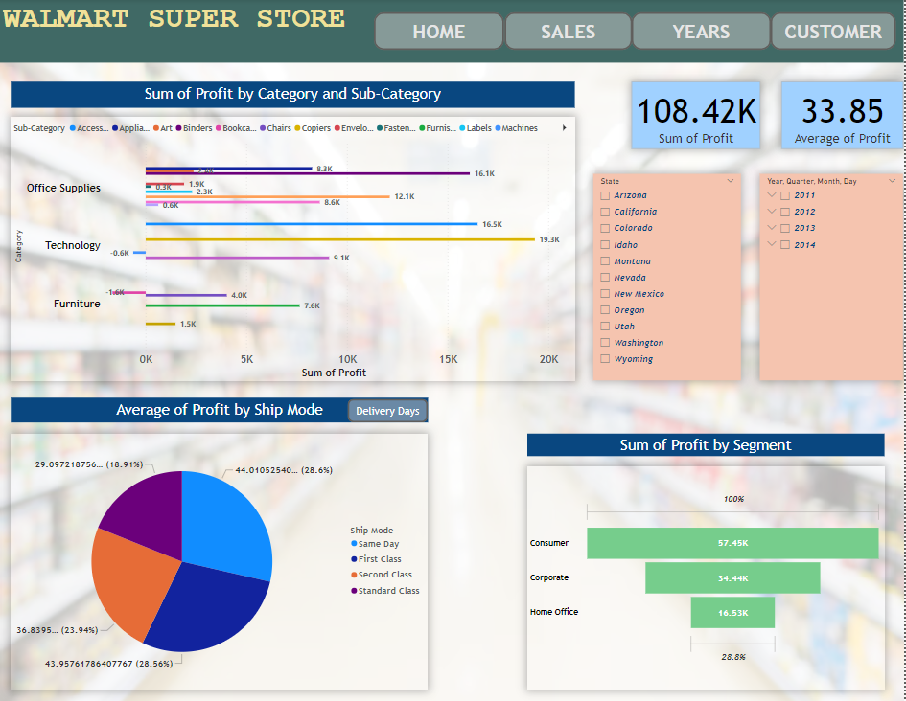

**Profit Page**



**Year Page**

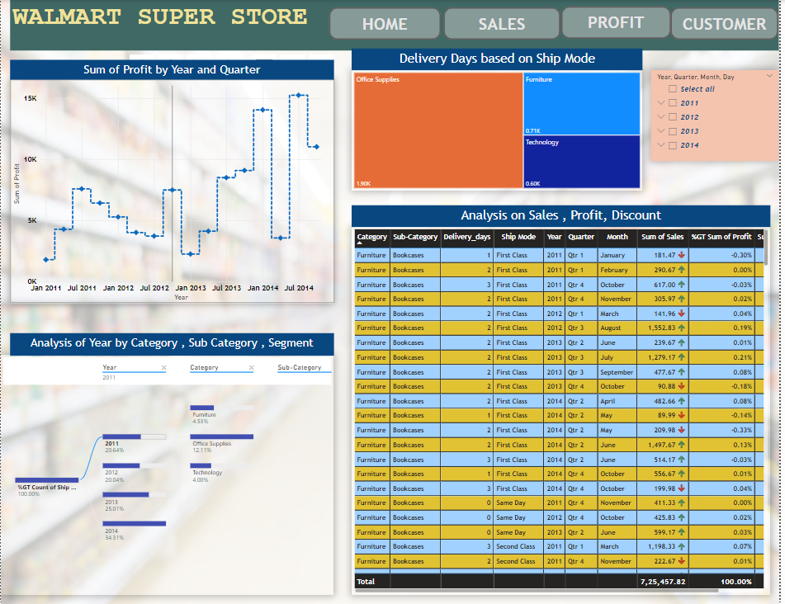

**Customer Page**

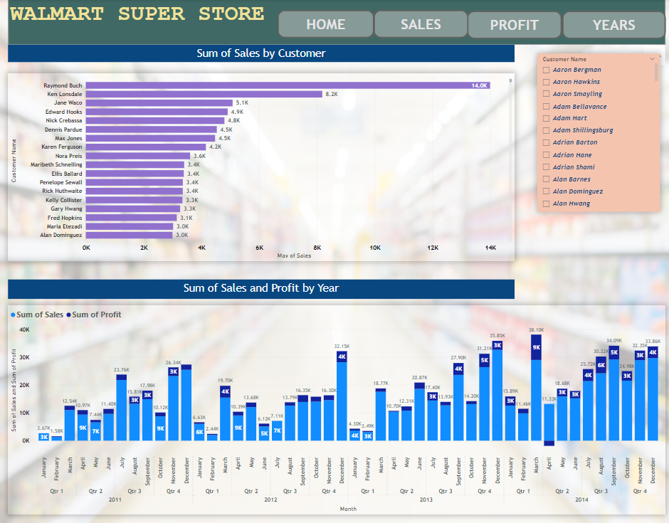

**End**