Deep Technical Architecture for Autonomous Demand Response (ADR) Frameworks
Closed-Loop Telemetry Protocols, Edge Thermal/Fluid Dynamics Math, and Distributed Grid Optimization Engines
With the unprecedented acceleration of non-dispatchable renewable energy generation and massive concurrent charging profiles of electric vehicles, modern electrical power networks face localized and systemic stability thresholds. To maintain grid frequency and nominal operating voltages without deploying capital-intensive or carbon-emitting fast-peaking infrastructure, utilities must transition from supply-side modulation to high-speed, machine-to-machine, automated demand-side resource dispatching.
Automated Demand Response (ADR) eliminates human intervention from the demand-side management (DSM) execution loop. This framework replaces manual callbacks with open-source cryptographic protocols, deterministic edge control strategies, and programmatic verification engines. This paper provides an exhaustive engineering breakdown of the open-source protocol suites, mathematical mechanics of edge load-shedding, and telemetric metrology required to execute ADR safely within mission-critical infrastructure.
1. System Topography: High-Fidelity OpenADR Architecture
The foundational structural layout of automated demand response relies on a decoupled, client-server paradigm specified by the OpenADR alliance standard. This logical topography abstracts intricate grid telemetry networks into two core functional processing tiers:
- Virtual Top Node (VTN): The Virtual Top Node (VTN) represents the absolute data-orchestration server. Deployed within an utility's SCADA environment, balancing authority core, or independent aggregator's cloud cluster, the VTN handles bulk-grid stability evaluations, computes real-time locational marginal pricing vectors, generates structured event payloads, and enforces deterministic downstream scheduling.
- Virtual End Node (VEN): The Virtual End Node (VEN) represents the high-performance edge client executing within the consumer environment. This software client can be integrated directly within an industrial facility's SCADA master station, embedded inside a commercial Building Automation System (BAS) controller, or implemented as a cloud-to-cloud bridge by a managed service provider. The VEN ingests structural XML event streams, checks local operational constraints, translates payloads into specific hardware control signals, and continuously streams validation telemetry upstream.
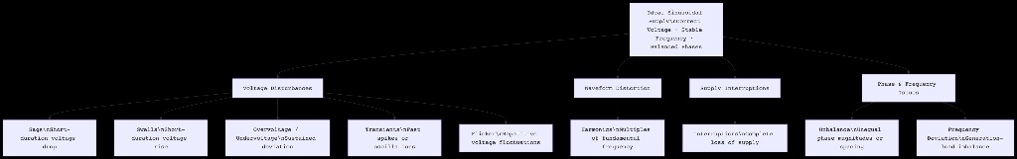
Figure 1: High-Fidelity Architectural Topology Map of OpenADR VTN-to-VEN Communications Framework.
2. Protocol Dynamics: XSD Structural Models and Signaling Automata
To avoid vendor lock-in and enable cross-manufacturer interoperability, modern ADR architectures deploy the standardized OpenADR 2.0b profile specification. Operating on the Application Layer via HTTP/REST or XMPP transport layers, the standard enforces structured XML schemas (XSD) to govern four foundational service interfaces:
A. The EiEvent Service Layer
The EiEvent payload models the lifecycle of a load modulation directive. The VTN broadcasts an 'oadrDistributeEvent' XML schema containing explicit temporal boundaries, geographic/topological targeting indices, and direct reduction parameters. The reduction parameter can be expressed as a relative pricing multiplier, an absolute kW target restriction, or a normalized duty cycle percentage adjustment.
B. The EiReport Service Layer
EiReport acts as the real-time metrology transport backbone. The VEN leverages this interface to push persistent historical and high-frequency live telemetry streams back to the VTN. These payloads encapsulate instantaneous active power (kW), reactive power (kVAR), localized baseline models, and immediate dispatchable capacity availability metrics.
C. The EiOpt Service Layer
The EiOpt service layer implements localized sovereign override mechanisms. If an industrial VEN experiences a spontaneous production shift or critical safety event, it transmits an 'oadrCreateOpt' schema to the VTN. This temporarily alters its availability signature to 'Opt-Out', instantly steering the utility's automated forecasting algorithms away from dispatching that specific asset.
D. The EiRegisterParty Service Layer
EiRegisterParty handles initial device onboarding, cryptographic device identity verification, transport layer parameter negotiation, and persistent connection state maintenance between the node architectures.
3. Edge Mathematics: Deterministic Physics of Load Modulation
Once the edge VEN parsing engine captures and validates an upstream demand reduction payload, it initiates machine-to-machine control routines. Rather than executing crude, unsafe binary asset shutdowns, modern architectures execute precise, continuous adjustments derived from thermodynamic and fluid mechanical laws.
A. Thermodynamic Modeling of HVAC Chiller Infrastructure
To modulate large commercial HVAC loads without compromising occupant safety or precision manufacturing cleanroom envelopes, systems use the Equivalent Thermal Parameter (ETP) differential model. The structural internal temperature trajectory can be formalized as:
C_th * (dT_i / dt) = (T_o - T_i) / R_th - Q_hvac
Where C_th represents the composite thermal capacitance of the building envelope, T_i is the interior air temperature vector, T_o is the instantaneous outdoor ambient temperature, R_th represents the equivalent thermal resistance of the structural insulation, and Q_hvac is the net cooling thermal energy extracted by the chiller array. By programmatically resetting indoor air setpoints upwards by delta-T (typically 1.5°C to 2°C), the internal thermal capacitance acts as a virtual battery, allowing the chiller compressor motor to throttle down its input electrical demand instantly.
B. Fluid Dynamics and Kinetic Energy Optimization in Industrial VFDs
In heavy industrial pumping and ventilation loops, enormous electrical power changes can be accomplished via minor speed adjustments governed by the centrifugal fluid mechanics Affinity Laws. The relationship between variable frequency drive mechanical fan speed (N) and input electrical power draw (P) is intensely cubic:
P_1 / P_2 = (N_1 / N_2)^3
Because power scales with the cube of rotational velocity, an automated reduction of fan or pump speed by a mere 10% drops the required electrical power demand to (0.90)^3 = 0.729, which equates to an immediate 27.1% reduction in system power. This allows industrial VENs to capture massive, immediate shedding profiles across water treatment, mining, and heavy chemical manufacturing facilities without arresting process lines entirely.
C. Electrochemical Balancing with Battery Energy Storage Systems (BESS)
The most advanced automated demand response topology involves zero disruption to industrial throughput. Upon receiving an oadrDistributeEvent signal, the VEN initiates a bidirectional control routine with a local commercial BESS SCADA loop. The control algorithm instantly flips the battery from standby or charge configurations into active discharge mode, injection-matching the facility's instantaneous peak load:
P_grid(t) = P_load(t) - [P_bess(t) * eta_inv]
Where P_grid is the net grid-facing power measured at the revenue meter, P_load is the unmitigated facility baseline load, P_bess is the internal battery electrochemical discharge rate, and eta_inv represents the overall operational efficiency of the power conversion inverter. The utility observes a perfect, immediate demand drop at the meter, while the internal industrial assembly lines remain entirely undisturbed.
4. Operational Dispatch Classifications: Performance Metrics Matrix
The functional parameters of automated demand response vary significantly based on market clearings, network topology, and programmatic contractual frameworks. The table below details these attributes:
Dispatch Protocol Category | Telemetry & Metrology Bandwidth | Maximum Response Latency | Primary Edge Execution Strategy
Critical Peak Pricing (CPP) | Low Frequency; daily intervals via standard XML schemas. | 4 Hours to 24 Hours Notice | Structural pre-cooling cycles; industrial batch process rescheduling schedules.
Capacity Bidding / Fast Shed | Medium Frequency; 15-minute intervals pushed via EiReport. | 15 Minutes to 1 Hour Notice | Global temperature setpoint adjustments; automated cycling of auxiliary lighting matrices.
Fast Ancillary Frequency Regulation | High Frequency; sub-second streaming via dedicated telemetry pipelines. | Under 2 Seconds (Deterministic) | High-speed electrochemical BESS injection matching; emergency VFD frequency dampening.

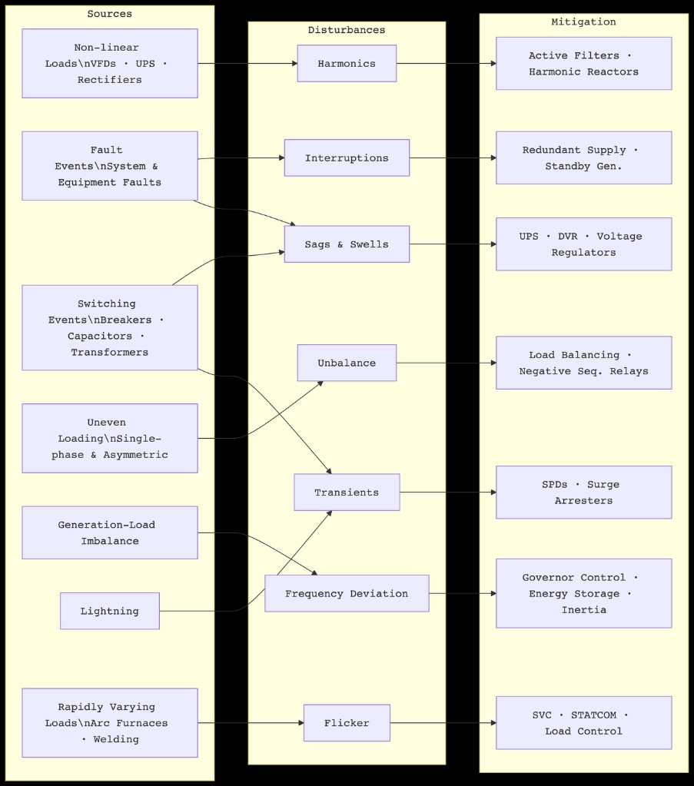
Figure 2: Closed-Loop Telemetry System Transaction Sequence and State Machine Dynamics.
5. System Risks: Latency Constraints, Telemetry Failures, and Cyber Vectors
As utilities transition from human-managed demand reduction programs to algorithmic machine control, severe systems-engineering risks emerge that require dedicated technical mitigation.
A. Network Jitter and Non-Deterministic Control Loop Failures
In advanced fast ancillary service markets, non-deterministic communication networks introduce packet latency and jitter. If an event payload transits congested public cellular links, it may arrive at the VEN after the contractual execution window has closed. Failure to shed load within millisecond tolerances can induce localized grid frequency drops and trigger severe financial non-compliance penalties against the facility.
B. Cyber-Physical Attack Surfaces and Infrastructure Security Protocols
By linking utility distribution management infrastructure directly with millions of internet-facing edge building systems, ADR significantly creates new physical security vulnerabilities. If a sophisticated threat actor gains unauthorized administrative access to an upstream cloud-based VTN server, they could broadcast malicious, coordinated load-drop schemas across thousands of industrial facilities simultaneously.
A sudden, massive, unexpected drop in regional electrical demand could trigger an extreme grid over-frequency transient event, causing localized utility protection relays to trip and inducing widespread regional blackouts. To mitigate this catastrophic risk, modern ADR deployments must enforce mandatory Transport Layer Security (TLS 1.3), enforce strict W3C XML Digital Signatures on every payload packet, mandate cryptographic hardware security modules (HSM) at the edge VEN, and execute validation plausibility checks before letting software control physical relays.
6. Advanced Horizon: Distributed Ledger Technologies and Predictive Edge AI
The upcoming paradigm of automated demand response features a migration away from rigid centralized server-client configurations to fully decentralized smart markets. Next-generation systems embed deep predictive neural networks directly onto edge VEN microprocessors. These systems continuously synthesize real-time ambient weather profiles, complex manufacturing pipeline velocities, historical electrical load curves, and spot-market pricing charts to generate ultra-precise local load-profile forecasts.
By integrating these intelligent edge nodes with distributed ledger technology (such as secure, decentralized blockchain consensus smart contracts), facilities can trade load-shedding capacity peer-to-peer within localized microgrid networks. This eliminates the central VTN single point of failure entirely. The future industrial facility ceases to be a vulnerable, passive drain on utility infrastructure; instead, it becomes a proactive, self-healing, intelligent cell of a resilient, automated, and entirely decarbonized energy architecture.

