## **3 Tier Resources & Environments**

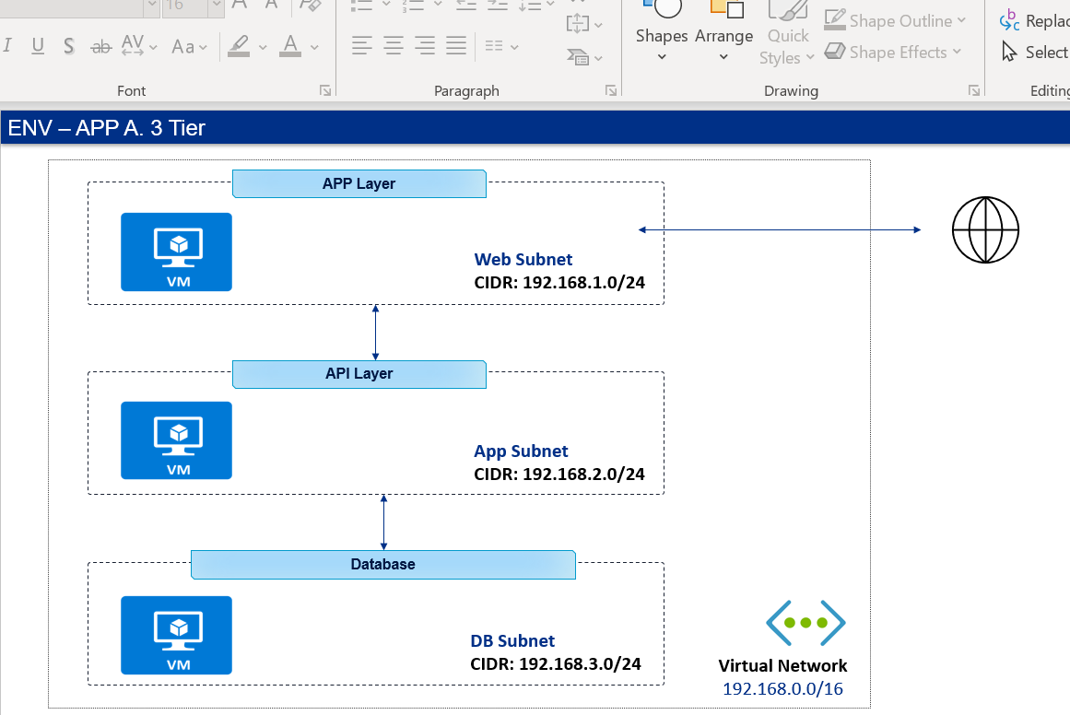

## **Solution Approach Azure DevOps:**

This solution is using HashiCorp Terraform as a IAAC tool to build, change 3-tier Azure infrastructure using Azure DevOps platform tools-based CI & CD orchestration Pipelines, Repositories. Azure DevOps Platform Repository are used to store and version the Terraform Modules, TF, Parameter files.

Build and Release Pipelines are orchestrating complete Terraform IAAC lifecycle along with approval workflows before deploying resources in Azure Subscriptions.

## **Process flow**

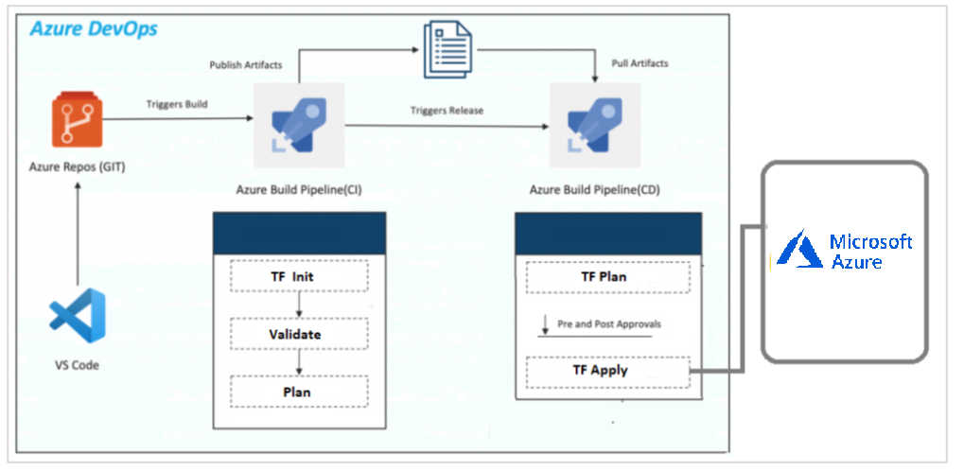

## **Repository**

Repository is containing the terraform files and Azure Pipeline Code

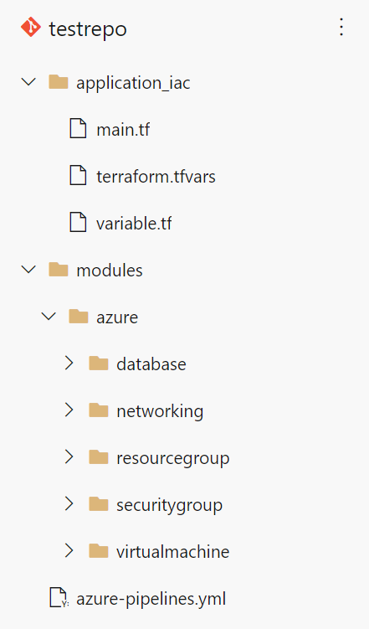

Application IAC folder contain the TF files to provision 3 – tier architecture resources. Module is containing the Resources Specific folders containing the TF implementation. Versioning is enabled inside resource folders using V1 & V2.

## **Build Pipelines (CI)**

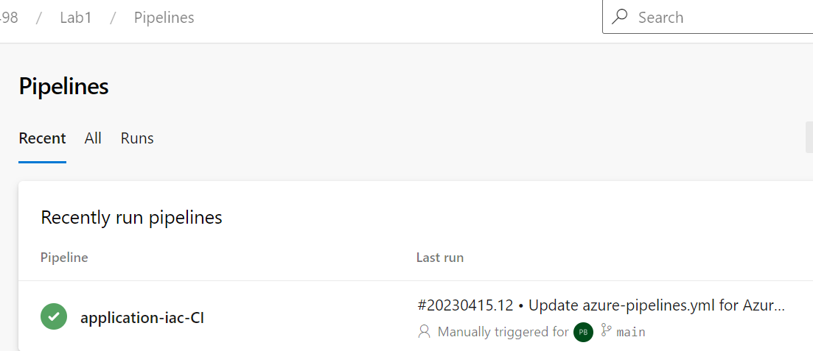

CI Pipeline is triggered when code or terraform configuration change is committed to main branch in repository.

This pipeline is having below tasks that are executed in sequence.

* Check out changed Terraform files on Build Server
* Initialize Terraform
* Validate Terraform Changes
* Check the Terraform Plan
* Publish artifacts

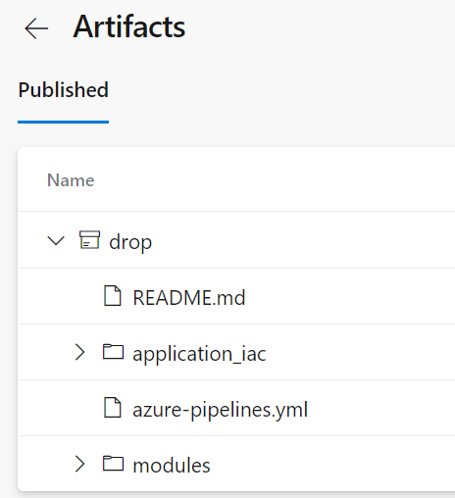

* Following is the logs of the pipeline

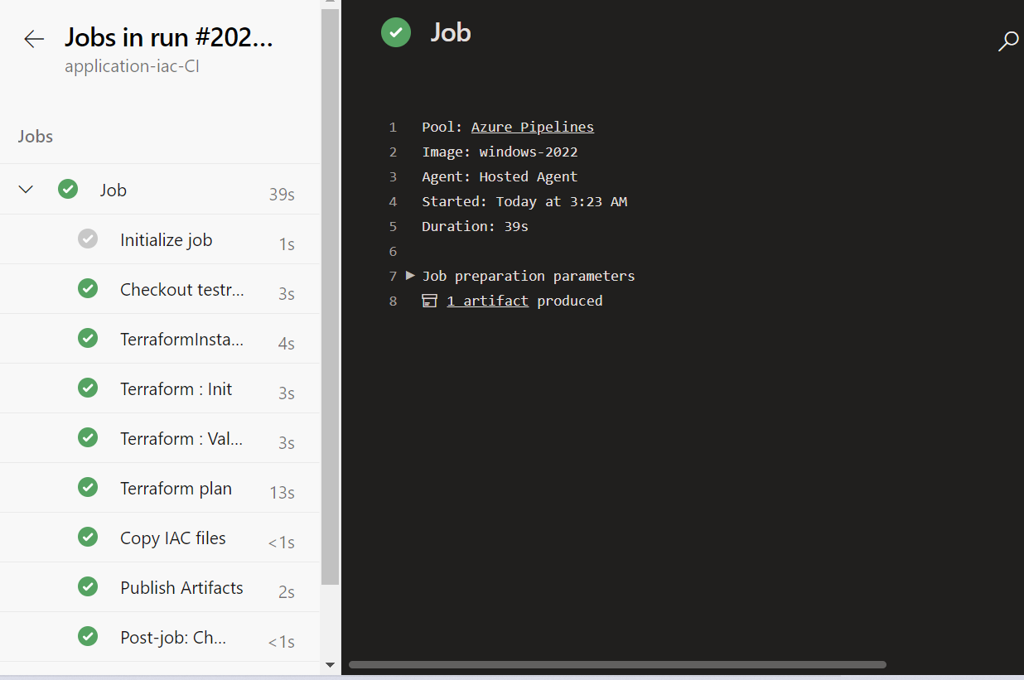

## **Release Pipelines (CD)**

CD Pipelines are created in Release section of each project. The Release pipeline provides the Continuous Deployment aspect of the Azure DevOps Platform, As define above in the Process diagram Release Pipelines are integrated with the Build Pipelines and using the latest version of the Artifact files during the execution.

Release Pipelines are created using the UI.

As per the process when **Build pipeline** will be triggered and completes the execution it will invoke the Release pipeline. The release pipeline will use the Artifacts generated from the Build Process and downloads it on the Build Machine.

* The major task it carries are Terraform Plan and Apply on the Azure cloud platform to provision or upgrade resource according to the defined configuration.
* Once the Plan is completed it then executes the Apply Stage. During Apply task specified Azure resources will be modified or created or destroyed.
* After the Apply stage the State file will be updated in the Specified Storage bucket.

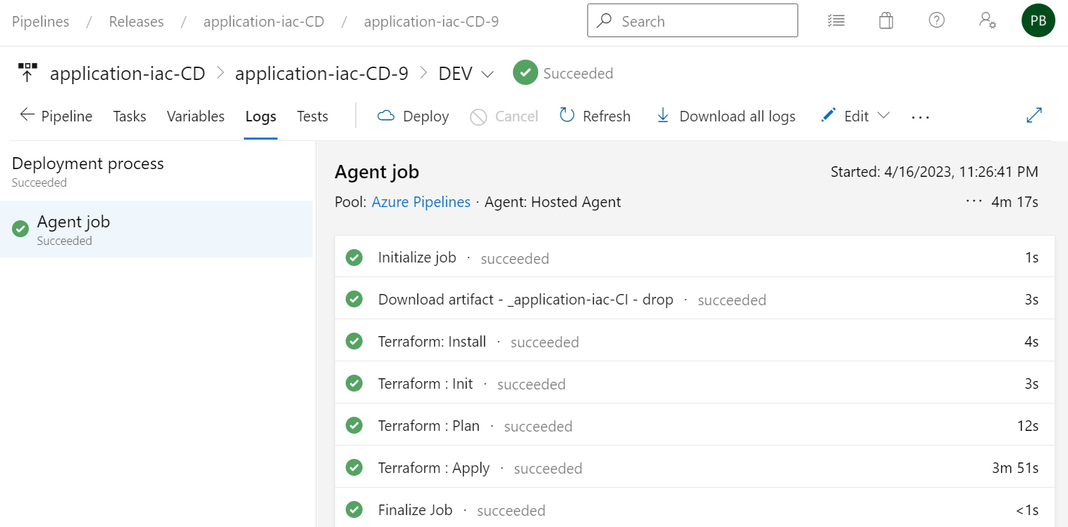

## **Azure Environment**

