## **Solution Approach Azure:**

Instance metadata Service running on Virtual machine provides the information of the VM using Rest API available at a well-known, non-routable IP address (169.254.169.254). You can only access it from within the VM. Communication between the VM and IMDS never leaves the host. Have your HTTP clients bypass web proxies within the VM when querying IMDS6

The PowerShell Script contains following steps

1. Get the VM instance
2. Use **Invoke-AzVMRunCommand** to run another script inside the Provided VM.
3. Get the JSON output in the variable

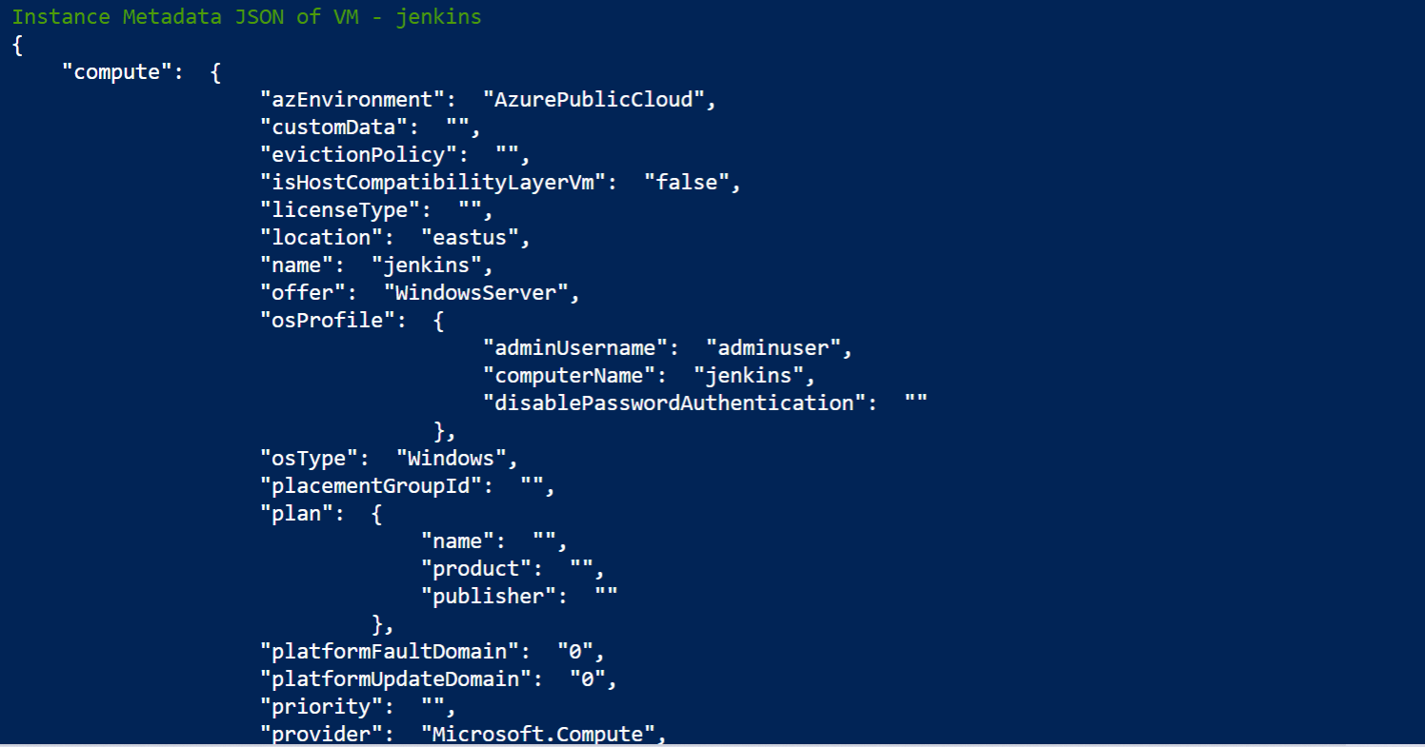

1. If Specific key is provided get the value of the Key from the Retrieved JSON.

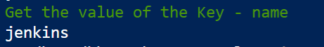

Other approach on the Azure Platform can be built using bash script with Az CLI the JQ parser.

On AWS Platform also the similar script can be developed using below command

TOKEN=`curl -X PUT "http://169.254.169.254/latest/api/token" -H "X-aws-ec2-metadata-token-ttl-seconds: 21600"`

curl -H "X-aws-ec2-metadata-token: $TOKEN" -v http://169.254.169.254/latest/meta-data/