Candidate Elimination.

Group Members:

Bharat Raghunathan (2015AAPS263H)

V Thejas (2015A7PS142H)

Nitish Ravishankar (2015A7PS152H)

Introduction:

The goal of Candidate Elimination is to try to correctly learn the TARGET CONCEPT / TARGET HYPOTHESIS by eliminating some other likely “candidates” which do not satisfy the given training examples (hence, the name Candidate Elimination). These target concepts could also be many, just bounded by the GB (General Boundaries) and SB (Specific Boundaries) of the Version Space representation of the Hypotheses, which converge on each training example.

Once learned, we assume that this Target Concept / Target Hypothesis MUST be able to correctly predict the result of new, unseen data or test instances according to a majority voting taken by all the candidate hypotheses present in the remaining Version Space.

However, this involves a lot of assumptions:

* There should be no NOISE or ERROR in the training data
* The given concept can be represented as a simple conjunction of attributes (i.e. it can be represented by simple ANDing of attributes only, no ORs or NOTs can be used)
* The given target concept is actually present in the Version Space Representation of the Hypotheses, represented by its GB (General Boundary) and SB (Specific Boundary) → **INDUCTIVE BIAS**

The last of these assumptions fall into a category of assumptions called Inductive Bias, wherein the learner assumes something and on combining that, its inductive inferences are provably deductive inferences.

More formally, Inductive Bias is the minimal set of additional assumptions **(B)** that need to be combined with the learner to justify the set of inductive inferences it makes as deductive inferences.



In the case of our Assignment, in which we had to perform a Multi-Class Classification (Classifying Animals as type 1, type 2, type 3, ..., type 7).

The Concepts (or Version Spaces) of type 3 and type 7 could not be learned by the Candidate Elimination algorithm, probably because the Inductive Bias was wrong or the hypothesis did not exist in the Version Space.

The algorithm was implemented strictly according to Page 33 of Machine Learning, Tom Mitchell with vectors used to represent a single hypothesis and a vector of vectors to represent a set of hypotheses for GB and SB, respectively.

Results:

These are the various Version Spaces predicted by the Algorithm for the Animal types from 1-7. (Here ‘all’ represents a ‘?’, meaning the attribute could take on any value)

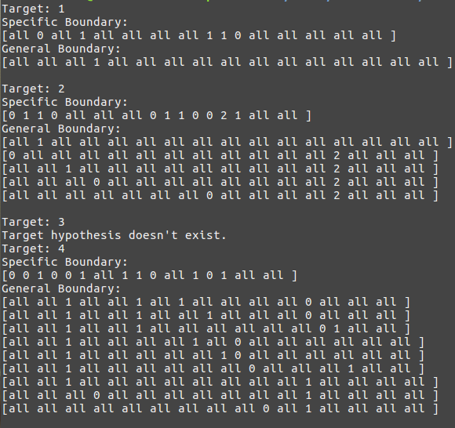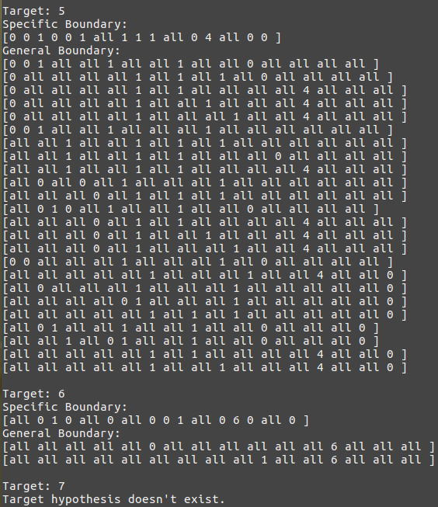

Apart from Version Spaces for **Type 3** and **Type 7**, wherein the target concept could not be found because it’s probably not a simple conjunction of attributes and it fails the inductive bias, the others predict the correct Version Space as shown by the GB (General Boundary) and SB (Specific Boundary) of each Target value (from Animal Type 1 to Animal Type 7) and it has already been verified on the training examples and provided the training examples didn’t contain any errors, these version spaces are sure to classify any test instance’s Animal Type correctly.