**CANDIDATE ELIMINATION**

Results

These are the various Version Spaces predicted by the Algorithm for the Animal types from 1-7. (Here ‘all’ represents a ‘?’, meaning the attribute could take on any value)

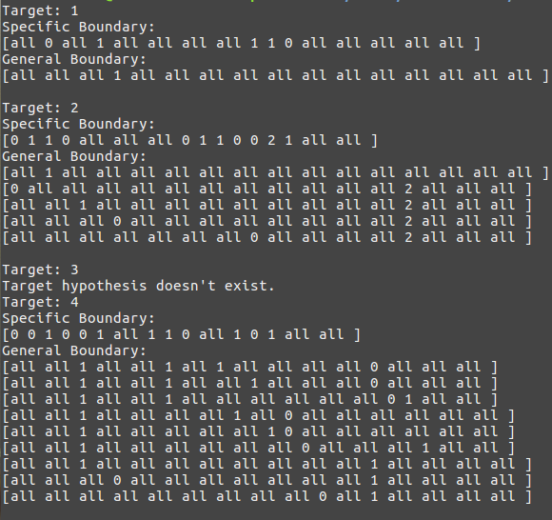

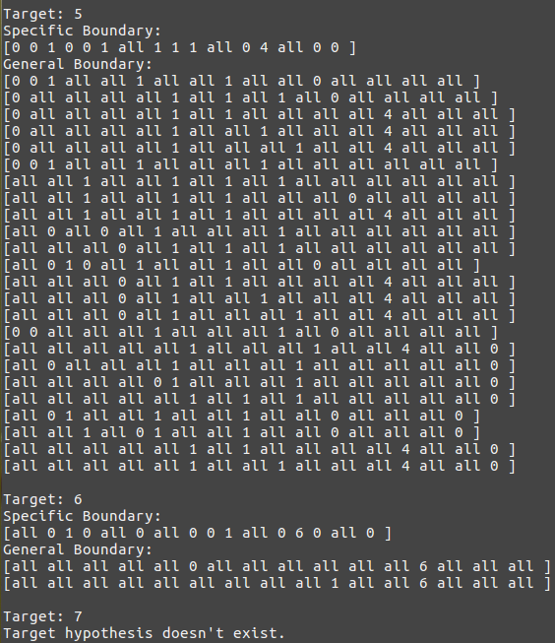

Apart from Version Spaces for Type 3 and Type 7, wherein the target concept could not be found because it’s probably not a simple conjunction of attributes and it fails the inductive bias, the others predict the correct Version Space as shown by the GB (General Boundary) and SB (Specific Boundary) of each Target value (from Animal Type 1 to Animal Type 7) and it has already been verified on the training examples and provided the training examples didn’t contain any errors, these version spaces are sure to classify any test instance’s Animal Type correctly.

These results have been obtained on successful implementation of the Candidate Elimination Algorithm given on page 33 of Machine Learning by Tom Mitchell.