Table of Contents
- Project Demonstration Video with Github Links
- Video Walkthrough Timeline
- Installation
- Project Overview
- Features
- Intent Recognition System
- Machine Learning Model Architecture
- Model Training Process
- Role of intents.json
- Training Data Preprocessing
- Order Management Dataset (orders.json)
- Product Recommendation Dataset (categories.json)
- Recommendation Engine Workflow
- Conversation Management
- Role of Flask
- Application Architecture
- Project Structure
- Running the Application
- Example User Flows
- Core Use Cases Covered
- Fallback and Escalation Handling
- Model Files
- Technology Stack
- Future Improvements

North Star Support Bot
AI-powered customer support chatbot developed by Bharat Agrawal for the Upwork Talent Accelerator AI Chatbot Development Project.

Project Demonstration Video
Video Link:
https://youtu.be/_D7yjGvh7ZE
GitHub Repository: http://github.com/BharatAgrawal-freelancer/north-star-support-chat-bot
Git Clone URL: https://github.com/BharatAgrawal-freelancer/north-star-support-chat-bot.git

Video Walkthrough Timeline
00:10 – Order Inquiry & Intent Recognition
Demonstrates how the chatbot identifies order tracking intent from natural language queries and transitions into the order tracking flow.
00:25 – Order Tracking (#222)
Demonstrates successful order lookup using the provided mock order dataset and displays the current order status.
00:30 – Invalid Order Number Handling
Demonstrates validation and error handling when a user provides an invalid order number.
00:40 – Returns & Exchange Policy
Demonstrates return policy explanation and return link assistance.
00:50 – Human Handoff Feature
Demonstrates escalation from chatbot support to a simulated Live Agent state.
01:00 – Thank You Flow & Product Recommendation
Demonstrates recommendation flow and conversational state management.
01:25 – Shipping Related Questions
Demonstrates shipping information support including standard and expedited shipping.
01:30 – Escalation Handling
Demonstrates explicit human support requests and escalation workflows.
01:38 – Fallback Handling
Demonstrates unsupported or unrecognized user inputs and chatbot recovery behavior.

Installation
- Clone the repository
git clone https://github.com/BharatAgrawal-freelancer/north-star-support-chat-bot.git
cd north_star_support_bot
- Install dependencies
pip install -r requirements.txt
- Download NLTK resources
import nltk
nltk.download('punkt_tab')
nltk.download('wordnet')
nltk.download('omw-1.4')
- Run the application
python app.py
- Open in browser
http://127.0.0.1:5000
Project Overview
North Star Support Bot is an AI-powered customer support chatbot designed for a small e-commerce business specializing in outdoor apparel and camping gear.
The chatbot supports:
- Order Tracking
- Returns & Exchanges
- Product Recommendations
- Shipping Information
- Human Handoff
- Fallback Handling
- Intent Recognition
- Conversation State Management
The system combines machine learning based intent classification with state-driven conversation management to create a realistic customer support experience.

Intent Recognition System
The chatbot uses a supervised machine learning model trained on predefined intents stored in intents.json.
The model identifies the user's intent from natural language inputs and routes the conversation to the appropriate workflow.
Examples:
"Where is my order?"
"Track my package"
"Can you check my shipment?"
All of these variations are classified as the Order Tracking intent.
Similarly:
"Recommend a tent"
"I need camping gear"
"What should I buy for hiking?"
are classified as recommendation intents.
This allows the chatbot to understand multiple ways of expressing the same request.

Machine Learning Model Architecture
The intent classification model is implemented using TensorFlow and Keras.
Training pipeline:
- Tokenization
- Lemmatization
- Bag-of-Words Feature Extraction
- Neural Network Classification
The neural network architecture consists of:
Input Layer
↓
Dense Layer (128 neurons, ReLU)
↓
Dropout Layer
↓
Dense Layer (64 neurons, ReLU)
↓
Dropout Layer
↓
Softmax Output Layer
The Softmax output predicts the probability of each supported intent.
The highest confidence prediction is selected as the detected intent.

Model Training Process
Training is performed using the notebook:
training_model.ipynb
Training workflow:
- Load intents.json
- Extract patterns and tags
- Tokenize sentences
- Lemmatize words
- Build vocabulary
- Create Bag-of-Words vectors
- Train TensorFlow classifier
- Save trained artifacts
Generated files:
model/chatbot_model.keras
model/classes.pkl
model/words.pkl
These files are loaded by the application during runtime.

Role of intents.json
The intents.json file serves as the primary training dataset.
Example structure:
{
"tag": "greeting",
"patterns": [
"Hi",
"Hello",
"Hey"
],
"responses": [
"Hello! How can I help you today?"
]
}
Components:
Tag: Defines the intent category.
Patterns: Example user inputs used for model training.
Responses: Predefined responses used by the chatbot after intent classification.
The model learns the relationship between user patterns and their corresponding intent tags.

Training Data Preprocessing
The training pipeline performs tokenization and lemmatization before model training.
Example code:
lemmatizer = WordNetLemmatizer()
tokenizer = word_tokenize
words = []
classes = []
documents = []
for intent in intents:
for pattern in intent['patterns']:
words_in_pattern = tokenizer(pattern.lower())

words_in_pattern = [
lemmatizer.lemmatize(word)
for word in words_in_pattern
]

words.extend(words_in_pattern)

documents.append(
(
words_in_pattern,
intent['tag']
)
)

if intent['tag'] not in classes:
classes.append(intent['tag'])
This process normalizes user inputs and improves classification accuracy.

Order Management Dataset
Order information is stored in:
data/orders.json
Example:
{
"order_id": "111",
"customer_name": "John Carter",
"product_name": "Summit Pro Camping Tent",
"product_description": "4-person waterproof family camping tent.",
"order_date": "2026-06-22",
"status": "Shipped",
"active_notes": "Arriving tomorrow"
}
The chatbot uses this dataset to:
  - Validate order numbers
  - Retrieve order status
  - Display delivery updates
  - Handle invalid order requests

Product Recommendation Dataset
Product categories are stored in:
data/categories.json
Example:
{
"id": "tent",
"name": "Camping Tents",
"description": "Shelters designed for outdoor camping, backpacking, and family adventures.",
"tags": [
"tent",
"camping",
"shelter",
"outdoor"
]
}
The recommendation engine:
- Detects the product category
- Collects user requirements
- Matches requirements against category metadata
- Recommends the most suitable subcategory
Example:
User:
"I need a tent"
Bot:
"What are your requirements?"
User:
"I need a tent for my family"
Bot:
"Family Camping Tents"
This creates a guided recommendation experience.

Conversation Management
The chatbot uses a state-based conversation manager.
Supported states:
MAIN_MENU
WAITING_FOR_ORDER_ID
WAITING_FOR_REQUIREMENTS
This allows the chatbot to maintain context across multiple messages and support multi-step workflows.

Role of Flask
Flask serves as the backend framework for the application.
Responsibilities:
  - Hosts the chatbot application
  - Serves the web interface
  - Receives user messages
  - Routes requests to the conversation manager
  - Returns chatbot responses
Communication flow:
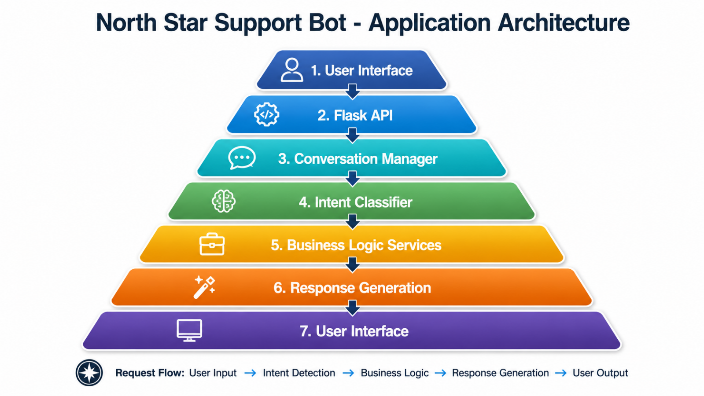

Project Structure
north_star_support_bot/
chatbot/
├── conversation_manager.py
├── intent_classifier.py
├── response_engine.py
data/
├── categories.json
├── intents.json
├── orders.json
model/
├── chatbot_model.keras
├── classes.pkl
├── words.pkl
services/
├── order_service.py
├── recommendation_service.py
static/
├── style.css
templates/
├── index.html
app.py
requirements.txt
training_model.ipynb
README.md

Developed By
Bharat Agrawal
GitHub Repository:
https://github.com/BharatAgrawal-freelancer/north-star-support-chat-bot
Git Clone URL:
https://github.com/BharatAgrawal-freelancer/north-star-support-chat-bot.git

