JAVASCRIPT
PRACTICAL LAB ASSIGNMENT — 02
Syntax • Variables • Data Types • Operators • Debugging

Student Name | Bharat Arora
Scholar Number | 2424341
Programme | BCA
Semester | V
University | Dev Sanskriti Vishwavidyalaya
Professional Track | Full Stack Developer

Part 1 — Syntax Warm-Up

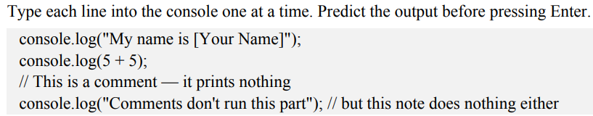

Task 1.1: Deliberately break the syntax — remove the closing quote from a string and press Enter. Read the error message carefully, then fix it.

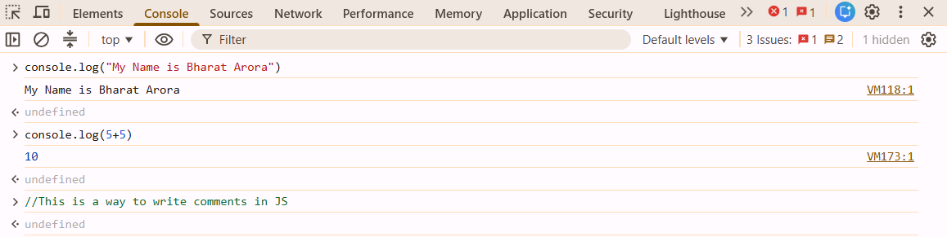

When we removing the closing quote from a string it shows syntax error that means we need to properly the rules and regulations for writing the code.

Task 1.2 (pair discussion): Type console.log("test"). Now imagine you had instead written console.log("Test") somewhere expecting it to match a variable called test. Why would that fail? Discuss case sensitivity with a partner and write one sentence explaining it.

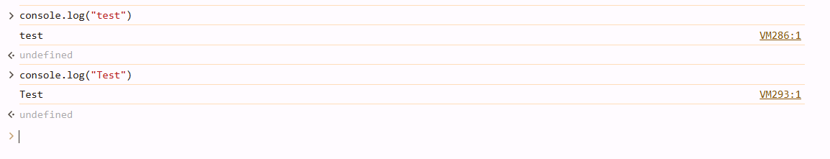
When I do that this simply prints the string inside the double quotes since we do not declare a variable their we simply pass the string in console.log for print it.

Part 2 — Variables

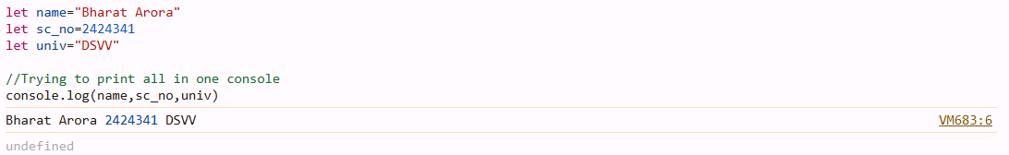
Simply get the proper output in one line

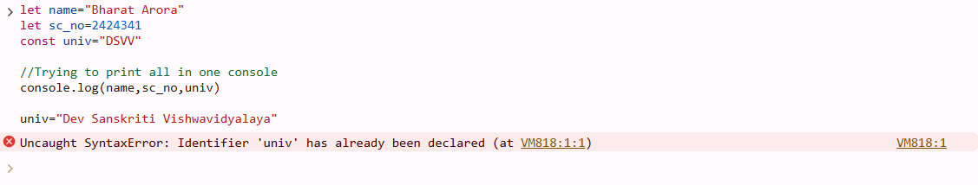
I got syntax error since I declare first it as a constant variable then I try to reassigning the value which is not possible….

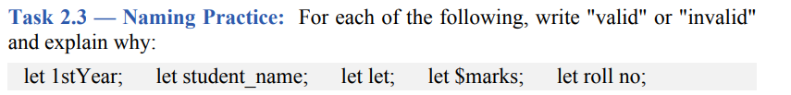
- Unvalid since it start with a number
- Valid since use of unnderscore between two words is a correct way to use
- Unvalid since use of keyword as a variable is not a correct way to implement
- Unvalid since use of Special character as a first character is not valid according to rules
- Unvalid since variable name must be a single word

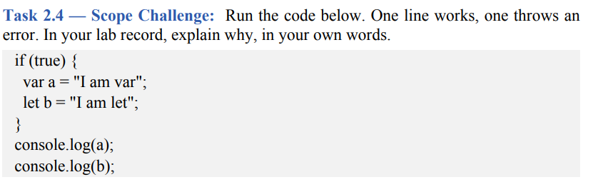
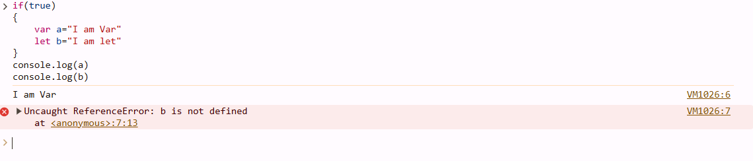
Here the value of var keyword is properly show their output because of the scope issue
Var keyword It allows you to use the variable outside that block of code that’s why in general we prefer to use let and const datatype accordingly with our conditions.

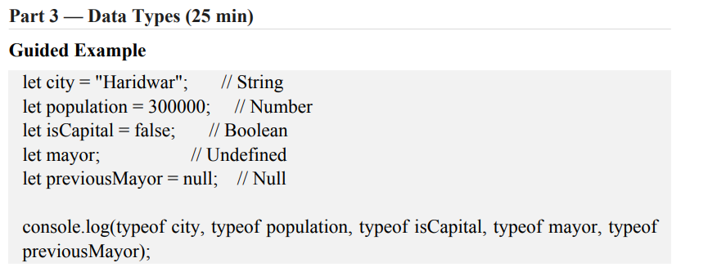
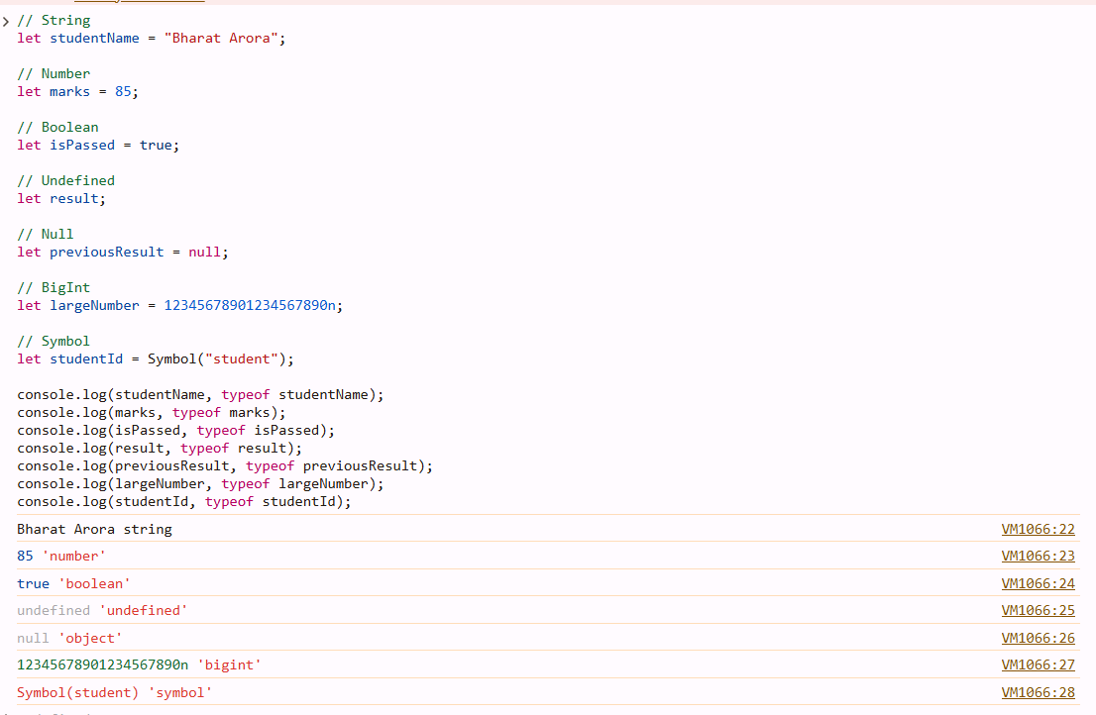

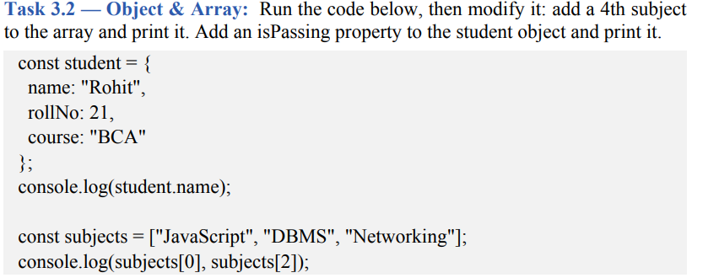

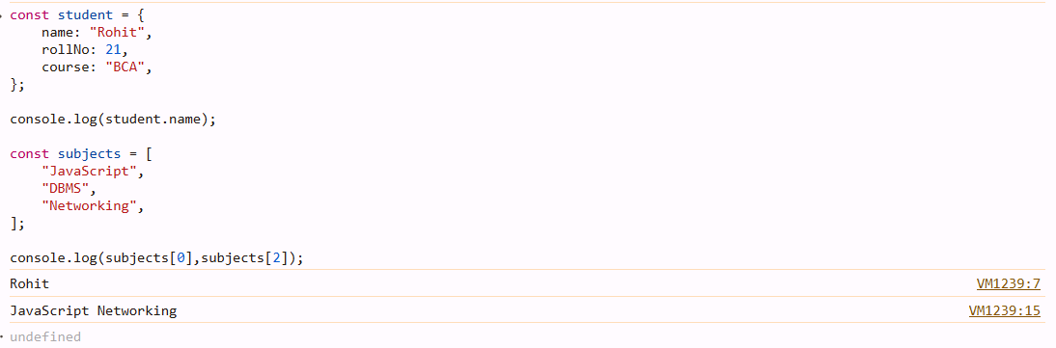

After Modification:-

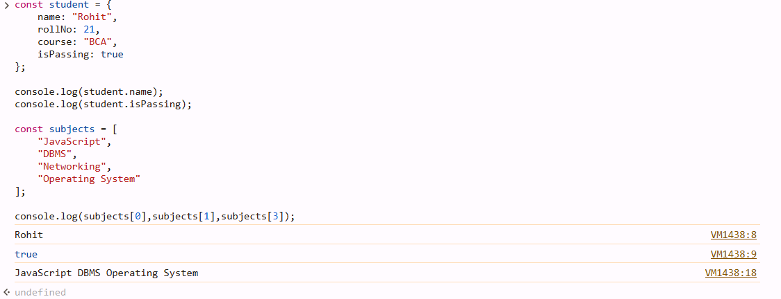
Typeof null returns "object" because of a historical JavaScript behavior retained for compatibility.
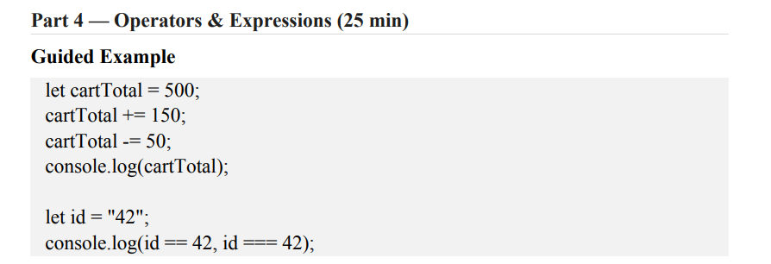
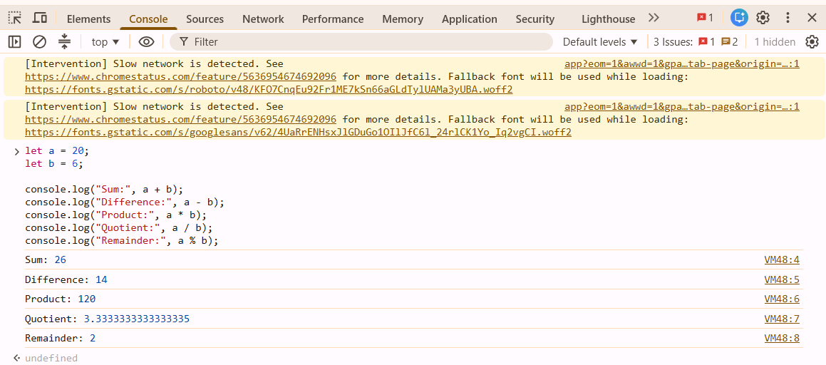

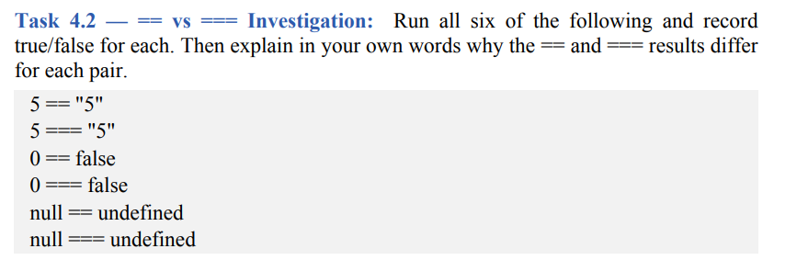
== is loose equality
=== is strict equality

Even though their types are different, == allows type conversion for the comparison.
== :- It checks both:
- Value
- Data type
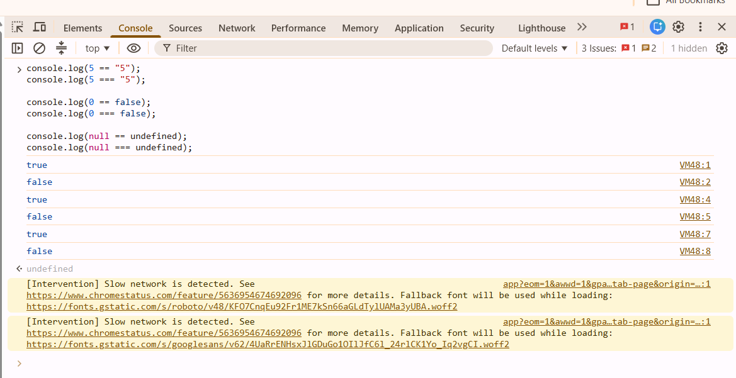
The == operator performs loose equality comparison and may convert one data type into another before comparing values. The === operator performs strict equality comparison and checks both value and data type. Therefore, 5 == "5" is true, while 5 === "5" is false. Similarly, 0 == false is true but 0 === false is false. null == undefined is true because of JavaScript's special loose-equality rule, whereas null === undefined is false because they have different types.

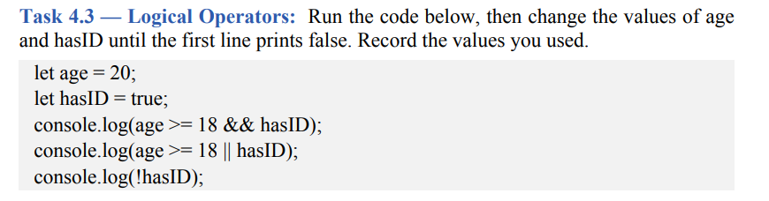
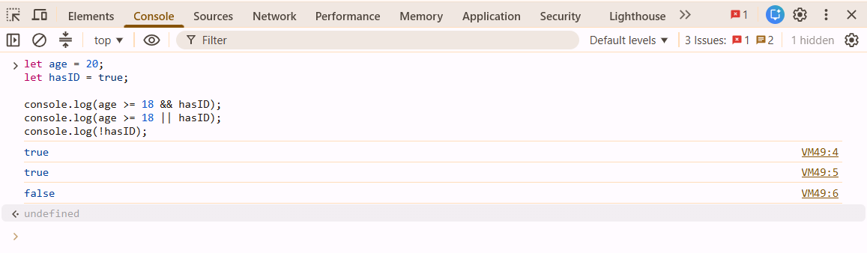
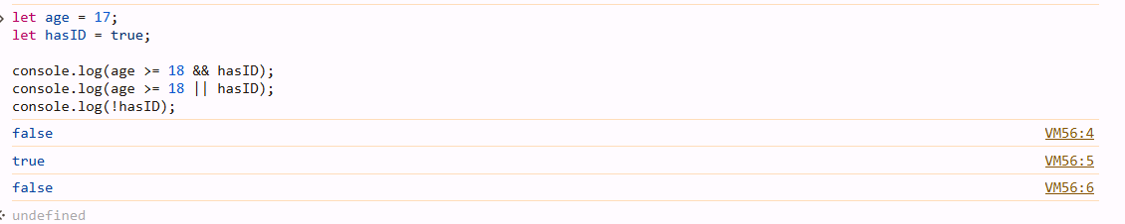
I use
Age = 17;
hasID = true;
Since if any of the conditional statement is false then the AND conditional operator return false

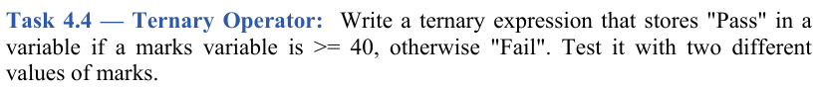
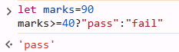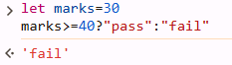
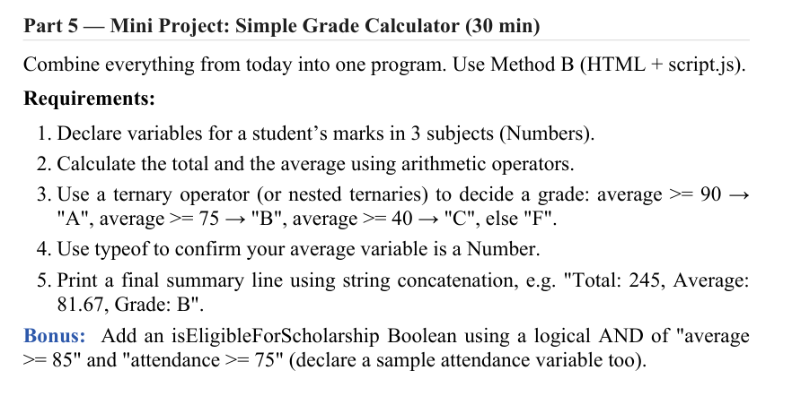
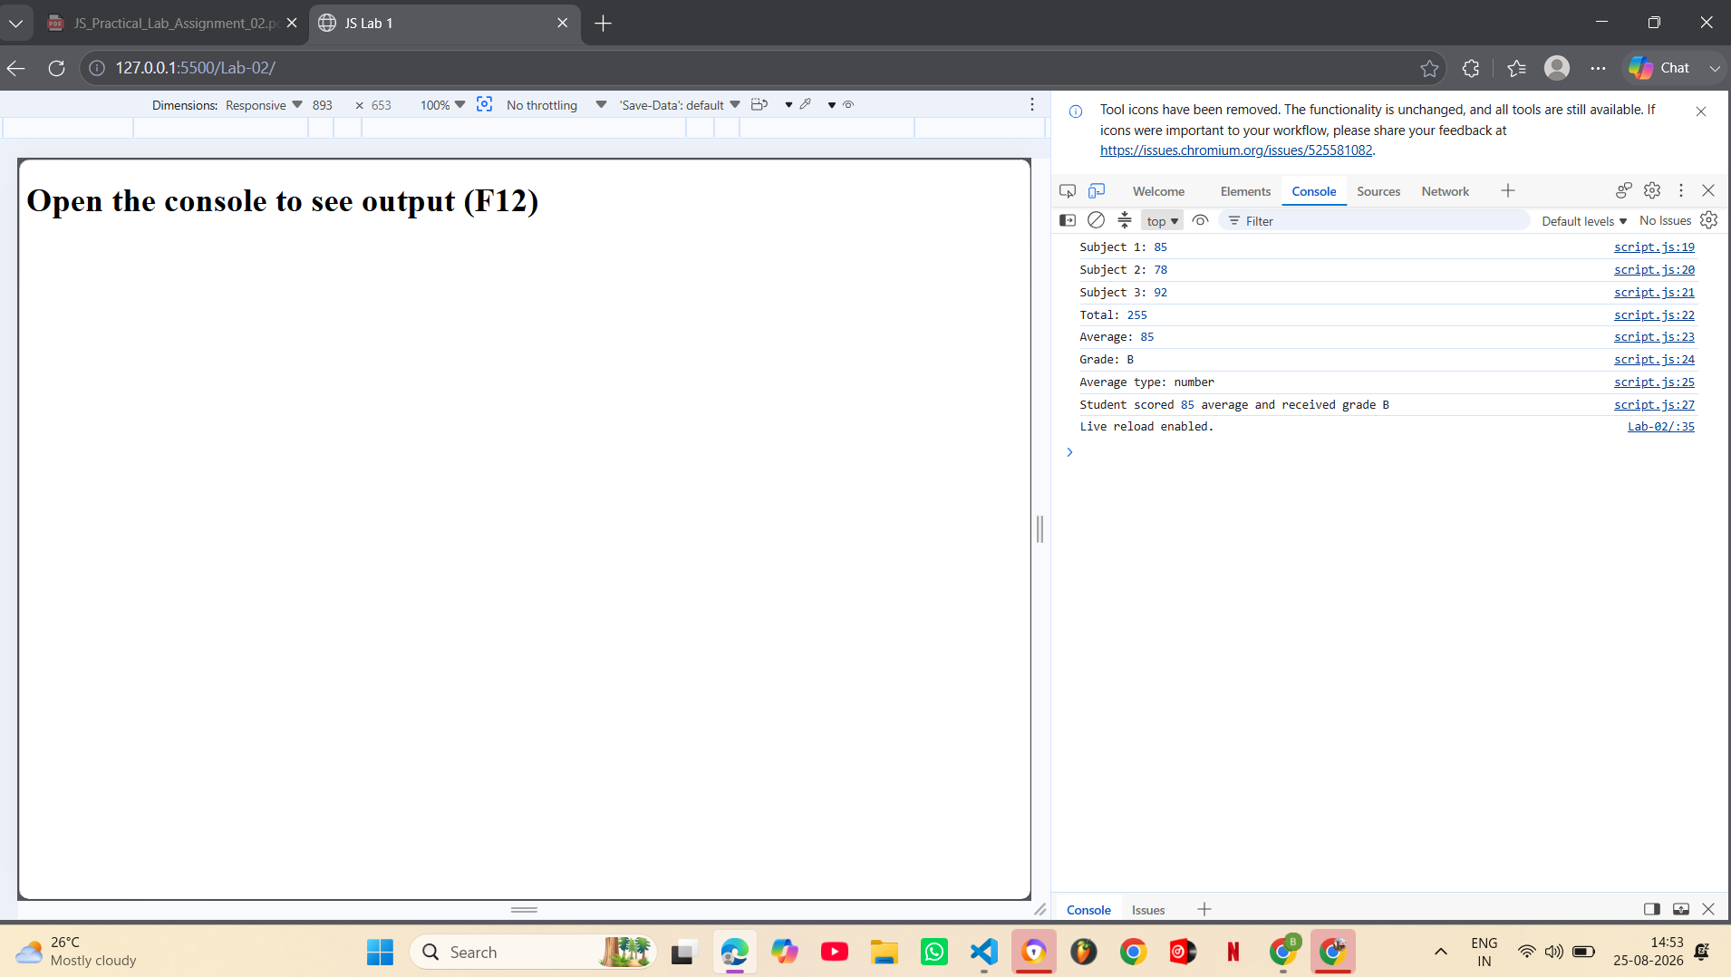

Sample run example:-

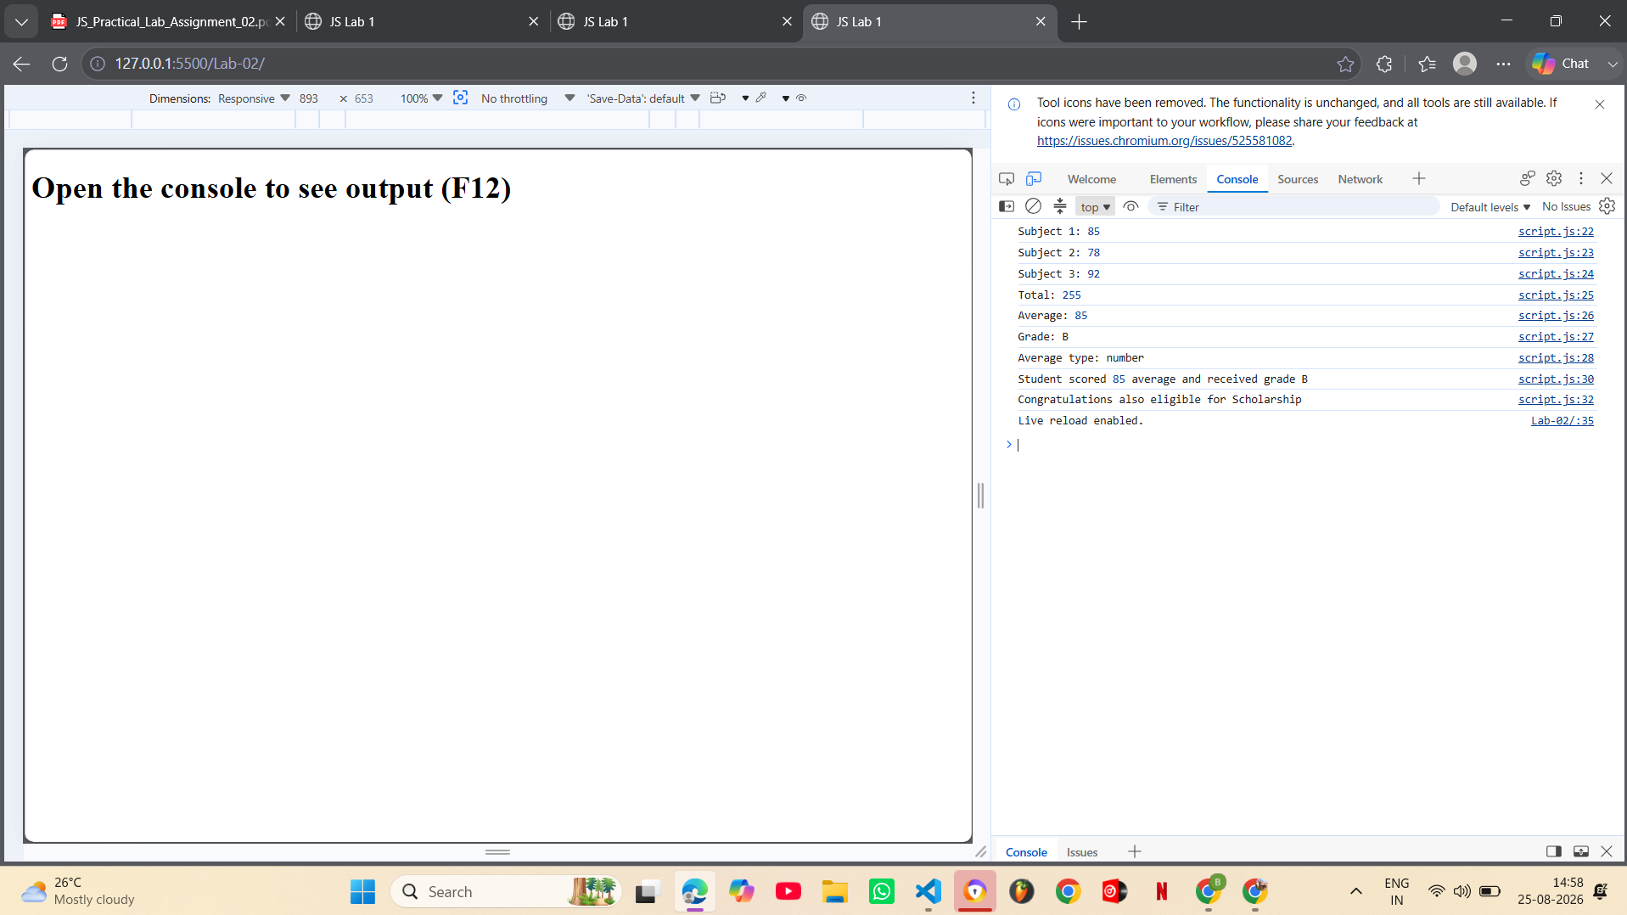
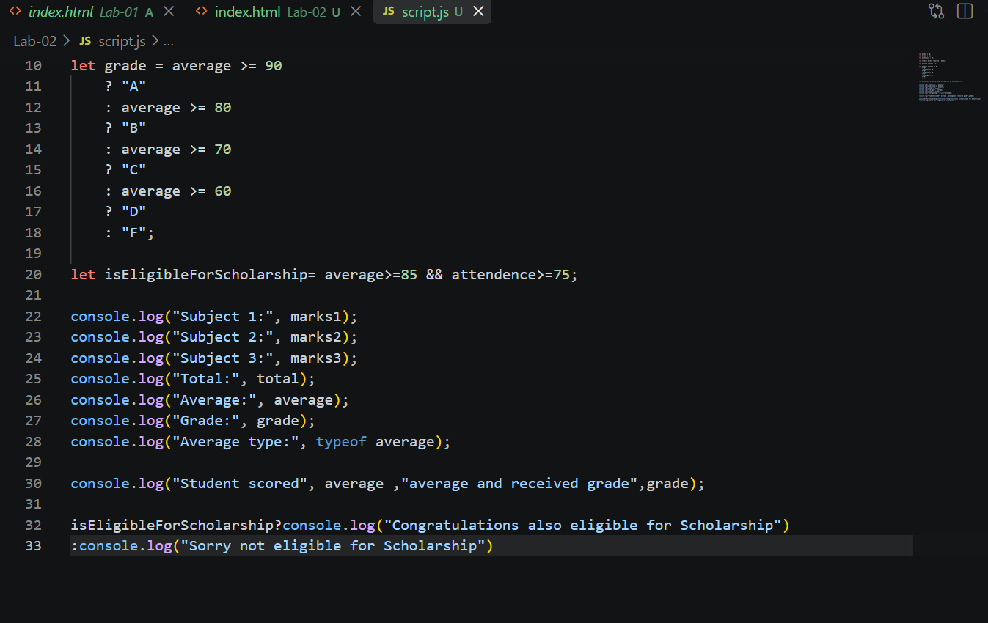
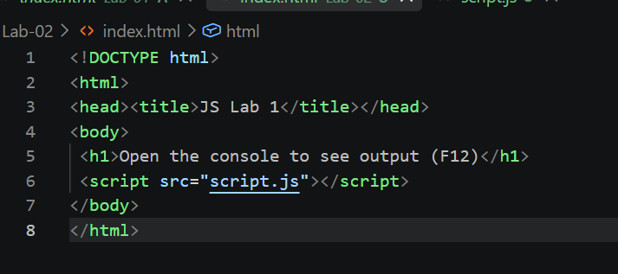

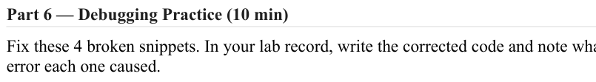
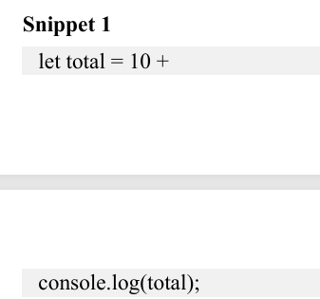

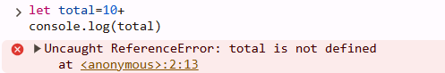

Reference error occur total is not defined properly
We can declare this in either two ways:-

1st:-
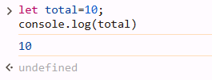

2nd:-
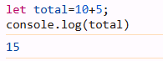

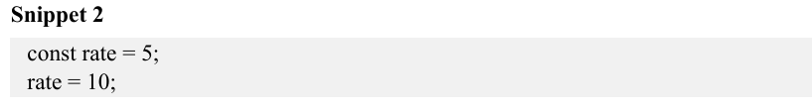

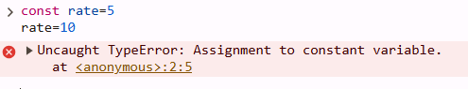

Since as we declare it as a const variable then we dont change it value during the execution of the whole program

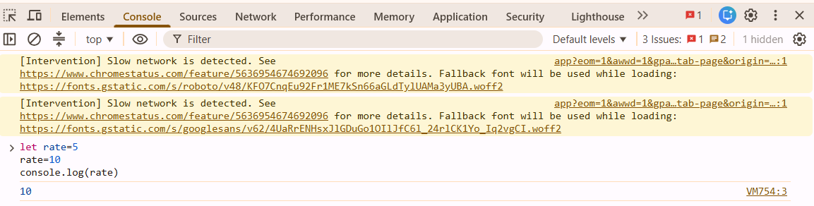

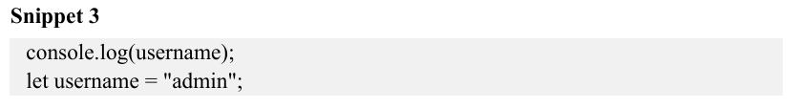

Correct code after debudding:-

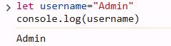

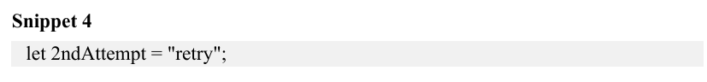

We ca declare the variable simply as
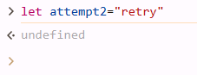

Most confusing part in today’s assignment :-

I was confused doing the conditional statement with nested ternary operator then I take help of google and chatgpt for syntax understanding then I do it.

