In below screen you can see loading python packages and dataset class labels

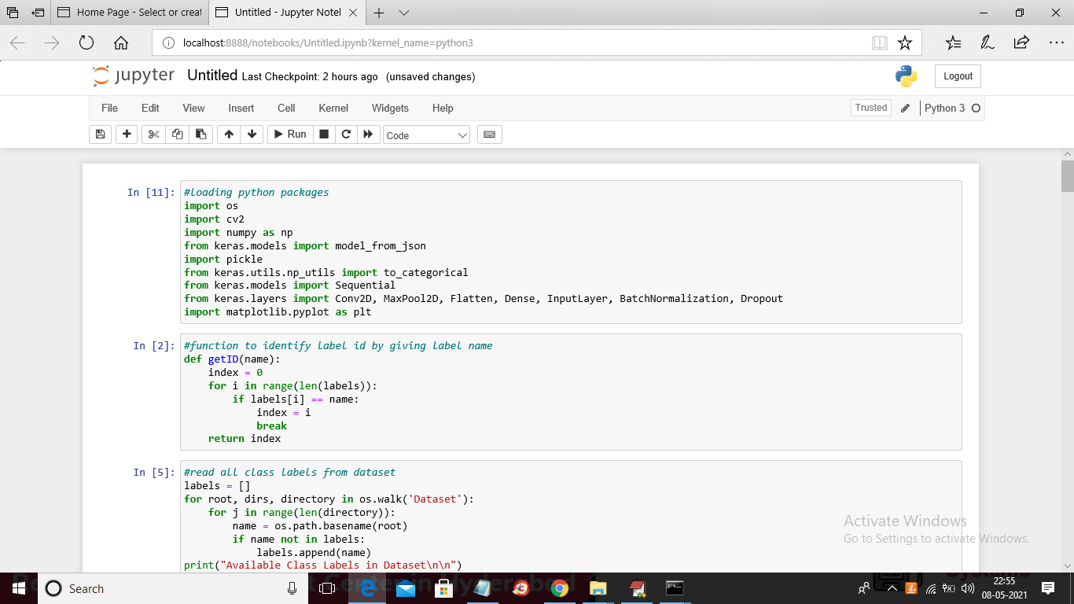

In below screen you can see loading of images

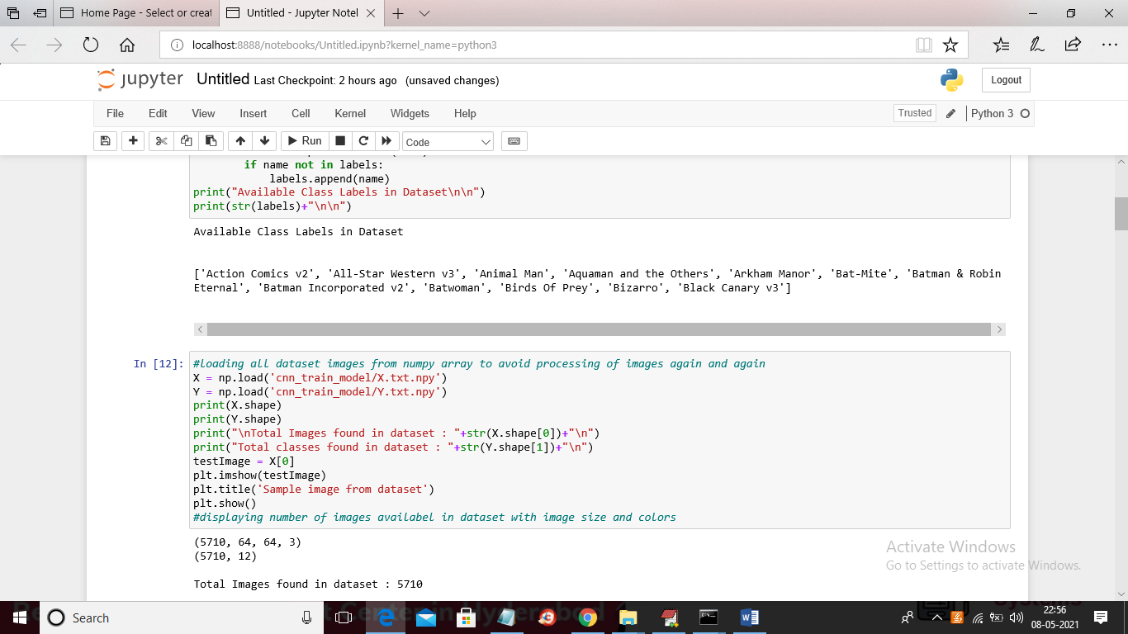

In below screen showing details of loaded images

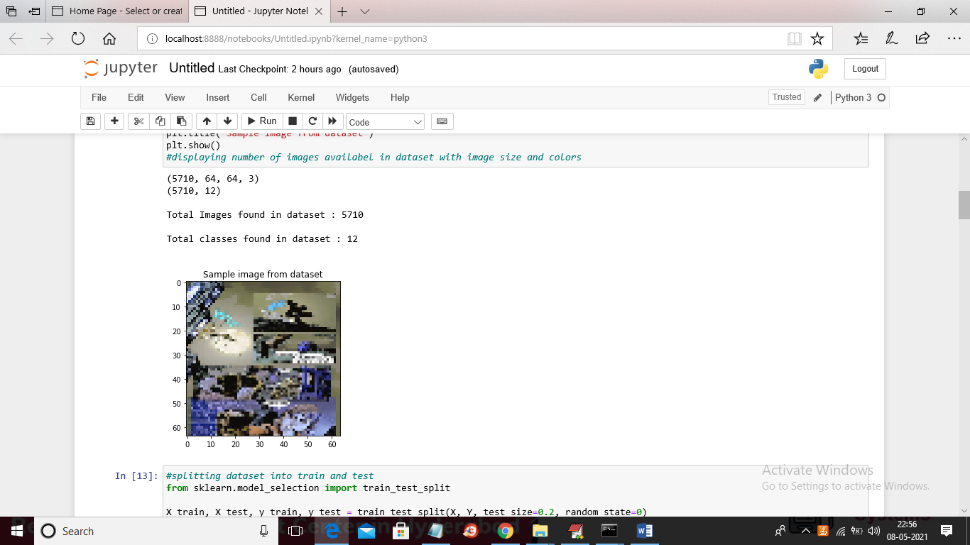

In below screen showing code for dataset split and then training with CNN

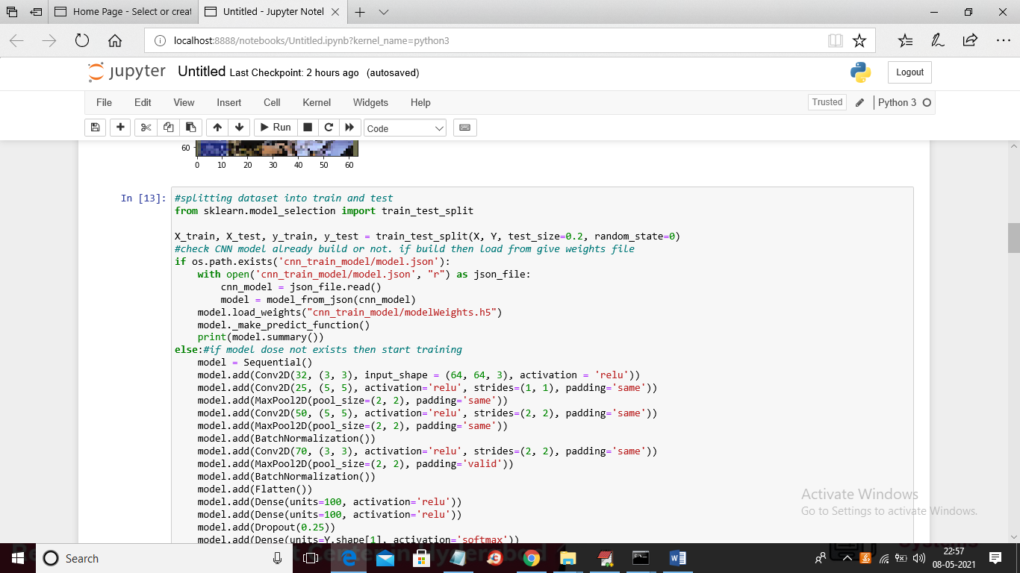

In below screen you can see CNN accuracy and loss calculation

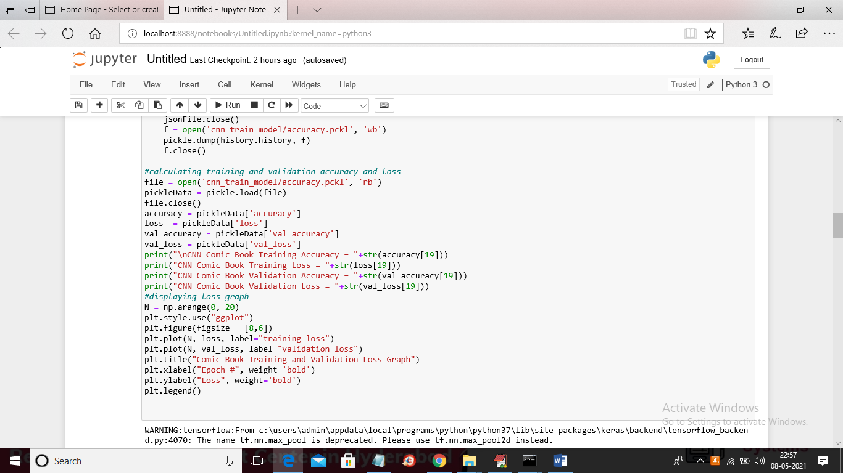

In below screen you can see CNN training details with accuracy and loss values

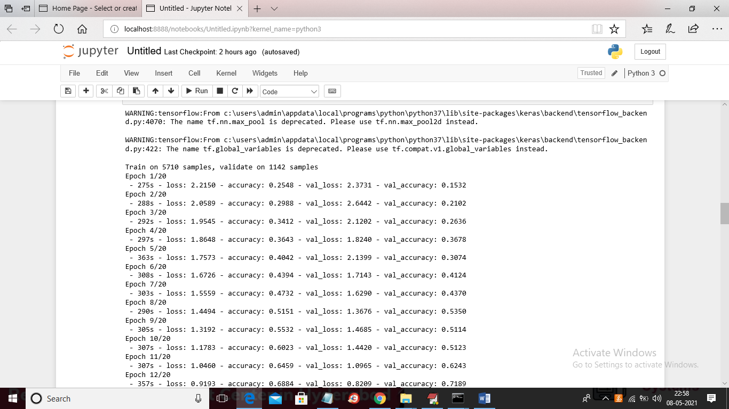

In below and above screen you can see we took 20 EPOCH and at each increasing epoch CNN accuracy getting increase and loss getting decrease

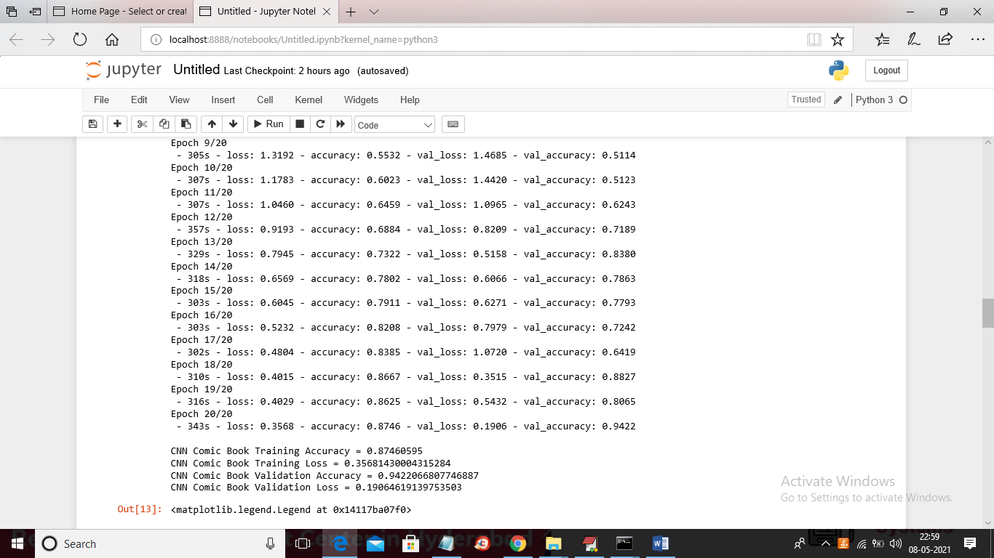

In above screen you can see CNN final accuracy and in below screen you can see CNN training and validation graph

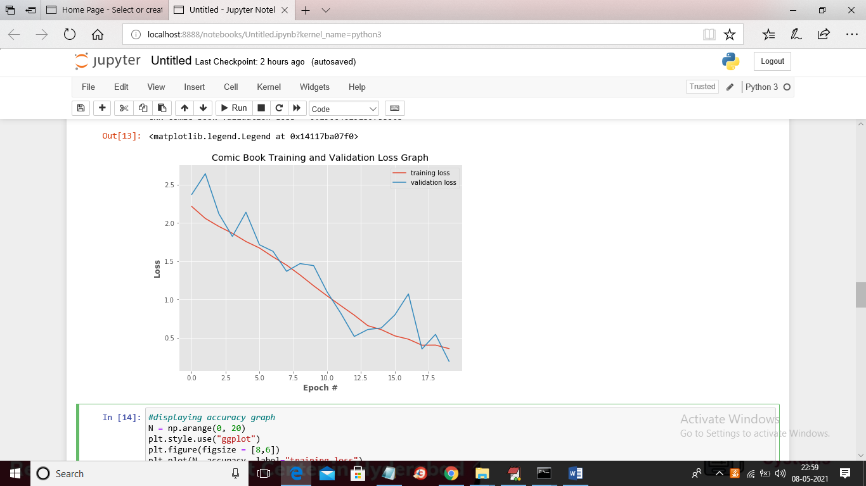

In below screen you can see CNN accuracy and validation accuracy graph

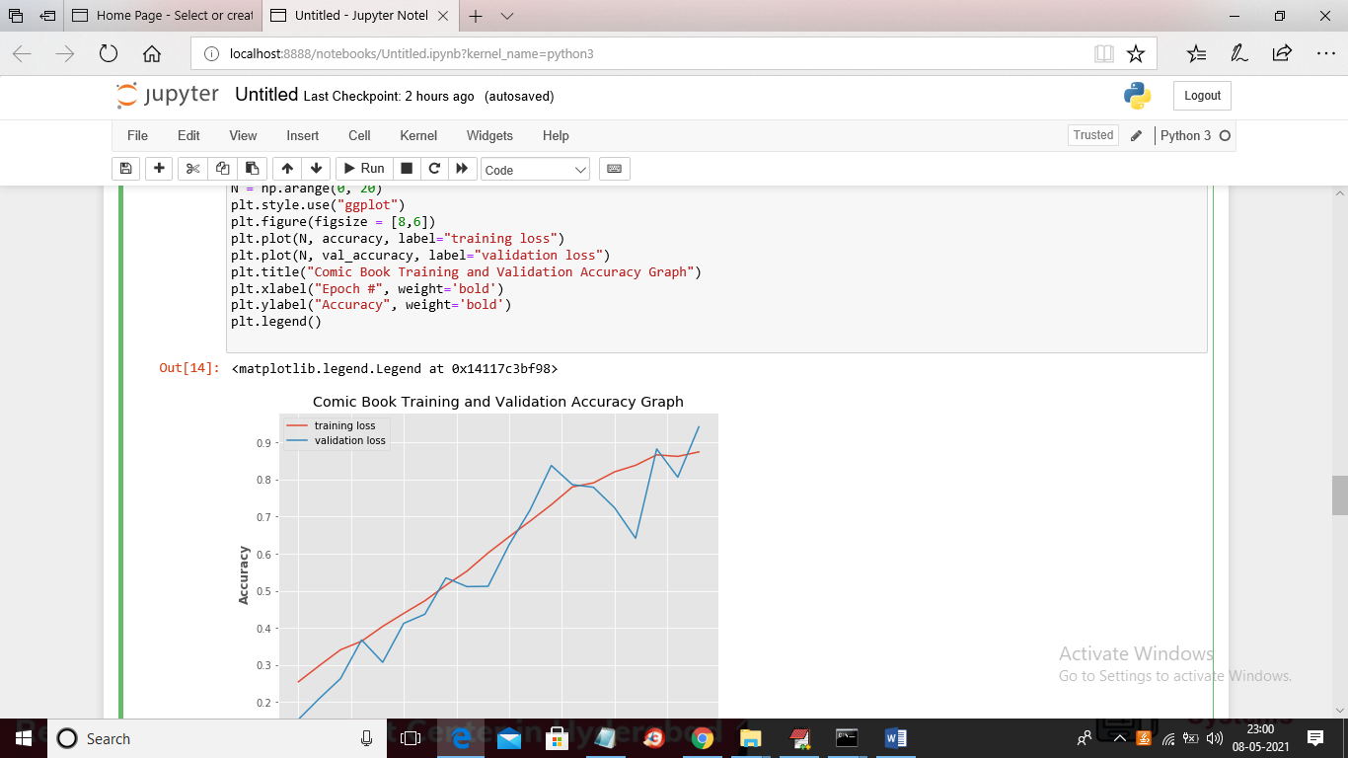

In below screens you can see confusion matrix values and graph

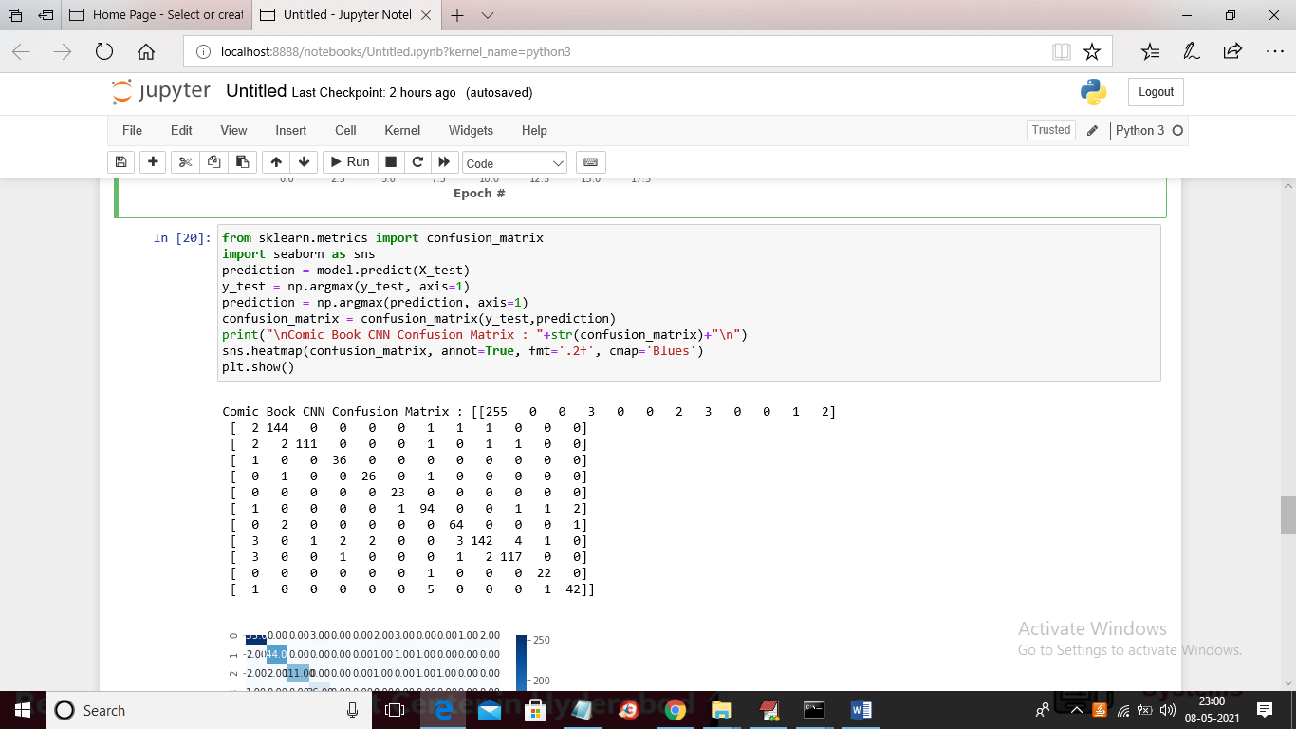

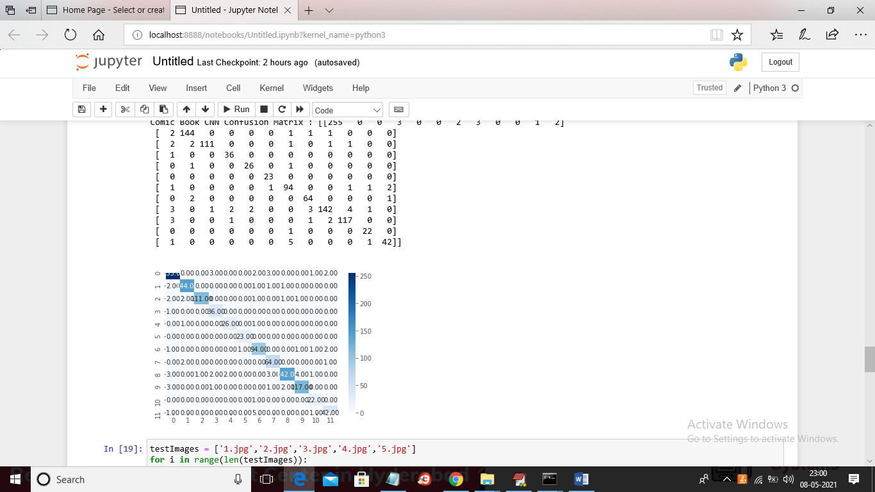

In below screen you can see for prediction we took 5 test images and then we are getting below prediction result for each image

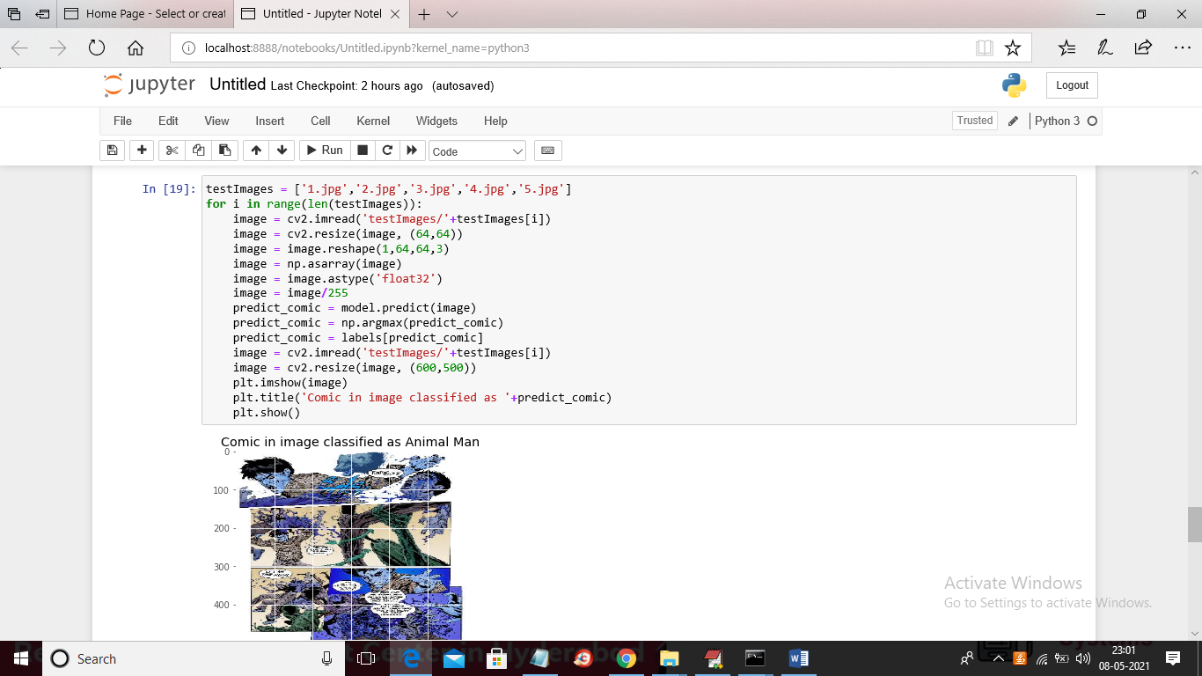

In above screen on top of image you can see prediction name of comic as ‘Animal Man’ and on top of each image you can see comic prediction/classification name

