LINUX SYSTEM AND SHELL SCRIPTING LAB
Complete Lab – Questions 1 to 4

Question 1

Step 1 — Create the LabFiles Directory
Create the LabFiles directory and verify it with ls.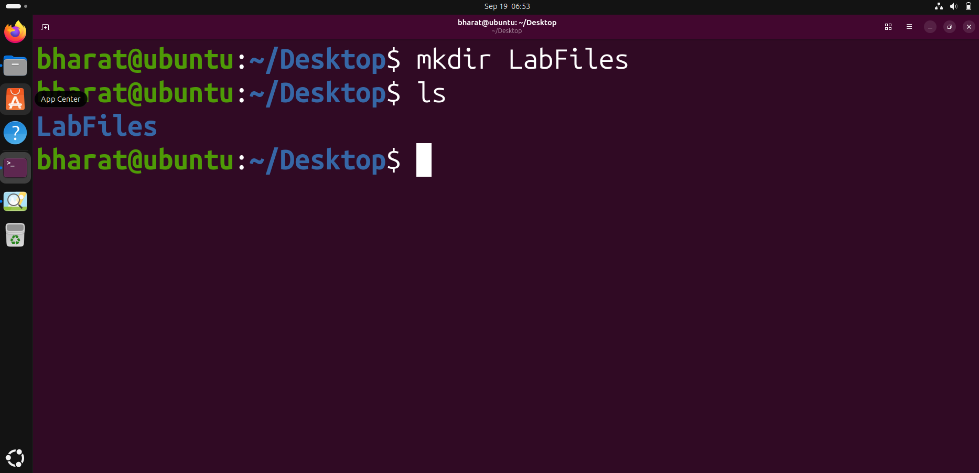

Step 2 — Create a File
Enter LabFiles, create an empty file with touch, and verify it.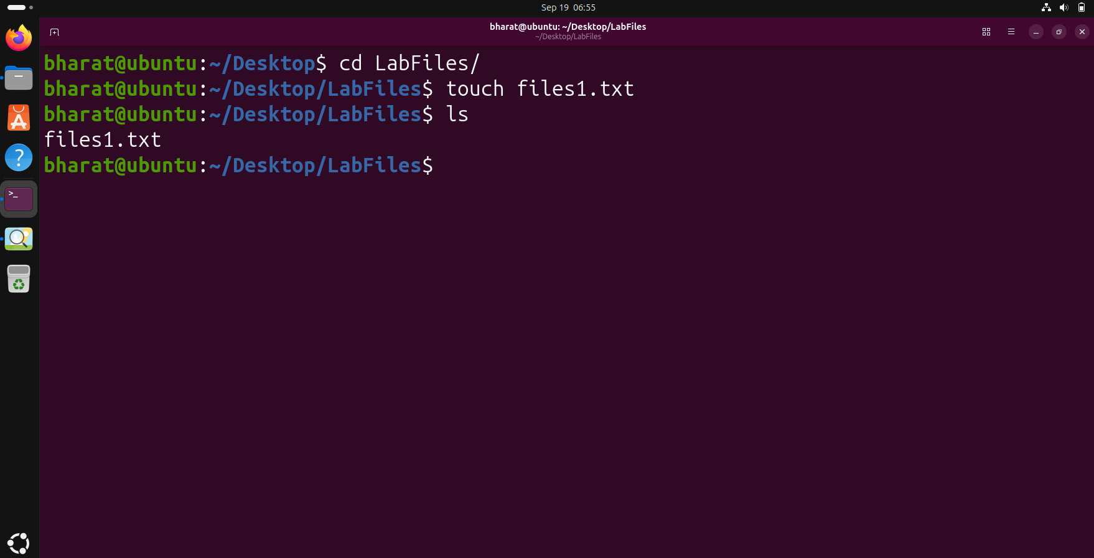

Step 3 — Copy a File
Copy files1.txt to files2.txt using cp and verify the copy.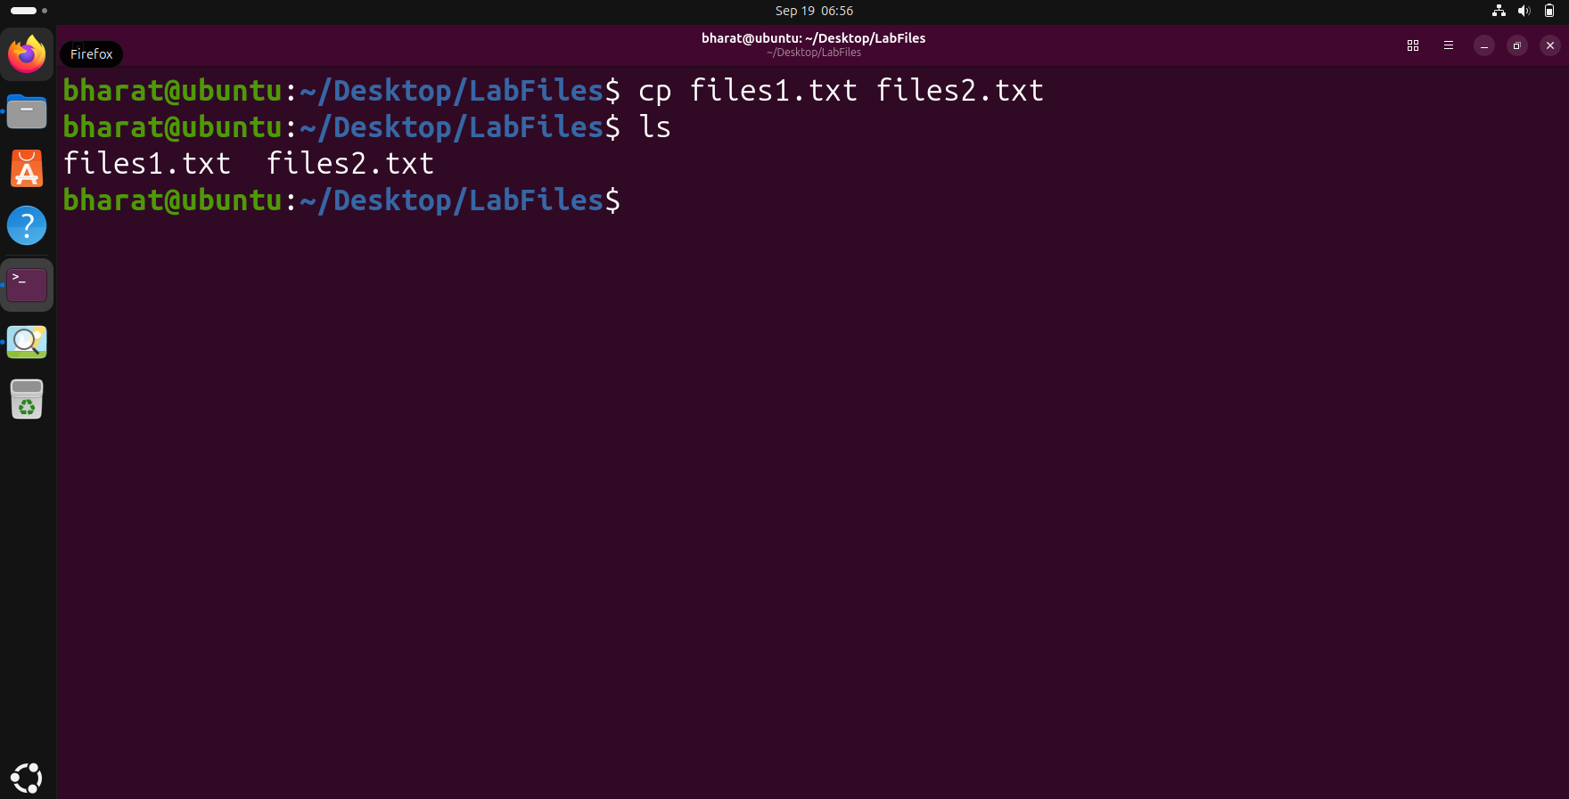

Step 4 — Move a File
Create Backup and move files3.txt into it using mv.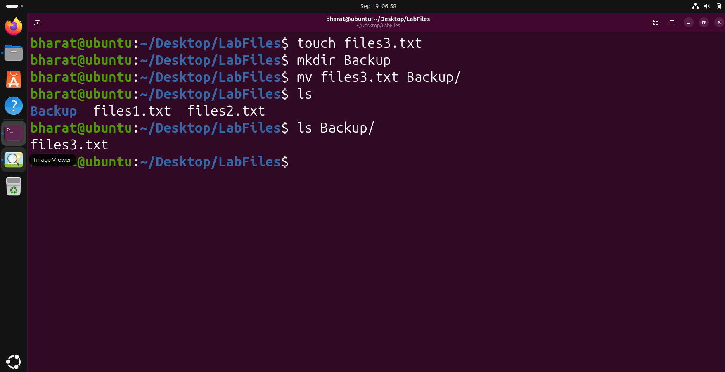

Step 5 — Rename a File
Rename files2.txt to file.txt using mv and verify it.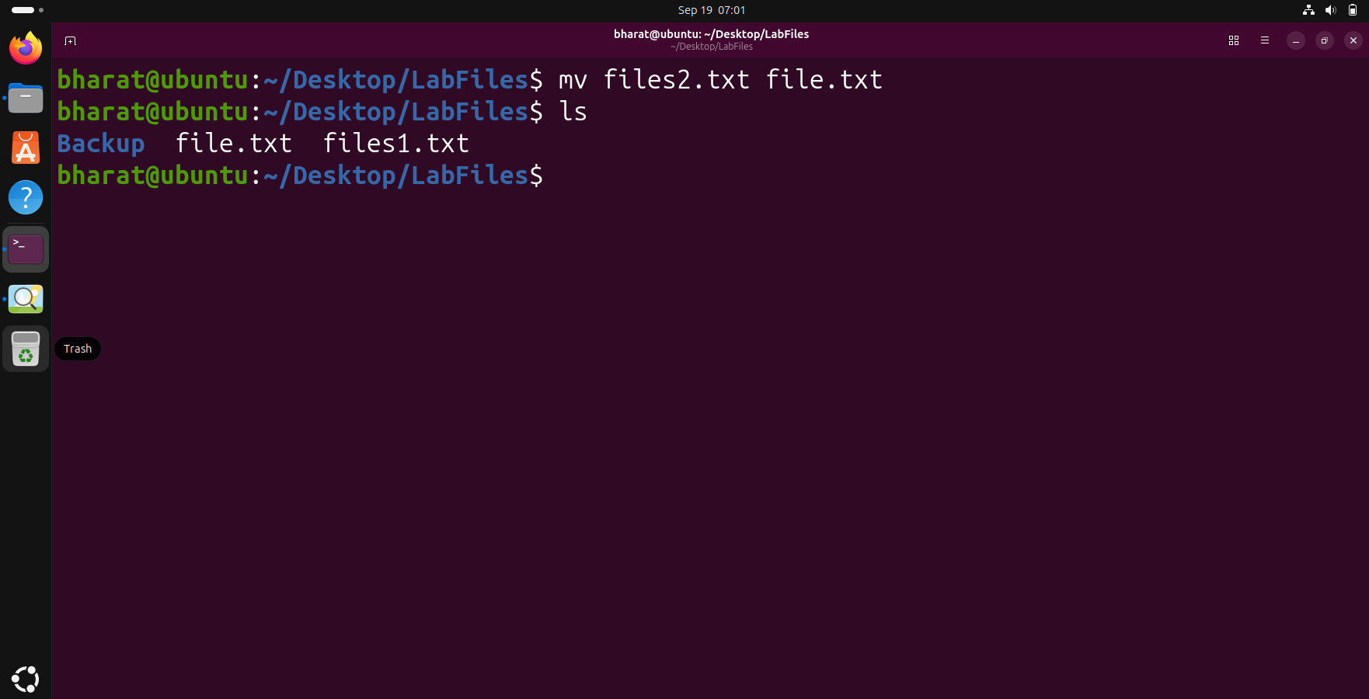

Step 6 — Display File Information
Use stat to display file metadata and status information.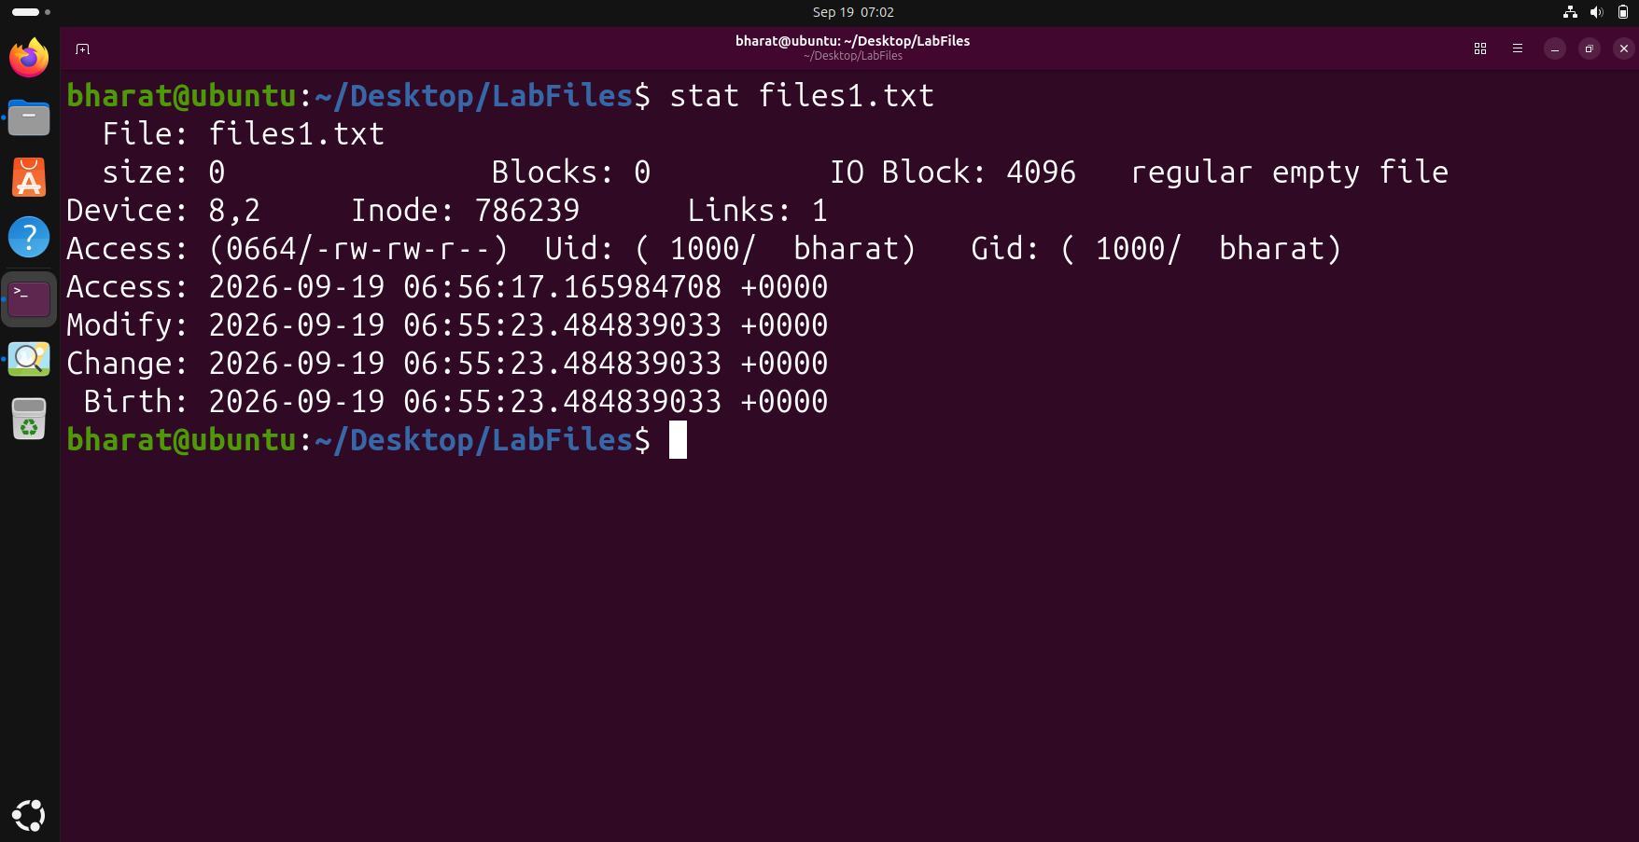

Step 7 — Delete a File
Delete file.txt using rm and verify the remaining files.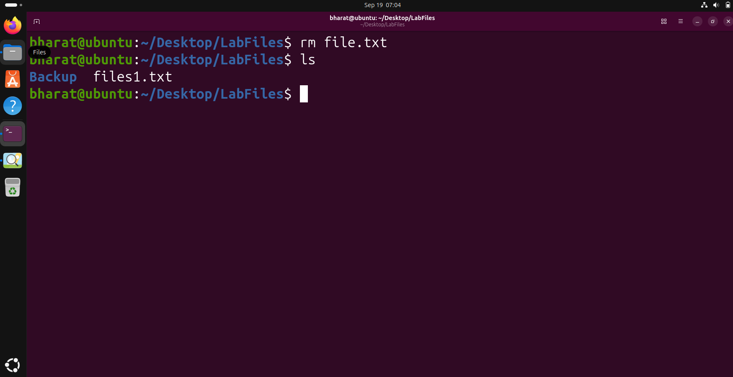

Step 8 — Delete Using unlink
Delete files1.txt using unlink and verify the remaining contents.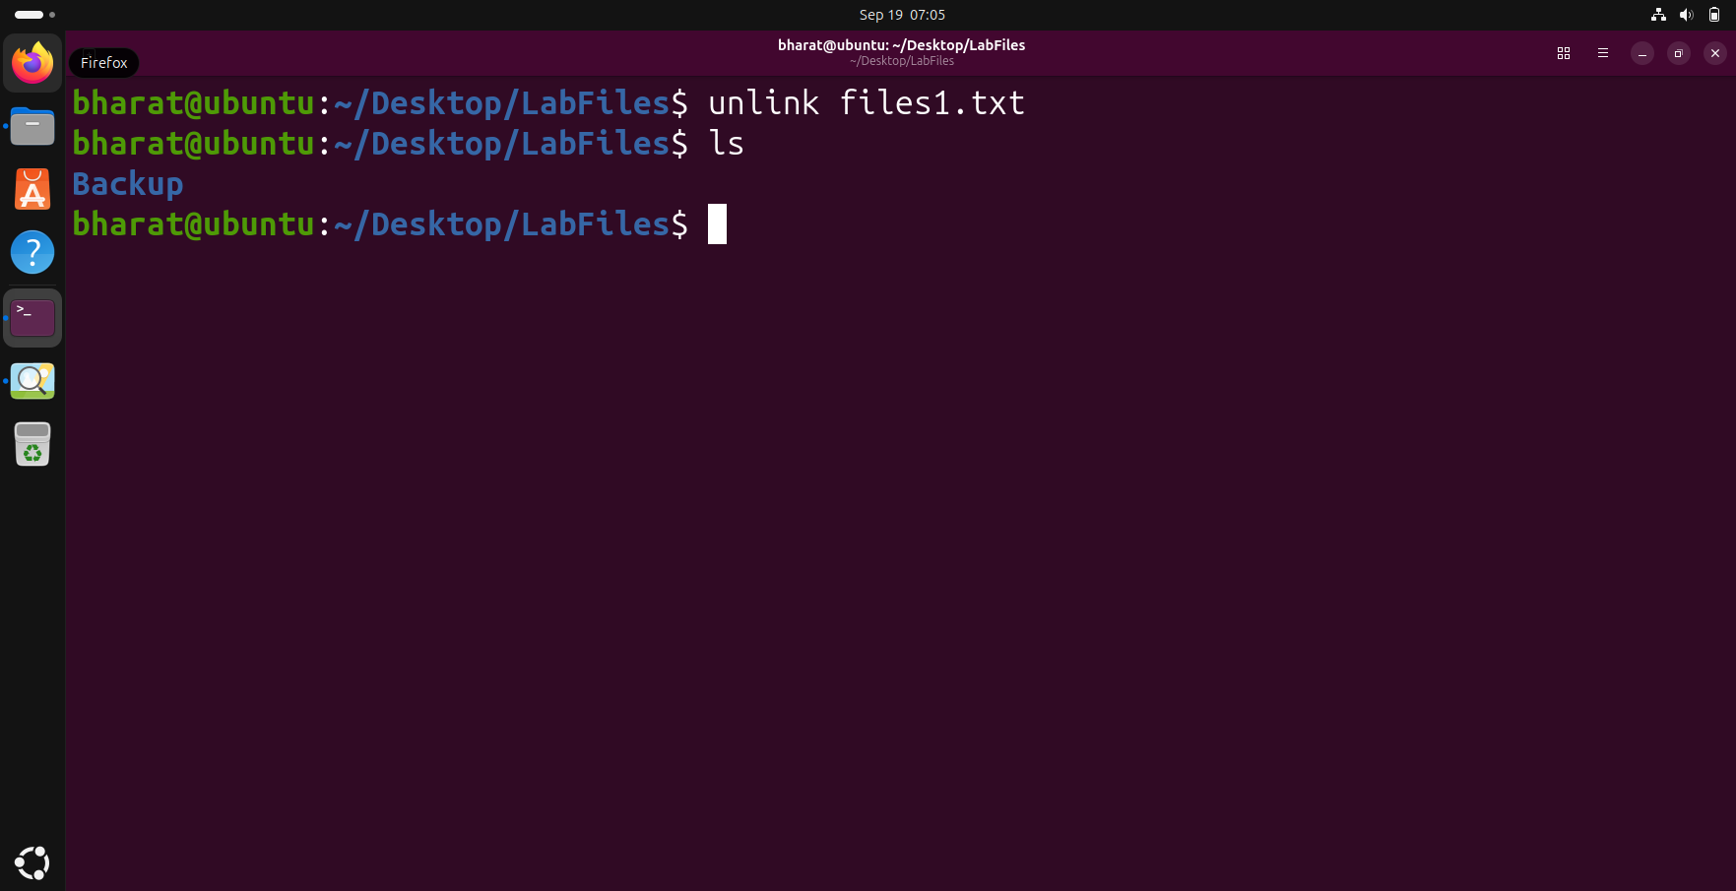

Question 2

Step 1 — Create and View the Input File
Create students.txt using output redirection (>) and display its contents using cat.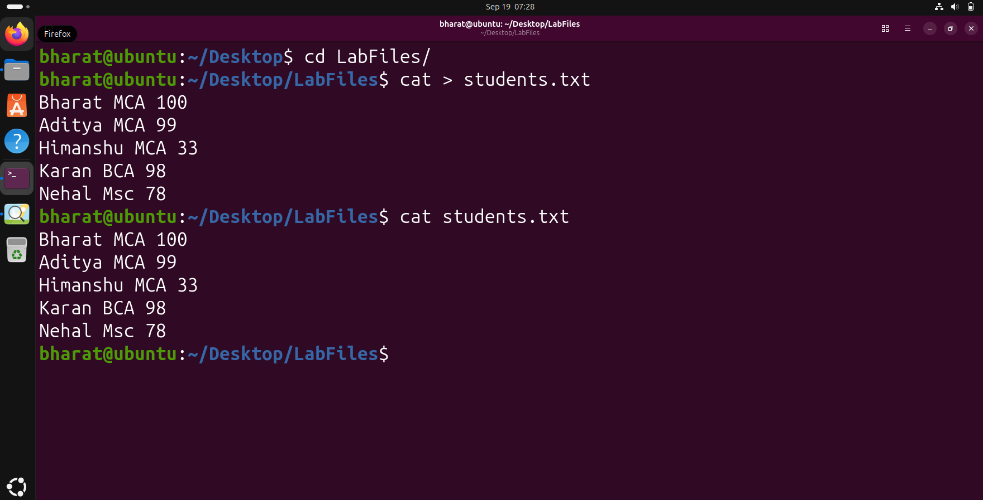

Step 2 — Create a Report Using Redirection
Copy the contents of students.txt into report.txt using output redirection (>), then display the report.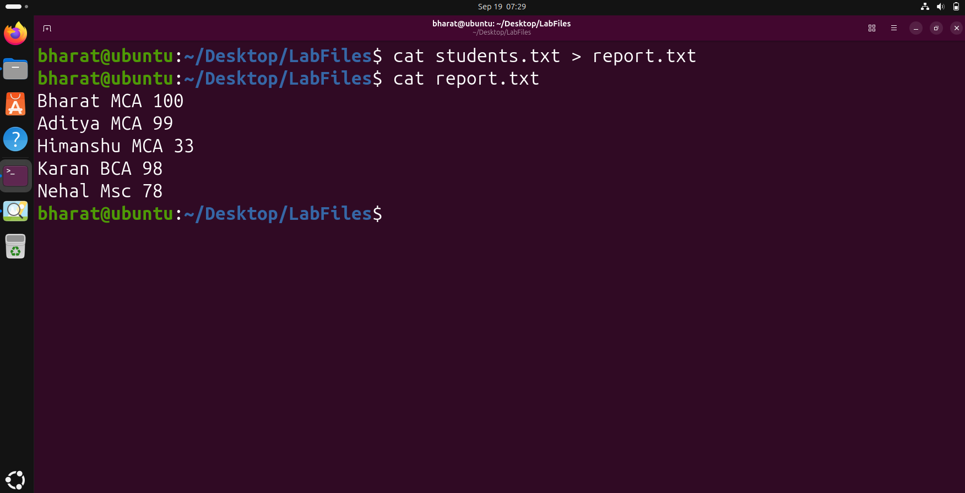

Step 3 — Append Data Using >>
Append an additional line to report.txt using >> and verify the updated report.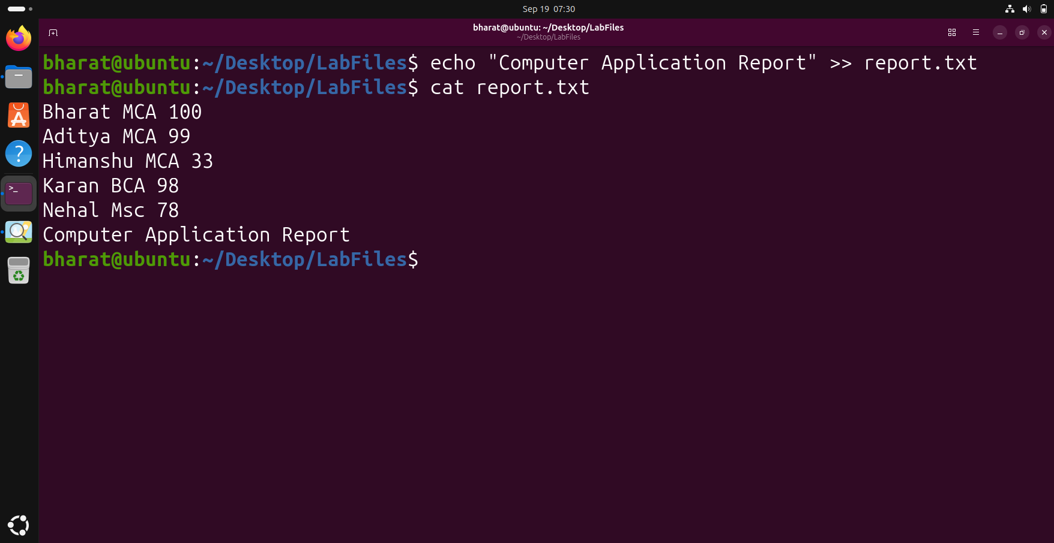

Step 4 — Input Redirection with wc
Use input redirection (<) to provide students.txt as input to wc -l and count the lines.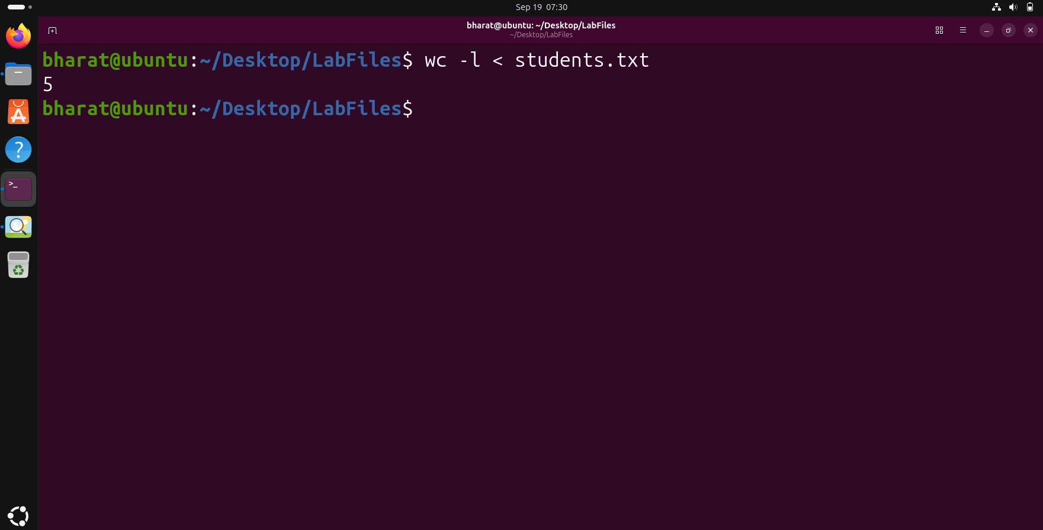

Step 5 — Error Redirection
Redirect the error produced by cat into error.txt using 2>.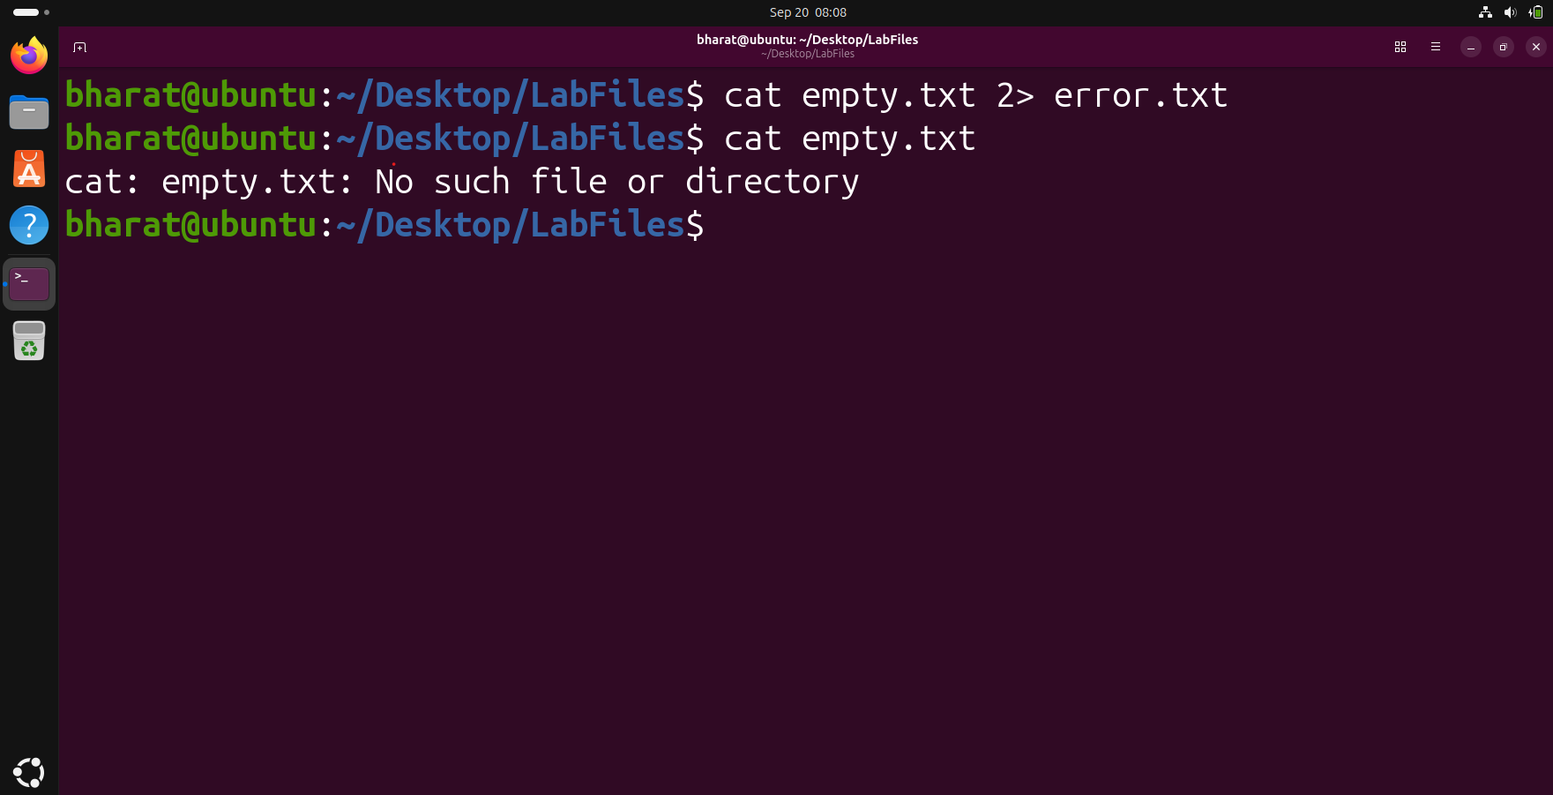

Step 6 — Combine Standard Output and Error
Use 2>&1 to redirect both standard output and standard error into combined.txt.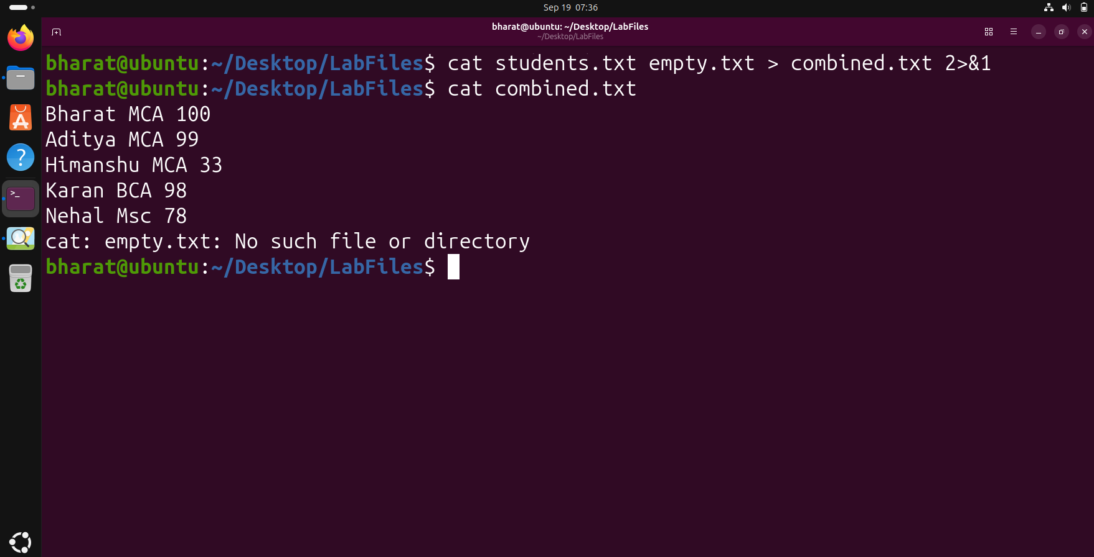

Step 7 — Use a Pipe with grep
Pass the output of cat through grep to filter only records containing MCA.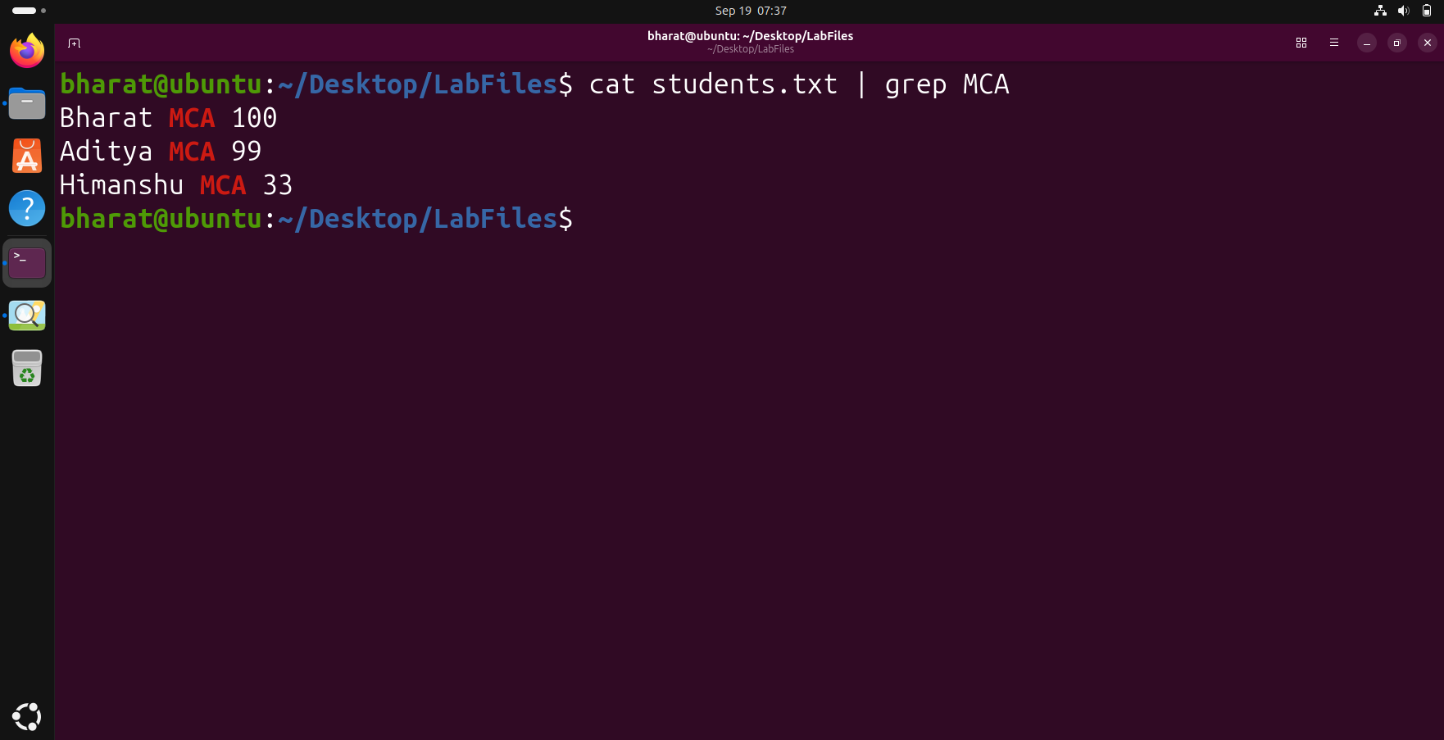

Step 8 — Remove Duplicate Lines with uniq
Use sort followed by uniq through pipes to display unique records.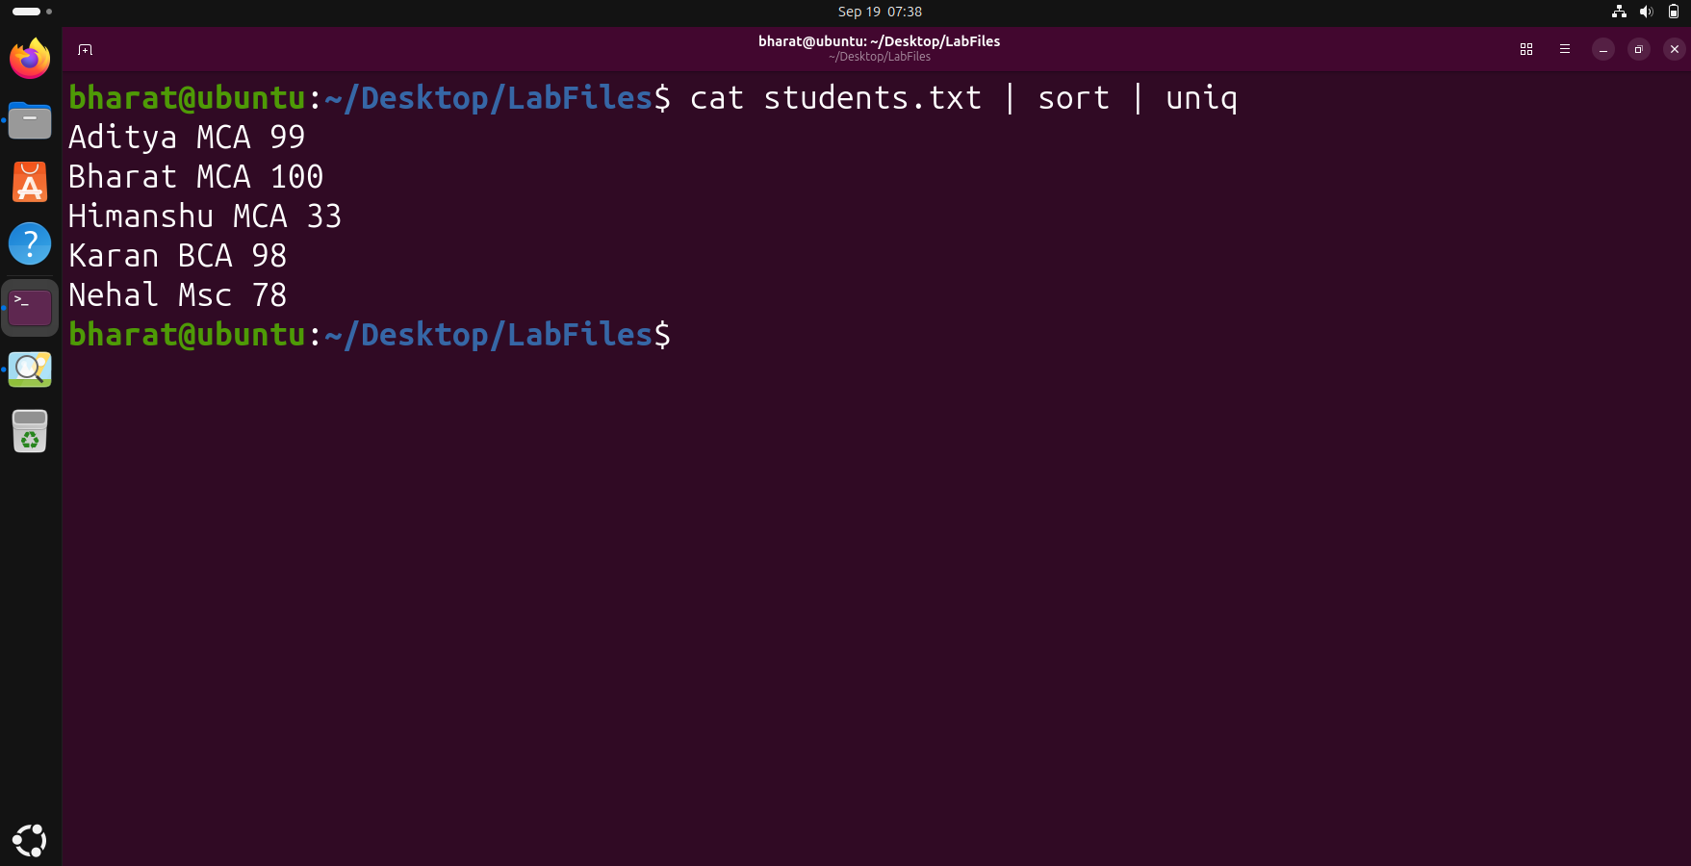

Step 9 — Count Filtered Records
Use grep and wc -l together through a pipe to count the number of MCA records.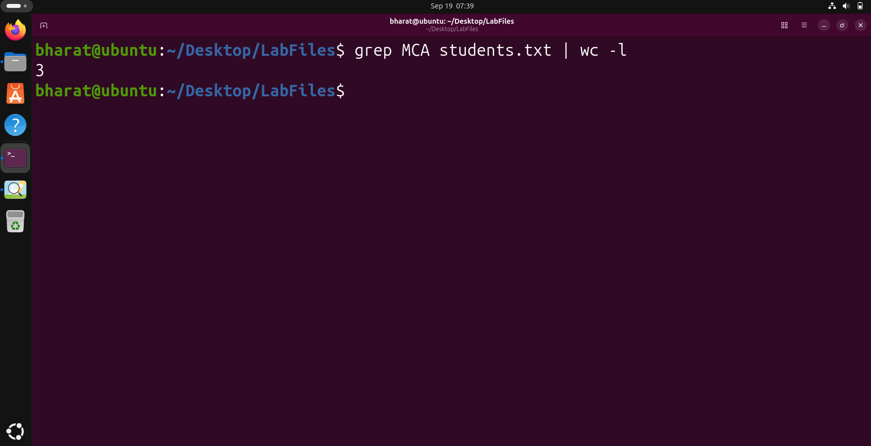

Step 10 — Save filtered output using tee
The tee command displayed the filtered MCA records on the terminal while simultaneously saving the same output into a report file.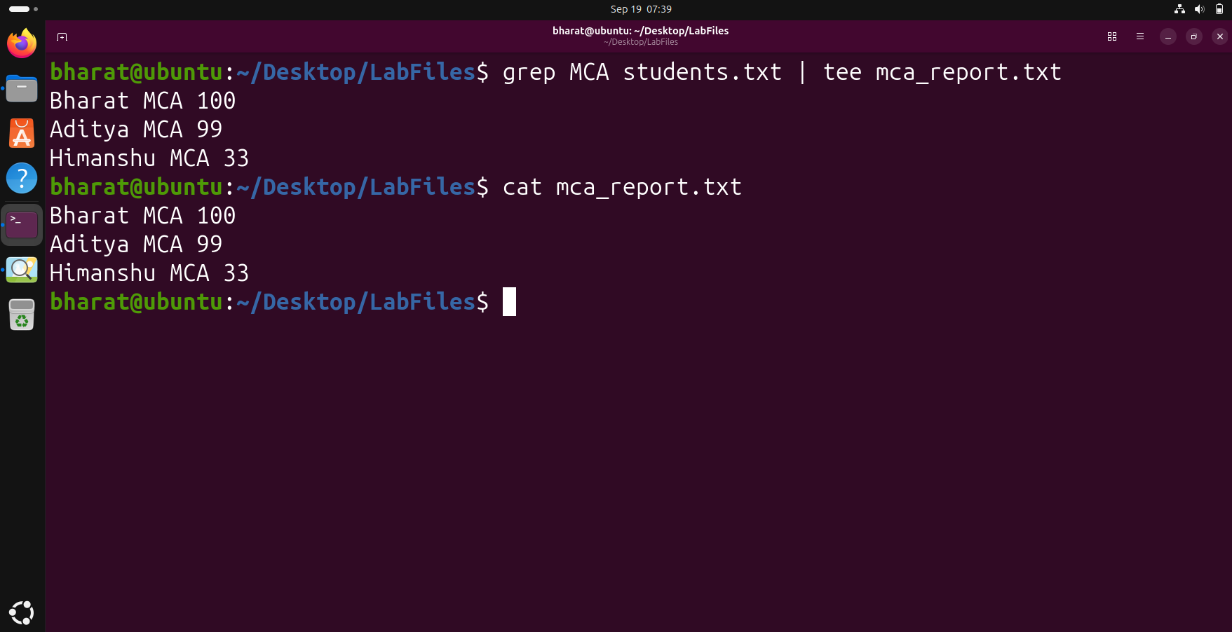

Step 11 — Generate the final filtered report
The final pipeline combined cat, grep, sort, uniq, the pipe operator and tee to generate a filtered MCA report. The saved report was then displayed to verify the result.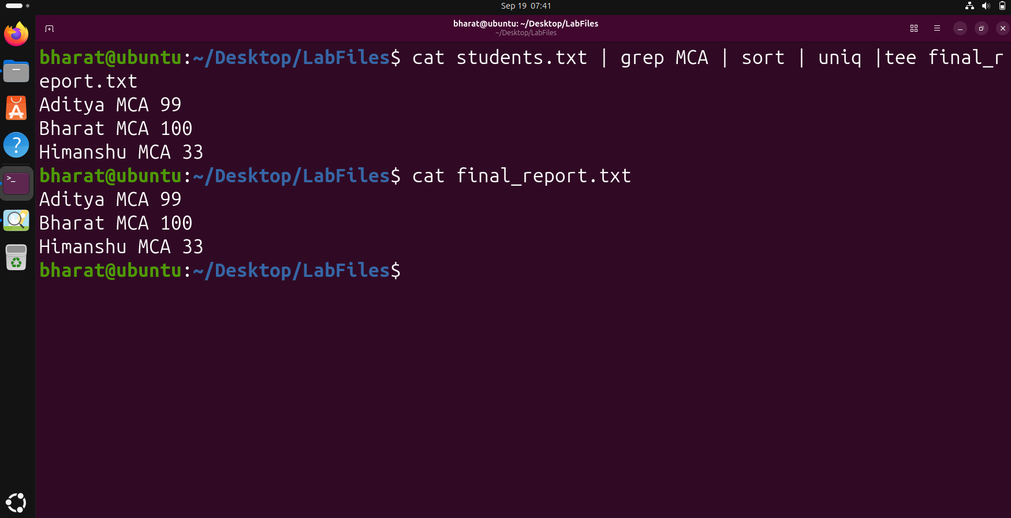

Question 3

Step 1 — Move to the Home Directory
Move to the home directory and display the current working directory.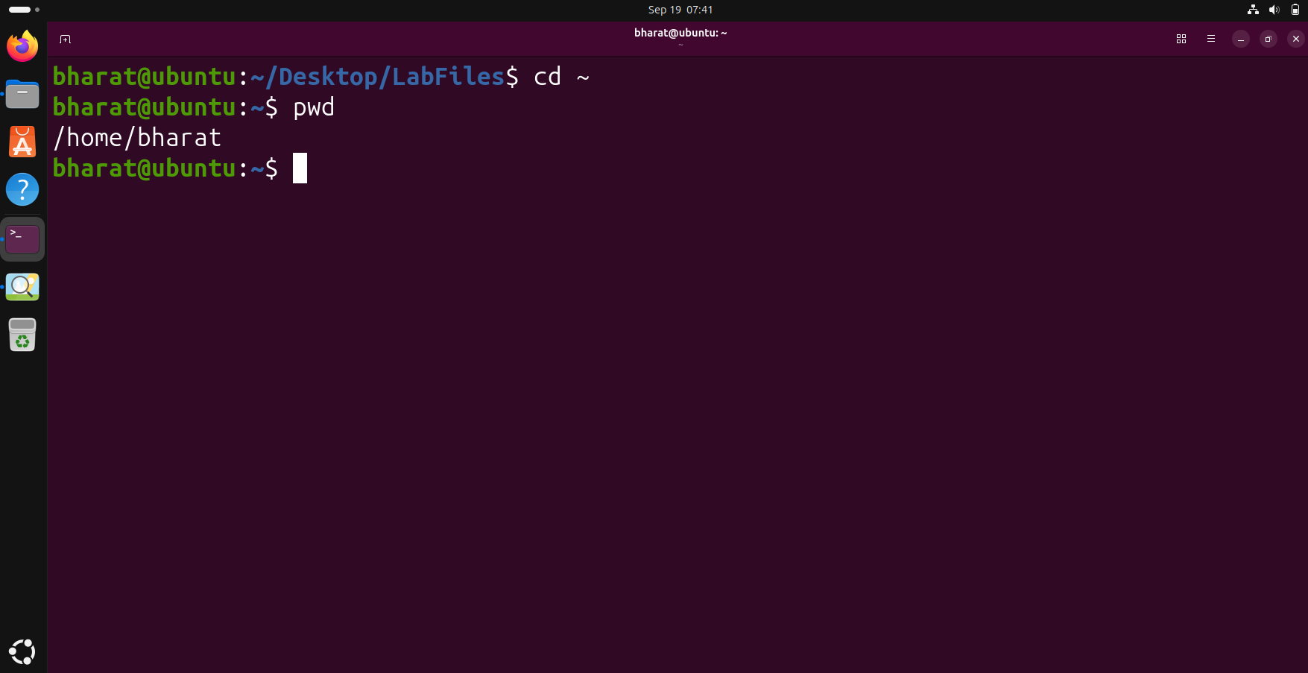

Step 2 — Create the College Directory
Create the College directory and verify it using ls.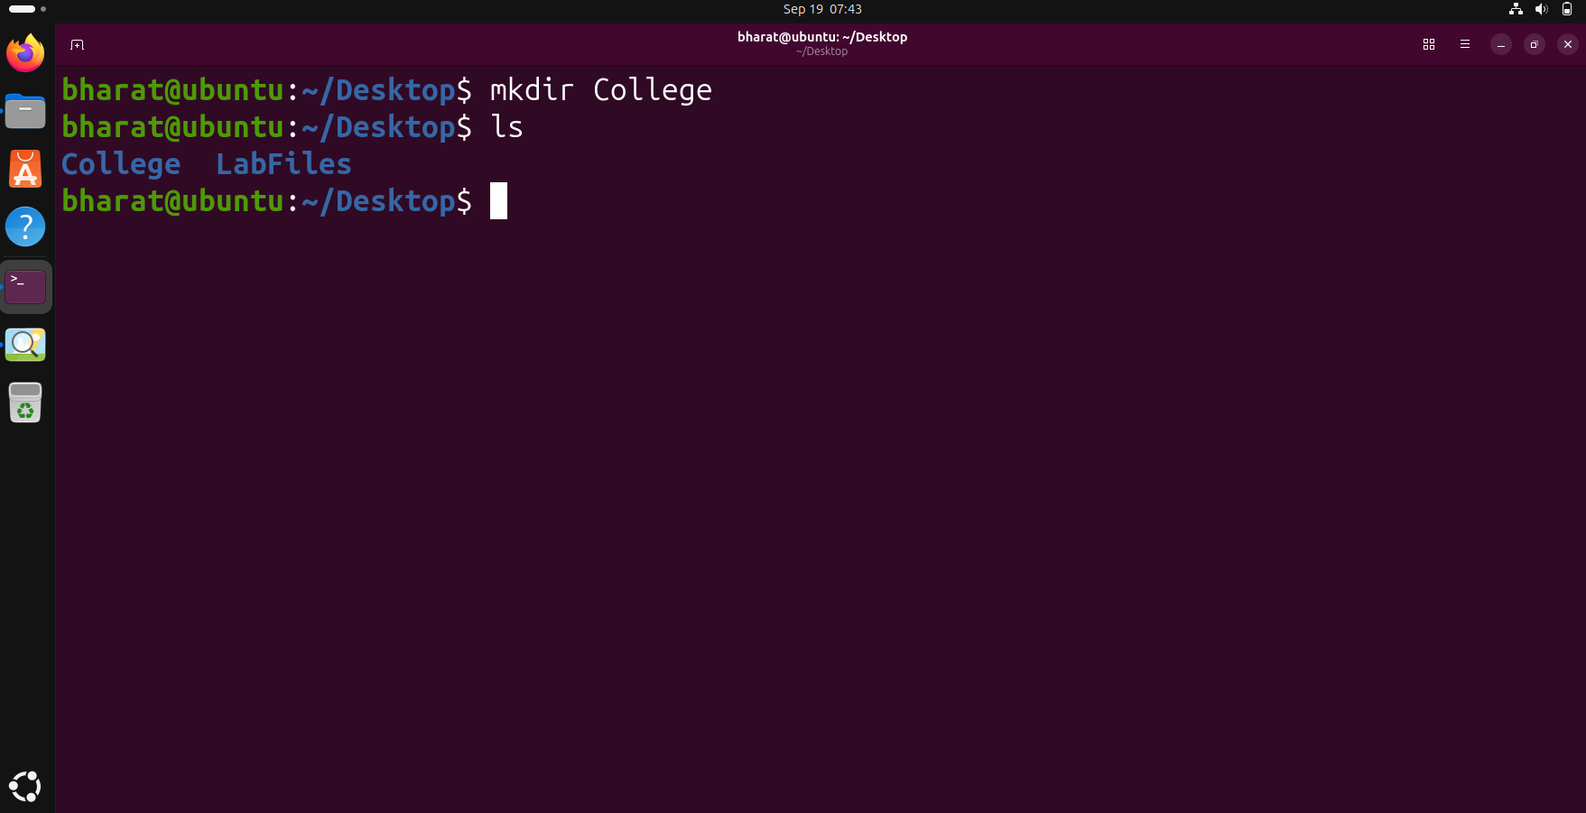

Step 3 — Enter the College Directory
Enter the College directory and display its absolute path.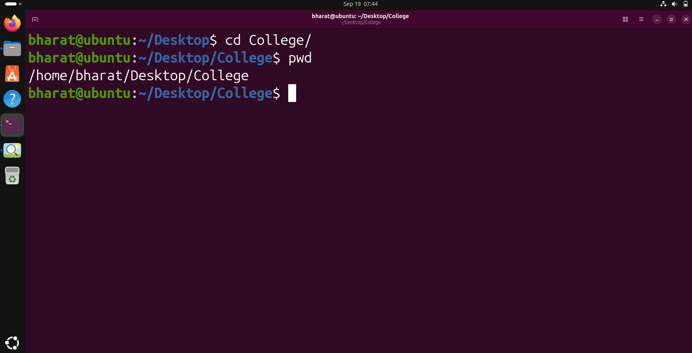

Step 4 — Create Department Directories
Create the CSE, ECE, ME and Civil department directories and list them.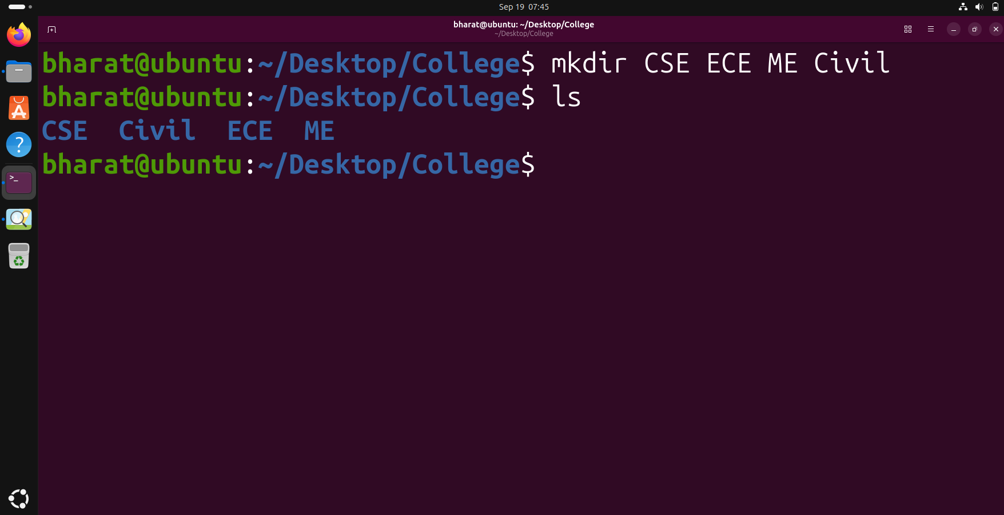

Step 5 — Create Semester Directories
Create Semester 1 and Semester 2 directories inside each department, then verify the CSE directory.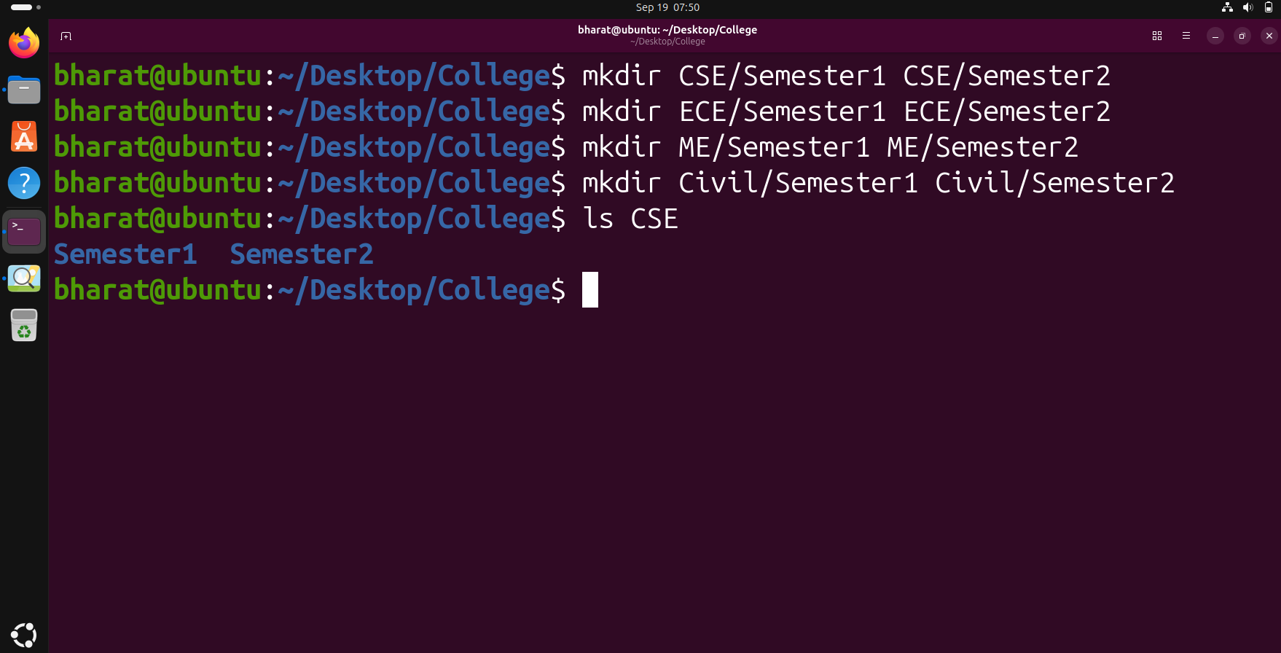

Step 6 — Display the Directory Tree
Display the complete College directory hierarchy using tree.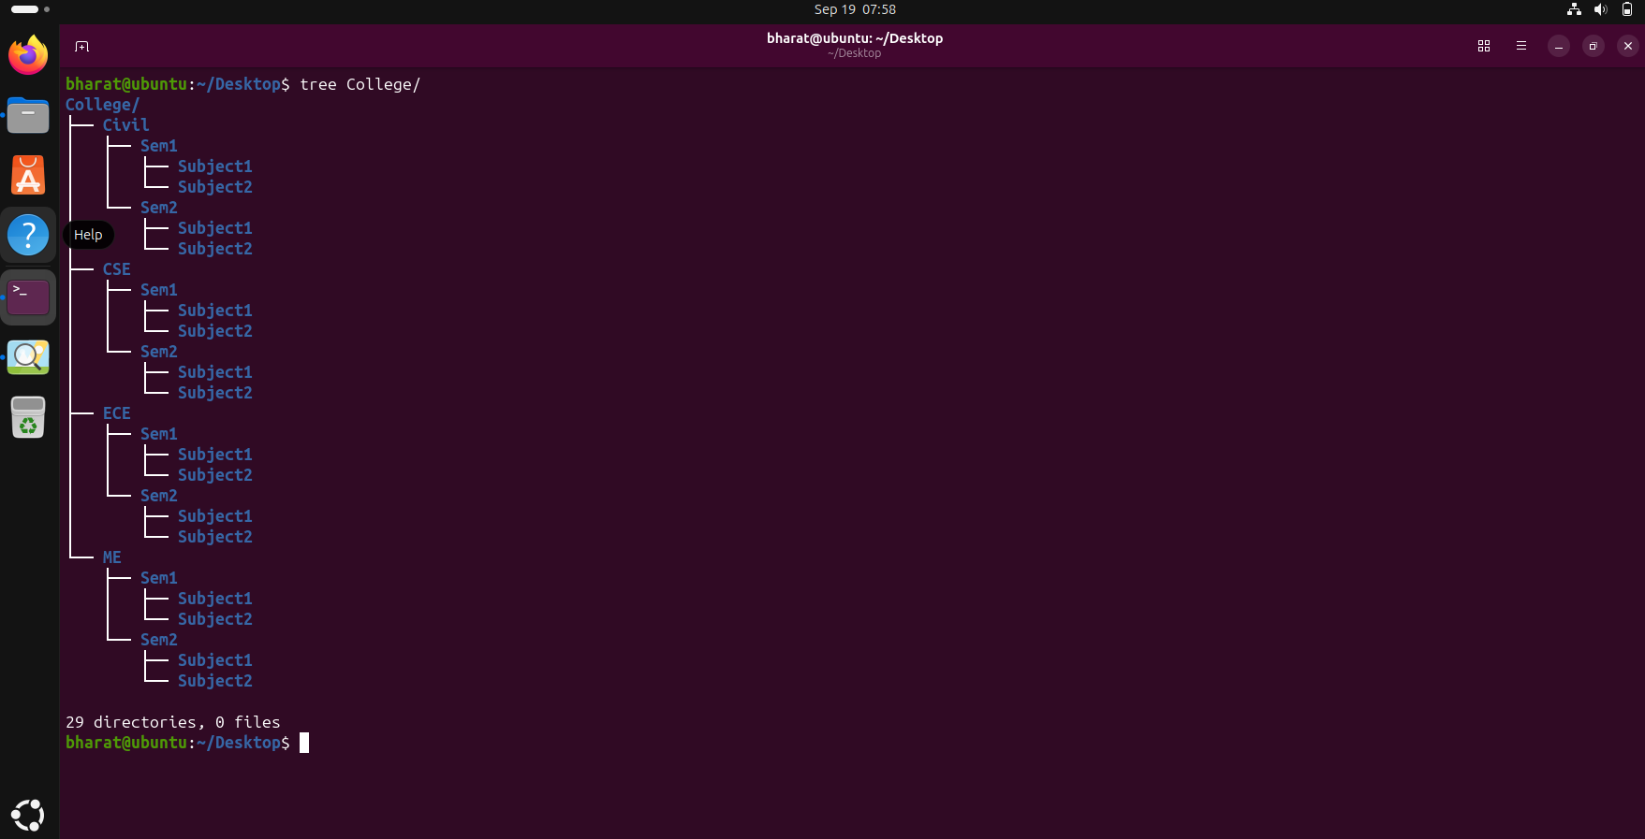

Step 7 — Navigate to CSE Semester 1
Navigate to CSE/Sem1, display the current path and list its contents.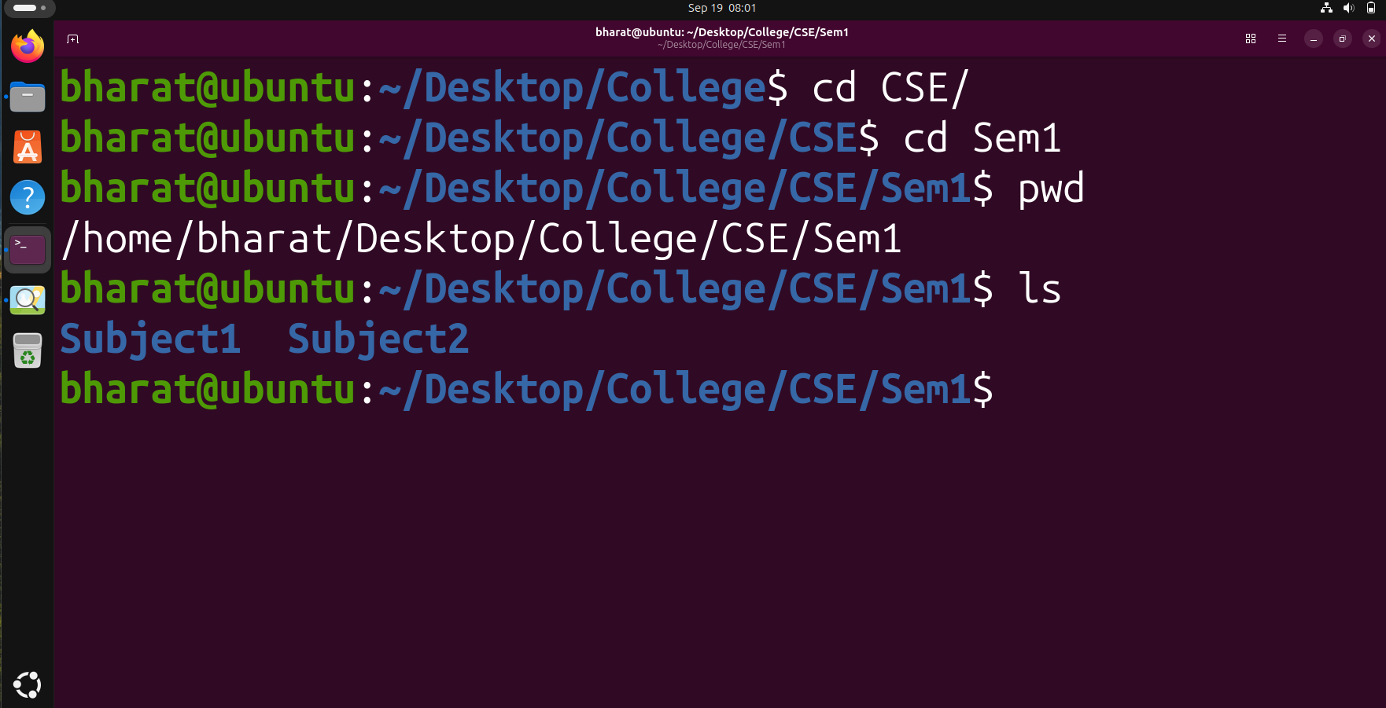

Step 8 — Create and Remove a Temporary Directory
Create a temporary directory, verify it, remove it using rmdir, and verify the result.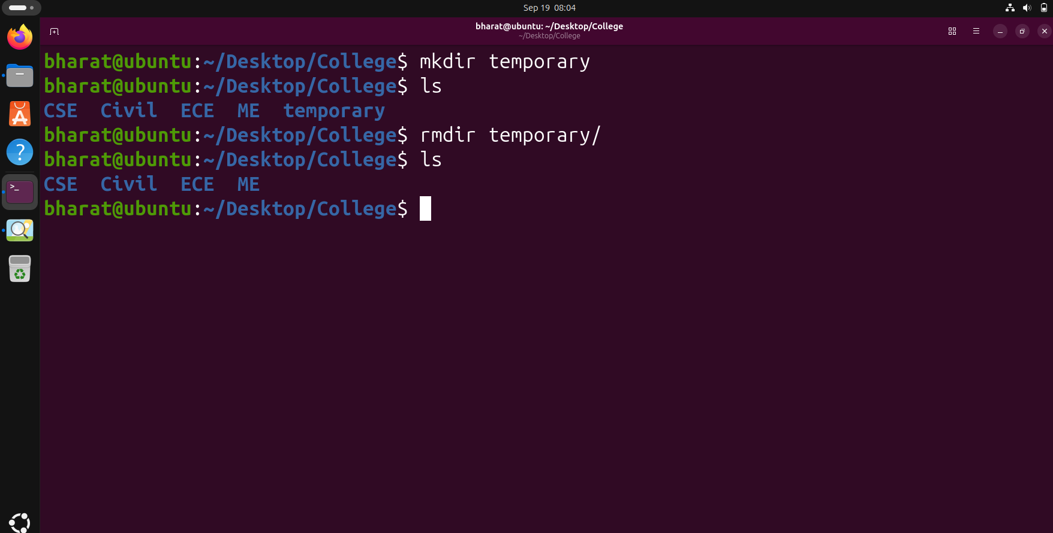

Step 9 — Display the First 20 Recursive Entries
Recursively list the College directory and display the first 20 lines using head.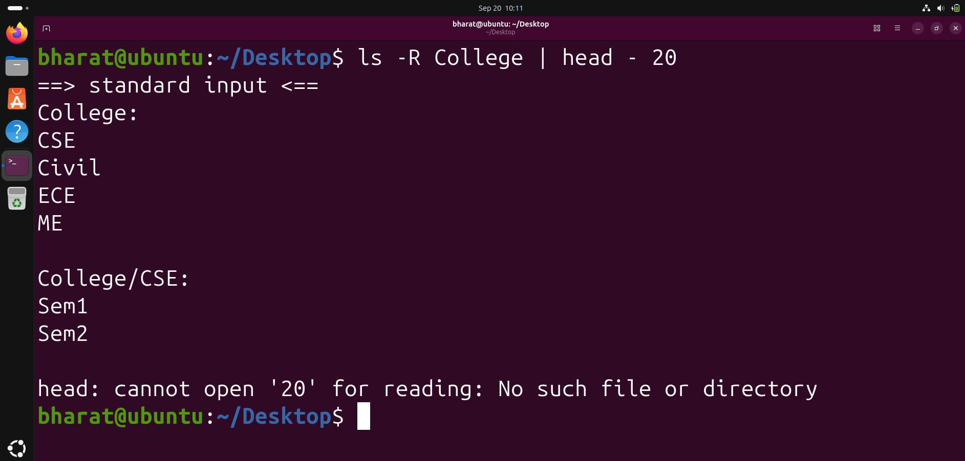

Question 4

Step 1 — Create permission.txt and verify the file
We created permission.txt using touch and used ls to verify that the file was created successfully.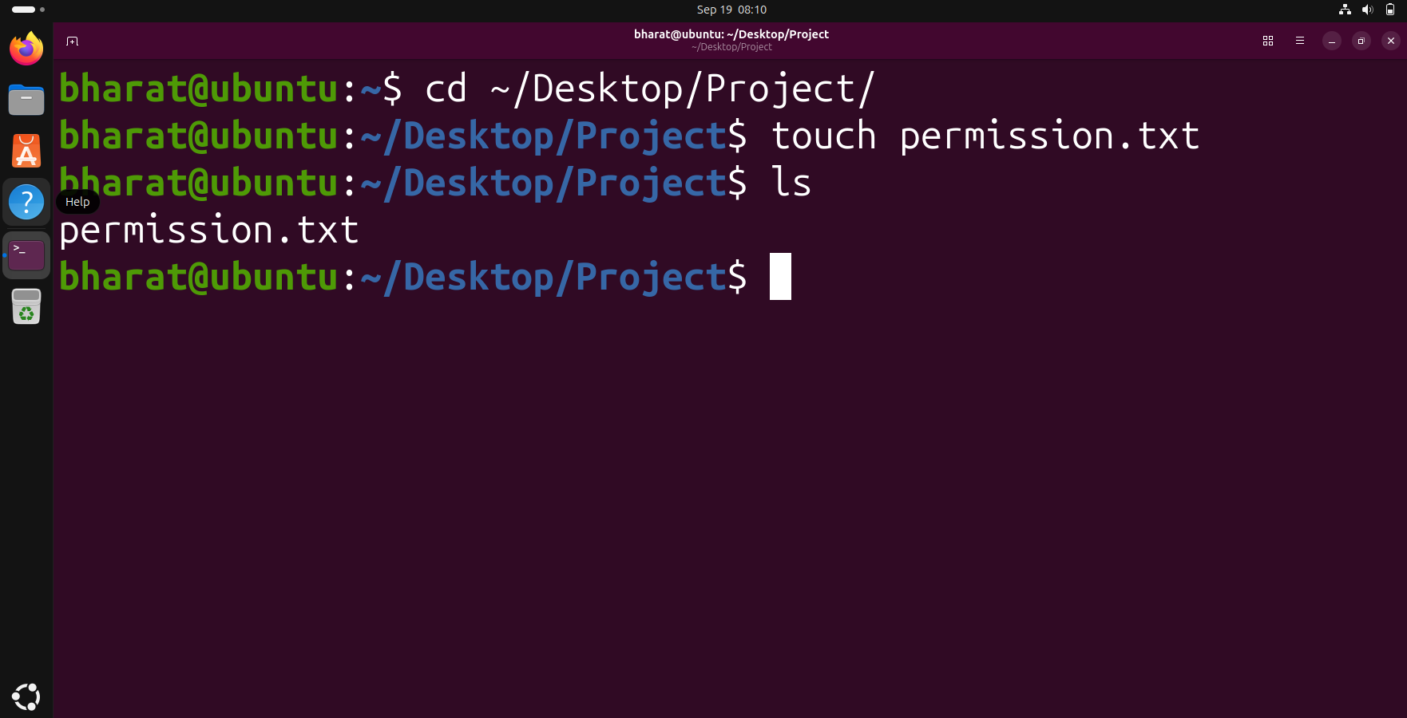

Step 2 — View the initial file permissions
We used ls -l to display the initial permissions, owner, group, size and other file details for permission.txt.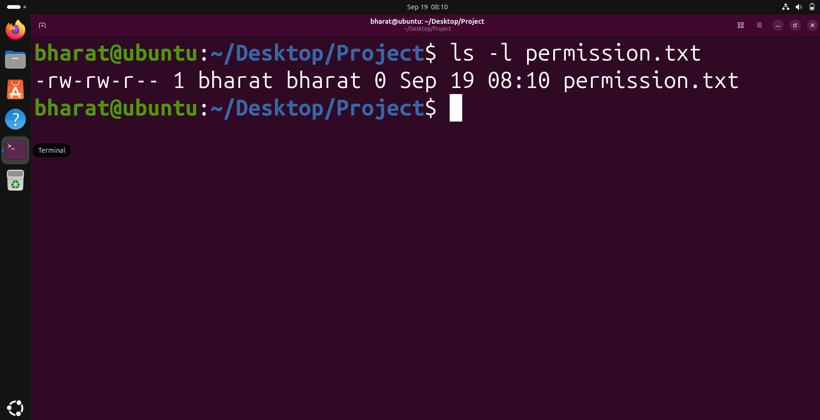

Step 3 — Change permission to 755
We changed the permissions of permission.txt to 755 using chmod and then verified the new permissions with ls -l.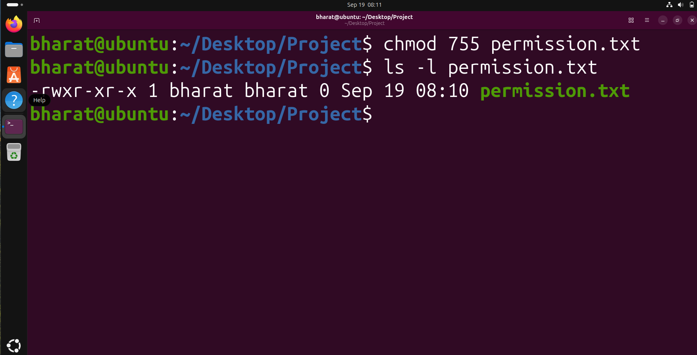

Step 4 — Change permission to 644
We changed the permissions back to 644 using chmod and verified the result with ls -l.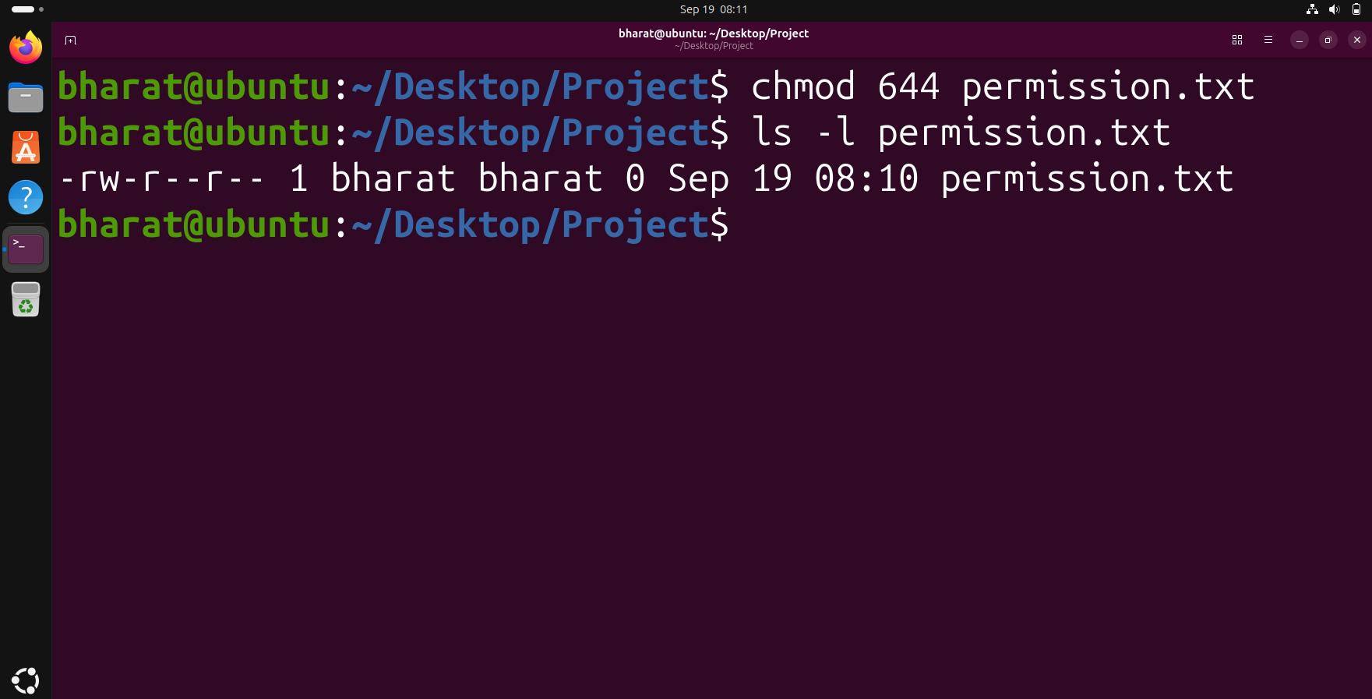

Step 5 — View detailed file information
We used stat to view detailed information about permission.txt, including its permissions, owner, group, size and timestamps.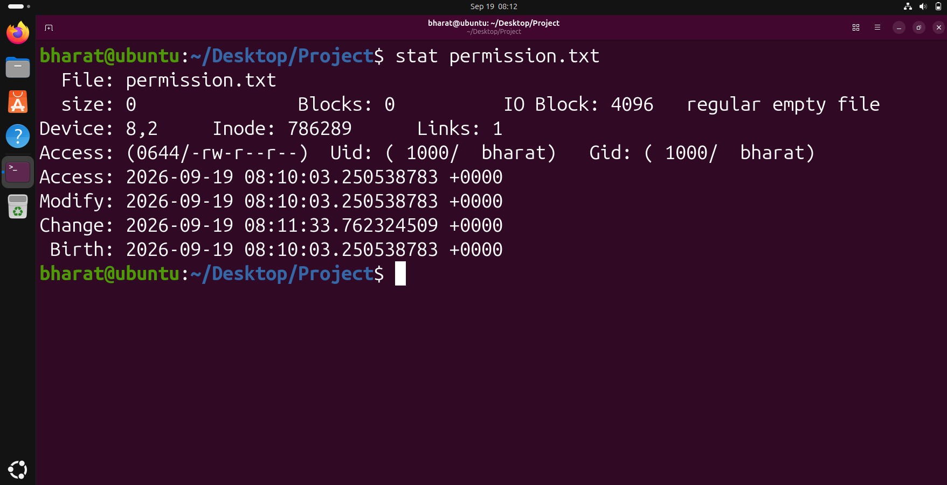

Step 6 — Change file ownership
We used chown to set the owner and group of permission.txt to bharat and then used ls -l to verify the ownership.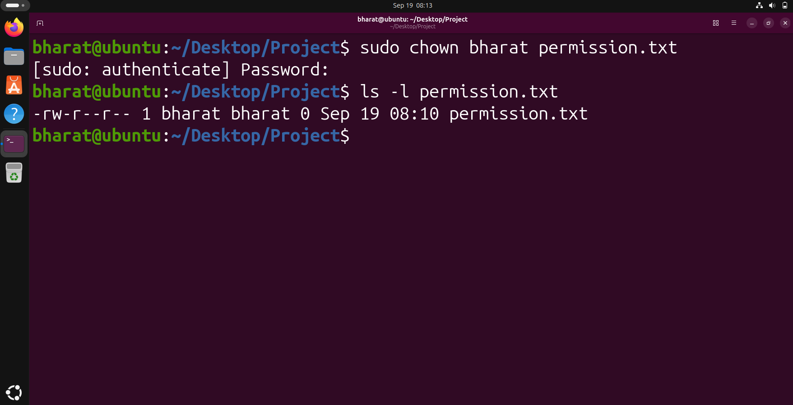

Step 7 —Verify the file information again
We ran stat again to verify the detailed metadata of permission.txt after the ownership operation.