LINUX LABORATORY
Question 1

Step 1 — Create the LabFiles Directory
Create the LabFiles directory and verify it with ls.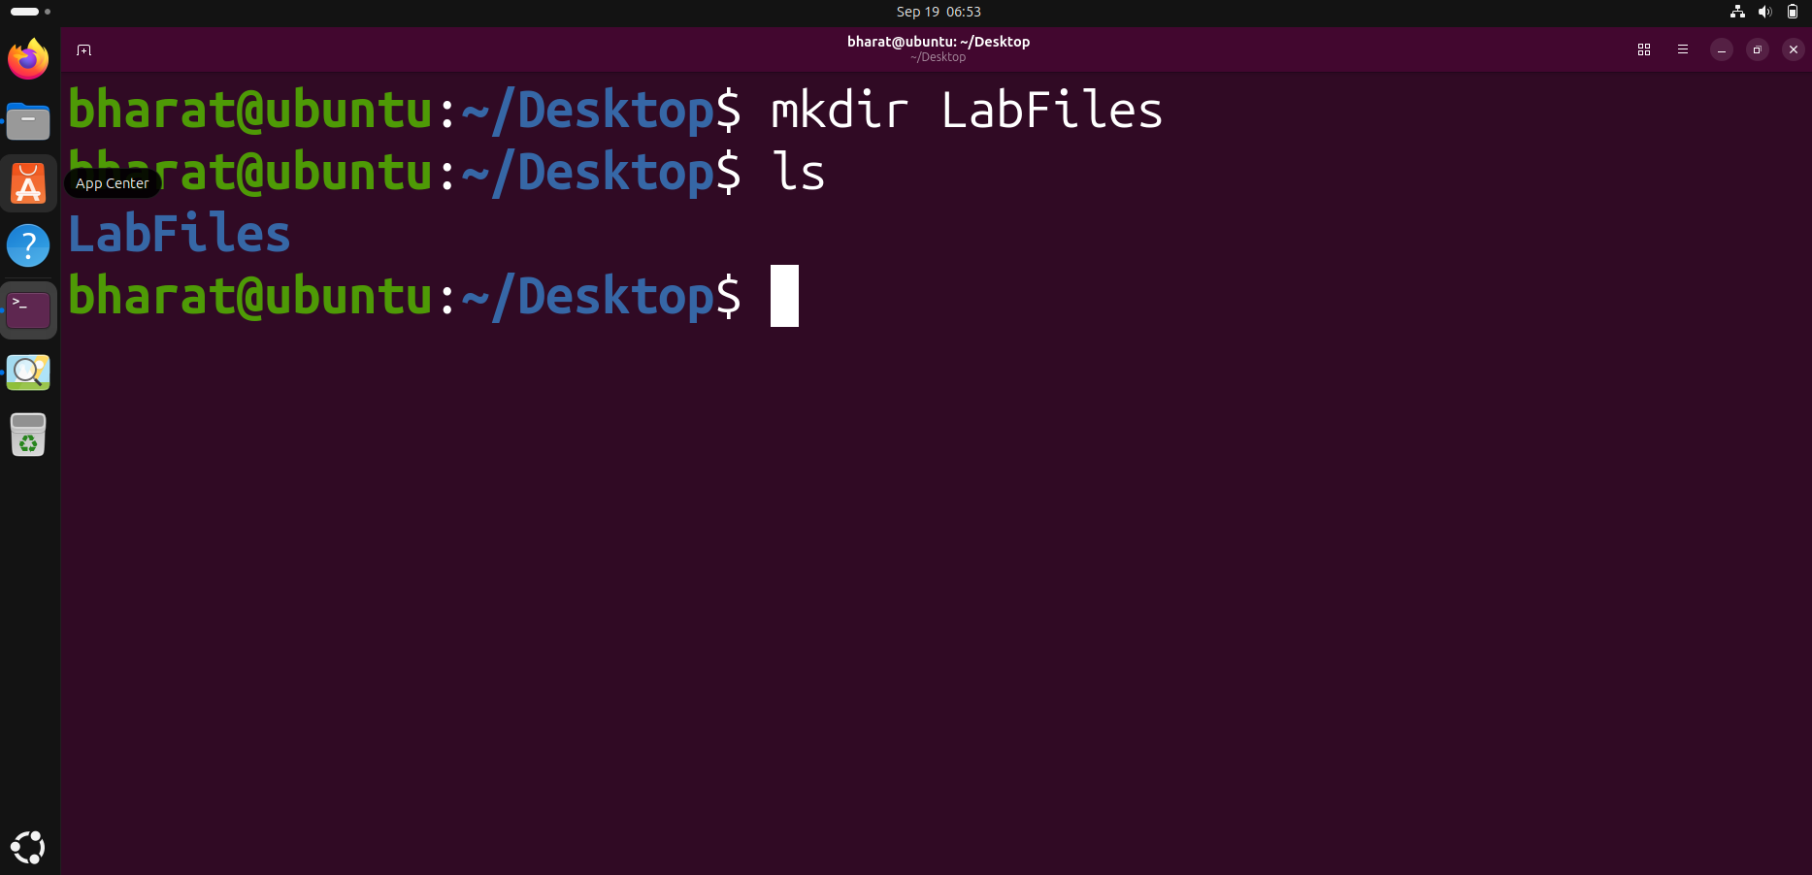

Step 2 — Create a File
Enter LabFiles, create an empty file with touch, and verify it.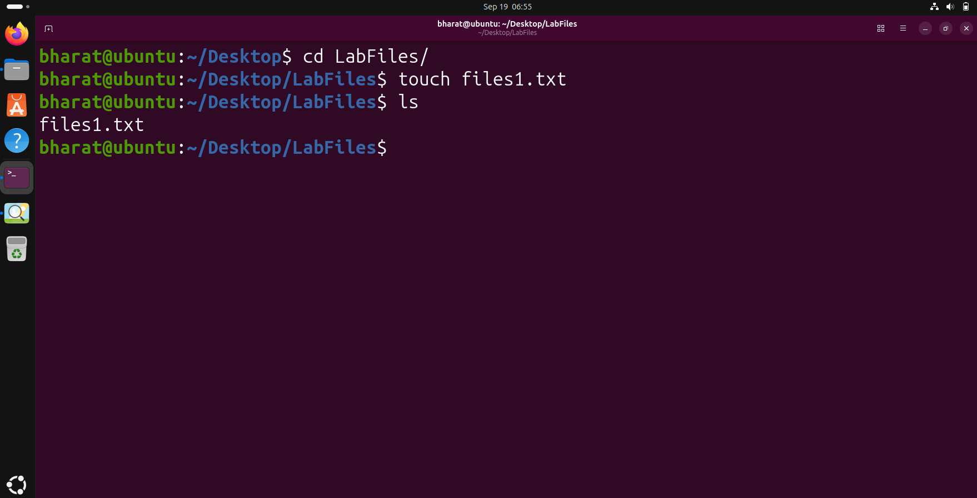

Step 3 — Copy a File
Copy files1.txt to files2.txt using cp and verify the copy.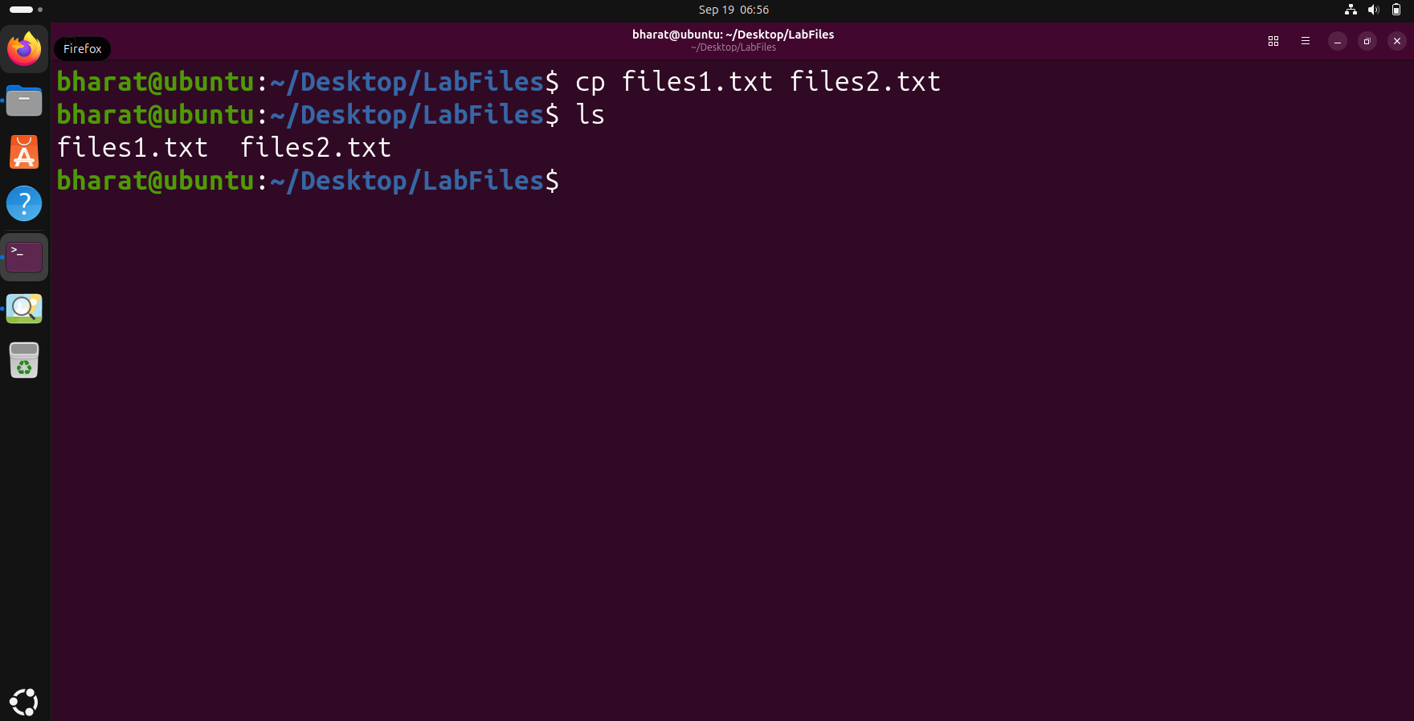

Step 4 — Move a File
Create Backup and move files3.txt into it using mv.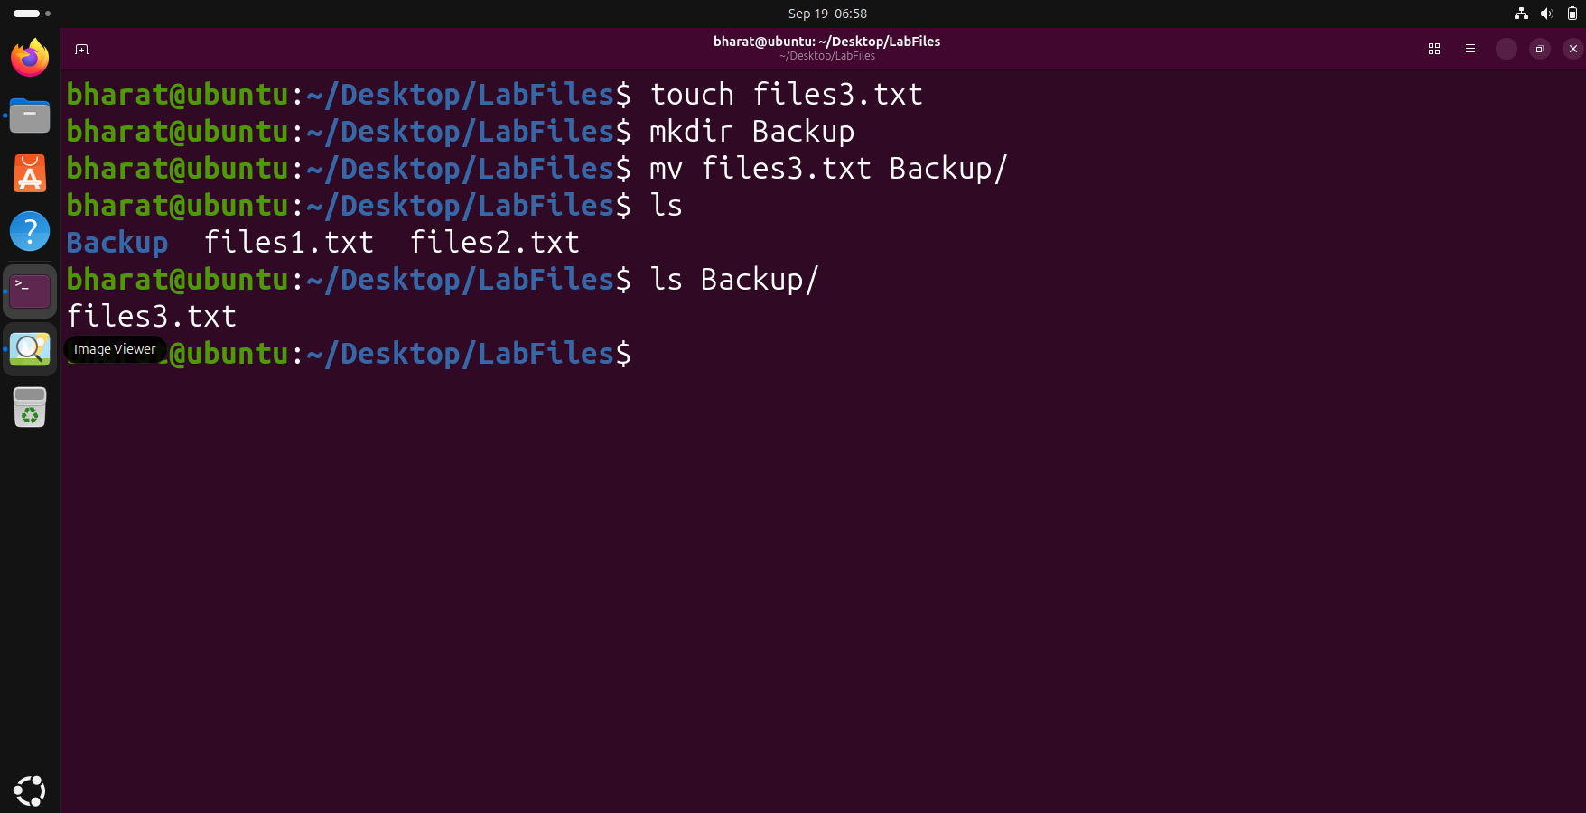

Step 5 — Rename a File
Rename files2.txt to file.txt using mv and verify it.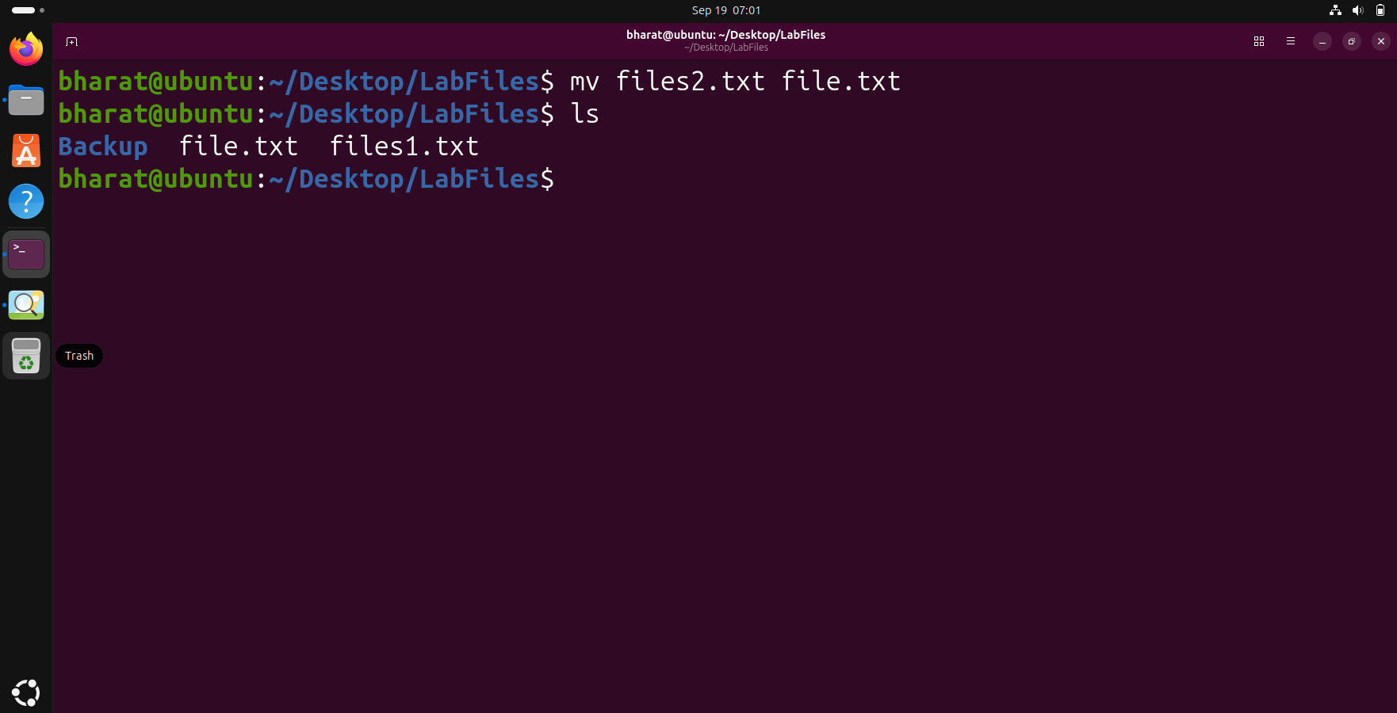

Step 6 — Display File Information
Use stat to display file metadata and status information.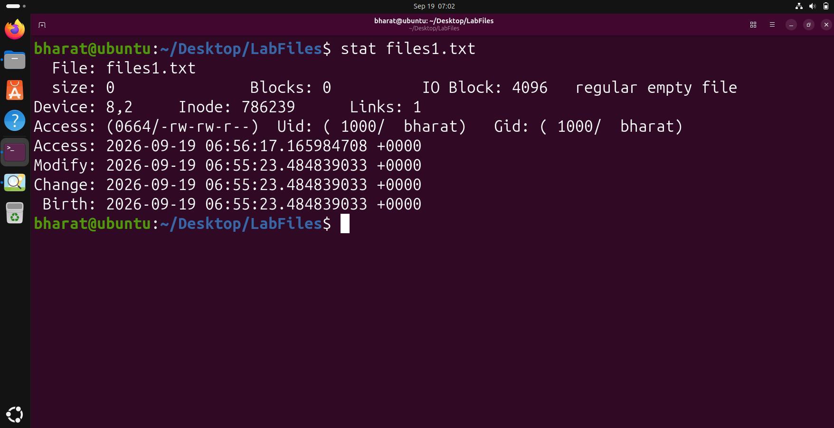

Step 7 — Delete a File
Delete file.txt using rm and verify the remaining files.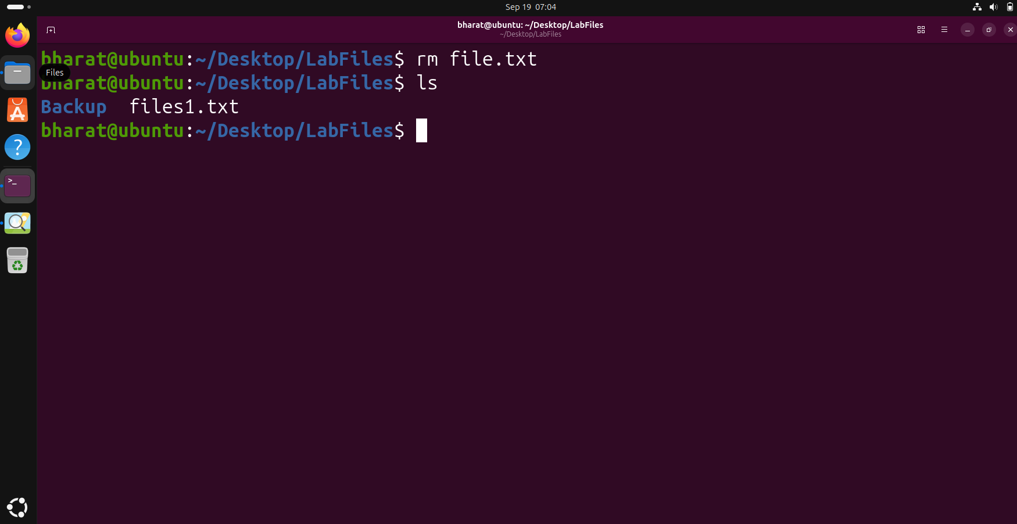

Step 8 — Delete Using unlink
Delete files1.txt using unlink and verify the remaining contents.