LINUX LABORATORY
Question 2

Step 1 — Create and View the Input File
Create students.txt using output redirection (>) and display its contents using cat.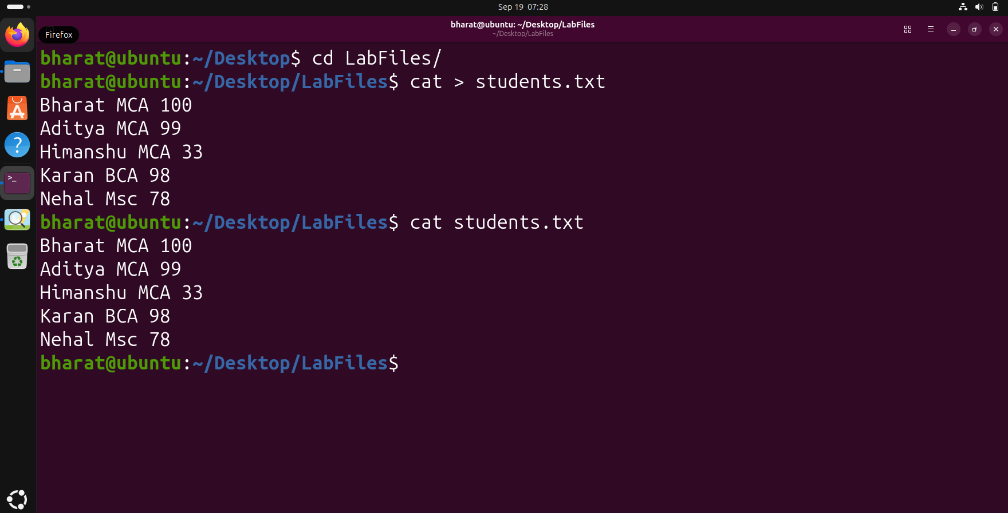

Step 2 — Create a Report Using Redirection
Copy the contents of students.txt into report.txt using output redirection (>), then display the report.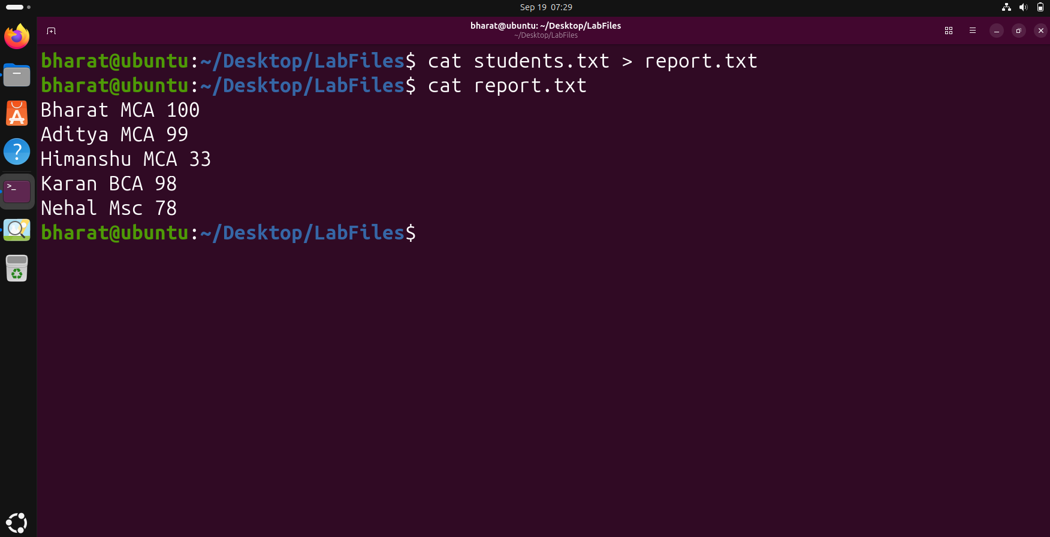

Step 3 — Append Data Using >>
Append an additional line to report.txt using >> and verify the updated report.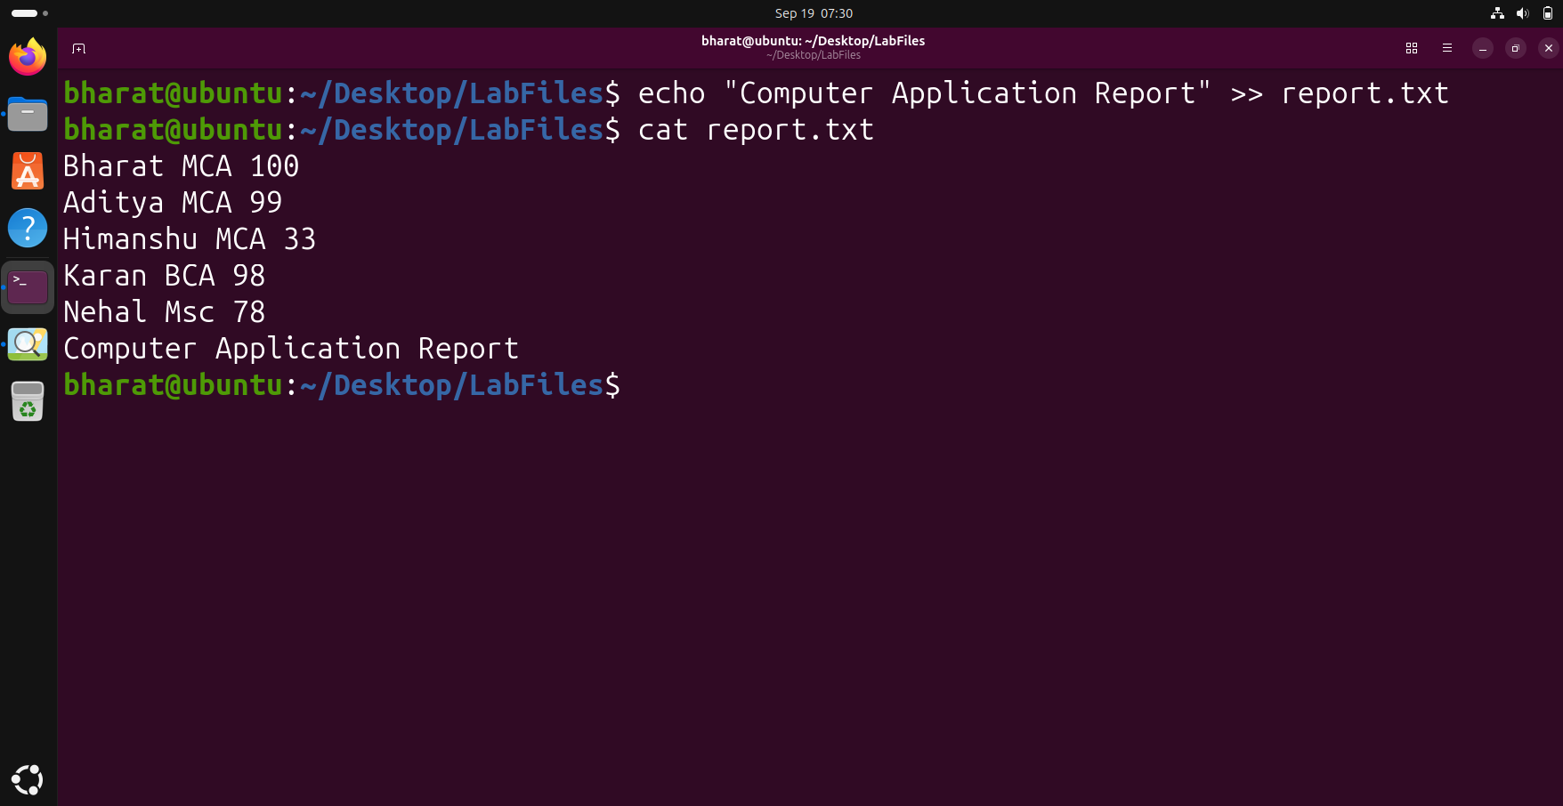

Step 4 — Input Redirection with wc
Use input redirection (<) to provide students.txt as input to wc -l and count the lines.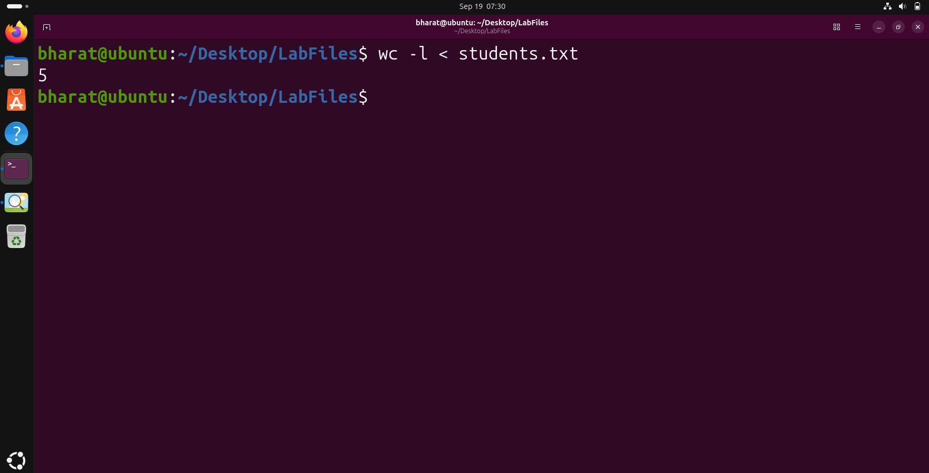

Step 5 — Error Redirection
Redirect the error produced by cat into error.txt using 2>.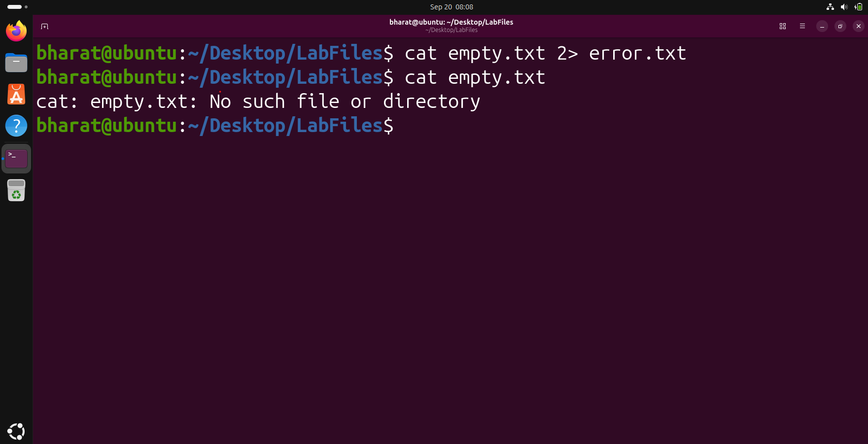

Step 6 — Combine Standard Output and Error
Use 2>&1 to redirect both standard output and standard error into combined.txt.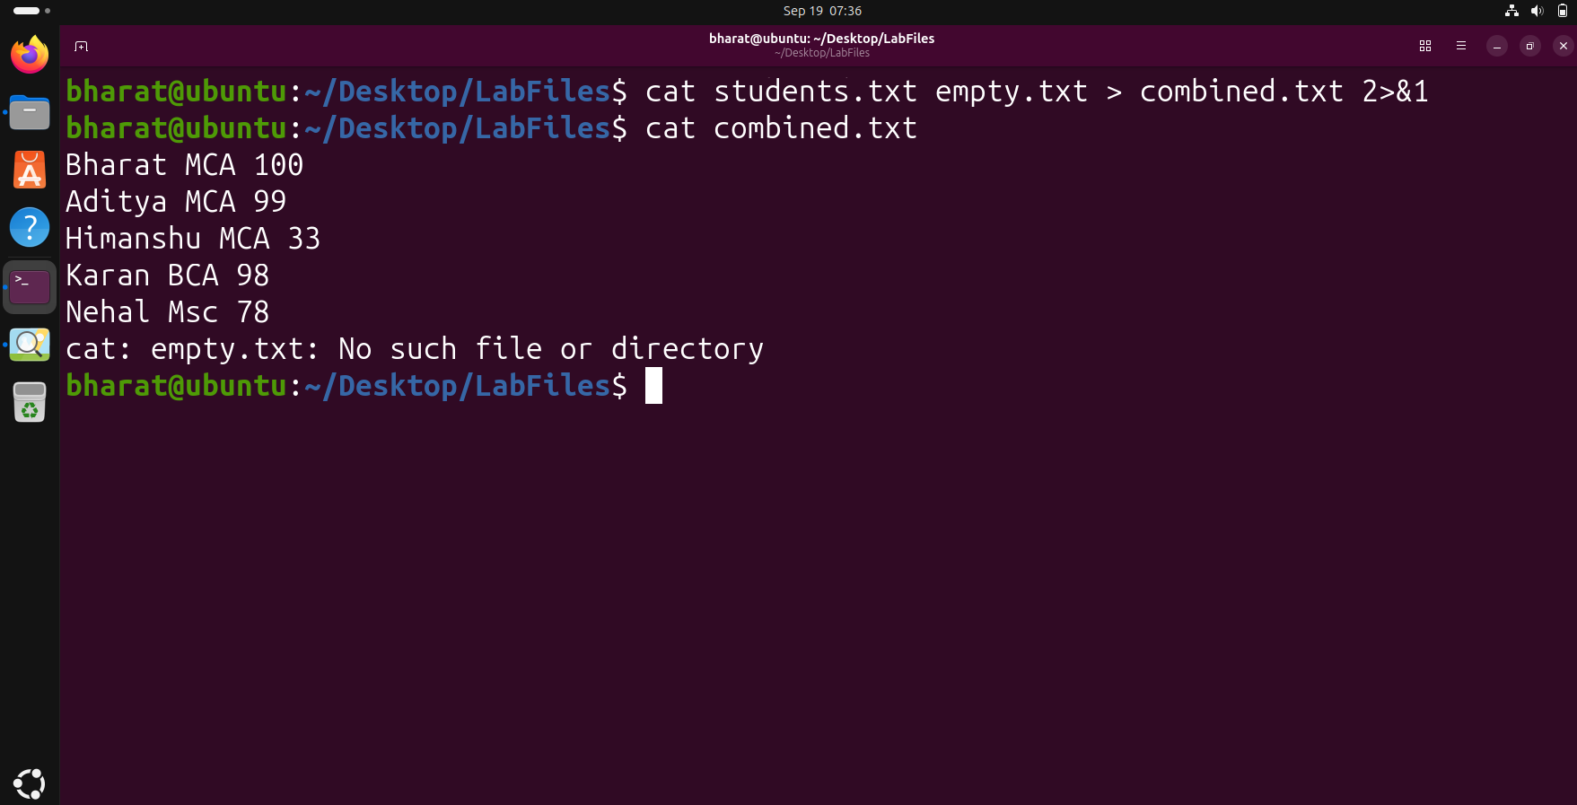

Step 7 — Use a Pipe with grep
Pass the output of cat through grep to filter only records containing MCA.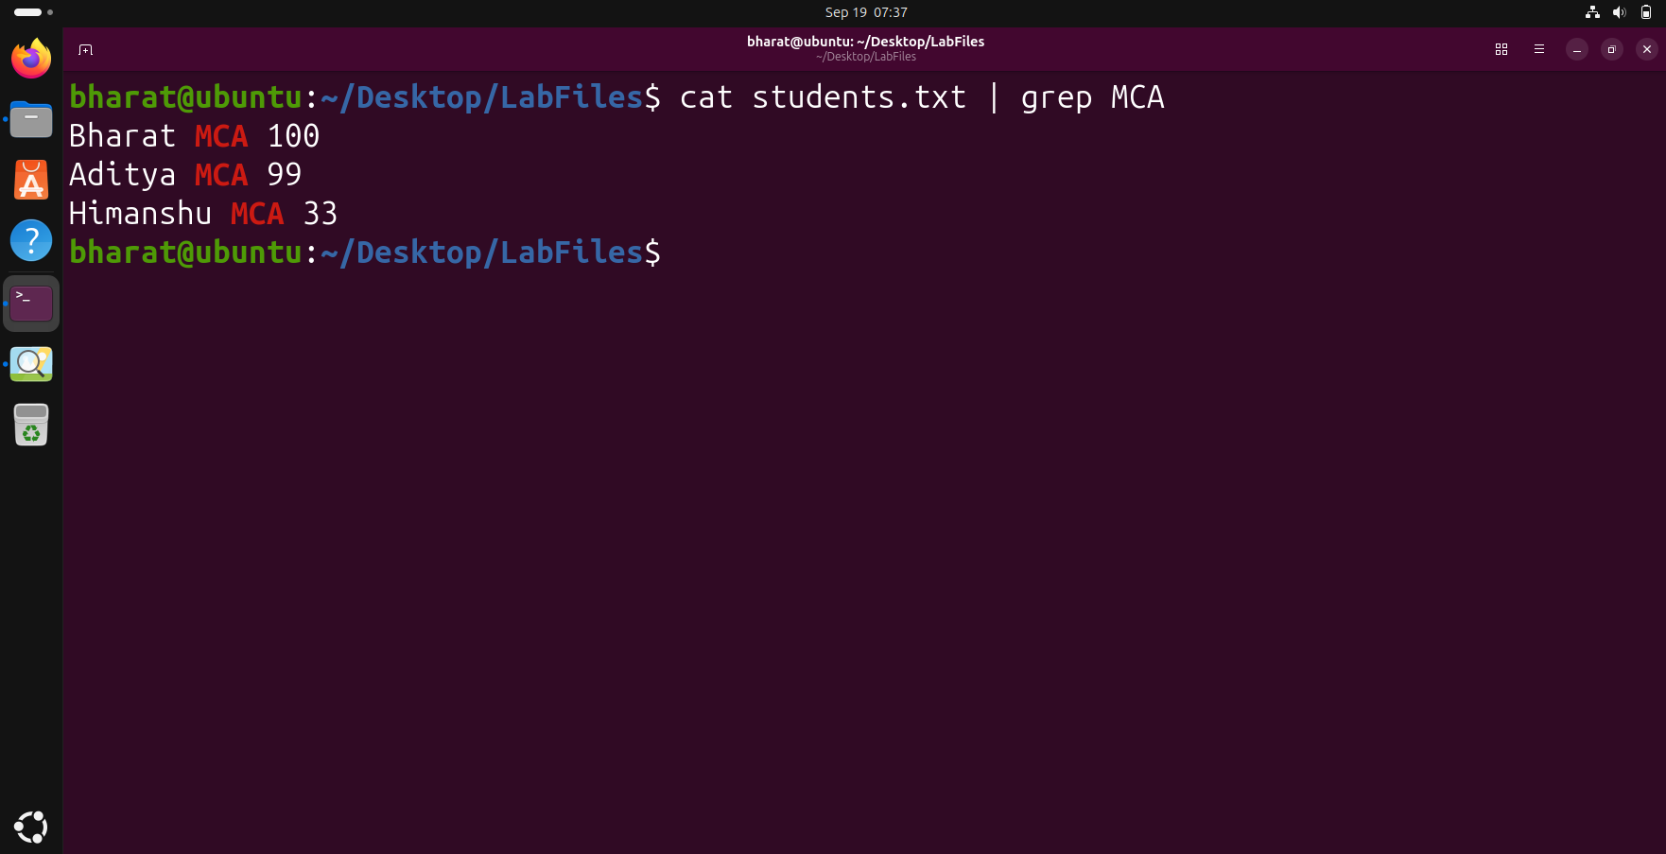

Step 8 — Remove Duplicate Lines with uniq
Use sort followed by uniq through pipes to display unique records.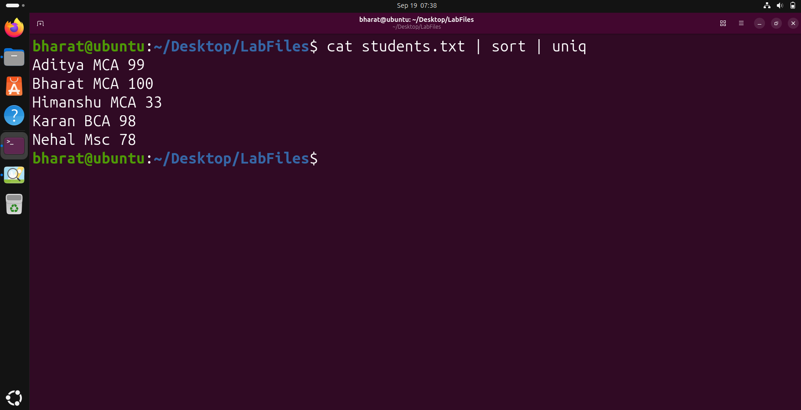

Step 9 — Count Filtered Records
Use grep and wc -l together through a pipe to count the number of MCA records.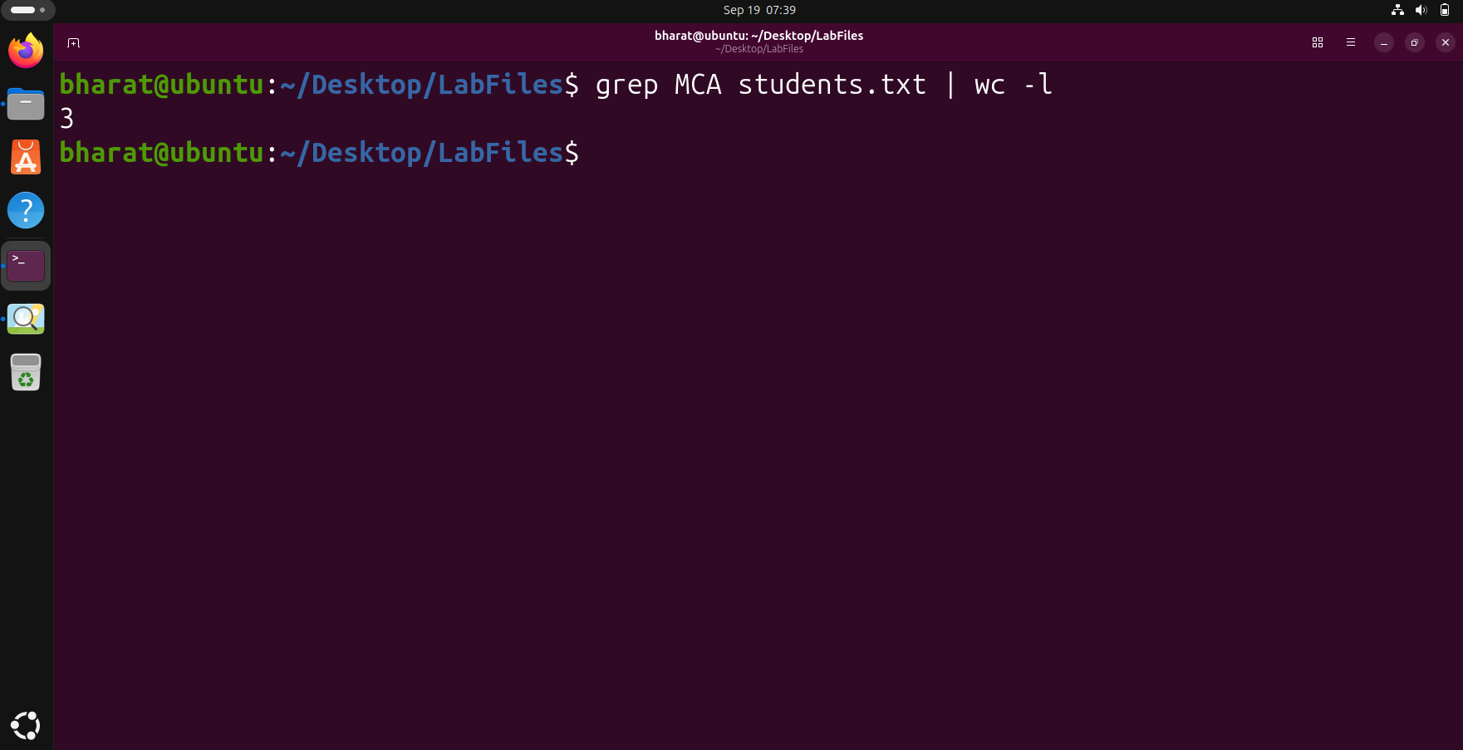

Step 10 — Save filtered output using tee
The tee command displayed the filtered MCA records on the terminal while simultaneously saving the same output into a report file.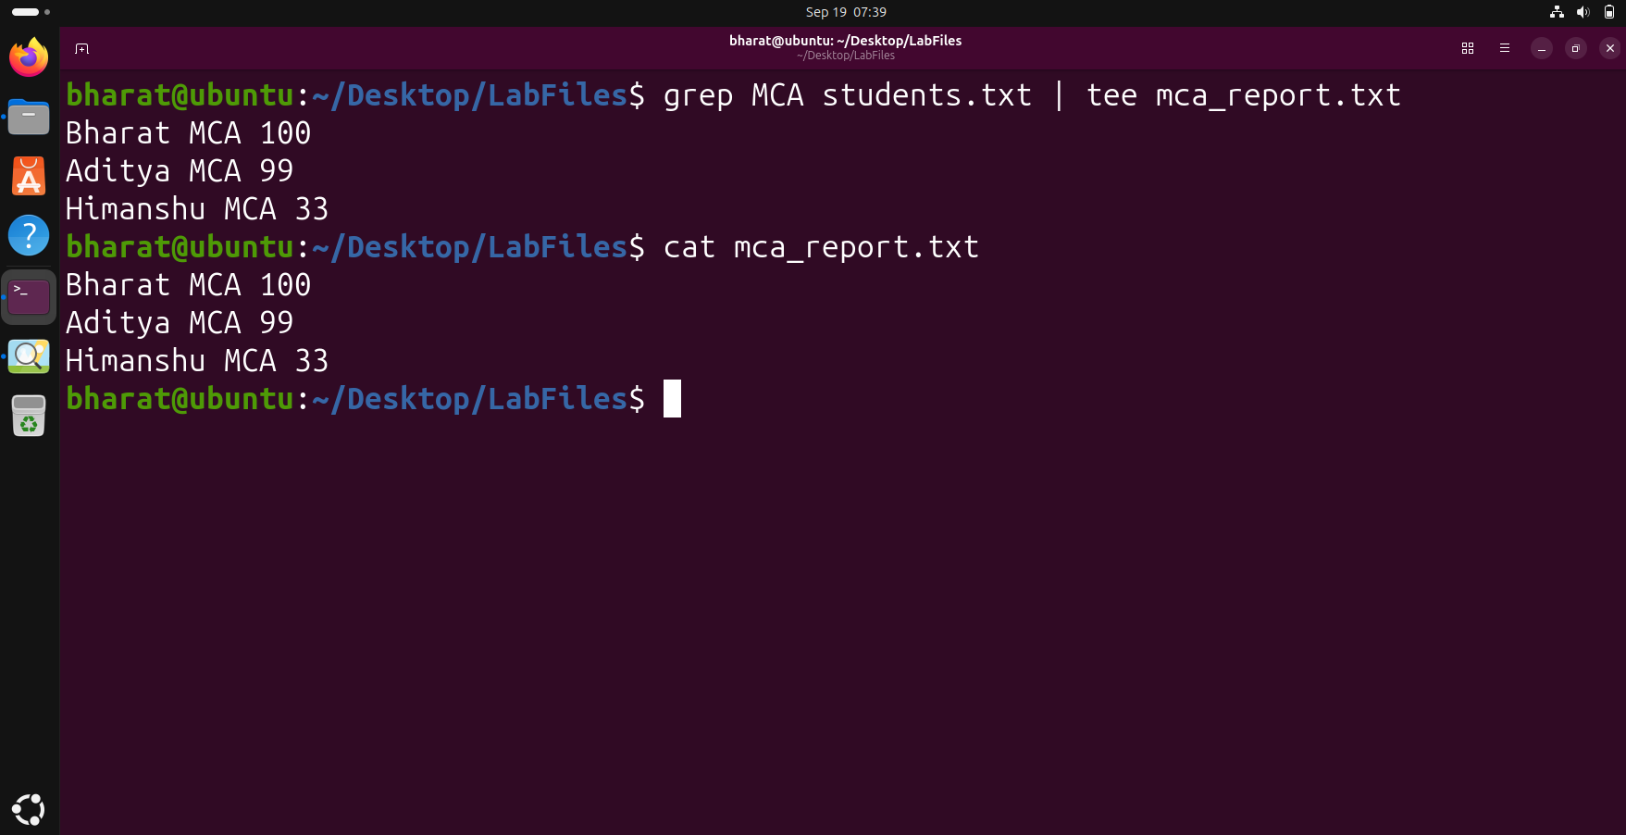

Step 11 — Generate the final filtered report
The final pipeline combined cat, grep, sort, uniq, the pipe operator and tee to generate a filtered MCA report. The saved report was then displayed to verify the result.