LINUX LABORATORY
Question 3

Step 1 — Move to the Home Directory
Move to the home directory and display the current working directory.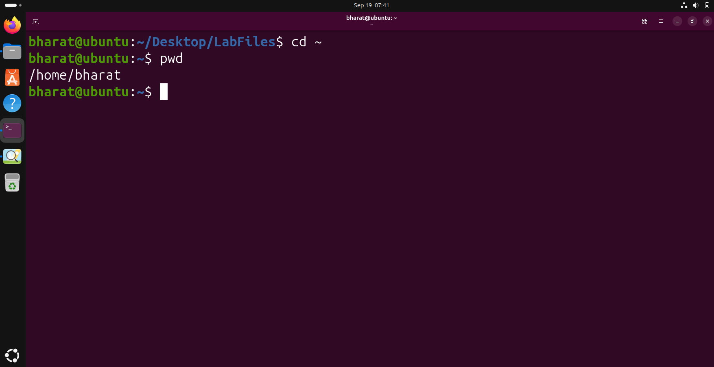

Step 2 — Create the College Directory
Create the College directory and verify it using ls.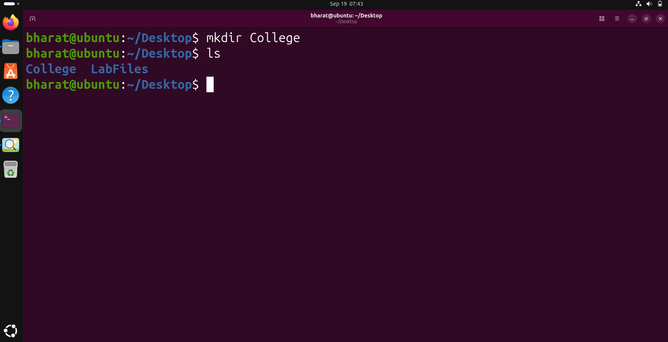

Step 3 — Enter the College Directory
Enter the College directory and display its absolute path.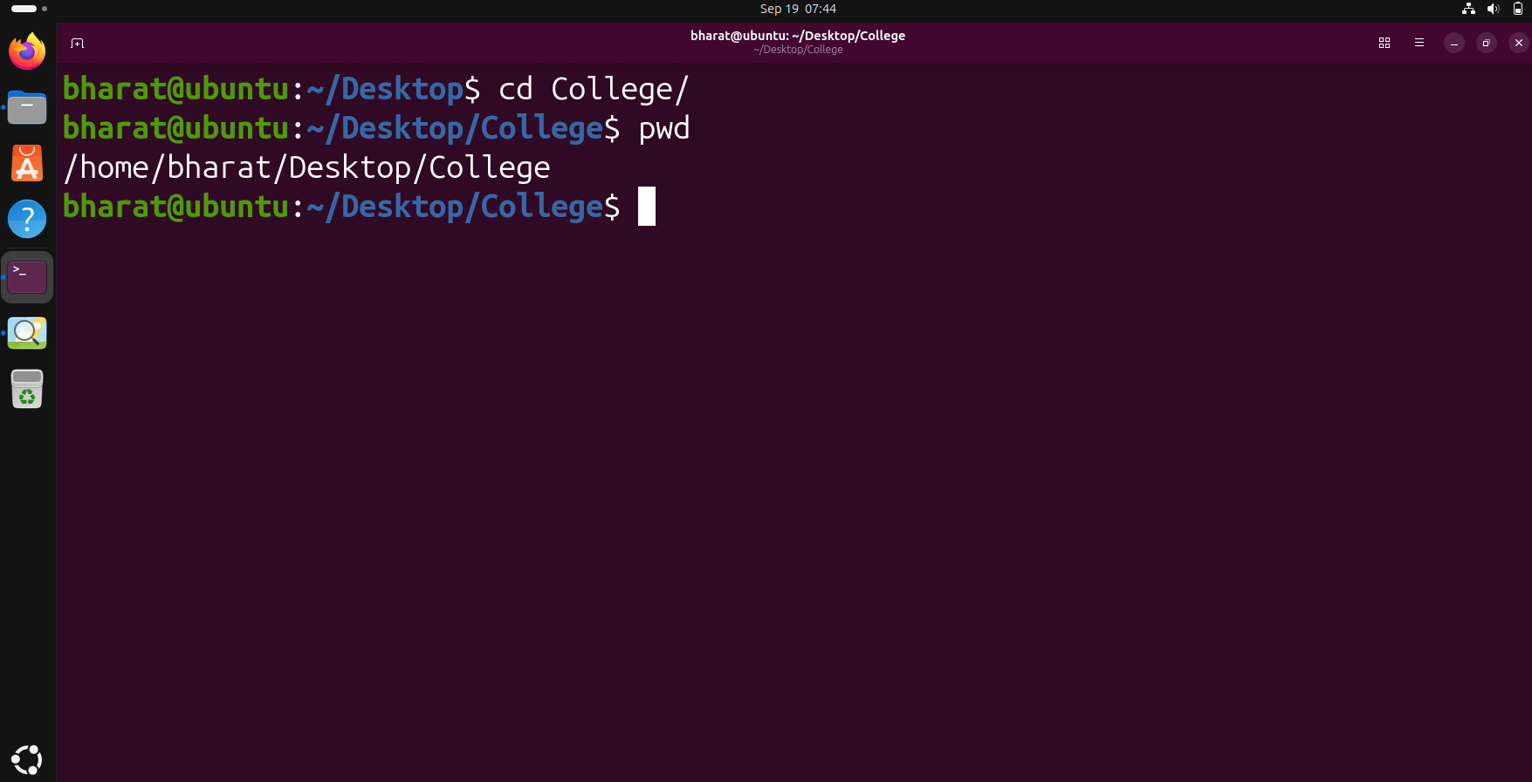

Step 4 — Create Department Directories
Create the CSE, ECE, ME and Civil department directories and list them.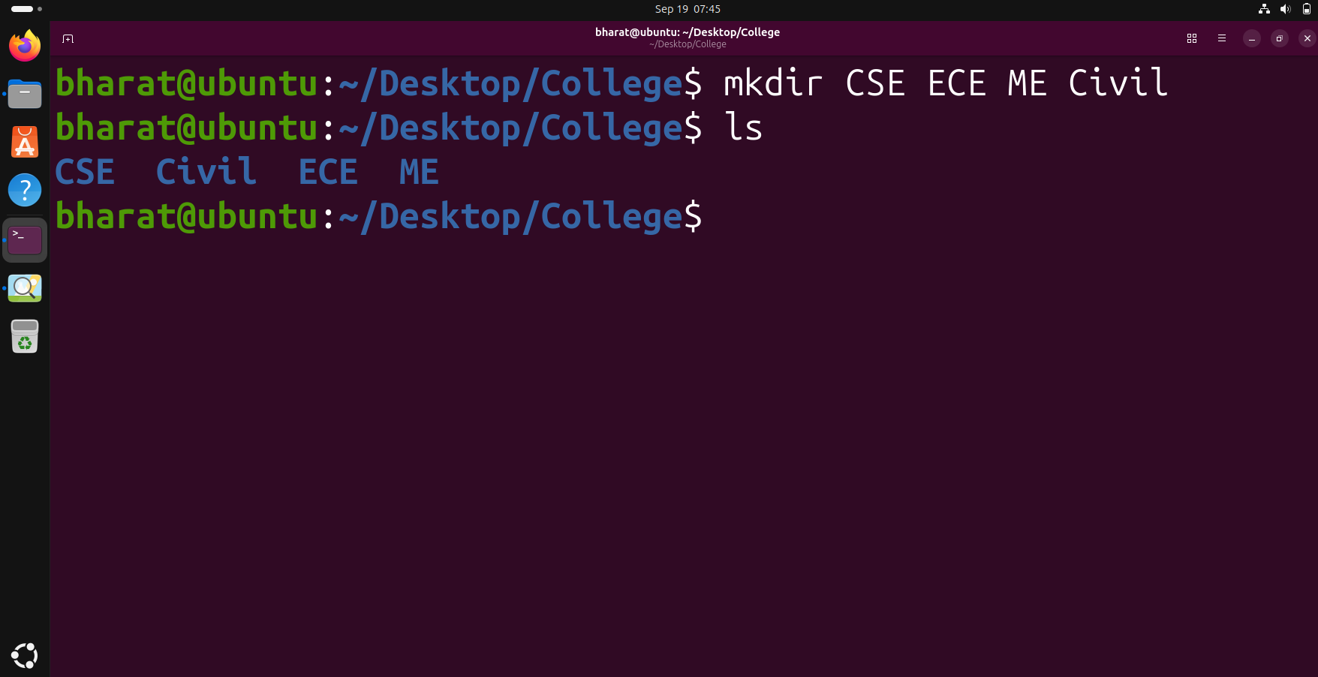

Step 5 — Create Semester Directories
Create Semester 1 and Semester 2 directories inside each department, then verify the CSE directory.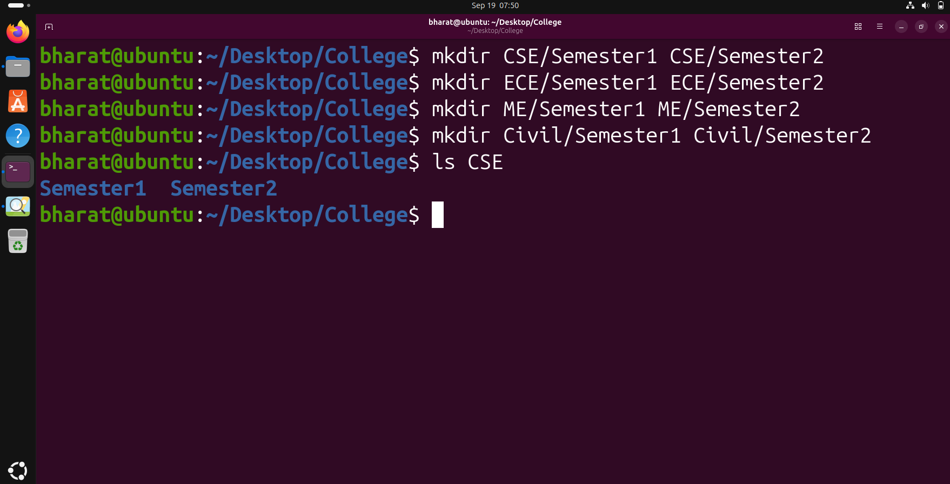

Step 6 — Display the Directory Tree
Display the complete College directory hierarchy using tree.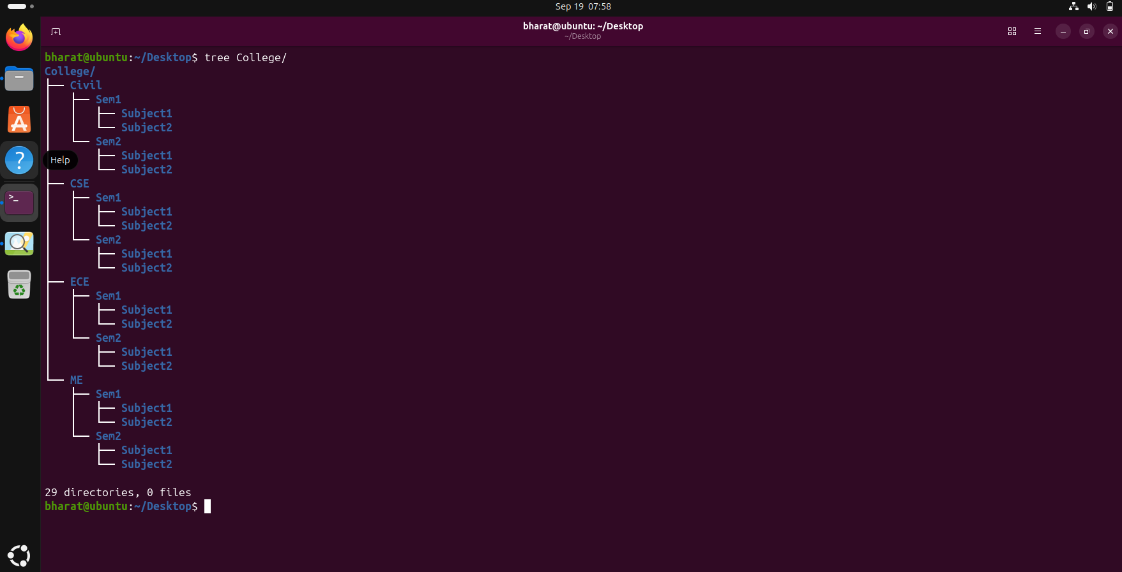

Step 7 — Navigate to CSE Semester 1
Navigate to CSE/Sem1, display the current path and list its contents.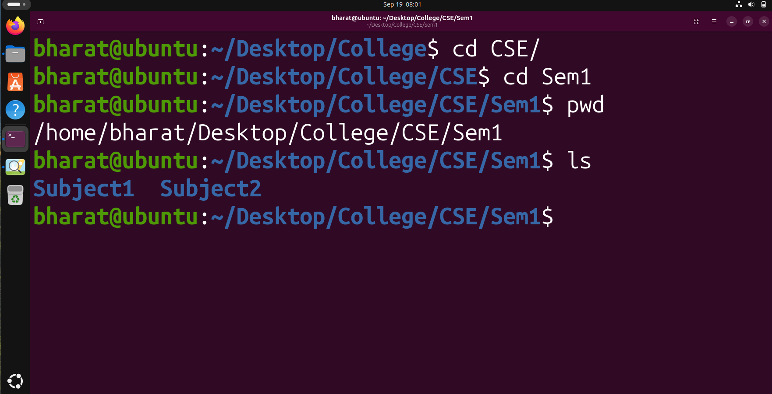

Step 8 — Create and Remove a Temporary Directory
Create a temporary directory, verify it, remove it using rmdir, and verify the result.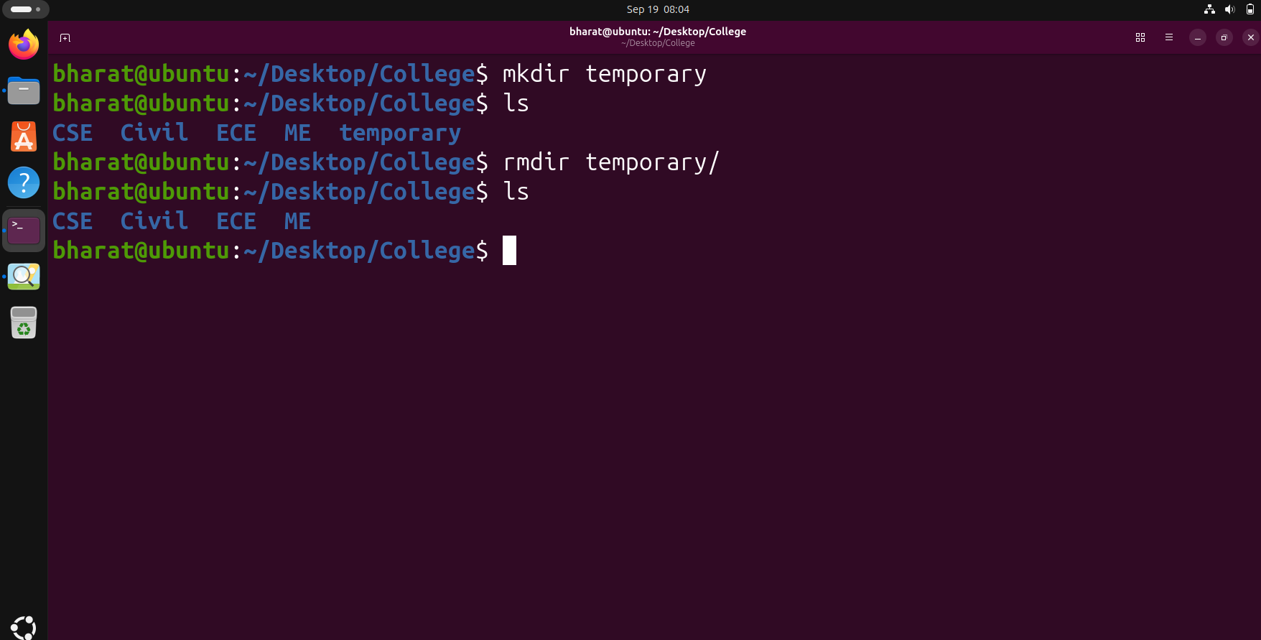

Step 9 — Display the First 20 Recursive Entries
Recursively list the College directory and display the first 20 lines using head.