LINUX LABORATORY
Question 4

Step 1 — Create permission.txt and verify the file
We created permission.txt using touch and used ls to verify that the file was created successfully.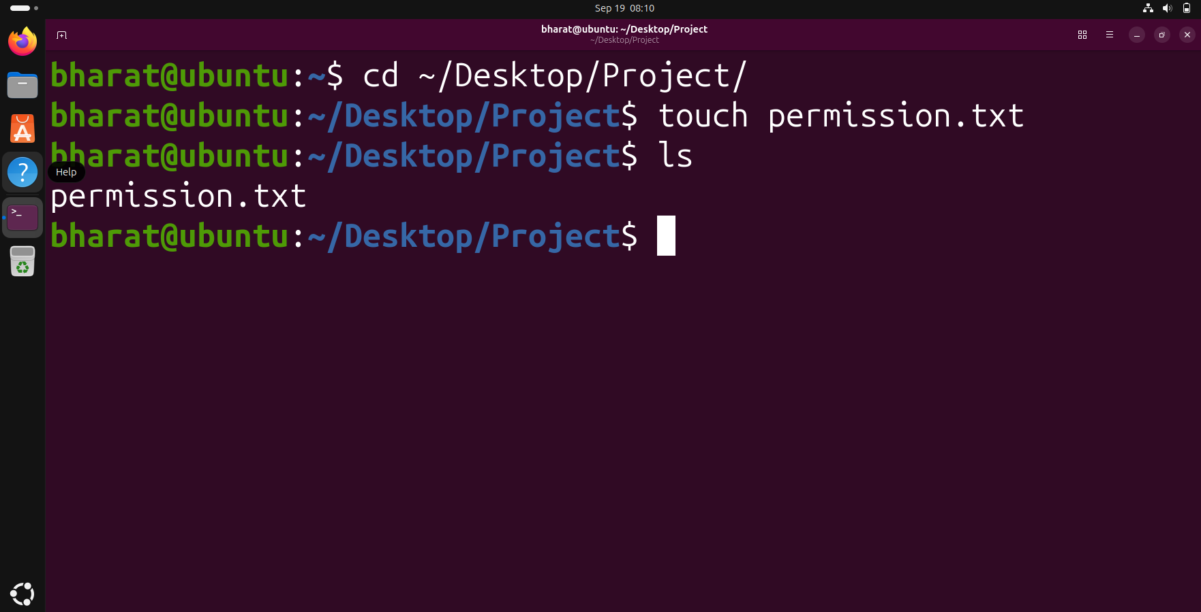

Step 2 — View the initial file permissions
We used ls -l to display the initial permissions, owner, group, size and other file details for permission.txt.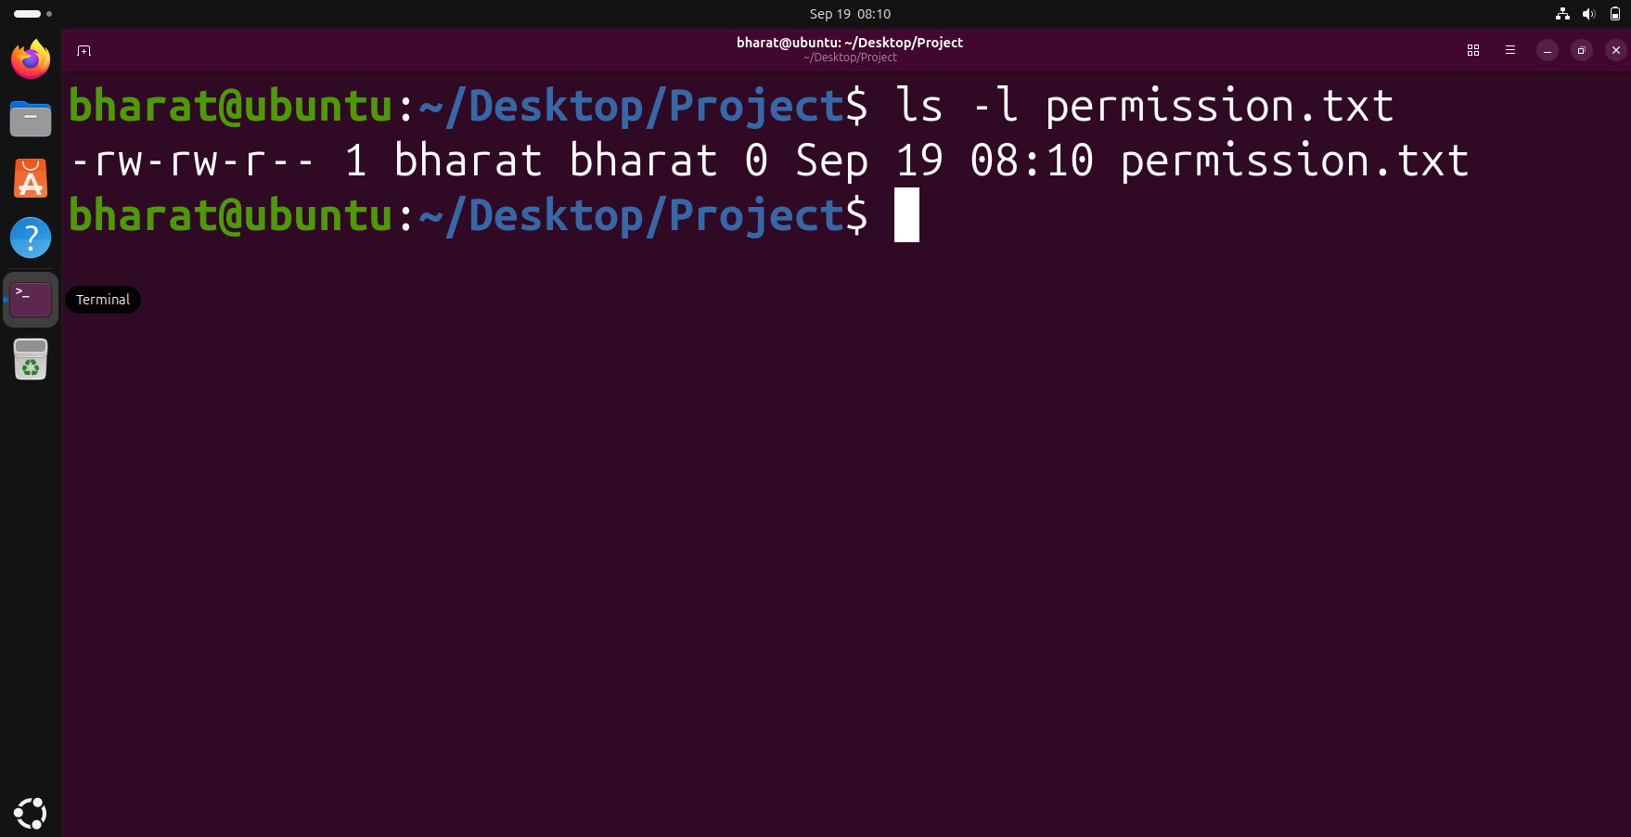

Step 3 — Change permission to 755
We changed the permissions of permission.txt to 755 using chmod and then verified the new permissions with ls -l.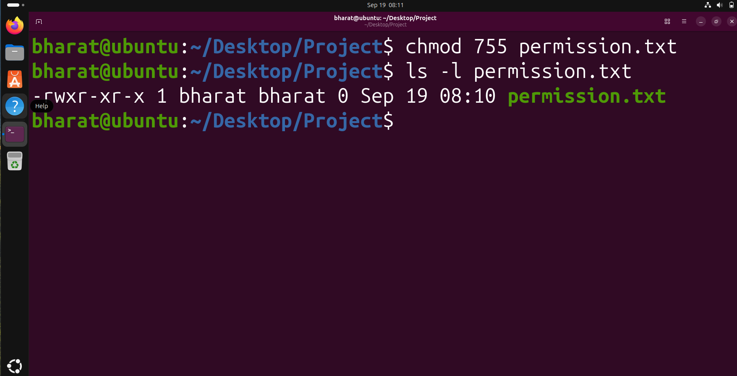

Step 4 — Change permission to 644
We changed the permissions back to 644 using chmod and verified the result with ls -l.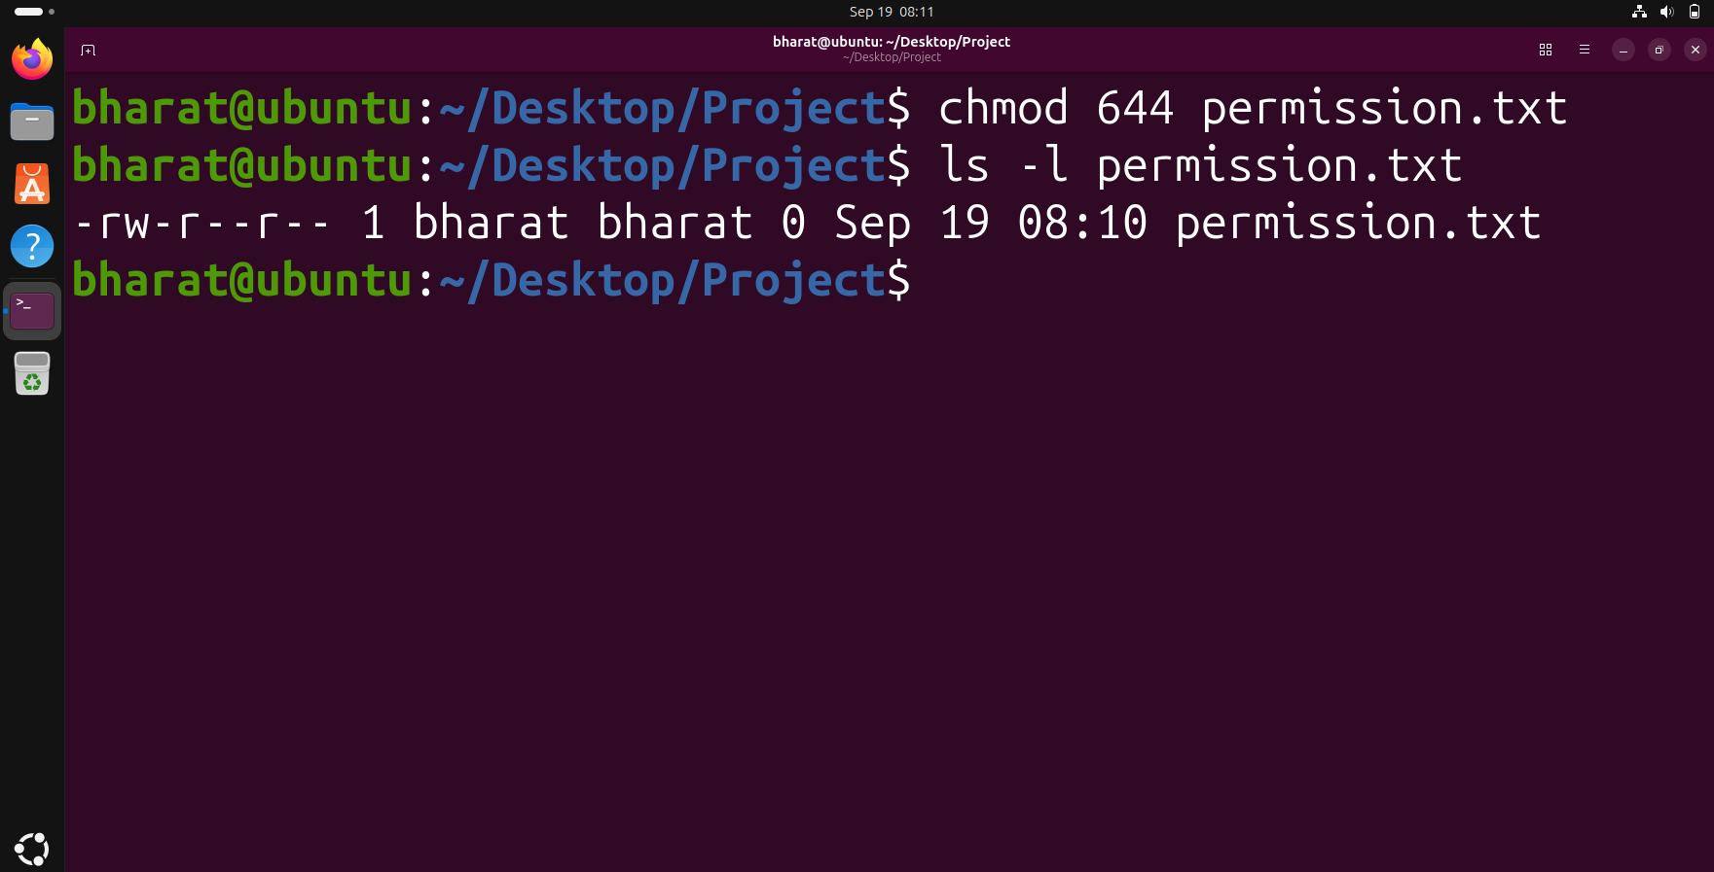

Step 5 — View detailed file information
We used stat to view detailed information about permission.txt, including its permissions, owner, group, size and timestamps.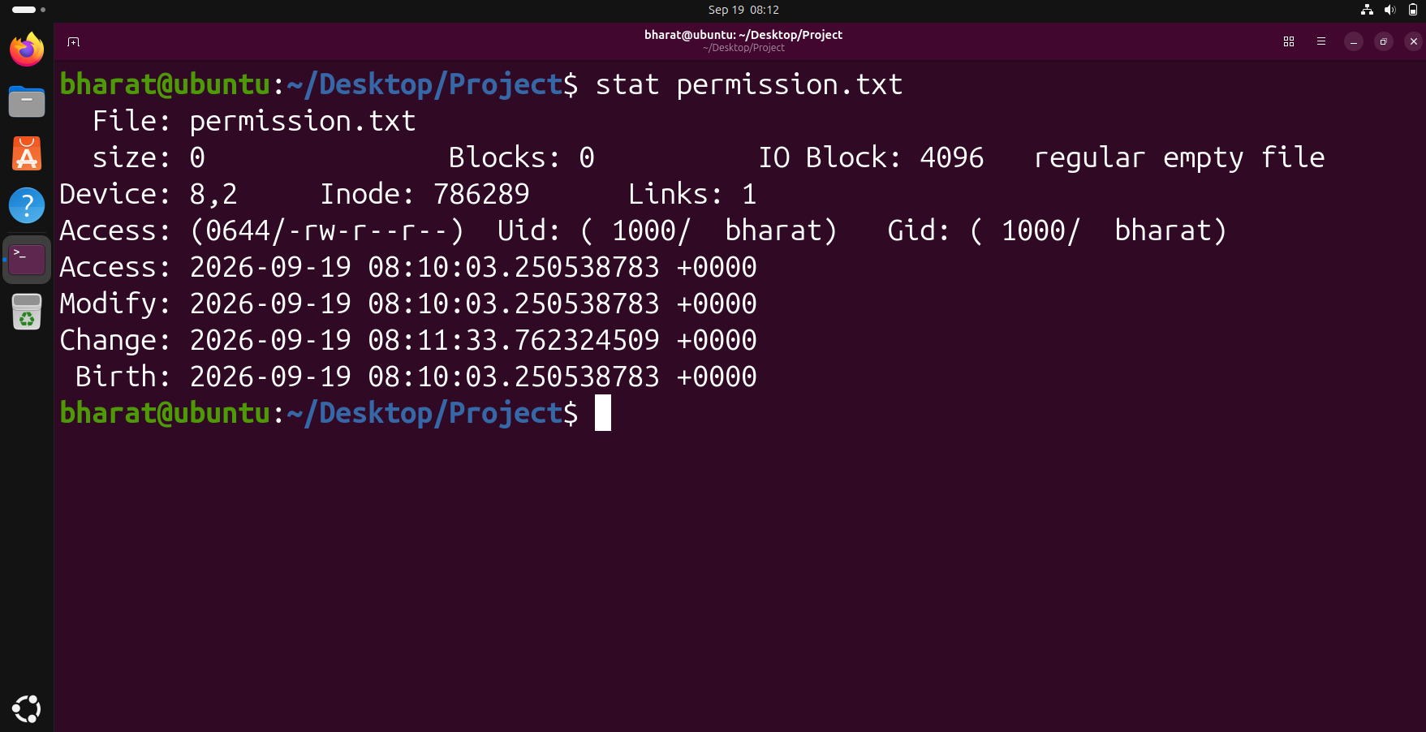

Step 6 — Change file ownership
We used chown to set the owner and group of permission.txt to bharat and then used ls -l to verify the ownership.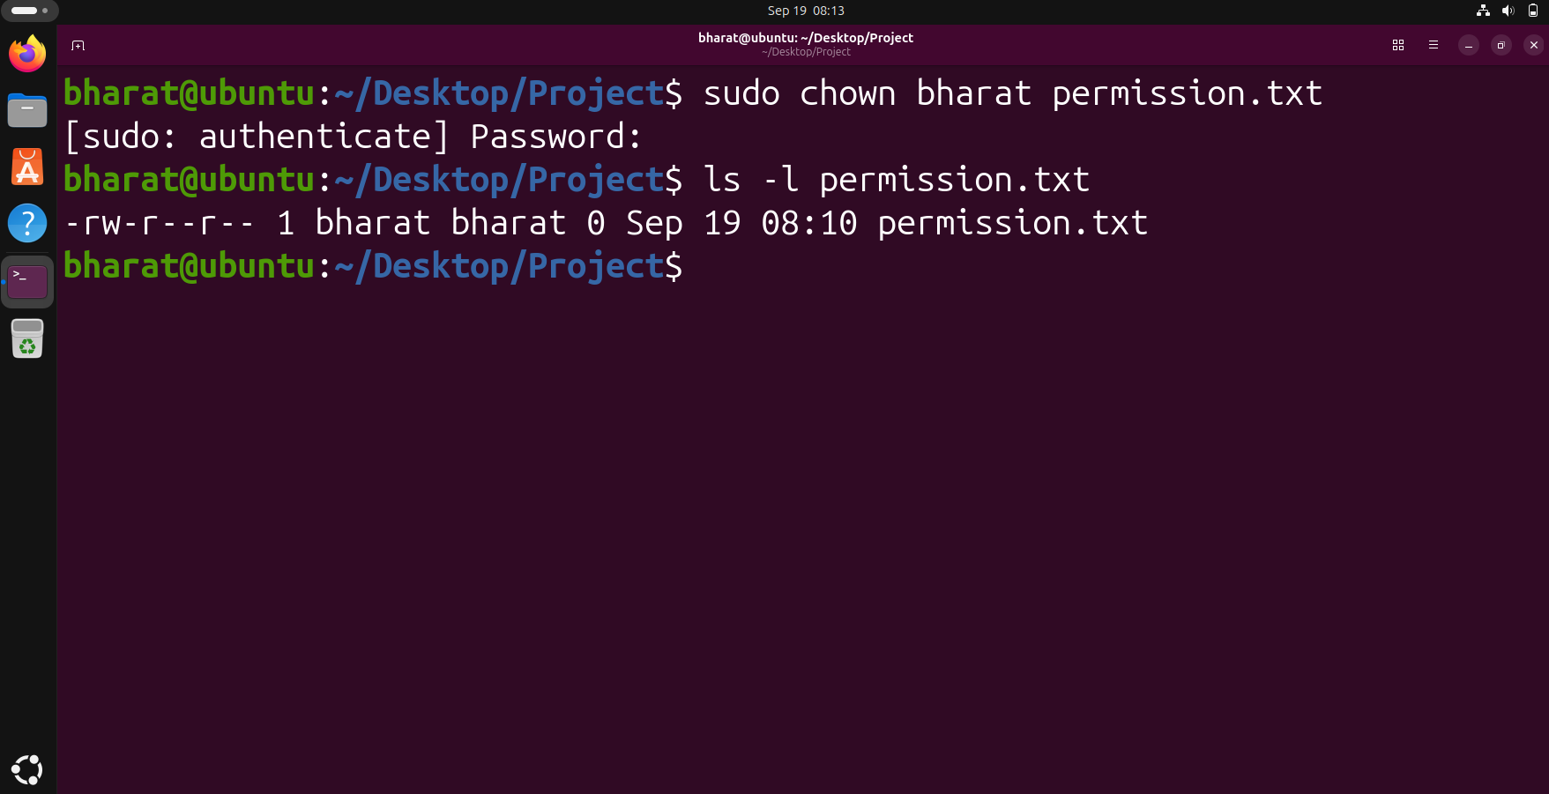

Step 7 —Verify the file information again
We ran stat again to verify the detailed metadata of permission.txt after the ownership operation.