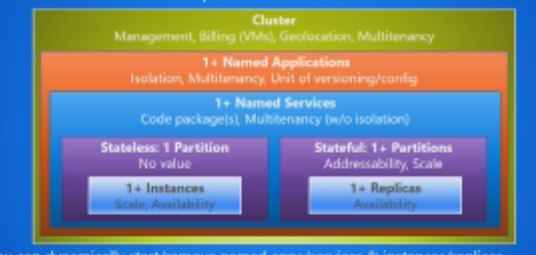

Now in Stateless, we have only instances. But in case of Statefull , we have replicas. But the fact is these are replicases of each partition. If we have 5 partitions, and each partition of 3 replicases, then we actually have 15 instances running.

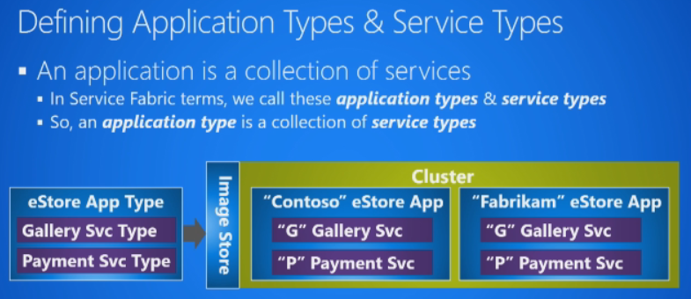

Left side is physical files(App type) and the right side ones are actual instances(Named Applications) of them.

Map the two.

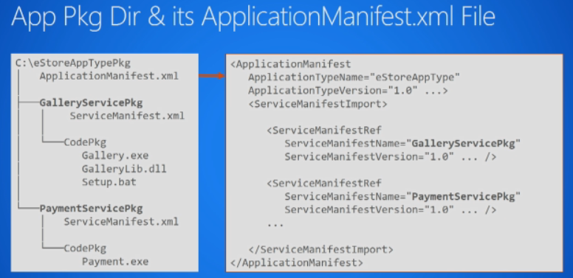

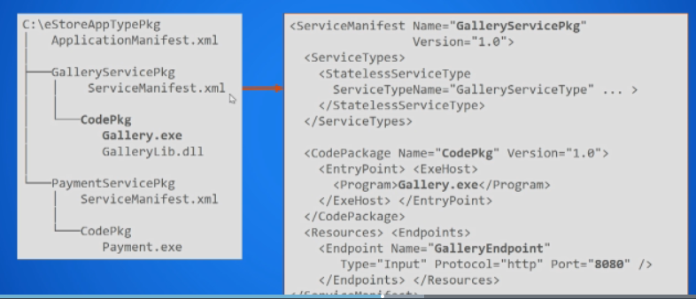

Service Type is name of service Type. Next is folder name CodePkg.

For Containers, the ExeHost will change to containerName location.

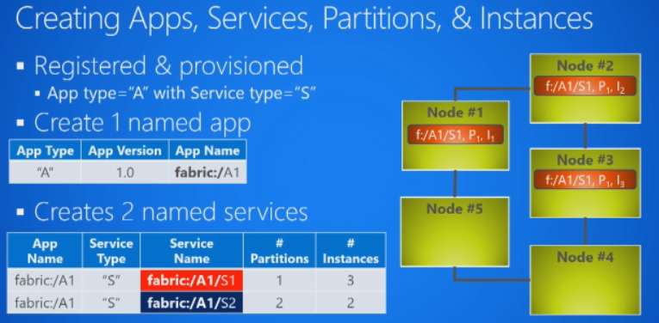

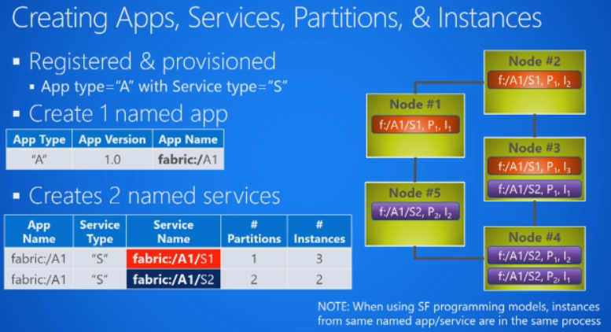

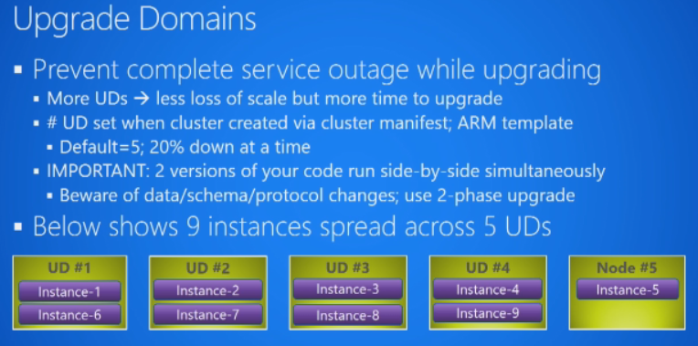

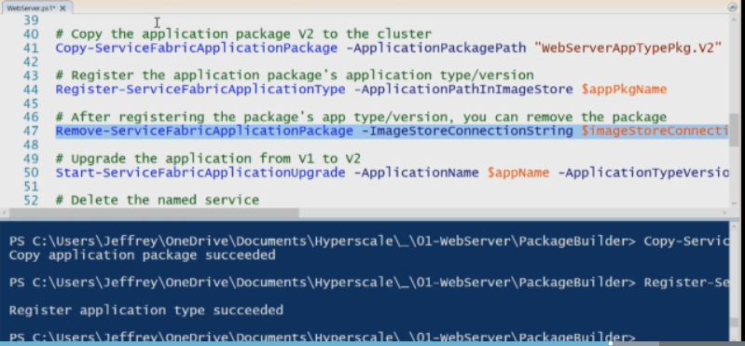

The second basically is a validation step.

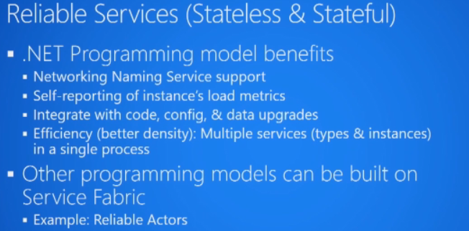

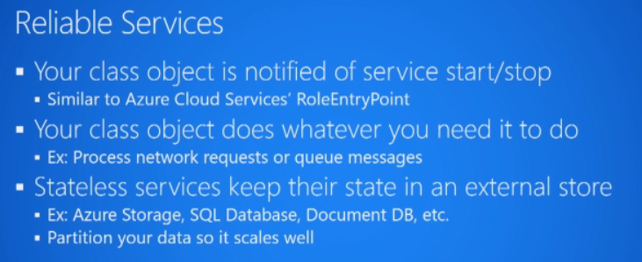

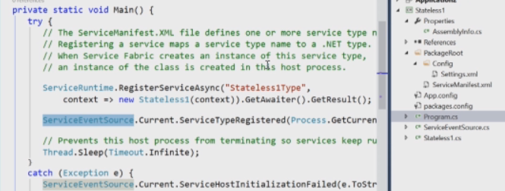

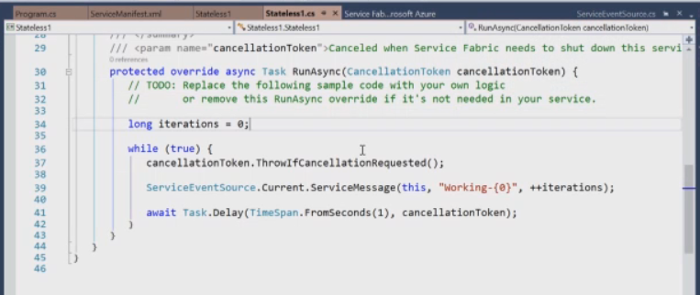

Cancellation token is passed when the instance is being brought down. This is for gracefull exit. The state file also has a listener class defining the code where it is listening for requests.

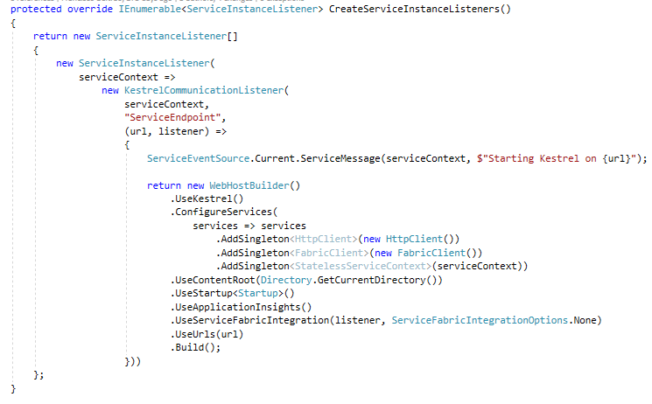

The listener in ASP.Net Core will be nothing but Kestral Server itself.

