Test report

- Build tested: 11.0.100-preview.7.26381.103
- Configurations tested:
Blazor Web App
- Static SSR
- Interactive Server
- Interactive WebAssembly
- Also exercised:
  - Published output
  - An existing .NET 10 app upgraded to .NET 11
  - More than one server instance, or a proxy in front
- OS, browser, IDE: Windows 11 Enterprise, Edge, VS 2026 Insiders [12023.133] Professional
- Sample app: BharatRamsf3693/BlazorWebApp-BasePath-Validation: BlazorWebApp-BasePath-Validation
- Outcome: 4 critical issues and 1 observation

Checks
S.NO | Check | Result | Evidence
1. | No request in the browser network log returns 404, including scripts, stylesheets and images. | Scenario Render Mode IIS Deployment Deployed Behind Reverse Proxy  New .NET 11 App (Created & Published) Static SSR Pass Pass  Interactive Server Pass Pass  Interactive WebAssembly Pass Pass  Upgraded App (from .NET 10 to .NET 11) and then published Static SSR Pass Pass  Interactive Server Pass Pass  Interactive WebAssembly Pass Pass | See the Evidence table after this table.
2. | The rendered <base href> matches the prefix the app is served under, including its casing, rather than the casing the app was mounted with.  Viewing the page source and looking at the base element and the script and stylesheet addresses. | Scenario Render Mode IIS Deployment Deployed Behind Reverse Proxy  New .NET 11 App (Created & Published) Static SSR Pass Fail Failure reason: The casing changes are not reflected in the base element. 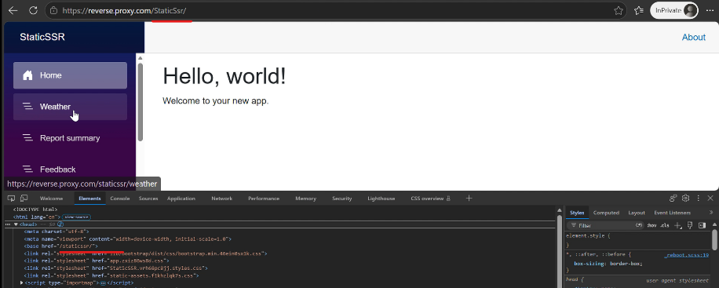  Interactive Server Pass Fail Failure reason: A crash is experienced by the app, and the casing changes are not reflected in the base element. 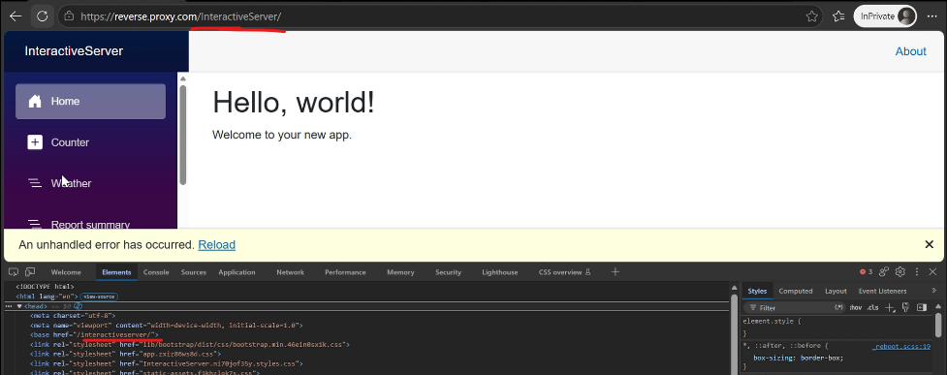  Interactive WebAssembly Pass Fail Failure reason: A crash is experienced by the app, and the casing changes are not reflected in the base element. 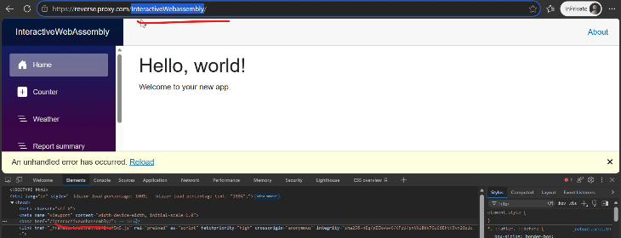  Upgraded App (from .NET 10 to .NET 11) and then published Static SSR Pass Fail Failure reason: The app crashes and the casing changes not reflected in the base element: 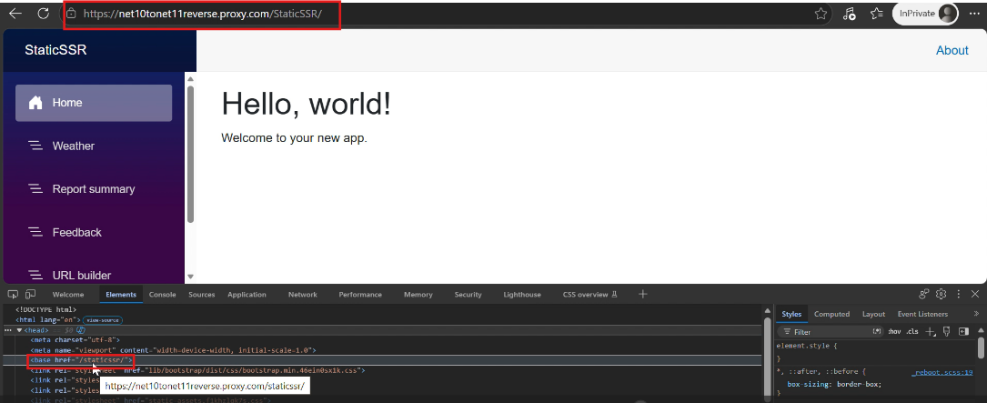  Interactive Server Pass Fail Failure reason: A crash is experienced by the app, and the casing changes are not reflected in the base element. 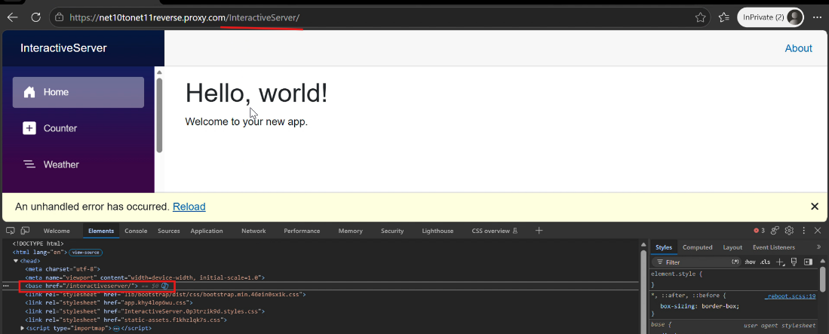  Interactive WebAssembly Pass Fail Failure reason: A crash is experienced by the app, and the casing changes are not reflected in the base element. 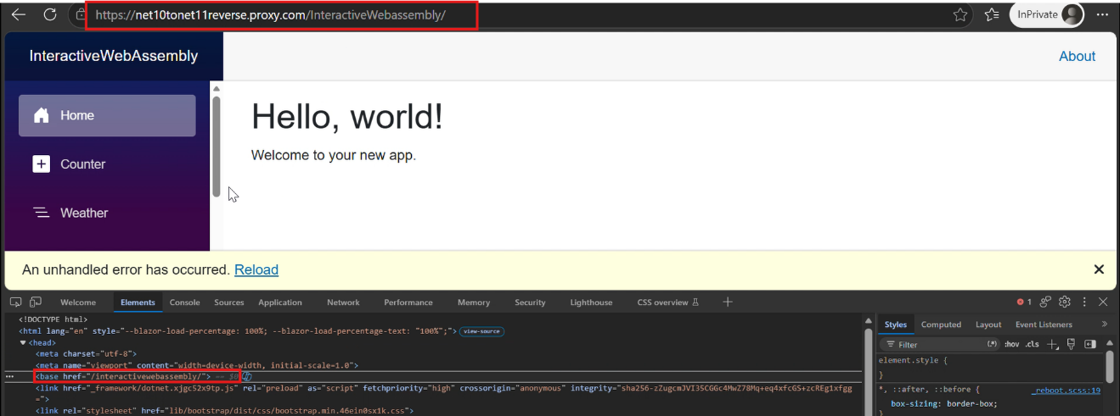 | See the Evidence table after this table.
3. | The app works through either spelling of the prefix. Neither one produces a blank page, a routing failure, or an error in the browser console or the server log. | Scenario Render Mode IIS Deployment Deployed Behind Reverse Proxy  New .NET 11 App (Created & Published) Static SSR Pass Fail Failure reason:. Case Sensitivity in Proxies: Casing changes in the reverse proxy do not affect the <BasePath /> component of the application. - Proxy subpath: /StaticSsr/ - App subpath: /staticssr/ - Result: The <BasePath /> component renders <base href="/staticssr/"> instead of <base href="/StaticSsr/">.  Interactive Server Pass Fail Failure reason: A crash is experienced by the app with the error below when the casing is changed: 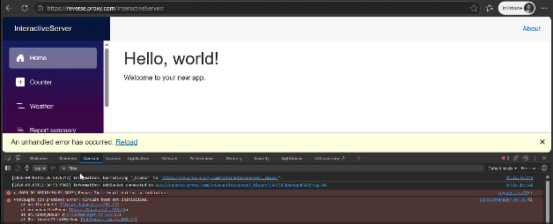  Interactive WebAssembly Pass Fail Failure reason: A crash is experienced by the app with the error below when the casing is changed: 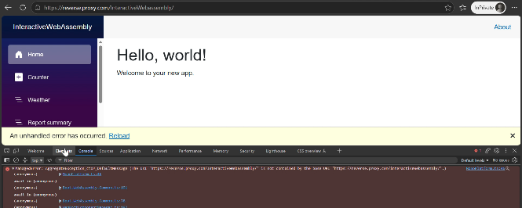  Upgraded App (from .NET 10 to .NET 11) and then published Static SSR Pass Fail Failure reason:. Case Sensitivity in Proxies: Casing changes in the reverse proxy do not affect the <BasePath /> component of the application. - Proxy subpath: /StaticSsr/ - App subpath: /staticssr/ - Result: The <BasePath /> component renders <base href="/staticssr/"> instead of <base href="/StaticSsr/">.  Interactive Server Pass Fail Failure reason: A crash is experienced by the app with the error below when the casing is changed: 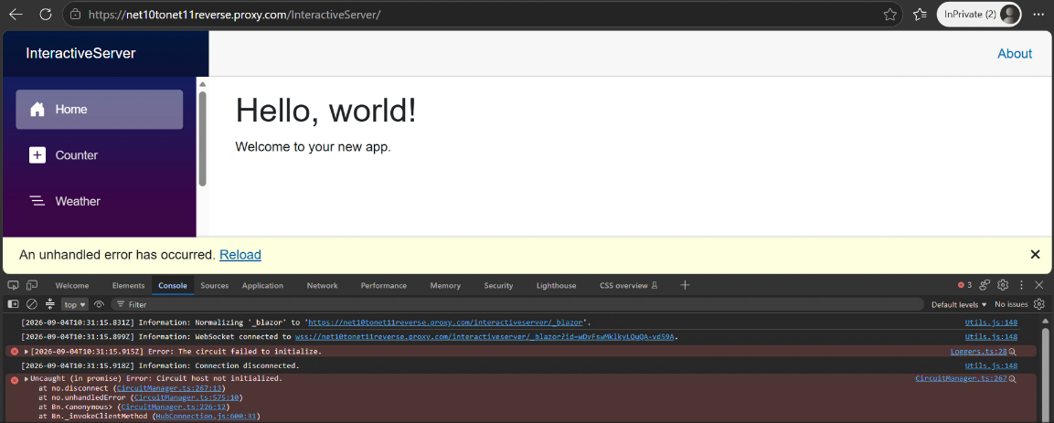  Interactive WebAssembly Pass Fail Failure reason: A crash is experienced by the app with the error below when the casing is changed: 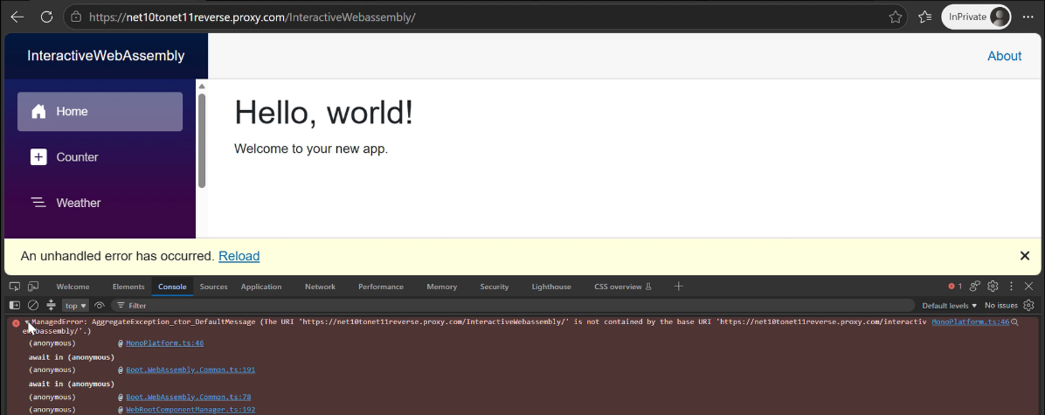 | See the Evidence table after this table.  Additionally, the server log of the IIS Deployment can be found here: BlazorWebApp-BasePath-Validation/Evidence/net11-new-app/ServerLog.log at main · BharatRamsf3693/BlazorWebApp-BasePath-Validation  And for the deployment behind a reverse proxy, the server log can be found here: BlazorWebApp-BasePath-Validation/Evidence/net11-new-app/ReverseProxy/ServerLog.log at main · BharatRamsf3693/BlazorWebApp-BasePath-Validation  Logs of Static SSR, Interactive Server, and Interactive WebAssembly samples are contained within each server log file.
4. | Opening a nested route directly under the prefix returns that page, and reloading it returns the same page again. | Scenario Render Mode IIS Deployment Deployed Behind Reverse Proxy  New .NET 11 App (Created & Published) Static SSR Pass Pass  Interactive Server Pass Pass  Interactive WebAssembly Pass Pass  Upgraded App (from .NET 10 to .NET 11) and then published Static SSR Pass Pass  Interactive Server Pass Pass  Interactive WebAssembly Pass Pass | See the Evidence table after this table.
5. | Navigation links resolve to addresses that include the prefix. | Scenario Render Mode IIS Deployment Deployed Behind Reverse Proxy  New .NET 11 App (Created & Published) Static SSR Pass Pass  Interactive Server Pass Pass  Interactive WebAssembly Pass Pass  Upgraded App (from .NET 10 to .NET 11) and then published Static SSR Pass Pass  Interactive Server Pass Pass  Interactive WebAssembly Pass Pass | See the Evidence table after this table.
6. | Navigating between pages using the links, then using browser back and forward. | Scenario Render Mode IIS Deployment Deployed Behind Reverse Proxy  New .NET 11 App (Created & Published) Static SSR Pass Pass  Interactive Server Pass Pass  Interactive WebAssembly Pass Pass  Upgraded App (from .NET 10 to .NET 11) and then published Static SSR Pass Pass  Interactive Server Pass Pass  Interactive WebAssembly Pass Pass | See the Evidence table after this table.
7. | A form post reaches the correct address under the prefix and is handled. | Scenario Render Mode IIS Deployment Deployed Behind Reverse Proxy  New .NET 11 App (Created & Published) Static SSR Pass Pass  Interactive Server Pass Pass  Interactive WebAssembly Pass Pass  Upgraded App (from .NET 10 to .NET 11) and then published Static SSR Pass Pass  Interactive Server Pass Pass  Interactive WebAssembly Pass Pass | See the Evidence table after this table.
8. | An image and a stylesheet loaded from the app's own static files. | Scenario Render Mode IIS Deployment Deployed Behind Reverse Proxy  New .NET 11 App (Created & Published) Static SSR Pass Pass  Interactive Server Pass Pass  Interactive WebAssembly Pass Pass  Upgraded App (from .NET 10 to .NET 11) and then published Static SSR Pass Pass  Interactive Server Pass Pass  Interactive WebAssembly Pass Pass | See the Evidence table after this table.
9. | A page that shows a URL it built itself from a relative path. | Scenario Render Mode IIS Deployment Deployed Behind Reverse Proxy  New .NET 11 App (Created & Published) Static SSR Pass Fail Failure reason: The app's URL is utilized as the absolute URI, rather than the proxy's URL. 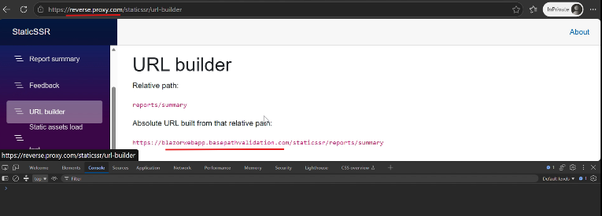  Interactive Server Pass Pass  Interactive WebAssembly Pass Pass  Upgraded App (from .NET 10 to .NET 11) and then published Static SSR Pass Fail Failure reason: The app's URL is utilized as the absolute URI, rather than the proxy's URL. 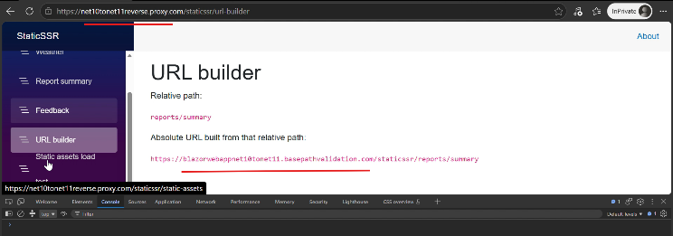  Interactive Server Pass Pass  Interactive WebAssembly Pass Pass | See the Evidence table after this table.
10. | Changing the prefix and restarting requires no source change and no rebuild. | Scenario Render Mode IIS Deployment  New .NET 11 App (Created & Published) Static SSR Pass  Interactive Server Pass  Interactive WebAssembly Pass  Upgraded App (from .NET 10 to .NET 11) and then published Static SSR Pass  Interactive Server Pass  Interactive WebAssembly Pass | For New .NET 11 App (Created & Published), evidence can be found here: Evidence/net11-new-app/WithChangedSubpath  For Upgraded App (from .NET 10 to .NET 11) and then published, evidence can be found here: Evidence/net10-to-net11-upgrade/WithChangedSubpath  Note: Extracting the files under the above locations provide the verification logs for the corresponding render mode. It includes a video recording tracking the first 10 testing scenarios alongside a complete network log (.har file)
11. | An app upgraded from .NET 10, which still has a literal <base href="/" />, before and after swapping in <BasePath />. The component lives in Microsoft.AspNetCore.Components.Endpoints, which the .NET 10 template does not import, so note whether the build failure you get points you at the missing @using. | Scenario Render Mode IIS Deployment  Upgraded App (from .NET 10 to .NET 11) and then published Static SSR Fail Failure Reason: No build errors are encountered when @using Microsoft.AspNetCore.Components.Endpoints is not added; the app is launched successfully with elements missing from the Head element.  Interactive Server Fail Failure Reason: No build errors are encountered when @using Microsoft.AspNetCore.Components.Endpoints is not added; the app is launched successfully with elements missing from the Head element.  Interactive WebAssembly Fail Failure Reason: No build errors are encountered when @using Microsoft.AspNetCore.Components.Endpoints is not added; the app is launched successfully with elements missing from the Head element. | The evidence can be found here: Evidence/net10-to-net11-upgrade/Issue_BasePath_MissingNamespace.zip
12. | - New BasePath component, .NET 11 release notes  - ASP.NET Core Blazor app base path  The base path page presents <BasePath /> as the first option for a Blazor Web App, but it does not mention that the component preserves the casing of the requested path, which is the behavior this scenario is mainly about, and it does not mention the namespace the component lives in. Say so in the report if either gap cost you time. | Fail | It appears that documenting the namespace where the component lives, as well as mentioning that it preserves the casing of the sub-path, is necessary. I became aware of these missing details while going through the validation task's requirements. While adding this information to the documentation would be highly useful, these gaps did not cost me any extra time.

Evidence Table:
Evidence Package Notes:
- IIS Deployment (.zip): Extracting this file provides the verification logs for the corresponding render mode. It includes a video recording tracking the first 10 testing scenarios alongside a complete network log (.har file).
- Deployed Behind Proxy (.zip): Extracting this file provides the proxy validation evidence. It includes a video recording tracking the first 9 testing scenarios, the reverse proxy routing rules (web.config), and a complete network log (.har file).

Scenario | Render Mode | IIS Deployment (With Subpath) | Deployed Behind Reverse Proxy
New .NET 11 App (Created & Published) | Static SSR | Evidence/net11-new-app/WithSubpath/StaticSSR.zip | Evidence/net11-new-app/ReverseProxy/StaticSSR.zip
 | Interactive Server | Evidence/net11-new-app/WithSubpath/InteractiveServer.zip | Evidence/net11-new-app/ReverseProxy/InteractiveServer.zip
 | Interactive WebAssembly | Evidence/net11-new-app/WithSubpath/InteractiveWebAssembly.zip | Evidence/net11-new-app/ReverseProxy/InteractiveWebAssembly.zip
Upgraded App (from .NET 10 to .NET 11) and then published | Static SSR | Evidence/net10-to-net11-upgrade/WithSubpath/StaticSSR.zip | Evidence/net10-to-net11-upgrade/ReverseProxy/StaticSSR.zip
 | Interactive Server | Evidence/net10-to-net11-upgrade/WithSubpath/InteractiveServer.zip | Evidence/net10-to-net11-upgrade/ReverseProxy/InteractiveServer.zip
 | Interactive WebAssembly | Evidence/net10-to-net11-upgrade/WithSubpath/InteractiveWebAssembly.zip | Evidence/net10-to-net11-upgrade/ReverseProxy/InteractiveWebAssembly.zip

