Test report

- Build tested: 11.0.100-preview.7.26381.103
- Configurations tested:
Blazor Web App
- Static SSR
- Interactive Server
- Interactive WebAssembly
- Also exercised:
  - Published output
  - An existing .NET 10 app upgraded to .NET 11
  - More than one server instance, or a proxy in front
- OS, browser, IDE: Windows 11 Enterprise, Edge, VS 2026 Insiders [12023.133] Professional
- Sample app: BharatRamsf3693/BlazorWebApp-BasePath-Validation: BlazorWebApp-BasePath-Validation
- Outcome: Failure

Checks
S.NO | Check | Result | Evidence
1. | No request in the browser network log returns 404, including scripts, stylesheets and images. |  | See the Evidence table after this table.
  Scenario | Render Mode | IIS Deployment | Deployed Behind Reverse Proxy
  New .NET 11 App (Created & Published) | Static SSR | Pass | Pass
   | Interactive Server | Pass | Pass
   | Interactive WebAssembly | Pass | Pass
  Upgraded App (from .NET 10 to .NET 11) and then published | Static SSR | Pass | Pass
   | Interactive Server | Pass | Pass
   | Interactive WebAssembly | Pass | Pass
2. | The rendered <base href> matches the prefix the app is served under, including its casing, rather than the casing the app was mounted with.  Viewing the page source and looking at the base element and the script and stylesheet addresses. |  | See the Evidence table after this table.
  Scenario | Render Mode | IIS Deployment | Deployed Behind Reverse Proxy
  New .NET 11 App (Created & Published) | Static SSR | Pass | Fail  Failure reason:  The casing changes are not reflected in the base element.  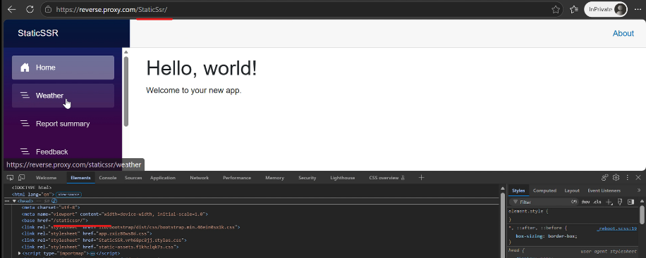
   | Interactive Server | Pass | Fail  Failure reason:  A crash is experienced by the app, and the casing changes are not reflected in the base element.  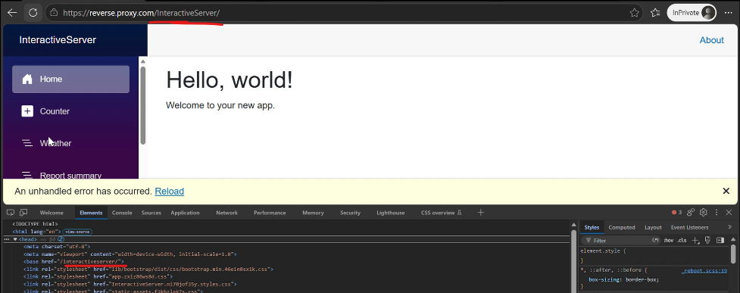
   | Interactive WebAssembly | Pass | Fail  Failure reason:  A crash is experienced by the app, and the casing changes are not reflected in the base element.  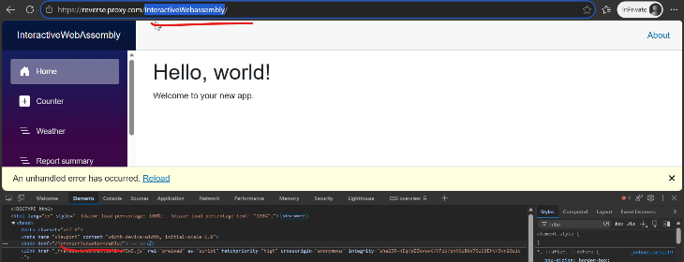
  Upgraded App (from .NET 10 to .NET 11) and then published | Static SSR | Pass | Fail  Failure reason:  The app crashes and the casing changes not reflected in the base element:  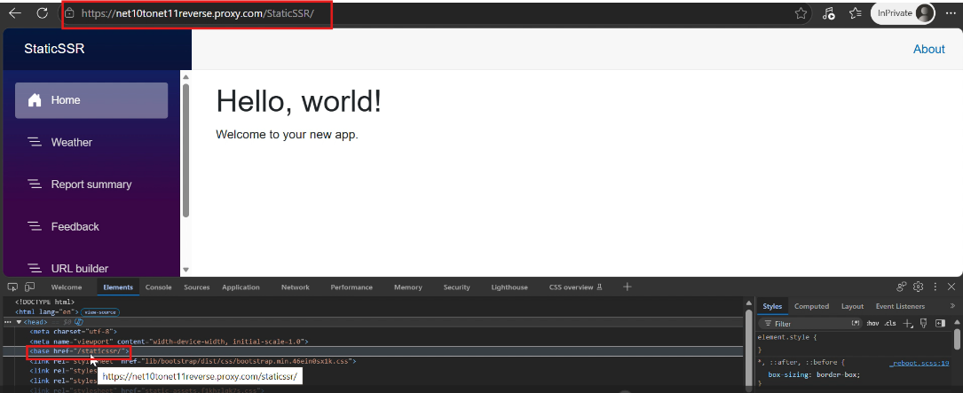
   | Interactive Server | Pass | Fail  Failure reason:  A crash is experienced by the app, and the casing changes are not reflected in the base element.  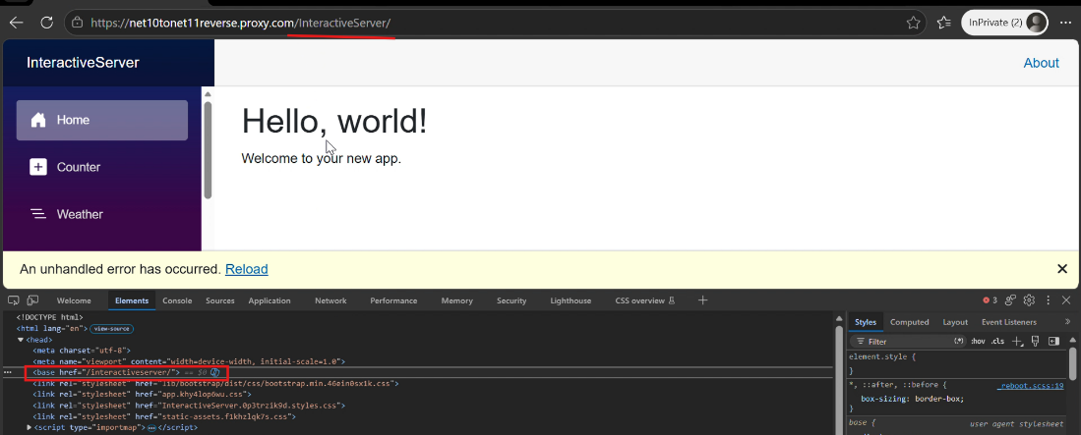
   | Interactive WebAssembly | Pass | Fail  Failure reason:  A crash is experienced by the app, and the casing changes are not reflected in the base element.  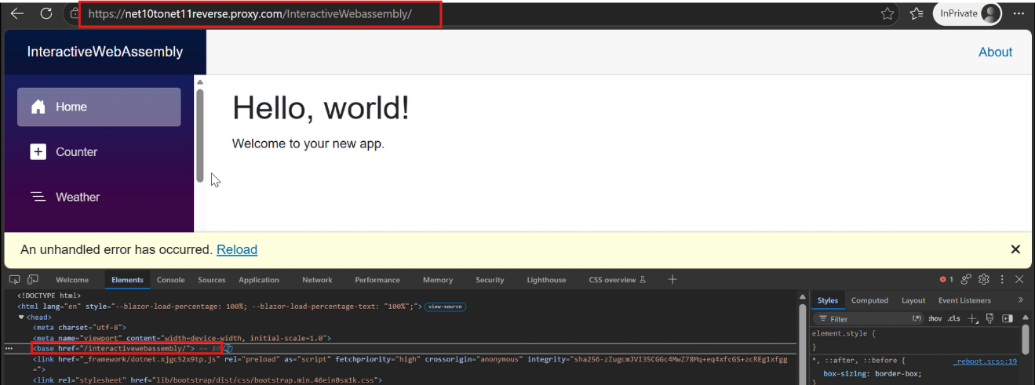
3. | The app works through either spelling of the prefix. Neither one produces a blank page, a routing failure, or an error in the browser console or the server log. |  | See the Evidence table after this table.  Additionally, the server log of the IIS Deployment can be found here: BlazorWebApp-BasePath-Validation/Evidence/net11-new-app/ServerLog.log at main · BharatRamsf3693/BlazorWebApp-BasePath-Validation  And for the deployment behind a reverse proxy, the server log can be found here: BlazorWebApp-BasePath-Validation/Evidence/net11-new-app/ReverseProxy/ServerLog.log at main · BharatRamsf3693/BlazorWebApp-BasePath-Validation  Logs of Static SSR, Interactive Server, and Interactive WebAssembly samples are contained within each server log file.
  Scenario | Render Mode | IIS Deployment | Deployed Behind Reverse Proxy
  New .NET 11 App (Created & Published) | Static SSR | Pass | Fail  Failure reason:.  Case Sensitivity in Proxies: Casing changes in the reverse proxy do not affect the <BasePath /> component of the application.  - Proxy subpath: /StaticSsr/  - App subpath: /staticssr/  - Result: The <BasePath /> component renders <base href="/staticssr/"> instead of <base href="/StaticSsr/">.
   | Interactive Server | Pass | Fail  Failure reason:  A crash is experienced by the app with the error below when the casing is changed:  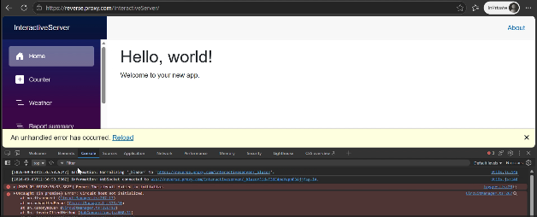
   | Interactive WebAssembly | Pass | Fail  Failure reason:  A crash is experienced by the app with the error below when the casing is changed:  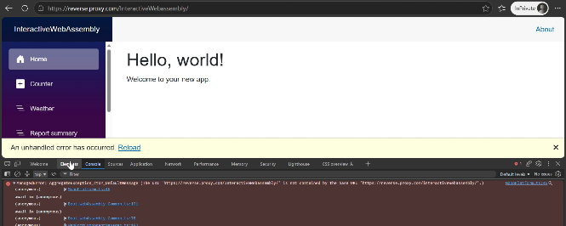
  Upgraded App (from .NET 10 to .NET 11) and then published | Static SSR | Pass | Fail  Failure reason:.  Case Sensitivity in Proxies: Casing changes in the reverse proxy do not affect the <BasePath /> component of the application.  - Proxy subpath: /StaticSsr/  - App subpath: /staticssr/  - Result: The <BasePath /> component renders <base href="/staticssr/"> instead of <base href="/StaticSsr/">.
   | Interactive Server | Pass | Fail  Failure reason:  A crash is experienced by the app with the error below when the casing is changed:  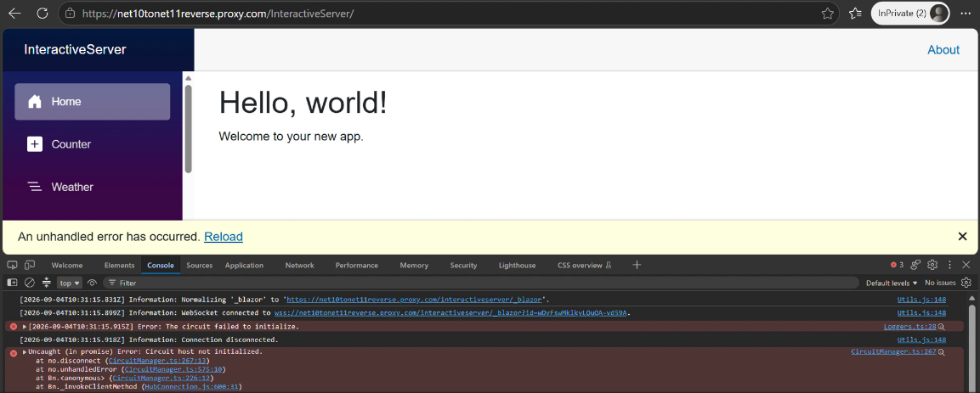
   | Interactive WebAssembly | Pass | Fail  Failure reason:  A crash is experienced by the app with the error below when the casing is changed:  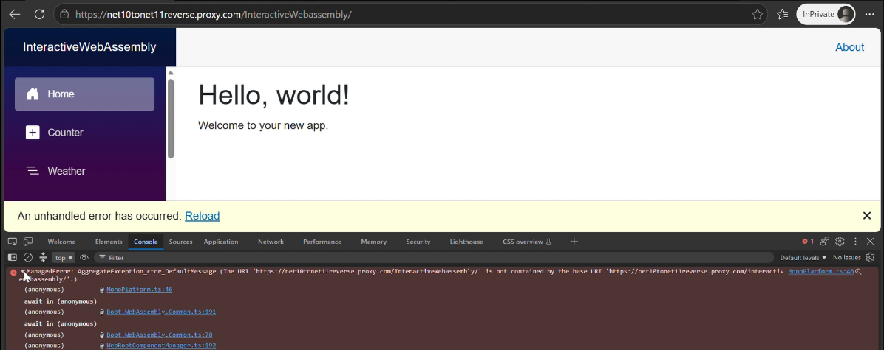
4. | Opening a nested route directly under the prefix returns that page, and reloading it returns the same page again. |  | See the Evidence table after this table.
  Scenario | Render Mode | IIS Deployment | Deployed Behind Reverse Proxy
  New .NET 11 App (Created & Published) | Static SSR | Pass | Pass
   | Interactive Server | Pass | Pass
   | Interactive WebAssembly | Pass | Pass
  Upgraded App (from .NET 10 to .NET 11) and then published | Static SSR | Pass | Pass
   | Interactive Server | Pass | Pass
   | Interactive WebAssembly | Pass | Pass
5. | Navigation links resolve to addresses that include the prefix. |  | See the Evidence table after this table.
  Scenario | Render Mode | IIS Deployment | Deployed Behind Reverse Proxy
  New .NET 11 App (Created & Published) | Static SSR | Pass | Pass
   | Interactive Server | Pass | Pass
   | Interactive WebAssembly | Pass | Pass
  Upgraded App (from .NET 10 to .NET 11) and then published | Static SSR | Pass | Pass
   | Interactive Server | Pass | Pass
   | Interactive WebAssembly | Pass | Pass
6. | Navigating between pages using the links, then using browser back and forward. |  | See the Evidence table after this table.
  Scenario | Render Mode | IIS Deployment | Deployed Behind Reverse Proxy
  New .NET 11 App (Created & Published) | Static SSR | Pass | Pass
   | Interactive Server | Pass | Pass
   | Interactive WebAssembly | Pass | Pass
  Upgraded App (from .NET 10 to .NET 11) and then published | Static SSR | Pass | Pass
   | Interactive Server | Pass | Pass
   | Interactive WebAssembly | Pass | Pass
7. | A form post reaches the correct address under the prefix and is handled. |  | See the Evidence table after this table.
  Scenario | Render Mode | IIS Deployment | Deployed Behind Reverse Proxy
  New .NET 11 App (Created & Published) | Static SSR | Pass | Pass
   | Interactive Server | Pass | Pass
   | Interactive WebAssembly | Pass | Pass
  Upgraded App (from .NET 10 to .NET 11) and then published | Static SSR | Pass | Pass
   | Interactive Server | Pass | Pass
   | Interactive WebAssembly | Pass | Pass
8. | An image and a stylesheet loaded from the app's own static files. |  | See the Evidence table after this table.
  Scenario | Render Mode | IIS Deployment | Deployed Behind Reverse Proxy
  New .NET 11 App (Created & Published) | Static SSR | Pass | Pass
   | Interactive Server | Pass | Pass
   | Interactive WebAssembly | Pass | Pass
  Upgraded App (from .NET 10 to .NET 11) and then published | Static SSR | Pass | Pass
   | Interactive Server | Pass | Pass
   | Interactive WebAssembly | Pass | Pass
9. | A page that shows a URL it built itself from a relative path. |  | See the Evidence table after this table.
  Scenario | Render Mode | IIS Deployment | Deployed Behind Reverse Proxy
  New .NET 11 App (Created & Published) | Static SSR | Pass | Fail  Failure reason:  The app's URL is utilized as the absolute URI, rather than the proxy's URL.  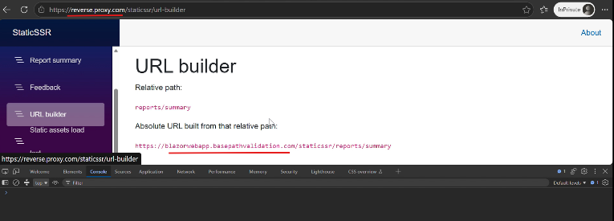
   | Interactive Server | Pass | Pass
   | Interactive WebAssembly | Pass | Pass
  Upgraded App (from .NET 10 to .NET 11) and then published | Static SSR | Pass | Fail  Failure reason:  The app's URL is utilized as the absolute URI, rather than the proxy's URL.  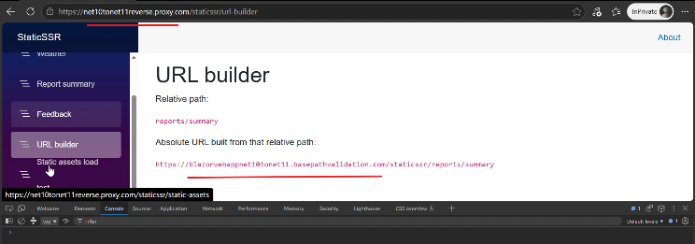
   | Interactive Server | Pass | Pass
   | Interactive WebAssembly | Pass | Pass
10. | Changing the prefix and restarting requires no source change and no rebuild. |  | For New .NET 11 App (Created & Published), evidence can be found here: Evidence/net11-new-app/WithChangedSubpath  For Upgraded App (from .NET 10 to .NET 11) and then published, evidence can be found here: Evidence/net10-to-net11-upgrade/WithChangedSubpath  Note: Extracting the files under the above locations provide the verification logs for the corresponding render mode. It includes a video recording tracking the first 10 testing scenarios alongside a complete network log (.har file)
  Scenario | Render Mode | IIS Deployment
  New .NET 11 App (Created & Published) | Static SSR | Pass
   | Interactive Server | Pass
   | Interactive WebAssembly | Pass
  Upgraded App (from .NET 10 to .NET 11) and then published | Static SSR | Pass
   | Interactive Server | Pass
   | Interactive WebAssembly | Pass
11. | An app upgraded from .NET 10, which still has a literal <base href="/" />, before and after swapping in <BasePath />. The component lives in Microsoft.AspNetCore.Components.Endpoints, which the .NET 10 template does not import, so note whether the build failure you get points you at the missing @using. |  | The evidence can be found here: Evidence/net10-to-net11-upgrade/Issue_BasePath_MissingNamespace.zip
  Scenario | Render Mode | IIS Deployment
  Upgraded App (from .NET 10 to .NET 11) and then published | Static SSR | Fail  Failure Reason:  No build errors are encountered when @using Microsoft.AspNetCore.Components.Endpoints is not added; the app is launched successfully with elements missing from the Head element.
   | Interactive Server | Fail  Failure Reason:  No build errors are encountered when @using Microsoft.AspNetCore.Components.Endpoints is not added; the app is launched successfully with elements missing from the Head element.
   | Interactive WebAssembly | Fail  Failure Reason:  No build errors are encountered when @using Microsoft.AspNetCore.Components.Endpoints is not added; the app is launched successfully with elements missing from the Head element.
12. | - New BasePath component, .NET 11 release notes  - ASP.NET Core Blazor app base path  The base path page presents <BasePath /> as the first option for a Blazor Web App, but it does not mention that the component preserves the casing of the requested path, which is the behavior this scenario is mainly about, and it does not mention the namespace the component lives in. Say so in the report if either gap cost you time. | Fail | It appears that documenting the namespace where the component lives, as well as mentioning that it preserves the casing of the sub-path, is necessary. I became aware of these missing details while going through the validation task's requirements. While adding this information to the documentation would be highly useful, these gaps did not cost me any extra time.

Evidence Table:
Evidence Package Notes:
- IIS Deployment (.zip): Extracting this file provides the verification logs for the corresponding render mode. It includes a video recording tracking the first 10 testing scenarios alongside a complete network log (.har file).
- Deployed Behind Proxy (.zip): Extracting this file provides the proxy validation evidence. It includes a video recording tracking the first 9 testing scenarios, the reverse proxy routing rules (web.config), and a complete network log (.har file).

Scenario | Render Mode | IIS Deployment (With Subpath) | Deployed Behind Reverse Proxy
New .NET 11 App (Created & Published) | Static SSR | Evidence/net11-new-app/WithSubpath/StaticSSR.zip | Evidence/net11-new-app/ReverseProxy/StaticSSR.zip
 | Interactive Server | Evidence/net11-new-app/WithSubpath/InteractiveServer.zip | Evidence/net11-new-app/ReverseProxy/InteractiveServer.zip
 | Interactive WebAssembly | Evidence/net11-new-app/WithSubpath/InteractiveWebAssembly.zip | Evidence/net11-new-app/ReverseProxy/InteractiveWebAssembly.zip
Upgraded App (from .NET 10 to .NET 11) and then published | Static SSR | Evidence/net10-to-net11-upgrade/WithSubpath/StaticSSR.zip | Evidence/net10-to-net11-upgrade/ReverseProxy/StaticSSR.zip
 | Interactive Server | Evidence/net10-to-net11-upgrade/WithSubpath/InteractiveServer.zip | Evidence/net10-to-net11-upgrade/ReverseProxy/InteractiveServer.zip
 | Interactive WebAssembly | Evidence/net10-to-net11-upgrade/WithSubpath/InteractiveWebAssembly.zip | Evidence/net10-to-net11-upgrade/ReverseProxy/InteractiveWebAssembly.zip

Problems
1. BasePath Component Fails to Trigger Build Error or Documentation Lacks Sufficient Guidelines When Required Namespace Is Missing in .NET 10 to .NET 11 Upgraded Apps

Short Summary
A Blazor Web App upgraded from .NET 10 to .NET 11 does not report a build error when the <BasePath /> component is used without its required namespace, nor does the documentation provide adequate guidelines regarding this dependency. Although the application builds successfully with only a warning, the browser treats the unrendered <BasePath /> tag as an unknown element, causing all subsequent <head> elements to be incorrectly pushed into the <body> tag at runtime.
What Happened
After replacing the <base href="/" /> element with the <BasePath /> component in a Blazor Web App upgraded from .NET 10 to .NET 11, the application builds and launches successfully with only a warning—even when the required @using Microsoft.AspNetCore.Components.Endpoints namespace is missing from _Imports.razor.
No build errors are reported, and the current documentation lacks explicit instructions regarding this setup. Because the component is unrecognized by the compiler, the literal <BasePath /> tag is outputted directly to the browser. This invalid HTML structure causes the browser to prematurely close the <head> section and force all subsequent expected <head> elements into the <body> tag at runtime.
What You Expected Instead
One of the following should occur:
- Build Validation: A build error should occur, clearly indicating that the required namespace is missing.
- Documentation Guidelines: If this silent fallback behavior is intentional by design, the official documentation should explicitly state the component's required namespace and mention that it preserves the casing of the requested sub-path to prevent developer confusion.

Steps to Reproduce
- Create a Blazor Web App in .NET 10 using one of the following render modes:
  - Static SSR
  - Interactive Server
  - Interactive WebAssembly
- Update the project's Target Framework Moniker (TFM) in the .csproj file from net10.0 to net11.0:
<Project Sdk="Microsoft.NET.Sdk.Web">
<PropertyGroup>
- <TargetFramework>net10.0</TargetFramework>
+ <TargetFramework>net11.0</TargetFramework>
</PropertyGroup>
</Project>
- In App.razor, replace:
<base href="/" />
with:
<BasePath />
- Build and run the application without adding the following namespace to _Imports.razor or App.razor:
@using Microsoft.AspNetCore.Components.Endpoints

Actual Result
The application builds and launches successfully without any build errors, and the official documentation lacks clear guidelines regarding the necessary namespace setup. At runtime, the compiler outputs the literal <BasePath /> string as text, which breaks the HTML parsing structure and forces subsequent <head> elements into the <body> tag.

Expected Result
The build should fail with a clear compiler error indicating that the Microsoft.AspNetCore.Components.Endpoints namespace is required to use the <BasePath /> component. Alternatively, if a build failure is not possible by design, the official documentation must provide sufficient guidelines by detailing the required namespace and stating that the component preserves sub-path casing.

Evidence: BlazorWebApp-BasePath-Validation/Evidence/net10-to-net11-upgrade/Issue_BasePath_MissingNamespace.zip at main · BharatRamsf3693/BlazorWebApp-BasePath-Validation

2. BasePath Component Fails to Preserve Sub-path Casing Behind a Reverse Proxy

Short Summary

The <BasePath /> component fails to adapt to case-sensitivity changes introduced by a reverse proxy. When the public proxy URL uses a specific casing (for example, /StaticSsr/) while the backend application uses a different casing (for example, /staticssr/), the <BasePath /> component incorrectly falls back to the backend application's casing instead of preserving the casing of the public request path.

This mismatch causes console errors in Interactive Server and Interactive WebAssembly samples. In the Static SSR sample, no console errors occur, but changes to the sub-path casing in the browser URL are not reflected in the rendered <base> element.

What Happened

When an IIS reverse proxy is configured to forward traffic from a public URL with a specific casing to a backend application path, casing variations in the incoming request are ignored. For example, requests arriving through the reverse proxy at:

https://reverse.proxy.com/InteractiveWebAssembly

are rewritten to the backend application path.

However, instead of dynamically preserving the exact casing of the incoming public request path (/InteractiveWebAssembly/), the <BasePath /> component renders the <base> element using the backend application's configured path casing:
/interactivewebassembly/

What You Expected Instead

The <BasePath /> component should dynamically inspect the request path and preserve the exact casing of the requested public URL path, producing:

/InteractiveWebAssembly/

Alternatively, if the design requires strict casing uniformity, the documentation should explicitly state that the component does not support casing changes introduced by reverse proxies, or provide documentation for setting up the reverse proxy to handle this scenario.

Steps to Reproduce

Phase 1: Deploy the Backend Application in IIS

- Open Internet Information Services (IIS) Manager.
- In the Connections panel, right-click Sites and select Add Website.
- Configure the new website:
  - Site name: Enter a recognizable name.
  - Physical path: Map it to a new empty folder, since the actual application will run inside a sub-path application node.
- Configure the Binding section:
  - Set Type to https.
  - Assign an available port (for example, 443).
  - Leave IP Address as All Unassigned.
  - Enter a custom local test domain as the Host name (for example, blazorwebapp.basepathvalidation.com).
  - Select an SSL certificate:
    - A self-signed certificate can be used for local validation.
    - If a certificate is not available, create one and bind it to the website.
- Click OK to create the parent website.
- Right-click the newly created website and select Add Application to create the sub-path environment.
- Configure the sub-path application:
  - Alias: Enter a lowercase application path alias (for example, staticssr, interactiveserver, or interactivewebassembly).
  - Physical path: Map it to the published output folder containing the .NET 11 application binaries.
  - Application pool: Select the required application pool.
- Verify that the backend application works independently by navigating to:
https://blazorwebapp.basepathvalidation.com/interactivewebassembly

Phase 2: Set Up the Reverse Proxy
- Ensure that the URL Rewrite and Application Request Routing (ARR) modules are installed and enabled on the IIS server.
- Create a separate website to act as the public-facing reverse proxy (for example, reverse.proxy.com).
- Configure the new website:
  - Site name: Enter a recognizable name.
  - Physical path: Map it to a new empty folder.
  - Configure the Binding section:
    - Set Type to https.
    - Assign an available port (for example, 443).
    - Leave IP Address as All Unassigned.
    - Enter a custom local test domain as the Host name (for example, reverse.proxy.com).
    - Select an SSL certificate:
      - A self-signed certificate can be used for local validation.
      - If a certificate is not available, create one and bind it to the website.
  - Click OK to create the parent website.
- Right-click the newly created website and select Add Application.
- Configure the sub-path application:
  - Alias: Enter a lowercase application path alias (for example, staticssr, interactiveserver, or interactivewebassembly).
  - Physical path: Map it to a new empty folder.
  - Application pool: Select the required application pool.
- Click OK to create the application.
- Select the newly created application. In the center pane, click URL Rewrite.
- Click Add Rule(s) and use the Reverse Proxy rule template.
- After adding the rule, the following web.config file is created in the mapped Physical path folder.
Example Rule Structure
<?xml version="1.0" encoding="UTF-8"?>
<configuration>
<system.webServer>
<rewrite>
<rules>
<rule name="ReverseProxyInboundRule1" stopProcessing="true">
<match url="(.*)" />
<action type="Rewrite" url="https://blazorwebapp.basepathvalidation.com/interactivewebassembly/{R:1}" />
</rule>
</rules>
</rewrite>
</system.webServer>
</configuration>

Phase 3: Execute the Validation Scenarios
- Open a browser and navigate to the reverse proxy URL using the exact lowercase sub-path alias configured for the backend application: https://reverse.proxy.com/interactivewebassembly
Result: The page loads successfully.
- Navigate to the same application using a mixed-case path: https://reverse.proxy.com/InteractiveWebAssembly
- Open the browser developer tools and inspect the rendered HTML within the <head> element.
Observation: The <base> element does not reflect the mixed-case sub-path used in the request URL.

Actual Result

This mismatch causes console errors in the browser for the Interactive Server and Interactive WebAssembly samples. For the Static SSR sample, no console errors occur; however, the casing change in the browser URL is not reflected in the rendered <base> element.

The <BasePath /> component renders:

/interactivewebassembly/

instead of preserving the casing used by the client request:

/InteractiveWebAssembly/

Expected Result

The application should load successfully regardless of the subpath casing used in the incoming request URL. The <BasePath /> component should preserve the exact casing of the requested path, ensuring that all static asset URLs resolve correctly using that same casing from the reverse proxy URL.

Evidence:
New .NET 11 App (Created & Published) scenario: BlazorWebApp-BasePath-Validation/Evidence/net11-new-app/ReverseProxy at main · BharatRamsf3693/BlazorWebApp-BasePath-Validation
Upgraded App (from .NET 10 to .NET 11) and then published scenario: BlazorWebApp-BasePath-Validation/Evidence/net10-to-net11-upgrade/ReverseProxy at main · BharatRamsf3693/BlazorWebApp-BasePath-Validation

3. Static SSR fails to use proxy domain when constructing absolute URIs

Short Summary
When a Blazor Web App using Static SSR is deployed behind a reverse proxy, generating an absolute URI from a relative path incorrectly utilizes the backend application's host domain instead of the proxy's public domain. This issue is uniquely reproducible in the Static SSR render mode, while working correctly in Interactive Server and Interactive WebAssembly modes.

What Happened
In a Static SSR Blazor application running behind an IIS reverse proxy, absolute URIs generated dynamically default to the backend application URL (e.g., https://basepathvalidation.com...) instead of preserving the public-facing reverse proxy domain (e.g., https://proxy.com...).
As shown in the below image, providing a relative path like reports/summary generates an absolute URL mapped directly to the backend domain hidden behind the proxy.

What You Expected Instead
The NavigationManager should detect and construct the absolute URI using the proxy's public URL domain. Absolute URLs generated within the application should match the public domain that the user interacts with rather than falling back to the backend hosting domain.

Steps to Reproduce
- Set up the backend application and the IIS reverse proxy architecture by following the Phase 1 (Deploying the Backend Application in IIS) and Phase 2 (Setting up the Reverse Proxy) infrastructure configurations detailed in the "BasePath Component Fails to Preserve Sub-path Casing Behind a Reverse Proxy" issue.
- Ensure that during deployment, you choose the Static SSR application for the backend node configuration.
- Open a web browser and navigate to the URL builder page via the public proxy endpoint address: https://proxy.com
- Observe the generated absolute path string displayed on the UI.
  - Actual Result: The absolute URL resolves with the backend server domain (https://basepathvalidation.com), bypassing the public proxy host domain completely.
  - Expected Result: The absolute URL should build seamlessly using the public reverse proxy endpoint domain (https://proxy.com).
(Note: This issue is not reproducible when switching the application backend node to use the Interactive Server or Interactive WebAssembly render modes.)

Evidence:
New .NET 11 App (Created & Published) scenario: BlazorWebApp-BasePath-Validation/Evidence/net11-new-app/ReverseProxy at main · BharatRamsf3693/BlazorWebApp-BasePath-Validation
Upgraded App (from .NET 10 to .NET 11) and then published scenario: BlazorWebApp-BasePath-Validation/Evidence/net10-to-net11-upgrade/ReverseProxy at main · BharatRamsf3693/BlazorWebApp-BasePath-Validation

Observation
1. Subpath Mismatches between Reverse Proxy and Backend Application Cause Crash / Asset Breakage

Short Summary
Deploying a Blazor application at the root domain while hosting it behind a reverse proxy using a subpath (e.g., /staticssr/) causes the application to break. Static assets fail to load, and routing fails, causing a crash across all render modes: Static SSR, Interactive Server, and Interactive WebAssembly.
What Happened
When the subpath configured in the reverse proxy does not match the base path of the backend Blazor application, the application cannot resolve its static assets or routing endpoints.
For example:
- Reverse Proxy URL: https://reverse.proxy.com/staticssr/
- Backend App URL: https://blazorwebapp.basepathvalidation.com/

Attempted Configurations (IIS Rewrite Rules)
The following patterns were tried in the reverse proxy's web.config to match and rewrite requests, but both failed:
Pattern 1: (.*)
<?xml version="1.0" encoding="UTF-8"?>
<configuration>
<system.webServer>
<rewrite>
<rules>
<rule name="ReverseProxyInboundRule1" stopProcessing="true">
<match url="(.*)" />
<action type="Rewrite" url="https://blazorwebapp.basepathvalidation.com/{R:1}" />
</rule>
</rules>
</rewrite>
</system.webServer>
</configuration>
Pattern 2: ^staticssr/(.*)
<?xml version="1.0" encoding="UTF-8"?>
<configuration>
<system.webServer>
<rewrite>
<rules>
<rule name="ReverseProxyInboundRule1" stopProcessing="true">
<match url="^staticssr/(.*)" />
<action type="Rewrite" url="https://blazorwebapp.basepathvalidation.com/{R:1}" />
</rule>
</rules>
</rewrite>
</system.webServer>
</configuration>

What Was Expected Instead
The Blazor application should either load successfully behind a reverse proxy that uses a different subpath, or the documentation should explicitly state that this scenario is not supported.

Steps to Reproduce
- Deploy the backend Blazor Web App directly to a root domain without a subpath (e.g., https://blazorwebapp.basepathvalidation.com/).
- Configure a reverse proxy with subpath (e.g., https://reverse.proxy.com/staticssr/).
- Add a rewrite rule by using reverse proxy rule template to forward requests from proxy to the backend root domain.
- Launch the application via the proxy URL (https://reverse.proxy.com/staticssr/).
- Observe the failure: The page layout may load without styles; the console will show 404 errors for blazor.web.js and other assets.

Evidence: BlazorWebApp-BasePath-Validation/Evidence/net11-new-app/ProxyBackendSubpathMismatch at main · BharatRamsf3693/BlazorWebApp-BasePath-Validation

