Test report
- Build tested: 11.0.100-preview.7.26381.103
- Configurations tested:
The following project types were verified:
- Static SSR (Server-Side Rendering)
- Interactive Server
- Interactive WebAssembly
- Interactive Auto
- Also exercised:
  - Container: Verified by successfully launching the application inside the container from Visual Studio 2026 Insider.
  - Published Output: Verified by containerizing the application via the Docker CLI.
- OS, browser, IDE: Windows 11 Enterprise, Edge, VS 2026 Insiders [12023.133] Professional
- Sample app: https://github.com/BharatRamsf3693/BlazorWebApp-ContainerSupport-Validation
- Outcome: 1 critical issue.

Checks:
S.NO | Check | Result | Evidence
1. | The creation dialog offers Enable container support for the Blazor Web App template, in the same place as for other ASP.NET Core templates. | Blazor Web App Result  Static SSR Pass  Interactive Server Pass  Interactive WASM While creating an interactive WebAssembly app with container support, we faced the following issue: 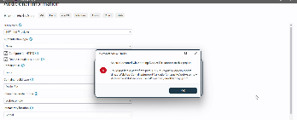  Interactive Auto While creating an interactive Auto app with container support, we faced the following issue: 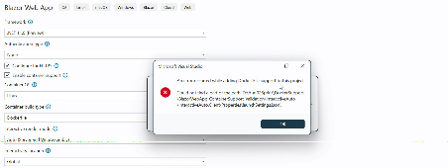 | BlazorWebApp-ContainerSupport-Validation/Evidence/ContainerSupport-On-CreationDialog/blazor-creation-dialog.zip at main · BharatRamsf3693/BlazorWebApp-ContainerSupport-Validation
2. | All four apps build a container image and run in it with no manual edits to the Dockerfile or the project files. | Blazor Web App Docker CLI Visual Studio 2026 Insider Container Launch  Static SSR Pass Pass  Interactive Server Pass Pass  Interactive WASM - The following issue was faced while creating the Docker image: 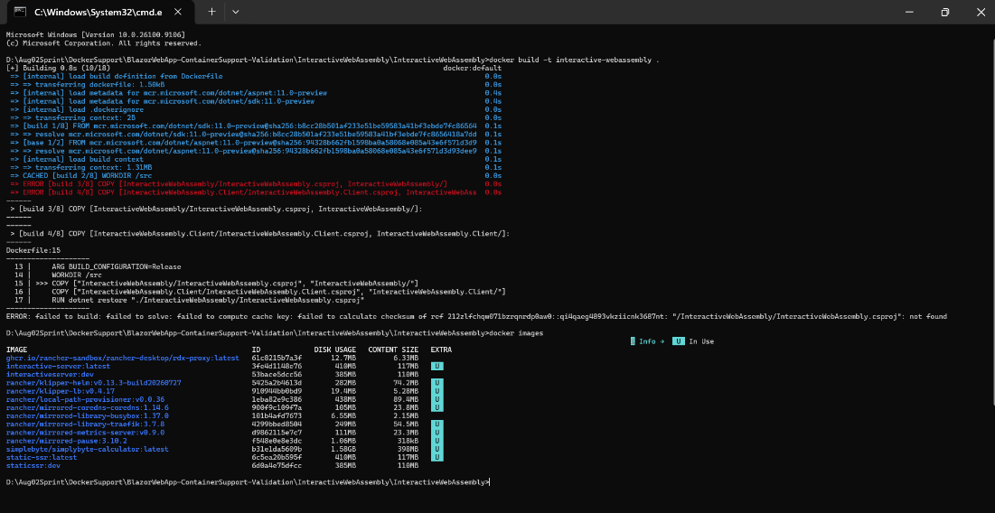 - After moving the Dockerfile from the server project folder to the root folder of the project, the COPY path issue was fixed. The image was generated successfully, and it is running fine in the container. 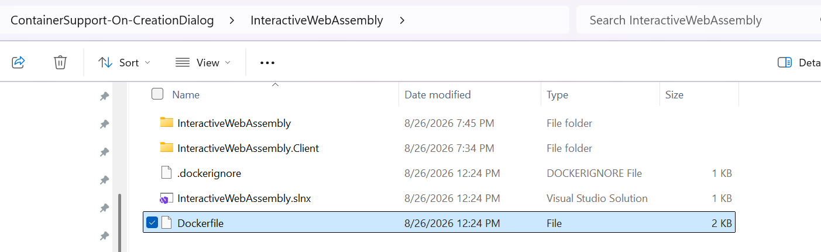 Pass  Interactive Auto - The following issue was faced while creating the Docker image: 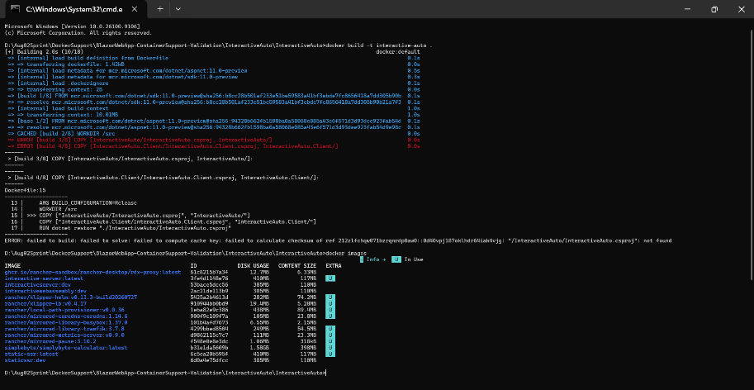 - After moving the Dockerfile from the server project folder to the root folder of the project, the COPY path issue was fixed. The image was generated successfully, and it is running fine in the container. 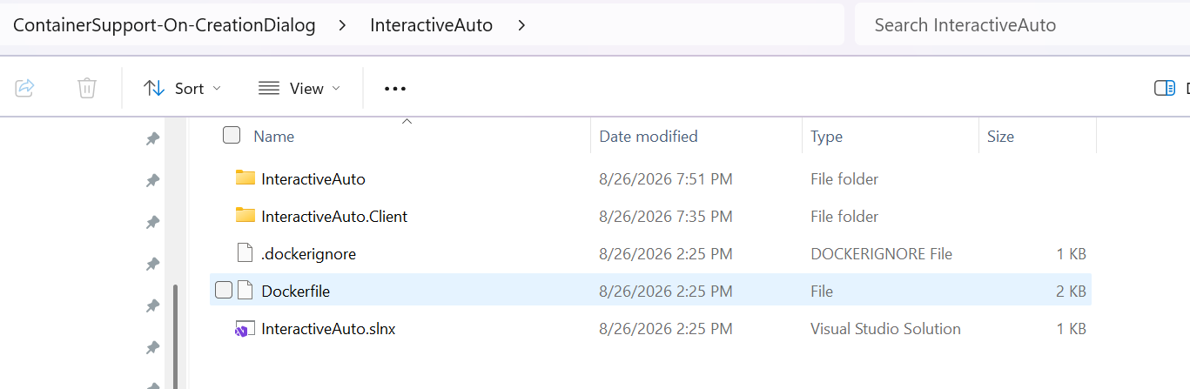 Pass | Docker CLI: BlazorWebApp-ContainerSupport-Validation/Evidence/ContainerSupport-On-CreationDialog/cli-container-run.zip at main · BharatRamsf3693/BlazorWebApp-ContainerSupport-Validation  Visual Studio 2026 Insider Container Launch: BlazorWebApp-ContainerSupport-Validation/Evidence/ContainerSupport-On-CreationDialog/vs-container-run.zip at main · BharatRamsf3693/BlazorWebApp-ContainerSupport-Validation
3. | In the container, every sample page works, interactivity starts, and the image and stylesheet on your own page load with no 404 in the browser network log. | Blazor Web App Docker CLI Visual Studio 2026 Insider Container Launch  Static SSR Pass Pass  Interactive Server Pass Pass  Interactive WASM Fail Pass  Interactive Auto Fail Pass | Docker CLI: BlazorWebApp-ContainerSupport-Validation/Evidence/ContainerSupport-On-CreationDialog/cli-container-run.zip at main · BharatRamsf3693/BlazorWebApp-ContainerSupport-Validation  Visual Studio 2026 Insider Container Launch: BlazorWebApp-ContainerSupport-Validation/Evidence/ContainerSupport-On-CreationDialog/vs-container-run.zip at main · BharatRamsf3693/BlazorWebApp-ContainerSupport-Validation
4. | The two-project shapes behave the same as the single-project ones, with the .Client project's assets present in the image. | Blazor Web App Docker CLI Visual Studio 2026 Insider Container Launch  Interactive WASM Fail Pass  Interactive Auto Fail Pass | Docker CLI: BlazorWebApp-ContainerSupport-Validation/Evidence/ContainerSupport-On-CreationDialog/cli-container-run.zip at main · BharatRamsf3693/BlazorWebApp-ContainerSupport-Validation  Visual Studio 2026 Insider Container Launch: BlazorWebApp-ContainerSupport-Validation/Evidence/ContainerSupport-On-CreationDialog/vs-container-run.zip at main · BharatRamsf3693/BlazorWebApp-ContainerSupport-Validation
5. | Reading the generated Dockerfile for the two-project shapes, checking how the .Client project is restored and copied. | Blazor Web App Result  Interactive WASM It appears that the Dockerfile generated for the client project is unnecessary, as building and publishing the client project is redundant since it is a dependency of the server project. Additionally, the Dockerfile in the server project should be moved to the root folder of the project in order to resolve the COPY path issue and containerize the app successfully.  Interactive Auto It appears that the Dockerfile generated for the client project is unnecessary, as building and publishing the client project is redundant since it is a dependency of the server project. Additionally, the Dockerfile in the server project should be moved to the root folder of the project in order to resolve the COPY path issue and containerize the app successfully. | Interactive Webassembly:  Server project Dockerfile: BlazorWebApp-ContainerSupport-Validation/ContainerSupport-On-CreationDialog/InteractiveWebAssembly/InteractiveWebAssembly/Dockerfile at main · BharatRamsf3693/BlazorWebApp-ContainerSupport-Validation  Client project Dockerfile: BlazorWebApp-ContainerSupport-Validation/ContainerSupport-On-CreationDialog/InteractiveWebAssembly/InteractiveWebAssembly.Client/Dockerfile at main · BharatRamsf3693/BlazorWebApp-ContainerSupport-Validation  Interactive Auto:  Server project Dockerfile: BlazorWebApp-ContainerSupport-Validation/ContainerSupport-On-CreationDialog/InteractiveAuto/InteractiveAuto/Dockerfile at main · BharatRamsf3693/BlazorWebApp-ContainerSupport-Validation  Client project Dockerfile: BlazorWebApp-ContainerSupport-Validation/ContainerSupport-On-CreationDialog/InteractiveAuto/InteractiveAuto.Client/Dockerfile at main · BharatRamsf3693/BlazorWebApp-ContainerSupport-Validation
6. | The same projects still build and run outside a container | Blazor Web App Result  Static SSR Pass  Interactive Server Pass  Interactive WASM Pass  Interactive Auto Pass | The application was tested and verified in debug mode on the local machine's Kestrel web server.  BlazorWebApp-ContainerSupport-Validation/Evidence/ContainerSupport-On-CreationDialog/outside-container.zip at main · BharatRamsf3693/BlazorWebApp-ContainerSupport-Validation
7. | A published image runs on its own outside the IDE. | Blazor Web App Result  Static SSR Pass  Interactive Server Pass  Interactive WASM The Docker image could not be created using the Docker CLI.  Interactive Auto The Docker image could not be created using the Docker CLI. | Here is the Docker Hub repository for the static-SSR and interactive-server samples:  - https://hub.docker.com/r/bharatramh/static-ssr  - https://hub.docker.com/r/bharatramh/interactive-server
8. | Creating the app with the option switched off, then adding container support from the project context menu afterwards, and comparing the result. | Blazor Web App Docker CLI Visual Studio 2026 Insider Container Launch  Static SSR Pass Pass  Interactive Server Pass Pass  Interactive WASM - The server project was right-clicked, and container support was added. - The following issue was faced while creating the Docker image: 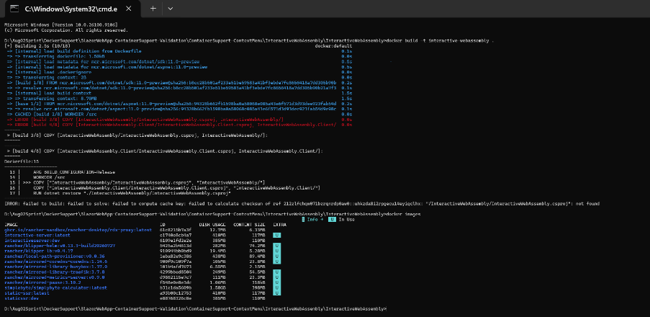 - After moving the Dockerfile from the server project folder to the root folder of the project, the COPY path issue was fixed. The image was generated successfully, and it is running fine in the container. 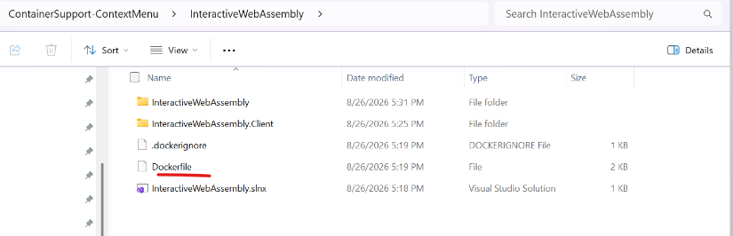 Pass  Interactive Auto - The server project was right-clicked, and container support was added. - The following issue was faced while creating the Docker image: 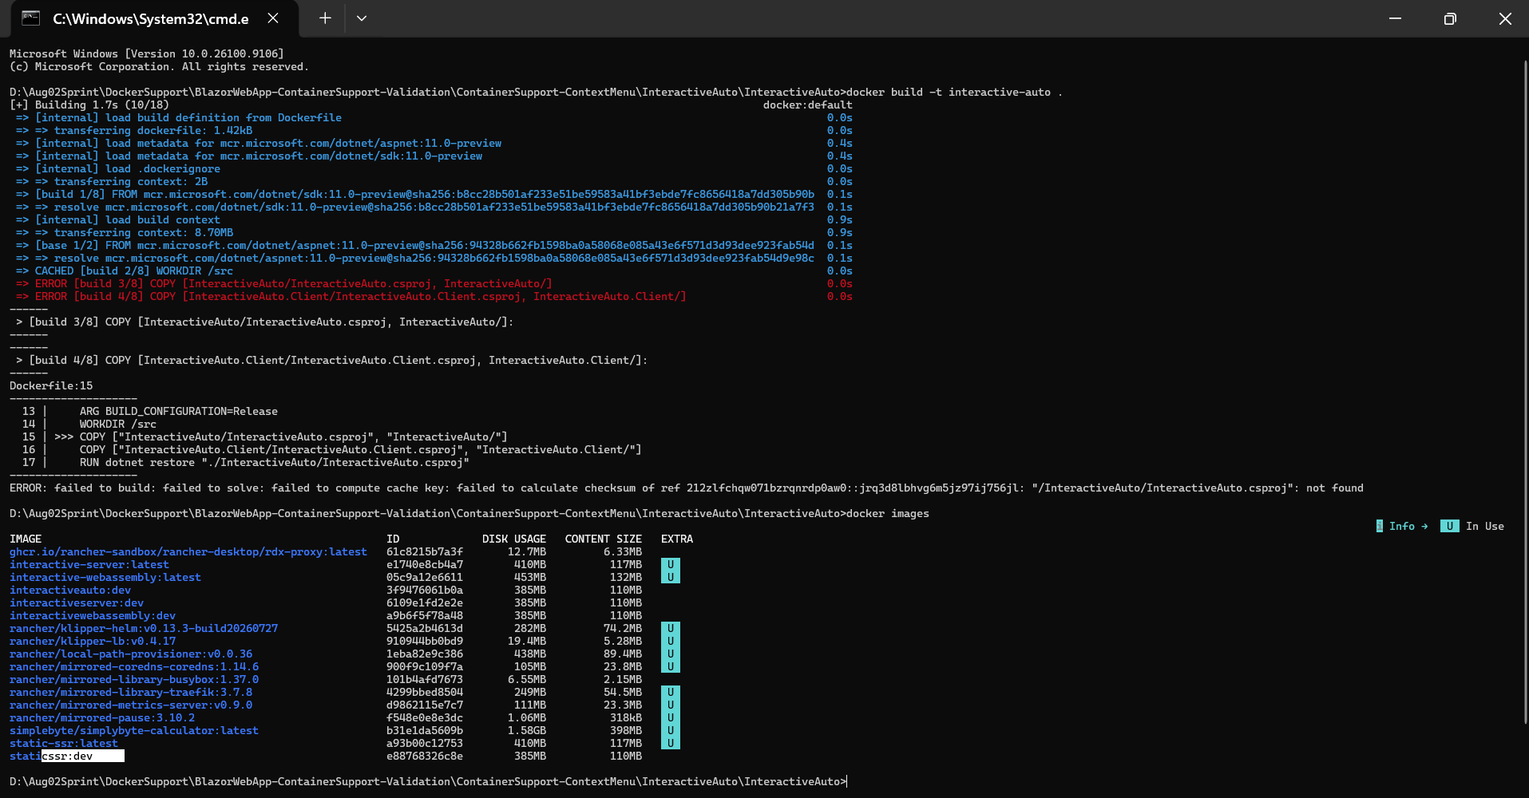 - After moving the Dockerfile from the server project folder to the root folder of the project, the COPY path issue was fixed. The image was generated successfully, and it is running fine in the container. 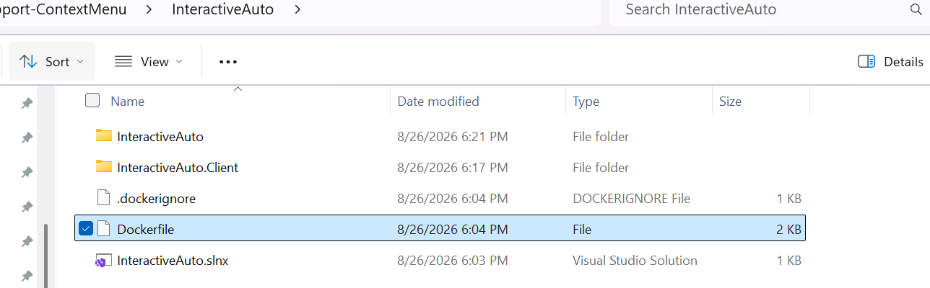 Pass | BlazorWebApp-ContainerSupport-Validation/Evidence/ContainerSupport-ContextMenu at main · BharatRamsf3693/BlazorWebApp-ContainerSupport-Validation

Problems
Short Summary
Container support generates broken COPY paths and unnecessary client Dockerfile for Blazor WASM/Auto apps.
What Happened
When adding container support to a Blazor Web App during initial project creation, Visual Studio generates an unnecessary Dockerfile for the client project and places a Dockerfile inside the server project folder. The Dockerfile in the server project has an incorrect COPY path, which causes a failure during image creation.
What Was Expected Instead
Visual Studio should generate a single, unified Dockerfile in the root folder of the project, or it should correct the COPY path within the server project's Dockerfile. A separate Dockerfile for the client project should not be created, as the client project is a dependency built and published automatically by the server project. The Docker image should build successfully.
Steps to Reproduce
Scenario A: Via the Project Creation Dialog
- Open Visual Studio 2026 Insider.
- Create a new Blazor Web App using the project creation wizard.
- Select the Interactive WebAssembly or Auto interactive render modes.
- Enable Container Support directly within the creation dialog.
- Create the project. You will first encounter the following issue:
Could not find a part of the path "D:\Aug02Sprint\DockerSupport\Repo\Attempt2\BlazorWebApp-ContainerSupport-Validation\ContainerSupport-On-CreationDialog\InteractiveWebAssembly\InteractiveWebAssembly.Client\Properties\launchSettings.json"

- Attempt to build the Docker image from server project’s Dockerfile and observe the COPY path error.
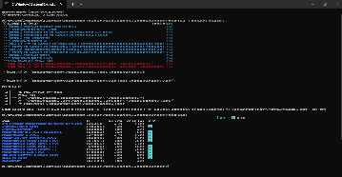

Scenario B: Via the Project Context Menu
- Open an existing Blazor Web App with WebAssembly/Auto render modes.
- Right-click the server project in the Solution Explorer.
- Select Add, then choose Container Support.
- Attempt to build the Docker image and observe the same COPY path error.
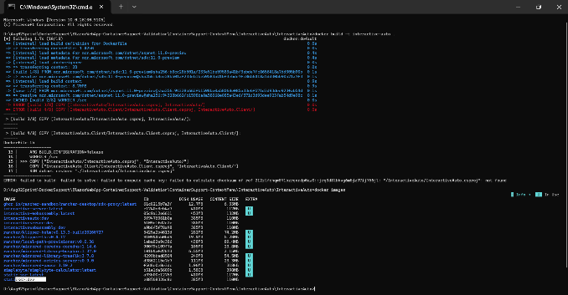
Additional details
After moving the Dockerfile from the server project folder to the root folder of the project, the COPY path issue was fixed. The image was generated successfully, and it is running fine in the container.

