Build tested: 11.0.100-rc.1.26425.128
Configurations tested:
- Interactive Server
- Interactive WebAssembly
- Standalone WebAssembly
Also exercised: An existing .NET 10 app upgraded to .NET 11
OS, browser, IDE: Windows 11 Enterprise, Edge, VS 2026 Insiders [12023.133] Professional
Sample app: BharatRamsf3693/custom-event-validation: custom-event-validation
Outcome: Success

Checks

S.No | Check | Result | Evidence
1. | Start with .NET 10 and observe the behavior. Then update to .NET 11 and observe again to confirm the fix. |  | See the Evidence table after this table.
   | Interactive Server | Interactive WebAssembly | Standalone WebAssembly
  .NET 10 | Pass | Pass | Pass
  .NET 11 | Pass | Pass | Pass
2. | Calling Blazor.registerCustomEventType('scroll', { browserEventName: 'scroll' }) throws a JavaScript error synchronously. |  | See the Evidence table after this table.
   | Interactive Server | Interactive WebAssembly | Standalone WebAssembly
  .NET 11 | Pass | Pass | Pass
3. | The error contains a descriptive message and names the conflicting value. |  | See the Evidence table after this table.
   | Interactive Server | Interactive WebAssembly | Standalone WebAssembly
  .NET 11 | Pass  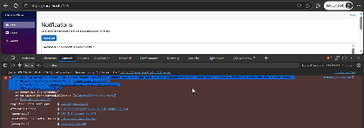 | Pass  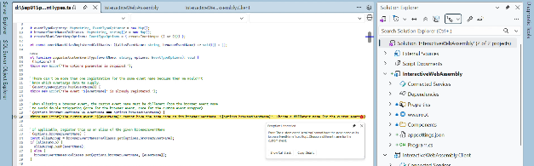  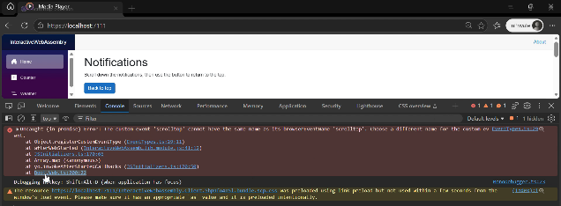 | Pass  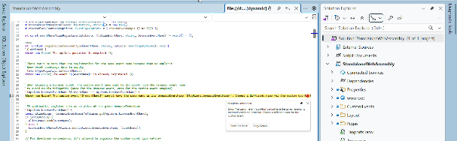  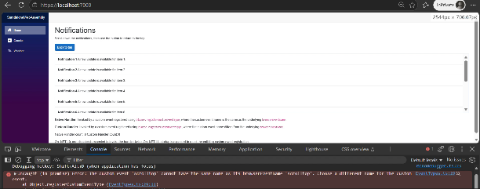
4. | After correcting the name to something different (e.g., customscroll), the registration succeeds and the event fires exactly once per user interaction. |  | See the Evidence table after this table.
   | Interactive Server | Interactive WebAssembly | Standalone WebAssembly
  .NET 11 | Pass | Pass | Pass

Evidence Table:

Configuration | Video Evidence
Interactive Server | custom-event-validation/Evidence/InteractiveServer.zip at main · BharatRamsf3693/custom-event-validation
Interactive WebAssembly | custom-event-validation/Evidence/InteractiveWebAssembly.zip at main · BharatRamsf3693/custom-event-validation
Standalone WebAssembly | custom-event-validation/Evidence/StandaloneWebAssembly.zip at main · BharatRamsf3693/custom-event-validation

Concern:

Built-in Event Registration Fails Before Double-Firing Can Be Validated

Based on the requirement details, registering a built-in browser event in custom event registration and declaring the corresponding EventHandler in C# results in the following compilation error:

The attribute 'onscroll' was matched by multiple event handler attributes. Duplicates: Microsoft.AspNetCore.Components.Web.EventHandlers InteractiveServer.CustomEvents.EventHandlers

Because of this compile-time validation, we are unable to reproduce the reported double-firing behavior using built-in events. Therefore, to validate this issue, we used a custom event instead. This allowed us to verify the behavior related to event registration without encountering the duplicate event handler compilation error.

Given that issue is specifically about collisions between custom event name and browser event name, it seems unusual that the validation requirement expects testing with a built-in event, as such registrations are already blocked by compile-time validation.

