**5. IMPLEMENTATION**

First we have to start Hadoop File System by the following codes in terminal :

1. **start-dfs.sh**

2. **start-yarn.sh**

3. **jps**

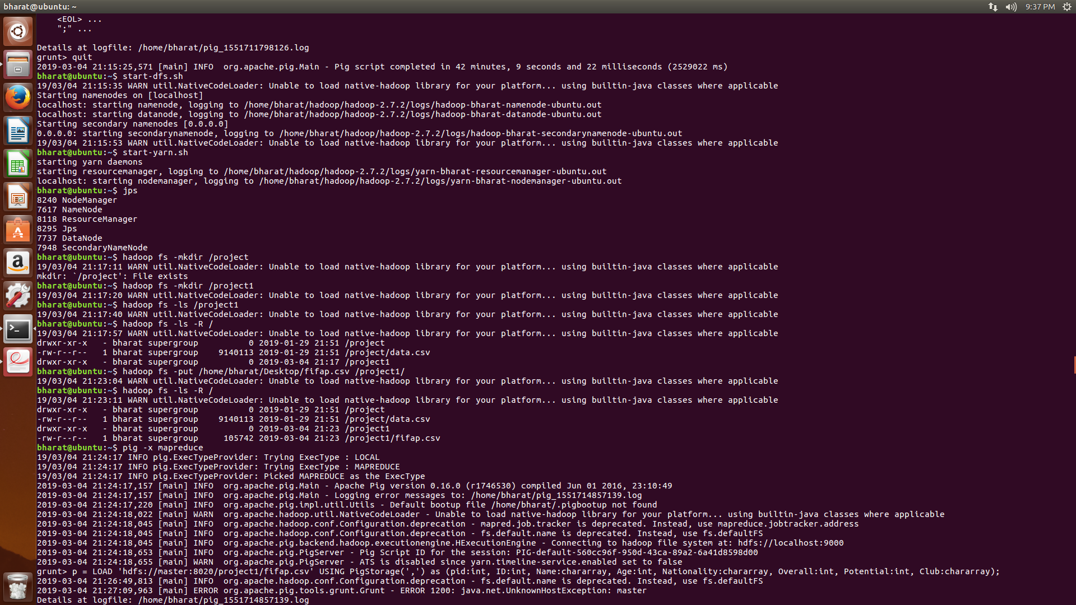

The **jps** command should start :

1. ***NodeManager***

2. ***NameNode***

3. ***ResourceManager***

4. ***Jps***

5. ***DataNode***

6. ***SecondaryNameNode***

Then we will create a directory in HDFS by following command :

**hadoop fs -mkdir /project1**

we will send the database file inside HDFS from Local Storage by using following command :

**hadoop fs -put /home/bharat/Desktop/fifap.csv /project1/**

we can check contents by using following command :

**hadoop fs -ls -R /**

we will start PIG by using following command :

**pig -x mapreduce**