Logical Reasoning

Clock :

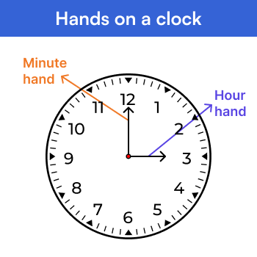

A clock has two main pointers: the smaller one is known as the hour hand, and the longer one is known as the minute hand. The hour hand shows the hour, and the minute hand shows the minute.
Angle
- Hour Hand
- Minute Hand
- Hour Hand
The hour hand on a clock is the shorter hand that indicates the current hour by its position.Over a 12-hour period, it makes a complete 360-degree rotation around the clock's face.

Angle covered by hour hand in 12 hours = 360°
Angle covered by hour hand in 1 hour = (360°)/12 = 30°
So, the hour hand moves at a rate of 30 degrees per hour.
Angle covered by hour hand in 1 min = 30°/60 = (1/2)° (∴ 1 hour = 60 minutes) The hour hand moves at a rate of (1/2) degrees per minute.

Question: How many degrees does an hour-hand move in 10 mins?
Solution:
- Hour Hand: 12 hours= 360° 1 min = (1/2)°, 10 mins = (10)*(1/2)°= 5°
Therefore, Hour Hand covers 5° in 10 mins.

Minute Hand :
The minute hand on a clock is the longer hand that shows how many minutes have passed within an hour. The minute hand on a clock covers a full 360 degrees as it completes a full circle around the clock face.
Angle covered by Minute hand in 60 minutes = 360°
1 min = 360°/60 = 6°
So, the minute hand moves at a rate of 6 degrees per minute.
Question: How many degrees will the minute hand move in the same time, in which the hour hand moves 10 degrees?
Solution:
- Hour Hand:
12 hours = 360°
1 min = (1/2)°
Assume hour hand covers 10 degrees in X mins X mins = 10°
X mins = (10°)/(1/2)°= 20
- Minute Hand:
1 min = 6°
20 mins = 20*6° = 120°
Therefore, Minute Hand covers 120° in 20 mins.

Angle between Hands of the clock
The angle between the hands of a clock represents the difference in position between the hour and minute hands. If the angle between the hands of a clock is greater than 180° then subtract the angle from 360°.

Conventional Method:
Question: Find the angle between the hands of the clock at 3:10?
Solution: Time is 3:10

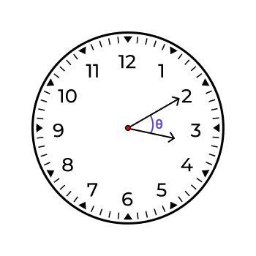
Let we consider angles made by clock hands be α and β.

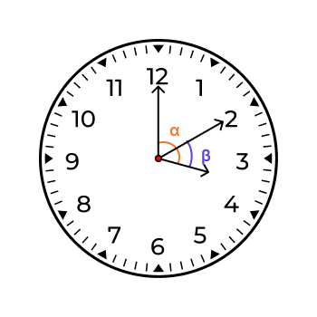

- Hour Hand:
1 hour = 30°
3 hours = 3* 30° = 90°
1 min = (1/2)°
10 min = (10°)/(1/2)°= 5°
α = 90°+5°
α=95°
- Minute Hand:
1 min = 6°
10 min =10* 6°
β = 60°
Angle between hands of the clock is:
θ = α~β = 95° ~ 60° =35°
Shortcut Method:
Angle between hands of the clock is θ =30H ~ (11/2)M Here H is hours and M is minutes
By using shortcut method to solve above problem,
Time is 3: 10
H=3
M =10
θ = 30H ~ (11/2)M
=30x3 ~ (11/2)x10
= 90 ~ (11)x5
= 90 ~ 55 θ =35°

Reflex Angle :
A reflex angle is an angle that measures more than 180 degrees but less than 360 degrees.
Question: Find the reflex angle between hands of the clock at 2:20?
Solution:

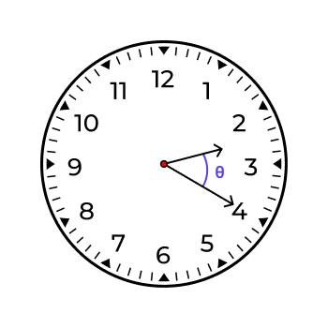
H = 2, M =20
Here using Shortcut method, Angle between hands of the clock is
θ =30H ~ (11/2)M
= 30x2 ~ (11/2)x20
= 60 ~ (11)x10
=60 ~ 110 θ
=50 Reflex angle
= 360° - 50°
= 310°

Clock – 2 :
Clock based on Time
Every 65(5/11)minutes, the hour hand and minute hand of a clock meet each other.This happens due to the different speeds at which these hands move around the clock.
Coincide or Overlap

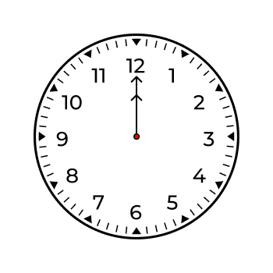
- On a clock, when the minute hand and the hour hand points to the exact same position and they create an angle of zero degree with each other.
- The hands of a clock coincide or overlap, 11 times in every 12-hours period. They first meet at 12 o'clock after that at 1:05(5/11), and then keep meeting after every 65(5/11) minutes. But they don't meet in between 11 o'clock and 12 o'clock, which makes 11 times.
- The hands of the clock coincide or overlap, 22 times in every 24-hours period.

Question: At what time between 2 O'clock and 3 O'clock will the hands of a clock be together?
Solution: Hands of a clock be together means they are forming 0 degree. H=2 Using shortcut method, Angle between hands of the clock θ = 30H ~ (11/2)M 0 = 30x2 ~ (11/2)M (11/2)M =60 M=120/11 M=10(10/11) Time: 2 hours 10 (10/11) minutes

Opposite :
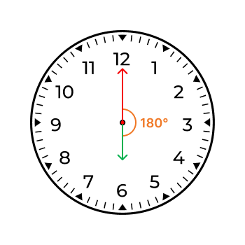

- On the clock, when hour and minute hands are exactly opposite to each other and forms a straight line, create an angle of 180 degrees.
- The hands of a clock are opposite to each other 11 times in 12-hours period.
- The hands of a clock are opposite to each other 22 times in 24-hours period.

Question: At what time between 3 O'clock and 4 O'clock will the hands of a clock be opposite to each other?
Solution: Hands of clock opposite to each other means they are forming 180 degrees. H =3 Using shortcut method, Angle between hands of the clock θ =30H ~ (11/2)M 180 = 30*(3) ~(11/2)M 180=(11/2)M - 90 180 + 90=(11/2)M 270 =(11/2)M (270*2)/11 =M 540/11 = M M = 49 1/11 Time: 3 hours 49 1/11 minutes

Right Angle:

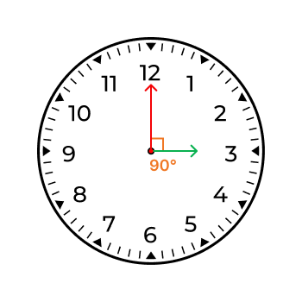
- A right angle in a clock is the position where the angle between the hour hand and the minute hand is exactly forming 90 degrees.
- The hands of a clock form a right angle 22 times in 12 hour-period.
- The hands of a clock form a right angle 44 times in 24 hour-period.
Question: At what time between 3 hours 30 and 4 O'clock will the hands of a clock are right angle to each other?
Solution: Right angle means 90 degrees H=3 Using shortcut method, Angle between hands of the clock θ =30H ~ (11/2)M 90 = 30*(3) ~ (11/2)M 90= 90 ~ (11/2)M (11/2)M= 90-90 M= 0 But in question 3:30 90 =90 ~(11/2)M 90= (11/2)M - 90 90+90 = (11/2)M 180 * 2= 11M 360 =11M M=32 (8/11) Time: 3 hours 32 (8/11) minutes.

Random angle :

A random angle in a clock is the angle formed between the hour and minute hands at a specific time, and it can vary as time passes.
Range of Angle = [0-360]degrees

- Question: The Angle between the two hands of clock is 45 degrees, When the hour hand is lies between 3 and 4. What time does the watch show?
Solution: Angle is 45 degrees H = 3 Using shortcut method, Angle between hands of the clock θ = 30H ~ (11/2)M 45 = 30*3 ~ (11/2)M 45 = 90 ~(11/2)M (11/2)M =90 - 45 11M = (45*2) 11M= 90 M= 90/11 M=8 (2/11) Time: 3 hours 8 (2/11) minutes.

Clock – 3 :
Clock Gain:
When a clock is said to gain time, it means that it runs faster than the standard clock. This results in the clock displaying a time that is ahead of the actual time.

Example: If a clock gains 5 minutes every hour, it will display 1:05 PM when the actual time is 1:00 PM.The rate of gain is usually specified over a standard period, like

Question: A watch gains 3 minutes every hour and was set right at 7 AM. What time will it show at 10 PM on the same day?
Solution: Time duration: From 7 AM to 10 PM is a total of 15 hours. Gain rate: The watch gains 3 minutes every hour. Total Gain: In 15 hours, the total gain will be 15*3 minutes = 45 minutes At 10 PM, the watch, which gains 3 minutes every hour, will show 10:45 PM. This is because it has gained a total of 45 minutes over the course of 15 hours

Clock Loss:
When a clock is said to lose time , it means that it runs slower than the standard clock. This results in the clock displaying a time that is behind the actual time.

Example: If a clock loses 3 minutes every hour, it will display 11:57 AM when the actual time is 12:00 PM.Similar to gain, the rate of loss is typically specified over
Question: A watch loses 10 seconds every hour and was set right at 6 AM. What time will it show at 5 PM on the same day?
Solution: Time duration: From 6 AM to 5 PM is 11 hours. Lose rate The watch loses 10 seconds every hour. Total lose: In 11 hours, the total loss will be 11*10 =110 seconds. 110 seconds = 60 seconds + 50 seconds = 1 minute 50 seconds. At 5 PM, the watch, which loses 10 seconds every hour, will show 4:58:10 PM. This is because it has lost a total of about 1 minute and 50 seconds over the course of 11 hours (from 6 AM to 5 PM).

Mirror Image Time on clock:
For 12-Hour clock:
Mirror image for 12-hours clock, subtract the given time from 11:60 hours. This method flips the time to its opposite position on the clock.
Question: What is the actual time if the time shown by the watch in a mirror is 3:10?
Solution: 11- hours: 60 – minutes Mirror time is 3:10
Actual time
= (11-3): (60-10)
= 8: 50

For 24-Hour clock:
Mirror image for 24-hours clock subtract the given time from 23:60 hours. This method flips the time to its opposite position on the clock.
Question: What is the actual time if the time shown by the watch in a mirror is 14:30?
Solution: 23- hours: 60 – minutes Mirror time is 14:30 (or 2:30 PM in 12-hour format)
Actual time = (23-14): (60-30)
= 9: 30

Clocks based on Directions:
The clock-based direction is a method of describing directions using the face of an analog clock as a reference.
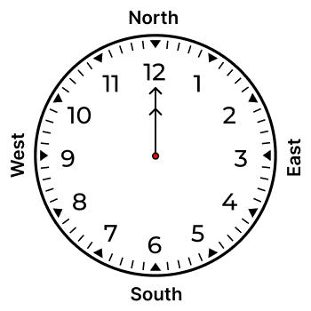
In this system, if 12 o'clock represents North, then 3 o'clock represents East, 6 o'clock represents South, and 9 o'clock represents West.
Question: The time on the watch is 5:15. If the minute hand points towards the west, in which direction will the hour hand point?
Solution:

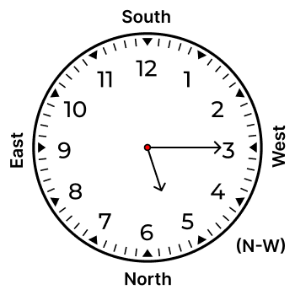

The minute hand at 15 minutes (3 on the clock) points west. The hour hand, at 5:15, is halfway between the 5 and the 6 on the clock. Means hour hand points North-West.

Calendars :
Odd days:
Odd days in a calendar refer to the extra days left over after dividing the total number of days by 7.
Note
Sunday has 0 odd day
Monday has 1 odd day
Tuesday has 2 odd days
Wednesday has 3 odd days
Thursday has 4 odd days
Friday has 5 odd days
Saturday has 6 odd day

Odd days in year:
In Normal year:
A standard calendar year has 365 days. There are 52 full weeks with 1 extra day,called an odd day
, because each week has 7 days.
In Leap year:
- A leap year has 366 days. There are 52 full weeks with 2 extra days, called odd days
, because each week has 7 days.
- Any year ,which is divisible by 4 is called a leap year, except centuries.
Example : 2004 ,1940
- A century will become a leap year only if it is divisible by 400.
Example : 2000 ,1600, 400

Odd days in 100 years:
100 is divided into 2 parts. Leap years and Normal years
- Leap years = 100/4 = 25 but 100 is not a leap year = 25-1 = 24 No.of odd days = 24*2 =48 Here we multiplied 24 with 2,because each leap year has 2 odd days.
- Normal years = 100 years - No.of leap years in 100 years = 100-24 = 76 No.of odd days = 76*1 =76 Here we multiplied 76 with 1, because each Normal year has 1 odd day.
Total no.of odd days = 48 + 76 = 124 = 124/7 = 124 divided by 7 (a week) leaves a remainder of 5. =5 100 years have 5 odd days.

Odd days in 200 years:
As 100 years have 5 odd days,200 years have 10 odd days . 10 odd days = 1 week + 3 odd days = 3 . 200 years have 3 odd days.
Odd days in 300 years:
As 100 years have 5 odd days ,300 years have 15 odd days . 15 odd days = 2 week + 1 odd day = 1 . 300 years have 1 odd day.
Odd days in 400 years:
As 100 years have 5 odd days ,400 years have 20 odd days. One extra day as 400 is a leap year. 21 odd days = 3 weeks + 0 odd day
= 0 . 400 years have 0 odd days.
Note
100 years have 5 odd days
200 years have 3 odd days
300 years have 1 odd day.
400 years have 0 odd day.

Odd days in Month:
Odd days in a month are the extra days left after forming complete weeks, indicating the days that don't fit into a 7-day-a-week pattern for that particular month.
- January: January has 31 days. No.of odd days = 4 weeks + 3 odd days = 3
- February : In a leap year , February has 29 days. No.of odd days = 4 weeks + 1 odd day. = 1 In a normal year , February has 28 days. No.of odd days = 4 weeks + 0 odd day. = 0
- March : March has 31 days. No.of odd days = 4 weeks + 3 odd days = 3
- April : April has 30 days. No.of odd days = 4 weeks + 2 odd days = 2
- May : May has 31 days. No.of odd days = 4 weeks + 3 odd days = 3
- June : June has 30 days. No.of odd days = 4 weeks + 2 odd days = 2
- July : July has 31 days. No.of odd days = 4 weeks + 3 odd days = 3
- August: August has 31 days. No.of odd days = 4 weeks + 3 odd days = 3
- September: September has 30 days. No.of odd days = 4 weeks + 2 odd days = 2
- October : October has 31 days. No.of odd days = 4 weeks + 3 odd days = 3
- November: November has 30 days. No.of odd days = 4 weeks + 2 odd days = 2
- December: December has 31 days. No.of odd days = 4 weeks + 3 odd days = 3

Note
Month No.of odd days
January 3 odd days February 0 or 1 odd day March 3 odd days
April 2 odd days May 3 odd days
June 2 odd days July 3 odd days
August 3 odd days
September 2 odd days
October 3 odd days
November 2 odd days
December 3 odd days
Question: What will be the day of the week 9th April, 2009?
Solution: 9-April -2009
9 days:
Odd days in 9 days = 1 week + 2 odd days = 2 odd days
April:
4th month - April:
2009 is not divisible 4 ,So it is not a leap year
So February has 0 odd days.
Here we consider months before April
Month Odd days Jan 3 Feb 0 March 3
Total odd days before April month =(3+3) =6
2009 :
2009 year is considered 2009 before year i.e; 2008
2000 + 8
2000 is divisible by 400 (meaning it is one of the centuries), So,odd days are 0.
No.of odd days in 8 years=Leap year + Normal year
- Leap years =No.of leap years in 8 years =(8/4 ) = 2 No.of odd days in leap years = 2*2 = 4
- Normal years= 8 years - No.of leap years in 8 years = (8- (8/4) = (8-2) = 6
No.of odd days in Normal years = 6*1 = 6
No.of odd days in 8 years= 4+6 = 10 = 3 (1 week + 3 odd days)
Total odd days = Odd days in

9 days
+ Odd days in before
April
+ Odd days in
2008
= 2+ 6 + 3 = 11 11 divided by 7 we get remainder as 4 odd days (11 days = 1 week + 4 odd days)
4 odd days -Thursday

Calendars – 2 :
Year Repetition
When a year in a calendar is similar to another year in terms of matching of days and dates. It's like having two different years where the days and dates are arranged in exactly the same way.
Leap Year | Leap Year + 1 | Leap Year + 2 | Leap Year + 3
+28 | +6 | +11 | +11

Question : 2015 calendar can be used again in which year?
Solution : 2015 before leap year is 2012. 2012 + 3 =2015 Add 3 to Leap year , we get 2015. So, Add 11 to 2015 according to the above table. We get the year ,2015 calendar will be reused. 2015 + 11 = 2026. The calendar for 2015 will be the same as the calendar for 2026.

Calendar Questions based on IF condition
"IF" condition in calendar questions indicates where a specific date or day might or might not exist, and the resulting day depends on the validity of the condition.
Question : If today is Saturday after 50 days, what is the day?
Solution : No.of Odd days = 50/7 = 50 divided by 7 we get remainder is 1
= 7 weeks +1 odd day = 1 Saturday + 1 odd day = 6+ 1 = 7 =7/7, we get remainder as 0
= 0
Sunday = 0 odd day If today is Saturday, after 50 days it is Sunday.

Question : If 11th March ,2010 is on Sunday ,then what day of the week is on 11th March, 2013 ?
Solution :
=>11-March-2010 is Sunday =>11-March-2011 is Monday
(Sunday + 1 odd day = Monday ,Here added 1 odd day because 2011 is Normal year) =>11-March-2012 is Wednesday (Monday + 2 odd days = Wednesday ,Here added 2 odd days because 2012 is Leap year) =>11-March-2013 is Thursday (Wednesday + 1 odd day = Thursday ,Here added 1 odd day because 2013 is Normal year) =>11th March ,2013 is Thursday.

Dates with respect to Day
Calculate future dates based on a known month,year and day of the week. In a weekly cycle, finding the same day in subsequent weeks involves adding 7 days to the initial date.
Question : On which dates of March, 2005 will a Monday come?
Solution : X-3-2005 = Monday X is the Date representing Monday in the March Month. March : 2005 is not divisible by 4 So ,Feb have 0 odd day Month odd day Jan 3 Feb 0 Total odd days =(3+0) =3 2005 :
2005 before 2004 2004 consider as 2000 + 4 2000 is divisible by 4 and it is also a one of the century and divisible by 400. 2000 has 0 odd days. Total odd days in 2004 = odd days of 2000 year + Odd days in Leap years + Odd days in Normal year = 0 + ((4/4)x2) + (4-(4/4))x1 = (1x2) + (4-1)x1 = 2 + 3 = 5
X-March-2005 = 1 ( Monday - 1 odd day) X+ odd days of before months of march + odd days of 2004 =1 X+3+5=1 X+8 =1 7 + 8 =1 15 =1 (15=2 weeks + 1 odd day) 1=1 Here take X=7 then it will satisfy LHS =RHS means 1=1 Monday comes on dates of 7th ,14th ,21st ,28th.

Data Interpretation :
Data Interpretation Tables :
Data interpretation tables are used to organise and present data in clear and a structured format.These tables display information in rows and columns, allowing for easy comparison and analysis of data.
Four basic Formulas :
1. Average : The Average is calculated by dividing the total sum of all values in a set by the number of values. Average = (Sum of data points)/ (Number of data points)
2.Percentage(%) : A percentage is a value which is represented as a fraction of 100. Percentage is denoted as %.
a % of b = (a/100) x b
of represents the multiplication.
Percentmeans any value divided by 100.
3.Percentage Change : Percentage Change can be defined as change in the values divided by initial value, the the resultant is multiplied by 100.
Percentage Change = ((Final Value - Initial Value)/(Initial Value))x100
4.Ratio : Ratio is a comparison of two or more quantities of the same unit. Having no dimension means it has no unit.
Student Test Score Table
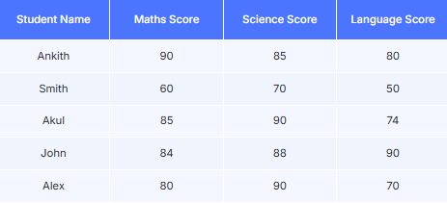

Question : What is the Average Test Score of Akul ?
Solution : Average = Total score of Akul in all subjects / Number of Subjects = (85 + 90 + 74) / 3 = 249/3 = 83 Average Score of Akul is 83.

Question : What is the ratio between the Total test score of Smith and the Total test score of Alex ?
Solution : Total test score of Smith = 60 + 70 + 50 = 180 Total test score of Alex = 80 + 90 + 70 = 240 Ratio = Total test score of Smith : Total test score of Alex = 180 : 240 = 3 : 4

Question : Total test score of Ankith is approximately what percent of Total test score of John?
Solution : x% of Total test score of John = Total test score of Ankith Total test score of John = 84 + 88 + 90 = 262 Total test score of Ankith = 90 + 85 + 80 = 255 x% of 262 = 255 (x/100) x 262 = 255 x = (255 x 100)/(262) = 25500 / 262 = 97.3 But in the question asked approximate percent = 97%
Question : What is the Total Test Score of John?
Solution :
Total Test score of John = 84 + 88 + 90
= 262
Question : What is the percentage change in test score of Ankith in Maths and Science with respect to Maths?
Solution : Percentage Change = ((x - y)/x) x 100 x = Test score of Ankith in Maths y = Test score of Ankith in Science Percentage Change = ((90 - 85 )/90 ) x 100 = (5/90) x 100 = 5.56 %

Data Interpretation Graph :
- A Data Interpretation graph is a visual representation of data using horizontal or vertical bars.
- The x-axis shows one parameter,while the y-axis represents the other.
- The length of each bar corresponds to the value it represents.
- Graph represents the data in the form of a bar graph or line chart.

Bar Graph :
In a bar graph , data is represented as rectangular bars. The graph consists of an x-axis which means horizontal ,displaying categories and a y-axis which means vertical ,showing numerical values. The bars are plotted along the x-axis,with their height or length , representing the data on the y-axis,visually comparing different categories.
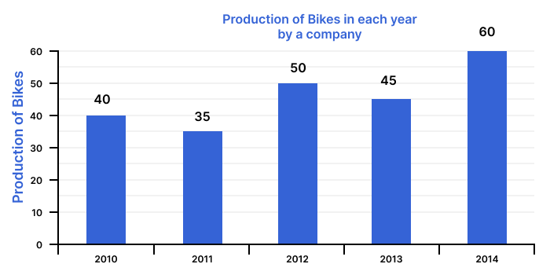

Question : What is the Total Production of bikes?
Solution :
Total production of bikes = Production of bikes in 2010 + Production of bikes in 2011 + Production of bikes in 2012 + Production of bikes in 2013 + Production of bikes in 2014 = 40 + 35 + 50 + 45 + 60 = 230
Question : In the period from 2011 to 2014, what was the average bike Production of the Company?
Solution : Average = Sum of the All values / Number of values Average production of bikes = X/Y X = Sum of the production of bikes from 2011 to 2014 Y = Number of Years X = Production of bikes in 2011 + Production of bikes in 2012 + Production of bikes in 2013 + Production of bikes in 2014 = 35 + 50 + 45 + 60 = 190 Y = 4 years Average production of bikes = 190/4 = 47.5

Question : In how many of the given years was the production of bikes less than the average Production of the given years?
Solution : Average Production of bikes = Total Productions of bikes / Number of years Total production of bikes = Production of bikes in 2010 + Production of bikes in 2011 + Production of bikes in 2012 + Production of bikes in 2013 + Production of bikes in 2014 = 40 + 35 + 50 + 45 + 60 = 230 Number of years = 5 Average Production of Bikes = 230/5 = 46 2010 , 2011 , 2013 has less production of cars compared to the Average Production of cars. so, 3 years has less production of cars compared to the Average Production of cars.
Question : In which year was the higher number of bikes produced by the company?
Solution : 2014 Produced a higher number of bikes i.e; 60.

Line Chart :
A line chart is a type of graph that displays information as a series of data points called 'markers' connected by a straight line. It is typically used to visualise data over intervals of time.This chart is showing changes in the value of an item or group of items over a continuous interval or time span.
line graph shows the number of black and green colored candies (in lakhs) produced in 5 different years.

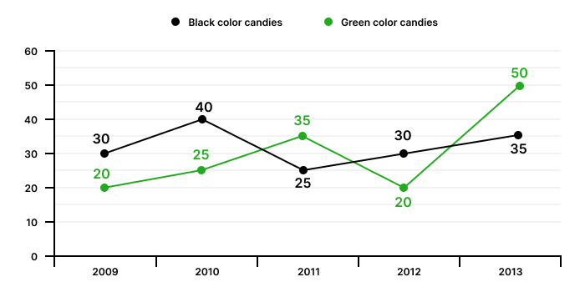

Question : What is the difference between the total number of black candies and the total number of green candies produced in 6 years?
Solution : Total number of black candies = black candies produced in 2009 + black candies produced in 2010 + black candies produced in 2011 + black candies produced in 2012 + black candies produced in 2013 = 30 + 40 + 25 + 30 + 35 = 160 Total number of green candies = 20 + 25 + 35 + 20 + 50
= 150 Required Difference = 160 -150 = 10

Question : In which year was the difference between green colour candies and black colour candies produced the maximum ?
Solution : Difference between Green colour candies and Black candies Produced in 2009
= 20 - 30 = - 10 Difference between Green colour candies and Black candies Produced in 2010 = 25 - 40 = -15
Difference between Green colour candies and Black candies Produced in 2011 = 35 - 25 = 10
Difference between Green colour candies and Black candies Produced in 2012 = 20 - 30 = -10 Difference between Green colour candies and Black candies Produced in 2013 = 50 -35 = 15 In 2013, Maximum candies were produced.

Question : What is the percentage increase or decrease of sum of candies from 2010 to
2011?
Solution : Sum of candies Produced in 2010 = Green colour candies Produced in 2010+ Black colour candies Produced in 2010 = 25 + 40 = 65 Sum of candies Produced in 2011 = Green colour candies Produced in 2011+ Black colour candies Produced in 2011 = 35 + 25 = 60 Percentage Change = ((Finval value -Initial value)/Initial value)*100 = ((60 -65)/65)*100 = ((-5)/65)*100 = - (100)/13 = - 7.69 % Here
-
indicates decrease. Therefore, 7.69 is the percentage decrease of the sum of candies from 2010 to 2011.

Data Interpretation Pie chart :
Pie chart displays data in a circular graph.
Pie chart can be divided into either Percentage or Angle.

Pie chart with Percentage :
In Pie chart with Percentage ,where each percentage indicates the proportion of data.A proper pie chart will be divided into percentages but sum of all the percentages will be equal to 100%.

Note
Total Percentage = 100%



Pie Chart with Angle :
In Pie chart with angle ,where each slice's angle indicates the proportion of data.A complete pie chart is divided into slices,the sum of the angles must be equal to 360°.

Note
Sum Of Angles = 360°

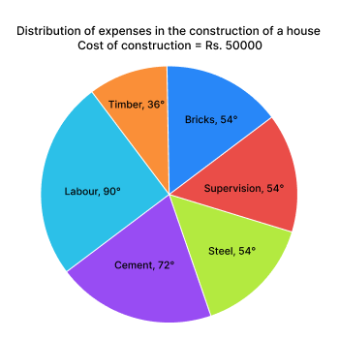

Study the following Pie-Chart and Answer the Questions
If the Company Budget = 400000



Question : What is the ratio of the budget allocation for Human Resources (HR) to the budget allocation for Information Technology (IT)?
Solution: 16.7% Budget allocation on HR department 16.7% Budget allocation on IT department Ratio = 16.7 : 16.7 = 1 : 1

Question : What is the central angle of the sector corresponding to the Budget allocation on Marketing Department?
Solution : Pie chart Total angle =360° Pie chart total percentage =100% Marketing Department Percentage = 25% 100% = 360 degrees 25% = x degrees x = (360*25)/100 = 90°

Question : What is the central angle of the sector corresponding to the Budget allocation on Marketing Department?
Solution : Pie chart Total angle =360° Pie chart total percentage =100% Marketing Department Percentage = 25% 100% = 360 degrees 25% = x degrees x = (360*25)/100 = 90°
Question : What is the Total Budget Allocation on Operations and IT Department?
Solution : 33.3% of Budget Allocation on Operations 16.7 % of Budget Allocation on IT = (33.3 + 16.7) % = 50% = 50% of Total Company Budget Allocation Operations and IT Department = 50% of 400000 = (50/100)*400000 = 2,00,000 = Rs.2,00,000.

Ranking :
Ranking
- Ranking is the process of arranging items or individuals in an order based on their relative importance, performance and merit.
- They are arranged in a line, either from top to bottom or left to right.
- Determining the position of a person or object in a row or queue.

Ranking Based Questions :
Ranking based questions divided into following categories.
1.Total number of Persons : In this category,to find the total persons or candidates in a row or queue or class.
Total number of Persons = Rank from top + Rank from bottom -1
(or)
Total number of Persons = Position from left + Position from Right -1
Question : In a class, a girl is 10th from either of the ends, how many are there in the queue?
Solution : Total Girls = Girl position from left + Girl position from Right - 1 = 10 + 10 -1 = 20 -1 = 19 Therefore, Total number of Girls in a class is 19.
Question : In a row of Students ,Ankur is 18th from the left end and 12th from the right end. Calculate the total number of Students in the row.
Solution : Total Number of Students = Ankur Position from left + Ankur Position from right-1 = 18 + 12 -1 = 29 Therefore ,Total number of students is 29.

2.Position from Left or Right : In this category ,to find the person's position from either the left or right .
- Total number of Persons = Position from left + Position from right-1
- If the Person is Positioned from the left = Total number of Person - Position from right +1
- If the Person is Positioned from the right = Total number of Person - Position from left +1

Question : In a row of 20 boys, Akul is 8th from the left end. Calculate Akul's position from the right end.
Solution: Akul Position from right = Total number of boys -Position from left +1 = 20 - 8 +1 = 20 -7 = 13
Therefore, Akul is 13th from the right.

3. Rank from Top or Bottom : In this category ,to find the person or student rank from top or bottom.
- Total number of Persons = Rank from top + Rank from bottom -1
- The Rank of the person from the top =Total number of Persons - Rank from bottom+1
- The Rank of the person from the bottom =Total number of Persons - Rank from top+1

Question : Aman ranked 10th in a class of 25 students. What is his ranking from the bottom of
the class?
Solution :
Aman Rank from bottom = Total number of students in class - Aman Rank from top +1 = 25 - 10 +1 = 25 -9 = 16 Therefore, Aman Rank from bottom is 16th.

4 .Persons between two persons(without overlapping) : In this category , to find number Persons between two persons without overlapping their positions.
Number of persons between two persons= Total number of persons or students - Sum of Position two different persons opposite ends.

Question : In a queue of 30 persons. Amith is 10th from the left side of the queue and Bhanu is 13th from the right side of the queue. Find out the total number of persons sitting between these Amith and Bhanu.
Solution :
Total number of persons = 30 Amith Position from left = 10 Bhanu Position from right = 13 Sum of the positions of Amith and Bhanu = 10 + 13 = 23 Number of persons between Amith and Bhanu = Total number of persons - Sum of the positions of Amith and Bhanu = 30 - 23 = 7 Therefore , 7 persons there between Amith and Bhanu.

5. Persons between two persons (with overlapping) : In this category , to find the number of persons between two persons with overlapping of their positions.
- If sum of the Positions of two persons > Total number of persons then it is called
Overlapping.
- Number of persons between two people = Sum of the positions of two people -Total number of persons-2

Question : In a row of 20 people, Samir is the15th from the right side of the of row and Emma is 10th person from the left side of the row. Determine the total number of people sitting between Samir and Emma.

Solution : Total number of people = 20 Samir Position from right = 15 Emma Position from left = 10 Sum of the Position of Samir and Emma = 15 + 10 = 25
25 > 20 ( overlapping)
Number of people between Samir and Emma=Sum of the Position of Samir and Emma - Total number of people-2 = 25 - 20 -2 = 25 -22 = 3 Therefore , there are 3 people there in between Samir and Emma.

6. Interchanging position: Interchanging positions involves two persons swapping their original places in a row or queue.In this category ,to find positions either from left or right after interchanging.
Question : In a row of boys, Rahul is 8th from the left, and Surya is 11th from the right. If they interchange their places, Rahul will become 10th from the left, what will be the new position of Surya from the right?
Solution : Position of Rahul from left = 8 Position of Surya from right = 11 After interchange their positions are Position of Surya from left = 8 Position of Rahul from right = 11 According to the question Rahul position from left = 10 Total number of boys = Rahul Position from left+Rahul Position from right-1 = 10 + 11 -1 = 10 + 10 = 20 Surya new Position from right = Total number of boys-Surya from left+1 = 20 - 8 + 1 = 20 - 7 = 13 Therefore,Surya's new Position from the right is 13th.

Direction :
Direction refers to the path a person or object is moving or facing. Directions used to solve problems involving the movement of objects or persons in specific directions.
- Four main Directions : North ,South ,East, West.
- Four Sub Directions : North-East, South-East, South-West, North-West.
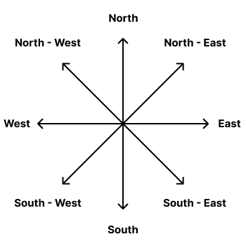

Directions based on Turns:
In this type of question , determine the present direction of the based on movements ,starting particular direction then turn left or right.
Question :If a person moves towards the East, then turns to his left, then turns to his left ,in which direction is he travelling now?
Solution :
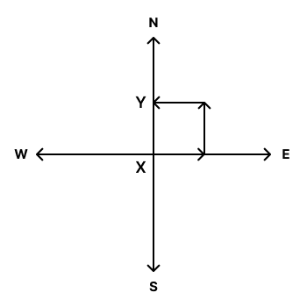

X is the starting point and Y is the end point.According to the above diagram, the present direction is West.
Directions based on Distance :
Direction based distance involves determining how far and in which direction a person or object has moved from their initial starting point. And direction of a starting point with respect to the present position and short distance and Total distance travelled by a person.
Question :A woman walks 10 km towards North and then turns to her left. After walking 8 km, She turns to her left again and walks 10 km. How far and in which direction she from the starting place?
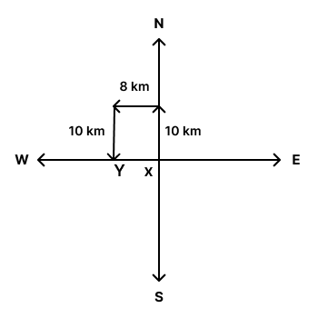
According to the above diagram X is the starting point and Y is the end point. Woman direction from the starting place is West. 8 km far from her starting place.
Question : A man walks 5 km towards West and then turns to his right,after walking 2 km, He turns to his right again and walks 7 km. Now, what is the direction of the starting point with respect to his present position?
Solution :

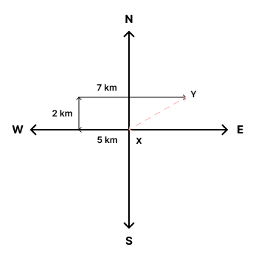
According above diagram , X is the starting point and Y is the end point. Starting point direction with respect to present position is South-West.

Question : Ravi left his home and travelled towards South and turned to his left after travelling 15 km. Then he travelled 10 km before turning to his left. After that, he travelled 25 km and turned towards his left and travelled 10 km. Find the total Distance covered by him?
Solution:
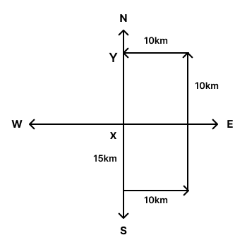

X is the starting point and Y is the end point. Total distance travelled by Ravi = 15 km + 10 km + 25 km + 10 km = 60 km
Short Distance :
Short distance is also called displacement. It is used to find the short distance between starting point and final point of person.
Pythagoras theorem states that in a right-angled triangle, the square of the length of the hypotenuse is equal to the sum of the squares of the lengths of the other two sides.

c^2 = a^2 + b^2
Question : A man walks 4 km towards East and then turns to her left and walks 3 km. How far is he from his starting point?

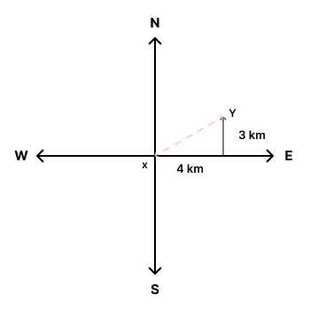

X is the starting point and Y is the end point. c^2 = a^2 + b^2 = (4)^2 + (3)^2 = 16 + 9 = 25 c^2 = (5)^2 c=5 km

Directions based on Rotations :
In this type of question ,determine the direction after rotation with some angle and direction is clockwise or anti clockwise
Question : A woman is facing towards the North. She turns 90 degrees in the clockwise
direction.Then, she turns 180 degrees in the anti-clockwise direction. Which direction is she facing right now?
Solution :
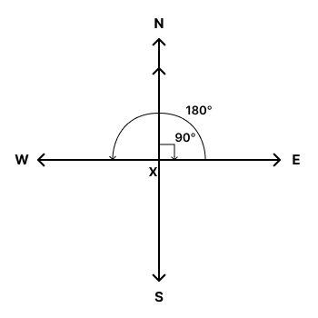

According to the above diagram, X is the starting point and Y is the end point. The women's final direction is West.
Question : If South-East becomes North-East, West becomes South, and so on, what will East become?
Solution :
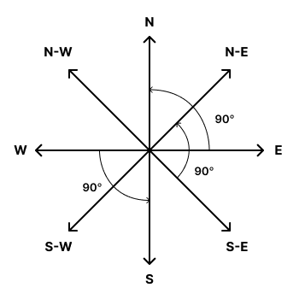

According to the above diagram, South -East becomes North-East , means rotate 90 degrees in anti-clockwise from the South-East. West becomes South , which means rotate 90 degrees in anti-clockwise from the South. Rotate 90 degrees from East , East becomes North.

Another way :
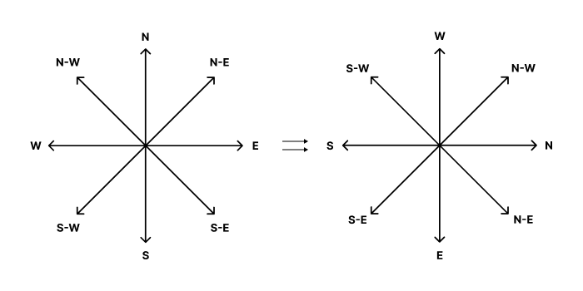

According to the diagram East becomes North.
Shadow based :
Shadows always fall in the opposite direction of the Sun.
For example: In the morning, when the sun rises in the east, shadows will be towards the
West.
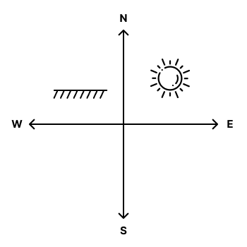
In the evening, with the sun in the west, shadows point towards the east.

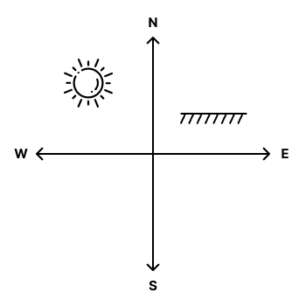

Question : one evening Ajay and Aman, walking opposite to each other.It is observed that Ajay’s shadow is to the left of Aman.In which direction Aman is facing?
Solution :
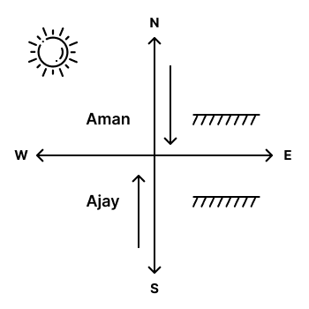

According to the diagram , Aman is facing South.

Coding and Decoding :

Number Series
A Number series
is a sequence of numbers arranged in a specific order or pattern. Each number in the series follows a certain rule or a set of rules based on arithmetic operations like addition, subtraction, multiplication, division, or more complex mathematical functions.
The pattern or rule,that is used to find the next number or missing number in the series.
Preference Answer: While solving and selecting answers on Number series problems follow the preferences below.
- Addition(+)/ Subtraction(-)
- Multiplication(x)/Division(/)
- Natures of terms: Odd numbers, Even numbers, Prime numbers, Square numbers, Cubes.
- Multiple operators

Question: Find the next term in the series: 4, 7 , 10 , 13 , ?
Solution:
4 + 3 = 7 7 + 3 = 10 10 + 3 = 13 Here in the series, we add 3 to the previous number. 13 + 3 =16 The next term in the series is 16.

Question: Find the next term in the series: 43 , 42 , 40 , 37, 33 ,?
Solution: 43 - 1 = 42 42 - 2 = 40 40 - 3 = 37 37 - 4 = 33 In these series, we subtract consecutive numbers starting from 1, from the previous number.
The next consecutive number is 5. 33 -5 = 28 The next term in the series is 28.

Question: Find the next term in the series: 2 , 4 , 12 , 48 , ?
Solution: 2x2 = 4 4x3 = 12 12x4 = 48 Here the series, multiply the previous term with consecutive numbers start from 2. 2 ,3 ,4 completed. The next consecutive number is 5. 48x5 = 240. The next term in the series is 240.
Question : Find the next term in the series : 4 , 7 , 12 , 19 , 30 ,?
Solution : 4 + 3 = 7 7 + 5 = 12 12 + 7 = 19 19 + 11 = 30 Here the series is based on prime numbers starting from 3 added to the previous number. The next prime number is 13. 30 + 13 = 43. The next term in the series is 43.

Question : Find the next term in the series : 3 , 2 , 4 , 3 , 6 ,5 , ?
Solution : 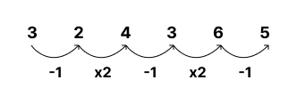
The above series is considered as (3,2) (4,3) (6,5) Series is 3-1 = 2 2x2 = 4 4-1 = 3 3x2 =6 6-1 = 5 Next term is 5x2 =10 The next term is 10.
Question : Find the next term in the series : 3 , 5 , 7 ,?
Solution: 3 + 2 = 5 5 + 2 = 7 Here the pattern is to add 2 to the previous number. 7 + 2 = 9 The next term is 9.

Another way: 3 ,5 ,7 are Prime numbers. If we follow the prime numbers pattern then the next number is 11. According to the Preference Answers. The addition is first Priority. Therefore , the next term in the series is 9.
Question : Find the missing number in the series :5 , 15 , 26 ,? ,51, 65.
Solution :
5 + 10= 15 15 + 11 = 26 Here the series,Add consecutive numbers starting from 10 to the previous number. The next number is 12. 26 + 12 = 38 38 + 13 = 51 51 + 14 = 65 The missing number is 38.

Alphabet series :
- Alphabet series is a sequence of letters that follows a specific pattern or rule. Just like number series, each letter in an alphabet series is based on a certain rule or set of rules, and also involves the positions of letters in the alphabet, such as skipping letters, reversing order, or using a fixed numerical increment or decrement.
- Alphabet series based on Alphabets and Its position.
- The total number of alphabets is 26.
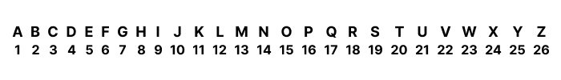

Question : MAB , NCD, OEF ,?
Solution : MAB , NCD , OEF In this pattern , The first letter increased by 1 position and the next two letters increased by 2 positions.
2nd Term: NCD M+1 =N A+2 =C B+2 =D 3rd Term: OEF N+1 =O C+2 =E D+2 =F Next Term : O+1 =P E+2 =G F+2 =H Therefore next term in the series is PGH.
Question : ACE , FHJ , KMO , ?
Solution :
In this pattern, Previous letter + 5 = Next letter 1st term : ACE A+5 =F C+5 =H E+5 =J 2nd term : FHJ F+5 =K H+5 =M J+5 =O 3rd term : KMO K+5 =P M+5 =R O+5 =T Therefore next term in the series is PRT.
Question : M4A , NB7 , O5C , PD6, ? , RF5.
Solution : In the series , Alphabets follow +1 logic . M+1 =N A+1 =B N+1 =O B+1 =C O+1 =P C+1 =D P+1 =Q D+1 =E Q+1=R E+1 =F Number series follow alternative +1 and -1 logic.(focus on the position of the number also). In every next term the last two values interchanging their positions. 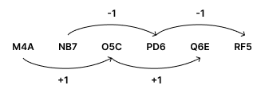
Center positioned numbers logic is 4+1 = 5 5+1 =6 The last positioned number logic is 7-1 =6 6-1 =5 The missing term is Q6E.
Question : ZY , WV , TS , QP?
Solution : Here the pattern starts from the last alphabet Z. 1st term : ZY Z-1 =Y 2nd term : WV Y-2 =W W-1 =V 3rd term : TS V-2 =T T-1 =S 4th term : QP S-2 =Q Q-1 =P Here pattern is,
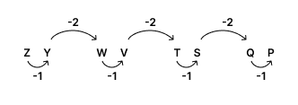
Subtract 1 from 1st term 1st letter ,we get 2nd letter. Subtract 2 from 1st term 2nd letter then we get the 2nd term. Same pattern for all the terms. Next Term : P-2 =N N-1 =M The Next term in the series is NM.

Odd man out & Analogies :
Odd man out
Odd man out is an element or number or term in a series that is different from the others. It stands out because it doesn't follow the same pattern or share the same characteristics as the rest of the series.
Question : Find the Odd man out : 10 , 20 , 40 , 51 ,60 ?
Solution : The series follows multiples of 10 . All numbers are multiples of 10 except 51. 51 not follow the pattern.
Question : Find the Odd man out : ADH , BEI , CFM, DGK .
Solution : 1st Term : ADH A A+3 =D (D=3) D+4 =H (H=8) 2nd Term : BEI A+1 =B (A=1 , B=2) B+3 =E (B=2 , E=5) E+4 =I (E=5 , I=9) 3rd Term : B+1 =C (B=2 ,C=3) C+3 =F (C=3 ,F=6) F+4 =J (F=6 , J=10) But in the series, CFM is there. CFM does not follow Pattern . 4rth Term : DGK C+1 =D (C=3 ,D=4) D+3 =G (D=4, G=7) G+4 =K (G=7 , K=11)
Analogy :
Analogy is comparisons between two things and finding similar comparisons in other things.
Question : 345 : 678 :: 261 : ?
Solution : 345 : 678 3+3 =6 4+3 =7 5+3 =8 Same pattern is followed by 261 2+3 =5 6+3 =9 1+3 =4 261 : 594 Therefore ,the Analogy is 345 : 678 :: 261 : 594.
Question : ABC : ZYX :: GHI : ?
Solution : ABC : ZYX 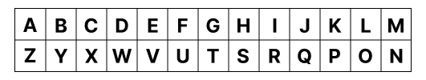
Reverse of A is Z . Reverse of B is Y. Reverse of C is X. Same pattern for GHI G - T H - S I - R Therefore,Analogy is ABC : ZYX :: GHI : TSR.

Question : Fish : Water :: Bird : ?
Solution : Fish : Water Fish move through water as birds move through air. Bird : Air Analogy is Fish : Water :: Bird : Air.
Question : Speedometer : Speed :: Odometer : ?
Solution : Speedometer : Speed A speedometer measures the speed of a vehicle. Odometer : odometer measures the distance travelled Analogy is Speedometer : Speed :: Odometer : Distance.

Coded language:
Coding means changing words, numbers, letters ,or symbols into a special form using certain rules or patterns.
Decoding is the process of converting these special forms into their original words, numbers, letter or symbols by understanding and applying these rules or patterns.
Letter to Letter Coding:
Question : If ‘COMPUTER’ is written as ‘DPNQVUFS’ in a certain code, then how ‘LAPTOP’
would be written in that same code?
Solution : COMPUTER -> DPNQVUFS C+1 = D O+1= P M+1=N P+1= Q U+1 =V T+1 =U E+1 = F R+1 = S Here the pattern is Added 1 to each letter in a word. Same pattern for LAPTOP L+1=M A+1 =B P+1=Q T+1=U O+1=P LAPTOP -> MBQUPQ Therefore ,LAPTOP is written as MBQUPQ.

Letter to Number Coding:
Question : If GRAPH is coded as 23156, NOTE is coded as 4078, how can PHONE be coded in that language?
Solution :
GRAPH -> 23156 NOTE -> 4078 G = 2 N = 4 R = 3 O = 0 A = 1 T = 7 P = 5 E = 8 H = 6 PHONE P = 5 H = 6 O = 0 N = 4 E = 8 Therefore, PHONE is coded as 56048.

Word Coding:
Question : In a certain code, "gim tol sim" means "what is this"; "dak gim sim" means "who is this". What would be the code for "what"?
Solution :
"gim tol sim" -> what is this "dak gim sim" -> who is this. In both sentences this is common and the common code is gim sim. Remaining word in the gim tol sim is “tol”. Therefore ,”what” is coded as “tol”.

Question : In a certain code, "785" means "book is good"; "248" means "good or bad", "376" means "book and paper". What stands for "is" in that code?
Solution : Sentence 1: 785 is coded as a “book is good”.
Sentence 2: 248 is coded as a “good or bad”. Sentence 3: 376 is coded as a “book and paper”. In sentence 1 and 2 number 8 is common and the common word is “good”. 8 = good In sentence 1 and 3 number 7 is common and the common word is “book”. 7 = book In sentence 1 , number 7 and 8 have words. Remaining number is 5 and the word is “is”. Therefore the “is” code is 5.

Letter to Symbol Coding
Question : In a certain code ‘HONEY’ is written as ‘ % * + & # ’ and ‘WARD’ is written as ‘ ? @ ! / ’ . How can ‘HEAD’ be written in that code?
Solution : HONEY written as, WARD written as ,
H = % W = ? O = * A = @ N = + R = ! E = & D = / Y = # HEAD written as H = % E = &
A = @ D = / Therefore , HEAD is written as “% & @ / “.

Number to Letter Coding
Question : In a certain code, 2431 is written as RMNO, 05678 is written as HICAG. How is
7260 written in that code?
Solution : 2431 written as RMNO 05678 written as HICAG 2 = R 0 = H 4 = M 5 = I 3 = N 6 = C 1 = O 7 = A 8 = G 7260 written as 7 = A 2 = R 6 = C 0 = H Therefore , 7260 written as “ARCH”.

Data Arrangements :
Linear Arrangement
A linear arrangement is a type of sitting arrangement where objects or individuals are placed in a straight line, one after the other, without changing the order.
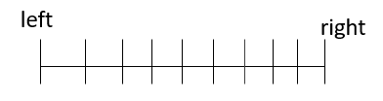
Question : In a row, six individuals - K, L, M, N, O, and P - are seated. M is not sitting beside N, who is sitting on the extreme right. O is between K and M. K is not sitting beside P and N. L is between P and N. Who is sitting immediately to the right of K?
Solution :

Six positions : - - - - - - Statement 1 : M is not sitting beside N who is sitting on the extreme right This means M doesn’t sit on either side ( left of N or right of N) of N and N is extreme right means N sits right end because there is only 2 ends either left or right. - - - - - N
Statement 2 : O is between K and M. Here we don’t know the exact positions of K and M but between K and M O is sitting. K O M Statement 3 : K is not sitting beside P and N. Statement 4 : L is between P and N. We know the position of N. - - - P L N Now we consider statement 3 : K is not sitting beside P and N. This Means K is not on either side ( left of N or right of N and left of P or right of P) of P and N. we know the position of P. Place statement 2 in the remaining places. K O M P L N. Arrangement :
K O M P L N
O is sitting immediately to the right of K.
- N who is sitting at the extreme right is a Direct hint.
- M is not sitting beside N is an Indirect Hint.
- O is between K and M is Confusion Hint.

Note
When one person is said to be "to the left of" another, it means that person is positioned anywhere on the left side to the other person.
Example : In a queue of 5 people - X,Y, P,M,G . X is at the extreme left of the queue.
X - - - -
Y is present to the right of X . The above sentence means Y is present in any one place out of 4 to the right of X.The sentence doesn’t mean Y is to the immediate right of X.

Note
if any question mentions a person is "4 places to the right" of another person, it means that there are four gaps between them but not 4 people.

Example : In a queue of 4 persons -A,B,C,D .A is Extreme left of the queue.B is present 2 places to the right of A. A _ B 1 2 The Two gaps represent 2 places. It is mentioned B is present 2 places to the right of A. Which means there is one person and two gaps in between them.

Circular Arrangement
- Circular Arrangementis a type of arrangement, where objects or people are positioned in a circular pattern, facing either towards the center of the circle or outward.
- Circular Arrangement can be Clockwise Direction and Anticlockwise Direction.

Statement : Six people – L, M, N, O, P and Q are sitting around a circular table, facing toward the center. L is sitting two places to the right of N. O is sitting two places to the right of L. P is sitting directly opposite N. Q is not sitting next to O. Who is sitting directly to the left of P?
Question : Who is sitting directly to the left of P?
Solution :

In the given data mentioned ,all are facing the center. Statement 1 : L is sitting two places to the right of N. Statement 2 : O is sitting two places to the right of L. Statement 3 : P is sitting directly opposite N. Statement 4 : Q is not sitting next to O. In the remaining place M is sitting.

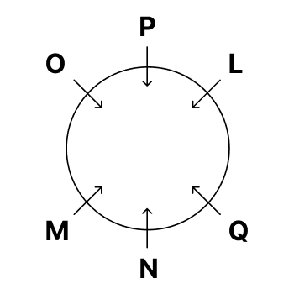

According to the above diagram, L is sitting directly to the left of P.

Note
In a circular arrangement, one person is to the left of another, it means that the person is immediately to the left of the other person.
Question : Who is sitting 2 places to the right of M ?
Solution : 2 places to the right of M Here we count the two gaps ,not two persons. Q is sitting 2 places to the right of M.

Question : Who is adjacent to P ?
Solution : O and L are adjacent to P.

Question : If L and M exchange places, who is sitting together ? A)PN B) OL C)OM D) NO
Solution : If L and M exchange their places OL are sitting together. Option B is correct. PN and OM,No sitting together is not possible.

Question : Who is sitting in between N and L in an anticlockwise Direction?
Solution : Q sits in between N and L.

Statement : Five friends Five friends : A, B, C, D, and E – are sitting around a circular table, facing outward. A is sitting three places to the left of C. B is sitting two places to the right of D. E is not sitting next to C.
Question : Who is sitting to the right of A ?
Solution : In the given data mentioned, facing outwards.
E is sitting to the right of A.
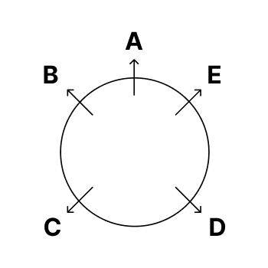

E is sitting to the right of A.

Note
In a circular arrangement, one person is to the right of another, it means that the person is immediately to the right of the other person.
Question : Who is sitting two places to the left of C?
Solution : E is sitting two places to the left of C.
Question : What is the position of D? A)Between E and C B)Adjacent to A C) Immediate left of B D)data Inadequate.
Solution : D is sitting in between E and C. Option A is correct.

Blood Relations :
Blood Relation
- Blood relations define how people in a family are related to each other through birth or marriage or any other reasons.
- Blood Relation finds relationships between two specific people in the family such as parents and their children, siblings, and other relatives like grandparents, aunts, uncles, and cousins.

1st Generation :
In blood relations, 1st Generation refers to the most senior level in a family hierarchy, which usually includes GrandMother and GrandFather.

2 types of GrandMother and GrandFather
1. Paternal - GrandMother and GrandFather
If anything related to a father or father's side of the family then called paternal.
2. Maternal - GrandMother and GrandFather
If anything related to a mother or the mother's side of the family then called maternal.

2nd Generation :
In blood relations, 2nd Generation refers to the children of the 1st Generation, which includes Father-in-law, Mother-in-law , Father , Mother , Aunt , and Uncle.

Father-in-law :
He is the father of person's spouse (wife or Husband), connected to the person through marriage
then called Father-in-law.

Mother-in-law :
She is the Mother of person's spouse (wife or Husband) , connected to the person through marriage then called Mother-in-law.

Uncle and Aunt :
Aunt :
An Aunt is a woman who is the sister or sister-in-law of a Parent.
Uncle :
A Uncle is a man who is the brother or brother-in-law of a parent.

2 types of Uncle and Aunt:
1. Maternal Uncle and Aunt :
Mother’s Brother is the Maternal Uncle.
Mother’s Sister isMaternal Aunt.
2. Paternal Uncle and Aunt :
Father’s Brother is the Paternal Uncle.
Father’s Sister is Paternal Aunt.

3rd Generation :
In the 3rd Generation ,Husband and Wife , Brother and Sister , Sister in law and Brother in law and Cousin there.

Husband and Wife :
Husband and Wife Spouse to each other or Couples or Partners.

Brother :
A boy who is the sibling of a person is called a Brother.

Sister :
A girl who is the sibling of a person is called a Sister.

Brother-in-law and Mother-in-law:
Partner siblings are Brother in law and Sister in law.

Cousin :
The parent’s sibling child is called Cousin.

4th Generation:
The 4th generation refers to the grandchildren of a 1st Generation and Children of a 3rd Generation. This Generation includes Son ,Daughter ,Niece , Nephew , Son in law and Daughter in law.

Son :
A son is a male child in relation to his parents.
Daughter :
A daughter is a female child in relation to her parents.
Son-in-law:
A son-in-law is the husband of a daughter.
Daughter-in-law:
A daughter-in-law is the wife of a son.
Niece :
Parent's sibling (sister or brother) daughter is called a Niece.
Nephew :
Parent's sibling (sister or brother) son is called Nephew.

Family Tree Notations :
Male : Square
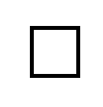
Female : Circle


Spouse : Square ⇔ Circle
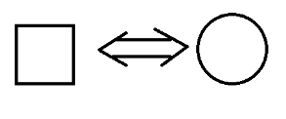

Sibling : Circle = Square = Circle
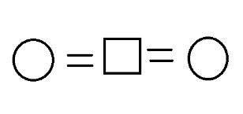

Next Generation : Down Arrow


Question : X is the father of Y. Y is the brother of Z. W is the daughter of Z. V is the sister of W. U is the father of V. T is the son of Y. S is the nephew of Z. How is V related to X?
Solution :
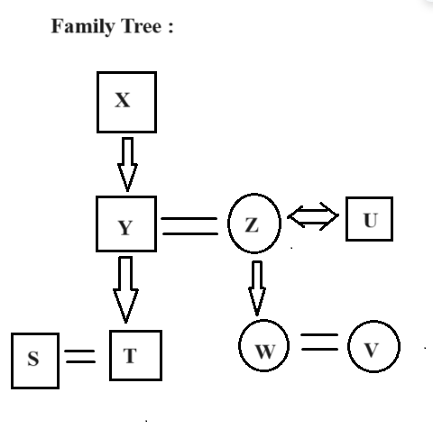
V is the Granddaughter of X.

Question : How many Female members are there in the family?
Solution :
3 female members are there in the family.

Question : How is Z related to S?
Solution : Z is Aunt to S.

Question : How is T related to the V?
Solution :
T is Cousin to the V.

Question : Who is the Father of Z ?
Solution : X is the Father of Z.

Symbol Based Blood Relation :
In this type of question use symbols like + , # , $ , & , - etc.These are used to define the relationship between two persons.
Question : If A - B means A is the mother of B; A + B means A is the brother of B; A x B means A is the father of B and A / B means A is the sister of B, which of the following shows that M is the maternal aunt of L. A)M+N/O+L B) M/N -O+L C) MxL+N/O D)M-N+O+L
Solution :
A - B —> A is the Mother of B. A + B —> A is the brother of B. A x B —> A is the father of B. A / B —> A is the sister of B.
A) M+N/O+L Here M is the brother of N. M is Male. In the question mentioned M is Maternal Aunt but here already M is Male.
B) M/N -O+L
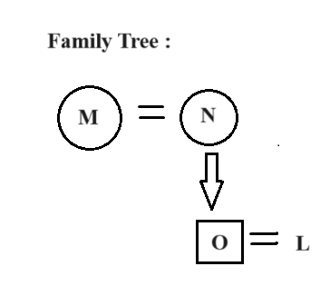

According to the above diagram , M is the Maternal Aunt of L. This Option is Correct.
C) MxL+N/O Here M is the father of L . M is not female , So no need to check the complete option. In the question mentioned M is Maternal Aunt but here already M is Male.
D) M-N+O+L
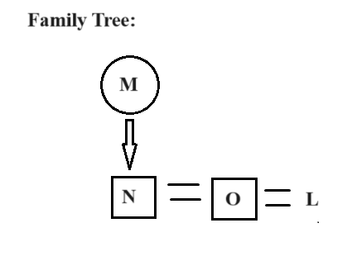

According to the above diagram , Here M is the Mother of L. The option is wrong.

Blood Relations 2 :
Personal Narratives Models
- In this model, blood relation question based on the particular person itself and if condition.
- This type of question is based on “Myself” ,”I” ,”My” and Particular person's name.
- We never determine the gender of a person with respect to their name.
- If we read the question from "My", "i" ,"Myself" then we will easily evaluate the relationship.

Question : Pointing to a photograph of a boy, Sunitha said, "He is the son of the only daughter of my father." How is Sunitha related to that boy?
Solution : Read the question from “My”. "My father" means Sunitha’s Father.(Here sunitha saying) "Only daughter" means the Father has only one Daughter means sunitha is his daughter. "He is the son of the only daughter" means the boy is Sunitha’s Son.
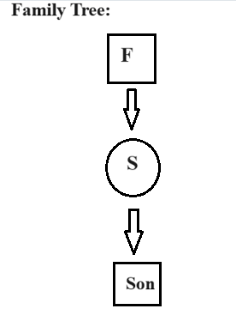

Sunitha is Mother is of the boy. In the above diagram , F -> Father S -> Sunitha

Question : Kiran said, "This man is the husband of the granddaughter of my father." How is Kiran related to the man?
Solution:
Read the question from “My “. My father means Kiran father because Kiran said. Granddaughter Here 2 Family trees are possible. 1.She is daughter of Kiran The man is husband of kiran’s daughter

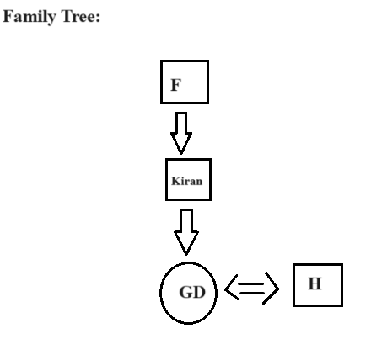

According to this relationship Kiran is Father in law of that man.
2 . Another possibility : She is the daughter of Kiran’s brother or sister The man is the husband of Kiran’s brother or sister’s daughter.
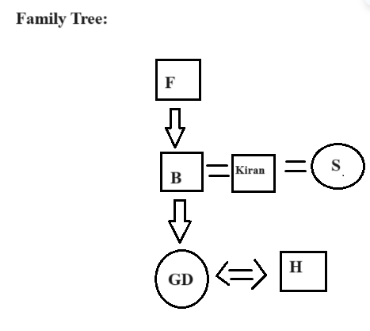

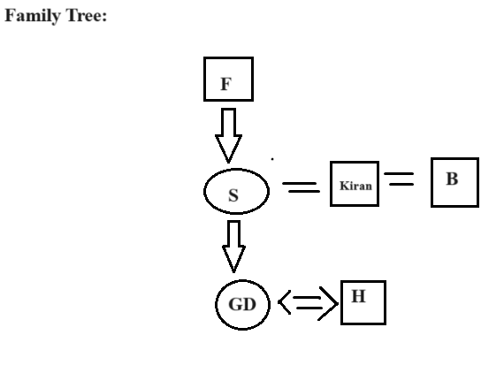
According to this relationship , Kiran is uncle to that man. because Kiran is the sibling of his wife's Father or Mother. In the above diagram, F -> Father S -> Sister B -> Brother GD -> GrandDaughter H -> Husband
Question : If C is the sister of X, Y is the son of X, Z is the brother of C, W is the daughter of Y, Who is the aunt of Y?
Solution :

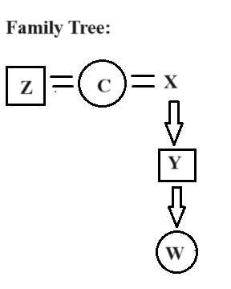
According to the above diagram, C is the aunt of Y.

Venn Diagram
- A Venn diagram is a graphical way to represent the relationships between different sets of items. It uses overlapping circles, where each circle represents a set, and the overlap shows common elements between the sets.
- Venn diagrams are particularly used for demonstrating relationships like union, intersection etc.
- The Overlap circles show the intersection between two sets. It means common elements.
- μ
represents a universal set or a whole set of items or people.

Venn diagram for two sets :
Example : In a high school, 300 students.180 students play soccer, 160 playing basketball and 70 play both soccer and basketball.

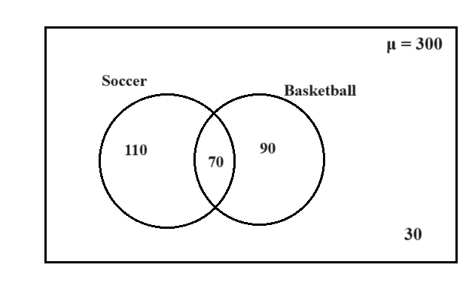

Here, the left circle represents the students who are playing soccer. And the right circle represents the students who are playing basketball. While drawing the circles, first consider the common value, and then we will easily add the remaining values inside the circles.
The sum of all the values in a specific circle should be equal to the value of the circle.
70 + 110 = 180 Here, 70 represents students who like both soccer and basketball. Here, 30 indicates these students have not played any game.

Venn diagram for Three sets :
Example : In a club of 850 members, 450 members enjoy swimming, 350 enjoy cycling and 300 enjoy running. 100 members enjoy both swimming and cycling, 80 enjoy both cycling and running, and 120 members enjoy both swimming and running. 40 members enjoy all three activities.

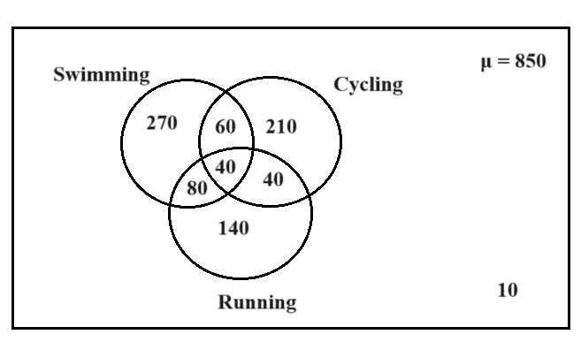

Question : In a community of 900 people, 500 members watch Tennis, 400 members watch Badminton,
and 350 members watch Squash. 150 members watch both Tennis and Badminton, 120 watch both Badminton and Squash, and 180 members watch both Tennis and Squash. 60 members watch all three sports.Then find how many members watch :
Venn diagram for above question
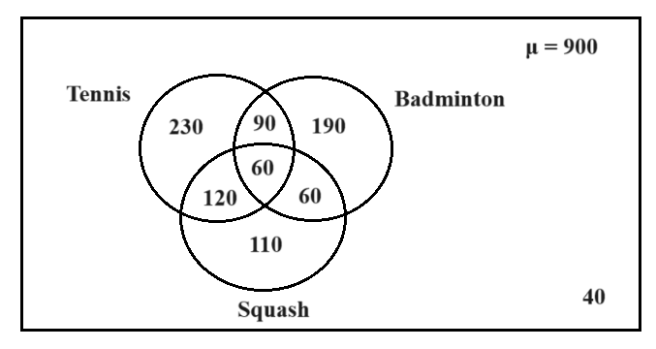

1.Exactly two games?
Solution:
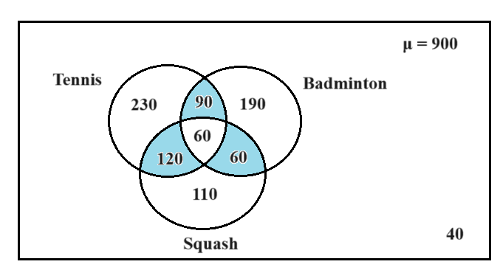

90 members watch both Tennis and Badminton. 120 watch both Tennis and Squash. 60 members watch both Badminton and Squash. Sum of members who watch both games =90 + 60 + 120 = 270 A total of 270 members watched exactly two games.
2.Badminton or Squash?
Solution :
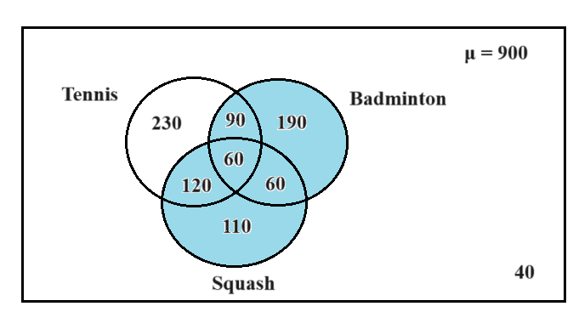

Total number of members who watch Squash = 350 As per the question they should watch either Badminton or Squash. Members who watch Badminton but not Squash are 190 + 90 =280. Total members who watched Badminton or Squash = 350 + 280 = 630.

3.only Tennis and Squash ?
Solution :
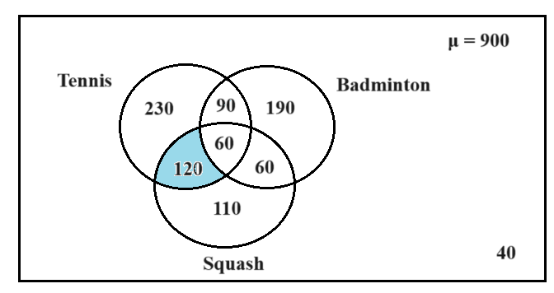
Here only Tennis and Squash means common members who watched both Tennis and Squash . 120 members watch both Tennis and Squash.
4.Exactly one game?
Solution :
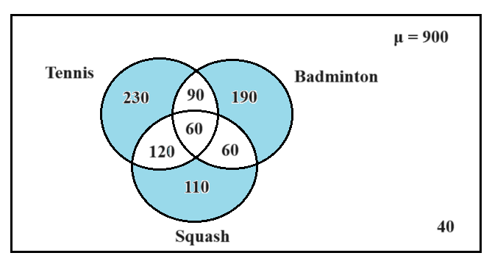

230 members only watch Tennis . 190 members only watch Badminton. 110 members only watch Squash. Sum of members who watched only one game = 230 + 190 + 110 = 530 530 members watched one game.
5.None of these games ?
Solution: Total members = 800 Add the values represented in a circle 230+ 90 + 60 + 60 + 120 + 190 +110 = 860 900 - 860=40 40 members did not watch any game.

Venn Diagrams :
Venn Diagram
- A Venn diagram is a graphical way to represent the relationships between different sets of items. It uses overlapping circles, where each circle represents a set, and the overlap shows common elements between the sets.
- Venn diagrams are particularly used for demonstrating relationships like union, intersection etc.
- The Overlap circles show the intersection between two sets. It means common elements.
- μ represents a universal set or a whole set of items or people.

Venn diagram for two sets :
Example : In a high school, 300 students.180 students play soccer, 160 playing basketball and 70 play both soccer and basketball.


Here, the left circle represents the students who are playing soccer. And the right circle represents the students who are playing basketball. While drawing the circles, first consider the common value, and then we will easily add the remaining values inside the circles.
The sum of all the values in a specific circle should be equal to the value of the circle.
70 + 110 = 180 Here, 70 represents students who like both soccer and basketball. Here, 30 indicates these students have not played any game.

Venn diagram for Three sets :
Example : In a club of 850 members, 450 members enjoy swimming, 350 enjoy cycling and 300 enjoy running. 100 members enjoy both swimming and cycling, 80 enjoy both cycling and running, and 120 members enjoy both swimming and running. 40 members enjoy all three activities.


Question : In a community of 900 people, 500 members watch Tennis, 400 members watch Badminton, and 350 members watch Squash. 150 members watch both Tennis and Badminton, 120 watch both Badminton and Squash, and 180 members watch both Tennis and Squash. 60 members watch all three sports.Then find how many members watch :
Venn diagram for above question


1.Exactly two games?
Solution:



90 members watch both Tennis and Badminton. 120 watch both Tennis and Squash. 60 members watch both Badminton and Squash. Sum of members who watch both games =90 + 60 + 120 = 270 A total of 270 members watched exactly two games.
2.Badminton or Squash?

Solution :


Total number of members who watch Squash = 350 As per the question they should watch either Badminton or Squash. Members who watch Badminton but not Squash are 190 + 90 =280. Total members who watched Badminton or Squash = 350 + 280 = 630.
3.only Tennis and Squash ?

Solution :


Here only Tennis and Squash means common members who watched both Tennis and Squash . 120 members watch both Tennis and Squash.
4.Exactly one game?
Solution


230 members only watch Tennis . 190 members only watch Badminton. 110 members only watch Squash. Sum of members who watched only one game = 230 + 190 + 110 = 530 530 members watched one game.5.None of these games ?
Solution: Total members = 800 Add the values represented in a circle 230+ 90 + 60 + 60 + 120 + 190 +110 = 860 900 - 860=40 40 members did not watch any game.

Syllogisms :
Syllogism
- Syllogism consists of statements and candidates work with provided statements to derive conclusions from the given statements.
- In syllogism, we find whether the conclusions will follow the statements or not.
- Usually, the 5 standard options of syllogism-based questions are.
1) If only conclusion I follows.
2) if only conclusion II follows.
3) if either conclusion I or II follows.
4) if neither conclusion I nor II follows.
5) If both conclusions I and II follows.
Question: Statements: All laptops are wireless devices. No wireless device is a desktop computer. Conclusions: I. Some laptops are not desktop computers.. II. No desktop computer is a laptop.
Solution:
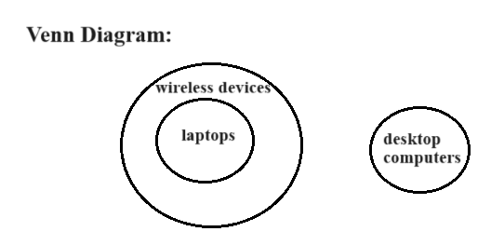
Conclusion I is satisfied with the above Venn diagram. Some laptops are not desktop computers because there is no relation between two sets, which means there is no intersection between two sets.
Conclusion II satisfies the above Venn diagram. No desktop computer is a laptop because there is no intersection between two sets. Therefore ,both conclusion I and conclusion II followsthe statements.

Question : Statements: Some cars are electric vehicles. Some electric vehicles are bikes. Conclusions: I. No bike is a car. II. Some cars are bikes
Solution :
Case -1 : Minimum Possibility

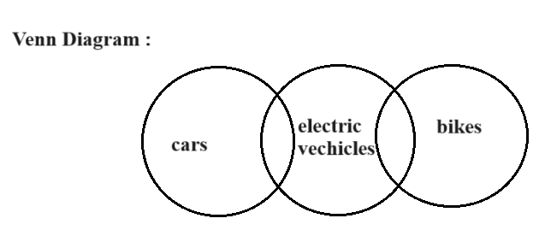

Case -2 : Maximum Possibility
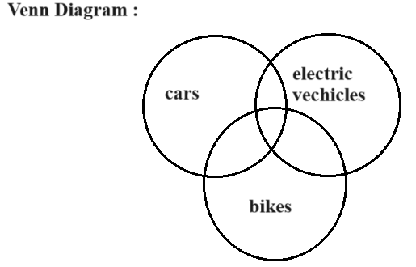
Conclusion I is satisfied in case-1. According to the Venn diagram in case -1 ,there is no intersection between bike and car. Conclusion I is not satisfied in case-2. According to the Venn diagram in case -2 , there is intersection between bike and car.
Conclusion II is not satisfied in case-1. According to the Venn diagram in case -1 ,there is no intersection between bike and car. Conclusion II is satisfied with case-2. According to the Venn diagram in case -2 , there is intersection between bike and car.
The above possibility is either Conclusion I or Conclusion II follows. Therefore ,
either Conclusion I or Conclusion II follows the statements.

Question: Statements: All fruits are edible. Many edibles are seeds. No seed is a tree. Conclusions: I. Some seeds are fruits. II. Some trees are edibles.
Solution:
Case -1: Minimum Possibility
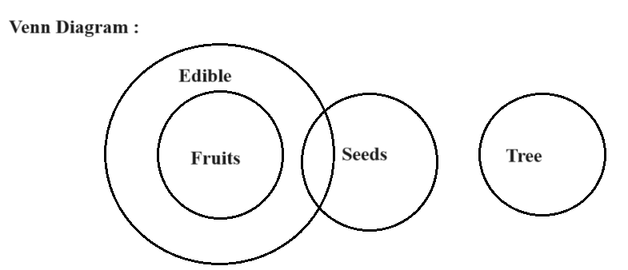

Case -2: Maximum Possibility
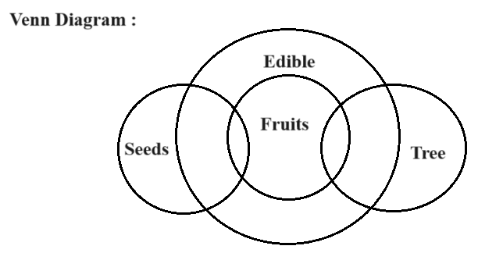

Conclusion I is not satisfied in case-1. According to the Venn diagram in case -1 ,there is no intersection between fruits and seeds. Conclusion I is satisfied in case-2. According to the Venn diagram in case -2 , there is intersection between fruits and seeds.
Conclusion II is not satisfied in case-1. According to the Venn diagram in case -1 ,there is no intersection between trees and edibles. Conclusion II is satisfied in case-2. According to the Venn diagram in case -2 , there is intersection between trees and edibles. All fruits are edible and Some fruits are trees (According to the case-2 ) then some trees are also edible.
Therefore ,neither Conclusion I nor Conclusion II follows the statements. This means none of the conclusions follows the statements.

Question: Statements: All artists are musicians. Some painters are artists Conclusions: I.Some painters are musicians II.No musician is a painter
Solution:
Case -1: Minimum Possibility
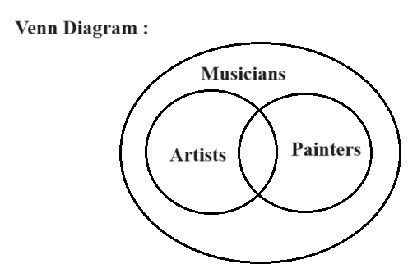

Case -2: Maximum Possibility

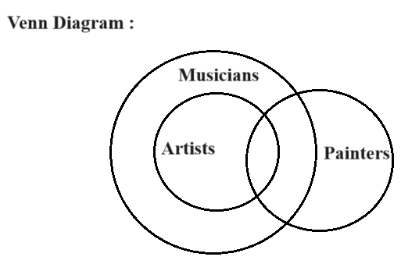
Conclusion I is satisfied in case -1. According to the Venn diagram in case -1 , there is a relation between musicians and painters. All painters are Musicians. Then, some painters are also musicians. Conclusion I is satisfied in case -2 . There is an intersection between musicians and painters.
Conclusion II is not satisfied in case 1. According to the Venn diagram in case -1,some painters are also musicians. Conclusion II is not satisfied in case -2 because there is an intersection between painters and musicians. Therefore , Conclusion I followsthe statements.

Syllogism 2 :
Syllogism - Tick and Cross
Single Statement Conclusions :
1.All A’s are B’s
Conclusions :
Some A’s are B’s
Some B’s are A’s
2.Some A’s are B’s
Conclusion :
Some B’s are A’s
3.No A’s are B’s
Conclusions:
Some A’s are not B’s
Some B’s are not A’s
No B’s are A’s
4.Some A’s are not B’s
Conclusion:
No conclusion

Tick and Cross ( ✔ and X ) :
1.All A’s are B’s.
2.Some A’s are B’s.
3.No A’s are B’s.
4.Some A’s are not B’s.
Tick and Cross for above Statements:
1. All A’s are B’s - Universal Positive Statement ✔ ✔
2.No A’s are B’s - Universal Negative Statement X ✔
3.Some A’s are not B’s - Particular Negative Statement X X
4. Some A’s are B’s - Particular Positive Statement

Syllogism Tick and Cross methodology have below Limitations and Rules.
Limitation: Complementary Pair : Using this methodology we can solve all syllogism based question except one condition where the solution would either(1) or (2). Excluding either(1) or (2) conclusion ,all the other models are solved by using the tickt and cross method.

Rules: Rule-1: In two statements, there should be 3 terms with one term as common and common term should have atleast one tick.

Question :
Statements:-
All cats are mammals.
All birds are animals.
Conclusions:-
A.All mammals are birds.
B.All birds are cats.
C.Some cats are birds.
D.None of these.

Solution :
All cats are mammals.
All birds are animals.
According to the rule ,there should be atleast one common term but here no common term in the statements.
Therefore,No conclusion .
According to the options ,the answer is None of these.

Note
If the common term in the statements, doesn't have at least one tick that implies there is no conclusion.

Rule-2: If both statements are particular, there is no conclusion.
Question:
Statements:-
Some cars are trucks.
Some trucks are vans.
Conclusion:-
A.Some cars are not vans.
B.No car is van C.
Some vans are not cars.
D.None of these.

Solution :
"Some" exists in both statements .
Both the statements are particular statements.
According to above rule ,
These statements have no conclusion.
Therefore,the answer is none of these.

Rule-3: If both statements are negative, there is no conclusion.
Question :
Statements:-
No pens are books .
No books are buckets.
Conclusions:-
A.Some buckets are pens.
B.Some pens are buckets.
C.All books are pens.
D.None of these.

Solution:
"No" exists in both statements.
Both the statements are Negative Statements. According to the above rule,
These statements have no conclusion.
Therefore, the answer is none of these.

Rule- 4: If one of the statements is particular, the conclusion must be particular.
Questions :
Statements:-
All A’s are B’s.
Some B’s are C’s.
Conclusions:-
A.No A’s are C’s.
B.Some C’s are B’s.
C.Both (A) and (B).
D.None of these.

Solution :
According to the above rule, In option B ,"Some" term is there and also according to the single statement conclusion,
Some B’s are C’s.
Conclusion:
Some C’s are B’s.
Therefore,Option B is correct.

Rule-5 : In two statements if we have a common term and the common term have atleast one tick then we will have a possibility to get a conclusion with other two terms. While considering the other two terms, if a term in statement is cross,that term must be cross in conclusion and if a term is tick in statement that term can be either tick or cross in conclusion.

Question:
Statements:-
All trees are plants.
Some living things are trees.
Conclusions:-
A.Some living things are not plants.
B.Some plants are not living things.
C.Some living things are plants.
D.Both (A) and (C)
Solution :

Tick and Cross for above statements,
✔ X 1. All trees are plants. X X
2.Some living things are trees. In both statements ,"tree" is a common term and one term has a tick. Now,consider the remaining two terms plants and living things. Plants and living things have cross. So, the conclusion must have cross. -> Tick and Cross for option A. X ✔ Some living things are not plants. This option is wrong because one tick is there. -> Tick and Cross for option B. X ✔ Some plants are not living things. This option is wrong because one tick is there. -> Tick and Cross for option C. X X Some living things are plants. Option C is correct according to the above rule.

Question :
A.Some cats are animals.
B.All animals are pets.
C.No cats are pets.
D.No bird is a pet.
E.All cats are birds.
F.Some animals are birds.
A. DEC B. AFE C. BFD D. CDE

Solution :
When options are DEC or ABC ,where the first two characters represent statements and the third character represents the conclusion. Option A: DEC D, E are statements and C is the conclusion. Statements : D - No bird is a pet E - All cats are birds Conclusion : C - No cats are pets -> Tick and Cross for above two statements: ✔ ✔ D - No bird is a pet. ✔ X E - All cats are birds.

Here, in both statements "bird" is a common term and one term has a tick. Now, consider the remaining two terms pet and cat. Pet has tick and cat has tick , According to the Rule-5, -> Tick and Cross for Conclusion C ✔ ✔ No cats are pets. Conclusion satisfied according to the above rule. Therefore, option A is correct.

Cubes :
Cube
- A cube is a three-dimensional solid object.
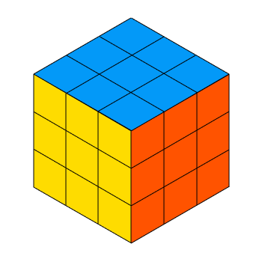
Face : Flat surface of the three-dimensional object is known as the "face of that object".


- A cube has 6 faces.
- Corner : A point where two or more edges or sides of a three-dimensional object meet is known as “Corner”.
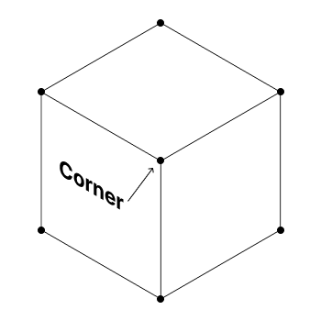

- A cube has 8 corners.
- Edge : A straight line that connects two corners or vertex on a three-dimensional object is known as “ edge”.
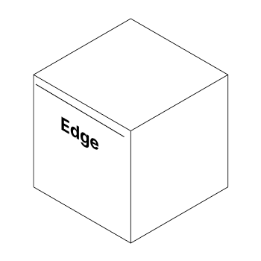
- A cube has 12 edges.
- The length, breadth and height are equal in a cube.
Length=Breadth=Height.
Note
A cube has 6 faces, 12 edges and 8 corners.
Maximum/Minimum number of Cubes
Formula:
- Minimum number of pieces = Number of cuts + 1
- Maximum number of Cubes = (nl + 1)x(nw + 1)x(nh + 1)
nl = Number of cuts towards the length
nw = Number of cuts towards the Width
nh = Number of cuts towards the Height.
nl = Number of cuts/3 Here, divided with 3 because the cube has 3 dimensions: Length (nl), Width(nw),
Height(nh). nl= nw = nh
Question : How many minimum and maximum number of pieces can be obtained when 9 cuts are made on a cube?
Solution :
Total number of cuts =9
Minimum number of pieces = Number of cuts + 1
Minimum number of pieces = 9 +1 = 10
nl = Number of cuts/3 Here, divided with 3 because the cube has 3 dimensions: length ,width,height. According to the properties of cube length, width and height are equal. nl = 9/3 = 3

Maximum number of pieces(cubes) = (nl + 1)x(nw + 1)x(nh + 1)
nl = 3
nw = 3
nh = 3
Maximum number of pieces(cubes) = (3+1)x(3+1)x(3+1)
= 4 x 4 x 4
= 64
Therefore , Minimum number of pieces is 10 and Maximum number of Cubes is 64.

Question : How many maximum numbers can be obtained when 19 cuts are made on a cube?
Solution :
If the number of cuts is not feasible to divide evenly by 3, then distribute the cuts consecutively to width, height and length.
nl = 6
nw = 6
nh = 7
Maximum number of pieces = (nl + 1)x(nw + 1)x(nh + 1)
= (6+1)x(6+1)x(7+1)
= 7 x 7 x 8 = 392
Therefore , Maximum number of pieces is 392.

Note
Number of cuts are divided into 3 parts(nl,nw,nh)and these three parts(nl,nw,nh) are either equal or consecutive.
Maximum/Minimum number of Cuts
Formulas:
- Minimum number of Cuts = (nl + nw + nh)
- Maximum number of Cuts = Number of Cubes - 1
Question : How many minimum/maximum number of cuts on a cube are required to obtain 216 pieces?
Solution :

216 = 6 x 6 x 6
= (5+1)x(5+1)x(5+1)
Maximum number of Cubes = (nl + 1)x(nw + 1)x(nh + 1)
Here, using Maximum number of Cubes formula to obtain the values of nl ,nw,nh.
Therefore, nl = 5
nw = 5
nh = 5
Minimum number of cuts = (nl + nw + nh)
= 5 + 5 + 5
= 15
Maximum number of Cuts = Maximum number of Cubes -1
= 216 -1
= 215.
Therefore, Minimum number of cuts is 15 and Maximum number of cuts is 215.

Painted Cubes.
Case -1 : When all sides of the cube is painted ,then we can use following formulas:
- Number of cubes painted on 3 sides = 8
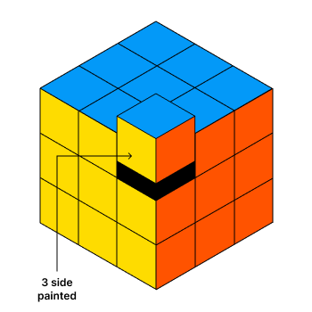
2.Number of cubes painted on 2 side = 12 x (n - 2)
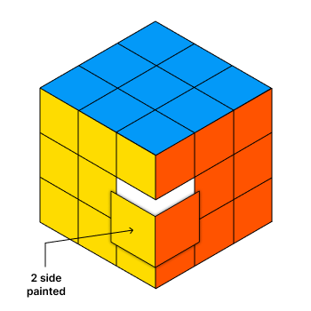

3. Number of cubes painted on 1 side = 6 x (n -2)^2
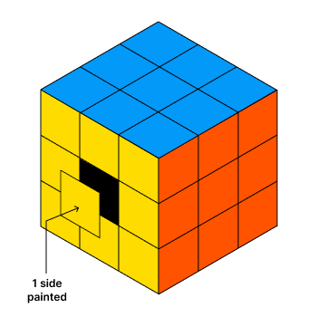

4.Number of cubes with no sides painted = (n -2)^3

Question : 64 small and identical cubes are put together to form a large cube, which is then painted on all six faces. Determine how many small cubes have:
1.No face painted
2.Exactly one face painted
3.Exactly two faces painted
4.Three faces painted
Solution :
n^3 = 64
n^3 = 4^3
n = 4
  - No face painted : Number of cubes with no sides painted = (n-2)^3
= (4-2)^3
= 2^3 = 8
Therefore ,No face painted cubes are 8.
  - Exactly one face painted : Number of cubes painted on 1 side = 6 x (n-2)^2
= 6 x (4 -2)^2
= 6 x (2)^2
= 6 x 4 = 24
Therefore, 24 cubes are one face painted.

  - Exactly two faces painted : Number of cubes painted 2 side = 12 x (n - 2)
= 12 x (4 - 2)
= 12 x 2 = 24
Therefore, Exactly two faces painted cubes are 24
  - . 4. Three faces painted :
Number of cubes painted on 3 sides = 8.
Therefore , three faces painted cubes are 8.

Case -2 : Two adjacent faces painted with same colour
Question : 125 small and identical cubes are put together to form a large cube. This large cube is painted on all six faces, with two adjacent faces painted the same colour (pink, blue, green). Find how many small cubes have:
1. Only pink colour on them
2. blue and pink on them
3. blue colour on them
Solution :
n^3 = 125
n = 5
1. Only pink colour on them :
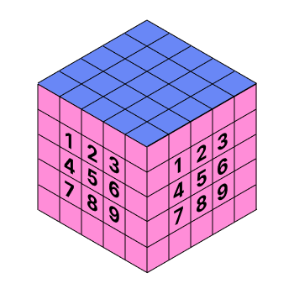
Here, two adjacent faces have the same colour pink. In one face, 9 cubes are there with the same colour pink means number cubes only one face painted with pink.
Another face has the same number of cubes with pink colour. Total number cubes with one face painted = 9+9 = 18

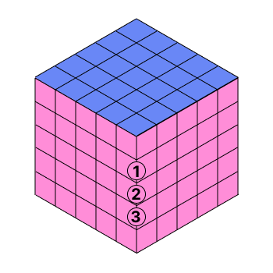

Here,
3 cubes are two faces painted with pink colour.
Total number of pink colour cubes = 2x9 + 3
= 18 + 3
= 21.
Shortcut Method:
For two adjacent face with same colour :
Number cubes only one face painted of single face of original cube= (n-2)^2
Number of cubes having one face painted with pink = 2x(n-2)^2
= 2x(5-2)^2
= 2x(3)^2
= 2x9 = 18
Number of Cubes having two face painted with pink = (n-2)
= (5-2)
= 3
Total number of cubes with only pink colour = 18 + 3
= 21.
Therefore , 21 cubes are painted only with pink.

2.blue and pink on them :
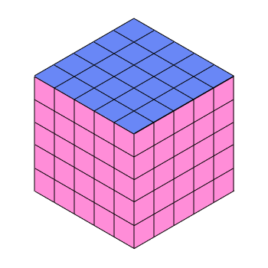

Cubes which have blue and pink colour on them are the cubes at the edges of cube where blue and pink colour intersect.
So, 3 edges will intersect here in this case (with 2 common vertices).
5 + 4 + 4 = 13
Shortcut Method :
Number of cubes which are painted on sides with pink and blue = (nx3)-2
= (5x3) - 2
= 15 - 2
= 13
Therefore , 13 cubes are painted pink and blue.
blue colour on them :
There are 2 faces of compounded cube painted with blue colour.
So no. of cubes in 2 faces are:
= (no. of cubes in a face)x2
= (nxn)x2
=(5x5)x2
= 50
But adjacent face are painted, so 1 common edge is computed twice.
So, subtract n(5) from above result = 50-5 = 45.
Therefore, 45 cubes have blue colour on them.
Case 3 : Three adjacent faces are painted with same colour
Question : A cube is painted in such a way that three adjacent faces are painted with the same colour(green & yellow).Then this cube is cut into 64 small and identical cubes, then find how many resulting cubes have :
1. only green colour on them.
2. green and yellow colour on them.

Solution :
n^3 = 64
n^3 = 4^3
n = 4
1. Only green colour on them :
3 adjacent faces are of green colour, and other 3 faces are of yellow colour. So, here compute
the number of cubes residing in the 3 adjacent green faces except cubes at the edge which
are interacting with Yellow colour.
Number of cubes with 1 face painted in Green colour = 3x((n-2)^2)
= 3x(4-2)^2
= 3x4
= 12
Number of cubes with 2 face painted in Green colour = 3x(n-2)
= 3x(4-2)
= 6
Number of cubes with 3 face painted in Green colour = 1
Total number of small cubes in Green are = 12 + 6 +1
= 19.
Therefore, 19 cubes are only with green colour.

- Green and yellow colour on them:
Small cubes which have green and yellow colour on them are the cubes at the edges of cube
where green and yellow colour intersect.
So, 6 edges will intersect here in this case (with 6 common vertices).
Cubes have green and yellow colour on them are = (nx6)-6
= (4x6)-6
= 24 - 6
= 18.
Therefore, 18 cubes are painted with green and yellow.

Puzzles :
Puzzle
Puzzle reasoning is analysing the given data and arranging the data based on given clues, identifying the correct solution. Puzzles are 2 types:
1. Paragraph based Puzzles
2. Characteristic based Puzzles

Paragraph based Puzzles
- Paragraph based puzzles provide a description that is given in a paragraphs and we need to find answer or solve a problem based on given data.
- In paragraph based puzzles,convert the data into a tabular form or diagrammatic form, based on the clues mentioned in given data then we find the answer in an easy manner.
Question : In a small village, there are three houses in different colours: red, blue and green. Three people live there: teacher,doctor and an artist. Each one has a different pet: a cat, a dog, and a bird. The teacher lives in the red house. Next to it, on the right side, is the green house. The doctor has a cat. The person with the bird lives in the blue house. Now, find out who owns the dog.

Solution :
Convert the given data into below form,
House : Red Green Blue
People : Teacher
Pet : Bird
Another clue , the doctor has a cat . In the above form, there is only one possibility to place ,the doctor and cat . The possibility is only in green house .
House : Red Green Blue
People : Teacher doctor
Pet : cat Bird
In the above data, dog and artist are not placed in any house.
House : Red Green Blue
People : Teacher doctor Artist
Pet : dog cat Bird
Therefore , Teacher owns the dog.

Characteristic based Puzzles:
Characteristic puzzles are figure-based puzzles containing various figures and we find a logical relationship between the elements. Once a logic is identified, it must satisfy all the figures.
Question : What number will replace the question mark?
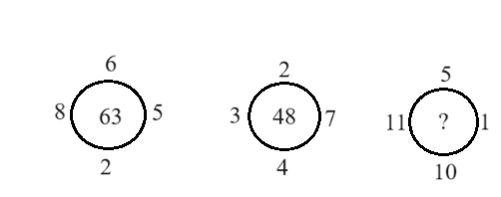
a)34 b)80 c)55 d)81

Solution :
Let we consider the figure-1 ,
Numbers are 8 ,6,5, 2.
Sum of these numbers = 8 + 6 + 5 + 2 = 21
Multiply 21 with 3 , get 63.
Figure - 2 :
Numbers in figure-2 are 3,2,7,4.
Sum of these numbers = 3 + 2 + 7 + 4
= 16
Multiply 16 with 3 , get 48.
The above logic is satisfied in figure-1 and figure -2. So,
same logic for figure-3.
Figure -3 :
Numbers in figure-3 are 11,5,10,1.
Sum of these numbers = 11 + 5 + 10 +1
= 27
Multiply 27 with 3 , get 81.
Therefore,option d is correct.

Data Sufficiency :
- Data Sufficiency refers to determining whether the provided information is sufficient to answer a question or solve a problem.
- Data Sufficiency based questions usually give a problem and statements of data and these questions are either quantitative or logical.
- The main challenge is not necessarily to solve the problem completely but to evaluate whether the data in the statements are sufficient to answer the question.
- Usually the 5 standard options of Data Sufficiency based questions are :

- If statement I alone is sufficient
- If statement II alone is sufficient
- If both statements I and II together are sufficient
- If either statement I or II is sufficient
- If neither statement I nor II is sufficient

Question : Five lectures are to be conducted from Monday to Friday. On which day, the astronomy lecture planned?
Statement I: The psychology lecture is on Thursday, immediately after the environmental science lecture.
Statement II: The biology lecture is on the Wednesday, and three lectures are scheduled after the physics lecture.
Statement I :
Day Lecture
Monday
Tuesday
Wednesday
Thursday Psychology lecture
Friday Environmental science
By using statement I ,we only find two lectures in 2 days.
Statement I is not sufficient to find all lectures and days.
Statement II :
Day Lecture
Monday
Tuesday Physics
Wednesday Biology
Thursday Psychology lecture
Friday Environmental science
Both statements are sufficient to find the answer for the question.
Remaining lecture is astronomy.
Day lecture
Monday Astronomy
Tuesday Physics
Wednesday Biology
Thursday Psychology lecture
Friday Environmental science
Therefore , the answer is both statements I and II together are sufficient.

Question : What is the LCM of A & B, if A:B = 3:4?
Statement I: HCF of A & B is 6 .
Statement II: A & B are multiples of 3.
Solution :
Statement I :
HCF is 6, then A and B can be expressed as 3x and 4x,
where x is the HCF.
So, A = 3x6 = 18
B = 4x6 = 24.
LCM (18, 24) = 72.
Statement II :
Statement II is not sufficient to determine the exact values of A and B or their LCM.
Therefore , Statement I alone is sufficient.

