Introduction To Numerical Ability

Numbers
A number is an arithmetic value used to represent quantity.
Classification Of Numbers
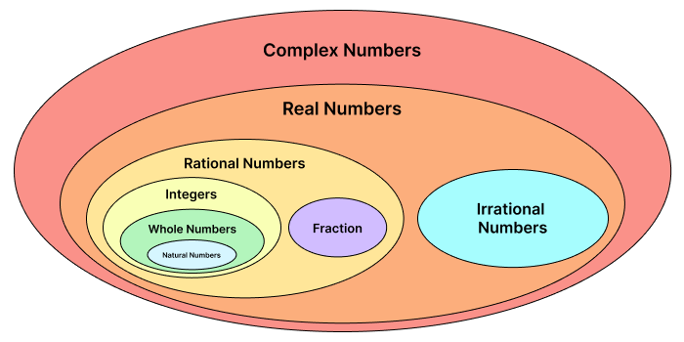

Complex Number :
Complex numbers have both a real and an imaginary part, typically written as (a + ib), where
A and b are real numbers and I is the imaginary unit (i²) = -1.
Ex: (2 + 3i) , (32 + 5i) etc.
Real Number:
A real number is any number that can be found on the number line.
This includes all rational numbers such as integers and fractions, as well as irrational numbers.
Ex: 7.4 , 12.1, 23, 45/7, 3.565574,
Rational Number:
A number that can be expressed in the form of (p/q) , where p and q are integers and q can not be zero.
Ex: (⅘) , (⅝) , 1.9 , 5 , 89
Note : Rational number is further classified into Integer and Fraction.

Irrational Number:
Irrational numbers cannot be expressed in the form of (p/q) where p and q are integers.
or
Any term which is non-terminating and non-repeating is also known as an irrational number.
A non-terminating and non-repeating number is a decimal number that goes on forever without ending or forming a repeating pattern.
Ex: (√2),(√3), 4.56746..... , 985.467
Note : There is no further classification for irrational numbers.

Integer:
Integers include all positive and negative natural numbers including zero.
Ex: -5,-6,7,8,0 etc

Whole Number:
Whole numbers are the set of positive integers including zero.
Ex : 0,1,2,3,4,5 etc

Natural Number:
Natural numbers are the set of positive integers, excluding zero.
Ex: 1,3,5,6,8 et
Fraction:
A number that can be expressed in the form of (p/q), where P and q are natural numbers.
Ex: (⅗) - Here, 3 is numerator, and 5 is denominator.
Fraction is further classified into proper, improper, mixed fraction.
Proper Fraction
A proper fraction is a fraction where the numerator (the top number) is less than the denominator (the bottom number). In other words, the part is less than the whole.
Ex: (⅔) - Here, 2 is less than 3, making it a Proper Fraction

Improper Fraction:
An improper fraction is a fraction where the numerator is equal to or greater than the denominator. The part is as much as or more than the whole.
Ex: (7/4) - Here, 7 is greater than 4, making it an Improper Fraction

Mixed Fraction
A mixed fraction combines a natural number and a proper fraction.
Ex: 2 (¼) - Here, 2 is the natural number, and (¼) is the proper fraction part.

Divisibility Rules
Divisibility rule of 2:
A number is divisible by 2 if its last digit is even (0, 2, 4, 6, or 8).

Divisibility rule of 4:
A number is divisible by 4 if the last two digits from a number divisible by 4.

Divisibility rule of 3:
A number is divisible by 3 if the sum of its digits is divisible by 3.

Divisibility rule of 9:
A number is divisible by 9 if the sum of its digits is divisible by 9.

Divisibility rule of 5:
A number is divisible by 5 if its last digit is 0 or 5.

Divisibility rule of 10:
A number is divisible by 10 if it ends in 0.

Divisibility rule of 6:
A number is divisible by 6 if it is divisible by both 2 and 3.

Divisibility rule of 12:
A number is divisible by 12 if it is divisible by both 4 and 3.

Divisibility rule of 7
If a number is divisible by 7, you can check by doubling the last digit, subtracting that from the remaining part of the number, and if the result is a multiple of 7 or zero, then the original number is divisible by 7.

Divisibility rule for 11
If the difference of the sum of alternative digits of a number is divisible by 11, then that number is divisible by 11 completely.
Sum of digits in odd places – Sum of digits in even places = 0 or a multiple of 11.

Concept of Co-Prime numbers
Co-prime numbers are pairs of numbers that don't share any common factors except for 1.
To be considered co-prime, a set of numbers must have at least two numbers, and the only common factor between them should be 1.
The Highest Common Factor (HCF) of co-prime numbers always is 1.
The Lowest Common Multiples (LCM) of co-prime numbers always equals the product of numbers.
Ex: 5 and 6 are co-prime numbers because the only factor

Division Algorithm :

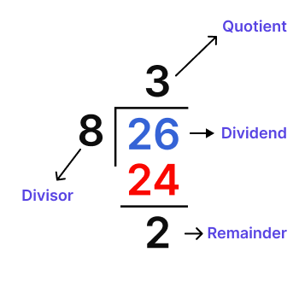

For any integer a , and any positive integer b, there exist unique integers n and r, such that
a = b*n + rwhere r is greater than or equal to 0 and less than b.
0 ≤ r < b
In the division algorithm equation, a is the dividend
b is the divisor
r is the remainder
And nis the quotient

Power cycle :

Unit Digit Concept
The unit digit concept involves focusing on the rightmost digit of a number, which is commonly referred to as the unit digit. The unit digit is in the one’s place, representing the smallest place value in the number.
Ex: Unit digit of 847 is 7

Simple Product Type
To find the unit digit of the product, we only need to focus on the unit digits of the numbers being multiplied.
Ex: What is the unit digit of the product 478×593
- Identifying Unit Digits:
The unit digit of 478 is 8.
The unit digit of 593 is 3.
- Multiply the unit digits:
8×3=24
The unit digit of the result is 4.
Hence, The unit digit of 478×593 is 4.

Power Cycle Type :
The power cycle of a number is like a special pattern formed by its digits when you keep raising the number to different powers. It's the set of all unique combinations of digits you get before the pattern starts repeating.

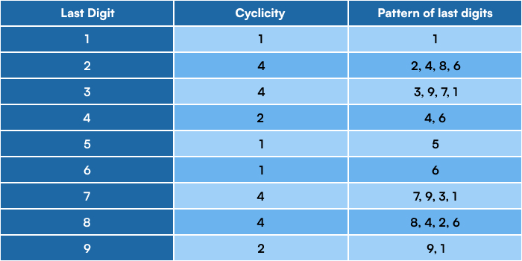

The cyclicity concept refers to the repeating pattern of unit digits that occurs when certain numbers are raised to powers.
Based on cyclicity, digits are organised into three categories.
- Numbers ending with (0, 1, 5, 6)
- Numbers ending with (4,9)
- Numbers ending with (2,3,7,8)
Digits 0, 1, 5, and 6:
Here, when each of these digits is raised to any power(except 0), the unit digit of the final answer is the number itself.
Examples:
5² = 25: Unit digit is 5, the number itself.
1⁵ = 1: Unit digit is 1, the number itself.
0⁹ = 0: Unit digit is 0, the number itself.
6² = 36: Unit digit is 6, the number itself.

Question: Find the unit digit of 121²⁶.
Solution: The unit digit of 121²⁶ is 1.
This is because the unit digit of any power of 1 is always 1.

Digits 4 and 9:
Both of these two digits, 4 and 9, have a cyclicity of two different digits as their unit digit.
- 4^{odd} = 4: If 4 is raised to the power of an odd number, the unit digit will be 4.
- 4^{even} = 6: If 4 is raised to the power of an even number, the unit digit will be 6.
- 9^{odd} = 9: If 9 is raised to the power of an odd number, the unit digit will be 9.
- 9^{even} = 1: If 9 is raised to the power of an even number, the unit digit will be 1.
Examples:
4² = 16: Unit digit is 6.
4³ = 64: Unit digit is 4.
9² = 81: Unit digit is 1.
9³ = 729: Unit digit is 9.
It can be observed that the unit digits 6 and 4 are repeating in an odd-even order. So, 4 has a cyclicity of 2 . Similar is the case with 9.
Question: Find the unit digit of 34⁵⁶.
Solution: The unit digit of powers of 4 follows a cyclicity pattern: 4, 6, 4, 6, and so on.

Since 56 is an even number, the unit digit of 34⁵⁶ will be the same as the unit digit of 4^2, which is 6.
Therefore, the unit digit of 34⁵⁶ is 6.

Digits 2, 3, 7, and 8:
These digits have a cyclicity pattern that repeats every four numbers.
Let see the cyclicity of 2.
2¹ = 2: Unit digit is 2.
2² = 4: Unit digit is 4.
2³ = 8: Unit digit is 8.
2⁴ = 16: Unit digit is 6.
2⁵ = 32: Unit digit is 2.
2⁶ = 64: Unit digit is 4.

It can be observed that the unit digits 2, 4, 8, and 6 repeat themselves after a period of four numbers.
Similarly:
- The cyclicity of 3 has 4 different numbers: 3, 9, 7, 1.
- The cyclicity of 7 has 4 different numbers: 7, 9, 3, 1.
- The cyclicity of 8 has 4 different numbers: 8, 4, 2, 6.
Understanding these cyclicity patterns simplifies calculations when dealing with powers of 2, 3, 7, and 8
Question: Find the unit digit of 253¹²⁵.
Solution: To find the unit digit of 253¹²⁵, we can use the cyclicity pattern of the unit digit of 3. The unit digit of powers of 3 follows a cyclicity of 4: 3, 9, 7, 1.
Since, (125 = 4 * 31 + 1(R)), the unit digit of 253¹²⁵ will be the same as the unit digit of (3^1), which is 3.
Therefore, the unit digit of 253¹²⁵ is 3.
Trailing Zeroes
Trailing zeros refer to the zeros that appear at the end of a number, after the last nonzero digit.
Trailing zeros in a natural number are a result of the factors of 10 in its prime factorization. Here's a method to determine the number of trailing zeros in a natural number:
Step 1: Prime Factorization:
Break down the number into its prime factors.
Step 2: Count Factors of 2 and 5:
Determine the count of factors of 2 and 5 in the prime factorization.
(2*5 = 10), so every pair of factors of 2 and 5 contributes one trailing zero.
Step 3: Determine the Number of Trailing Zeros:
The count of trailing zeros will be equal to the minimum value between the count of factors of 2 and the count of factors of 5.
This is because, in each pair of factors, we need both a factor of 2 and a factor of 5 to get a factor of 10.
Example:
Consider the natural number 4 x 9 x 125.
Prime factorization: (2² x 3² x 5³).
Count of factors of 2: 2, count of factors of 5: 3.
Minimum count: 2 (number of trailing zeros in 4 x 9 x 125).

- Remainder cycle:
What is Remainder?
When you divide a number N by another number x, the result can be expressed in the form of N = Q x + R , where:
- N is the original number.
- X is the divisor.
- Q is the quotient.
- R is the remainder.

In your example, when dividing 10 by 3:
The number being divided , N = 10
The divisor ,x = 3
The quotient Q is 3, because 3*3 = 9, which is the largest multiple of 3 and less than 10.
The remainder Ris 1, because 10 - 9 = 1
Thus, the expression becomes 10 = 3*3 + 1.
Basic Remainder Theorem:
The basic remainder theorem is based on the product of individual remainders.
When we divide a product of numbers by a divisor, the remainder can be found using the remainder of each individual number divided by the same divisor.
Let's suppose three numbers a , b , and c and we want to multiply them together:
axbxc.
Assume d as divisor.
a_{r} remainder when a is divided by d.
b_{r} remainder when bis divided by d.
c_{r} remainder when cis divided by d.
Multiply these remainders together: (a_{r} x b_{r} x c_{r})
Finally, divide (a_{r} x b_{r} x c_{r}) by d. The remainder you get here will be the same as if we had multiplied axbxc and then divided by d.
Exponential Remainder Cycles Theorem:
Exponential remainder cycles deals with finding the remainder of a large exponent expression when divided by a number.
The cycle refers to the repeating pattern of remainders that occur when raising a base to successive powers and then dividing by a fixed divisor.
Example:
Suppose we want to find the remainder when ( 2¹⁰⁰ ) is divided by 5.
- Find the Remainder Cycle:
Calculate the remainder of 2¹ when divided by 5, which is 2.
Calculate the remainder of 2² when divided by 5, which is 4.
Calculate the remainder of 2³ when divided by 5, which is 3 (since (2³ = 8) and (8 mod 5 = 3)).
Calculate the remainder of 2⁴ when divided by 5, which is 1 (since (2⁴ = 16) and (16 mod 5 = 1)).
Now, when you calculate 2⁵, the remainder is 2 again (as (2⁵ = 32) and (32 mod 5 = 2 )).
So, you can see a cycle of remainders: 2, 4, 3, 1, and then it repeats.
- Use the Cycle for the Exponent:
The cycle length is 4. Now, you need to find the position in the cycle for the 100th power of 2.
To find this, divide the exponent (100) by the cycle length (4).
The remainder of (100/4) is 0, which means that the 100th power of 2 will have the same remainder as the 4th power of 2 in the cycle.
- Determine the Remainder:
Since the remainder for 2⁴ in the cycle is 1, the remainder of (2¹⁰⁰) when divided by 5 is also 1.

LCM
The LCM(Least Common Multiple) is the smallest number that is a multiple of two or more numbers.
To find the LCM of two numbers, you follow these steps:
- List the Prime Factors of Each Number:
Break down each number into its prime factors
- Identify Common and Unique Prime Factors:
Identify both the prime factors that are shared by both numbers and those that are unique to each number.
- Multiply the Highest Power of All Prime Factors:
For each prime factor, find the highest power that appears in the factorization of either number, and then multiply those highest powers together.
Example: Find the LCM of 12 and 18.
- Prime Factorization:
12 = 2 × 2 × 3 = 2²*3
18 = 2 × 3 × 3 = 2*3²
- Identify Common and Unique Factors:
Common Prime Factors: 2,3
Unique Prime Factors: 2² in 12 and 3² in 18
- Multiply the Highest Powers
From 12: 2²
From 18: 3²
LCM = 2²*3² = 4 × 9 = 36
Therefore, the LCM of 12 and 18 is 36.It means 36 is the smallest number that can be divided by 12 & 18 without leaving a remainder

HCF
The Highest Common Factor (HCF), also called the Greatest Common Divisor (GCD), is the biggest number that can divide two or more numbers evenly, meaning without any remainders.
HCF By Prime Factorization Method
Follow the below-given steps to find the HCF of numbers using the prime factorisation method.

Step 1: Write each number as a product of its prime factors. This method is called prime factorization.
Step 2: Now list the common factors of both the numbers
Step 3: The product of all common prime factors is the HCF ( use the lower power of each common factor)

Example: Find HCF of 18 and 27.
To find the Highest Common Factor (HCF) of 18 and 27, we will first express each number as a product of its prime factors and then identify the common factors.
- Prime Factorization:
18 = 2¹*3²
27 = 3³
- Identify Common Prime Factors:
The common factors of 18 and 27 are 3².
- Calculate HCF:
The HCF is the product of the lowest power of all common prime factors.
In this case, the lowest power of 3 common to both 18 and 27 is 3².
Therefore, the HCF of 18 and 27 is 3² = 9.
Properties of LCM and HCF
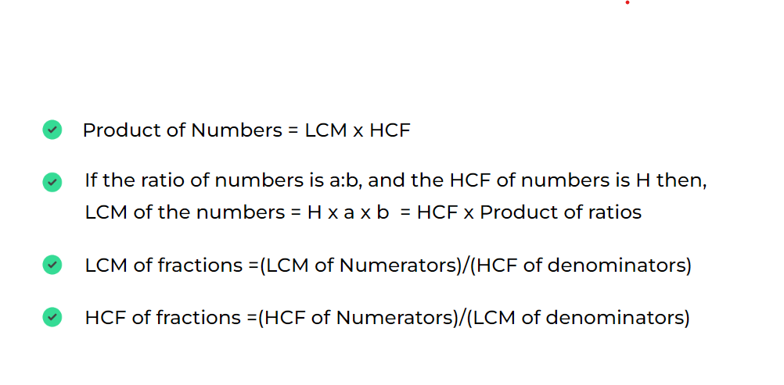

(i) Product of Numbers = LCM of numbers * HCF of numbers
Question: LCM and HCF of two numbers are 168 and 7. One number is 21 then, find the other number?
Solution: Let the other number be x. Formulae: Product of Numbers = LCM of Numbers * HCF of Number 21*x = 168x7 x= 56 Hence another number is 56.

(ii) If the ratio of numbers is a:b, and the HCF of numbers is H then, LCM of the numbers = H x a x b = HCF x Product of ratios
Question: Two numbers are in the ratio 15:11 their HCF is 13 then find the LCM of the numbers.
Solution: Number are in ratio 15:11 Let the number be 15x and 11x Formulae: LCM of numbers = HCF of numbers * Product of ratios of number
LCM= 13 x (11 x 15) LCM = 2145

(iii) LCM of fractions =(LCM of Numerators)/(HCF of denominators)
Question: Find LCM of (4/5) and (3/7).
Solution: Formulae: LCM of fractions =(LCM of Numerators)/(HCF of denominators) LCM of ((4/5), (3/7)) = LCM of numerator(4,3) / HCF of denominators(5,7) =(12/1)

(iv) HCF of fractions =(HCF of Numerators)/(LCM of denominators)
Question: Find HCF of (4/5) and (3/7).
Solution: Formulae: HCF of fractions =(HCF of Numerators)/(LCM of denominators) HCF of ((4/5), (3/7)) = HCF of numerator(4,3) / LCM of denominators(5,7) =(1/35)

Multiple
A multiple is the product of a number multiplied by an integer, which is not a fraction. To find the multiples of a whole number, we multiply it by the counting numbers (positive integers including zero).
Let's consider the number 5 and find some of its multiples.
Multiplying by Different Integers:
- When 5 is multiplied by 1, the product is 5*1 =5
- When 5 is multiplied by 2, the product is 5*2 =10
- When 5 is multiplied by 3, the product is 5*3 =15
- Similarly, when multiplied by 4, 5, 6, etc., we get 20, 25, 30, and so on.
Understanding Multiples:
- All these products (5, 10, 15, 20, 25, 30, ...) are called the multiples of 5.
- Multiples can also be negative. For example, 5x(-1)= -5, 5x(-2)= -10 , etc., are also multiples of 5.
Zero as a Multiple:
- Zero is a multiple of every number because when you multiply any number by 0, the product is 0. So, 0 is a multiple of 5 as well.
Common Multiple:
Multiples that are common to two numbers are known as common multiples of those numbers.
Let's consider two numbers, 4 and 6, and find some of their common multiples.
Multiples of Each Number:
- The multiples of 4 include 4, 8, 12, 16, 20, 24, 28, 32, 36, 40, and so on.
- The multiples of 6 include 6, 12, 18, 24, 30, 36, 42, 48, 54, 60, and so on.
Identifying Common Multiples:
- The numbers that appear in both lists are the common multiples.
- For 4 and 6, the common multiples include 12, 24, 36, 48, and so on.
Least Common Multiple (LCM):
- Among the common multiples, the smallest one is known as the Least Common Multiple (LCM). For 4 and 6, the LCM is 12.

Type of Question asked on multiple:

(i) The Least number which is exactly divisible by x,y and z.
Question: Find the least number which is exactly divisible by 10,15 and 20.
Solution: Prime factorization: 10 = 2x5 15 = 3x5 20 = 2x2x5 LCM(10,15,20) = 2x3x2x5 = 60. Hence, 60 is the least number which is divisible by 10,15 and 20.

(ii)The Least number which when divided by x,y and z leaves the same remainder R in each case.
Question: The Least number which is exactly divisible by 8,10 and 12 leaves the same remainder 4 in each case.
Solution: Prime factorization: 8 = 2x2x2 10 = 2x5 12 = 2x2x3 LCM(8,10,12) = 2x2x2x3x5 = 120 So, 120 is the least number which is exactly divisible by 8,10 and 12. But we want the least number which when divided by 8,10 and 12 leaves the remainder 4. Hence, Actual number = 120+4 = 124.

(iii) The Least number which when divided by x,y and z leaves remainder a, b and c respectively.
Question: Find the least number which, when divided by 4, 5, and 6 leaves the remainder 2, 3, and 4, respectively.
Solution: a=4, b=5, c=6. x=2, y=3, z=4 k = a-x = b-y = c-z = 4-2 = 5-3 = 6-4 = 2 k=2 Actual value = LCM(a,b,c) - k Actual value =LCM(4,5,6) = 60 - 2 = 58 Hence, 58 is the value which when divided by 4,5 and 6 leaves remainder 2,3 and 4.
Highest power of a number in a factorial.
If p is prime number, then the highest power of p in a factorial n is given by [n/p]+[n/(p^2)]+[n/p^3]+…
Example: Highest power of 3 in 15!
Highest power of 3 in 15! is given by,
=>[15/3]+[15/(3²)]+[15/(3³)]+... => 5 + 1 + 0 (Here, we are adding integral part of quotients) => 6

Question: Highest power of 12 in 50!.
Solution: 12 = 3* 2²
Highest power of 2 in 50! is, => [50/2] + [50/(2²)] + [50/(2³)] + [50/(2⁴)] + [50/(2⁵)] => 25+12+6+3+1 = 47 (Adding integral part of quotients) Highest power (2^2) in 50! is (47/2) = 23(integer part of quotient) Highest power of 3 in 50 => [50/3] + [50/(3²)] + [50/(3³)] => 16+5+1 = 22 (Adding integral part of quotients)
Since the maximum power of 3 is less than the maximum power of 2², the maximum power of 12 in 50! will be equal to the maximum power of 3 in 50! which is 22.

Factors
A factor of a number is a number that divides the given number evenly or exactly, leaving no remainder.
Note
When we are studying factors of a number, we only consider positive integers. A factor cannot be a fraction or a decimal. Also, since division by 0 is undefined, 0 cannot be a factor of any number
To check if x is a factor of a certain number n, simply divide n by x.
If the remainder is 0, then x is a factor of n. Otherwise, x is not a factor of n.
Examples of factors for different numbers:
Factors of 18:
- Factors of 18: 1, 2, 3, 6, 9, 18
Factors of 24:
- Factors of 24: 1, 2, 3, 4, 6, 8, 12, 24
Factors of 36:
- Factors of 36: 1, 2, 3, 4, 6, 9, 18

Terms related to factors of numbers:
- Total number of factors
- Sum of factors
- Product of factors
- Even Factors
- Total number of factors
- Suppose any number N Prime factorization of N = A^{p} x B^{q} x C Total number of factors for N = (p + 1)x(q +1)x(r +1)
Question: Find the total number of factors of 120.
Solution: Prime factorization of 120. 120= 2³ x 3¹ x 5¹
Here, A= 2 , B= 3 , C= 5 p= 3 , q= 1 , r= 1 Number of factors of 120= (3 + 1)(1 +1)(1+1) = (4)x(2)x(2) = 16

Sum of factors:
The sum of factors of a number is the total of all the numbers that divide that number exactly, including 1 and the number itself. Suppose any number N, Prime factorization of N= a^{p} x b^{q} x c^{r}Sum of factors of N = (a⁰ + a¹ + ... + a^{p}) × (b⁰ + b¹ + ... + b^{q}) × (c⁰ + c¹ + ... + c^{r})

Question: Determine the total number of factors of 162 along with the product of all factors.
Solution: First, write the prime factorization of 162. 162 = 2 × 3 × 3 × 3 × 3 162 = 2¹ × 3⁴
Here, X = 2, Y = 3 and a = 1, b = 4 Therefore, Total number of factors of 162 = (a +1)(b+1) = (1+1)(4+1) = 2 × 5 = 10 Product of factors of 162 = 162^{(10/2)} = 162⁵
Product of factors :
The formula for the product of all factors is given by
Product of factors of
N= N ^{((Total No. of Factors)/2)}
Question: Determine the total number of factors of 162 along with the product of all factors.
Solution: First, write the prime factorization of 162. 162 = 2 × 3 × 3 × 3 × 3 162 = 2¹ × 3⁴
Here, X = 2, Y = 3 and a = 1, b = 4 Therefore, Total number of factors of 162 = (a +1)(b+1) = (1+1)(4+1) = 2 × 5 = 10 Product of factors of 162 = 162^{(10/2)} = 162⁵

Even FactorsLet N
is the number whose the prime factorization is N = a^{p}. b^{q}. c^{r} ...
Where (a<b<c) ... are prime numbers and a, b, c , ... positive integers.
Total Number of even Factors of N= a^{p}. b^{q}. c^{r}.... is (p) x (q + 1) x ( r + 1)... if ( a = 2 ) (N is an even number)
Note
Total Number of even Factors of N= a^{p}. b^{q} is 0, if ( a != 0) (N is an odd number)
Question: Find the total number of even factors of 120.
Solution: Prime Factorization of 120 is 120 = 2³ × 3¹ × 5¹.
Thus, Total number of even factors of 120 is (3)(1 + 1)(1 + 1) = 3 × 2 × 2 = 12.

Percentage
A percentage is a way to express a number as a fraction of 100. The term
percent-> per centum , which means by the hundred. The symbol % is used to denote a percentage.
When we want to calculate the percentage of a specific number, we divide that number by the total amount and then multiply the result by 100.This calculation converts the fraction to a percentage.
Or
To determine the percentage, we have to divide the actual value by the total value and then multiply the resultant by 100.

Note
Percentage formula = (Actual Value/Total value) × 100
Percentages can also be represented in decimal or fraction form, such as 0.6%, 0.25%, etc

Example: If we have 50 apples out of 100,then the percentage of apples we have? Actual apple = 50 Total apple = 100
Percentage formula = (Actual Value/Total value) × 100 Percentage of apples = ((50/100)*100)% = 50% This means we have 50 percent of the total apples.
Examples on basics of percentage:

Question: If 40% of a number is 20, then find the number.

Solution: Let X be the required number. 40% of a number is 20 (given) (40/100) × X = 20 So, X = (20 × 100) / (40) X = 50

Question: Which number is 50% less than 90?
Solution: Required number = 50% of 90 = (50 x 90)/100 = 45 Therefore, the number 45 is 50% less than 90.

Decimal to Fraction Conversion

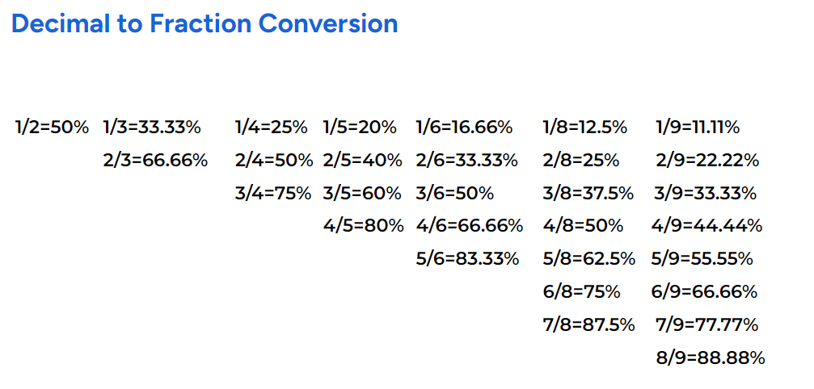

Let see how to convert Decimal to Fraction with few examples.
Question: What is 50% of 108?
Solution: 50% = ½ (50% = 50/100 = ½) 50% of 108 = ½ *108 = 108/2 = 54.

Question: What is 33.33% of 99?
Solution: 33.33% = ⅓
33.33% of 99 = ⅓ *99 = 99/3 = 33.

Question: What is 16.66% of 120?
Solution: 16.66% = ⅙ 16.66% of 120 = ⅙ *120 = 120/6 = 20.

Question: What is 37.5% of 160?
Solution: 37.5% = ⅜ 37.5% of 160 = (⅜)x160 = (160x3)/8 = 60.

Magic Cycle
- Magic Circle of (1/7):
Themagic circle of 1/7refers to the repeating decimal pattern that occurs when we divide 1 by 7. The result is a recurring decimal with a specific sequence that repeats indefinitely.
When 1 is divided by 7, the result is approximately 0.142857. This decimal repeats indefinitely, so it can be written as 0.142857142857..., and so on.

The magic aspect of this cycle is that the sequence of numbers (142857) keeps repeating in the same order. Additionally, if you multiply this repeating decimal by any integer from 1 to 6, the product will be a rearrangement of the same digits (142857).

For example:
- 2/7 = 28.5714%
- 3/7 = 42.8571%
- 4/7 = 57.1428%
- 5/7 = 71.4285%
- 6/7 = 85.7142%
- Each result is a rearrangement of the same digits (142857), which is a unique
property of the fraction 1/7.

Question: What is 28.5714% of 140?

Solution: 28.5714% = 2/7 28.5714% of 140 = (2/7) x140 = 140x(2/7) = 40.

Percentage Change:
Percentage change is a way to describe how much a value has increased or decreased in comparison to its original value.
It's commonly used to represent changes in prices, costs, or values over time.
Percentage Change comprises into two parts:
- Percentage Increase
- Percentage Decrease

Percentage Increase:
Percentage increase is a measure of how much a quantity has grown compared to its original value, expressed as a Percentage Increase.
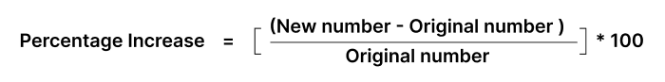
where,
Increase in number = New number – original number
Example: Let's say the population of a town was 2,000 people in 2010 and it increased to 2,500 people in 2020.
Original number (2010 population): 2,000 people New number (2020 population): 2,500 people % Increase= [(New number – Original number)/Original number] x 100
% Increase = [(2500-2000)/2000]*100 = 25 % So, the population of the town increased by 25% from 2010 to 2020.

Percentage Decrease:
Percentage decrease is a measure that shows how much a quantity has reduced compared to its original value, expressed as a Percentage Decrease.
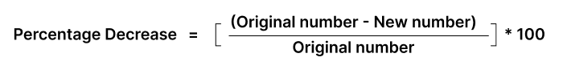
where,
Decrease in number = Original number – New number
Example: Let's consider a scenario where a company's profits decreased from 8000 in one year to 7000 the next year.
Original number (previous year's profits): 8000 New number (current year's profits): 7000
% Decrease = [(Original number - New number)]*100 % Decrease = [(8000 - 7000)/8000]*100 = 12.5%
Successive Percentage Change:
When two or more percentage changes are applied to a quantity consecutively,then the percentage change is called a “successive percentage change.”
Example: Let's say a product's price is initially 100. First, it increases by 20%, and then it decreases by 10%.
Initial Price: 100 First Change (20% Increase): New Price = Original Price + (Percentage Increase × Original Price) New Price = 100 + (20% × 100) = 100 + 20 = 120 Second Change (10% Decrease on the New Price): New Price = Previous New Price - (Percentage Decrease × Previous New Price) New Price = 120 - (10% × 120) = 120 - 12 = 108 So, after a 20% increase and a 10% decrease, the final price of the product is 108.
Successive Percentage Change for two consecutive intervals:
Successive change for two consecutive intervals involves applying one percentage change after another to a value. The final value is determined by the compounded effect of these changes.
Net % Change or Overall Percentage Change = x + y + (xy/100) Where,
x,y → Increment or Decrement Percentage
+ve→ Increment
-ve→ Decrement

Question: Price of gold increased by 10% in the first year and decreased 20% in the second year. Find the overall percentage change after 2 years.
Solution: Let, x = +10% (increment) y = -20% (decrement) Overall Percentage change = 10 + (-20) + [10*(-20)]/100 Overall Percentage change = 10 - 20 + (-2) = -12 Hence, After 2 year overall percent change = -12%(Decrement)

Question: Price of petrol increased by 20% in the first year and increased by 20% in the second year. Find the overall percentage change after 2 years.
Solution: Let, x = 20% (increment) y = 20% (increment) Overall Percent change = 20 + (20) + [20*20]/100 Overall Percent change = 20 + 20 + 4 = 44 Hence, After 2 year overall percent change = 44%

Profit and loss :
Cost Price
This is the amount seller has to pay to buy a product or commodity. It's often abbreviated as CP.
Selling Price
This is the amount at which a product is sold to a customer. It's often abbreviated as SP.
Or
This price is what the buyer pays for the item, and it can be different from the cost price.
Difference between selling price and cost price:
Cost Price is the amount at which the retailer/seller has bought the product.
Selling Price is the amount at which the buyer/customer is willing to purchase that product.
Profit(P)
The amount gained by selling a product for more than its cost price.
Note
Profit = Selling Price(SP) - Cost Price(CP)
Question: Suppose a shopkeeper has bought 1 kg of apples for Rs. 400. And sold it for Rs. 550. How much is the profit gained by him?
Solution: Cost Price for apples is 400. Selling Price for apples is 550. Profit(P) gained by shopkeeper is P = SP – CP P = 550 – 400 = 150
Loss(L)
The amount lost by selling a product for less than its cost price.
Note
Loss = Cost Price(CP) - Selling Price(SP)
Question: John bought a bicycle for 5000 (Cost Price, CP). He later sold the bicycle for 4000 (Selling Price, SP). Calculate the loss John incurred on this sale.
Solution: Cost Price for Bicycle 5000. Selling Price for Bicycle is 4000. loss(L) gained by shopkeeper is L = CP – SP L = 5000 - 4000 = 1000
Profit Percent
Profit percentage is a measure of how much profit you make on a sale relative to the cost price.

Note
Profit Percent(P%) =[(SP - CP)/CP]*100
Question: Emma runs a small jewellery business. She bought a necklace for Rs. 12,000 (Cost Price, CP) and sold it for Rs. 18,000 (Selling Price, SP). Calculate the profit percentage Emma made on this sale.
Solution: CP = 12,000 SP = 18,000 Profit Percent(P%) =[(SP - CP)/CP]*100 Profit Percent(P%) = [(18,000-12,000)/12,000]*100 Profit Percent(P%) = 50%
Loss Percent
Loss percent is a measure of how much loss you incur on a sale relative to the cost price.
Note
Loss Percent(L%) = [(CP - SP)/CP)]*100
Question: Mike owns a small electronics store. He purchased a smartphone for Rs.15,000 (Cost Price, CP) but was only able to sell it for Rs. 12,000 (Selling Price, SP) due to a new model being released. Calculate the loss percent Mike incurred on this sale.
Solution: CP = 15,000 SP = 12,000
Loss Percent(L%) = [(CP - SP)/CP)]*100 Loss Percent(L%) = [(15,000 - 12,000)/15,000]*100 Loss Percent(L%) = 20%

Discount :
Marked Price(MP)
The Marked Price is the price a shopkeeper puts on a product, usually so they can offer discounts to customers. This makes it seem like customers are getting a good deal when they buy the product at a lower price than the marked price.
Discount
The Discount Value is the actual amount by which the price of an item is reduced from its original or marked price.
Note
Discount = Marked Price(MP) - Selling Price(SP)

Question: If a book is priced at Rs. 300 and the store is selling it at price Rs. 275, how much discount do shopkeepers offer on book?
Solution: Marked Price = 300 Selling Price = 275
Discount = Marked Price - Selling Price
Discount = 300 - 275 = 25
Discount Percent(D%)
The Discount % is the percentage by which the price of an item is reduced.
Discount Percent(D%) = (Discount/Marked Price) x 100 = [(MP - SP)/MP] x 100
Question: A bag originally costs Rs.1000 and is being sold for Rs.800, What is a discount %?
Solution: Marked Price(MP) = 1000 Selling Price(SP) = 800 Discount = MP-SP = 1000 - 800 = 200
Discount % = (Discount/Marked Price) x 100 = (200/1000) x 100 Discount % = 20
Discount percent can be categorized into three main types:
- Up to
- Flat
- Successive

Up to Discount
This kind of discount advertises savings of "up to" a certain percentage.
Example: A sale might say "up to 50% off". This means that some items might have a 50% discount, but others might have less, like 10% or 20%. The key point is that the discount varies across different items, and the maximum discount available is the percentage advertised.
Flat Discount
A flat discount is a straightforward reduction on the price by a specific amount or percentage.
Example: A sign might read "Flat 30% off", which means that all applicable items are being sold at 30% less than their marked prices.

Successive Discount
Successive discounts involve applying multiple discounts one after the other. Successive discounts compound and usually offer greater savings than a single discount of the same total percentage.
Method to calculate two successive discount %: Let a shopkeeper offer successive discounts
x% and y% on a product. Find the overall discount% or effective discount%.
Note
Effective Discount% = [(-X) + (-Y) + (-X)*(-Y))/100] Effective Discount% = [- X - Y + (XY))/100]
Where,
X= First discount
Y= Second discount
-ve sign represents reduction in price.
Question: What is the effective discount on two successive discounts of 40% and 50%?
Solution: The successive discounts are 40% and 50%. Successive discount% = - X - Y + (XY)/100 Successive discount% = - 40 - 50 + 40*50/100 = - 90 + 20 = - 70 -ve sign represents reduction in price. Hence, Effective discount = 70%.

Simple Interest
Simple Interest is a way to calculate how much extra money you will pay or earn on a loan or investment .This extra amount is a percentage of the borrowed money, decided upon an agreement, and is paid every year.
The formula used to calculate the simple interest is:
Note
SI = (P x R x T)/100
Where,
SI → Simple Interest
P → Principal
R → Rate of Interest
T → Time (in years)
In simple interest,
- The Principal is the amount borrowed.
- The rate of interest is the percentage charged on that amount.
- Time is the duration for which the money is borrowed.

Amount
Amount refers to the total sum that the borrower needs to repay, which includes the original borrowed money (principal) plus the interest charged over the borrowing period.

Question: Find the SI and amount on rupees 1000 deposited for 4 years at 6% per annum.
Solution: Given, P = Rupees 1,000 R = 6% per annum T = 4 years
SI = (P x R x T)/100 SI = (1,000×6×4)/100 = 240
Amount = Principal(P) + SI Amount = 1000+240 = 1240 Thus the interest and amount earned is rupees 240 and 1240 in 4 years.

Method to Calculate SI when time duration is in:
Months:
Convert time duration in year by dividing given months with 12. Now, Use Formulae:
Note
SI = (P x R x T)/12*100
Where,
T is given a time duration in months.
Question: Find the SI on rupees 10,000 deposited for 9 months at 5% per annum.
Solution: Given, P = Rupees 1,000 R = 5% per annum T = 9 months
SI = (P x R x T)/12*100 SI = (10,000×5×9)/12*100 = 375
Thus the interest earned is rupees 375 in 9 months.
Days:
Convert time duration in year by dividing given days with 365. Now, Use Formulae:
SI = (P x R x T)/365*100
Where, T is given time duration in days.
Question: Find the SI on rupees 5,000 deposited for 73 days at 5% per annum.
Solution: Given, P = Rupees 5,000 R = 5% per annum T = 73 days
SI = (P x R x T)/365*100 SI = (5,000×5×73)/365*100 = 50
Thus the interest earned is rupees 50 in 73 days.
Important Concept:
A sum of money becomes m times of itself in a years at simple interest. In how many years
"y" sum becomes n times of itself.
Let , Principal → P
Rate of Interest → R
Time → a

Sum becomes m times of itself(P) in a years.
Means,
SI for a year = m*P - P = P(m-1)
(P x R x a)/100 = P(m-1)
Sum becomes n times of itself(P) in y years.
Means,
SI for y year = n*P - P = P(n-1) (P x R x y)/100 = P(n-1)
Now,
=> SI for "a" years/ SI for "y" years
= P(m-1) / P(n-1) => {(P x R x a)/100} / {(P x R x y)/100} = (m-1) / (n-1) => a/y = (m-1) / (n-1) => y = a(n-1) / (m-1)
Question: A sum of money becomes 4 times of itself in 9 years at simple interest. In how many years the sum becomes 6 times of itself.
Solution: Let number of years to becomes sum 6 times of itself is “y” A sum of money becomes 4 times of itself in 9 years. m = 4 a = 9 n = 6 y = ?
Formulae used:
a/y = (m-1) / (n-1) 9 / y = (4-1) / (6-1) y = (9*5)/3 = 15 years.
Hence it takes 15 years to become sum 6 times of itself.

Compound Interest:
Compound interest is the interest that is calculated against a loan or deposit amount in which interest is calculated for the principal as well as the previous interest earned.
It is denoted by C.I
Note
Compound Interest (C.I) = Amount – Principal
Amount:
Sum of money at the end of the compounding period, which includes both the initial principal and all the interest earned during each compounding interval.
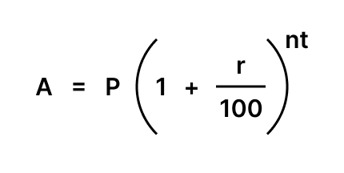

Where,
A = Amount
P = Principal
r = Rate of interest
n = Number of times interest is compounded per year
t = Time (in years)

We have two method to calculate CI:
Using Simple Interest:
Steps:
- Calculate Simple Interest for One Period: Calculate the Simple Interest for the first period (usually one year) using the formula:
S.I = (P x R x T)/100
- Add Interest to Principal for Next Period: After calculating the Simple Interest for the first period, add this interest to the principal amount. This sum becomes the new principal for the next period.
- Repeat for Each Period: Repeat the process of calculating Simple Interest on the new principal for each subsequent period.
- Total Compound Interest: After the final period, subtract the original principal from the final amount to get the total Compound Interest earned over the entire period.
Question: Aman has deposited Rs. 1,000 into a savings account that earns compound interest at an annual rate of 5%. If the interest is compounded annually, how much money will be in the account after 2 years?
Solution: Principal(P) = 1,000 R = 5% p.a T = 2 years
SI for 1st years = (P x R xT)/100 = (1000x5x1)/100 = 50
Amount for 1st year = 1,000+50 = 1,050
Now, Principal(P’) = 1050 R = 5% p.a T = 2 years SI for 2nd year = (P’ x R xT)/100 = (1050x5x1)/100 = 52.5 Amount after 2nd year = 1,050+52.5 = 1102.5
Hence, C.I for 2 years = Amount for 2 years - Principal(P) C.I for 2 years = 1102.5 - 1000 = 102.5
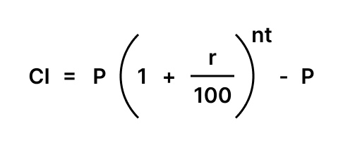

Where,
CI= compound Interest
P= principal
r= rate of interest
n= number of times interest is compounded per year
t= time (in years)
Question: Aman has deposited Rs. 1,000 into a savings account that earns compound interest at an annual rate of 5%. If the interest is compounded annually, how much money will be in the account after 2 years?
Solution: Principal(P) = 1,000 R = 5% p.a n=1 t = 2 years (compounded annually)
C.I = P{1+(r/100)}^{nt} - P C.I = 1000{1+(5/100)}^{(1*2)}- 1000 C.I = 1000{1+(1/20)}² - 1000 C.I = 1000{(21/20)²} - 1000 C.I = 1102.5 - 1000 C.I = 102.5
Half yearly Compound Interest
If the principal invested be P and the rate of interest is R % per annum which is compounded half-yearly for ‘t’ years
As it is compounded half-yearly, the principal will be changed at the end of 6 months, and interest earned till then will be added to the principal and then this becomes the new principal.
Hence, Rate of Interest(R) becomes half. Time(t) becomes double.
Note
A = P(1 + R/200)^{2t}
CI = A – P
Question Find the compound interest on Rs. 1000 at the rate of 8 % per annum for 1 year. When interest is compounded half-yearly?
Solution: Principal(P) = 1000 Rate(R) = 8% p.a Time(t) = 1 ( 2 half years )
A = P{1 + R/(2*100)}^{2t}
= 1000 (1 + 8/200)²
= 1000(26/25)²
= 1081.6
Compound Interest = A - P = 1081.6 – 1000 = 81.6

Quarterly Compound Interest
If the principal invested be P and the rate of interest is R % per annum which is compounded quarterly for ‘t’ years.
As it is compounded quarterly, the principal will be changed at the end of 4 months, and interest earned till then will be added to the principal and then this becomes the new principal.
Hence, Rate of Interest(R) becomes one-fourth of itself. Time(t) becomes four times of itself.
Note
A = P(1 + R/400)^{4t}
CI = A – P
Question Find the compound interest on Rs. 10000 at the rate of 8 % per annum for half years. When interest is compounded quarter year?
Solution: Principal(P) = 10000 Rate(R) = 8% per annum->2% per quarter year Time(t) = (½) y → ( 2 quarter years )
A = P x {1 + R/(4*100)}^{2n}
= 10,000 * (1 + 8 / (4x100))²
= 10,000 * (51/50)²
= 10,404 Compound Interest = A - P = 10,404 – 10,000 = 404
Difference between Compound Interest and Simple Interest
Compound Interest (CI) | Simple Interest (SI)
CI is the interest that is calculated both on the principal  and the previously earned interest. | SI is the interest that is calculated only on the principal.
For the same principle, Rate, and Time period  CI > SI | For the same principle,Rate, and Time period  SI < CI
A = P(1 + R/100)^{nT} | SI = (P×R×T) / 100

Question: Find the difference between Compound Interest and Simple Interest when principal = Rs 8000, rate = 10% per annum and time = 2 years.
Solution: principal = Rs 8000, rate = 10% per annum time = 2 years.
Calculating Compound Interest for 2 years:
Interest for first year = (8000 × 10 × 1)/100 = 800
Amount at the end of first year = 8000 + 800 = 8800
Interest for second year = (8800 × 10 × 1) / 100 = 880
Amount at the end of second year = 8800 + 880 = 9680
Compound Interest = 9680 – 8000 = 1680
Calculating Simple Interest for 2 years:
S.I for 2 years = (8000 × 10 × 2)/100 = 1600
Difference b/w C.I and S.I
= C.I - S.I = 1680 - 1600 = 80

Ratio :
Ratio is a comparison of two or more quantities of the same unit. It is unitless quantity means it has no unit.
Note
a : b
Where,
a → Antecedent
b → Consequent
Ratio of Two Quantity :
The ratio of two numbers a and b is written as a:b or as a fraction a/b.
To write a:b in simplest form:
HCF(a,b) = c
Divide a and b with c to convert it into the simplest form.
Question:If there are 4 apples and 2 oranges, the ratio of apples to oranges is:
Solution: Ratio of Apple and Orange is Apple : Orange = 4 : 2
Convert into simplest form:
HCF(4,2) = 2 Apple : Orange = (4/2) : (2/2) Apple : Orange = 2 : 1

Question:In a room there are 15 men and 10 women, the ratio of men to women is:
Solution: Ratio of Men and Women is Men : Women= 15 : 10
Convert into simplest form:
HCF(15,10) = 5 Men : Women = (15/5) : (10/5) Men : Women = 3 : 2
Ratio of Three Quantity
The ratio of three numbers a, band c is written as a:b:c.
To write a:b:c in simplest form:
HCF(a,b,c) = d
Divide a , b and c with d to convert it in simplest form.

Question: In a basket, there are 9 guavas, 6 bananas and 3 pineapples. What is the ratio of guava , banana and pineapple?
Solution: Ratio of Guava, Banana and Pineapple: Guava : Banana : Pineapple = 9 : 6 : 3
Convert into simplest form:
HCF((9,6,3)) = 3 Guava : Banana : Pineapple = (9/3) : (6/3) : (3/3) Guava : Banana : Pineapple = 3 : 2 : 1
Question: In a bag, there are 20 black, 10 blue and 4 green balls. What is the ratio of black,blue and green ball?
Solution: Ratio of black , blue and green ball: Black ball: Blue ball : Green ball = 20 : 10 : 4
Convert into simplest form:
HCF((20,10,4)) = 2 Black ball: Blue ball : Green ball = (20/2) : (10/2) : (4/2) Black ball: Blue ball : Green ball = 10 : 5 : 2
Properties of Ratios
- If a ratio is multiplied by the same term then there is no change in the actual ratio.
For example, ak:bk = a:b
- If a ratio is divided by the same number then also there is no change in the actual ratio.
For example, a/k:b/k = a:b
- If two ratios are equal then their reciprocals are also equal.
For example: if a:b = c:d then b:a = d:c
- If two ratios are equal then their cross-multiplications are also equal.
For example a:b = c:d ⇒ ad = bc
- The ratios for a pair of comparisons can be the same but the actual value may be different.
For example, 20:30 = 5:6 and 150:180 = 5:6 hence ratio 5:6 is the same but actual value is different.

Manipulation of Ratios
Given Ratios: Suppose the given ratios are a:b and b:c .
Consistency in Ratios To combine these ratios into a single ratio a:b:c , it's essential to ensure that the b part in both ratios should be the same value.

Example: Let's say the given ratios are a:b = 2:3 and b:c = 5:6. To make
B consistent , multiply the first ratio by 5 and the second ratio by 3. This gives,
a:b = 10:15
b:c = 15:18
The b part in both ratios is same. The combined ratio a:b:c = 10:15:18

Proportion
When we have two ratios, if they are equal to each other, then they are proportional.
For example, if we have the ratio a:b and it's equal to the ratio c:d,
a:b=c:d , then we can say that a:b is proportional to c:d.
Two proportional ratios are represented by a double colon"::". If two ratios a:b and c:d are equal then they are represented as, a:b :: c:d
Where,
A and d → extreme term
B and c → mean term
Properties of Proportions
For two ratios in proportion.
a/b = c/d
can be written as
a/c = b/d
. For two ratios in proportion.
a:b::c:d
, the product of mean terms is equal to the product of extreme terms
a*d = b*c
Question: Given a constant x, such that x:5 is proportional to 12:30. Find the value of x.
Solution:
Since x:5 is proportional to 12:30, we can write, x / 5 = 12 / 30 x = (12*5)/30 = 2 So, the value of x is 2.

Question:The salaries of Anuj and Anil are in the ratio 1:2.If the salary of each is increased by 4,000 the new ratio becomes 3:4. What is Anuj’s salary?
Solution: Let the salary of Anuj and Anil be 1x and 2x
Increased 2000 and get ratio is 3:4 (1x+4000) / (2x+4000)=3/4 4x + 16000 = 6x + 12000 2x = 4000 x = 2000 Anuj’s salary 1x=1*2000 = 2,000

Mixture:
When we are mixing or combining two or more different substances then the resultant solution is known as mixture.
Example: Suppose the Beaker(A) has 10 liters of milk and the Beaker(B) has 5 liters of water. Now, put the milk(10 liter) and water(5 liter) in beaker(c) Then we can say that the resultant substance in beaker C is a mixture of milk and water with a quantity of 15 liters.
Alligation:
Alligation is a rule which is used to solve problems related to mixture and ingredient. It helps us to find the ratio in which two or more ingredients at the given price must be mixed to produce a mixture of desired price.
Alligation Rule :
When two elements are mixed to make a mixture and one of the elements is cheaper and other one is dearer then,
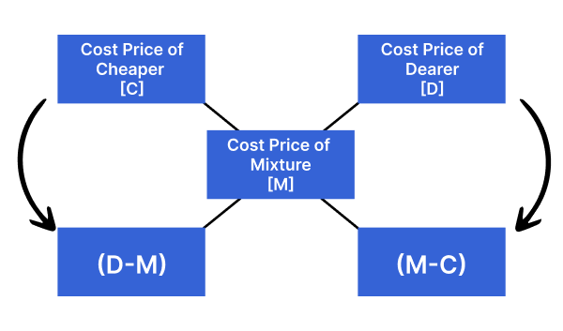

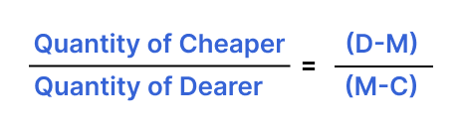
Question: In what ratio must rice(A) at Rs 10/kg be mixed with rice(B) sold at Rs. 12/kg, so that the mixture be worth Rs. 11 per kg?
Solution: Using the rule of alligation, we have:
C.P. of 1 kg of rice(A) = Rs. 10 → cheaper value(c) C.P. of 1 kg of rice(B) = Rs. 12 → dearer value(d) CP of 1 kg of rice(C) = Rs. 11 → mean value(m)
Quantity of Cheaper rice: Quantity of Dearer rice= (d - m)/ (m - c) Quantity of Cheaper rice: Quantity of Dearer rice= (12 - 11)/(11 - 10) Quantity of Cheaper rice: Quantity of Dearer rice= 1:1
Ratio of rice at Rs 10/kg and rice at Rs. 12/kg = 1:1
Question: In what ratio must a grocer mix two varieties of pulses costing Rs.15 /Kg and Rs.20/Kg respectively so as to get a mixture worth Rs.18/Kg.
Solution Using the rule of alligation, we have:
C.P. of 1 kg of pulse(A) = Rs. 15 → cheaper value(c) C.P. of 1 kg of pulse(B) = Rs. 20 → dearer value(d) CP of 1 kg of pulse(C) = Rs. 18 → mean value(m)
Quantity of Cheaper pulse: Quantity of Dearer pulse= (d - m)/ (m - c) Quantity of Cheaper pulse: Quantity of Dearer pulse= (20 - 18)/(18 - 15) Quantity of Cheaper pulse: Quantity of Dearer pulse= 2:3
Ratio of pulse at Rs 15/kg and rice at Rs. 20/kg = 2:3
Question: If a shopkeeper mixes two varieties of sweets costing Rs.400 /Kg and Rs.x /Kg respectively in the ratio of 7:5 so as to get a mixture worth Rs. 650/Kg?
Solution Using the rule of alligation, we have:
C.P. of 1 kg of sweet(A) = Rs. 400 → cheaper value(c) C.P. of 1 kg of sweet(B) = Rs. x → dearer value(d) CP of 1 kg of sweet(C) = Rs. 650 → mean value(m)
Quantity of Cheaper pulse: Quantity of Dearer pulse= (d - m)/ (m - c) Quantity of Cheaper pulse: Quantity of Dearer pulse= (x - 650)/(650 - 400) 7:5 = (x - 650)/(650 - 400) 7/5 = (x - 650)/ 250 250*7 = 5x - 3250 1750 = 5x - 3250 5x = 1750 + 3250 x = 1000 Hence, the value of x is Rs. 1000.

Partnership
When two or more individuals invest, and work together to run the business is called a partnership. They share the work and the money they make or lose.
For Example: Ram and Shyam have decided to open a company and they are investors in the company. Ram and Shyam are considered as partners for the company.
Formula for Partnership:
Note
Profit = investment × time
Question: Three partners A, B and C invested in a business. A invested 5000 for 4 months, B invested 6000 for 7 months and C invested 7000 for 6 months. Find the ratio of their profits.
Solution: Formulae used: Profit = investment × time
Profit(A) = Investment(A) * time = 5000 x 4 Profit(B) = Investment(B) * time = 6000 x 7 Profit(C) = Investment(C) * time = 7000 x 6
Profit(A) : Profit(B) : Profit(C) = 5000 x 4 : 6000 x 7 : 7000 x 6 Profit(A) : Profit(B) : Profit(C) = 10 : 21 : 21
Question: Three partners shared the profit in a business in the ratio 3: 6: 5. They had partnered for 12 months, 9 months, and 6 months respectively. What was the ratio of their amount invested?
Solution: Let's consider the investments as A, B, C A for 12 months, B for 9 months, and C for 6 months Then their ratio of investment is
12A : 9B : 6C = 3 : 6 : 5 → (Given) Divide the 12A by 9B 12A/9B = 3/6 4A/3B = 1/2 B = 8A/3
Divide the 12A by 6C 12A/6C = 3/5 2A x 5 = 3 x C 10A/3 = C A : B : C = A : 8A/3 : 10A/3 = 3A : 8A :10A = 3: 8: 10
Question: Aman started a business with Rs. 70,000. Ajeet later joined him with Rs. 35,000. For how long did Ajeet join if the profits at the end of the year were divided in the ratio of 8:2?
Solution: Let Ajeet invest for a months. Aman investment is 70,000 in 12 months. Ajeet investment is 35,000 in a months Their profit ratio is 8:2 (70,000 x 12) / (35,000 x a) = 8/2 24/a = 8/2 a = (24*2)/8 a = 6 months
Hence Ajeet has joined for 6 months.

Ages
Age is the amount of time that has passed since someone or something was born or created. It's usually measured in years.
For Example: If Arvind is 10 years old, it means 10 years have passed since Arvind was born.
Important Concept
- If someone is a years old now, in n years they will be a + n years old. If we go back n years, they were a – n years old.
- If we compare two people's ages as a ratio, like p:q, then one person's age is pa and the other's is qa.
- If someone is a years old now, after n times that age, they will be a*n years old.
- If someone is a years old now, then one part out of n parts of their age is a/n.

Question: Ratio of the present ages of Amisha and Nandana is 13: 11. Four years hence, the ratio of their ages will be 15: 13. What is Amisha’s age at present?
Solution: Let the present ages of Amisha and Nandana be 13a and 11a respectively.
After Four years, Amisha and Nandana are (13a+4) and (11a+4). (13a+4) / (11a+4) = 15/13 13(13a+4) = 15(11a+4) 169a + 52 = 165a + 60 169a - 165a = 60 - 52 4a = 8 a = 2
The current age of Amisha: 13 x a = 13 x 2 = 26

Question:The ratio of the father’s age to his son’s age is 9: 5. The product of their age is 2205. The ratio of their ages after five years will be :
Solution: Let the father’s age and son’s age be 9a and 5a.
According to the question; Product of father’s age and son’s age = 2205 9a * 5a = 2205 45a2 = 2205 a2= 2205/ 45 a2= 7*7. Father’s age =9a = 9*7 = 63 Son’s age = 5a = 5*7 = 35
After 5 years Father’s age and Son’s age are 68 and 40. Father’s age: Son’s age = 68/40 Father’s age: Son’s age = 17: 10

Average
An average is the sum of numbers divided by the count of those numbers.
Note
Average = Sum of Observation(Sn) / Number of Observation(N)
Average = Sn/N
Example: Imagine we have 3 apples that weight 100 grams, 150 grams, and 200 grams. To find the average weight of an apple. Add up all their weights (100+150+200 = 450 grams) and then divide by the number of apples, which is 3.
So, Average weight = 450/3 = 150 grams.
The average weight of an apple is 150 grams.
Question: Find the average weight of 4 boys having weights of 30kg, 40kg, 50kg, and 60kg.
Solution: Sum of weights(Sn) = 30+40+50+60 = 180 Number of Observation(N):4 Average = Sn/N = 180/4 = 45 kg.
Properties of Average
If we add or subtract a number let's say x from every item in a list, the average of the list will also increase or decrease by that same number x.
Suppose you have three numbers: 10, 20, and 30. The average of these numbers is (10+20+30)/3 = 20.
- Now, if we add 5 to each of these numbers, they become 15, 25, and 35. The new average is (15+25+35)/3 = 25, which is the original average(20) + 5.
- Similarly, if we subtract 5 from the original numbers (making them 5, 15, and 25), The new average is (5+15+25)/3 = 15, which is the original average (20) - 5.
Imagine we have three numbers: 2, 4, and 6.
The average is (2+4+6)/3 = 4.
- Now, if we multiply each number by 3, the numbers become 6, 12, and 18. The new average is (6+12+18)/3 = 12, which is the original average(4) multiplied by 3.
- Similarly, if we divide the original numbers by 2 the numbers become 1, 2, and 3. The new average is (1+2+3)/3 = 2, which is the original average(4) divided by 2.

If Sequence or consecutives are in A.P:
If the number of observations is odd then the average is the middle term of the sequence.
Question: Find the average of 1, 3, 5, 7, 9, 11, 13.
Solution: 1, 3, 5, 7, 9, 11, 13. Given sequences are in AP and have an odd number of observations. Hence the average should be a middle value which is 7.
Let's check, Sn = 1+3+5+7+9+11+13 = 49 N = 7 Average = Sn / N = 49/7 = 7 If the number of observations are Even then the average is the average of two middle numbers.
Question: Find the average of 2, 4, 6, 8, 10, 12.
Solution: 2, 4, 6, 8, 10, 12 Given sequences are in AP and have an even number of observations. Hence the average should be an average middle value(6,8) which is (6+8)/2 = 7.
Let's check, Sn = 2+4+6+8+10+12= 42 N = 6 Average = Sn / N = 42/6 = 7

Distance
Distance is the total length of the path traveled by an object. Distance is measured in units like meters , kilometers, miles , etc.
Time
Time refers to the duration over which an object has been moving to cover a certain distance. It's a fundamental quantity measured in seconds, minutes, hours, etc.
Speed
Speed is a measure of how fast something is moving.It's calculated as the distance covered per unit of time. The standard unit is meters per second (m/s) and kilometers per hour km/hr.
Relationship Between Speed, Time and Distance
Note
Speed(S) = Distance(D)/Time(T)
Unit Conversion
Kilometers per hour(km/hr) to Meters per second(m/s)
Note
x km/hr = x*(5/18) m/s
Question: Convert 54 Km/hr to m/s?
Solution: 54 km/hr = 54*(5/18)m/s = 15m/s
Meters per second(m/s) to Kilometers per hour(km/hr)
Note
x m/s = x*(18/5) km/hr
Question: Convert m/s to km/hr?
Solution: 25 m/s = 25*(18/5) = 90km/hr
Average Speed
The average speed is determined by the formula
Note
Average Speed = (Total distance traveled)/(Total time taken)

Question: A truck covers a distance of 900 km in 30 hours and next 500 km in 40 hours. What is the average speed of the truck?
Solution: Total distance = 900 + 500 =1400 Km Total time= 30 + 40 = 70 hr
Speed = Total distance/Total time Speed = 1400/70 km/hr = 20 km/hr

Case 1:
When a body travels at a speeds of x and y for equal distances, The average speed is (2xy)/(x+y)
Question: Raman goes Delhi to Pune at a speed of 40km/h and comes back at a speed of 60 km/h. Find his average speed of the journey.
Solution: let x = 40 km/hr, y = 60 km/hr Average Speed = 2xy/(x+y) = (2x40x60)/(40+60) = 48 km/hr
Case 2:
When the body travels at speeds of x and y for equal time durations, the average speed is (x+y)/2.
Question: When a car travels at a speed of 48 km/hr for an hour and then at a speed of 36 km/hr for the next 1 hour, what is the average speed of the car for the entire journey?
Solution: let x = 48 km/hr , y = 36 km/hr Average Speed = (x+y)/2 = (48+36)/2 = 84/2 = 42 km/hr

Relative Speed:
Relative speed is the speed of one object or body in relation to another object. It tells us how fast one thing is moving compared to another thing.
If two objects are travelling opposite to each other then the relative speed is sum of individual speeds
Note
Speed of object(A) = x km/hr
Speed of object(B) = y km/hr
Relative Speed = (x+y) km/hr
Question: Two cars, initially 140 kilometers apart, are driving opposite to each other. The first car is traveling at 45 km/h, and the second car is moving at 25 km/h.After how much time will they meet?
Solution: First car(A) travelling at speed = 45 km/hr Second car(B) travelling at speed = 25 km/hr
Relative Speed of A and B = (45+25) km/hr = 70 km/hr Time = Total distance / Relative speed = 140/70 = 2hr
If two objects are travelling in the same direction then the relative speed is difference between individual speeds.
Note
Speed of body(A) = x km/hr Speed of body(B) = y km/hr
When Speed(A) > Speed(B) Relative Speed = (x - y) km/hr
When Speed(B) > Speed(A) Relative Speed = (y - x) km/hr

Question: Two bikes, initially 50 kilometers apart, are driving in the same direction. The bike(A) is traveling at 40 km/h, and the bike(B) is moving at 30 km/h.After how much time will they meet?
Solution: First car(A) travelling at speed = 40km/hr Second car(B) travelling at speed = 30km/hr
Relative Speed of A and B = (40 - 30) km/hr = 10 km/hr Time = Total distance / Relative speed = 50/10 = 5hr

Important terms:
Stream: A stream is like the flowing water in a river.
Upstream Speed Suppose a body or boat go against the direction of the stream. That means it's moving in the opposite direction of the flowing water. This is called upstream. When a boat or body goes upstream, we measure its speed relative to the stream, and we call this speed as upstream speed.
Note
Let the speed of the boat be x km/hr. Speed of stream be y km/hr Upstream speed = Speed of the boat - Speed of steam = (x - y) km/hr
Question: What is the upstream speed of a woman when she rows in a river with a 3 km/hr current if she can row at 16 km/hr in still water?
Solution: Woman’s speed in still water = 16 km/hr Speed of stream = 3 km/hr Upstream Speed = Woman’s speed - Stream speed = 16 - 3 = 13 km/hr
Downstream Speed
Suppose a body or boat go in the same direction of the stream. That means it's moving in the same direction of the flowing water. This is called downstream. When a boat or body goes downstream, we measure its speed relative to the stream, and we call this speed as downstream speed.
Note
Let the speed of the boat be x km/hr.
Speed of stream be y km/hr
Downstream speed = Speed of the boat + Speed of steam = (x + y) km/hr
Question: What is the speed of the boy when he is swimming along the river, if the speed of the river is 4km/hr and the speed of the boy in still water is 9km/hr.
Solution: Boy’s speed in still water = 9 km/hr Speed of stream = 4 km/hr Downstream Speed = Boy’s speed + Stream speed = 9 + 4 = 13 km/hr
Question: The speed of the boat in still water is 13 km/hr and the rate of stream is 7 km/hr. The distance travelled in downstream for 30 mins is?
Solution: Speed of downstream speed = Speed of boatman's + Speed of water = 13+7 = 20 kmph Distance covered for 30 minutes = Speed of downstream speed*Time = 20 kmph *(30/60)hr = 10 km

Train problem :
Relative speed of trains moving in same direction
The relative speed of two trains traveling in the same direction is the difference between their respective speeds.
Speed of train(A) is x km/hr. Speed of train(B) is y km/hr. Speed of train(A) > Speed of train(B) Relative speed of trains = (x-y) km/hr Speed of train(B) > Speed of train(A) Relative speed of trains = (y-x) km/hr
Relative speed of trains moving in opposite direction
The relative speed of two trains traveling in opposite directions is equal to the sum of their individual speeds.
Speed of train(A) is x km/hr.
Speed of train(B) is y km/hr.
Relative speed of trains = (x+y) km/hr
Distance covered when two trains are moving in the same and opposite direction
The distance traveled by two trains traveling in the same direction or in different directions is equal to the sum of their respective lengths.
Speed and length of train(A) is x km/hr and a km. Speed and length of train(B) is y km/hr and b km.
Total distance = Length of Train(A)+Length of Train(B) = (a+b) km Relative speed of trains = (x-y) km/hr (moving in same direction) Relative speed of trains = (x+y) km/hr (moving in opposite direction)
Question: Two trains are moving in the same directions at 12 m/s and 13 m/s. Their lengths are 700 m and 500 m respectively. The time taken by the faster train to cross the slower train in seconds is:
Solution: The speed of trains are 12 m/s and 13 m/s. The length of trains are 700m and 500m. Relative Speed of trains, when moving in same direction= 13 - 12 = 1 m/s Total Distance = Sum of length of trains =700+500 = 1200 m Time = Total Distance / Relative Speed Time = 1200/1 = 1200 s
Question: Two trains are moving in the opposite directions at 12 m/s and 13 m/s. Their lengths are 1100 m and 900 m respectively. The time taken by the slower train to cross the faster train in seconds is:

Solutions:
The speed of trains are 12 m/s and 13 m/s The length of trains are 1100 m and 900 m Relative Speed of train when moving in opposite direction= 13 + 12 = 25 m/s Total Distance = Sum of length of trains = 1100+900 = 2000 m Time = Total Distance / Relative Speed Time = 2000/25 = 80 s
Distance covered by a train crosses a stationary object
When a train crosses a stationary object, the distance covered by the train is equal to the length of the train. Question: A train 264 meters long passes a pole in 24 seconds.Find the speed of the train.
Solution:
Length of train = 264 m Time = 24 s Speed of train = Length of train / Time Speed of train = 264/24 = 11 m/s
Distance covered by a train crosses a platform or bridge
The total distance covered by a train when it passes a platform or a bridge is equal to the sum of the train's length and the length of the bridge or platform.
Speed and length of train(A) is x km/hr and a km. Length of platform is b km
Total Length covered = (a+b) km
Question: The length of bridge, which a train 260 m long and traveling at 45 km/hr can cross in 30 s, is:
Solution: Let the length of bridge is x m Length of train = 260 m Speed of train = 45 km/hr = (25/2) m/s Total Distance = Length of bridge +Length of train = (x+260) m Time = Total Distance/ Speed 30 = (x+260)/(25/2) 30 x (25/2) = x+260 375 - 260 = x x = 115 m Hence, Length of the bridge = 115 m.

Race :
A Beats B
If A beats B , it implies that A has successfully overcome or performed better than B in the given task. For Example: In a 100-meter sprint, if Runner A beats Runner B, it means Runner A crosses the finish line before Runner B.
Deadheat
In a race ,A and B both reach the finish line simultaneously, which is known as deadheat. This means there's no clear winner due to their identical finishing times.
Headstart
In a contest or race, a headstart is an advantage or lead granted to one individual or team over another.
Linear Track
A linear track is a straight path with one starting point and one ending point used for races.
Question: In a 450 meters race, X beats Y 60 meters or 20 seconds.Find the time taken by to complete the race.
Solution: Y Speed=distance/time = 60/20 = 3 m/s Time taken by Y to complete the race=Distance of race/Speed of Y = 450/3 = 150 s
Question: In a 200 m race X gives a 40 m headstart to Y and beats by 10 sec. If the headstart is 80 m the race ends in deadheat.Find the speed of Y and X.
Solution: When Y takes 40 m headstart then Y is defeated by 10 sec. When Y takes 80 m headstart then Y takes the same time as X takes(deadheat). Means , Difference between headstarts = (80m-40m) = 40 m Difference between time taken is 10 sec It means Y will take 10 sec to cover 40 m Speed of Y=Distance/Time = 40/10 = 4 m/s
Y covers (200 - 80) = 120 m with speed 4 m/s. Time taken by Y = Time taken by X 120/4 = 200/Speed of X Speed of X = (200 x 4)/120 = 20/3 m/s.
Circular Track
A circular track is a rounded path designed for racing where participants continuously follow the circular route.
Question: P, Q, R run around a circular track of 2400 m long with speed of 9, 18, 27 kmph. If they start from the same point, at the same time in the same direction, when will they meet again at the starting point?
Solution: Length of track = 2400 m Speed of P(x) = 9 x 5/18 = 2.5 m/s Speed of Q (y) = 18 x 5/18 = 5 m/s Speed of R (z) = 27 x 5/18 = 7.5 m/s LCM of L/x, L/y, L/z is the first time where they will meet. L/x = 2400 / 2.5 = 960 L/y = 2400 / 5 = 480 L/z = 2400 / 7.5 = 320 Here, L

Time and work :
Time :
Duration taken to complete a particular task.
Efficiency
It is defined as work done per unit time. Efficiency inversely proportional to the time taken.
Efficiency ∝ 1/Time
Work
It can be defined as product of time and efficiency.
Work = Time*Efficiency
Note
If a piece of work is done in x number of days, then the work done in one day = 1/x
Rules and Tricks
Rule 1:
A can do a task in x days, and B can do it in y days . If they work together, In how many days can they complete the task?
Number of days taken by A = x
Number of days taken by B= y
Amount of work done by A in 1 day = 1/x Amount of work done by B in 1 day = 1/y Both A and B can complete part of work in 1 day = 1/x + 1/y Time taken by A and B together to complete the task= xy/(x+y)
Another method:
A can do a task in x days, and B can do it in y days. If they work together,In how many days can they complete the task?
Number of days taken by A = x
Number of days taken by B= y
Total work can be assumed as LCM(x,y)
Efficiency of A= LCM/(Days taken by A) = LCM/x
Efficiency of B= LCM/(Days taken by B) =LCM/y
Time taken by A and B to complete the task = LCM / (Efficiency of A + Efficiency of B)

Question: Aman can do a task in 8 days and Ajeet can do a task in 12 days .If they work together,In how many days can they complete the task?
Solution:
Number of days taken by Aman = 8 Number of days taken by Ajeet = 12
Total work done by Aman and Ajeet= LCM (8,12) = 24 units Efficiency of Aman = LCM/(Days taken by A) = 24/8 = 3 units/day Efficiency of Ajeet = LCM/(Days taken by B) = 24/12 = 2 units/day
Time taken by Aman and Ajeet to complete the task = LCM / (Efficiency of Aman + Efficiency of Ajeet) = 24/(3+2) =(24/5) days
Rule 2:
A can do a task in x days, B can do in y days and C can do in z days. If they work together,In how many days can they complete the task?
Number of days taken by A= x
Number of days taken by B= y
Number of days taken by C= z
Total work can be assumed as LCM(x,y,z)
Efficiency of A= LCM/(Days taken by A)
Efficiency of B= LCM/(Days taken by B)
Efficiency of C= LCM/(Days taken by C)
Time taken by A ,B and C to complete the task = LCM / (Efficiency of A + Efficiency of B+ Efficiency of C)

Question: A can do a task in 2 days and B can do a task in 3 days , C can do a task in 6 days .If they work together, In how many days can they complete the task?
Solution:
Number of days taken by A = 2 Number of days taken by B = 3 Number of days taken by C = 6
Total work done by A ,B and C =LCM(2,3,6) = 6 units Efficiency of A = LCM/(Days taken by A) = 6/2 = 3 units/day Efficiency of B = LCM/(Days taken by B) = 6/3 = 2 units/day Efficiency of C = LCM/(Days taken by C) = 6/6 = 1 unit/day Time taken by A ,B and C to complete the task= LCM / (Efficiency of A + Efficiency of B+ Efficiency of C) = 6/(3+2+1) = 6/6 = 1 day.

Pipes and Cisterns :
Inlet Pipe
A pipe which fill up the tank is known as inlet.
Outlet Pipe
A pipe which empties the tank is known as outlet.
Note
If pipe(A) is filled a tank in x hours, then the part of tank filled in one hour= 1/x
Rules and Tricks:
Rule 1:
If pipe(A) can fill a tank in x hours and pipe(B) can fill it in y hours. If they are open together to fill the tank, how many hours will it take to fill the tank?
Number of hours taken by A= x
Number of hours taken by B= y
Parts of tank filled by A in 1 hour = 1/x
Parts of tank filled by B in 1 hour = 1/y
Both A and B together fill the tank in 1 hour = 1/x + 1/y Time taken by A and B to fill a tank = xy/(x+y)
Another method:
If pipe(A) can fill a tank in x hours and pipe(B) can fill it in y hours . If they are opened
together,how many hours will it take to fill the tank?
Number of hours taken by A= x
Number of hours taken by B= y
Total capacity can be assumed as LCM(x,y)
Efficiency of A= LCM/(hours taken by A)
Efficiency of B= LCM/(hours taken by B)
Time taken by pipe A and B
to fill the tank = LCM / (Efficiency of A + Efficiency of B)

Question : If pipe A and pipe B can fill a cistern in 40 and 60 hours respectively. Both the pipes are opened together, how long will it take to fill the cistern?
Solution
Number of hours taken by A = 40 Number of hours taken by B = 60
Total capacity of cistern= LCM(40,60) = 120 L (L =liters) Efficiency of A = LCM/(hours taken by A) = 120/40 = 3 L/hr (hr=hour) Efficiency of B = LCM/(hours taken by B) = 120/60 = 2 L/hr
Time taken by pipe A and B to fill the cistern = LCM / (Efficiency of A + Efficiency of B) = 120/(3+2) = 120/5 = 24 hrs (or) 24 hours.
Rule 2:
If pipe(A) can fill a tank in x hours ,pipe(B) can fill in y hours and pipe(C) can empty it in z hours. If they are open together to fill the tank, how many hours will it take to fill the tank?
Number of hours taken by A= x
Number of hours taken by B= y
Number of hours taken by C = -z (- indicate negative work)
Total capacity of the tank = LCM (x,y,z)
Efficiency of A = LCM/(hours taken by A)
Efficiency of B= LCM/(hours taken by B)
Efficiency of C= LCM/(hours taken by C) Time taken by pipe
A,B and C to fill the tank = LCM / (Efficiency of A + Efficiency of B+ Efficiency of C)
Question: Pipes A and B can fill a tank in 12 and 18 hours respectively. Pipe C can empty it in 30 hours. If all three pipes are opened together, then the tank will be filled in how many hours?
Solution:
Number of hours taken by A = 12 Number of hours taken by B = 18 Number of hours taken by C = -30
Total capacity of tank = LCM(12,18,30) = 180 L Efficiency of A = LCM/(hours taken by A) = 180/12 = 15 L/hr Efficiency of B = LCM/(hours taken by B) = 180/18 = 10 L/hr Efficiency of C = LCM/(hours taken by C) = 180/(-30) = -6 L/hr Time taken by A,B and C to fill the tank = LCM / (Efficiency of A + Efficiency of + Efficiency of C) = 180/(15+10-6) = 180/19 hrs (or) 180/19 hours.

Man-chain Rule and wages :
Man-Chain-Rule:
- If a worker can complete a work in x days, he will complete 1/x of work in a single day.
- On the other hand, if a worker completes 1/xwork in a single day, it will take x days to finish the work.
- (M1 x D1 x H1 x E1) / W1 = (M2 x D2 x H2 x E2) / W2
where, M = Number of workers
D = Number of days
H = Number of working hours in a day
E = Efficiency of workers
W = Units of work

Question: If Akhil completes (⅓)rd of work in a single day. How many days, he will take to complete the work?
Solution:
Akhil completes (⅓)rd of work in a single day. Number of days Akhil take to complete the work = 1/(⅓) = 3 days
Question: If 18 men take 15 days to complete a task, how many days will 45 men take to finish the same task?
Solution:
M1 = 18 men D1 = 15 days M2 = 45 men D2 = ?
M1 x D1 = M2 x D2 18 x 15 = 45 x D2 D2 = (18 x 15)/45 = 6 days
Question: 16 workers can complete a project in 18 days, and 10 technicians can finish the same project in 10 days. What is the ratio between the capacity of a worker and a technician?
Solution:
16 workers 1 day work = 1/18 1 worker 1 day work = 1/(16 x 18)
10 technicians 1 day work= 1/10 1 technician 1 day work= 1/(10 x 10)
Ratio of capacity of worker and technician = 1/(16 x 18) : 1/(10 x 10) = 25 : 72

Wages:
"Wage" is defined as money paid to workers based on how much work they do or how long they work.
Question: X, Y together earn Rs.500 for 1 day's work. X earns Rs.800 for 4 days of work. How much money would Y earn for a 10-day's work?
Solution:
(X+Y) together earn Rs in 1 day =500 X earn Rs in 4 days =800 X earn Rs in 1 day =800/4 =200 Y earn Rs in 1 day =(X+Y)-(X) = 500-200 = 300 Y earn Rs in 10 days =10*300 = Rs 3,000.

Permutation & Combinations :
Permutation
Arrangement of similar or distinct objects in a sequence, either by selecting some of them or all at once.
Or
Selection and arrangement of objects is called permutation.
Representation of Permutation:
(i) n(P,r) (ii) nPr
Note
nPr→ Arranging r elements in n positions.
nPr = n!/(n-r)!
N people can be arranged in N seats in N! ways
Example: In how many ways 8 people can sit in 8 vacant places. 8 People can sit in 8 positions by 8! ways. Position:
_ _ _ _ _ _ _ _
= 8x7x6x5x4x3x2x1 = 8!
Number Based Permutation
With Repetition
The arrangement of numbers where each number can be used multiple times in different arrangements.
Question: How many 4-digit numbers can be formed using 1,5,3,4,0 and 6 , if repetition of digits is allowed?
Solution:
Number of digits is 6 ( 1,5,3,4,0,6) Filling position from left to right.
_ _ _ _
Number of possible digits in first place is 5. (because 0 can not be placed) Number of possible digits in second place is 6. Number of possible digits in third place is 6. Number of possible digits in fourth place is 6. Position:
_ _ _ _
= 5x6x6x6 =1080

Without Repetition
The arrangement of numbers where each number can be used single time in different arrangements.
Question: How many 5-digit numbers can be formed using 1,4,7,8,3 and 6 ,if repetition of digits is not allowed?
Solution:
Number of digits is 6 ( 1,4,7,8,3,6 ) Filling position from left to right.
_ _ _ _ _
Number of possible digits in first place is 6. Number of possible digits in second place is 5. Number of possible digits in third place is 4. Number of possible digits in fourth place is 3. Number of possible digits in fifth place is 2. Position:
_ _ _ _
= 6x5x4x3x2 = 720
Alphabet based Permutation
Note
The vowels are A, E, I, O, U.
The remaining letters are Consonants.
Keeping Vowels together:
Question: In how many ways the given name BHARAT can be arranged, if the vowels are always together?
Solution:
- The word BHARAT has 6 letters.
- 6 letters are arranged in 6!/2! ways (2! because two A's are present in BHARAT).
- But all vowels are together assumed as single letter.
- Then, we have to arrange the letters BHRT(AA).
- Number of letters 5(4+1) can be arranged = 5!
- (AA) can be arranged among themsleves = 2!/2! = 1
- Total arrangement = 5!x1= 5!= 5x4x3x2x1 = 120

Keeping Consonant together:
Question: In how many ways the given name AMISHA can be arranged, if the consonants are always together?
Solution:
- The word AMISHA has 6 letters.
- 6 letters are arranged in 6!/2! (2! because two A's) ways.
- But all consonants are together assumed as single letter.
- Then, we have to arrange the letters AAI(MSH).
- Number of letters 4(3+1) can be arranged = 4!/2!
- (MSH) can be arranged in 3! ways.
- Total arrangement = (4!/2!)x3! = 72
Rank:
Alphabetical arrangement of letters in a word is called a "Rank".
Question: Find the rank of the word "ROHIT". If all words that can be formed using the letters are arranged in alphabetical order.
Solution :
- Arrange in alphabetical order (H I O R T).
- According to the dictionary,H will come first.
H - - - - = 4! = 24 (but in ROHIT H is not starting letter)Keeping H in first place, we can make 24 words.
- I - - - - = 4! = 24 (but in ROHIT I is not starting letter)Similarly I in first place , 24 words are possible.
- In a similar way we will check for all letters.
O - - - - = 4! = 24
R H - - - = 3! = 6 (If we get the correct first letter,then we look for all other letters in a similar way.)
R I - - - = 3! = 6
ROHIT = 1
Sum up all possibilities = 24+24+24+6+6+1=85
The Rank of ROHIT is 85th.

Circular permutation:
- Circular permutation involves placing the object in a circular loop.
- As Compared to linear arrangements, the beginning and end locations are unclear in a circular arrangement.
- Since one object can be fixed and the others are positioned around it, there are (n-1)! circular permutations of the ‘n’ objects.
Question: How many different ways are there to arrange 5 men around a circular table?
Solution: 5 men sit around a circular table = (5-1)! = 4! = 4 x 3 x 2 x 1 = 24 ways
Note
Clockwise and Anti-Clockwise Order is Different P(n) = (n-1)!
Clockwise and Anti-Clockwise Order is Identical P(n) = (n-1)!/2

Question: In how many ways do 10 players sit around a table?
Solution: Clockwise and Anti-Clockwise Order is Different P(n) = (n-1)! P(number of players) = P(10) = (10-1)! = 9!
Clockwise and Anti-Clockwise Order is Identical P(n) = (n-1)!/2
P(number of players) = P(10)/ = (10-1)! /2 = 9! /2

Problem based on Rank:
Question: Find the rank of word "BLOCK" if all words that can be formed using the letters are arranged in alphabetical order:
Solution Arrange in alphabetical order (B C K L O) BC - - - = 3! = 6 BK - - - = 3! = 6 BLC - - = 2! = 2 BLK - - = 2! = 2 BLOCK = 1 Sum of all possibilities = 6+6+2+2+1 =17 Therefore , the rank of "BLOCK" is 17th.

Combination :
A combination is the process of selecting objects from a given set but the sequence in which we are selecting them is not important.
Or
Selection of items where order doesn't matter.
Representation of Combination: - n(C,r) - nCr nCr → Selection of r elements out of n
objects.
nCr = n! / [r!*(n-r)!)]
Note
nCn = 1
nC1 = n
0! = 1
Different Types of Question asked in Combination:
Question: From a group of 12 men and 15 women,10 men and 14 women are selected for a committee. In how many ways can it be done?
Solution: 10 men selected out of 12 = 12C10 = 66 14 women selected out of 15 = 15C14 =15 The total number of ways to form a committee by selecting 10 men and 14 women = 66x15 = 990
Question: There are 9 non collinear points on plain board,how many triangles can be formed on board by joining points.
Solution: As we know for creating a triangle we need 3 points. But we have 9 points on the table. Total number of triangles = 9C3 = 84
Question: In a Board, there are 12 vertical and 10 horizontal lines. Find the number of rectangles formed .
Solution: A rectangle is formed by 2 horizontal and 2 vertical lines. Total number of rectangles in board is 12C2 x 10C2 = 66x45 = 2970.

Probability:
Probability
- Probability is defined as the number of favourable outcomes divided by the total number of outcomes.
- Probability = Number of favourable outcomes /Total number of outcomes. This formula is used to determine how likely an event is to occur.
- The Probability result always falls between 0and 1 , where 0 means the event cannot happen and 1 (or 100%) means it is certain to happen.
- Probability-based questions can be categorised into four types: coins, dice, cards, and miscellaneous
Probability based on Coins:
- A coin has 2
faces : Head (H)and Tail (T)
- Total number of outcomes =2^n
- n=number of coins.

Probability based on Dice:
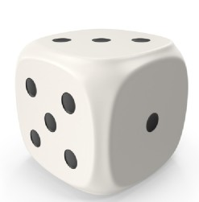
- A Dice has 6 faces.
- Total number of outcomes =6^n
- n= number of dice

Two dice are rolled simultaneously :
Total number of outcomes =6^n
Here n=2 because, two dices are rolled simultaneously. Total number of outcomes = 6^2 = 36 The total number of outcomes are
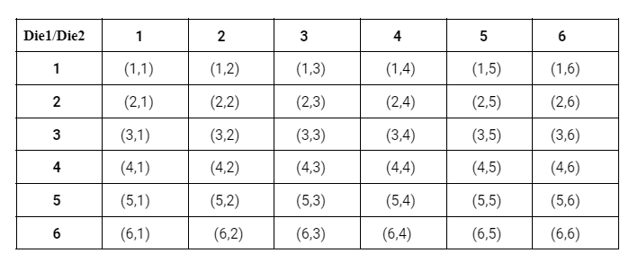
Shortcut Method : 2 Dice-Triangle
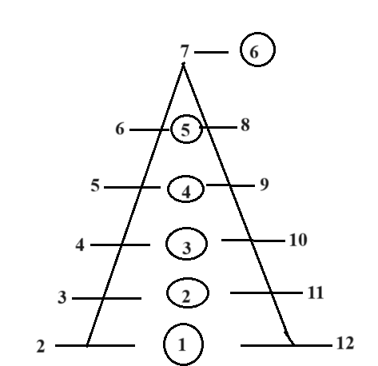

In the above diagram ,
Triangle left and right values represents sum values and inside circle values represent the number of favourable outcomes for these sum values. In the above diagram, Sum 4 has 3 favourable outcomes. Probability = Number of favourable outcomes/Total number of outcomes = 3/36 = 1/12 Therefore, the probability of getting a sum as 4 is 1/12.
B)Sum as 4 multiples : 4 multiples means sum 4,8 and 12 are possible ,when two dice rolled simultaneously. Favourable outcomes of sum as 4 = { (1,3),(3,1),(2,2) } Number of Favourable outcomes of sum as 4 = 3. Or According to the 2 Dice traingle, sum as 4 has 3 favourable outcomes.
Similarly for sum as 8, we have 5 favourable outcomes . And sum as 12 has 1 favourable outcome. Sum of the favourable outcomes of sum as 4 multiples (4,8,12) = 3 + 5 + 1 = 9 Probability = Number of favourable outcomes/Total number of outcomes = 9/36 = 1/4 Therefore, the probability of getting a sum as 4 multiples is 1/4.

Probability - 2
Probability based on Cards
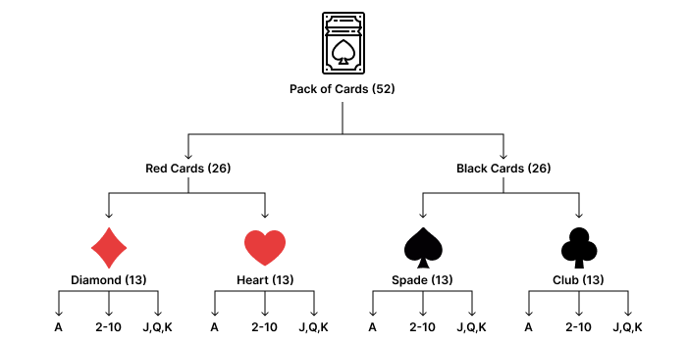

- Each set of 13 cards has an Ace(A), the numbers 2 to 10 and then Jack(J), Queen(Q), and King(K).
- J, Q and K cards are called face cards.

Question : What is the probability of drawing a King from a deck of 52 cards?
Solution : Number of King cards = 4 Total number of cards = 52 Probability of King card = Number of King cards / Total number of cards = 4/52 = 1/13.
Question : What is the probability of drawing a diamond card from a deck of 52 cards?
Solution : Number of Diamond cards = 13 Total number of cards = 52 Probability of Diamond card =Number of Diamond cards/Total number of cards = 13/52 = 1/4.

With Replacement :
With replacement means that each time an item is selected from a set, it is put back before the next selection, allowing it to be chosen again.
Without Replacement :
Without replacement ensures that each selected item from a set is not put back, hence cannot be selected again. It means each item can be chosen once.
Question : If two cards are picked at random. What is the probability that both of them are red? A)With replacement B)Without replacement
Solution : Number of red cards = 26 Probability of picking one red card =Number of red cards/Total number of cards = 26/52 A)With replacement : Probability of picking one red card = 26/52 Probability of picking another red card = 26/52 (because we replaced the card) Probability of being both red cards = (26/52) * (26/52) = (1/2) * (1/2) = 1/4. B)Without replacement : Probability of picking one red card = 26/52 Probability of picking another red card = 25/51 Here we consider 25/51 because out of 26 red cards already one red card is drawn. So, there are 25 red cards. Out of 52 cards, 1 card is drawn. So, the remaining total number of cards are 51. Probability of being both red cards = (26/52) *(25/51) = (1/2) * (25/51) = 25/102
Note
If the question does not specify whether to consider with or without replacement, then assume without replacement
Probability based on Miscellaneous
This type of question is based on picking a ball or pen, any object from the container,
Bag orbox then finding the probability of picking that object.
Question : A bag contains 7 red and 8 blue pens. One pen is drawn at random.What is the probability that the pen drawn is red?
Solution : Total number of pens =(7+8)=15 Total number of red pens =7 Probability of red pen =7/15.
Question : A container holds 4 orange balls, 7 purple balls, and 9 black balls. If two balls are drawn at random , what is the probability that the first ball is black and the second ball is orange? A) With replacement B) Without replacement

Solution : Total number of balls = 4 + 7 + 9 = 20 Number of black balls =9 Number of orange balls = 4 A)With replacement: Probability of black ball = Number of black balls / Total number of balls = 9 /20 Probability of orange ball = Number of orange balls / Total number of balls = 4/20 Probability of first ball is black and the second ball is orange = Probability of black ball * Probability of orange ball = (9/20) * (4/20) = (9/20 )*(1/5) = 9/100. B)Without replacement: Probability of black ball = 9/20 Probability of orange ball = 4/19
Here we consider the total number of balls to be 19 because one is already drawn from 20 balls. Probability of first ball is black and the second ball is orange = (9/20)*(4/19) = (9/5)* (1/19) = 9/95.

